WEEK 2 DELIVERABLE
Exploratory Data Analysis and Visualization Framework
A reusable, step-by-step process for understanding any dataset with Python
pandas | matplotlib | seaborn | plotly | scipy

7  EDA STAGES |  | 20+  PLOT TYPES COVERED |  | 8  PYTHON LIBRARIES |  | 33 h  PLANNED EFFORT

Purpose. This document defines a complete framework for exploratory data analysis (EDA) and visualization that can be applied to any tabular dataset. No dataset is required: the focus is on the process, techniques, tools and reporting plan. Examples are drawn from the Urban Air Quality Forecasting project planned in Week 1, so the framework connects directly to the upcoming technical work.

Contents
1. Introduction to EDA
2. Understanding Data Types
3. Initial Data Inspection
4. Data Exploration Techniques
5. Handling Missing Data and Outliers
6. Visualization Strategies
7. Tools and Python Libraries
8. Documentation and Reporting Plan
9. Effort Plan and Quality Checklist
10. Conclusion

How to use this framework
Work through the stages in order for a new dataset, but expect to loop back. Each section gives the goal of a stage, the techniques to apply, the Python tools to use, and what to record. The code snippets are short templates that work on any pandas DataFrame named df.

1. Introduction to EDA

1.1 What is EDA?
Exploratory Data Analysis is the process of examining a dataset with summary statistics and visualizations to understand its structure, quality and patterns before any formal modeling. The approach was popularized by the statistician John Tukey, who argued that analysts should look at data openly and ask questions of it, rather than only testing pre-set hypotheses.
In practice, EDA answers questions such as: What does each variable mean and how is it distributed? How much data is missing or suspicious? Which variables move together? Are there trends, cycles or groups hidden in the data? Do the data support the assumptions that a model will make?

1.2 Why EDA matters
Benefit | Why it matters in a data science project
Data quality | Reveals missing values, duplicates, wrong units and impossible values before they silently damage a model.
Better questions | Patterns found in EDA sharpen the problem definition and show which questions the data can actually answer.
Smarter features | Skewed distributions, seasonality and interactions suggest transformations and new features.
Model choice | Checking linearity, scale, class balance and correlation helps pick suitable algorithms and avoid broken assumptions.
Risk reduction | Finding leakage, bias or unrepresentative samples early is far cheaper than discovering them after deployment.
Communication | Clear plots build stakeholder trust and make findings easy to explain.

1.3 EDA versus confirmatory analysis
EDA is open-ended and generates hypotheses. Confirmatory analysis (hypothesis testing, model validation) tests specific hypotheses with a pre-defined method. A key discipline is to avoid mixing the two: a pattern found by exploring the full dataset should be confirmed on held-out data, otherwise it may be chance. In time-series projects, EDA should be done mainly on the training period so the test period stays untouched.

1.4 The EDA workflow
The framework uses seven stages, summarized in Figure 1. Stages 2 and 3 make sure the data can be trusted; stages 4 to 6 move from single variables to relationships; stage 7 turns understanding into a documented result.
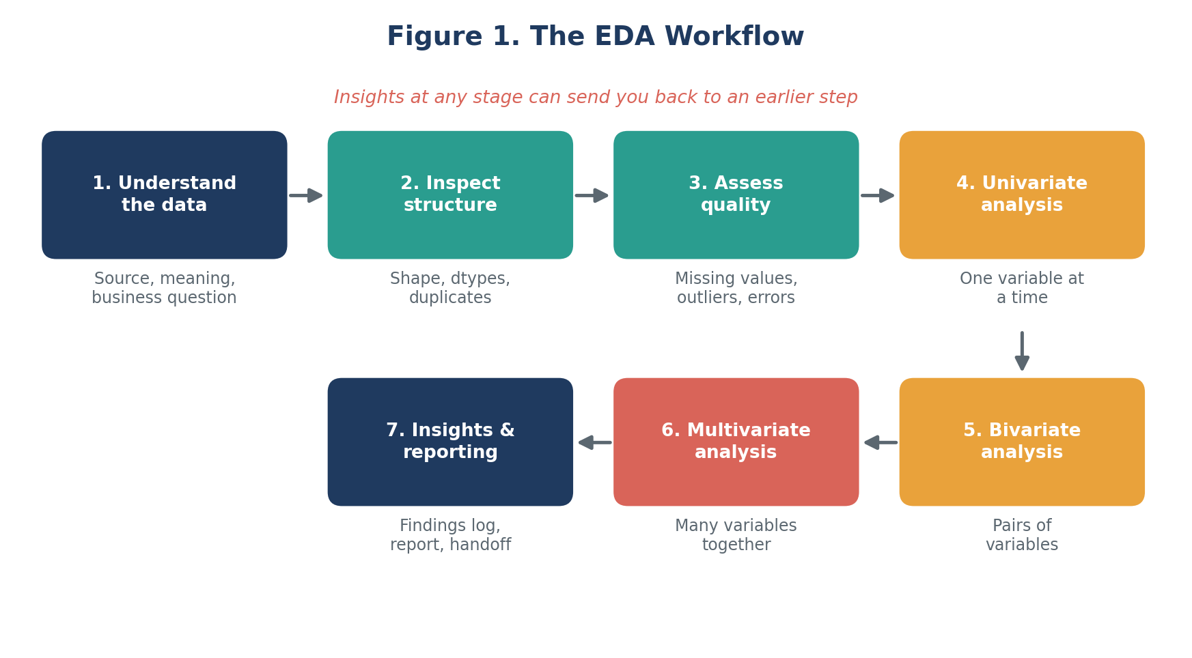
Figure 1. The seven-stage EDA workflow

2. Understanding Data Types
The type of a variable decides which statistics, plots and cleaning methods are valid. Averages make sense for a temperature but not for a postal code; a histogram suits a continuous variable but not a category. The first task in EDA is therefore to classify every column correctly, using its meaning rather than only the type pandas guessed.
Data type | Description and examples | pandas dtype | Typical EDA approach
Numerical continuous | Measured on a scale; any value in a range. Examples: PM2.5 level, temperature, price. | float64 | Histogram, KDE, box plot; mean, median, std, skewness; outlier checks.
Numerical discrete | Counts, whole numbers. Examples: number of vehicles, visits per day. | int64 | Bar chart or histogram; check zero inflation and range.
Categorical nominal | Labels with no order. Examples: station name, city, weather type. | object / category | Value counts, bar chart; check rare levels and spelling variants.
Categorical ordinal | Labels with a meaningful order. Examples: AQI category (Good to Hazardous), rating. | category (ordered) | Ordered bar chart; map to ranks when modeling.
Binary / boolean | Two outcomes. Examples: holiday flag, sensor_ok. | bool / int | Proportion, grouped comparisons.
Date and time | Timestamps, dates, durations. Examples: hourly reading time. | datetime64 | Check range, gaps and frequency; line plots, seasonality, lags.
Text | Free text. Examples: comments, descriptions. | object / string | Length, word counts, common terms; clean before analysis.
Geospatial | Coordinates or regions. Examples: station latitude and longitude. | float / geometry | Maps, spatial grouping, distance features.
Identifiers | Unique keys. Examples: record ID, sensor ID. | int / object | Check uniqueness and duplicates; exclude from modeling.

2.1 Scales of measurement
Variables can also be described by their scale: nominal (labels), ordinal (ordered labels), interval (equal steps but no true zero, such as temperature in Celsius) and ratio (equal steps with a true zero, such as concentration or count). The scale determines which comparisons are meaningful: ratios such as "twice as polluted" only make sense on ratio scales.

2.2 Structure of datasets
- Tabular (cross-sectional): each row is an independent observation, for example one customer.
- Time series: rows are ordered in time; order must be preserved and autocorrelation checked.
- Panel (longitudinal): many entities observed over time, for example many stations over three years. Analyse within and between entities.
- Hierarchical or grouped: observations nested in groups, which affects how summaries and comparisons should be made.

3. Initial Data Inspection
Before any plotting, a structured inspection answers the basic questions: how big is the data, what is in it, and is it trustworthy at first glance. Each check below takes only a line or two of pandas and should be recorded in the data-quality log.
Check | What to look for
Shape and size | Number of rows and columns; memory use; does the size match expectations?
Column names and meaning | Clear, consistent names; every column documented in a data dictionary.
Data types | Numbers stored as text, dates stored as strings, wrong categories.
Head, tail and random sample | Formatting issues, header rows repeated in data, sorting, unexpected values.
Duplicates | Fully duplicated rows or repeated keys (for example the same timestamp and station twice).
Summary statistics | Impossible minimums or maximums, wrong units, constant columns.
Cardinality | Number of unique values per column; very high for categories, very low for numbers.
Missing value count | Share of missing values per column and per row; patterns in where they occur.

3.1 Python template
import pandas as pd

df = pd.read_csv("data/raw/dataset.csv", parse_dates=["timestamp"])

print(df.shape) # rows, columns
df.info() # dtypes, non-null counts, memory
print(df.head(), df.tail(), df.sample(5, random_state=42))
print(df.describe(include="all").T) # summary statistics
print(df.nunique().sort_values()) # cardinality per column
print(df.duplicated().sum()) # duplicated rows
print(df.isna().mean().sort_values(ascending=False)) # share missing

Good practice
Never edit the raw file. Load it, apply every correction in code, and save the result to a separate data/processed folder. This keeps the analysis reproducible and every decision traceable.

4. Data Exploration Techniques
Exploration moves from simple to complex: one variable, then pairs, then many variables together. Each level reveals different problems, and findings at one level guide what to check at the next.

4.1 Univariate analysis (one variable)
The aim is to understand the distribution of each variable on its own: its centre, spread, shape and unusual values.
Variable type | Statistics | Plots
Numerical | Mean, median, mode; standard deviation, variance, IQR, range; skewness and kurtosis; percentiles | Histogram, KDE plot, box plot, violin plot, Q-Q plot (normality)
Categorical | Counts, proportions, number of levels, rare categories | Bar chart, count plot, ordered bar chart
Date / time | Start and end, frequency, gaps, number of records per period | Line plot, records-per-day bar chart

- Reading the shape: a long right tail (positive skew), common for pollution and income, suggests a log transform; two peaks suggest mixed groups worth separating.
- Mean versus median: a large gap indicates skew or outliers; use the median as a more robust centre.
- Zero inflation and caps: many exact zeros, or a pile-up at a maximum value, often signals sensor limits or default values.

num_cols = df.select_dtypes("number").columns
print(df[num_cols].agg(["mean", "median", "std", "skew", "kurt"]).T)

df[num_cols].hist(bins=30, figsize=(12, 8)) # quick overview of all numbers
df["station"].value_counts(normalize=True).plot.bar() # categorical balance

4.2 Bivariate analysis (two variables)
Bivariate analysis checks how two variables relate, in particular how each feature relates to the target. The right technique depends on the pair of types.
Pair | Technique | Plot
Numeric vs numeric | Pearson correlation (linear), Spearman correlation (monotonic, robust to outliers); look at the shape, not just the number | Scatter plot, hexbin plot, regression line, lag plot
Numeric vs categorical | Group means and medians; t-test or ANOVA (Kruskal-Wallis if non-normal) to check if differences are likely real | Box plot, violin plot, strip plot, bar with error bars
Categorical vs categorical | Cross-tabulation; chi-square test of independence; Cramer's V for strength | Grouped or stacked bar chart, heatmap of counts
Variable vs time | Rolling statistics, seasonal decomposition, autocorrelation (ACF and PACF) | Line plot, seasonal plot, autocorrelation plot

Correlation is not causation
A strong correlation can come from a hidden third variable or from chance. Always inspect the scatter plot: the same correlation coefficient can come from very different shapes, including outlier-driven or curved relationships (Anscombe's quartet).

import seaborn as sns

df[["pm25", "temp", "wind"]].corr(method="spearman")
sns.scatterplot(data=df, x="wind", y="pm25", alpha=0.4)
sns.boxplot(data=df, x="season", y="pm25")
pd.crosstab(df["season"], df["alert_level"], normalize="index")

4.3 Multivariate analysis (three or more variables)
Multivariate analysis looks at how several variables interact. It finds redundant features, groups of similar observations and effects that only appear when variables are combined.
- Correlation matrix and heatmap: shows all pairwise correlations at once; highlights groups of redundant features (multicollinearity).
- Pair plot: a grid of scatter plots and histograms for a handful of key variables.
- Conditioned plots: colour, size or facets add a third or fourth variable, for example PM2.5 against wind speed, coloured by season.
- Variance Inflation Factor (VIF): quantifies multicollinearity; values above about 5 to 10 suggest dropping or combining features.
- Dimensionality reduction (PCA, t-SNE, UMAP): projects many variables into two dimensions to reveal structure or clusters.
- Clustering and group profiles: k-means or hierarchical clustering to discover natural segments, then profile each group.
- Time-aware checks: for time series, check stationarity, seasonality, lag relationships and whether relationships change over time.

corr = df.select_dtypes("number").corr(method="spearman")
sns.heatmap(corr, annot=True, fmt=".2f", cmap="RdBu_r", vmin=-1, vmax=1)

sns.pairplot(df[["pm25", "temp", "wind", "season"]], hue="season", corner=True)
sns.relplot(data=df, x="wind", y="pm25", hue="season", col="station", col_wrap=3)

5. Handling Missing Data and Outliers

5.1 Missing data

Step 1: Measure and visualize
Start by counting missing values per column and per row, then look for patterns: are gaps clustered in time, in one station, or in rows where another variable is also missing? A missingness heatmap or a bar chart of percent missing (see Figure 5) makes these patterns visible.

Step 2: Understand the mechanism
Mechanism | Meaning | Implication
MCAR | Missing Completely At Random: gaps unrelated to any data. | Safest case; deleting rows causes little bias, only less data.
MAR | Missing At Random: gaps depend on other observed variables (for example one sensor fails more in rain). | Imputing using the related variables is reasonable; plain deletion can bias results.
MNAR | Missing Not At Random: gaps depend on the missing value itself (for example a sensor fails at very high readings). | Hardest case; simple methods are biased; consider a missing indicator and domain advice.

Step 3: Choose a treatment
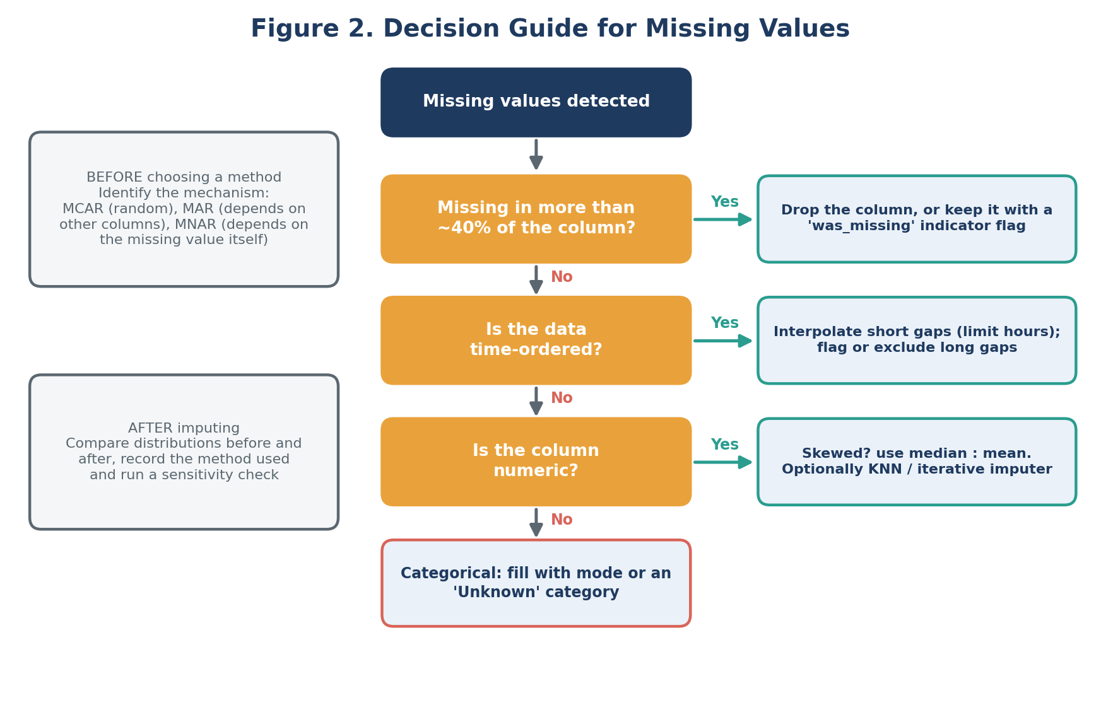
Figure 2. Decision guide for missing values
Method | When to use it | Caution
Delete rows | Very few rows affected and data is MCAR. | Loses information; can bias results if not MCAR.
Drop column | Column is mostly empty and not important. | Check it is not informative before dropping.
Mean / median / mode | Quick baseline for small gaps; median for skewed data. | Reduces variance and weakens correlations.
Forward / backward fill, interpolation | Time series with short gaps. | Set a limit; do not fill long outages.
KNN or iterative imputation | Missingness depends on other variables (MAR). | Slower; fit on training data only to avoid leakage.
Missing indicator flag | The fact that a value is missing may be informative. | Adds a column; use together with another method.

missing = df.isna().mean().mul(100).sort_values(ascending=False)
missing.plot.barh(title="% missing by column")

df["pm25_was_missing"] = df["pm25"].isna().astype(int) # indicator flag
df["pm25"] = df["pm25"].interpolate(method="time", limit=3) # short gaps only
df["wind"] = df["wind"].fillna(df["wind"].median()) # simple fallback

5.2 Outliers
An outlier is an observation far from the rest. It may be an error (a faulty sensor reading), a rare but real event (a festival-night pollution spike) or simply a long tail. Treatment depends on which, so detection is always followed by investigation (Figure 3).
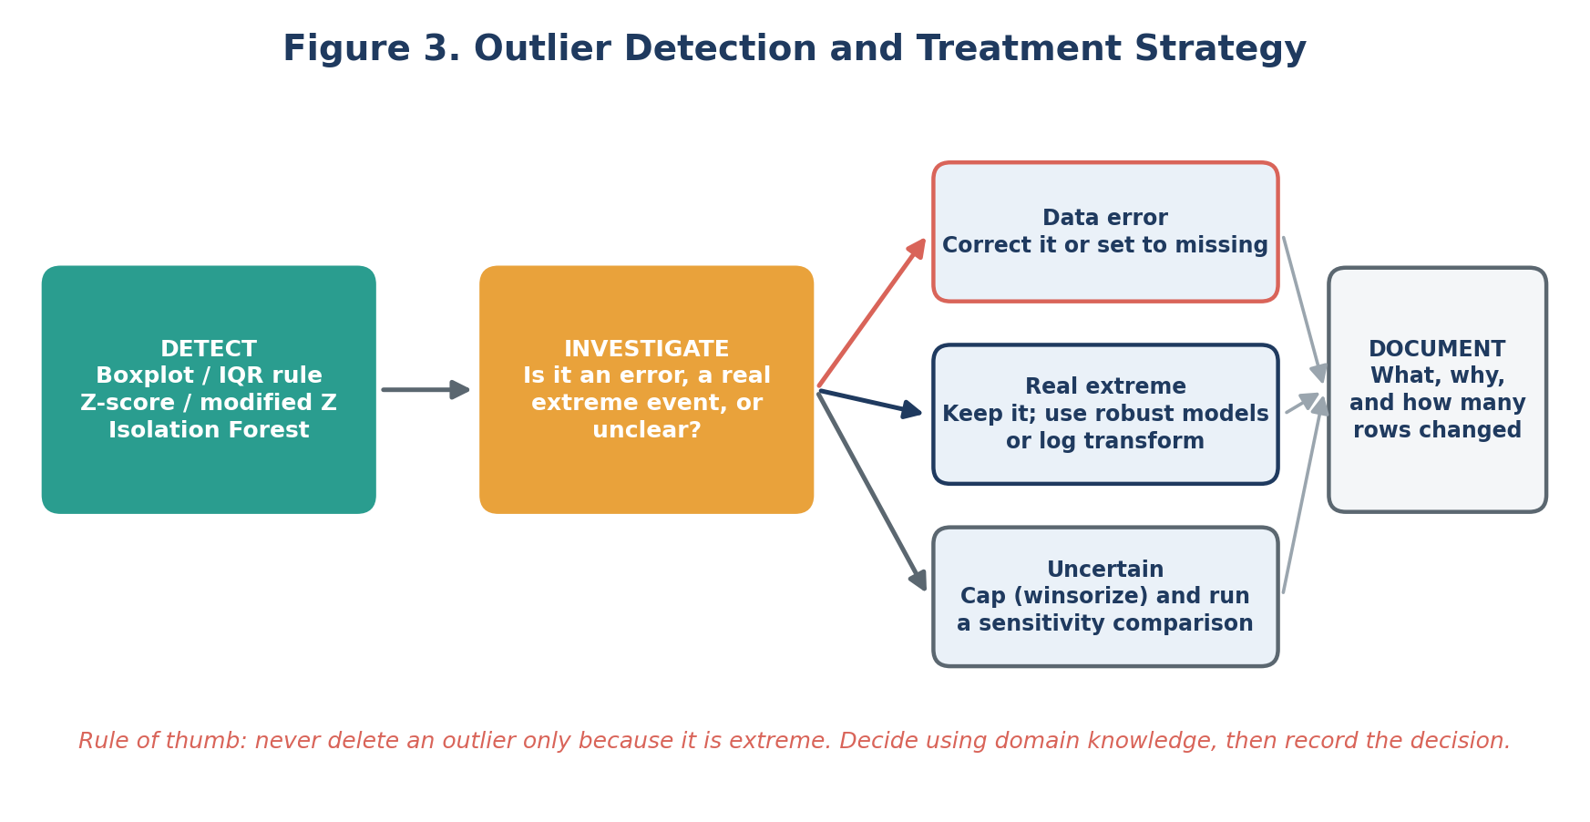
Figure 3. Outlier detection and treatment strategy
Detection method | How it works | Best used when
Visual: box plot, scatter plot | Points beyond the whiskers or far from the cloud stand out. | Always as a first look.
IQR rule | Flag values below Q1 minus 1.5 x IQR or above Q3 plus 1.5 x IQR. | Skewed data; no normality assumption.
Z-score / modified Z-score | Flag values more than about 3 standard deviations from the mean (modified Z uses the median). | Roughly symmetric data; modified version for robustness.
Isolation Forest / LOF | Model-based detection of unusual combinations of variables. | Multivariate outliers that look normal one variable at a time.
Domain rules | Physical limits and logical checks (negative concentration, humidity above 100%). | Whenever the subject area has known limits.

q1, q3 = df["pm25"].quantile([0.25, 0.75])
iqr = q3 - q1
mask = (df["pm25"] < q1 - 1.5 * iqr) | (df["pm25"] > q3 + 1.5 * iqr)
print(mask.sum(), "potential outliers")

df.loc[df["pm25"] < 0, "pm25"] = pd.NA # impossible values -> missing
df["pm25_capped"] = df["pm25"].clip(upper=df["pm25"].quantile(0.99)) # winsorize

Treatment options: correct the value if the true value is known; set impossible values to missing and then impute; cap (winsorize) extremes; apply a log or square-root transform; or keep the values and use robust methods (median, tree-based models). Every action is recorded in the cleaning decisions log with the number of rows affected.

6. Visualization Strategies
Visualization is the main tool of EDA. A good plot is chosen to answer a specific question, and a good dashboard or report shows only the plots that support a finding. The strategy below has three parts: choosing the right plot, building a gallery of standard plots, and following design principles.

6.1 Choosing the right plot
Start from the question, not from the chart. Figure 4 maps common analytical questions to suitable plots.
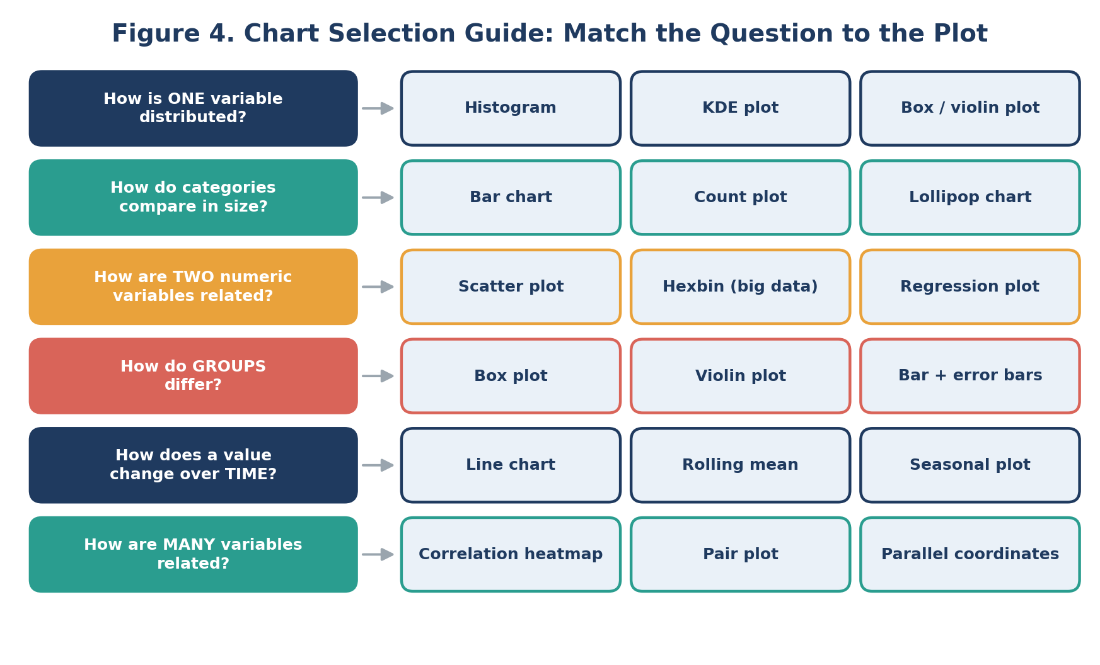
Figure 4. Chart selection guide: match the question to the plot

6.2 Standard plot gallery
Figure 5 shows six core plots produced with matplotlib and seaborn on synthetic air-quality-style data. The data are illustrative only, to show what each plot looks like and what it reveals.
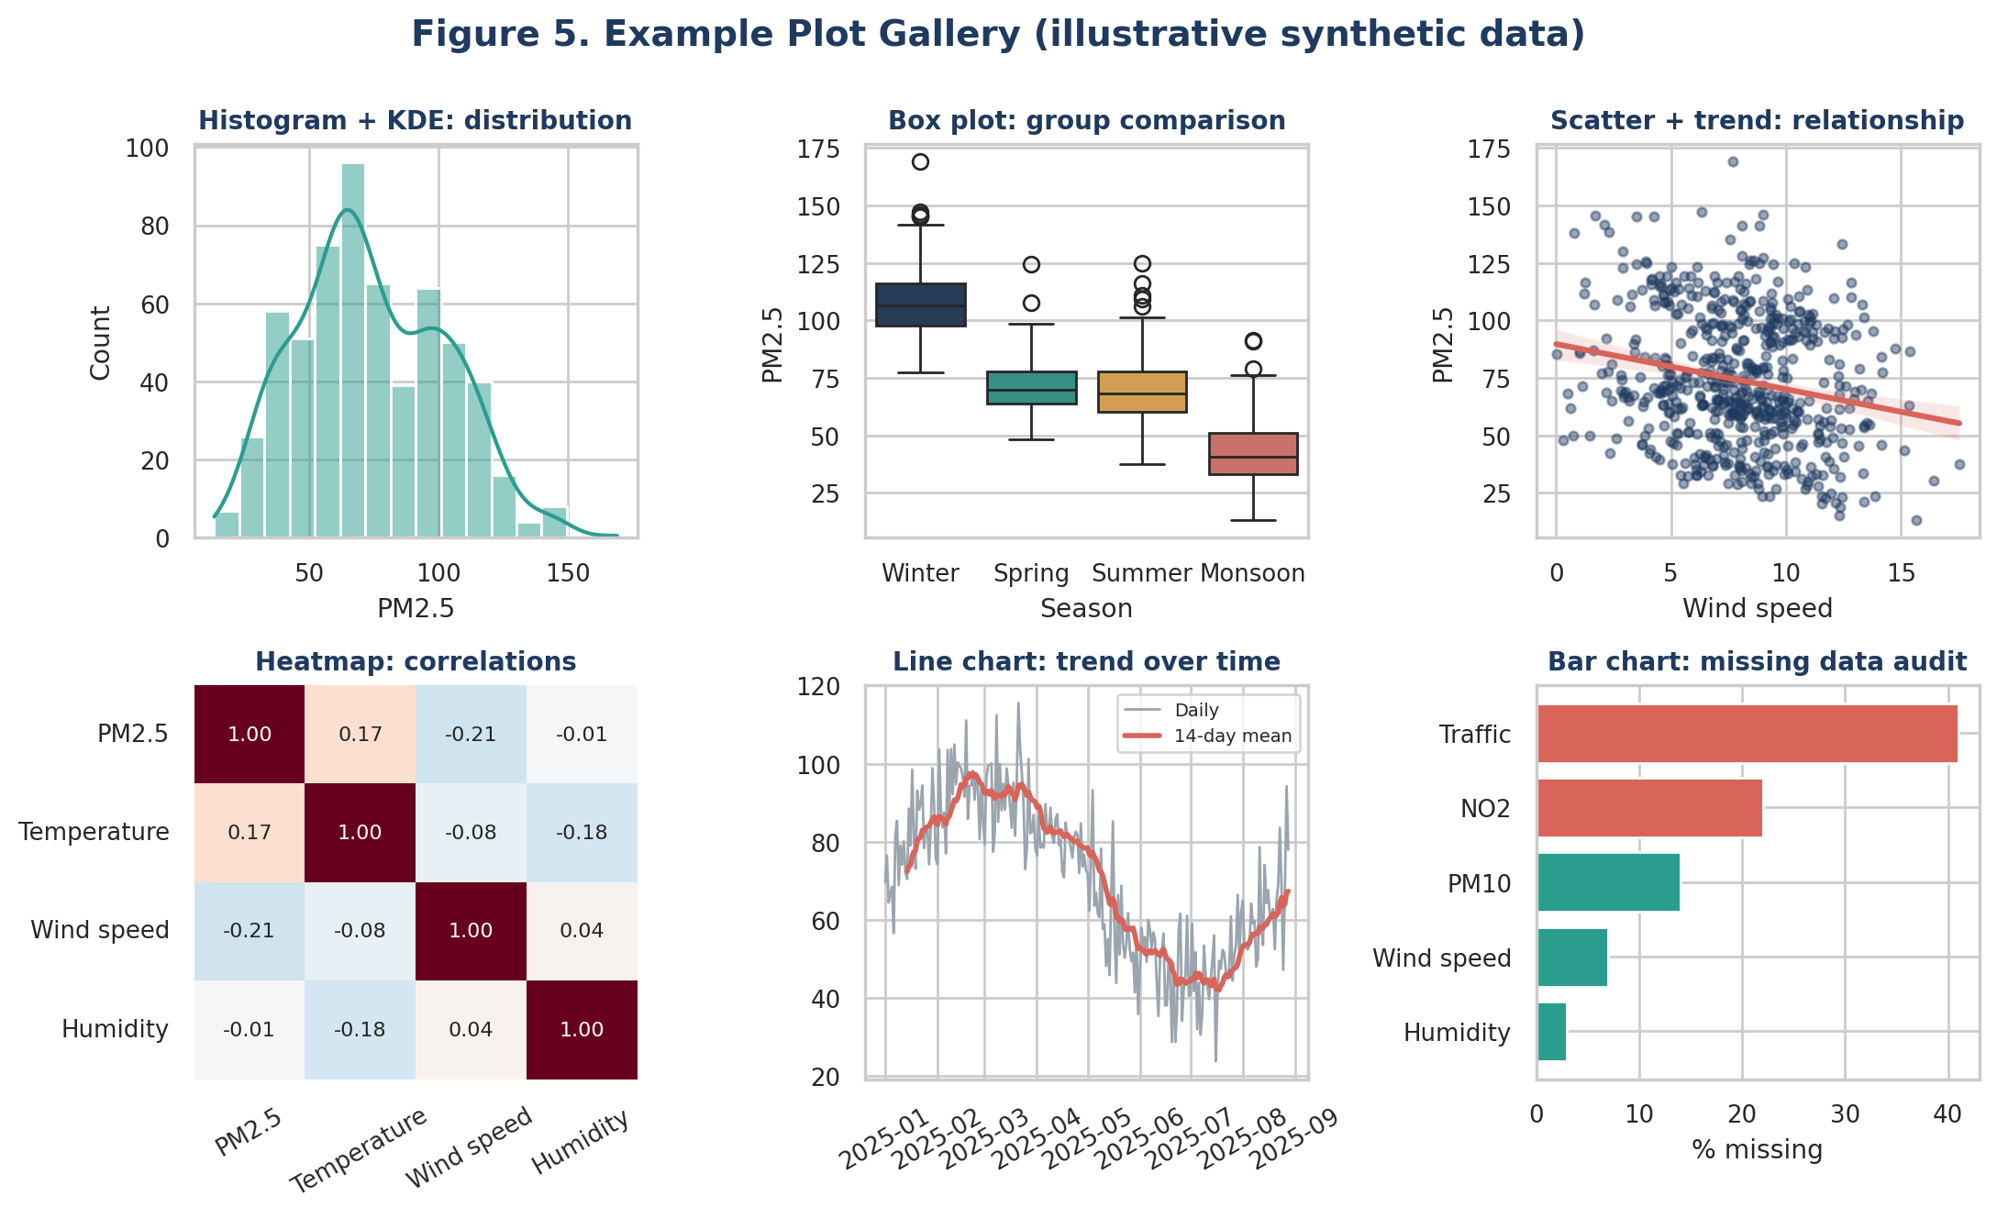
Figure 5. Example plot gallery (illustrative synthetic data)
Plot | What it reveals | Library call | Watch out for
Histogram + KDE | Shape, skew, peaks, spread of one variable | sns.histplot(kde=True) | Bin width changes the story; try several.
Box / violin plot | Median, spread and outliers across groups | sns.boxplot / violinplot | Hides multimodality in box plots; violin shows it.
Scatter + trend | Direction, strength and shape of a relationship | sns.regplot / scatterplot | Overplotting; use alpha or hexbin for big data.
Correlation heatmap | Pairwise relationships among many variables | sns.heatmap(corr) | Only linear or monotonic; use a diverging palette.
Line chart | Trend, seasonality, gaps over time | df.plot / plt.plot | Add rolling mean; keep a consistent time axis.
Bar chart | Counts or percentages per category | sns.countplot / barh | Sort bars; start the axis at zero.

6.3 Additional plots in the toolkit
- Q-Q plot: compares a variable with a normal distribution to judge whether a transform is needed.
- Pair plot and facet grids: many relationships, or the same plot split by group, in one view.
- Hexbin and 2D density plots: scatter plots for very large datasets.
- Autocorrelation (ACF/PACF) and seasonal decomposition plots: reveal memory and cycles in time series.
- Calendar heatmap (hour by weekday): shows daily and weekly rhythms at a glance.
- Missingness matrix: shows where data are missing across rows and columns.
- Maps (folium, plotly): spatial patterns across stations or regions.
- Interactive plots (plotly): zoom, hover and filter for deeper exploration and for the dashboard.

6.4 Design principles
Principle | Practice
One message per plot | Give each figure a clear title that states the takeaway, not just the variable names.
Label everything | Axis labels with units, legends, readable font sizes, and source or sample size in a caption.
Honest scales | Start bar charts at zero; avoid truncated or dual axes that exaggerate effects.
Use colour carefully | Consistent colours per category; colourblind-safe palettes; diverging palettes only for data with a meaningful midpoint.
Reduce clutter | Remove unnecessary gridlines, borders and 3D effects; avoid pie charts with many slices.
Handle overplotting | Use transparency, sampling, hexbin or density plots for large data.
Consistency | One theme (for example sns.set_theme) and one palette across the whole project.

import matplotlib.pyplot as plt, seaborn as sns

sns.set_theme(style="whitegrid", context="notebook", palette="colorblind")

fig, ax = plt.subplots(figsize=(8, 4.5))
sns.histplot(df["pm25"], kde=True, ax=ax)
ax.set(title="PM2.5 is right-skewed with a long tail of high-pollution hours",
xlabel="PM2.5 (\u00b5g/m\u00b3)", ylabel="Number of hours")
fig.savefig("reports/figures/pm25_distribution.png", dpi=200, bbox_inches="tight")

7. Tools and Python Libraries
The toolkit combines data handling, static and interactive plotting, statistics and documentation tools. Each library has a clear role in the EDA process.
Library / tool | Role in EDA | Typical functions
pandas | Core data manipulation: loading, inspecting, cleaning, grouping, resampling. | read_csv, info, describe, groupby, pivot_table, isna, resample, merge
NumPy | Fast numerical operations and array maths under the hood. | log, percentile, where, corrcoef
matplotlib | Foundation plotting library with full control of figures. | subplots, hist, scatter, plot, savefig
seaborn | Statistical plots with attractive defaults, built on matplotlib. | histplot, boxplot, violinplot, heatmap, pairplot, regplot
plotly | Interactive charts with hover, zoom and filters; useful for dashboards. | px.scatter, px.line, px.box, px.imshow
SciPy / statsmodels | Statistical tests, distributions, time-series analysis. | pearsonr, spearmanr, ttest_ind, f_oneway, chi2_contingency, seasonal_decompose, acf
scikit-learn | Imputation, scaling, outlier detection, PCA and clustering. | KNNImputer, IterativeImputer, IsolationForest, PCA, KMeans
missingno | Dedicated missing-data visualization. | matrix, bar, heatmap
ydata-profiling | Automatic EDA report as a fast first look (supplement, not replacement). | ProfileReport(df)
Jupyter, Git | Notebooks for narrative analysis; version control for reproducibility. | Notebook cells, Markdown, commits

Tool choice in practice
Use pandas and seaborn for most exploration, matplotlib when a figure needs fine control, and plotly when interactivity helps the audience. Automated profiling reports save time, but the analyst still has to interpret results and decide what matters.

8. Documentation and Reporting Plan
EDA only creates value if its findings are recorded and communicated clearly. The plan below treats documentation as part of the analysis, not an afterthought (Figure 6).
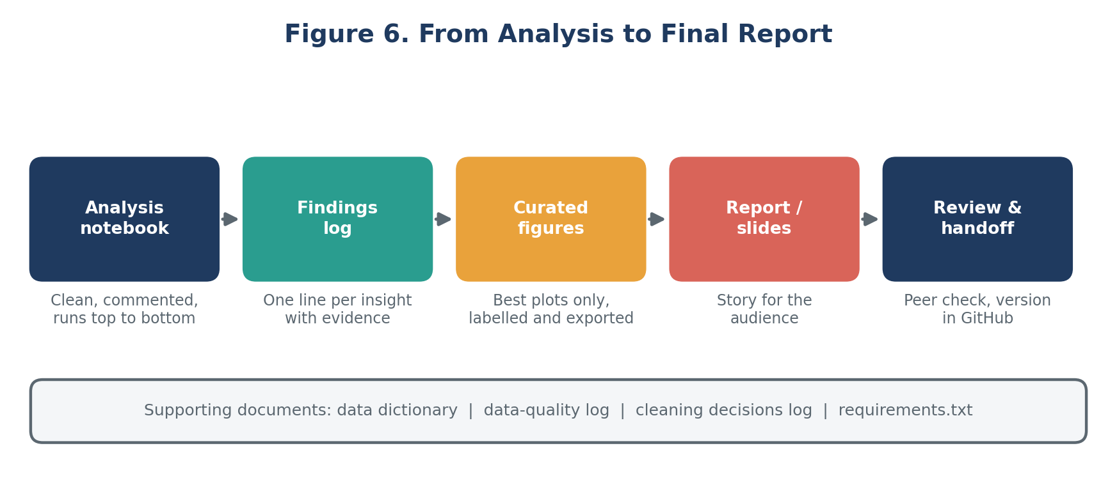
Figure 6. From analysis to final report

8.1 Working documentation (during EDA)
Document | Content
Data dictionary | Every column: name, meaning, unit, type, allowed range, source, known issues.
Data-quality log | Missing values, duplicates, inconsistencies and suspicious values found, with counts.
Cleaning decisions log | Each cleaning action: what, why, method, rows affected, and the alternative considered.
Findings log | One line per insight, with the supporting plot or statistic and the implication for modeling.
Analysis notebook | Well-organized Jupyter notebook with Markdown explanations; runs cleanly from top to bottom; fixed random seeds.
Repository | Code, notebooks and reports in GitHub with a README and requirements file.

8.2 Notebook structure
- Title, objective, author, date and data source.
- Imports, settings and helper functions (including the shared plotting theme).
- Data loading and initial inspection.
- Data quality: missing values, duplicates, outliers, with decisions.
- Univariate, bivariate and multivariate analysis, each with a short written interpretation.
- Summary of key findings and implications for feature engineering and modeling.
- Open questions and next steps.

8.3 Final report outline
No. | Section | Content
1 | Executive summary | Three to five key findings and recommendations in plain language.
2 | Background and objectives | The problem, the questions asked of the data, and the data sources.
3 | Data description | Size, period, variables, structure, and the data dictionary summary.
4 | Data quality assessment | Missing data and outliers found, how they were handled, and the effect on the data.
5 | Key findings | Univariate, bivariate and multivariate results, each supported by a labelled figure.
6 | Implications | What the findings mean for feature engineering, model choice and risks.
7 | Limitations | Data gaps, assumptions, possible bias, and what EDA could not show.
8 | Next steps | Recommended actions and the plan for the modeling phase.
A | Appendix | Extra plots, statistical test details, code references.

8.4 Presentation plan (8 to 10 slides)
- Title and objective; the problem in one slide.
- Data overview: sources, size, period, and quality at a glance.
- Three to four insight slides, each with one large plot and a headline that states the finding.
- What it means: implications for modeling and for the decision-makers.
- Risks, limitations and next steps.

Reporting principles
Lead with the conclusion, support it with one clear figure, and state limitations honestly. Tailor the depth to the audience: technical readers get method details in the appendix; stakeholders get a short narrative with the key plots.

9. Effort Plan and Quality Checklist

9.1 Planned effort (33 hours)
Activity | Output | Hours | Share
Frame the EDA and review concepts | Scope, questions, workflow design | 3 | 9%
Data types and inspection design | Type table, inspection checklist and templates | 4 | 12%
Univariate, bivariate, multivariate techniques | Technique tables and code templates | 6 | 18%
Missing-data and outlier strategy | Decision guides and treatment tables | 4 | 12%
Visualization strategy and plot gallery | Chart guide, example plots, design rules | 6 | 18%
Tools and libraries mapping | Library table and setup notes | 2 | 6%
Documentation and reporting plan | Logs, notebook structure, report and slide outline | 4 | 12%
Review, diagrams and formatting | Final document and quality check | 4 | 12%
Total |  | 33 | 100%

9.2 Quality checklist
 | Before calling EDA complete
☐ | Every column has a verified type, meaning and unit in the data dictionary.
☐ | Missing values quantified, mechanism considered, and treatment justified and logged.
☐ | Outliers detected, investigated (error or real) and handled with a recorded reason.
☐ | Every key variable examined alone, against the target, and in combination.
☐ | Duplicates, leakage risks and sampling bias checked.
☐ | For time series: order preserved, gaps and seasonality checked, no use of future data.
☐ | All figures titled, labelled with units, readable and saved in a figures folder.
☐ | Findings log complete and linked to implications for modeling.
☐ | Notebook runs top to bottom; random seeds, library versions and data version recorded.

9.3 Common pitfalls to avoid
- Skipping data types: treating category codes as numbers or dates as text.
- Blind deletion: dropping outliers or missing rows without understanding why they occur.
- Leakage during EDA: computing imputation values or scaling on the full dataset, including the test period.
- Over-reading correlation: claiming a cause from a pattern, or trusting a coefficient without looking at the plot.
- Plot overload: producing hundreds of charts without writing down what each one shows.
- Cherry-picking: reporting only the patterns that support a favoured story; record negative findings too.

10. Conclusion
This framework gives a repeatable path for exploring any dataset: classify the data, inspect and clean it, examine variables one at a time, in pairs and together, choose visualizations that answer specific questions, and record every decision and finding. Because it is built on general principles (data types, distributions, relationships, quality and communication) rather than on one dataset, it adapts easily to different domains.
Applied to the Urban Air Quality Forecasting project, it will guide the exploration of sensor, weather and calendar data in the technical weeks that follow, and its documentation templates will make the later modeling stages faster, more reliable and easier to explain.

Understand the data first. Model it second.
EDA and Visualization Framework | Week 2

