WEEK 3 DELIVERABLE
Machine Learning Model Development and Evaluation Plan
A step-by-step Python plan for building, validating and maintaining a customer churn prediction model
pandas | scikit-learn | LightGBM | Optuna | MLflow | SHAP

8  WORKFLOW STAGES |  | 5  MODELS COMPARED |  | 8  EVALUATION METRICS |  | 33 h  PLANNED EFFORT

Purpose. This document is a detailed plan for developing and evaluating a machine learning model in Python. It covers problem definition, preprocessing, model selection, training, evaluation, validation and deployment. The worked example is a hypothetical customer churn prediction project for a subscription business. No code is executed: the snippets are short templates showing how each step would be implemented, and the plan reflects the process a full-scale project would follow.
Contents
1. Introduction and Problem Definition
2. Data Collection and Understanding
3. Data Preprocessing
4. Model Selection
5. Training and Hyperparameter Tuning
6. Evaluation Metrics
7. Validation Strategy
8. Deployment and Maintenance
9. Risks, Effort Plan and Quality Checklist
10. Conclusion

How to use this plan
Work through the stages in order, but expect to loop back: error analysis feeds feature engineering, and monitoring feeds retraining. Each section states the goal of a stage, the techniques to apply, the Python tools to use and what to record. The code snippets are templates that assume a pandas DataFrame named df and a scikit-learn pipeline named model.

1. Introduction and Problem Definition

1.1 Problem statement
A subscription business loses revenue every time a customer cancels. Retention offers such as discounts, outreach or plan changes work best when they reach the right people before they leave, but they cost money and annoy customers who were never going to leave. The goal is a model that ranks customers by their probability of cancelling in the next 30 days, so a limited retention budget can be focused on the highest-risk customers.
The task is binary classification: for each customer and snapshot date, the label is 1 if the customer cancels within the next 30 days and 0 otherwise. The output is a calibrated probability, not only a yes or no.

1.2 Why machine learning is a good fit
Reason | Why it applies to churn
Many weak signals | Usage drops, billing disputes, support contacts, plan changes and contract status each say a little. A model can combine dozens of them, which hand-written rules cannot do well.
Labelled history exists | Every past cancellation is a labelled example, so supervised learning applies directly.
Repeated decisions at scale | The same scoring decision is made for every customer every cycle, so a modest improvement in targeting compounds.
Measurable cost of errors | A missed churner costs lost revenue; an unnecessary offer costs a discount. This allows metrics and thresholds to be chosen on business grounds.

1.3 Success criteria
- Business: the retention campaign reaches more true churners per contact than the current rule-based approach, measured in a controlled A/B test after launch.
- Technical: the model clearly beats a logistic regression baseline and an always-predict-no-churn rule on PR AUC and recall at the contact budget, with well-calibrated probabilities.
- Operational: scores are produced on schedule, explanations are available to the retention team, and monitoring flags problems before they affect decisions.

1.4 Assumptions and scope
- The company has two to three years of customer history in a data warehouse (assumed for this exercise).
- Churn is the minority class, assumed to be roughly 10 to 25 percent of customers per observation period.
- Out of scope: choosing which retention offer to make. That would be a separate uplift-modelling project.

1.5 The machine learning workflow
The project follows eight stages, summarized in Figure 1. Stages 1 to 3 make sure the problem and data are sound; stages 4 to 6 build and judge the model; stages 7 and 8 put it to use and keep it healthy. Two feedback loops make the process iterative.
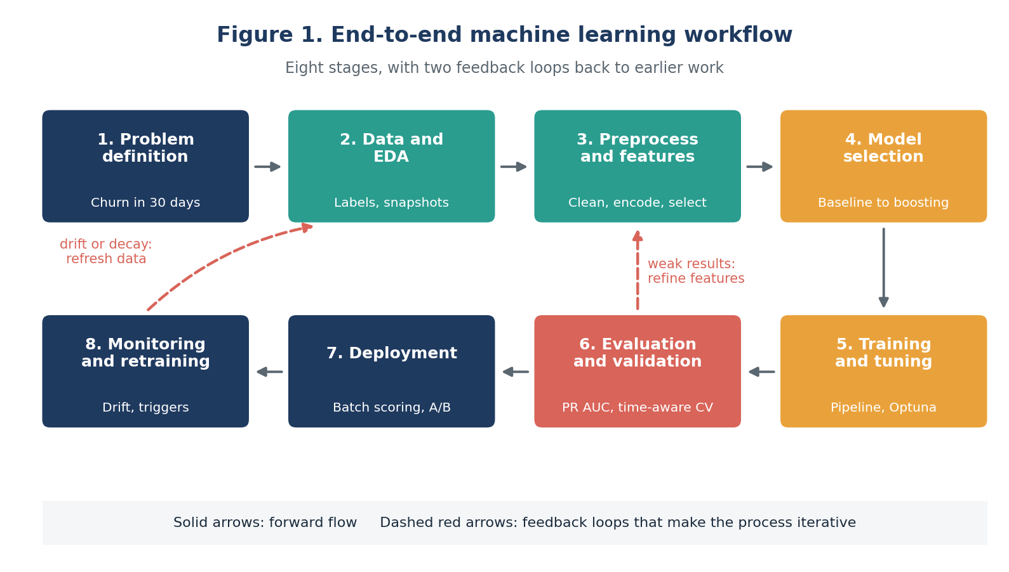
Figure 1. The eight-stage machine learning workflow

2. Data Collection and Understanding
Good models start with a clear view of where the data comes from and what each field means. This stage defines the sources, builds the label and explores the data before any modelling.

2.1 Data sources
Source | Example fields | Use
Customer master | Tenure, plan type, contract type, region, signup channel | Static profile features
Billing | Monthly charges, late payments, payment method, disputes | Financial-stress and price-sensitivity features
Usage logs | Minutes, data volume, logins, feature use per week | Engagement trends
Support | Tickets opened, resolution time, complaint category | Dissatisfaction signals
Cancellation records | Cancellation date and reason | Label construction

2.2 Label and snapshot design
For each customer and each snapshot date, the label is 1 if the customer cancels within the next 30 days. Every feature is computed only from information available on or before the snapshot date. Several snapshots per customer, for example one per month, are stacked to form the training table. This design prevents the most common failure in churn projects: features that quietly use information from after the prediction moment.

2.3 Exploratory data analysis
- Check class balance, missing-value rates, duplicate rows and obvious outliers with pandas.
- Plot churn rate against tenure, plan type and contract type with matplotlib or seaborn to find strong signals and sanity-check them against business knowledge.
- Compare early and recent months for distribution shifts, since these predict problems later.
- Write a short data dictionary so that every feature has a definition, a source and a refresh time.

3. Data Preprocessing
Preprocessing turns raw tables into a clean, numeric feature matrix. Every step is wrapped in a scikit-learn Pipeline so that it is fitted on training data only and then applied unchanged to validation and test data.

3.1 Data cleaning
Issue | Approach
Missing values | Separate "not applicable" (no support tickets means no resolution time) from "not recorded". Use median or mode imputation for the second kind and add a missing-indicator column where missingness itself may carry meaning.
Duplicates and inconsistencies | Remove duplicate customer-snapshot rows, standardise category spellings and fix impossible values such as negative tenure or future dates.
Outliers | Inspect heavy-tailed fields such as data usage. Cap at a high percentile (winsorising) or log-transform rather than deleting rows that may be real heavy users.
Types | Parse dates, cast categories and make sure IDs are not treated as numeric features.

3.2 Normalization and encoding
- Scaling: standardise numeric features (zero mean, unit variance) for the logistic regression baseline. Tree-based models do not need it, but the same pipeline can apply it harmlessly.
- Categorical encoding: one-hot encode low-cardinality fields such as contract type. For high-cardinality fields (region, device model) use target encoding computed inside cross-validation folds, or native categorical support in LightGBM.
- Skewed features: apply log or Box-Cox transforms to heavily skewed monetary and usage values for the linear baseline.

3.3 Feature engineering
Feature group | Examples | Why it helps
Trend | Change in usage over the last 30 days compared with the prior 90 days | A falling trend is often more informative than the level
Recency and frequency | Days since last login, logins in the last 14 days, days since last support contact | Disengagement precedes cancellation
Billing stress | Late payments, bill increase in the last cycle, promotional price ending | Price shocks trigger switching
Support experience | Tickets per month, unresolved tickets, average resolution time | Bad service experiences drive churn
Lifecycle | Tenure, months until contract end | Risk rises near contract end
Ratios | Charges per unit of usage | Captures perceived value for money

3.4 Feature selection
- Remove constant and near-constant columns, and one of each pair of highly correlated features (absolute correlation above 0.9).
- Rank the remaining features with model-based importance and permutation importance on validation data.
- Use L1-regularised logistic regression or recursive feature elimination as a second opinion.
- Keep the smaller feature set only if validation performance does not drop. Simpler models are easier to monitor and explain.

3.5 Potential challenges and solutions
Challenge | Why it matters | Planned solution
Class imbalance | A model can score high accuracy by predicting "no churn" for everyone | Stratified splits, class weights, PR-based metrics. Resampling such as SMOTE only inside training folds and only if weights are not enough
Data leakage | Features using information from after the snapshot inflate results and fail in production | Snapshot-date feature construction, a timing review of every feature, time-based splits
Concept drift | Customer behaviour and pricing change over time | Evaluate on the most recent months, monitor drift, schedule retraining
Messy data | Hurts quality and breaks pipelines | Imputation inside the Pipeline, schema checks on every run
Train/serve mismatch | Features computed differently in training and production | One shared feature-building code path and versioned feature definitions
Privacy and fairness | Customer data is sensitive; some features can proxy protected attributes | Exclude protected attributes, minimise personal data, audit performance across segments

3.6 Python template
from sklearn.compose import ColumnTransformer
from sklearn.pipeline import Pipeline
from sklearn.impute import SimpleImputer
from sklearn.preprocessing import StandardScaler, OneHotEncoder
from lightgbm import LGBMClassifier

num_cols = ["tenure", "monthly_charge", "logins_14d", "usage_trend_30_90"]
cat_cols = ["contract_type", "plan", "payment_method"]

prep = ColumnTransformer([
("num", Pipeline([("imp", SimpleImputer(strategy="median", add_indicator=True)),
("sc", StandardScaler())]), num_cols),
("cat", OneHotEncoder(handle_unknown="ignore"), cat_cols),
])
model = Pipeline([("prep", prep),
("clf", LGBMClassifier(class_weight="balanced", random_state=42))])

Good practice
Never edit the raw data. Load it, apply every correction in code and save the result separately. Fit all preprocessing inside the Pipeline so that no information from validation or test data leaks into training.

4. Model Selection
Several model families are compared before one is chosen. Starting with a simple, interpretable baseline makes it possible to judge whether a more complex model is worth its cost.

4.1 Candidate models
Model | Strengths | Weaknesses | Role in this project
Logistic regression (L1 or L2) | Fast, interpretable coefficients, well-calibrated probabilities | Cannot capture non-linear effects or interactions without manual features | Baseline and benchmark
Decision tree | Easy to explain, handles mixed data | Unstable and prone to overfitting when deep | Explanatory tool, not final model
Random forest | Robust, little tuning, handles non-linearity | Larger and slower; probabilities less well calibrated | Strong ensemble comparator
Gradient-boosted trees (LightGBM, XGBoost) | Typically best accuracy on tabular data, handles missing values and categories, fast | More hyperparameters; can overfit if untuned | Primary candidate
Neural network (MLP) | Flexible | Needs more data and tuning, rarely beats boosting on tabular data, harder to explain | Considered, not prioritised

4.2 Argument for the chosen model
The chosen model is gradient-boosted decision trees, for these reasons:
- Churn data is tabular, mixed-type and contains non-linear effects. For example, risk rises sharply near contract end, which boosting captures naturally.
- Boosting usually delivers the strongest ranking performance on this kind of data, which matters because the business uses the ranking to decide whom to contact.
- It copes with missing values and skewed features with little preprocessing.
- It supports class weighting, early stopping and fast training, so tuning is practical in the available time.
- It can be explained with SHAP values, giving both global insight and per-customer reasons for a high score.
The logistic regression baseline stays in the project as a sanity check. If boosting only slightly beats it, the simpler model may be preferred for transparency. The final choice is made on validation results, not on preference.

5. Training and Hyperparameter Tuning

5.1 Data splitting
- Training period: the earliest months of snapshots.
- Validation period: the following months, used for model selection and tuning.
- Test period: the most recent months, held out and touched only once after all decisions are final.
- A gap of at least 30 days between periods prevents labels from overlapping with later features.
- All snapshots of one customer stay in the same split where possible, to avoid memorising individuals.

5.2 Training steps
- Fit the preprocessing-plus-model pipeline on the training data with a fixed random seed.
- Train the baseline first and record its metrics.
- Train the random forest and boosted trees with default settings to see a reference range.
- Apply class weights for imbalance and compare results with and without them.
- Use early stopping on a validation fold to choose the number of boosting rounds.
- Track every run (parameters, data version, metrics, plots) with MLflow or a similar tool.

5.3 Hyperparameter tuning strategy
Model | Key hyperparameters | Approach
Logistic regression | Regularisation strength C, penalty type | Grid search over a small space
Random forest | Number of trees, max depth, min samples per leaf, max features | Randomised search
LightGBM / XGBoost | Learning rate, number of trees, num leaves or max depth, min child samples, subsample, column sample, L1/L2 regularisation, class weight | Bayesian optimisation (Optuna) with early stopping

- Start with a coarse randomised search to find a promising region, then refine with Bayesian optimisation.
- Use time-aware cross-validation inside the training period, scored on PR AUC.
- Limit the number of trials and prefer simpler settings when scores are within noise, to avoid overfitting the validation data.
- Never use the test period for tuning.

5.4 Python template
import optuna
from sklearn.model_selection import TimeSeriesSplit, cross_validate

cv = TimeSeriesSplit(n_splits=3) # rows sorted by snapshot_date

def objective(trial):
params = {
"learning_rate": trial.suggest_float("learning_rate", 0.01, 0.2, log=True),
"num_leaves": trial.suggest_int("num_leaves", 15, 127),
"min_child_samples": trial.suggest_int("min_child_samples", 20, 200),
"subsample": trial.suggest_float("subsample", 0.6, 1.0),
"colsample_bytree": trial.suggest_float("colsample_bytree", 0.6, 1.0),
}
model.set_params(**{f"clf__{k}": v for k, v in params.items()})
res = cross_validate(model, X_train, y_train, cv=cv, scoring="average_precision")
return res["test_score"].mean()

study = optuna.create_study(direction="maximize")
study.optimize(objective, n_trials=50)

6. Evaluation Metrics
Accuracy alone is misleading here: if only 15 percent of customers churn, predicting "no churn" for everyone is 85 percent accurate and useless. The plan therefore uses several metrics, each answering a different question.
Metric | What it answers | Why it is used here
Confusion matrix | How many churners are caught, missed or falsely flagged? | Foundation for all threshold-based metrics
Precision | Of customers flagged, how many would truly churn? | Controls wasted retention spend
Recall | Of true churners, how many did we flag? | Controls revenue lost from missed churners
F1-score | Balance of precision and recall at one threshold | Single summary for comparing models at a chosen threshold
ROC AUC | Does the model rank churners above non-churners overall? | Threshold-independent; stable but optimistic when classes are very imbalanced
PR AUC | How good is the ranking on the minority class? | Primary metric: focuses on the positive class and reacts to imbalance
Recall or lift at top-k | If we can contact only the top 10 percent, how many churners do we reach? | Matches the real contact budget
Brier score, calibration curve | Are predicted probabilities trustworthy? | Needed if probabilities feed expected-value calculations

6.1 Choosing the decision threshold
The default 0.5 threshold is rarely right. The threshold is chosen on validation data from business costs: the cost of an unnecessary offer versus the value of keeping a customer who would have left. It is set to maximise expected net benefit, or equivalently to select the top-k customers that fit the campaign budget, and it is reviewed whenever costs or campaign size change.

6.2 Beyond a single number
- Error analysis: inspect false negatives and false positives for patterns, such as a specific plan or region, and feed findings back into feature engineering.
- Segment performance: report metrics by tenure band, plan and region to detect uneven performance.
- Comparison baselines: always report results against the logistic regression baseline and a simple business rule.

7. Validation Strategy

7.1 Why cross-validation
A single train-validation split can give a lucky or unlucky score. Cross-validation repeats the evaluation across several splits and reports the average and the spread, so the team can tell a real improvement from noise and can detect unstable models.

7.2 Planned scheme
Technique | Role in this project
Stratified k-fold (k = 5) | Default for quick comparisons; keeps the churn rate the same in every fold
Time-series (expanding window) cross-validation | Main scheme for final selection. Each fold trains on earlier months and validates on the next block, which mimics deployment and avoids using the future to predict the past
Group-aware splitting | A customer rows are never split across training and validation in the same fold
Nested validation | The inner loop selects hyperparameters; the outer loop estimates performance, giving a less biased estimate
Final holdout test | After the model and threshold are fixed, evaluate once on the untouched most recent period and report that number as the expected real-world performance

Figure 2 illustrates the splits. Each validation block lies after its training data, and the test block is used once.
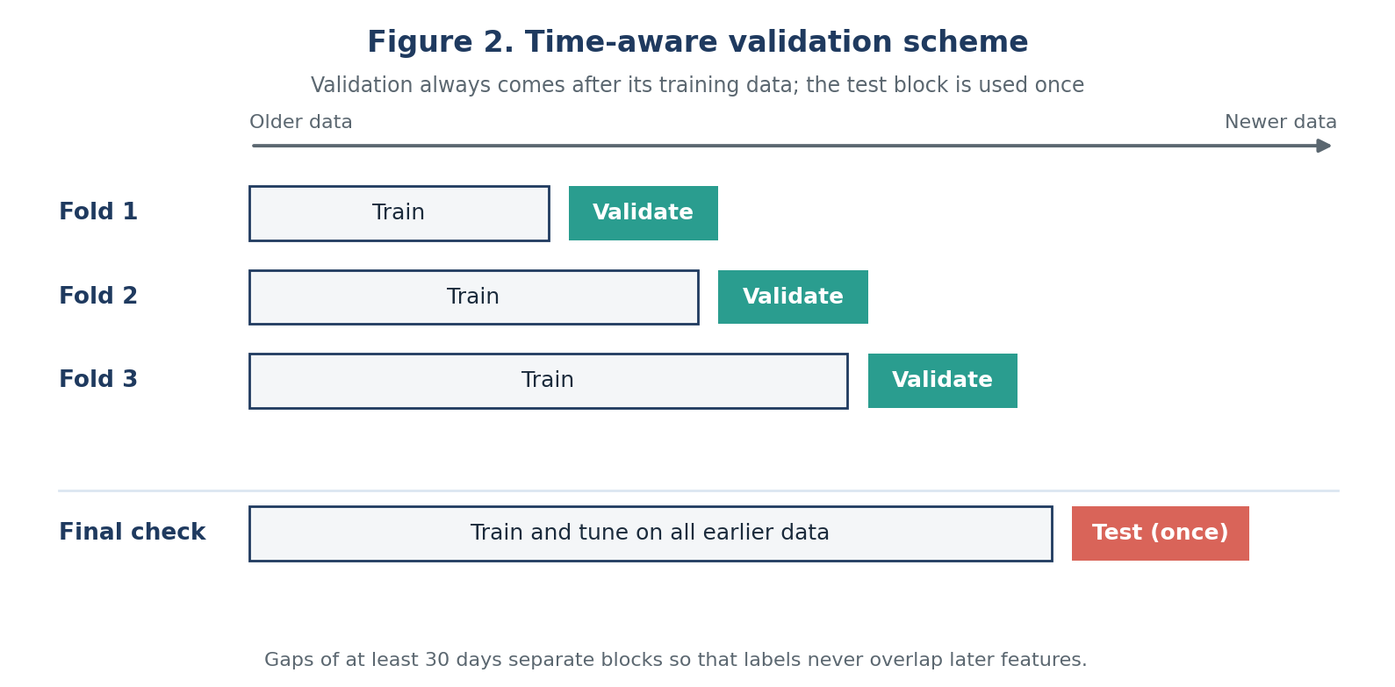
Figure 2. Time-aware validation with three folds and a final test

7.3 Guarding against overfitting and leakage
- Compare training and validation scores; a large gap signals overfitting.
- Use early stopping and regularisation.
- Fit all preprocessing inside each fold.
- Repeat key experiments with different random seeds and report the variation.

7.4 Python template
from sklearn.metrics import average_precision_score, roc_auc_score, f1_score

scores = cross_validate(model, X_train, y_train, cv=cv,
scoring=["average_precision", "roc_auc", "f1"])
print({k: (v.mean().round(3), v.std().round(3)) for k, v in scores.items()})

# One-time final check on the untouched test period
model.fit(X_train_val, y_train_val)
p = model.predict_proba(X_test)[:, 1]
print("PR AUC", average_precision_score(y_test, p), "ROC AUC", roc_auc_score(y_test, p))

8. Deployment and Maintenance
Deployment is an optional extension, but a plan for it shows how the model stays useful after launch.

8.1 Deployment approach
Because retention teams act on lists rather than instant decisions, batch scoring is the simplest fit. A scheduled job, for example weekly, builds features for all active customers, loads the registered model, scores them and writes ranked results to a table or CRM. If a real-time need appears later, the same model can be wrapped in a REST API such as FastAPI.
- Package the pipeline and model as one versioned artefact in a model registry.
- Use a containerised environment (Docker) so training and production use identical library versions.
- Add automated tests for data schema, feature ranges and a known-answer prediction check.
- Release first to a small group or in shadow mode, then compare with the current process in an A/B test.

8.2 Monitoring and updating
Figure 3 shows the maintenance loop: scores are acted on, true outcomes arrive 30 days later, monitoring compares them with expectations, and a retrained model replaces the live one only if it wins.
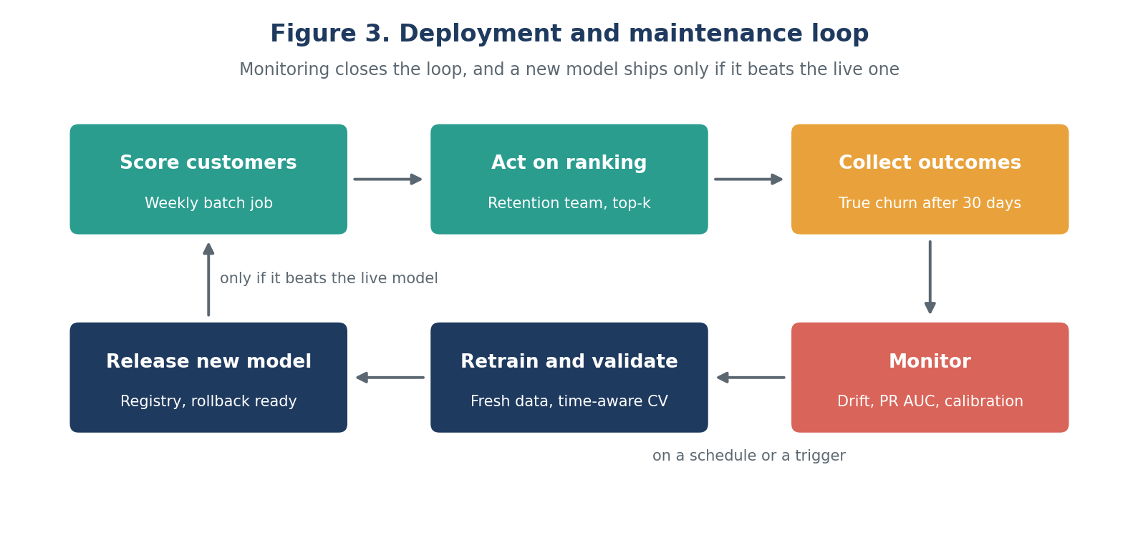
Figure 3. Deployment and maintenance loop
What to monitor | How | Action when triggered
Input data drift | Compare feature distributions with training data, for example with the population stability index | Investigate upstream data changes; retrain if the shift is genuine
Prediction drift | Track the distribution of scores over time | Check the data pipeline and recalibrate
Model performance | Once true outcomes arrive, compute PR AUC, recall at top-k and calibration on recent data | Retrain if performance falls below an agreed floor
Business outcome | Retention rate and cost in the A/B test | Review threshold and campaign design
Fairness and segments | Metrics by segment | Fix or retrain if gaps widen

Retraining runs on a regular schedule, for example monthly or quarterly, and also whenever a trigger above fires. A new model replaces the live one only if it beats it on the latest holdout period and passes the same tests. The previous model stays available for quick rollback.

9. Risks, Effort Plan and Quality Checklist

9.1 Risks and mitigations
Risk | Mitigation
Label delay: churn is known only 30 days later | Evaluate with lagged labels; use proxy signals for early monitoring
Intervention changes behaviour: successful retention hides churn in new data | Keep a small randomised control group so the true churn rate stays measurable
Overfitting from heavy tuning | Nested validation, limited trials, one-time final test
Model not trusted by the business | SHAP-based reasons and a simple dashboard
Data quality incidents | Automated schema and range checks with alerts

9.2 Effort plan (33 hours)
Phase | Activities | Hours
Problem definition | Problem statement, success criteria, assumptions | 3
Data understanding and EDA | Sources, label design, exploratory analysis | 4
Preprocessing and features | Cleaning, encoding, feature engineering and selection | 6
Model selection and training | Baseline, candidate models, ensemble training | 7
Hyperparameter tuning | Search design, tuning, early stopping | 3
Evaluation and validation | Metrics, threshold, cross-validation, error analysis | 4
Deployment planning | Batch scoring design, monitoring and retraining plan | 3
Documentation and diagrams | Workflow figures, write-up, review | 3
Total |  | 33

9.3 Quality checklist
Check | Question to answer before sign-off
Leakage | Is every feature computed only from information available at the snapshot date?
Split | Do validation and test periods come after training data, with a gap?
Metrics | Are PR AUC and recall at top-k reported next to the baseline?
Calibration | Are predicted probabilities checked on the latest period?
Reproducibility | Are seeds, data version and parameters tracked for every run?
Monitoring | Are drift, performance and retraining triggers defined with owners?

10. Conclusion
This plan treats churn prediction as a complete system rather than a single model. The critical choices are the ones that make results trustworthy: leakage-free features built at a snapshot date, time-aware validation, metrics that match the imbalanced problem and the business budget, and monitoring that keeps the model useful after launch. Following these steps would give a full-scale implementation a clear, defensible path from raw data to a maintained production model.

Python tools referenced
Area | Tools
Data handling and exploration | pandas, NumPy, matplotlib, seaborn
Modelling and pipelines | scikit-learn (Pipeline, ColumnTransformer, model_selection, metrics), LightGBM or XGBoost
Tuning and tracking | Optuna, MLflow
Explainability | SHAP
Serving and packaging | FastAPI (if real-time scoring is needed), Docker

