Penetration Test Report

{{APPLICATION_NAME}}
{{CLIENT_NAME}}

Final Report
Friday, 11 October 2025

PT Perisai Digital Indonesia  MidPlaza 2, 25th Floor  Jl. Jend. Sudirman Kav.10-11  Jakarta 10220  Indonesia | T: +62 (21) 573-7777  E: info@cisometric.com  https://cisometric.com

CONFIDENTIALITY
This document is addressed to the management of {{CLIENT_NAME}}, especially management and other decision makers.
© Copyright PT Perisai Digital Indonesia. Copyright is protected by law.

This report is confidential and owned by the {{CLIENT_NAME}}. It is strictly prohibited to copy, reproduce, publish the contents of this report, in part or in whole, by any means, whether electronic or mechanical, including but not limited to photocopying or data storage systems on computers. It is strictly prohibited to disclose the information in this report to third parties without prior written approval from the management of {{CLIENT_NAME}}.

THANK YOU
PT Perisai Digital Indonesia extends its deepest gratitude and appreciation to the management and staff of {{CLIENT_NAME}} who have participated throughout this assignment.
Your cooperation and assistance have been invaluable to us, enabling us to fulfill our tasks successfully.

TABLE OF CONTENTS
CONFIDENTIALITY 2
THANK YOU 3
TABLE OF CONTENTS 4
DOCUMENT DETAILS 7
Version 7
SECURITY ASSESSMENT INFORMATION 8
Security Assessment Details 8
PROJECT DETAILS 9
Project Objective 9
Scope of Work 9
Period of Testing 10
Project Organization 11
Methodology 12
Web Application 12
Mobile Application 13
API 14
Infrastructure 15
Testing Tools 16
Testing Approach 17
Stages of Security Assessment 18
Classification of Level of Vulnerability 21
Status Description 22
EXECUTIVE SUMMARY 23
FINDINGS TABLE 24
DETAILS OF FINDINGS 25
Critical-Risk Findings 25
1. {{FINDING_NAME}} 25
Description 25
Impact 25
Affected Items 25
Proof of Concept 25
Recommendation 26
High-Risk Findings 27
2. {{FINDING_NAME}} 27
Description 27
Impact 27
Affected Items 27
Proof of Concept 27
Recommendation 28
Medium-Risk Findings 29
3. {{FINDING_NAME}} 29
Description 29
Impact 29
Affected Items 29
Proof of Concept 29
Recommendation 30
Low-Risk Findings 31
4. {{FINDING_NAME}} 31
Description 31
Impact 31
Affected Items 31
Proof of Concept 31
Recommendation 32
Informational-Risk Findings 33
5. {{FINDING_NAME}} 33
Description 33
Impact 33
Affected Items 33
Proof of Concept 33
Recommendation 34
RETEST DETAILS 35
Critical-Risk Findings 35
1. {{FINDING_NAME}} 35
Action Taken 35
High-Risk Findings 36
2. {{FINDING_NAME}} 36
Action Taken 36
Medium-Risk Findings 37
3. {{FINDING_NAME}} 37
Action Taken 37
Low-Risk Findings 38
4. {{FINDING_NAME}} 38
Action Taken 38
Informational-Risk Findings 39
5. {{FINDING_NAME}} 39
Action Taken 39
Appendix A: Scope Details 40

DOCUMENT DETAILS
Company Name : {{CLIENT_NAME}}
Document Title : {{DOCUMENT_TITLE}}
Document Number : {{DOCUMENT_NUMBER}}
Date : {{DOCUMENT_DATE}}
Document Type : {{REPORT_TYPE}}

Version
Version | Date | Editor | Description of Change
1.0 | 25 September 2025 | [Pentester Name] | Document Initialization
1.1 | 25 September 2025 | [Lead Pentester Name] | Review & Approve
2.0 | 11 October 2025 | [Pentester Name] | Draft Final Report
2.1 | 11 October 2025 | [Lead Pentester Name] | Review & Approve

SECURITY ASSESSMENT INFORMATION

Security Assessment Details
Consulting Company |  | PT Perisai Digital Indonesia (Cisometric)
Examiner |  | {{PENTESTER_NAME}}  Qualification:  - {{PENTESTER_CERTIFICATIONS}}
Approver |  | Muhammad Luqman  Qualification:  - CISSP  - CASP+  - CCSP
Activity |  | Penetration Test
Target Name |  | {{APPLICATION_NAME}}
Client Name |  | {{CLIENT_NAME}}
Activity Timeline |  | {{TESTING_PERIOD}}

Jakarta, 7 December 2025

Penetration Tester |  |  | Penetration Tester Lead
[Pentester Name] |  |  | [Pentester Name]

PROJECT DETAILS

Project Objective
{{CLIENT_NAME}}, hereinafter referred to as the '{{CLIENT_NICK}}', has engaged Cisometric (PT Perisai Digital Indonesia) as an Independent Party to conduct a comprehensive security assessment. The primary objective of this engagement is to rigorously test the {{APPLICATION_NAME}} with the aim of identifying and evaluating potential vulnerabilities. This assessment seeks to uncover security weaknesses that could potentially be exploited, thereby endangering the confidentiality, integrity, and availability of data and services associated with the testing target.

Scope of Work
Cisometric has been engaged to conduct a penetration test as detailed in the table below.
Scope
Name | Target | Method | Area
{{#SCOPES}}
{{SCOPE_NAME}} | {{SCOPE_TARGET}} | {{TESTING_APPROACH}} | {{SCOPE_AREA}}
{{/SCOPES}}

Detailed information about the test scope can be found in Appendix A: Scope Details.
It is important to note that any systems or components not specifically listed in the table were not included in our testing scope.

Period of Testing
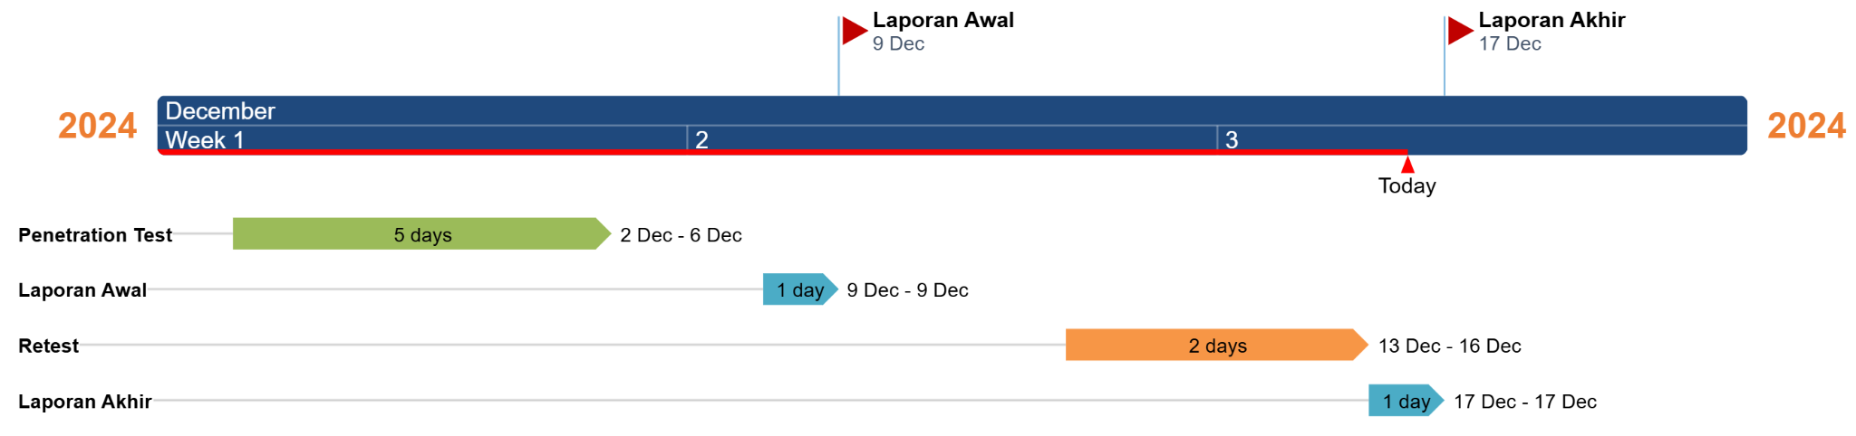
This project is implemented in the [internal/external] area, starting from 10 to 15 October 2025.

Project Organization
For the purposes of this project, Cisometric and {{CLIENT_NICK}} have agreed to form a working team. Both organizations have appointed representatives responsible for the project's execution, as listed below:
{{CLIENT_NICK}} Contact
Name | Title | Email
 |  | someone@xxx.com
 |  | someone@xxx.com

Cisometric Contact
Name | Title | Email
Andhika Hikmareta | Project Manager | andhika@cisometric.com
Muhammad Luqman | Lead Penetration Tester | luqman@cisometric.com
 | Penetration Tester | someone@cisometric.com

Methodology
The penetration testing conducted by Cisometric utilizes methodologies that adhere to industry standards. These methodologies are designed to ensure a systematic, structured, and effective approach in identifying and exploiting vulnerabilities within targeted systems or components.

Web Application
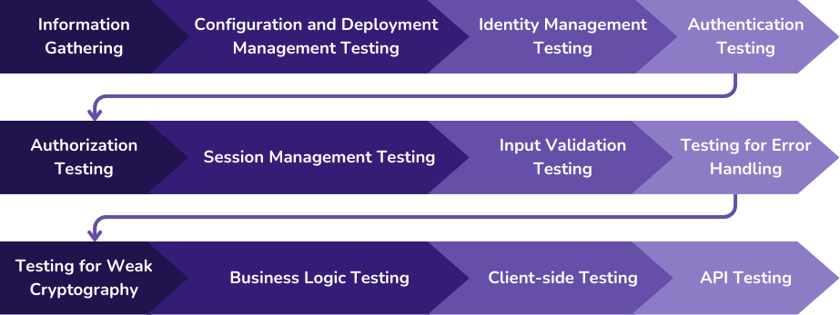
For web application testing, Cisometric employ the OWASP Web Security Testing Guide (WSTG). This methodology provides a framework for testing the security of web applications comprehensively.

Mobile Application
For mobile application testing, Cisometric employ the Mobile Application Security Verification Standard (MASVS). This methodology provides a framework for testing the security of mobile applications comprehensively.
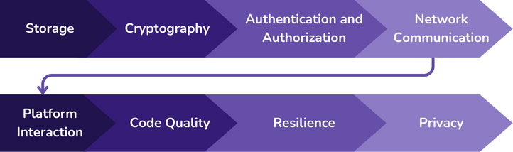

API
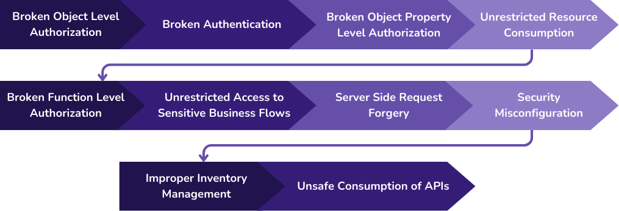
For API testing, Cisometric employ the OWASP Web Security Testing Guide (WSTG) and OWASP Top 10 API Security. This methodology provides a framework for testing the security of APIs comprehensively.

Infrastructure
For infrastructure testing, we follow the Penetration Testing Execution Standard (PTES). This methodology provides a detailed understanding of testing the security of network and system infrastructures, including information gathering, threat modelling, vulnerability analysis, exploitation, and post-exploitation.

Testing Tools
Cisometric uses various tools tailored to testing needs to ensure optimal results. The tools used include, but are not limited to:
- Nessus Professional
- Burp Suite Professional
- OWASP Zap
- TestSSL
- Custom Testing Tools

Testing Approach
The testing conducted by Cisometric utilizes an approach agreed upon with {{CLIENT_NICK}}, ensuring alignment with specific project needs. The table below outlines the details of our methodology, including definition, access level, focus, primary objective, and current usage.
Aspek | White-Box Testing | Grey-Box Testing | Black-Box Testing
Definition | The tester is given full access, such as source code, architecture diagrams, or network configurations. | The tester is given limited access or only partial information, such as user accounts or network details. | The tester is not given any information and tests the system as an external attacker.
Access Level | Full internal access, allowing examination of all aspects of the application and infrastructure. | Limited access, for example, only internal network access or restricted application features. | No internal access; only tests interfaces accessible from the outside.
Testing Focus | Comprehensive testing, including internal structure, application code, system configurations, and software architecture. | Testing internal and external vulnerabilities, focusing on known areas but with limited information. | Testing only external layers, such as application functionality and user interfaces, without knowledge of infrastructure or code.
Main Goal | Identify design and implementation vulnerabilities that may not be visible without full access to code or configurations. | Assess the application or infrastructure with partial knowledge to find potential vulnerabilities that could be exploited with limited information. | Evaluate external vulnerabilities that can be exploited by attackers without access or additional knowledge of the system.
Current Usage |  |  | 

Stages of Security Assessment
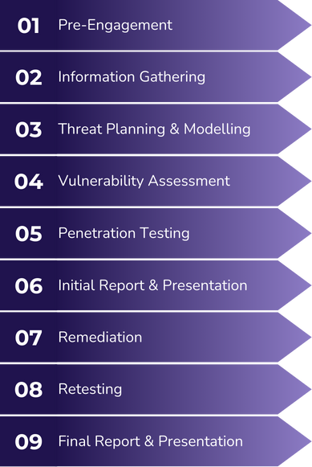
The security assessment process conducted by Cisometric consists of several key stages. Each stage is specifically designed to enhance the security posture of our client's systems. Below is an outline of each stage.

- Pre-Engagement
This phase includes all preparations before security testing begins, including setting the scope of work, identifying assets to be tested, agreeing on the methodology to be used, setting a testing timeline, and ensuring all permits and legal approvals have been obtained. This phase also establishes communication channels between the client and the tester to facilitate information exchange during the testing process.
- Information Gathering
The information gathering phase involves identifying and collecting data about the target that will be used during security testing. This includes obtaining information about the target's network infrastructure, systems, and applications, as well as gathering public data using techniques such as Open Source Intelligence (OSINT).
- Threat Planning & Modelling
In this phase, testers identify potential attack vectors and threats that could be exploited. This involves a detailed analysis of the system and application architecture, as well as potential threat models based on the information that has been gathered.
- Vulnerability Assessment
This phase focuses on using automated tools to identify known vulnerabilities in the system or application. The main goal is to discover weaknesses before conducting more in-depth penetration testing.
- Penetration Testing
This phase involves the active exploitation of identified vulnerabilities and in-depth manual analysis, using testing methodologies in accordance with industry standards. This exploitation is carried out to test the effectiveness of existing security controls and assess the extent of potential security breaches.
- Initial Report & Presentation
After the security testing is complete, this phase involves the preparation of a preliminary report that includes details of the successful exploitation of vulnerabilities found. This report is then presented to the client to provide an initial understanding of the vulnerabilities discovered.
- Remediation
Based on the findings in the report, the client will take steps to address the vulnerabilities discovered. This remediation phase involves implementing fixes and security enhancements in accordance with the recommendations provided.
- Retest
After remediation is performed, a retesting phase is conducted to ensure that all fixes have been successful and previous vulnerabilities have been properly addressed. This retesting helps verify the effectiveness of the remediation actions.
- Final Report & Presentation
This final phase involves the compilation and presentation of a detailed final report to the client. This report covers the results of all testing phases, including verification that all vulnerabilities have been addressed. The purpose of this report is to provide a comprehensive overview of the security of the assets after the completion of the security testing.

Classification of Level of Vulnerability
All identified findings were assessed according to the Common Vulnerability Scoring System (CVSS) v3.1.
CVSS provides a way to capture the principal characteristics of a vulnerability and generates a numerical score reflecting its severity, as well as a textual representation of that score. These numerical scores are then translated into qualitative representations (such as low, medium, high, and critical) to help organizations appropriately assess and prioritize their vulnerability management processes.
The qualitative scores from CVSS are as follows:
Vulnerability Level | CVSS Score
Critical | 9.0 - 10.0
High | 7.0 - 8.9
Medium | 4.0 - 6.9
Low | 0.1 - 3.9
Informational | N/A
Detailed information on CVSS can be seen on the following page: https://www.first.org/cvss/.

Status Description
In the penetration test report, each finding is categorized with a specific status to reflect its current state in the vulnerability management lifecycle. The statuses are as follows:
Status | Description
New | A finding that has been identified for the first time during the current penetration test. It indicates a potential security issue that has not yet been addressed or retested by the organization.
Closed | A finding that has been retested and resolved successfully. The issue is no longer present in the system, or the risk has been accepted.
Partially Open | A finding that has been retested and found to be resolved for some, but not all, of the identified impacted assets. This status indicates a partial success in remediating the vulnerability.
Open | A finding that has been retested but remains vulnerable for all identified impacted assets. The issue has either not been addressed, or the attempted remediation was not effective.

EXECUTIVE SUMMARY
Based on the testing conducted, the system has undergone a comprehensive security assessment.
The following are the detailed test results:
Target Total | {{TARGET_TOTAL}}
Severity | Total Findings | Fixed | Not Fixed
Critical | {{CRITICAL_COUNT}} | - | -
High | {{HIGH_COUNT}} | - | -
Medium | {{MEDIUM_COUNT}} | - | -
Low | {{LOW_COUNT}} | - | -
Informational | {{INFORMATIONAL_COUNT}} | - | -
This testing provides an overview of the current security condition of the system. It is essential to maintain good security practices and conduct regular testing to ensure the system remains protected against potential future threats.

FINDINGS TABLE
The following tables represent a categorized summary of all security findings identified during the penetration test conducted by Cisometric. Each finding is organized by its severity level – Critical, High, Medium, Low, and Informational – to provide a clear understanding of the risk landscape.
{{#HAS_CRITICAL_FINDINGS}}
Critical
No | Name | Target | Status
{{#CRITICAL_FINDINGS_TABLE}}
{{FINDING_NUMBER}} | {{FINDING_TITLE}} | {{TARGET}} | {{STATUS}}
{{/CRITICAL_FINDINGS_TABLE}}
{{/HAS_CRITICAL_FINDINGS}}
{{#HAS_HIGH_FINDINGS}}
High
No | Name | Target | Status
{{#HIGH_FINDINGS_TABLE}}
{{FINDING_NUMBER}} | {{FINDING_TITLE}} | {{TARGET}} | {{STATUS}}
{{/HIGH_FINDINGS_TABLE}}
{{/HAS_HIGH_FINDINGS}}

{{#HAS_MEDIUM_FINDINGS}}
Medium
No | Name | Target | Status
{{#MEDIUM_FINDINGS_TABLE}}
{{FINDING_NUMBER}} | {{FINDING_TITLE}} | {{TARGET}} | {{STATUS}}
{{/MEDIUM_FINDINGS_TABLE}}
{{/HAS_MEDIUM_FINDINGS}}
{{#HAS_LOW_FINDINGS}}
Low
No | Name | Target | Status
{{#LOW_FINDINGS_TABLE}}
{{FINDING_NUMBER}} | {{FINDING_TITLE}} | {{TARGET}} | {{STATUS}}
{{/LOW_FINDINGS_TABLE}}
{{/HAS_LOW_FINDINGS}}

{{#HAS_INFORMATIONAL_FINDINGS}}
Informational
No | Name | Target | Status
{{#INFORMATIONAL_FINDINGS_TABLE}}
{{FINDING_NUMBER}} | {{FINDING_TITLE}} | {{TARGET}} | {{STATUS}}
{{/INFORMATIONAL_FINDINGS_TABLE}}
{{/HAS_INFORMATIONAL_FINDINGS}}

DETAILS OF FINDINGS

Critical-Risk Findings
{{#HAS_CRITICAL_FINDINGS}}
{{#CRITICAL_FINDINGS}}

{{FINDING_NUMBER}}. {{FINDING_NAME}}
Critical | {{CVSS_SCORE}}  ({{CVSS_VECTOR}})
Target | {{TARGET}}
Date | {{FINDING_DATE}}
Status | {{STATUS}}

Description
{{DESCRIPTION}}

Impact
{{IMPACT}}

Affected Items
{{#AFFECTED_ITEMS}}
- {{AFFECTED_ITEM}}
{{/AFFECTED_ITEMS}}

Proof of Concept
{{POC_DESCRIPTION}}
{{#POC_IMAGES}}
{{POC_IMAGE}}
Figure {{FIGURE_NUMBER}}. {{FIGURE_CAPTION}}
{{/POC_IMAGES}}

Recommendation
{{RECOMMENDATION}}
Reference:
{{#REFERENCES}}
- {{REFERENCE}}
{{/REFERENCES}}

{{/CRITICAL_FINDINGS}}
{{/HAS_CRITICAL_FINDINGS}}
{{^HAS_CRITICAL_FINDINGS}}
There's no finding in this section.
{{/HAS_CRITICAL_FINDINGS}}

High-Risk Findings
{{#HAS_HIGH_FINDINGS}}
{{#HIGH_FINDINGS}}

{{FINDING_NUMBER}}. {{FINDING_NAME}}
High | {{CVSS_SCORE}}  ({{CVSS_VECTOR}})
Target | {{TARGET}}
Date | {{FINDING_DATE}}
Status | {{STATUS}}

Description
{{DESCRIPTION}}

Impact
{{IMPACT}}

Affected Items
{{#AFFECTED_ITEMS}}
- {{AFFECTED_ITEM}}
{{/AFFECTED_ITEMS}}

Proof of Concept
{{POC_DESCRIPTION}}
{{#POC_IMAGES}}
{{POC_IMAGE}}
Figure {{FIGURE_NUMBER}}. {{FIGURE_CAPTION}}
{{/POC_IMAGES}}

Recommendation
{{RECOMMENDATION}}
Reference:
{{#REFERENCES}}
- {{REFERENCE}}
{{/REFERENCES}}

{{/HIGH_FINDINGS}}
{{/HAS_HIGH_FINDINGS}}
{{^HAS_HIGH_FINDINGS}}
There's no finding in this section.
{{/HAS_HIGH_FINDINGS}}

Medium-Risk Findings
{{#HAS_MEDIUM_FINDINGS}}
{{#MEDIUM_FINDINGS}}

{{FINDING_NUMBER}}. {{FINDING_NAME}}
Medium | {{CVSS_SCORE}}  ({{CVSS_VECTOR}})
Target | {{TARGET}}
Date | {{FINDING_DATE}}
Status | {{STATUS}}

Description
{{DESCRIPTION}}

Impact
{{IMPACT}}

Affected Items
{{#AFFECTED_ITEMS}}
- {{AFFECTED_ITEM}}
{{/AFFECTED_ITEMS}}

Proof of Concept
{{POC_DESCRIPTION}}
{{#POC_IMAGES}}
{{POC_IMAGE}}
Figure {{FIGURE_NUMBER}}. {{FIGURE_CAPTION}}
{{/POC_IMAGES}}

Recommendation
{{RECOMMENDATION}}
Reference:
{{#REFERENCES}}
- {{REFERENCE}}
{{/REFERENCES}}

{{/MEDIUM_FINDINGS}}
{{/HAS_MEDIUM_FINDINGS}}
{{^HAS_MEDIUM_FINDINGS}}
There's no finding in this section.
{{/HAS_MEDIUM_FINDINGS}}

Low-Risk Findings
{{#HAS_LOW_FINDINGS}}
{{#LOW_FINDINGS}}

{{FINDING_NUMBER}}. {{FINDING_NAME}}
Low | {{CVSS_SCORE}}  ({{CVSS_VECTOR}})
Target | {{TARGET}}
Date | {{FINDING_DATE}}
Status | {{STATUS}}

Description
{{DESCRIPTION}}

Impact
{{IMPACT}}

Affected Items
{{#AFFECTED_ITEMS}}
- {{AFFECTED_ITEM}}
{{/AFFECTED_ITEMS}}

Proof of Concept
{{POC_DESCRIPTION}}
{{#POC_IMAGES}}
{{POC_IMAGE}}
Figure {{FIGURE_NUMBER}}. {{FIGURE_CAPTION}}
{{/POC_IMAGES}}

Recommendation
{{RECOMMENDATION}}
Reference:
{{#REFERENCES}}
- {{REFERENCE}}
{{/REFERENCES}}

{{/LOW_FINDINGS}}
{{/HAS_LOW_FINDINGS}}
{{^HAS_LOW_FINDINGS}}
There's no finding in this section.
{{/HAS_LOW_FINDINGS}}

Informational-Risk Findings
{{#HAS_INFORMATIONAL_FINDINGS}}
{{#INFORMATIONAL_FINDINGS}}

{{FINDING_NUMBER}}. {{FINDING_NAME}}
Info | {{CVSS_SCORE}}  ({{CVSS_VECTOR}})
Target | {{TARGET}}
Date | {{FINDING_DATE}}
Status | {{STATUS}}

Description
{{DESCRIPTION}}

Impact
{{IMPACT}}

Affected Items
{{#AFFECTED_ITEMS}}
- {{AFFECTED_ITEM}}
{{/AFFECTED_ITEMS}}

Proof of Concept
{{POC_DESCRIPTION}}
{{#POC_IMAGES}}
{{POC_IMAGE}}
Figure {{FIGURE_NUMBER}}. {{FIGURE_CAPTION}}
{{/POC_IMAGES}}

Recommendation
{{RECOMMENDATION}}
Reference:
{{#REFERENCES}}
- {{REFERENCE}}
{{/REFERENCES}}

{{/INFORMATIONAL_FINDINGS}}
{{/HAS_INFORMATIONAL_FINDINGS}}
{{^HAS_INFORMATIONAL_FINDINGS}}
There's no finding in this section.
{{/HAS_INFORMATIONAL_FINDINGS}}

Appendix A: Scope Details
Account
User | Role

Assets
Location | Server Name | IP

Menu Detail
Role | Menu | Sub-Menu

Binary File
Name | Version | SHA256
Test.apk | 3.11.0 | d3bc555172fde488755d89f307ccddda5085eb6d0fa334cd47559587ae225edf

Out-of-Scope
Menu | Note



http://www.cisometric.com

*This document contains confidential information. It is disclosed to you for informational and discussion purpose only.

