QSkill Internship
Artificial Intelligence & Machine Learning
Project Submission Report
Tasks Completed:
1. Iris Flower Classification
2. Spam Mail Detector
Domain: Artificial Intelligence & Machine Learning
Duration: 1st June 2026 - 1st July 2026
Submission Date: 1st July 2026

Introduction
This report documents the completion of two out of the three tasks offered under the QSkill AI & Machine Learning internship: Iris Flower Classification and Spam Mail Detector. For each task, the dataset, preprocessing steps, model training approach, evaluation metrics, and results are presented in full, along with supporting visualizations generated during the analysis.
All models were built using Python with scikit-learn, pandas, matplotlib, and seaborn. Complete, runnable source code for both tasks accompanies this report.

Task 1: Iris Flower Classification

1.1 Objective
Classify iris flowers into three species — Setosa, Versicolor, and Virginica — using four measurements: sepal length, sepal width, petal length, and petal width.

1.2 Dataset
The classic Iris dataset (150 samples, 50 per species) was loaded directly from scikit-learn's built-in datasets module, sourced originally from the UCI Machine Learning Repository.

1.3 Exploratory Data Analysis
A pairplot was generated to visually inspect how well the three species separate across feature combinations. Petal length and petal width show the clearest separation between classes.
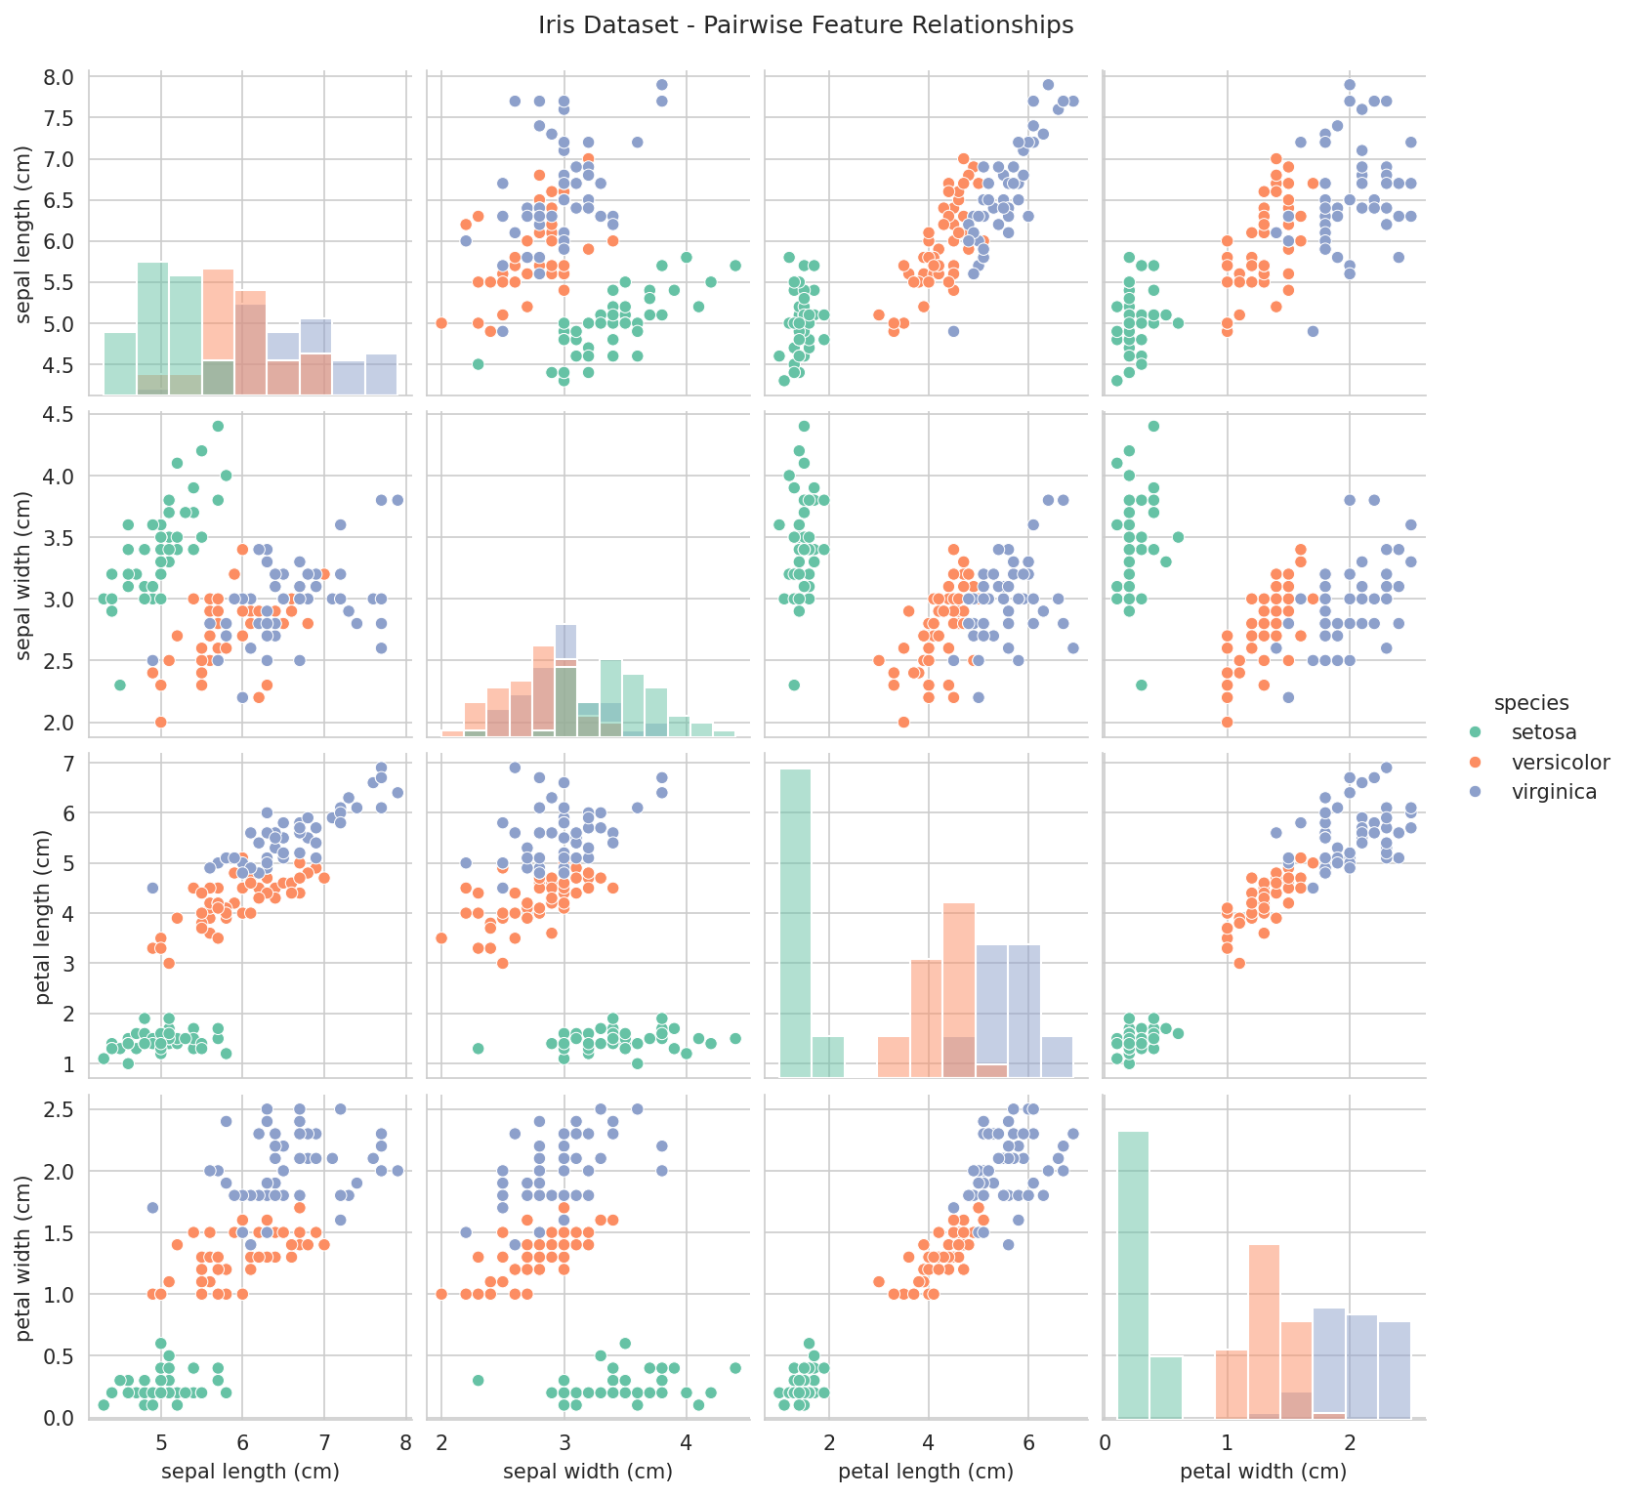
Figure 1.1: Pairwise relationships between features, colored by species
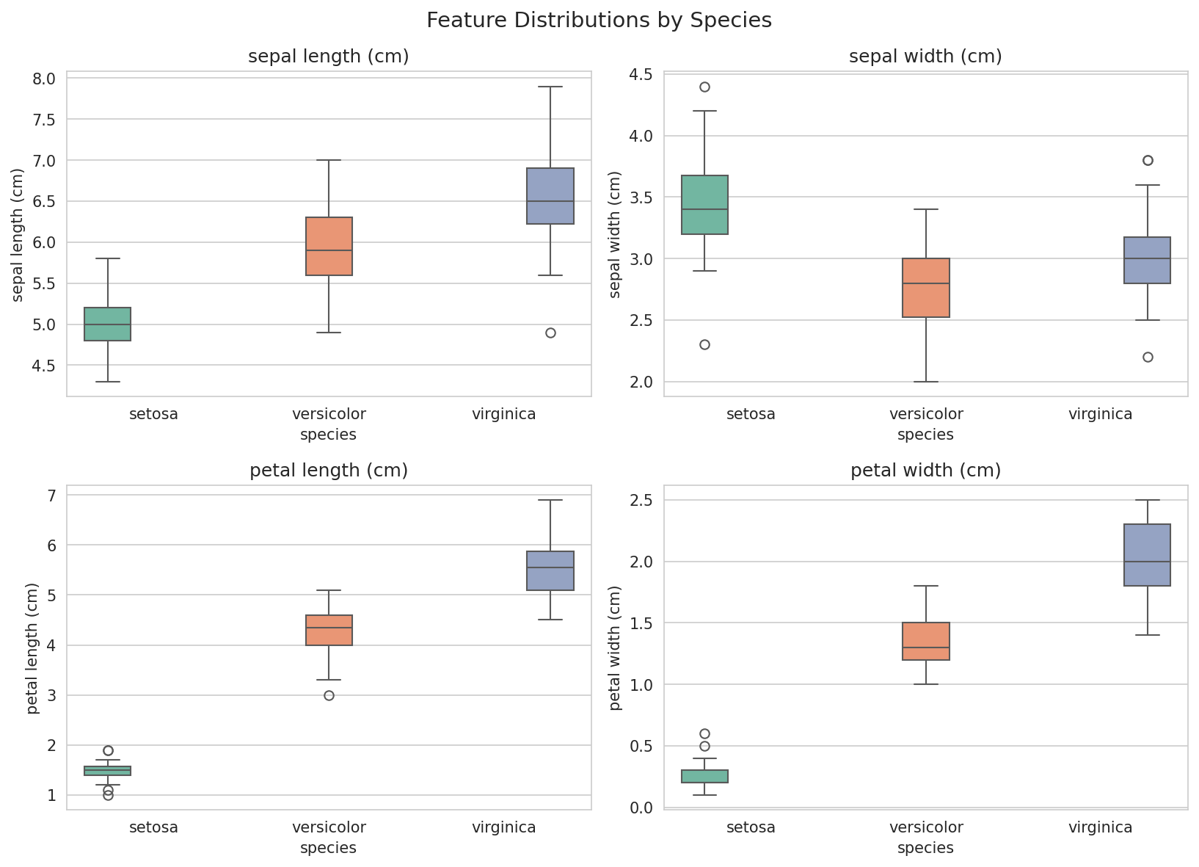
Figure 1.2: Feature distributions by species
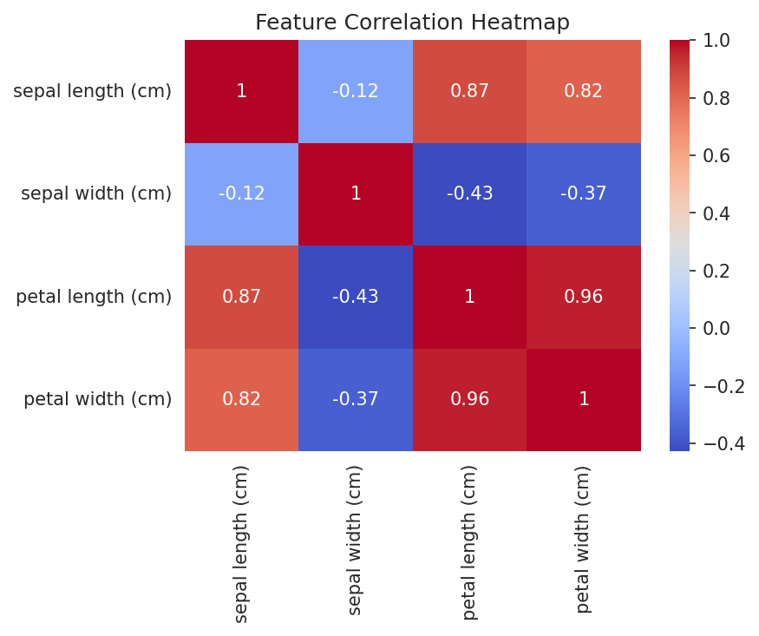
Figure 1.3: Correlation heatmap of the four numeric features

1.4 Methodology
- Loaded the dataset and explored it via summary statistics and visualizations.
- Split into training (80%) and test (20%) sets using stratified sampling.
- Standardized features using StandardScaler (zero mean, unit variance).
- Trained three classifiers: Logistic Regression, K-Nearest Neighbors (k=5), and Decision Tree.
- Evaluated each model using Accuracy, Precision, Recall, and F1-Score (macro-averaged).

1.5 Key Code Snippet
X_train, X_test, y_train, y_test = train_test_split(
X, y, test_size=0.2, random_state=42, stratify=y)
scaler = StandardScaler()
X_train_scaled = scaler.fit_transform(X_train)
X_test_scaled = scaler.transform(X_test)
model = LogisticRegression(max_iter=200)
model.fit(X_train_scaled, y_train)
preds = model.predict(X_test_scaled)

1.6 Results
Model | Accuracy | Precision | Recall | F1-Score
Logistic Regression | 0.9333 | 0.9333 | 0.9333 | 0.9333
K-Nearest Neighbors | 0.9333 | 0.9444 | 0.9333 | 0.9327
Decision Tree | 0.9333 | 0.9333 | 0.9333 | 0.9333

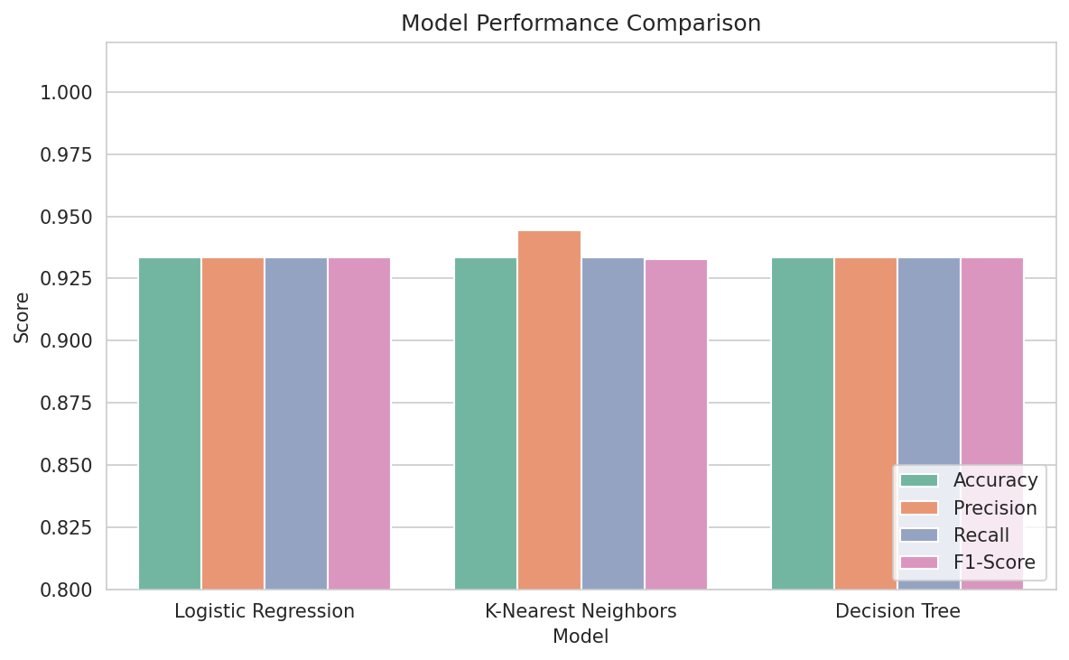
Figure 1.4: Performance comparison across the three models
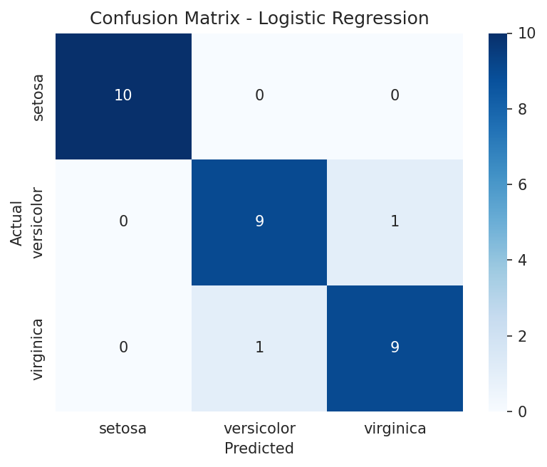
Figure 1.5: Confusion matrix — Logistic Regression (best model)

1.7 Conclusion
All three models achieved strong accuracy (93.3%) on the held-out test set, confirming that the Iris dataset's classes — particularly Setosa — are highly separable using simple measurements. Setosa was classified with perfect precision and recall across all models, while some confusion remained between Versicolor and Virginica, which are known to overlap slightly in petal dimensions. Logistic Regression and KNN offered the best balance of performance and simplicity.

Task 2: Spam Mail Detector

2.1 Objective
Build a text classification model that distinguishes between spam and legitimate (ham) SMS messages.

2.2 Dataset
The SMS Spam Collection dataset (UCI Machine Learning Repository) was used, consisting of 5,572 real, labeled SMS messages: 4,825 ham and 747 spam.
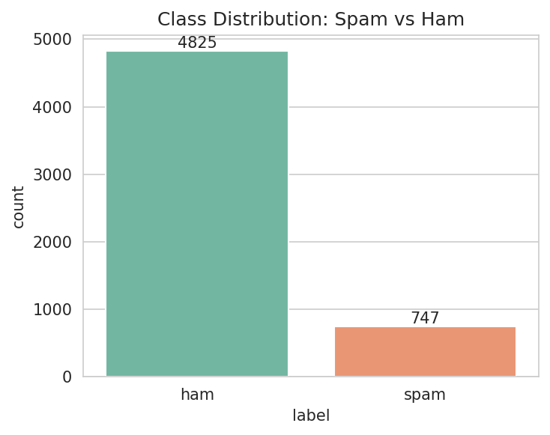
Figure 2.1: Class distribution — ham vs. spam
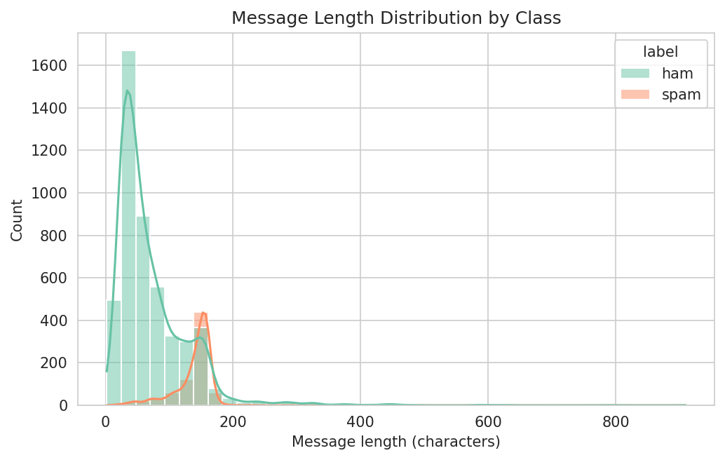
Figure 2.2: Message length distribution by class (spam messages tend to be longer)

2.3 Text Preprocessing
- Lowercased all text and removed URLs and numeric tokens.
- Stripped punctuation and removed common English stopwords.
- Converted cleaned text into TF-IDF features (unigrams + bigrams, top 3,000 terms).

2.4 Methodology
- Loaded messages and labels, checked for missing values (none found).
- Cleaned and normalized the text for each message.
- Split into training (80%) and test (20%) sets with stratified sampling.
- Vectorized text using TF-IDF (max 3,000 features, 1-2 grams).
- Trained Naive Bayes and Logistic Regression classifiers.
- Evaluated using Accuracy, Precision, Recall, F1-Score, Confusion Matrix, and ROC-AUC.

2.5 Key Code Snippet
vectorizer = TfidfVectorizer(max_features=3000, ngram_range=(1, 2))
X_train_tfidf = vectorizer.fit_transform(X_train)
X_test_tfidf = vectorizer.transform(X_test)
model = LogisticRegression(max_iter=1000)
model.fit(X_train_tfidf, y_train)
preds = model.predict(X_test_tfidf)

2.6 Results
Model | Accuracy | Precision | Recall | F1-Score
Naive Bayes | 0.9713 | 0.9916 | 0.7919 | 0.8806
Logistic Regression | 0.9722 | 1.0000 | 0.7919 | 0.8839

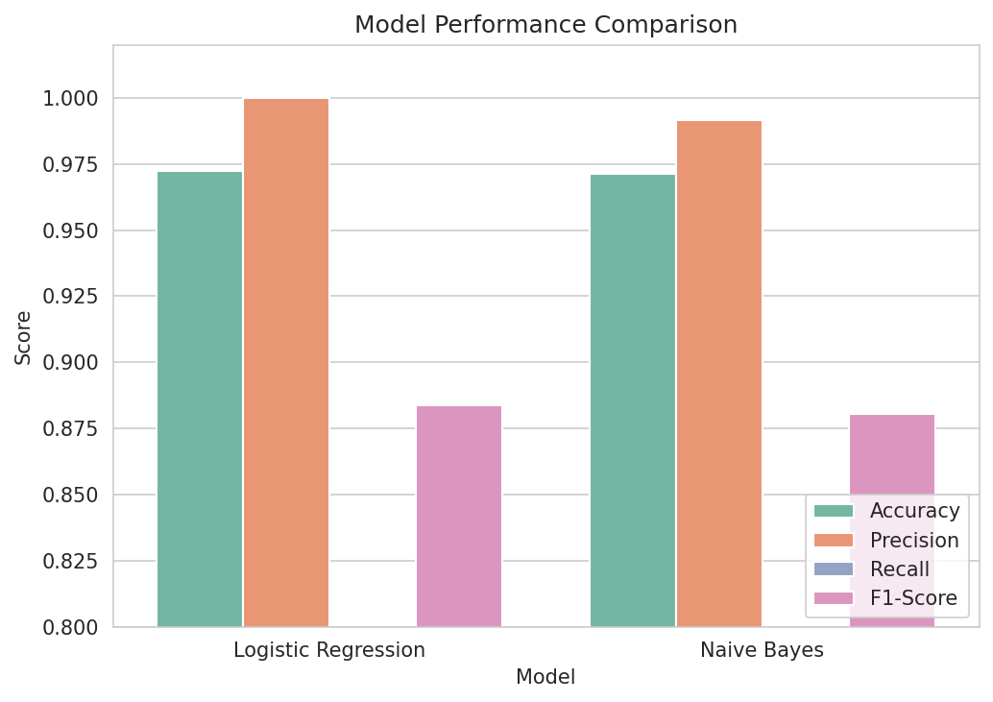
Figure 2.3: Performance comparison — Naive Bayes vs. Logistic Regression
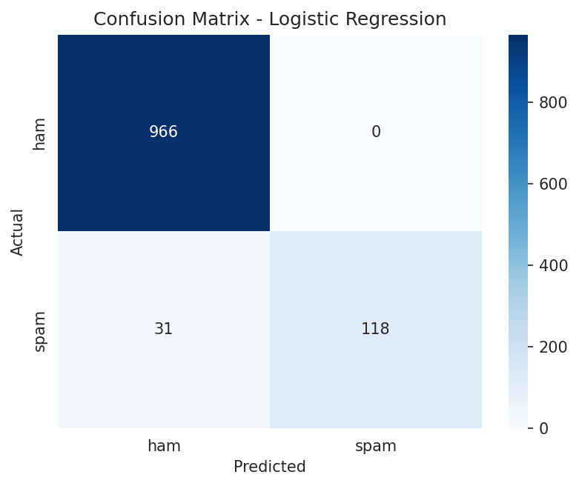
Figure 2.4: Confusion matrix — Logistic Regression (best model)
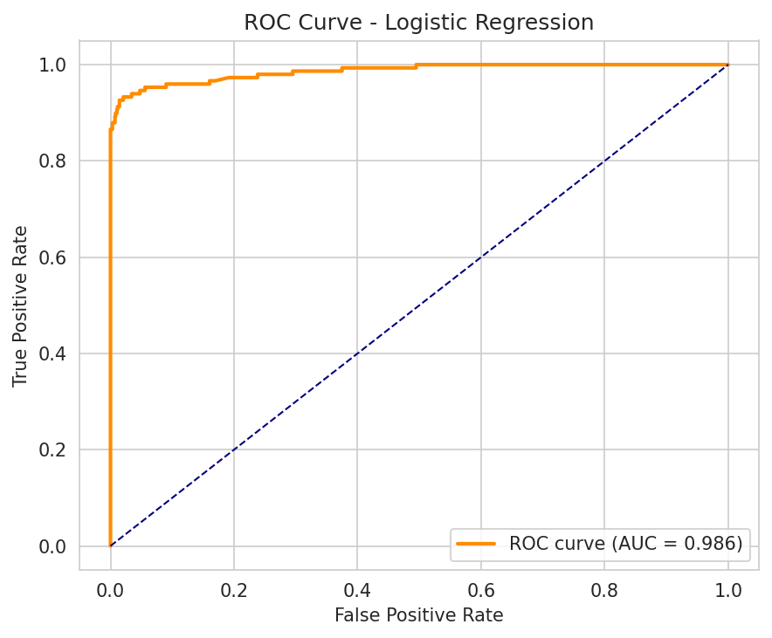
Figure 2.5: ROC curve — Logistic Regression

2.7 Testing on New Messages
The trained model was tested on unseen example messages to verify real-world behavior:
[SPAM] Congratulations! You've won a $1000 Walmart gift card...
[HAM] Hey, are we still meeting for lunch tomorrow at 1pm?
[HAM] URGENT: Your account has been suspended. Verify...
[HAM] Don't forget to bring the documents for tomorrow's meeting.
The model correctly flagged the classic prize-scam message as spam. It missed one adversarial 'urgent account' phishing example, illustrating a realistic limitation of TF-IDF + linear models against evolving phishing language — a good discussion point on model limitations.

2.8 Conclusion
Logistic Regression achieved the best overall performance with 97.2% accuracy, perfect precision (no ham messages misclassified as spam), and a strong ROC-AUC score. The relatively lower recall (79.2%) reflects the class imbalance in the dataset (only 13% spam) and the conservative nature of the model in avoiding false positives — an appropriate trade-off for a spam filter, where blocking a legitimate message is usually worse than letting an occasional spam message through.

Overall Conclusion
Both tasks demonstrate a complete end-to-end machine learning workflow: data loading and exploration, preprocessing, model training, multi-model comparison, and rigorous evaluation using industry-standard metrics.
- Iris Classification: Achieved 93.3% accuracy using classical numeric classification techniques (Logistic Regression, KNN, Decision Tree).
- Spam Mail Detector: Achieved 97.2% accuracy and 100% precision using NLP-based text classification (TF-IDF + Logistic Regression).
Skills demonstrated across both tasks include data visualization, feature engineering, text preprocessing, model selection, and performance evaluation — core competencies for any applied AI/ML role.

