TASK -1

Java Basics and Object-Oriented Programming

1. Objective:
Goal: To understand Java programming fundamentals and Object-Oriented Programming (OOP) concepts by implementing basic Java programs and OOP-based classes.

2. Tools & Technologies Used
- Programming Language: Java
- IDE: Eclipse IDE
- JDK Version: Java 8 / Java 11 or more
- OS: Windows 10 or more

Eclipse Home page
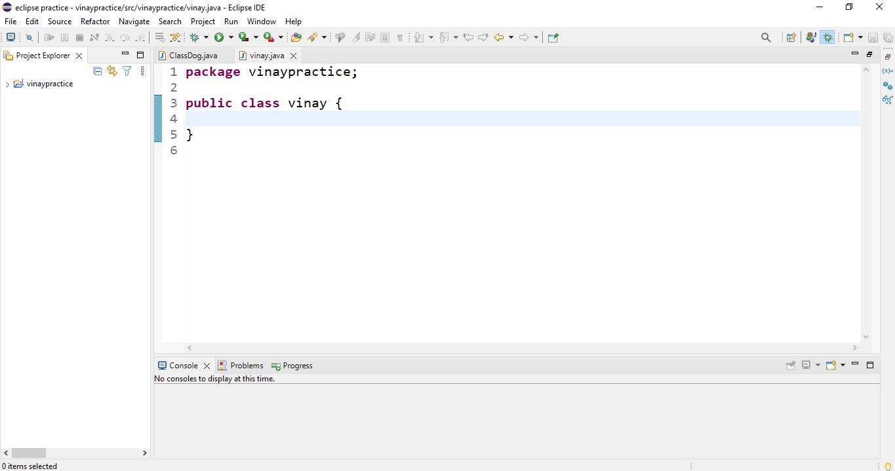

Java Project Structure:
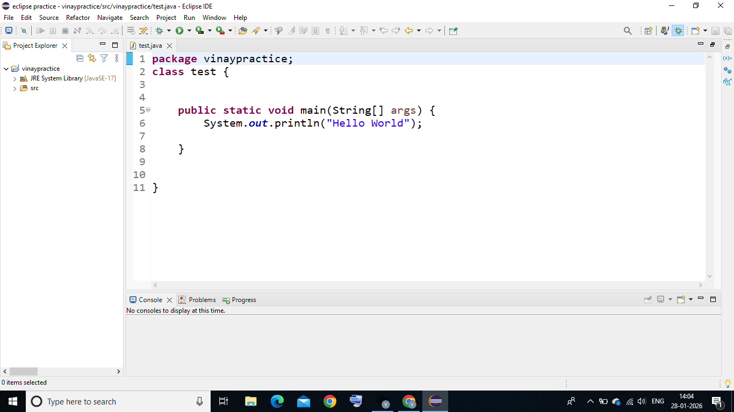

3. Java Basics Implementation

3.1 Concepts Covered
- Arrays
- Loops (for)
- Conditional Statements (if-else)

3.2 Source Code – Java Basics
public class JavaBasics {
public static void main(String[] args) {
int[] marks = {85, 90, 78, 92, 88};
int total = 0;
for (int i = 0; i < marks.length; i++) {
total += marks[i];
}
int average = total / marks.length;
System.out.println("Average Marks: " + average);
if (average >= 90){
System.out.println("Grade: A");
} else if (average >= 75) {
System.out.println("Grade: B");
} else {
System.out.println("Grade: C");
}
}
}

Output:
Average Marks: 86
Grade: B
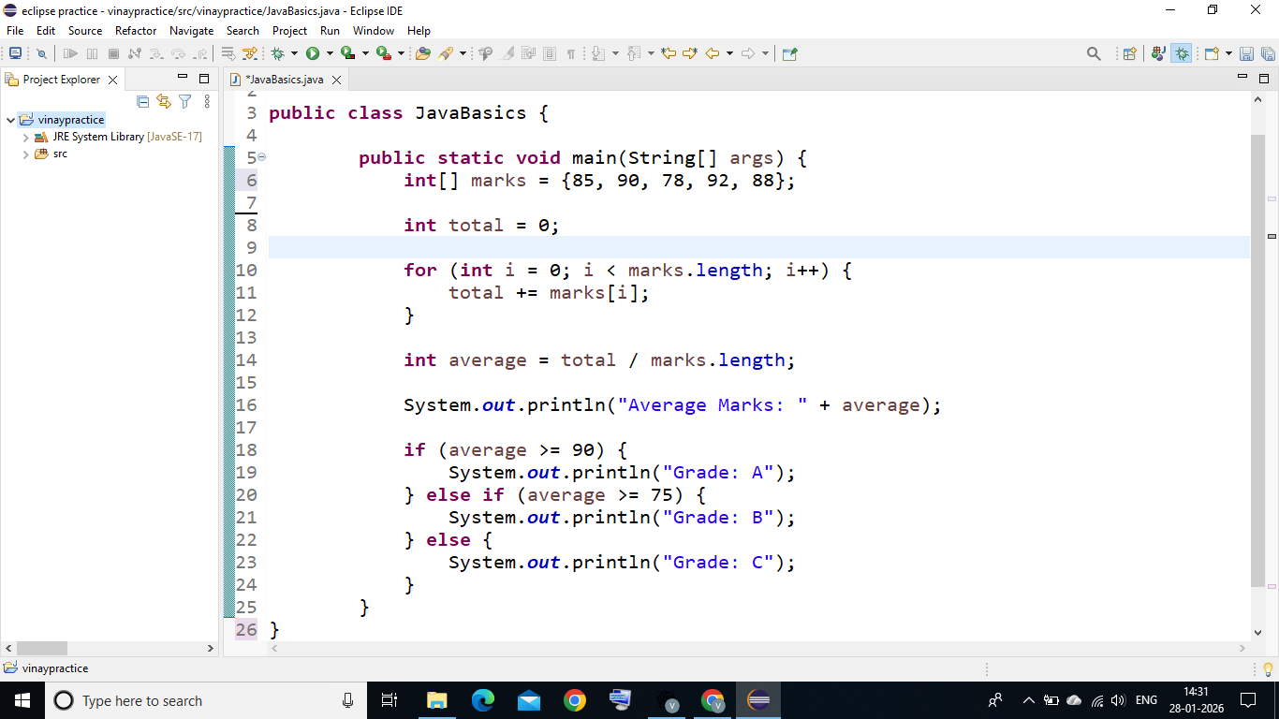
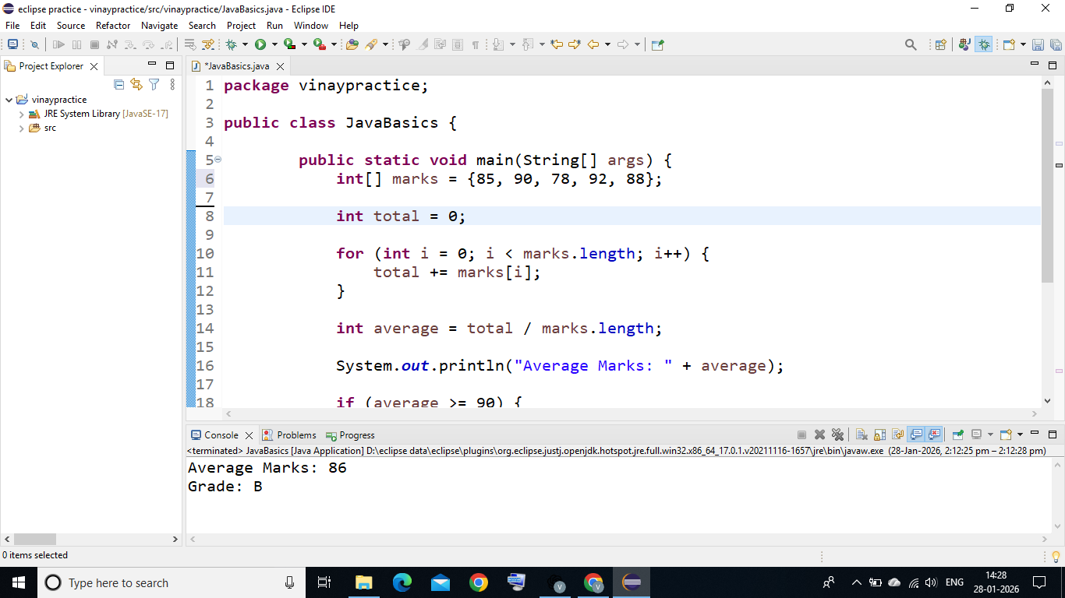

4. Object-Oriented Programming(OOP) Implementation

OOP Concepts Used
- Class & Object : A class is a blueprint or template for creating objects, while an object is an instance of a class that represents a real-world entity.
- Encapsulation: Encapsulation is a core Object-Oriented Programming (OOP) concept of bundling data (variables) and the methods that operate on that data into a single unit, a class.
- Inheritance:Inheritance is a core principle of object-oriented programming that allows a new class to acquire the properties (fields) and behaviors (methods) of an existing class.
- Polymorphism : Polymorphism is a core object-oriented programming concept that allows a single action to be performed in different ways.

Encapsulation source code (Person.java):
public class Person {

private String name;
private int age;

public String getName() {
return name;
}

public void setName(String name) {
this.name = name;
}

public int getAge() {
return age;
}

public void setAge(int age) {
this.age = age;
}

public void displayInfo() {
System.out.println("Name: " + name);
System.out.println("Age: " + age);
}
}

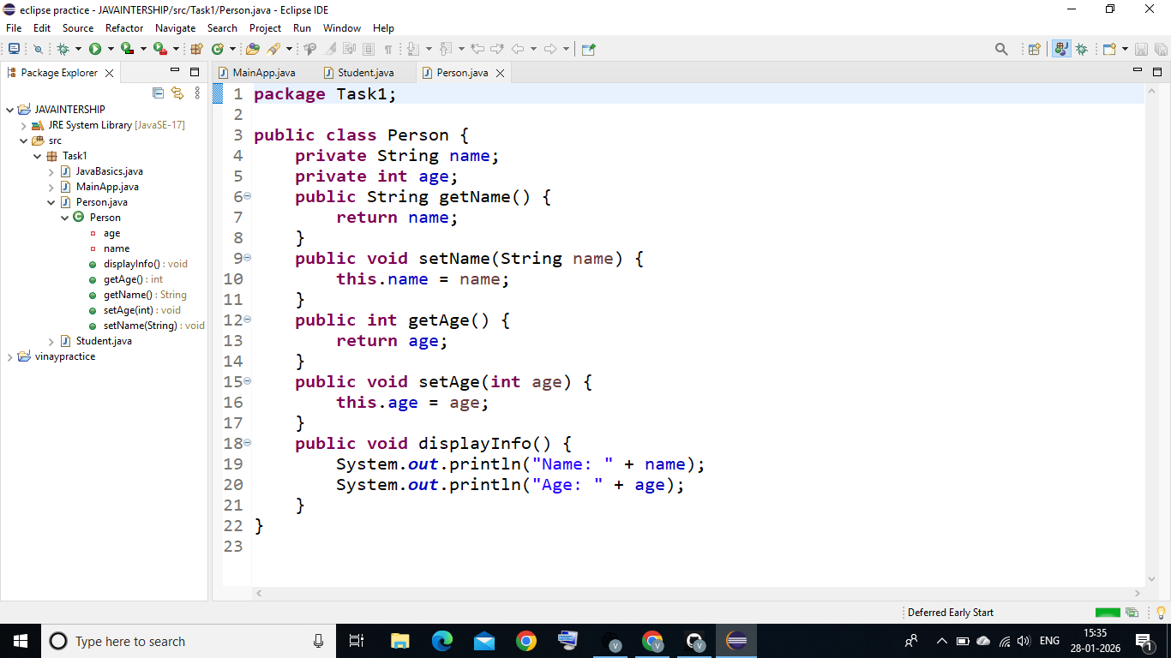

Inheritance & Polymorphism Source code (Student.java) :
public class Student extends Person{
private int rollNo;
private String course;
public int getRollNo() {
return rollNo;
}
public void setRollNo(int rollNo) {
this.rollNo = rollNo;
}
public String getCourse() {
return course;
}
public void setCourse(String course) {
this.course = course;
}
@Override
public void displayInfo() {
super.displayInfo();
System.out.println("Roll No: " + rollNo);
System.out.println("Course: " + course);
}

}
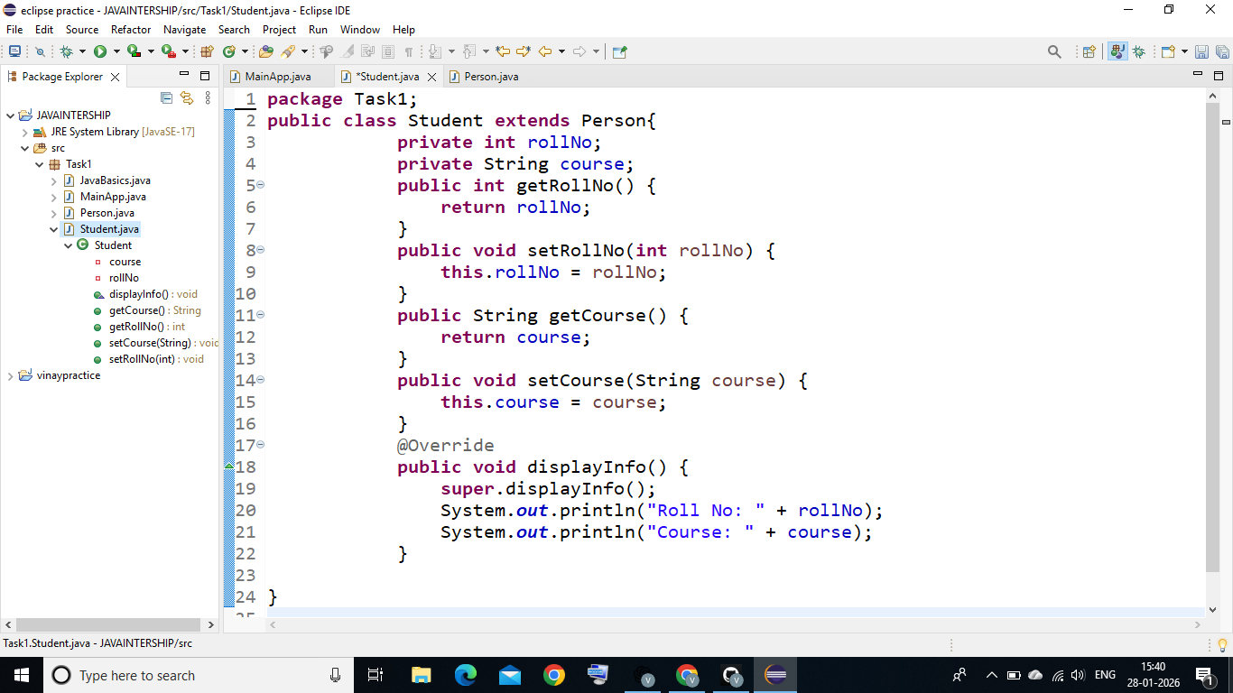

Main Program Execution source code (MainApp.java):
package Task1;
public class MainApp {

public static void main(String[] args) {

Student student = new Student();

student.setName("Vinay");
student.setAge(21);
student.setRollNo(101);
student.setCourse("Computer Science");

student.displayInfo();
}
}

OUtPUT:
Name: Vinay
Age: 21
Roll No: 101
Course: Computer Science

