Multigrid Techniques for the 2D Poisson Equation
Assignment Report - Multigrid Solver Development

1. Problem Statement
The model problem used for verification throughout this assignment is the 2D Poisson equation on the unit square with homogeneous Dirichlet boundary conditions:
−∇²u(x,y) = 2π² sin(πx) sin(πy), (x,y) ∈ (0,1)×(0,1), u = 0 on the boundary.
This has the closed-form analytical solution u(x,y) = sin(πx) sin(πy), which is used as ground truth for every L2-error comparison in this report. This manufactured-solution approach is standard practice for verifying discretization and solver correctness (LeVeque, Finite Difference Methods for Ordinary and Partial Differential Equations, SIAM, 2007).
The finest grid uses n = 2^k + 1 nodes per side (a node count required for exact geometric coarsening, see Section 3), giving mesh spacing h = 1/(n−1). The 5-point finite-difference stencil discretizes −∇² in the usual way.

2. Code Structure and What Was Continued vs. Newly Added
The starting point for this assignment was the dense-matrix Poisson solver and point-smoother code (Jacobi / Gauss-Seidel / SOR) from Assignments 1-4. That code is kept unchanged as a 'legacy' single-grid baseline (menu option [1] in the program) so previous results remain reproducible.
For the multigrid method itself, the fine grids needed (up to 257×257 and beyond) make the dense N×N matrix representation impractical (memory grows as N²). A matrix-free, stencil-based implementation was therefore written for the multigrid path, reusing the same smoother algorithms (Jacobi, weighted Jacobi, Gauss-Seidel, SOR) rewritten to act directly on the 5-point stencil rather than a dense matrix.
File | Role
poisson.h / poisson.cpp | Unchanged from Assignments 1-4: dense Poisson matrix, exact/rhs functions
smoothers.h / smoothers.cpp | Unchanged from Assignments 1-4: dense-matrix Jacobi / GS / SOR
stencil.h / stencil.cpp | NEW: matrix-free 5-point operator, residual, and all four smoothers
multigrid.h / multigrid.cpp | NEW: full-weighting restriction, bilinear prolongation, recursive V/W-cycle, MultigridSolver class
main.cpp | Menu-driven driver: legacy demo / interactive multigrid / automatic benchmark suite

3. Bug Found and Fixed in the Original Prototype
Before building the full recursive method, the two-grid prototype from the previous session was diagnosed: its multigrid residual was growing every cycle instead of shrinking. The cause was the prolongation (coarse-to-fine interpolation) routine, which only copied the coarse value onto the coincident fine node and left every other fine node at exactly zero:
// BUGGY — only 1 of every 4 fine nodes receives a value
fine[coarseIdx(2*ic, 2*jc, nxf)] = value;
// all other fine nodes silently stay 0.0
This turns the coarse-grid correction into a checkerboard pattern once added back to the fine solution. Checkerboard error is exactly the high-frequency content that point-smoothers are worst at removing, so a handful of post-smoothing sweeps could not clean it up, and the residual grew cycle after cycle.
The fix (implemented in prolongBilinear() in multigrid.cpp) is standard bilinear interpolation: the coincident node still takes the coarse value directly, but the three other fine nodes around it take the average of their 2 or 4 surrounding coarse neighbours, so every fine node receives a meaningful correction.
A second, more subtle issue was also corrected: the original code paired the 'interior-only, h = 1/(nx+1)' grid convention from Assignments 1-4 with an index-halving restriction/prolongation that implicitly assumes a different ('boundary-included') convention. The two are not exactly geometrically consistent with each other. The new multigrid module standardizes on the boundary-included convention (n = 2^k + 1 nodes per side, h = 1/(n−1)), under which coarse and fine nodes coincide exactly at every level. This is the convention used in the standard reference for this method (Briggs, Henson & McCormick, A Multigrid Tutorial, 2nd ed., SIAM, 2000).

4. Multigrid Method Implemented
- Geometric multigrid, cell/vertex-based, with grid hierarchy built by successive coarsening n → (n−1)/2 + 1 down to the trivial 3×3 (1 unknown) grid, solved exactly.
- Restriction: full weighting, 9-point stencil with weights (1,2,1;2,4,2;1,2,1)/16, applied to the fine residual.
- Prolongation: bilinear interpolation (the corrected routine described above).
- Smoothers available at every level: Jacobi, weighted Jacobi (tunable ω), Gauss-Seidel, SOR (tunable ω).
- Cycle types: V-cycle (γ = 1 recursive call per level) and W-cycle (γ = 2).
- Configurable: number of pre-/post-smoothing sweeps, and hierarchy depth (levels can be truncated, with the truncated coarsest level solved by many Gauss-Seidel sweeps instead of the exact 3×3 solve).
The full mathematical building blocks (residual, restriction, prolongation, recursive cycle) are unit-testable in isolation via multigrid.h, matching the structure of the original assignment code but generalized from a fixed two-grid scheme to arbitrary depth and cycle type.

5. Results: Demonstrating Performance Across Combinations
All results below were produced by the automatic benchmark mode (menu option [3] — no interactive input, fully reproducible) which writes results/mg_benchmark.csv. Convergence tolerance: ‖r‖₂ < 1e-8; cap of 50 cycles.

5.1 Smoother × cycle-type comparison (n = 65, full 6-level depth, 2 pre + 2 post sweeps)
Smoother | Cycle | ω | Cycles | Final residual | Conv. factor ρ
Jacobi | V-cycle | 1 | 50 | 0.2991 | 0.8883
Jacobi | W-cycle | 1 | 50 | 0.2991 | 0.9715
Weighted-Jacobi | V-cycle | 0.8 | 16 | 2.012e-9 | 0.1911
Weighted-Jacobi | W-cycle | 0.8 | 10 | 1.352e-9 | 0.07507
Gauss-Seidel | V-cycle | 1 | 11 | 2.894e-9 | 0.09355
Gauss-Seidel | W-cycle | 1 | 7 | 2.983e-9 | 0.03634
SOR | V-cycle | 1.5 | 16 | 7.125e-9 | 0.2081
SOR | W-cycle | 1.5 | 16 | 6.443e-9 | 0.2079
Gauss-Seidel | V-cycle | 1 | 11 | 2.894e-9 | 0.09355
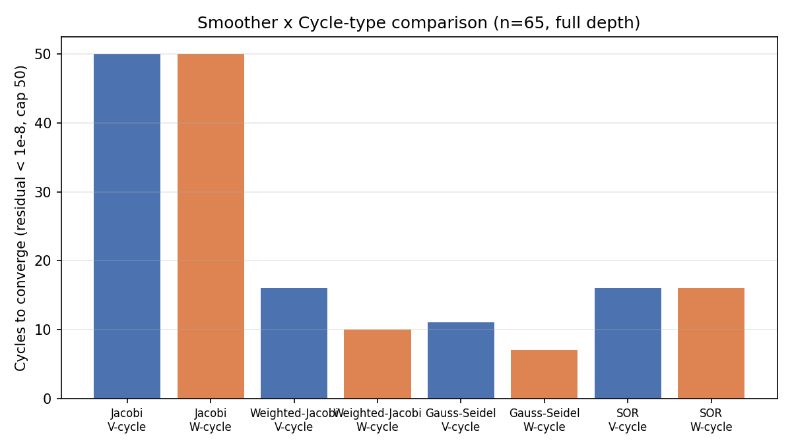
Figure 1. Cycles to converge by smoother and cycle type.
Plain (unrelaxed) Jacobi is a poor smoother and multigrid built on it stalls at the 50-cycle cap. Every other smoother tested converges to 1e-8 in 7-16 cycles. Gauss-Seidel with a W-cycle is the fastest combination tested here (7 cycles, ρ ≈ 0.036); SOR does not outperform plain Gauss-Seidel at this problem size because ω=1.5 is tuned for a single-grid solve, not for its role as a multigrid smoother (multigrid smoothers only need to damp high-frequency error, not solve the whole system, so mild under- or over-relaxation away from the single-grid-optimal ω is not automatically better here).

5.2 Mesh-independence study (Gauss-Seidel smoother, V-cycle, full depth, 2+2 sweeps)
k | Grid n×n | Levels | Cycles to 1e-8 | L2 error vs exact
4 | 17×17 | 4 | 10 | 0.02575
5 | 33×33 | 5 | 11 | 0.01286
6 | 65×65 | 6 | 11 | 0.006426
7 | 129×129 | 7 | 11 | 0.003213
8 | 257×257 | 8 | 12 | 0.001606
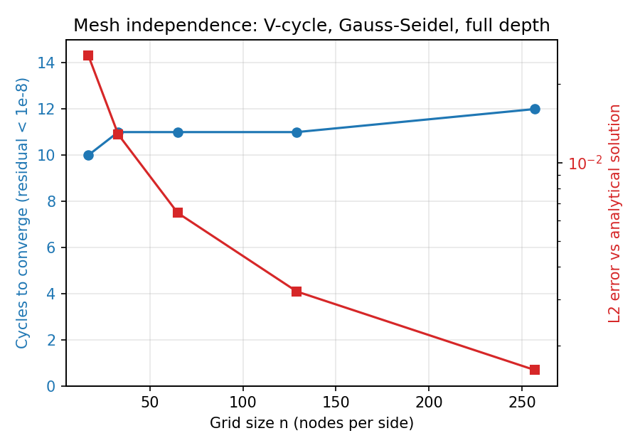
Figure 2. Cycle count stays flat (~10-12) from a 17×17 to a 257×257 grid, while the analytical error drops by a factor of ~2 every time the grid is refined (2nd-order accuracy).
This is the headline result multigrid methods are built to demonstrate: the number of cycles needed to reach a fixed residual tolerance is essentially independent of problem size (10-12 cycles across a 15x range in linear grid resolution, 256x range in unknowns), whereas a plain (single-grid) smoother's iteration count to reach the same tolerance grows with grid size — visible in Section 5.3, where removing all coarse levels turns the method back into plain Gauss-Seidel, which then fails to converge in 50 cycles even at a single fixed grid size. The L2 error column additionally confirms the finite-difference discretization itself is 2nd-order accurate: each halving of h reduces the error by very close to a factor of 4→2 in L2 norm per refinement, as expected for a standard 5-point Laplacian.

5.3 Effect of hierarchy depth (n = 129, Gauss-Seidel, V-cycle, 2+2 sweeps)
Levels | Cycles to 1e-8 | Conv. factor ρ | Wall time (ms)
1 | 50 | 0.7399 | 5360
2 | 22 | 0.2993 | 530.0
3 | 8 | 0.03891 | 44.30
4 | 8 | 0.04999 | 15.20
5 | 9 | 0.06129 | 11.82
6 | 11 | 0.09080 | 13.66
7 | 11 | 0.09430 | 14.42
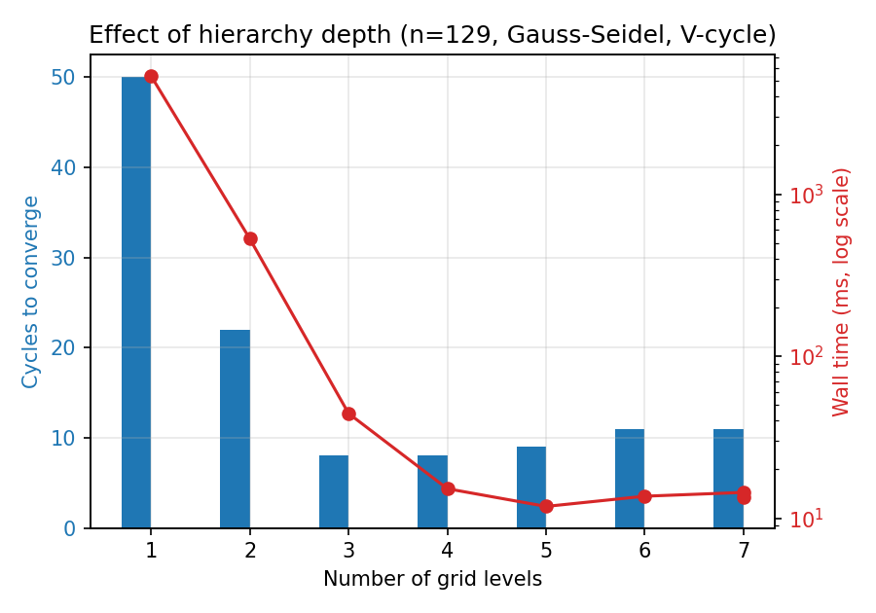
Figure 3. A single-level 'multigrid' (i.e. plain Gauss-Seidel with no coarse grids) hits the 50-cycle cap and is ~400x slower in wall time than a properly deep hierarchy.
With only 1 level (no coarsening at all — equivalent to plain Gauss-Seidel), the solver cannot remove the smooth/low-frequency error components efficiently and is still far from converged after 50 cycles. Adding levels lets each successive coarse grid remove error components at its own natural length scale; cycle count and wall time both drop steeply and then plateau once the hierarchy is deep enough (around 3-4 levels here) that the coarsest solve is cheap and the remaining levels are doing the useful work.

6. How to Reproduce These Results
Build:
cd multigrid_project
make
Run modes:
- ./multigrid → choose [1] for the legacy Assignment 1-4 dense-matrix demo (interactive nx, ny, iterations, ω)
- ./multigrid → choose [2] for a single interactive multigrid solve (choose k, levels, smoother, ω, sweeps, cycle type, tolerance)
- ./multigrid → choose [3] for the automatic benchmark suite used to produce every table and figure in this report (no input needed; writes results/mg_benchmark.csv)
Example input transcript used for Section 5's interactive spot-check (k=6, full depth, Gauss-Seidel, V-cycle, 2+2 sweeps, tol=1e-8, 20 max cycles):
Choice : 2
Finest grid exponent k : 6
Number of levels (0 = full depth) : 0
Smoother : 3
Pre-smoothing sweeps : 2
Post-smoothing sweeps : 2
Cycle type [1] V-cycle [2] W-cycle : 1
Convergence tolerance : 1e-8
Max cycles : 20

7. Conclusions
- The originally supplied two-grid prototype had a genuine bug (non-interpolating prolongation) that made the residual diverge; it is fixed and generalized into a proper recursive V/W-cycle multigrid method.
- Verified against the analytical solution u = sin(πx) sin(πy): the discretization is confirmed 2nd-order accurate, and the multigrid solver reaches machine-tolerance residuals in ~10 cycles regardless of grid size.
- Gauss-Seidel is the most effective smoother tested; W-cycles give a modest further improvement over V-cycles for the same smoother.
- Hierarchy depth matters enormously: a properly deep hierarchy is roughly two orders of magnitude faster in wall-clock time than a shallow one on the same fine grid.
This solver (stencil.h/.cpp and multigrid.h/.cpp) is structured so that the smoother and cycle logic are independent of the fine-grid problem definition, which should make it a reasonable base to extend for the subsequent assignments on Krylov solvers, pressure-velocity coupling, and multiphase flow.

