WHISKY GLASSES
IMAGE | ITEM NAME | PACK SIZE  (PCS) | PRICE /PCS  (INR)
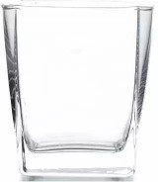 | SQUARE PLAIN 290 ML | 6 | 52
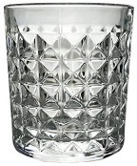 | DIAMOND CUT 325 ML | 6 | 52
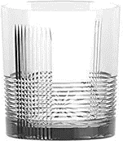 | STRAIGHT LINE 325 ML | 6 | 52
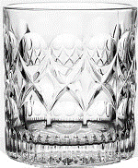 | HOURGLASS 325 ML | 6 | 52
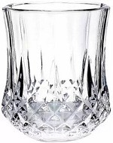 | FLOWER POT 325 ML | 6 | 52
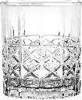 | X BLOCK 325 ML | 6 | 52
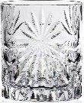 | FLOWER 300 ML | 6 | 52
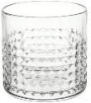 | LINE DIAMOND 340 ML | 6 | 54
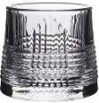 | ROLLING STRAIGHT CUT LINE 170 ML | 6 | 55
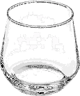 | DHOLAK ROUND 360 ML | 6 | 55
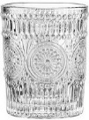 | SUNFLOWER 300 ML | 6 | 55
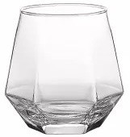 | DHOLAK HEXAGON 310 ML | 6 | 57
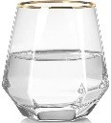 | DHOLAK HEXAGON 310 ML GOLD RIM | 6 | 79
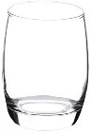 | BALLON 385 ML | 6 | 59
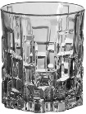 | BRICKS 340 ML | 6 | 60
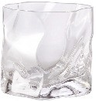 | TEDA MEDA 300 ML | 6 | 60
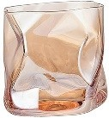 | TEDA MEDA 300 ML GOLD COLOUR | 6 | 78
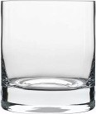 | OLD FASHION 290 ML | 6 | 64
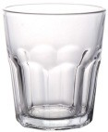 | NOVA 320 ML | 6 | 64
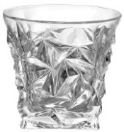 | CROSS DIAMOND 270 ML | 6 | 64
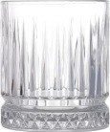 | CANINE 350 ML | 6 | 69
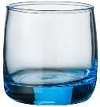 | ROUND PLAIN 315 ML BLUE COLOUR | 6 | 84
BEER MUGS/GLASSES
IMAGE | ITEM NAME | PACK SIZE  (PCS) | PRICE /PCS  (INR)
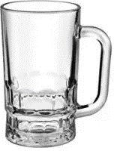 | STRAIGHT BLOCK 360 ML | 6 | 71
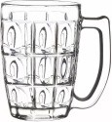 | OVAL BLOCK 380 ML | 6 | 73
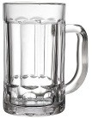 | STRAIGHT DOOR 405 ML | 2 | 82
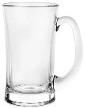 | LUGANO 330 ML | 2 | 89
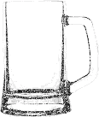 | ROUND PLAIN 350 ML | 2 | 109
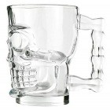 | SKULL 540 ML | 2 | 109
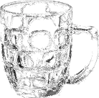 | SQUARE BLOCK 550 ML | 2 | 113
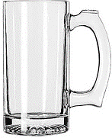 | ROUND PLAIN 500 ML | 2 | 118
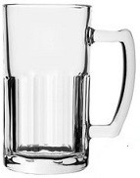 | STRAIGHT DOOR 600 ML | 2 | 123
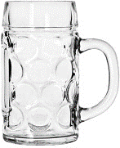 | BIG DOT 600 ML | 2 | 123
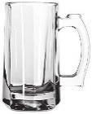 | LINE HEAVY 370 ML | 2 | 134
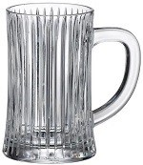 | PARALLEL LINE 550 ML | 2 | 146
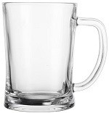 | BUCKET 600 ML | 2 | 150
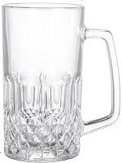 | DIAMOND 600 ML | 2 | 150
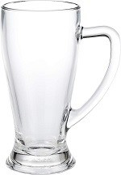 | PILSNER MUG PLAIN 650 ML | 2 | 164
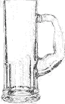 | MUSCLE MAN 600 ML | 2 | 184
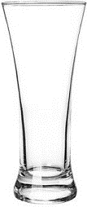 | BEER PILSNER 275 ML | 6 | 73
 | BEER PILSNER 350 ML | 6 | 83
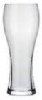 | BEER PILSNER 300 ML NADIR | 6 | 75
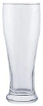 | BEER PILSNER 460 ML | 6 | 82
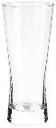 | BEER METROPOLITAN 390 ML | 6 | 82
 | BEER PILSNER 680 ML NADIR | 12 | 129
VODKA GLASSES
IMAGE | ITEM NAME | PACK SIZE  (PCS) | PRICE /PCS  (INR)
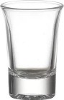 | TREE PLAIN 30 ML | 12 | 18
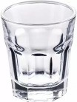 | STRAIGHT DOOR 50 ML | 6 | 18
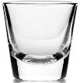 | SHOOTER 30 ML | 12 | 26
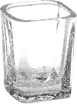 | SQUARE PLAIN 60 ML | 12 | 26
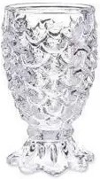 | PINEAPPLE 45 ML | 6 | 27
 | FLOWER POT 60 ML | 6 | 28
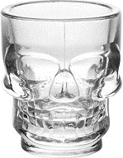 | SKULL 60 ML | 6 | 28
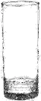 | TUBE 60 ML | 6 | 30
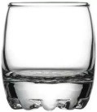 | BULKY PLAIN 80 ML | 6 | 32
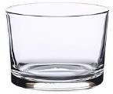 | APPERTIF 150 ML | 6 | 34
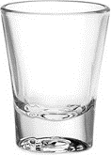 | SOLO SHOT 60 ML NADIR | 6 | 37
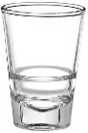 | VODKA CONE BLOCK PLAIN 80 ML | 6 | 35
 | VODKA CONE BLOCK PLAIN 115 ML | 6 | 47
WINE/COCKTAIL GLASSES
IMAGE | ITEM NAME | PACK SIZE  (PCS) | PRICE /PCS  (INR)
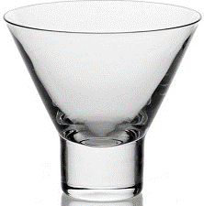 | ILHABELA 180 ML NADIR | 12 | 69
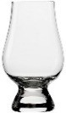 | RAYMOND 180 ML | 6 | 78
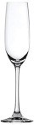 | TULIP 210 ML | 6 | 86
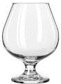 | MINI BRANDY 95 ML | 6 | 64
 | MINI BRANDY 180 ML | 6 | 66
 | BRANDY 360 ML | 6 | 88
 | BRANDY 330 ML NADIR | 12 | 119
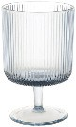 | BRANDY PARALLEL LINE 240 ML | 6 | 72
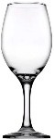 | ZINFANDEL 330 ML | 6 | 84
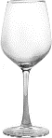 | ZINFANDEL 360 ML | 6 | 88
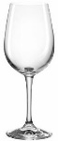 | ZINFANDEL 350 ML FINE RIM | 6 | 110
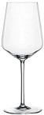 | ZINFANDEL 510 ML | 6 | 105
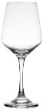 | MUSCAT BLANC 360 ML | 6 | 88
 | MUSCAT BLANC 420 ML | 6 | 92
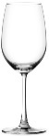 | MALBEC 465 ML | 6 | 88
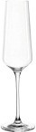 | CHAMP 250 ML | 6 | 96
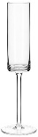 | CHAMP STRAIGHT 180 ML | 6 | 96
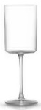 | WINE CUP 290 ML | 6 | 96
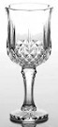 | ANTIQUE ROUND 230 ML | 6 | 101
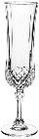 | ANTIQUE LONG 150 ML | 6 | 105
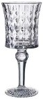 | ANTIQUE TREE 160 ML | 6 | 105
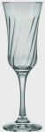 | LIRIO 195 ML NADIR | 12 | 111
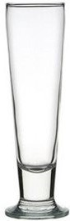 | VIVA FOOTED 300 ML NADIR | 6 | 113
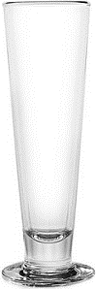 | VIVA FOOTED 420 ML OCEAN | 6 | 205
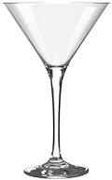 | MARTINI 190 ML | 6 | 113
 | MARTINI 250 ML NADIR | 6 | 145
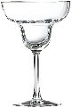 | MARGARITA 240 ML | 6 | 125
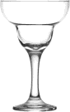 | MARGARITA 345 ML NADIR | 6 | 161
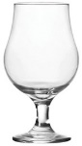 | DUBLIN 400 ML NADIR | 6 | 139
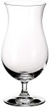 | HURRICANE 360 ML NADIR | 6 | 150
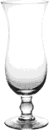 | HURRICANE 450 ML | 6 | 182
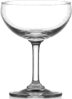 | SAUCER 200 ML NADIR | 6 | 161
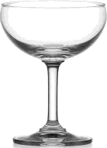 | SAUCER 340 ML NADIR | 6 | 205
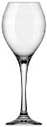 | PRESTIGE 350 ML NADIR | 12 | 161
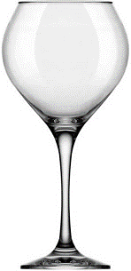 | PRESTIGE 600 ML NADIR | 6 | 193
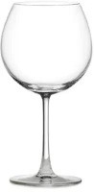 | MONTRASHET 600 ML NADIR | 6 | 201
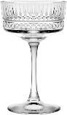 | COCKTAIL CANINE 250 ML | 4 | 147
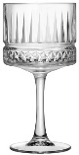 | COCKTAIL CANINE 500 ML | 4 | 157
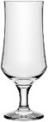 | FROZEN DESSERT 405 ML | 6 | 92
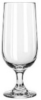 | FROZEN DESSERT 350 ML | 6 | 92
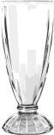 | SUNDAY CUP 340 ML | 6 | 105
WATER GLASSES
IMAGE | ITEM NAME | PACK SIZE  (PCS) | PRICE /PCS  (INR)
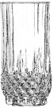 | FLOWER POT 300 ML | 6 | 52
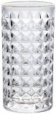 | DIAMOND CUT 300 ML | 6 | 52
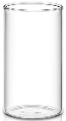 | BOROSIL 320 ML | 6 | 52
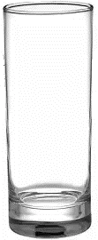 | HIGH BALL 295 ML | 6 | 54
 | HIGH BALL 330 ML | 6 | 59
 | COLLIN 310 ML | 6 | 61
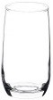 | SYLVANIA 280 ML | 6 | 53
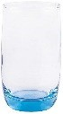 | SYLVANIA 290 ML BLUE COLOUR | 6 | 78
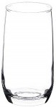 | SYLVANIA 360 ML | 6 | 57
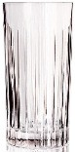 | PARALLEL LINE 340 ML | 6 | 68
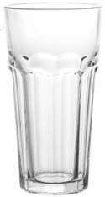 | NOVA 315 ML | 6 | 54
 | NOVA 370 ML | 6 | 65
 | NOVA 460 ML | 6 | 74
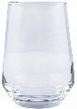 | DHOLAK ROUND 390 ML | 6 | 59
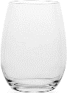 | BALLON 400 ML | 6 | 59
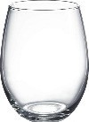 | BALLON 530 ML | 6 | 68
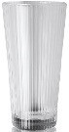 | LINE 410 ML | 6 | 85
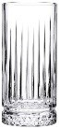 | CANINE 300 ML | 6 | 68
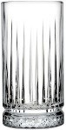 | CANINE 450 ML | 6 | 98
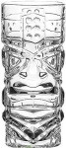 | TIKI 410 ML | 6 | 98
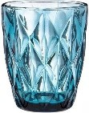 | CROSS DIAMOND 280 ML BLUE COLOUR | 6 | 65
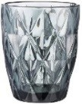 | CROSS DIAMOND 280 ML BLACK COLOUR | 6 | 65
CUP GLASSES
IMAGE | ITEM NAME | PACK SIZE  (PCS) | PRICE /PCS  (INR)
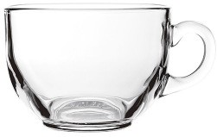 | BOWL PLAIN 150 ML | 6 | 40
 | BOWL PLAIN 470 ML | 3 | 85
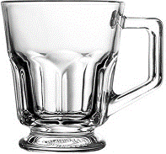 | IRISH COFFE 150 ML | 6 | 40
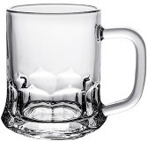 | STRAIGHT DOOR 155 ML | 6 | 42
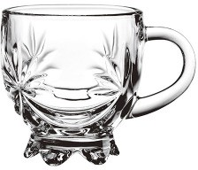 | CROWN DESIGN 155 ML | 6 | 42
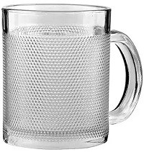 | DIAMOND DOT 200 ML | 6 | 42
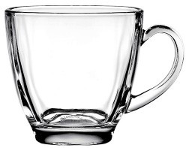 | BULKY PLAIN 190 ML | 6 | 46
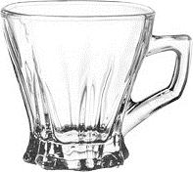 | CROWN PLAIN 160 ML | 6 | 46
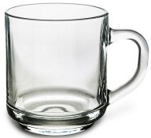 | HIGH BALL 240 ML | 6 | 48
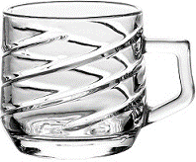 | PARALLEL LINE 210 ML | 6 | 55
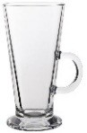 | CONE PLAIN 270 ML | 6 | 96
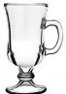 | IRISH COFFE LONG 240 ML | 6 | 96
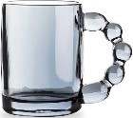 | BLACK BUBBLE HANDLE 330 ML | 6 | 95
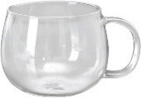 | BOROSIL PLAIN 410 ML | 2 | 95
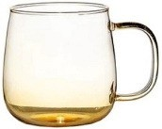 | BOROSILICATE 530 ML GOLD COLOUR | 6 | 98
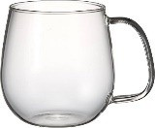 | BOROSILICATE 530 ML BLACK COLOUR | 6 | 98
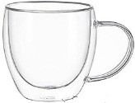 | BOROSIL DOUBLE WALL 250 ML | 1 | 190
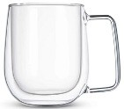 | BOROSIL DOUBLE WALL 270 ML | 1 | 195
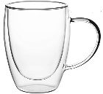 | BOROSIL DOUBLE WALL 350 ML | 1 | 210
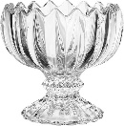 | ICE CREAM CROWN 120 ML | 6 | 50
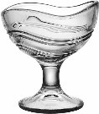 | ICE CREAM BOAT 150 ML | 6 | 65
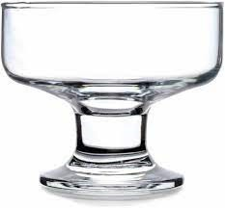 | ICE CREAM BOAT 205 ML | 6 | 72
DECANTERS
IMAGE | ITEM NAME | PACK SIZE  (PCS) | PRICE /PCS  (INR)
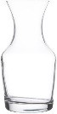 | LIBBEY 250 ML | 1 | 36
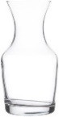 | LIBBEY 500 ML | 1 | 51
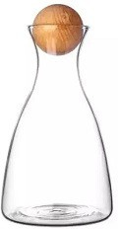 | WOODEN BALL 1.7 LTR | 1 | 315
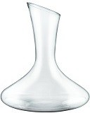 | WINE OPEN MOUTH 1.9 LTR | 1 | 614
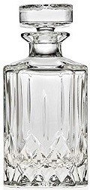 | OPERA 750 ML | 1 | 785
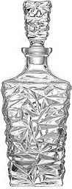 | SOLITAIRE 750 ML | 1 | 1024
BAR ACCESSORIES
IMAGE | ITEM NAME | PACK SIZE  (PCS) | PRICE /PCS  (INR)
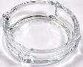 | ASHTRAY ROUND 120 ML | 1 | 50
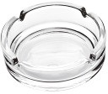 | ASHTRAY ROUND CUT 300 ML | 1 | 55
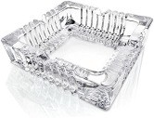 | ASHTRAY SQUARE CUT 300 ML | 1 | 55
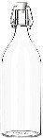 | WATER BOTTLE GLASS 1 LTR | 1 | 130
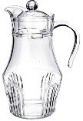 | WATER JUG PARALLEL LINE 1.8 LTR | 1 | 240
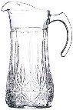 | WATER JUG BLOCK 1.7 LTR | 1 | 240
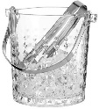 | ICE BUCKET LINE DIAMOND 900 ML | 1 | 240
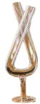 | BOROSILICATE GLASS LIIT X 300 ML | 1 | 480
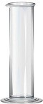 | BOROSILICATE GLASS LIIT 300 ML | 1 | 464
 | BOROSILICATE GLASS LIIT 500 ML | 1 | 478
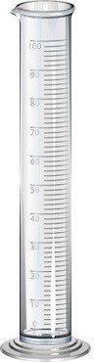 | ACRYLIC LIIT 300 ML | 1 | 478
 | ACRYLIC LIIT 500 ML | 1 | 614
 | ACRYLIC LIIT 1 LTR | 1 | 887
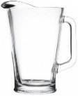 | BEER PITCHER 1.5 LTR | 1 | 650
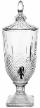 | JUICE DISPENSER DIAMOND CUT 2 LTR | 1 | 850
 | JUICE DISPENSER STRAIGHT CUT LINE 2 LTR | 1 | 850
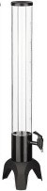 | BEER TOWER 1.5 LTR LTR HEAVY DUTY | 1 | 2100
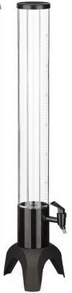 | BEER TOWER 3 LTR HEAVY DUTY WITH METAL BASE | 1 | 2200
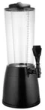 | BEER TOWER 2.5 LTR HEAVY DUTY WITH MULTICOLOR LIGHTS | 1 | 2200
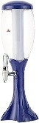 | BEER TOWER OVAL 3 LTR BLUE COLOR | 1 | 2200
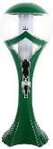 | BEER TOWER CROWN 3 LTR GREEN COLOR | 1 | 2200
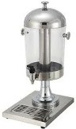 | BEER TOWER 7 LTR STAINLESS STEEL HEAVY DUTY | 1 | 2300
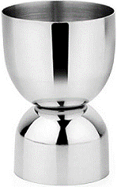 | MEASUREMENT CUP BOWL 30/60 ML SILVER | 1 | 61
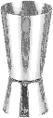 | MEASUREMENT CUP CONE 30/60 ML SILVER | 1 | 89
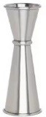 | MEASUREMENT CUP CONE RING 30/60 ML SILVER | 1 | 164
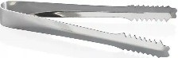 | ICE TONG SMALL | 1 | 35
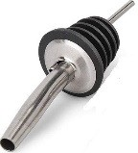 | POURER | 1 | 48
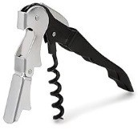 | WINE OPENER | 1 | 90
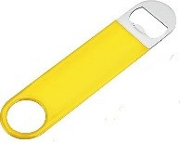 | BOTTLE OPENER | 1 | 125
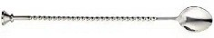 | BAR SPOON | 1 | 125
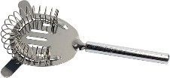 | STRAINER | 1 | 164
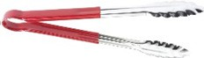 | ICE TONG BIG | 1 | 175
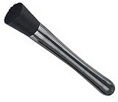 | MUDDLER | 1 | 180
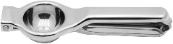 | LEMON SQUEEZER | 1 | 210
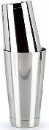 | SHAKER | 1 | 385
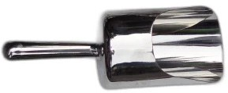 | ICE SCOUP STAINLESS STEEL | 1 | 420
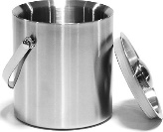 | ICE BUCKET 1 LTR STAINLESS STEEL | 1 | 490
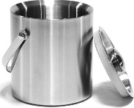 | ICE BUCKET 1.5 LTR STAINLESS STEEL | 1 | 560
SIPPERS
IMAGE | ITEM NAME | PACK SIZE (PCS) | PRICE /PCS (INR)
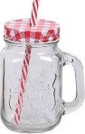 | MASON JAR 500 ML WITH COLORFUL LID AND STRAW | 1 | 90
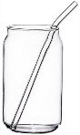 | BOROSILICATE JAR WITH STRAW 540 ML | 1 | 90
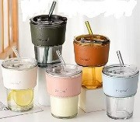 | SIPPER BAND 430 ML PLAIN WITH STRAW  Color: Black, Golden & White | 1 | 90
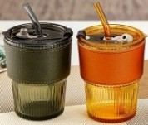 | SIPPER BAND 430 ML LINE WITH STRAW  Color: Black & Golden | 1 | 95
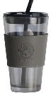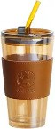 | SIPPER BAND 480 ML LONG WITH STRAW  Color: Black & Golden | 1 | 105
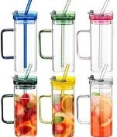 | BOROSILICATE SIPPER SQUARE WITH HANDLE, LID & GLASS STRAW 380 ML  Color: Blue, Green, Yellow & Brown | 1 | 120
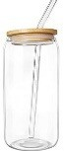 | SIPPER 540 ML WITH WOODEN LID & GLASS STRAW | 1 | 130
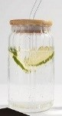 | SIPPER LINE 540 ML WITH WOODEN LID & GLASS STRAW | 1 | 140

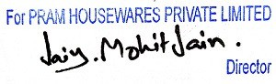
Note:
- Gst 18% should be extra
- Freight extra as actual is applicable
- Any dispute is subject to delhi jurisdiction

