VPC – Creation of one public server and accessing private server through public server

- Create a vpc
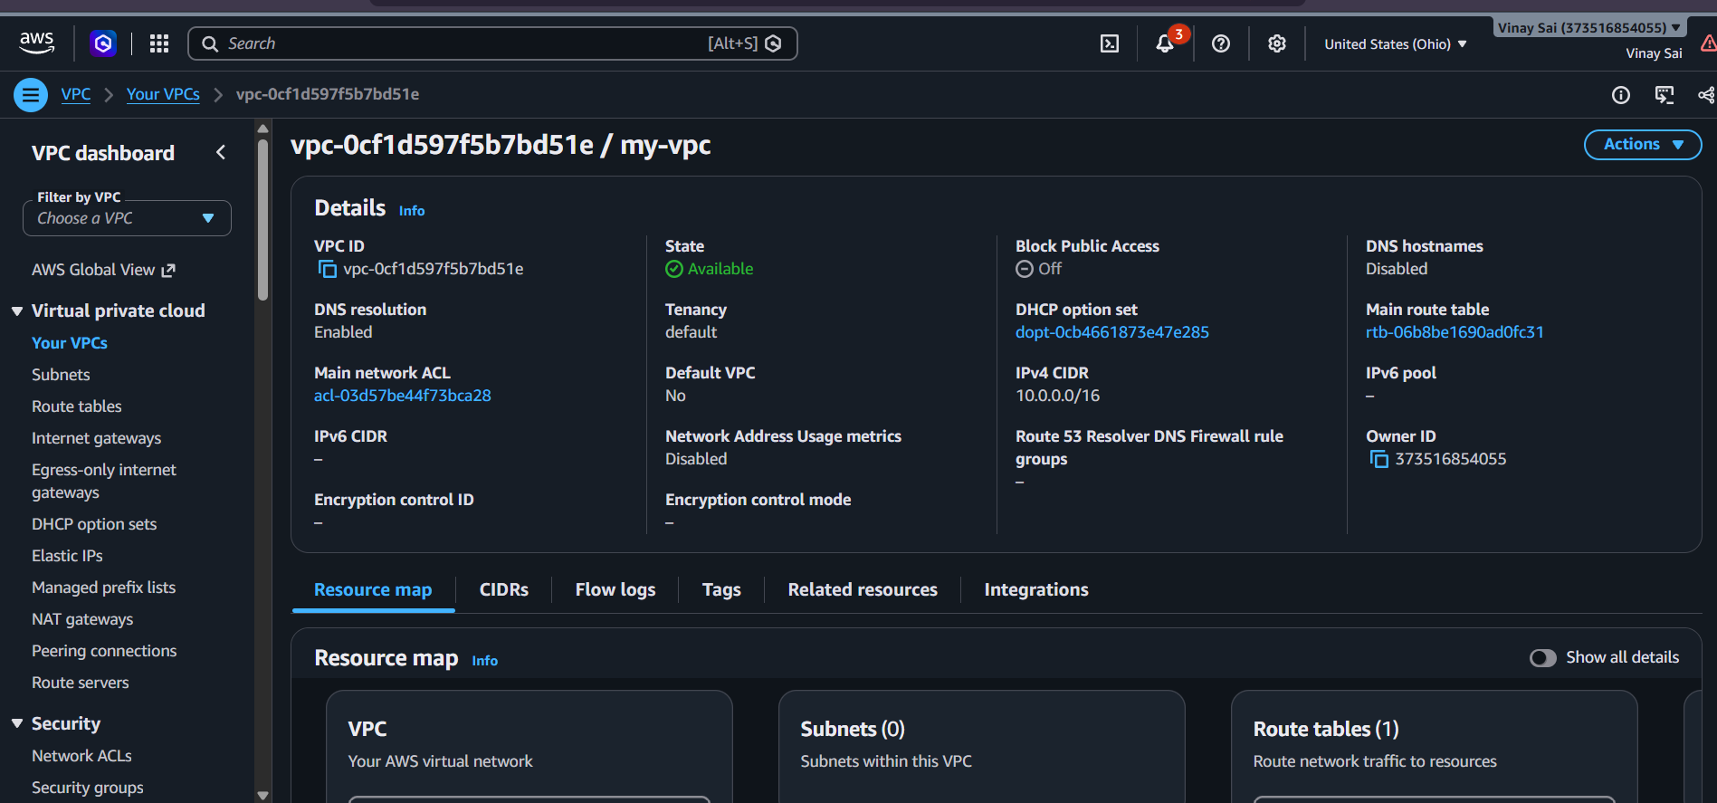

- Create 2 subnets[public and private] and give a range of ip
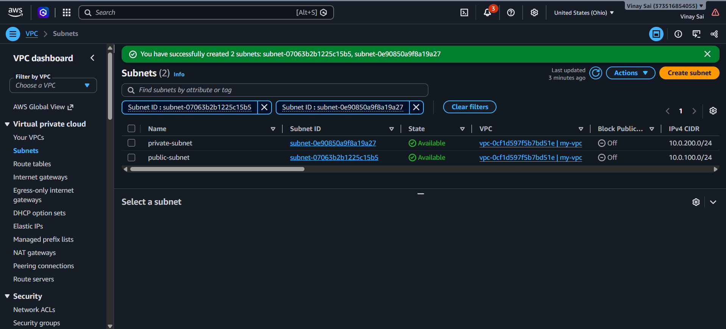

- Create a internet gateway and attach the created vpc to the IGW
\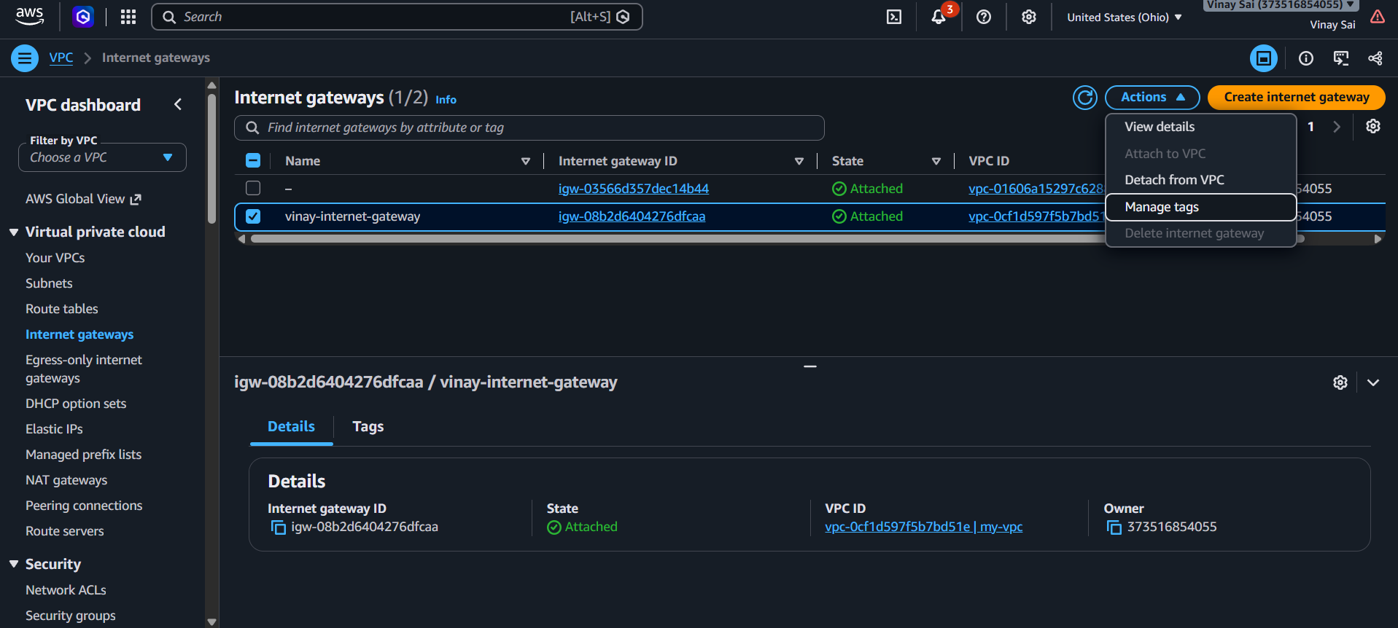

- Create route tables
- Public route table
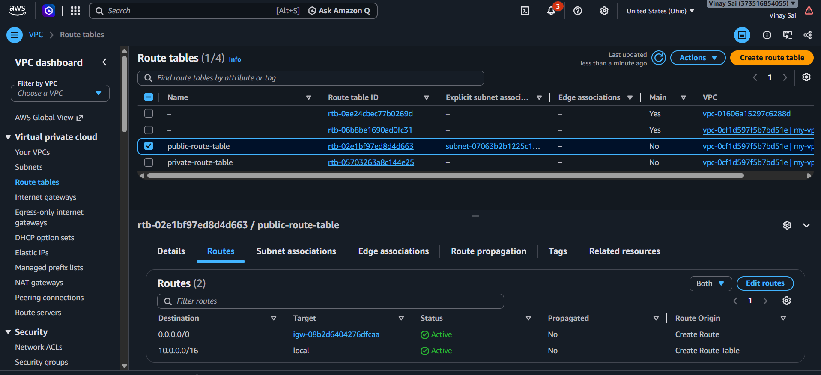
Add routes>edit>change and add route
0.0.0.0/0 and target – IGW
Add subnet - Subnet association> edit> choose public subnet
- Private route table – create NAT and connect NAT to private route table

- Create a NAT and attach public subnet to that
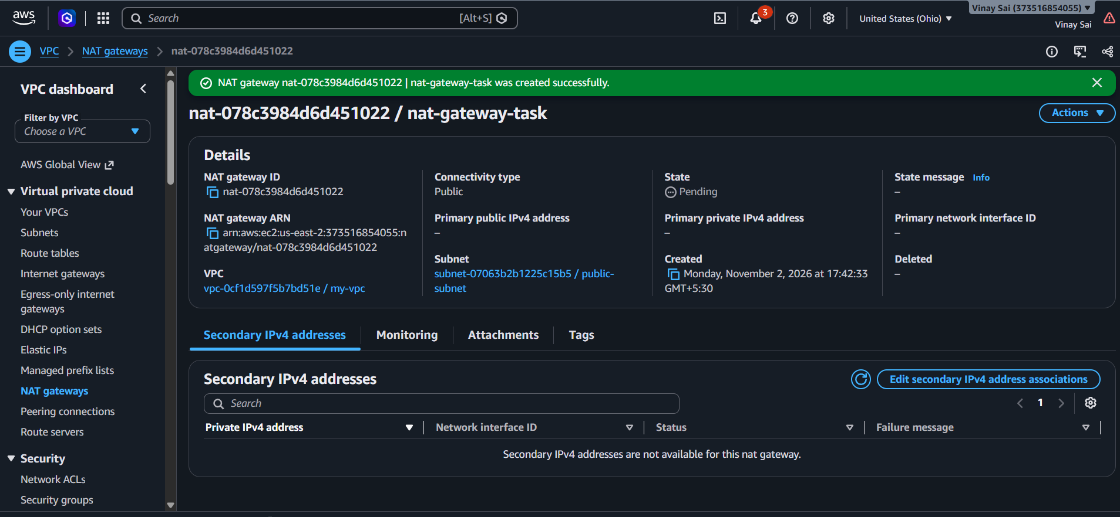

- Connect the NAT to private RouteTable
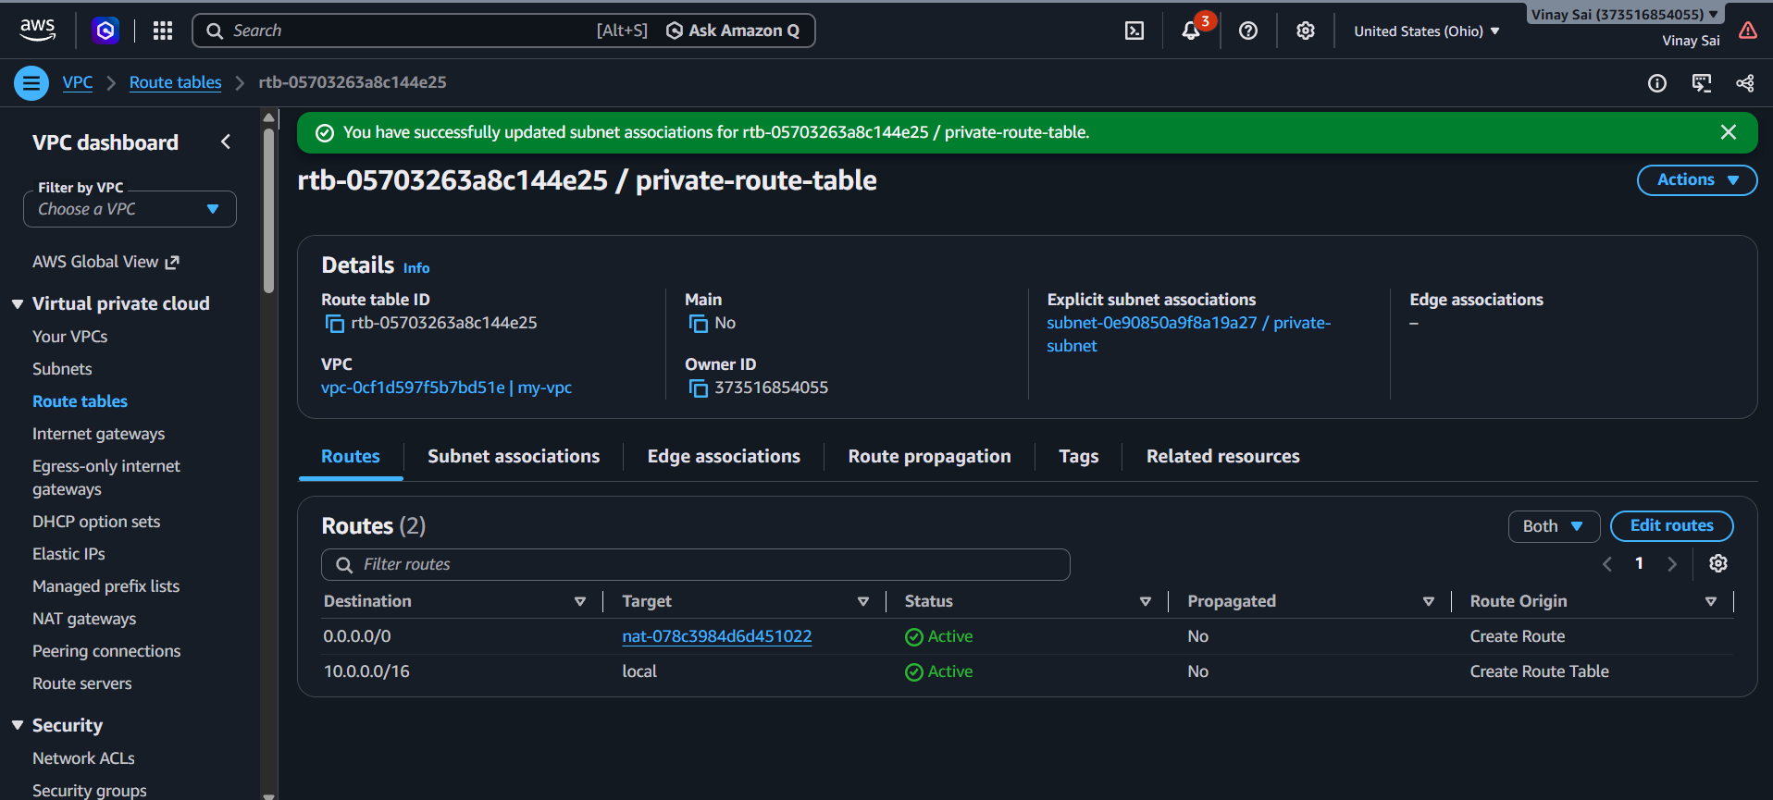
Routes> edit> add > open destination and target choose NAT

Go to subnet association> edit> choose private subnet > save

- Create 2 security groups public and private
For linux open inbound rules for SSH,HTTP,HTTPS
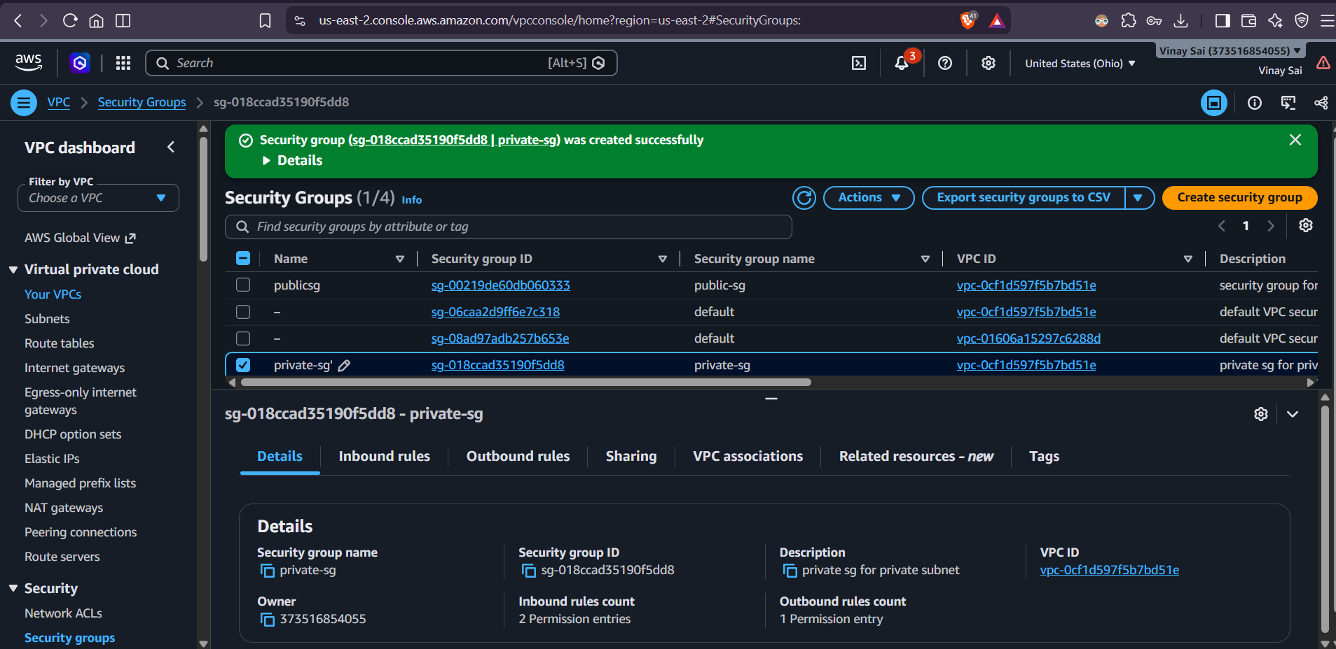

- Create 2 ec2 servers and add the index.html files
In public
ssh -i your-key.pem ubuntu@PRIVATE_IP
sudo apt update
sudo apt install nginx -y
sudo nano /var/www/html/index.html – add some content in private server
sudo systemctl enable nginx
sudo systemctl start nginx
Configure HOME EC2
sudo apt update
sudo apt install nginx -y
sudo nano /var/www/html/index.html – add some content for public server
sudo nano /etc/nginx/sites-available/default
sudo nginx -t
sudo systemctl restart nginx
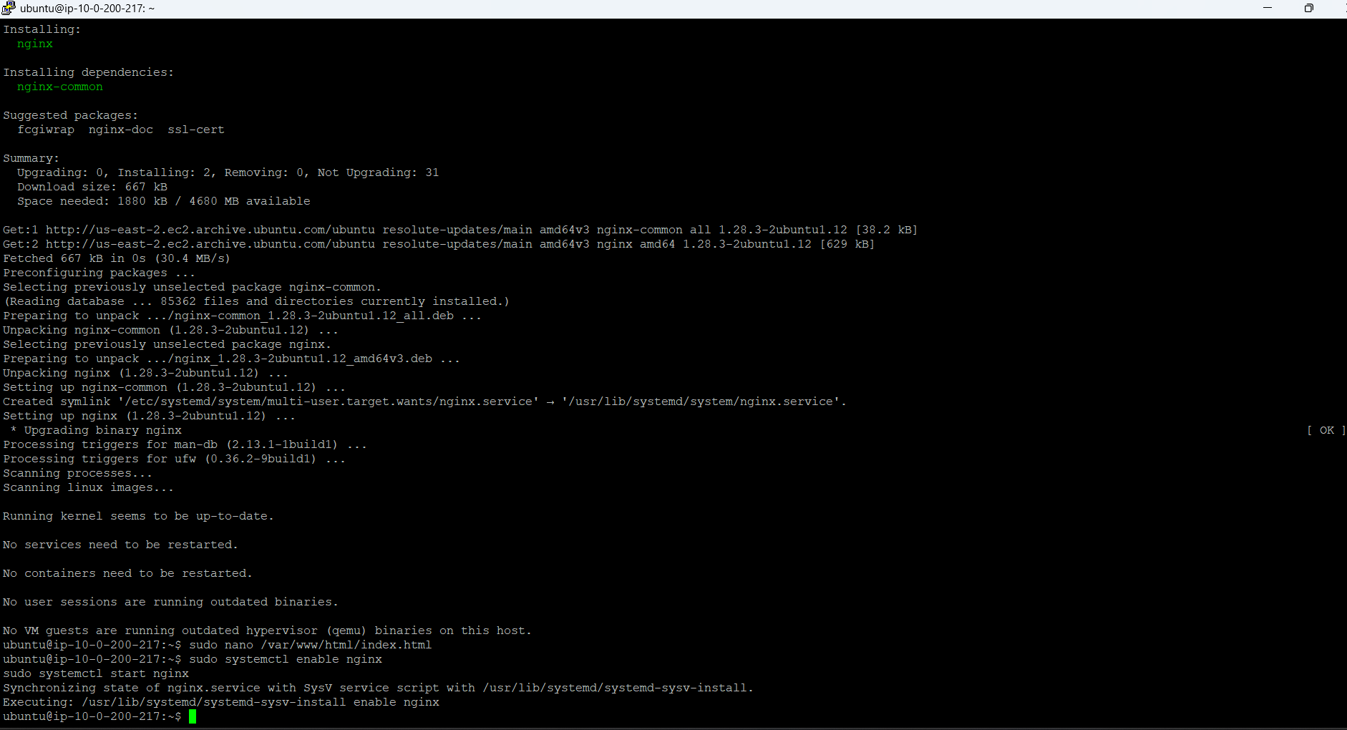
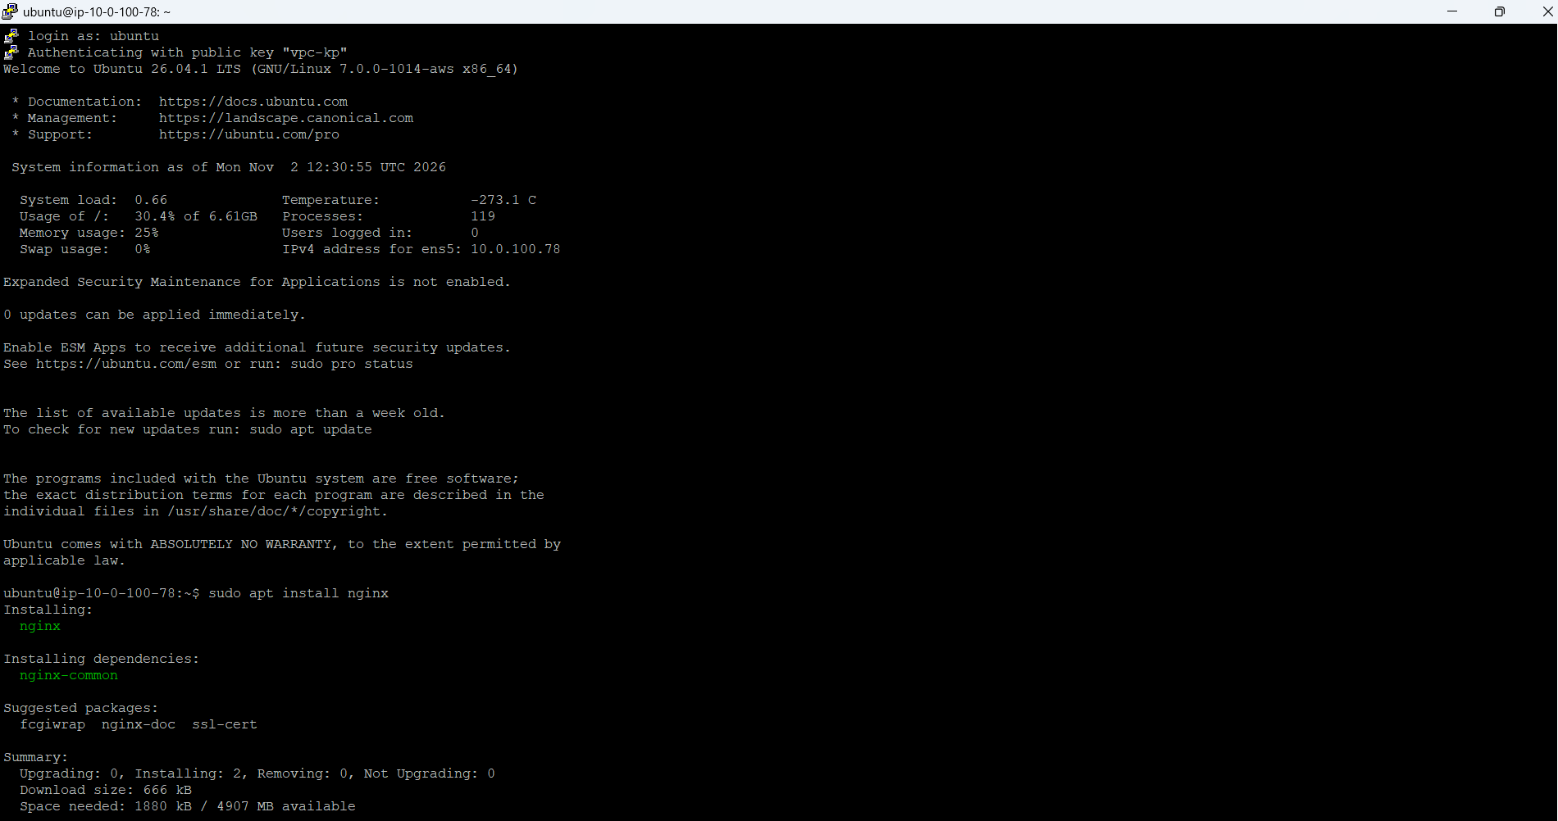

Result


