Front End (HTML, CSS, BOOTSTRAP)

HTML Elements: It is everything from start tag to end tag.
<html>, <body>, <title>,<p>
HTML Attributes: Tells additional information about the elements. All HTML elements have the attributes
<a href="link">, <img src="location" width="value" height="value">
HTML Headings:
<h1> to <h6>
HTML Paragraph:
<p>
HTML Styles:
- Background-color
- Color
- Font-family
- Font-size
- Text-align

HTML Formatting Elements:

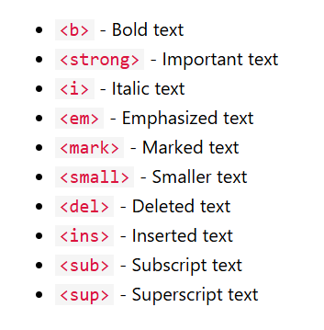
HTML Quotation Elements:
A. <blockquote>
- <q> - qutotes
- <abbr> - abbrevation
- <address> - address
- <cite> - to mention title
- <bdo> - rtl

HTML comments:
<!--->
HTML CSS:
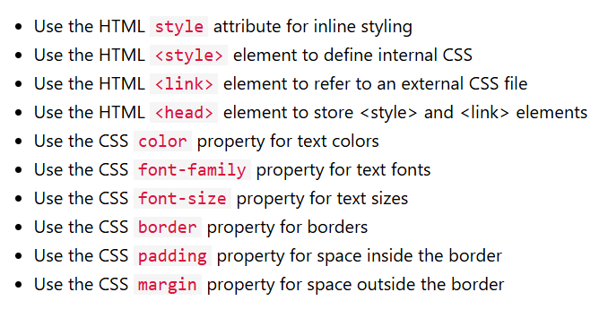
HTML Links:
<a>
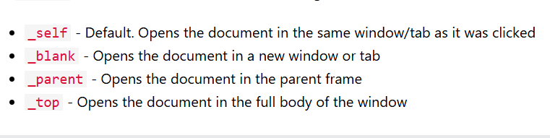
HTML image:
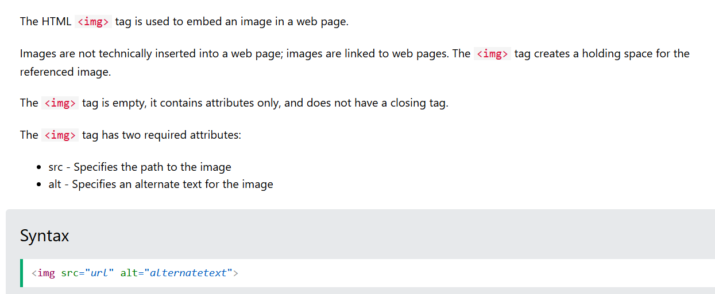

HTML Inputs:
For form fields we need to use for attribute in the label and use the id in the input. Name attribute is used as key and sent to the server.
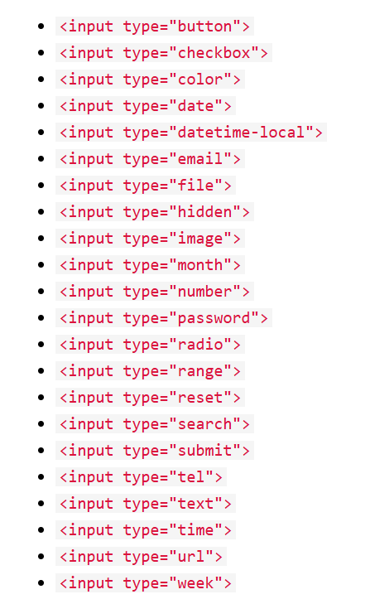
HTML Layouts:
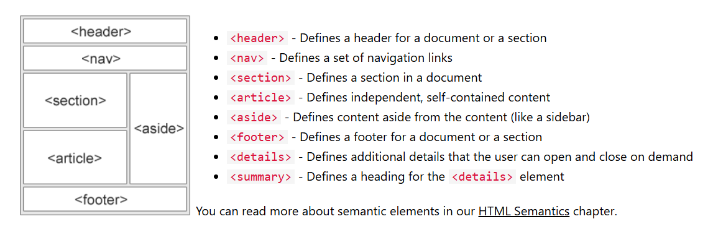

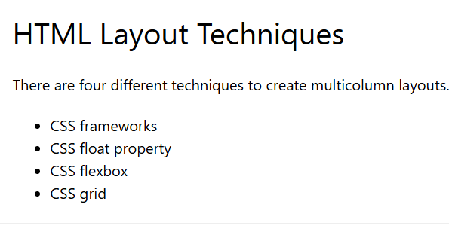
HTML Table:
<table> <th> <td> colspan and rowspan.
HTML lists:
<ol> <ul>
List style types:
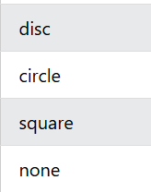
Audio and Video Tags:
🎵 Tag
- Used to embed sound files in a webpage.
- Common attributes:
  - src → file path of the audio.
  - controls → shows play/pause, volume, seek bar.
  - autoplay → starts automatically (often blocked).
  - loop → repeats audio.
  - muted → starts muted.
🎬 Tag
- Used to embed video files in a webpage.
- Common attributes:
  - src → file path of the video.
  - controls → shows play/pause, volume, fullscreen.
  - autoplay → starts automatically (often blocked).
  - loop → repeats video.
  - muted → starts muted.
  - poster → image shown before video plays.
  - width / height → set video size.

