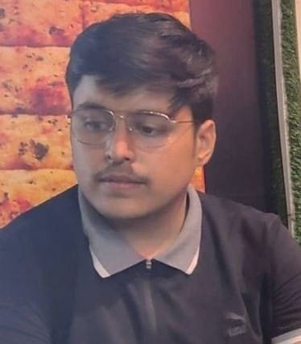**RESUME**

**VINEET BHATT**

**Address**:- 20/20 Tibbia College, Karol Bagh, New Delhi-110005

**Mail ID**: - bvineet249@gmail.com

**Contact No**. – 7678522614

**Career Objective**

To be the part of an enthusiastic work environment, where I can use my technical skills to accomplish organizational goals.

**Academic Background**

Pursuing B.Tech in Computer Science Engineering (Artificial Intelligence) from Dronacharya College Of Engineering, Gurugram, Approved By AICTE.

|  |  |  |  |
| --- | --- | --- | --- |
| **Institute / University** | **Degree/ Examination** | **Percentage** | **Year** |
| Dronacharya College of Engineering | B.Tech | Pursuing(1st Year) | ----- |
| CPS New Delhi | 12th | 82% | 2021 |
| CPS New Delhi | 10th | 80% | 2019 |

**Technical Skills**

* Languages Known: - Basic Concepts of Python, HTML, CSS, C/C++
* Operating Systems:- Microsoft Windows XP/Vista, Windows 10, Windows 11

**Certifications And Memberships**

* I am a 4-star coder at Hackerrank in C Language.
* I have completed certification module 1 in c (programming fundamentals) from Coursera.
* I have completed certification module 2 in c (structured programming) from Coursera.
* Qualified and secured AIR 24 in National Creativity and Aptitude Test(2022).

**Workshops And Technical Events**

* Attended Drone Workshop at Dronacharya College Of Engineering in December 2021.
* Attended Techpreksha 2022 organized by GFG.

**Achievements**

* Qualified and secured AIR 24 in National Creativity and Aptitude Test(2022).
* I have completed certification module 1 in c (programming fundamentals) from Coursera.
* I have completed certification module 2 in c (structured programming) from Coursera.
* I am a 4-star coder at Hackerrank in C Language.

**Strengths**

* Leadership Qualities
* The ability to work in a controlled environment.
* Hard-Working with lots of Patience.

**Extracurricular Activities**

* ESPORTS Player
* Fond Of Music
* Dancing