ISA
Architecture · Instruction Set Architecture
VINJEY
Quick Reference Guide
Renesas RX ISA
Covers RXv1, RXv2 and RXv3
Vinoth Kumar A and Aman Kumar
Opcodes at a glance
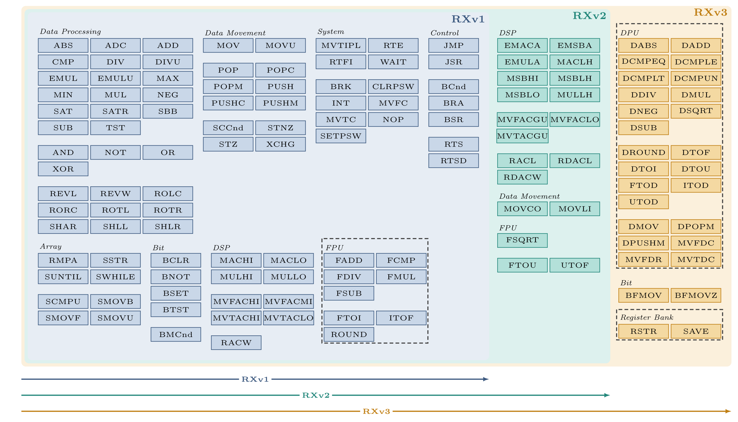

VINJEY Software Systems  Edition 1.0 (Draft), October 2026 | www.vinjey.com

—— Architecture · ISA series
Renesas RX ISA
Quick Reference Guide · Covers RXv1, RXv2 and RXv3
Vinoth Kumar A and Aman Kumar
Edition  1.0 (Draft), October 2026 | Article type  Long form | Series  Instruction Set Architecture
© 2026 VINJEY Software Systems. All rights reserved. No part of this publication may be reproduced, stored in a retrieval system or transmitted in any form or by any means without the prior written permission of the publisher, except for brief quotations in reviews and other uses permitted by copyright law.
Renesas and RX are trademarks of Renesas Electronics Corporation. All other product and company names are trademarks or registered trademarks of their respective owners. Their use does not imply endorsement.
This publication is provided “as is”, without warranty of any kind. The authors and publisher have taken care in its preparation but accept no liability for errors or omissions, or for any loss arising from use of the information it contains. Confirm details against the manufacturer’s documentation before using them in a product.
Corrections and feedback are welcome at info@vinjey.com. The latest edition is available at www.vinjey.com.

Published by  VINJEY Software Systems  Embedded audio, engineered  No. 429, First Floor, 12th Cross, WOC Road II Stage,  Mahalakshmipuram, Bengaluru 560086, India  CIN U72200KA2004PTC033636 | www.vinjey.com

VINJEY
Architecture · Instruction Set Architecture
ISA
About this guide
Every instruction of Renesas RX ISA v1, v2 and v3 in seven pages, organized by nature and type, with full encodings and a single-page cycles table. Calling conventions, intrinsics, floating point and exceptions make it a standalone reference, and deviations from the ISA manuals are listed.
For performance engineers who know RX, or another ISA such as RISC-V or AArch32.
Where this guide fits
Domain · The AAA framework
Application |  | Algorithms |  | ● Architecture
Series in Architecture
ISA |  | ILP |  | DLP |  | GPU |  | NPU |  | MEM |  | ARITH
Articles in the ISA series
01 QRG for AArch32 (ARM 32-bit) ISA
02 QRG for RISC-V MCU ISA (Espressif and Renesas)
03 QRG for Renesas RX (v1, v2 and v3) This guide
04 QRG for AArch64 (ARM 64-bit) ISA
05 QRG for TI C6x DSP
All titles and new releases: www.vinjey.com
VINJEY Software Systems
Embedded audio, engineered
No. 429, First Floor, 12th Cross, WOC Road II Stage,
Mahalakshmipuram, Bengaluru 560086, India
info@vinjey.com · +91 80 23492839 · CIN U72200KA2004PTC033636
www.vinjey.com © 2026 VINJEY Software Systems

