CAPSTONE PROJECT 4
FMCG Inventory Forecasting & Distribution Optimization Analytics Platform
Final Project Documentation
Informatica IDMC | AWS S3 | Snowflake (Bronze, Silver, Gold) | Snowpark Python | Streamlit

Item | Detail
Team | Anchal
Team members | Anchal, Isha, Shreyash, Pawan Satvik, Vinod
Group No. | [Group No.]
Domain | FMCG Retail, Inventory and Supply Chain
Programme | Graduate Trainee Capstone (LTMB13)
Document version | 1.0 (final)
Date | 9 November 2026

Contents
No. | Section
1 | Project Title and Team Member Details
2 | Business Problem Statement
3 | Project Objectives and Expected Business Outcomes
4 | Technology Stack
5 | Overall Architecture Diagram
6 | Source Dataset Description
7 | Data Ingestion Process
8 | Data Profiling and Quality Rules
9 | Bronze, Silver and Gold Layer Implementation
10 | Data Cleaning, Quarantine and Warning Handling
11 | Fact and Dimension Data Modeling
12 | Workflow and Pipeline Orchestration
13 | Data Validation and Reconciliation Results
14 | Dashboard Implementation and Business KPIs
15 | Error Handling and Monitoring
16 | Challenges Faced and Solutions Implemented
17 | Final Project Results and Business Insights
18 | Individual Team Member Contributions

1. Project Title and Team Member Details
Project 4: FMCG Inventory Forecasting & Distribution Optimization Analytics Platform. The team built an end-to-end data platform that takes raw FMCG files, cleans and governs them, models them for analytics, protects them with role-based security, scores stock risk with Snowpark, and presents the result in a Streamlit dashboard.

1.1 Team members and roles
Member | Area owned | Main responsibility
Anchal | IDMC, Bronze, Gold, documentation | Products and stores pipeline, the whole Gold layer, final presentation and documentation
Isha | Bronze, Silver orchestration, security | Sales events (JSON) and warehouse Bronze, stream and task sequence, RBAC
Shreyash | Bronze, Snowpark, Streamlit | Sales orders Bronze, risk scoring in Snowpark, dashboard
Pawan Satvik | Bronze and Silver | Inventory snapshots and replenishment orders (shared with Vinod)
Vinod | Bronze and Silver | Inventory snapshots and replenishment orders (shared with Pawan)

All five members worked hands-on with the three platforms (Snowflake, AWS and Informatica IDMC), as the programme required. Section 18 gives the detailed contribution of each member.

2. Business Problem Statement
An FMCG organisation sells products through many stores and supplies them from warehouses. Its data is spread across separate files: products, stores, warehouses, sales orders, inventory snapshots, replenishment orders and live sales events. Because these are not connected or governed, planning teams cannot reliably answer four questions.
- Stock-out risk. Which products and locations are at risk of running out of stock?
- Excess inventory. Where is stock sitting in excess and tying up money?
- Demand movement. How is demand moving, and is it driven by promotions or channel?
- Replenishment delays. Are warehouses fulfilling and delivering replenishment on time?
The source data also carries real-world quality problems (nulls, duplicates, mixed date formats, impossible values). Any analysis built directly on it would give wrong answers, so a governed pipeline that cleans, validates and secures the data is the core of the solution.

3. Project Objectives and Expected Business Outcomes

3.1 Objectives
- Build one trusted product, location, sales and inventory view of the business.
- Measure sales, stock availability, stock-outs and excess inventory.
- Measure replenishment fill rate and delivery performance.
- Create demand features from batch orders and the sales-event JSON.
- Score reorder and stock risk transparently with Snowpark.
- Deliver secure inventory and supply-chain dashboards with role-based access.

3.2 Expected business outcomes
Outcome | How the platform delivers it
Fewer stock-outs | Risk score flags products whose stock is near or below the reorder point and selling fast
Less excess stock | Inventory health mart separates Normal, Low, Excess and Out of Stock positions
Faster replenishment | Fill rate and on-time delivery measured per warehouse and store
Trusted numbers | Rejects, duplicates and warnings are isolated and logged, not silently mixed in
Controlled access | Four roles; cost and city columns masked from roles that do not need them

4. Technology Stack
Layer | Technology | Purpose in this project
Data integration | Informatica IDMC (Cloud Data Integration) | Profile, cleanse and route source files with mappings and a taskflow
Storage | AWS S3 (bucket anchal14-s3-bucket, folder trg/) | Holds cleaned and warning files; event source for Snowpipe
Access control (AWS) | IAM policy and role, S3 event notifications, SQS | Secure read access for Snowflake and file-arrival triggers
Ingestion | Snowflake storage integration, external stage, file format, Snowpipe | Continuous loading from S3 to Bronze
Warehouse | Snowflake (database FMCG_DB, warehouse COMPUTE_WH) | Bronze, Silver, Gold and Consumption schemas
Transformation | SQL, streams, tasks, stored procedure (SCD Type 2) | Incremental Bronze to Silver processing
Security | Roles, secure views, masking policies | Least-privilege access and column masking
Analytics | Snowpark Python | Reorder and stock-risk scoring
Presentation | Streamlit | Interactive dashboard for business users

5. Overall Architecture Diagram
Data moves in one direction. IDMC prepares the files, S3 stores them, Snowpipe loads them into Bronze, streams and tasks move them through Silver and Gold, and secure views feed Snowpark and Streamlit.
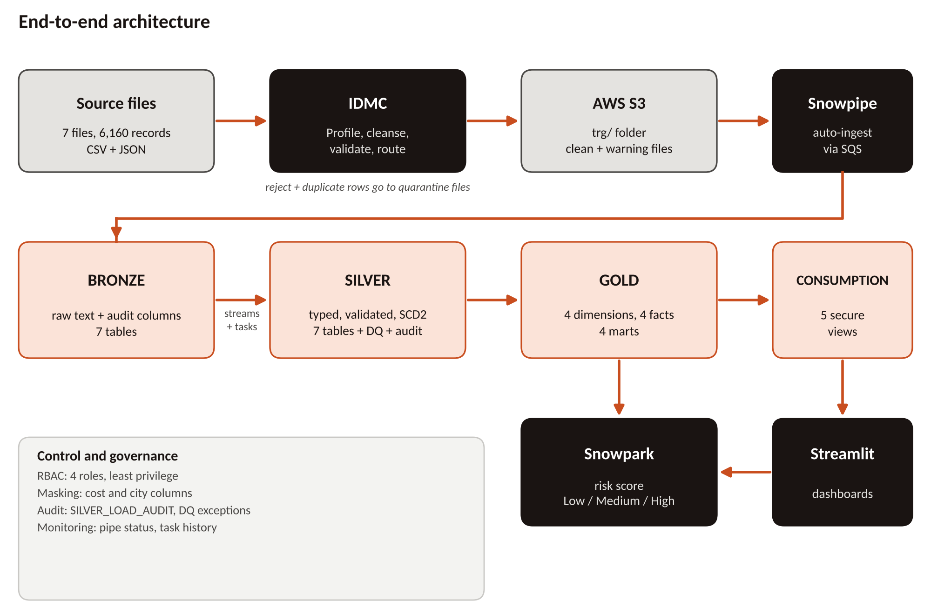
Figure 1. End-to-end architecture
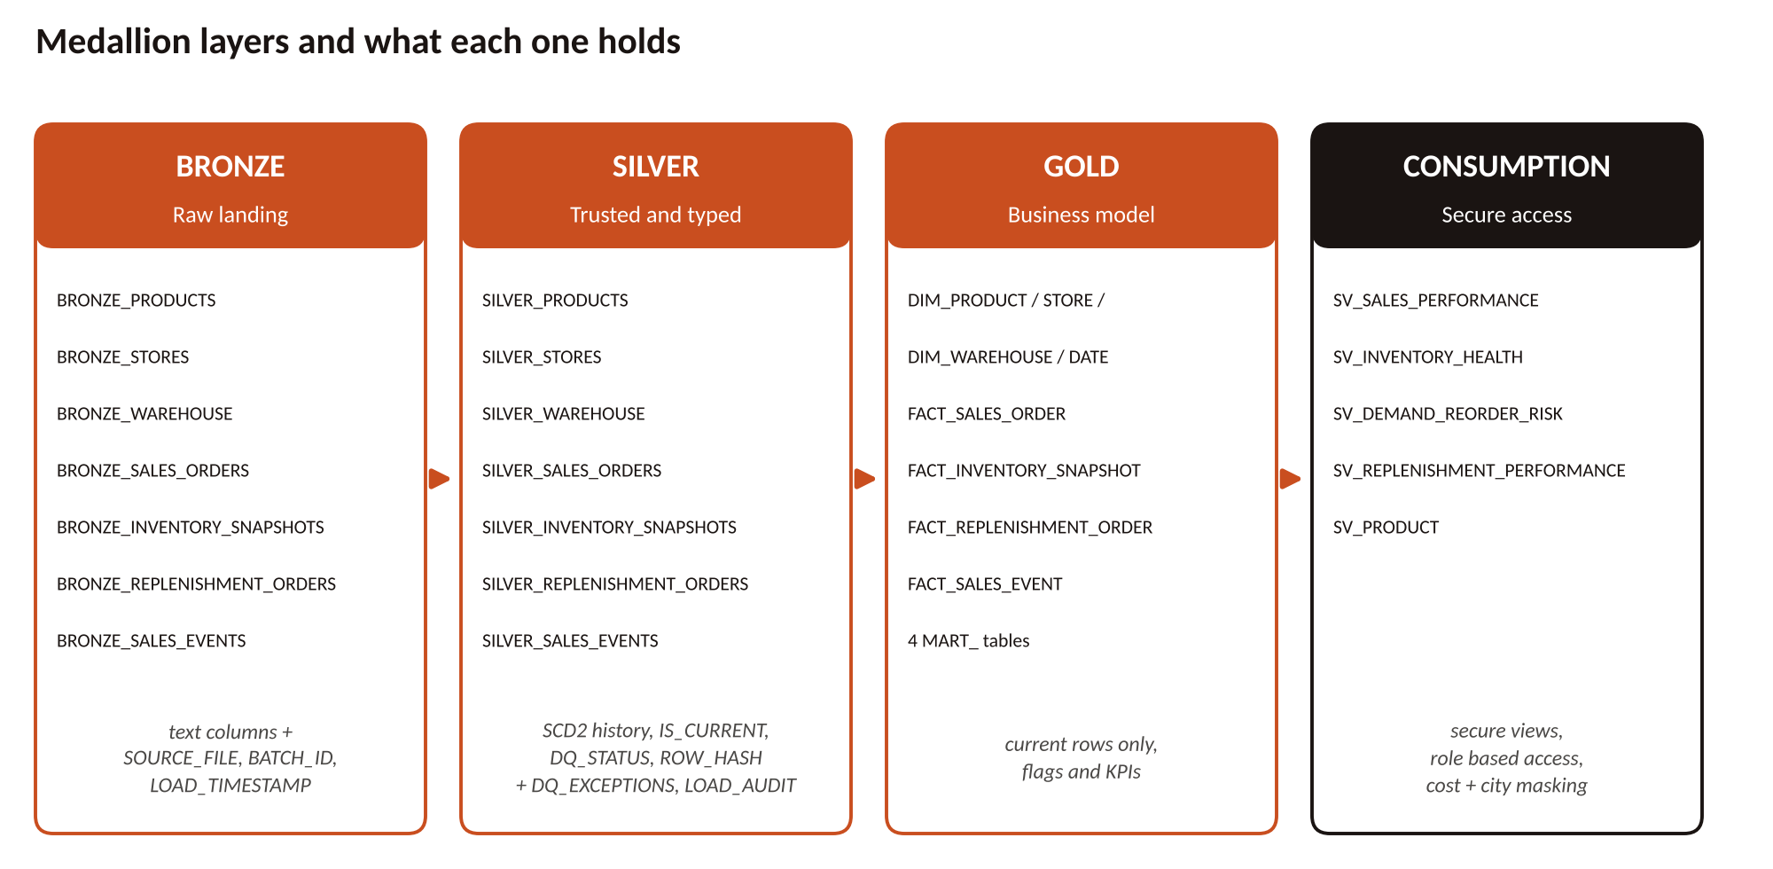
Figure 2. Medallion layers and their contents

5.1 Data flow in steps
- Source files (6,160 records across 7 files) are read by IDMC mappings.
- Each mapping applies rules and routes rows into clean, warning, reject and duplicate outputs.
- Clean and warning files are written to the trg/ folder in S3; rejects and duplicates are kept as quarantine files.
- S3 sends a notification to SQS and the Snowpipe for that dataset loads the file into its Bronze table.
- Streams on the Bronze tables detect new rows and a task graph calls one stored procedure to load Silver with SCD Type 2 history.
- Gold dimensions, facts and marts are built from the current Silver rows.
- Secure views in CONSUMPTION expose Gold to business roles; Snowpark scores risk and Streamlit displays results.

6. Source Dataset Description
The domain is FMCG Retail, Inventory and Supply Chain. Seven source files hold 6,160 records in total. The files were provided in the capstone package and are kept unchanged in folder 01_source_capstone.
File | Format | Records | Main columns
products | CSV | 800 | product_id, product_name, category, sub_category, brand, unit_cost, list_price, shelf_life_days, pack_size, active_flag
stores | CSV | 200 | store_id, store_name, city, state, region, store_format, opening_date, storage_capacity_units, active_flag
warehouses | CSV | 60 | warehouse_id, warehouse_name, city, state, region, warehouse_type, capacity_units, temperature_control_flag
sales_orders | CSV | 1,800 | order_id, store_id, product_id, order_date, quantity_sold, unit_price, discount_amount, tax_amount, net_amount, order_status, sales_channel
inventory_snapshots | CSV | 1,500 | snapshot_id, snapshot_date, location_type, location_id, product_id, on_hand_qty, reserved_qty, available_qty, reorder_point, safety_stock, stock_status
replenishment_orders | CSV | 1,000 | replenishment_id, source_warehouse_id, destination_store_id, product_id, request, allocation, dispatch, expected and delivered dates, quantities, status, priority
sales_events | JSON | 800 | event_id, store_id, product_id, event_timestamp, sales_channel, quantity, selling_price, promotion_flag, promotion_id, weather_code, event_context (terminal, basket size, payment mode)

6.1 Controlled data-quality issues
The package deliberately contains defects so the pipeline can prove it handles them.
Issue type | Examples in the data
Missing values (8) | Optional fields left empty
Duplicates (3) | Repeated business keys
Business anomalies (3) | Sales net amount does not match its parts; reserved quantity above on-hand; replenishment dispatched before it was requested
Outliers (2) | A sales order of 50,000 units; a sales event of 25,000 units
Mixed date formats (4) | Dates in more than one style

6.2 Source profile
Profiling the source files gave the following picture, which later explains the business insights in Section 17.
- Inventory status: Normal 40.1%, Excess 38.6%, Low 21.2%, Out of Stock 0.1%. There are 1,125 store rows and 375 warehouse rows across 47 distinct products.
- Sales orders: 61% Completed, 20% Returned, 19% Cancelled. Channel split: Store 34.9%, Online 32.9%, Mobile 32.2%.
- Replenishment: 807 orders Delivered and 193 Dispatched.
- Products: 5 categories of about 160 products each and 5 brands. Stores: regions Central 44, South 42, West 41, North 39, East 34; formats Supermarket 70, Express 69, Hypermarket 61.

7. Data Ingestion Process
Ingestion has two stages: IDMC prepares files, then AWS and Snowflake load them automatically.

7.1 Stage one: IDMC mappings
One mapping was built per dataset (seven in total). All follow the same pattern: Source, Expression, Router, then Targets.
- Source reads the raw CSV or JSON file.
- Expression standardises text, converts dates to YYYY/MM/DD and calculates validation flags.
- Router splits rows by rule into clean, warning, reject and duplicate groups.
- Targets write each group to its own file in S3.
A taskflow chains the mappings so they run together. Row counts from the three datasets whose results were recorded:
Dataset | Source | Clean | Warning | Reject | Duplicate
Products | 800 | 798 | 1 | 0 | 1
Stores | 200 | 199 | 1 | 0 | 0
Sales orders | 1,800 | 1,796 | 2 | 1 | 1

Clean files have one more property: in the trg/ folder S3 holds seven objects (products_clean, stores_clean, sales_orders_clean, clean_inventory_snapshots, cleaned_replenishment_orders, sales_events_cleaned and the sales-event file), and the Snowpipes load only these clean files, so Bronze starts from trusted data.

7.2 Stage two: S3 to Snowflake
Object | Role
IAM policy fmcg_snowflake_read_policy | Allows Snowflake to list and read the bucket
IAM role fmcg_snowflake_role | The identity Snowflake assumes to reach S3
Storage integration fmcg_s3_int | Snowflake object that holds the trust with the IAM role, so no keys are stored in code
Stage fmcg_stage | Points to the S3 trg/ folder
File format csv_fmt | Tells Snowflake how to read the CSV files
Snowpipe (one per dataset) | AUTO_INGEST pipe that copies new files into the matching Bronze table; S3 event notifications go to SQS

CREATE PIPE products_pipe AUTO_INGEST = TRUE AS
COPY INTO BRONZE_PRODUCTS
FROM @fmcg_stage
PATTERN = '.*products_clean.*'
FILE_FORMAT = (FORMAT_NAME = csv_fmt);
Listing 1. Pattern of every pipe (simplified); each dataset has its own PATTERN
Validation. SYSTEM$PIPE_STATUS was used to confirm each pipe was running, and the Silver products count (798) matched the IDMC clean count exactly.

8. Data Profiling and Quality Rules
Profiling was done first, in IDMC, to decide the rules, and the same rules were then enforced again in Silver so quality does not depend on one tool. The rules sort every row into one of four outcomes.
Outcome | Rule
Clean | Row passes every rule and moves forward
Warning | Row is usable but has an optional problem, so it is kept and flagged
Reject | Row is impossible or breaks a key rule, so it is removed and logged
Duplicate | Same business key already present; only one version is kept

8.1 Rules by dataset (enforced in Silver)
Dataset | Reject when | Warning when
Products | Missing product id; unit cost or list price missing or negative | List price below unit cost; missing shelf life or pack size; unknown active flag
Stores | Missing store id; negative capacity | Missing or future opening date; missing capacity; unknown active flag
Warehouses | Missing warehouse id; negative capacity | Missing capacity; unknown temperature or active flag
Sales orders | Missing order id; bad date, quantity or price; store or product not found | Missing or negative discount, tax or net amount; future order date
Inventory | Missing snapshot id; bad date or on-hand; negative reserved; product or location not found | Reserved above on-hand; available not equal on-hand minus reserved; missing reorder point or safety stock
Replenishment | Missing id; any date out of order (allocated, dispatched or delivered before its predecessor); warehouse, store or product not found | Allocated above requested; dispatched above allocated; delivered above dispatched; DELIVERED with no date; missing expected date
Sales events | Missing event id; bad timestamp, quantity or price; store or product not found | Promotion flag Y without promotion id, or the reverse; missing weather code

8.2 How the controlled defects are handled
Defect | Treatment
Mixed date formats | Standardised and kept (TO_DATE_ANY and TO_TS_ANY try nine formats)
Optional null | Warning, row retained
Duplicate key | Duplicate route, first version kept
Impossible sequence (dispatch before request) | Reject, logged
Extreme but possible (50,000 units) | Warning, row retained for review
Validation. The planted defects show up in the IDMC counts in Section 7 (the single rejected sales order, the duplicates and the warnings), and Silver records further exceptions in the table described in Section 10.

9. Bronze, Silver and Gold Layer Implementation

9.1 Bronze: raw landing
Bronze keeps data exactly as it arrived, so any later problem can be traced back. There are seven tables: BRONZE_PRODUCTS, BRONZE_STORES, BRONZE_WAREHOUSE, BRONZE_SALES_ORDERS, BRONZE_INVENTORY_SNAPSHOTS, BRONZE_REPLENISHMENT_ORDERS and BRONZE_SALES_EVENTS.
- All business columns are stored as text, so a bad value can never stop a load.
- Three audit columns are added to every row: SOURCE_FILE, BATCH_ID and LOAD_TIMESTAMP.
- Snowpipe loads the table automatically; nobody edits Bronze by hand.
Rule for the team: never run CREATE OR REPLACE on a Bronze table once streams exist, because it breaks the stream.

9.2 Silver: trusted, typed, versioned
Silver converts text to proper types, validates every row, removes duplicates and keeps history using SCD Type 2. It has seven tables (SILVER_PRODUCTS, SILVER_STORES, SILVER_WAREHOUSE, SILVER_SALES_ORDERS, SILVER_INVENTORY_SNAPSHOTS, SILVER_REPLENISHMENT_ORDERS, SILVER_SALES_EVENTS) plus two control tables.
Column group | Meaning
*_SK | Surrogate key for each version of a record
ROW_HASH | Hash of the business columns, used to detect real change
EFFECTIVE_FROM, EFFECTIVE_TO | Period in which the version was valid (open version ends 9999-12-31)
IS_CURRENT | TRUE only for the latest version
DQ_STATUS, DQ_REASON | VALID or WARNING, with the reason
SOURCE_FILE, BATCH_ID, BRONZE_LOAD_TS, SILVER_LOAD_TS | Lineage back to the file and load

SCD Type 2 rules:
- New key: insert version 1.
- Same key with changed values: close the old row (IS_CURRENT = FALSE, EFFECTIVE_TO set) and insert a new current row.
- Same hash: skip, so replaying a file creates no duplicates.
- Older than the current version: skip and log as STALE.

9.3 Gold: business model
Gold reads only current Silver rows (IS_CURRENT = TRUE) and shapes them for analysis: four dimensions, four facts and four marts. The full model is in Section 11.

9.4 Consumption: secure access layer
CONSUMPTION holds five secure views over Gold. Business users query only these views and never touch Bronze, Silver or Gold directly. Security is explained in Section 15.
Validation. Layer comparisons are listed in Section 13. Verified so far: Silver products (798) equals the IDMC clean count, and DIM_DATE holds 365 rows covering the full year.

10. Data Cleaning, Quarantine and Warning Handling
Handling is split into two places: IDMC splits files, and Silver logs every exception inside Snowflake.
Route | What happens | Where it lives
Clean | Loaded through Snowpipe to Bronze, then Silver | S3 trg/, folder 02_cleaned_datasets
Warning | Row is kept with DQ_STATUS = WARNING and a reason | Folder 04_warning_datasets and Silver
Reject | Removed from the main flow | Folder 03_quarantine_datasets and SILVER_DQ_EXCEPTIONS
Duplicate | Only one version kept | Folder 03_quarantine_datasets and SILVER_DQ_EXCEPTIONS

10.1 Silver exception and audit tables
SILVER_DQ_EXCEPTIONS stores one row per problem record: run id, table, record key, issue type (REJECT, DUPLICATE or STALE), reason, the full record as VARIANT, and time logged.
SILVER_LOAD_AUDIT stores one row per run per table: STAGED, REJECTED, DUPLICATES, STALE, EXPIRED, INSERTED, UNCHANGED and a status.
The audit table follows a fixed identity, which makes every run self-checking:
STAGED = REJECTED + DUPLICATES + STALE + INSERTED + UNCHANGED

If the two sides ever differ, a row was lost or double counted. Foreign keys are also checked: a sales order whose store or product is not in the current dimension is rejected, and dimensions load before facts so these checks always see the latest dimensions.
Validation. The IDMC counts in Section 7 show the sales-order reject, the duplicates and the warnings routed correctly, and Silver logs every further exception with its reason in SILVER_DQ_EXCEPTIONS.

11. Fact and Dimension Data Modeling
Gold uses a star schema: small descriptive dimensions around large measurable facts. This keeps queries simple and fast for dashboards.
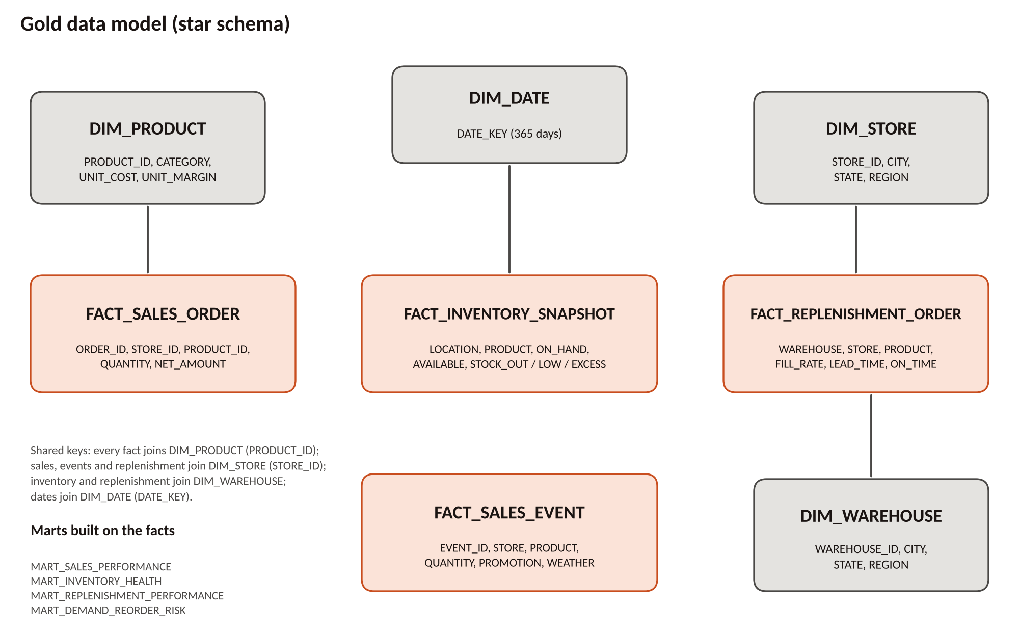
Figure 3. Gold star schema

11.1 Dimensions
Table | Content
DIM_PRODUCT | Product, category, brand, price; UNIT_COST and UNIT_MARGIN (masked for most roles)
DIM_STORE | Store, region, state, format, capacity; CITY (masked for some roles)
DIM_WAREHOUSE | Warehouse, type, region, capacity; CITY (masked for some roles)
DIM_DATE | One row per day, 365 rows, with calendar attributes

11.2 Facts
Table | Grain and measures
FACT_SALES_ORDER | One row per order: quantity, price, discount, tax, net amount, status, channel
FACT_INVENTORY_SNAPSHOT | One row per snapshot, location and product: on-hand, reserved, available, reorder point, stock flags (stock-out, low, excess)
FACT_REPLENISHMENT_ORDER | One row per replenishment: requested, allocated, dispatched and delivered quantities, fill rate, lead time, on-time flag
FACT_SALES_EVENT | One row per sales event: quantity, selling price, promotion, weather, terminal, basket size, payment mode

11.3 Marts
Mart | Business question answered
MART_SALES_PERFORMANCE | How much is selling, by product, store, channel and period?
MART_INVENTORY_HEALTH | Where is stock normal, low, excess or out?
MART_REPLENISHMENT_PERFORMANCE | How well do warehouses fulfil and deliver?
MART_DEMAND_REORDER_RISK | Which products need reordering first?
Validation. The checks in Section 13.2 cover orphan keys against the dimensions and totals against Silver.

12. Workflow and Pipeline Orchestration
Orchestration happens at two points: IDMC runs the mappings in a taskflow, and Snowflake moves data from Bronze to Silver with streams and tasks.
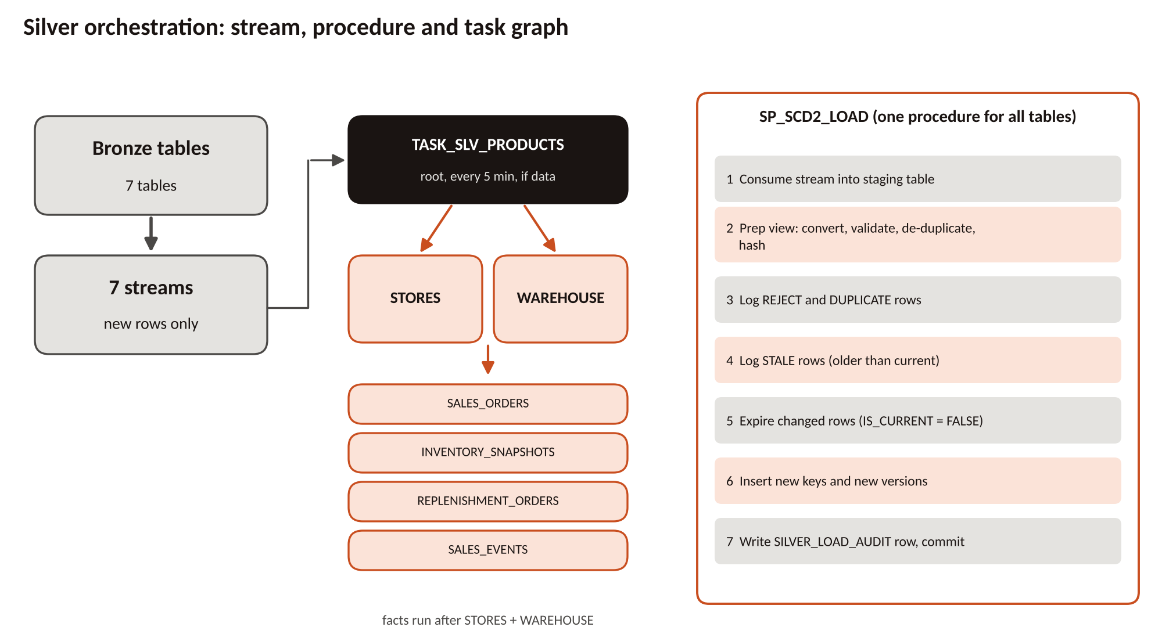
Figure 4. Streams, task graph and the Silver load procedure

12.1 Streams
A stream named STRM_BRONZE_<TABLE> sits on each of the seven Bronze tables (append-only, with initial rows shown). It reports only rows that have not yet been processed, so Silver never reads the same row twice.

12.2 One procedure for every table
SP_SCD2_LOAD receives the entity name, stream, staging table, prep view, target and key columns, and runs the same seven steps for each table. It runs in a single transaction: on any error it rolls back and writes a FAILED row to the audit table, so Silver is never left half loaded.

12.3 Task graph
Task | Rule
TASK_SLV_PRODUCTS (root) | Runs every 5 minutes on COMPUTE_WH, only when any of the seven streams has data (SYSTEM$STREAM_HAS_DATA)
TASK_SLV_STORES, TASK_SLV_WAREHOUSE | Run after products
Four fact tasks (sales orders, inventory, replenishment, sales events) | Run after stores and warehouse, so dimensions are loaded before facts

Order of enabling: resume the child tasks first and the root last.
Validation. The procedure is designed so that replaying a file creates no new versions (rows with the same hash are counted as UNCHANGED), and the audit identity in Section 10 is checked on every run.

13. Data Validation and Reconciliation Results
Validation compares counts and totals between every pair of layers so that no row is lost without an explanation.

13.1 Verified results
Check | Result | Status
Products: source 800 = clean + warning + duplicate | 798 + 1 + 1 = 800 | Passed
Stores: source 200 = clean + warning | 199 + 1 = 200 | Passed
Sales orders: source 1,800 = clean + warning + reject + duplicate | 1,796 + 2 + 1 + 1 = 1,800 | Passed
Silver products equals IDMC clean products | 798 = 798 | Passed
DIM_DATE covers the full year | 365 rows | Passed
Security tests by role (Section 15) | Each role saw exactly what it should | Passed

13.2 Reconciliation checks run at every layer
Check | Method | Expected
Source to clean + warning + reject + duplicate | IDMC counts per dataset | Totals equal
S3 clean file to Bronze | Row count of the pipe target | Equal
Bronze to Silver | Audit identity: STAGED = REJECTED + DUPLICATES + STALE + INSERTED + UNCHANGED | Identity holds
Silver current rows to Gold facts | COUNT of IS_CURRENT = TRUE versus fact count | Equal
Fact totals to mart totals | SUM(net amount) in FACT_SALES_ORDER versus MART_SALES_PERFORMANCE | Equal
Orphan keys | Facts with no matching dimension row | Zero
Business rules | Dispatch not before request; reserved not above on-hand after cleaning | Zero violations

-- Example: Silver audit identity must hold for every run
SELECT RUN_ID, TABLE_NAME,
STAGED,
REJECTED + DUPLICATES + STALE + INSERTED + UNCHANGED AS ACCOUNTED
FROM SILVER_LOAD_AUDIT
WHERE STAGED <> REJECTED + DUPLICATES + STALE + INSERTED + UNCHANGED;
-- Expected: no rows
Listing 2. Reconciliation query
Query outputs and screenshots are kept in folder 06_validation_evidence.

14. Dashboard Implementation and Business KPIs
The dashboard is built with Streamlit on top of the CONSUMPTION views and a Snowpark risk score. Because it reads secure views, a user sees only what their role allows.

14.1 Business KPIs
KPI | Meaning
Net sales and units sold | Value and volume of completed orders
Stock availability | Share of products with stock above the reorder point
Stock-out count | Product-locations with no available stock
Excess inventory share | Stock well above need, tying up capital
Fill rate | Delivered quantity divided by requested quantity
On-time delivery | Share of replenishments delivered by the expected date
Reorder risk level | Low, Medium or High per product-location

14.2 Snowpark risk score
Snowpark reads the demand and reorder mart and produces a transparent score from five components: stock gap against the reorder point, sales velocity against stock, supplier on-time rate, fill rate and reserved ratio. The component scores, total, category and timestamp are stored so every score can be explained.
Risk level | Score | Typical action
Low | below 35 | Monitor
Medium | 35 to 59 | Plan reorder
High | 60 and above | Reorder now

14.3 Dashboard tabs
- Risk and Actions: shows the highest-risk products with the recommended action.
- KPIs: shows sales, inventory and replenishment KPIs.
- Data Trust: shows rejects, warnings and load audit results so users can judge data quality.
Validation. Dashboard figures should match the mart queries (check in Section 13.2), and role access is confirmed by the security tests in Section 15.

15. Error Handling and Monitoring

15.1 Error handling
Where | Mechanism
IDMC | Router sends bad rows to reject and duplicate files instead of failing the job
Bronze | All-text columns so a bad value cannot stop a load
Silver | Transaction with rollback; failure written as FAILED in SILVER_LOAD_AUDIT
Rows | SILVER_DQ_EXCEPTIONS keeps the full record and the reason
Replays | ROW_HASH comparison makes reruns safe (idempotent)

15.2 Monitoring
- SYSTEM$PIPE_STATUS and COPY history for Snowpipe.
- Task history for the Silver task graph.
- SILVER_LOAD_AUDIT and SILVER_DQ_EXCEPTIONS for every run.
- SYSTEM$STREAM_HAS_DATA to see if anything is waiting.

15.3 Security and access control
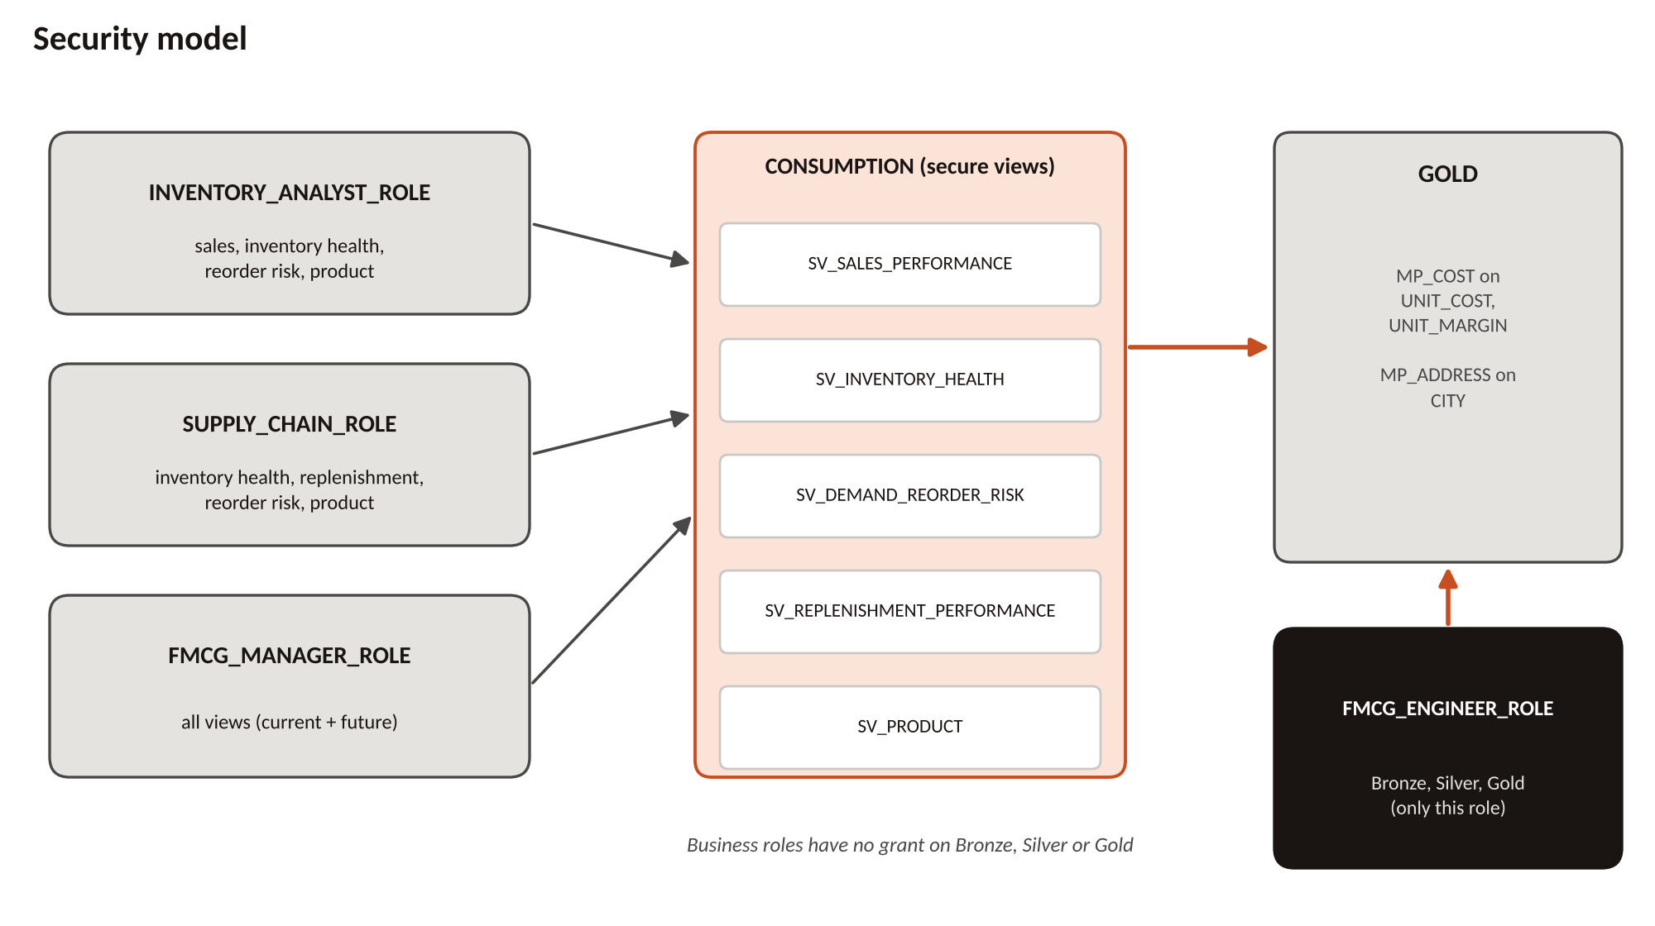
Figure 5. Roles, secure views and masking
Role | Can read | Cannot do
INVENTORY_ANALYST_ROLE | Sales performance, inventory health, reorder risk, product views | See real unit cost; open replenishment view; read Bronze or Gold
SUPPLY_CHAIN_ROLE | Inventory health, replenishment performance, reorder risk, product views | See real unit cost; open sales view; read Bronze
FMCG_MANAGER_ROLE | All current and future views in CONSUMPTION | Read Bronze, Silver or Gold directly
FMCG_ENGINEER_ROLE | Bronze, Silver, Gold (full build access) | Only role with access to the raw layers

Two masking policies protect sensitive columns. MP_COST hides UNIT_COST and UNIT_MARGIN (shown only to ACCOUNTADMIN and the manager). MP_ADDRESS hides CITY for the analyst role. The policies use CURRENT_ROLE() and secondary roles are switched off in tests so results are exact.
CREATE MASKING POLICY MP_COST AS (val NUMBER) RETURNS NUMBER ->
CASE WHEN CURRENT_ROLE() IN ('ACCOUNTADMIN','FMCG_MANAGER_ROLE')
THEN val ELSE NULL END;

ALTER TABLE GOLD.DIM_PRODUCT
MODIFY COLUMN UNIT_COST SET MASKING POLICY MP_COST;
Listing 3. Cost masking policy (simplified)
Validation. Each role was tested with USE ROLE and USE SECONDARY ROLES NONE: the analyst saw NULL cost and an error on the replenishment view, the supply chain role saw replenishment but not sales, the manager saw real cost, and the engineer saw Bronze data. Masking policies are removed if a Gold table is recreated, so they are re-applied after any Gold rebuild.

16. Challenges Faced and Solutions Implemented
Challenge | Cause | Solution
IDMC products mapping failed | Pack size was read as an integer but contained text values | Corrected the field datatype in the mapping and re-ran
Inventory mapping rejected all 1,500 rows on first run | Mistake in the expression logic | Fixed the expression; rows then routed correctly
S3 stage returned AccessDenied | IAM policy lacked list permission on the bucket | Added ListBucket to the IAM policy
Snowpipe column-count mismatch | File layout and table columns did not match | Aligned the table, file layout and load column list
Cost visible to the analyst role | Secondary roles were ALL, so another role granted access | Policy changed to CURRENT_ROLE() and secondary roles set to NONE for tests
Secure view command failed | ALTER VIEW IF EXISTS is not supported for this setting | Used ALTER VIEW ... SET SECURE directly
Bronze rebuild breaks streams | CREATE OR REPLACE changes the table identity | Rule adopted: never recreate Bronze; truncate or reload instead
Gold rebuild removes masking | Recreated tables drop attached policies | Masking script re-run after every Gold rebuild

17. Final Project Results and Business Insights

17.1 What was delivered
- A working IDMC to S3 to Snowflake pipeline for all seven datasets.
- Bronze, Silver (SCD Type 2) and Gold layers with automated, audited loads.
- A star schema with four dimensions, four facts and four marts.
- Role-based security with four roles, five secure views and two masking policies.
- A Snowpark risk score and a Streamlit dashboard for business users.

17.2 Business insights from the data
Finding | What it means for the business
38.6% of inventory rows are Excess while 21.2% are Low | Stock is badly distributed: money is tied up in some places while others run short. Rebalancing between locations is the first opportunity.
Out of Stock is only 0.1% but Low is 21.2% | Stock-outs have not happened yet at scale, but many items are close; this is the window for reorder action.
39% of sales orders are Returned or Cancelled | Only 61% of orders complete; returns and cancellations deserve root-cause review.
Online and Mobile together are 65.1% of orders | Digital channels are already the majority and should be planned for explicitly.
807 of 1,000 replenishments delivered, 193 still dispatched | Most supply is landing; the remainder should be tracked against expected delivery dates.

These insights come from profiling the source files and are the questions the Gold marts and the dashboard answer continuously.

17.3 Business value
- One trusted view replaces separate disconnected files.
- Bad data is isolated and explained instead of hidden.
- Planners see reorder risk early and can act before a stock-out.
- Sensitive cost and location data is visible only to the roles that need it.

18. Individual Team Member Contributions
Member | Contribution | Can explain
Anchal | Products and stores IDMC mappings and Bronze; the complete Gold layer (dimensions, facts, marts); final presentation and this documentation | Mapping pattern, Gold star schema, SCD-based current-row logic, KPIs
Isha | Sales events (JSON) and warehouse Bronze; Silver stream and task sequence; RBAC and masking | Streams and tasks, task order, roles, secure views, masking policies
Shreyash | Sales orders Bronze; Snowpark risk scoring; Streamlit dashboard | Risk score logic, dashboard tabs and KPIs
Pawan Satvik | Inventory snapshots and replenishment Bronze and Silver (shared with Vinod) | Inventory and replenishment rules, SCD2 procedure, reconciliation
Vinod | Inventory snapshots and replenishment Bronze and Silver (shared with Pawan) | Inventory and replenishment rules, SCD2 procedure, reconciliation

Everyone also took part in the AWS S3 and IAM setup, the Snowflake load and the validation work, so each member can describe the full flow as well as their own part.

