CAPSTONE PROJECT REPORT

SMART ENERGY CONSUMPTION, OUTAGE
& GRID ASSET ANALYTICS PLATFORM
AWS S3 · Snowflake · Informatica IDMC · Medallion Architecture · Snowpark · Streamlit · Cortex Analyst

Submitted by
GROUP - 10
HARSHADA HIRAKANT | 10877577
AGALYA NAGALINGAM | 10877646
CHIKOLU PRAVALLIKA | 10877367
RUSHIKESH RAJU NEELAKANTAM | 10877458

Abstract
Electricity distribution utilities collect information about customers, smart meters, interval meter readings, grid assets, outage incidents, asset maintenance and real-time grid events in separate feeds. When these feeds contain missing values, duplicate identifiers, inconsistent date formats, invalid references and semi-structured JSON, it becomes difficult to measure consumption reliably, detect failing assets early and plan maintenance with confidence.
This project builds the Smart Energy Consumption, Outage & Grid Asset Analytics Platform – a governed, automated analytics foundation on Snowflake. Seven source files (six CSV files and one JSON file) are staged in AWS S3 and loaded into a Snowflake Bronze layer with full audit columns. Informatica Intelligent Data Management Cloud (IDMC) profiles, standardises, validates and routes every record to clean, warning, reject and duplicate outputs. The cleansed Silver layer is then independently re-validated in Snowflake SQL, producing VALID, WARNING and REJECT tables with a machine-readable rejection reason on every quarantined record.
The Gold layer implements a fact-constellation model with four conformed dimensions (customer, meter, grid asset and date) and four fact tables (meter readings, outages, asset maintenance and grid events). Meter readings are processed incrementally through Snowflake dynamic tables, a dedicated SCD Type 2 customer dimension preserves customer history, and orphan records are preserved and audited instead of silently dropped. Four Gold data marts serve the business: daily consumption, outage summary, asset performance and a Snowpark-based explainable asset risk score.
Governance is built in through three RBAC roles, dynamic masking policies on customer email and phone number, and a secure customer view. Business users consume the platform through a five-page Streamlit dashboard and through Cortex Analyst, which answers plain-English questions over the governed Gold marts. This report explains what was implemented, why it was implemented, how it works and how the team validated the result.
Keywords: smart energy, utilities analytics, Snowflake, Informatica IDMC, medallion architecture, dynamic tables, SCD Type 2, Snowpark, Streamlit, Cortex Analyst, data quality, RBAC.

Table of Contents
Abstract
Chapter 1 Project Title, Team and Business Problem4
Chapter 2 Objectives, Expected Outcomes and Technology Stack6
Chapter 3 Overall Architecture and Source Datasets7
Chapter 4 Data Ingestion Process and Bronze Layer10
Chapter 5 Data Profiling and Quality Rules13
Chapter 6 IDMC Implementation, Silver Layer and Exception Handling15
Chapter 7 Silver Validation Framework in Snowflake20
Chapter 8 Gold Layer: Fact and Dimension Data Modelling24
Chapter 9 Gold Data Marts and Snowpark Asset Risk Score30
Chapter 10 Workflow, Pipeline Orchestration and Governance32
Chapter 11 Dashboard Implementation, Business KPIs and Cortex Analyst35
Chapter 12 Data Validation, Reconciliation, Error Handling and Monitoring38
Chapter 13 Challenges, Final Results and Team Contributions40
Chapter 14 Conclusion, USP and Future Scope42
Chapter 15 Delivery Tracking: Kanban Board and Burndown Chart44
Appendix A Submission Folder Structure and Execution Guide (README)45

Chapter 1 – Project Title, Team and Business Problem

1.1 Project title and team member details
Item | Details
Project title | Smart Energy Consumption, Outage & Grid Asset Analytics Platform
Domain | Energy & Utilities – electricity distribution (consumption, outages, grid assets)
Platform | AWS S3 · Snowflake (Bronze, Silver, Gold) · Informatica IDMC · Snowpark Python · Streamlit in Snowflake · Cortex Analyst
Snowflake database | SMART_ENERGY (schemas RAW, BRONZE, SILVER, SILVER1, GOLD)
Delivery model | Five-day sprint tracked on a Kanban board with a daily burndown (Chapter 15)

S. No. | Team member | Primary ownership area
1 | Harshada Hirakant Shinde | Customers & meters pipeline, DIM_CUSTOMER, FACT_GRID_EVENT, Daily Consumption Mart, Cortex Analyst, orphan-data handling
2 | Agalya Nagalingam | AWS S3 integration, Snowpipe, asset & maintenance pipeline, DIM_GRID_ASSET, FACT_ASSET_MAINTENANCE, Snowpark Asset Risk Mart & stored procedure
3 | Chikolu Pravallika | Outage & grid-event pipeline, DIM_DATE, FACT_OUTAGE, Outage Summary Mart, Streamlit dashboard
4 | Rushikesh Raju Neelakantam | Meter-reading pipeline, DIM_METER, FACT_METER_READING, Asset Performance Mart, RBAC, masking & secure views, dynamic-table incremental load

Detailed day-by-day contributions are documented in Chapter 13 and are taken directly from the team Kanban board shown in Chapter 15.

1.2 Introduction
A modern electricity distribution utility operates a hierarchy of substations, feeders and transformers that supply thousands of customers through smart meters. Each smart meter produces interval readings – energy consumed (kWh), peak demand (kW), voltage and power factor – while the grid itself emits alarm events such as voltage alerts, load alerts and power-factor alerts. At the same time, field teams record planned and unplanned outages and carry out preventive, corrective and inspection maintenance on grid assets.
These activities generate valuable data, but the data normally lives in separate operational systems and arrives in different formats. The purpose of this capstone is to bring all of it together on one governed analytics platform so that consumption, reliability and asset health can be analysed from a single, trusted view.

1.3 Project context
The project receives seven source datasets. Customer and meter master files describe who is supplied and through which meter and transformer. The meter-readings file is the high-volume transactional feed. The grid-assets file describes the substation–feeder–transformer hierarchy. The outage and maintenance files describe reliability events and field work. Finally, the grid-events file is a semi-structured JSON feed with nested measurement and alarm objects. Every file has its own quality issues: missing values, duplicate identifiers, dates and numbers delivered as text, codes in mixed case and records that reference parents that do not exist.

1.4 Business problem statement
The business problem is the absence of a unified, quality-controlled and secure analytical view across the utility's consumption, outage and asset datasets. Without integration and consistent definitions, analysts must clean and join data manually before they can answer basic questions such as how much energy was consumed per region, which transformers suffer the most outages or which assets have overdue maintenance.
Problem area | Operational difficulty
Data quality | Seven source files with inconsistent formats; missing, duplicate or invalid customers, meters and assets; dates and numbers arrive as text; semi-structured JSON grid events.
Operations | Manual, time-consuming cleaning; hard to separate bad and duplicate records; orphan meters, readings and outages with no parent; slow outage troubleshooting.
Business impact | Unreliable consumption view (estimated vs actual readings); late detection of outages and failing assets; overdue maintenance goes unseen; customer PII exposed to every user.
Analytics gaps | No single customer–meter–transformer view; outages, maintenance and events not correlated; no explainable asset risk score; business users cannot query without SQL.

The need: a governed, automated platform for smart energy consumption, outage and grid asset analytics. The platform is an analytical system; it does not replace operational metering, SCADA or outage-management systems, and it does not take automated switching decisions.

1.5 Scope

In scope
- Customer, meter and grid-asset master data, including the substation → feeder → transformer hierarchy.
- Meter readings (consumption, peak demand, voltage, power factor, reading type and quality flag).
- Outage incidents, asset maintenance records and JSON grid events.
- Bronze, Silver and Gold layers in Snowflake, with IDMC cleansing between Bronze and Silver.
- Incremental processing of meter readings with dynamic tables and SCD Type 2 history for customers.
- Four Gold data marts, an explainable Snowpark asset risk score, RBAC, masking and a secure view.
- Streamlit dashboard, Cortex Analyst natural-language querying, validation and reconciliation.

Out of scope
- Real-time SCADA streaming and automated grid switching.
- Billing, tariff calculation and payment processing.
- Weather and geospatial (GIS) enrichment.
- Production MLOps for predictive models (listed as future scope in Chapter 14).

1.6 Business questions supported
- What is the total and average energy consumption, and how does it vary by region, city, customer type and meter type?
- What share of readings are estimated rather than actual, and how complete is the reading set?
- How many outages occurred, how many were planned versus unplanned, and how long did they last?
- Which assets, regions and asset types experience the most outages and how many customers were affected?
- How many maintenance activities were completed or overdue, and what did they cost?
- Which grid assets carry a HIGH, MEDIUM or LOW risk score, and why?
- How many grid events occurred, and how many were high or critical severity?
- Can business users ask these questions in plain English and receive governed answers?

Chapter 2 – Objectives, Expected Outcomes and Technology Stack

2.1 Project objectives
- Integrate seven smart-energy source files (six CSV, one JSON) from AWS S3 into a centralised Snowflake environment.
- Preserve source-aligned raw records in a Bronze layer with INGEST_FILE_NAME and LOAD_TIMESTAMP audit columns.
- Profile the source data and define completeness, uniqueness, validity, referential-integrity and chronology rules.
- Use IDMC mappings to standardise, validate, de-duplicate and route every record to clean, warning, reject and duplicate outputs.
- Re-validate the Silver layer independently in Snowflake SQL and produce VALID, WARNING and REJECT tables with rejection reasons.
- Build a Gold fact-constellation model with four dimensions and four facts, including SCD Type 2 customer history.
- Process meter readings incrementally using Snowflake dynamic tables.
- Detect, preserve and audit orphan records instead of dropping them.
- Create four Gold data marts and an explainable Snowpark asset risk score.
- Apply RBAC, column masking and a secure view to protect customer PII.
- Deliver a Streamlit dashboard and enable Cortex Analyst natural-language analytics.
- Validate and reconcile counts and KPIs at every layer.

2.2 Expected business outcomes
Outcome | How the platform supports it
Trusted data foundation | IDMC cleansing, raw preservation in Bronze, typed and re-validated Silver tables with explicit rejection reasons.
Consistent analytics | Conformed dimensions shared by four facts; KPI logic centralised in four marts.
Faster outage insight | Outage summary by date, asset, asset type and region with planned/unplanned split and duration.
Proactive maintenance | Asset performance mart (completed, overdue, corrective, cost) and an explainable asset risk score.
Reliable consumption view | Estimated-reading percentage, corrected-reading precedence and orphan-reading flags.
Traceable history | SCD Type 2 customer dimension with EFFECTIVE_FROM, EFFECTIVE_TO and IS_CURRENT.
Governed self-service | RBAC roles, masked PII, secure view, Streamlit dashboard and Cortex Analyst.

2.3 Technology stack
Technology | Role in the project
AWS S3 | Landing zone for the seven source files (bucket folder accessed through a storage integration).
Snowflake storage integration & external stage | SMART_ENERGY_S3_INT secures access; SMART_ENERGY_S3_STAGE points to the S3 folder.
Snowpipe / COPY INTO | Loads each file as-is into its Bronze table with file name and load timestamp.
Informatica IDMC | Profiling, standardisation, validation, de-duplication and routing to clean/warning/reject/duplicate targets.
Snowflake SQL (Snowsight) | Bronze/Silver/Gold objects, validation framework, dimensional model, marts, security objects.
Dynamic tables | Incremental, declarative refresh of meter readings (DT_METER_READINGS and FACT_METER_READING).
SQL stored procedure | SP_LOAD_DIM_CUSTOMER_SCD2 – transactional SCD Type 2 load for customers.
Snowpark Python | SP_BUILD_ASSET_RISK – explainable asset risk scoring written to MART_ASSET_RISK.
Streamlit in Snowflake | Five-page interactive dashboard with Plotly charts, filters, KPI cards and CSV download.
Cortex Analyst | Natural-language questions over the governed Gold marts.
RBAC, masking policies, secure views | Engineer, analyst and manager roles; masked email and phone; V_CUSTOMER_SAFE.

The technologies play complementary roles: S3 and Snowpipe own acquisition, IDMC owns cleansing, Snowflake owns storage, validation, history and governance, Snowpark and SQL provide analytical logic, and Streamlit and Cortex Analyst provide user-facing access.

Chapter 3 – Overall Architecture and Source Datasets

3.1 End-to-end architecture
The architecture follows a medallion pattern with a dedicated data-quality gate. Source files land in AWS S3 and are loaded through a storage integration, external stage and Snowpipe into Bronze. IDMC then profiles, standardises, validates and routes the data, and the approved output becomes the Silver layer. Silver is re-validated in Snowflake before Gold builds dimensions, facts, dynamic tables and data marts. The serving layer consumes Gold through Streamlit, Cortex Analyst and secure views. Governance – RBAC, masking, secure view, orphan audit and KPI reconciliation – applies across all layers.
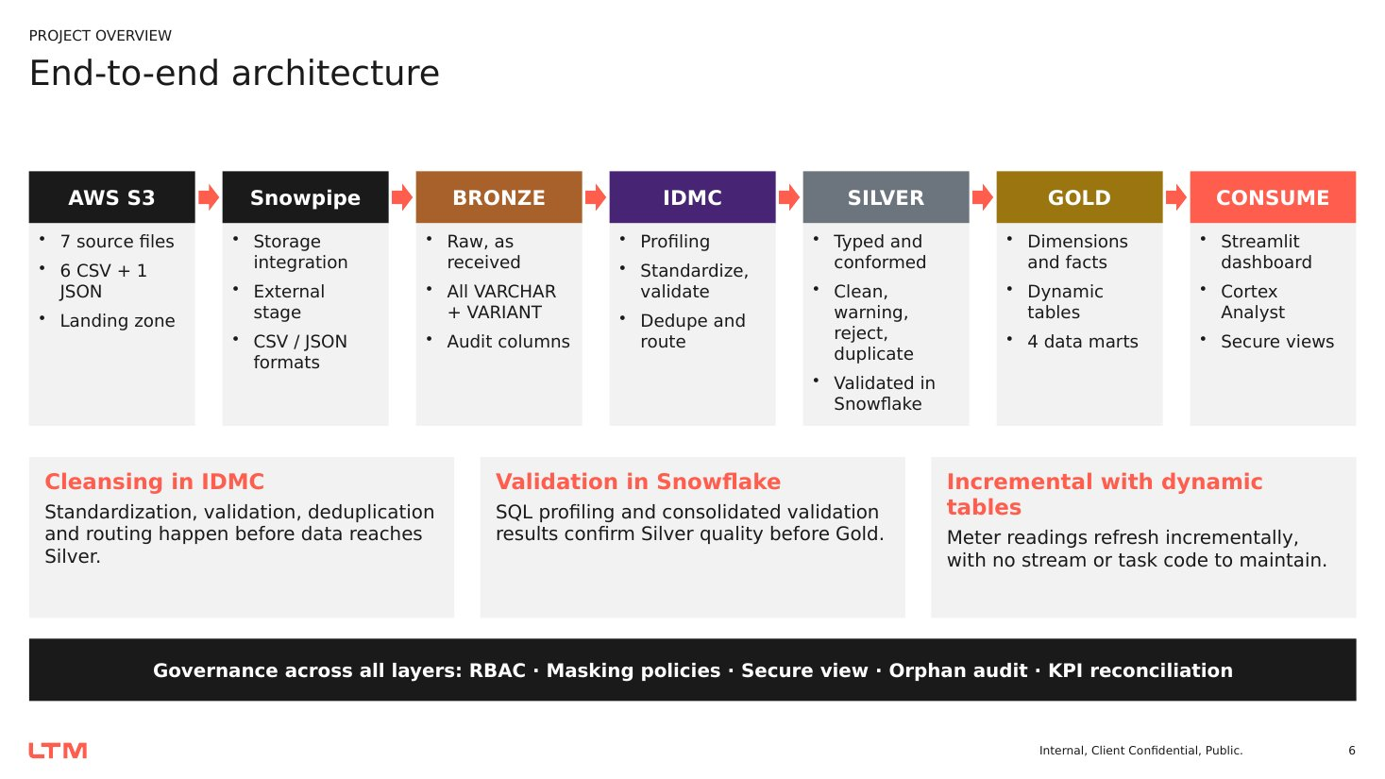
Figure 1: End-to-end architecture: AWS S3 → Snowpipe → Bronze → IDMC → Silver → Gold → Consume

Architecture principles
- Preserve raw source records in Bronze for traceability and reload.
- Cleanse and route data before it enters Silver, and keep a data-quality reason on every routed record.
- Validate twice: IDMC cleans, Snowflake SQL independently verifies.
- Never silently drop data – orphans are flagged and audited.
- Reuse conformed dimensions across all fact tables; declare the grain of every fact.
- Centralise KPI definitions in marts so dashboards and Cortex Analyst return the same numbers.
- Grant access through roles and secure views; mask PII by default.

3.2 Medallion layer design
Layer | Purpose | Project implementation
RAW | Connectivity objects | Storage integration, external stage, CSV and JSON file formats.
BRONZE | Raw landing and traceability | 7 tables, all VARCHAR plus one VARIANT; INGEST_FILE_NAME and LOAD_TIMESTAMP; VW_BRONZE_GRID_EVENTS flattens JSON.
SILVER | Cleansed, typed, validated | IDMC outputs (CLEAN / WARNING / REJECT / DUPLICATE) plus Snowflake VALIDATION_RESULT, VALID and REJECT tables.
SILVER1 | Curated hand-off schema | Final VALID tables moved here with helper columns removed, ready for Gold.
GOLD | Business-ready model | 4 dimensions, SCD2 customer dimension, 4 facts, 2 dynamic tables, 4 marts, orphan audit, secure view.

3.3 Source dataset description
# | Source file | Format | Business content | Bronze table
1 | customers.csv | CSV | Customer master: type, region, city, email, phone, status, connection date | BRONZE_CUSTOMERS
2 | meters.csv | CSV | Meter master: customer, transformer, meter type, manufacturer, install/retire dates, frequency, status | BRONZE_METERS
3 | meter_readings.csv | CSV | Readings: timestamp, kWh, peak kW, voltage, power factor, reading type, quality flag | BRONZE_METER_READINGS
4 | grid_assets.csv | CSV | Substation, feeder and transformer hierarchy with capacity, status and criticality | BRONZE_GRID_ASSETS
5 | outage_incidents.csv | CSV | Planned/unplanned outages, start and restoration, cause, customers affected, severity | BRONZE_OUTAGE_INCIDENTS
6 | asset_maintenance.csv | CSV | Maintenance type, schedule and completion dates, status, finding, cost, technician team | BRONZE_ASSET_MAINTENANCE
7 | grid_events.json | JSON | Alarm events with nested measurements (voltage, current, load %) and alarm object | BRONZE_GRID_EVENTS (VARIANT)

3.4 Key attributes per dataset
Dataset | Business key | Important attributes
Customers | CUSTOMER_ID | CUSTOMER_NAME, CUSTOMER_TYPE (Residential/Commercial/Industrial), REGION, CITY, EMAIL, PHONE_NUMBER, CUSTOMER_STATUS, CONNECTION_DATE
Meters | METER_ID | CUSTOMER_ID, TRANSFORMER_ID, METER_TYPE, MANUFACTURER, INSTALLATION_DATE, RETIREMENT_DATE, READING_FREQUENCY, METER_STATUS
Meter readings | READING_ID | METER_ID, READING_TIMESTAMP, CONSUMPTION_KWH, PEAK_DEMAND_KW, VOLTAGE, POWER_FACTOR, READING_TYPE (Actual/Corrected/Estimated), QUALITY_FLAG (Valid/Warning)
Grid assets | ASSET_ID | ASSET_NAME, ASSET_TYPE, PARENT_ASSET_ID (ROOT for top level), REGION, RATED_CAPACITY_KVA, INSTALLATION_DATE, ASSET_STATUS, CRITICALITY
Outage incidents | OUTAGE_ID | ASSET_ID, OUTAGE_TYPE (Planned/Unplanned), start and restoration time, CAUSE_CATEGORY, CUSTOMERS_AFFECTED, OUTAGE_STATUS, SEVERITY
Asset maintenance | MAINTENANCE_ID | ASSET_ID, MAINTENANCE_TYPE (Preventive/Corrective/Inspection), SCHEDULED_DATE, COMPLETION_DATE, MAINTENANCE_STATUS, FINDING_CATEGORY, MAINTENANCE_COST, TECHNICIAN_TEAM
Grid events | event_id | event_timestamp, asset_id, meter_id, event_type, severity, measurements.voltage/current/load_percentage, alarm.alarm_flag/alarm_code/severity

3.5 Relationships represented
Customers own meters. Each meter is connected to a transformer, and transformers sit under feeders, which in turn sit under substations through PARENT_ASSET_ID. Meter readings belong to meters. Outages, maintenance records and grid events reference a grid asset. These links drive the Gold fact-constellation model in Chapter 8 and the substation → feeder → transformer → meter → customer traversal used for asset-impact analysis.

Chapter 4 – Data Ingestion Process and Bronze Layer

4.1 Source landing in AWS S3
All seven source files are placed in a single S3 folder that acts as the landing zone. Keeping acquisition separate from Snowflake loading means any load can be repeated from S3 without re-extracting the source, and the original files remain available for audit.

4.2 Storage integration, stage and file formats
A storage integration (SMART_ENERGY_S3_INT) delegates authentication to an AWS IAM role, so no access keys are stored in Snowflake. The integration is validated with SYSTEM$VALIDATE_STORAGE_INTEGRATION before the external stage is created. Two reusable file formats are defined: CSV (header skipped, optionally quoted fields, empty fields as NULL) and JSON (outer array stripped). The AWS role ARN and bucket path are environment-specific configuration values and are shown masked below.
Code 1: Database, storage integration, stage and file formats (SMART_ENERGY.sql)
CREATE OR REPLACE DATABASE SMART_ENERGY;
USE DATABASE SMART_ENERGY;
CREATE OR REPLACE SCHEMA RAW;
USE SCHEMA RAW;

CREATE OR REPLACE STORAGE INTEGRATION SMART_ENERGY_S3_INT
TYPE = EXTERNAL_STAGE
STORAGE_PROVIDER = S3
ENABLED = TRUE
STORAGE_AWS_ROLE_ARN = 'arn:aws:iam::<account-id>:role/<role-name>'
STORAGE_ALLOWED_LOCATIONS = ('s3://<bucket>/<folder>/');

DESC INTEGRATION SMART_ENERGY_S3_INT;
SELECT SYSTEM$VALIDATE_STORAGE_INTEGRATION(
'SMART_ENERGY_S3_INT', 's3://<bucket>/<folder>/',
'validation_test.txt', 'list');

CREATE OR REPLACE STAGE SMART_ENERGY_S3_STAGE
URL = 's3://<bucket>/<folder>/'
STORAGE_INTEGRATION = SMART_ENERGY_S3_INT;

CREATE OR REPLACE FILE FORMAT SMART_ENERGY_CSV_FORMAT
TYPE = CSV FIELD_DELIMITER = ',' SKIP_HEADER = 1
FIELD_OPTIONALLY_ENCLOSED_BY = '"' EMPTY_FIELD_AS_NULL = TRUE;

CREATE OR REPLACE FILE FORMAT SMART_ENERGY_JSON_FORMAT
TYPE = JSON STRIP_OUTER_ARRAY = TRUE;

LIST @SMART_ENERGY_S3_STAGE;

4.3 Bronze table design
Bronze tables are source-aligned. Every business column is stored as VARCHAR so that no row is lost to a type-conversion error at the landing step; conversion happens later in Silver. The JSON grid-events feed is stored in a single VARIANT column. Every Bronze table carries two audit columns: INGEST_FILE_NAME (populated from METADATA$FILENAME) and LOAD_TIMESTAMP (CURRENT_TIMESTAMP at load).
Code 2: Bronze schema and representative tables (BRONZE.sql)
CREATE SCHEMA IF NOT EXISTS SMART_ENERGY.BRONZE;
CREATE SCHEMA IF NOT EXISTS SMART_ENERGY.SILVER;
CREATE SCHEMA IF NOT EXISTS SMART_ENERGY.GOLD;
USE SCHEMA BRONZE;

-- 1. Customer master
CREATE OR REPLACE TABLE BRONZE_CUSTOMERS (
CUSTOMER_ID VARCHAR(255), CUSTOMER_NAME VARCHAR(255),
CUSTOMER_TYPE VARCHAR(255), REGION VARCHAR(255), CITY VARCHAR(255),
EMAIL VARCHAR(255), PHONE_NUMBER VARCHAR(255),
CUSTOMER_STATUS VARCHAR(255), CONNECTION_DATE VARCHAR(255),
INGEST_FILE_NAME VARCHAR(255), LOAD_TIMESTAMP TIMESTAMP_NTZ(9));

-- 3. Meter readings
CREATE OR REPLACE TABLE BRONZE_METER_READINGS (
READING_ID VARCHAR, METER_ID VARCHAR, READING_TIMESTAMP VARCHAR,
CONSUMPTION_KWH VARCHAR, PEAK_DEMAND_KW VARCHAR, VOLTAGE VARCHAR,
POWER_FACTOR VARCHAR, READING_TYPE VARCHAR, QUALITY_FLAG VARCHAR,
SOURCE_FILE_NAME VARCHAR, INGEST_FILE_NAME VARCHAR,
LOAD_TIMESTAMP TIMESTAMP_NTZ);

-- 7. Grid events JSON
CREATE OR REPLACE TABLE BRONZE_GRID_EVENTS (
EVENT_DATA VARIANT, INGEST_FILE_NAME VARCHAR,
LOAD_TIMESTAMP TIMESTAMP_NTZ);

4.4 Loading the Bronze tables
Each CSV file is loaded with a COPY INTO statement that selects positional columns from the stage and appends METADATA$FILENAME and CURRENT_TIMESTAMP(). The same pattern is used for all six CSV files; only the target table, the number of positional columns and the file name change. The JSON file is loaded into the VARIANT column with STRIP_OUTER_ARRAY so that each array element becomes one row.
Code 3: COPY INTO for customers and grid events (BRONZE.sql)
COPY INTO SMART_ENERGY.BRONZE.BRONZE_CUSTOMERS
FROM (
SELECT $1,$2,$3,$4,$5,$6,$7,$8,$9,
METADATA$FILENAME, CURRENT_TIMESTAMP()
FROM @SMART_ENERGY.RAW.SMART_ENERGY_S3_STAGE
)
FILES = ('customers.csv')
FILE_FORMAT = (TYPE = CSV FIELD_DELIMITER = ',' SKIP_HEADER = 1
FIELD_OPTIONALLY_ENCLOSED_BY = '"' EMPTY_FIELD_AS_NULL = TRUE);
SELECT COUNT(*) FROM SMART_ENERGY.BRONZE.BRONZE_CUSTOMERS;

COPY INTO SMART_ENERGY.BRONZE.BRONZE_GRID_EVENTS
FROM (
SELECT $1, METADATA$FILENAME, CURRENT_TIMESTAMP()
FROM @SMART_ENERGY.RAW.SMART_ENERGY_S3_STAGE
)
FILES = ('grid_events.json')
FILE_FORMAT = (TYPE = JSON STRIP_OUTER_ARRAY = TRUE);

4.5 Flattening the JSON grid events
The grid-events feed contains nested objects. Instead of flattening it during load, the raw VARIANT is kept intact and a Bronze view (VW_BRONZE_GRID_EVENTS) exposes typed columns using Snowflake path notation and casts. This keeps the raw payload available while giving downstream processes a relational shape.
Code 4: VW_BRONZE_GRID_EVENTS (BRONZE.sql)
CREATE OR REPLACE VIEW SMART_ENERGY.BRONZE.VW_BRONZE_GRID_EVENTS AS
SELECT
EVENT_DATA:event_id::VARCHAR AS EVENT_ID,
EVENT_DATA:event_timestamp::TIMESTAMP_NTZ AS EVENT_TIMESTAMP,
EVENT_DATA:asset_id::VARCHAR AS ASSET_ID,
EVENT_DATA:meter_id::VARCHAR AS METER_ID,
EVENT_DATA:event_type::VARCHAR AS EVENT_TYPE,
EVENT_DATA:severity::VARCHAR AS SEVERITY,
EVENT_DATA:measurements.voltage::NUMBER(10,2) AS VOLTAGE,
EVENT_DATA:measurements.current::NUMBER(10,2) AS CURRENT_VALUE,
EVENT_DATA:measurements.load_percentage::NUMBER(10,2) AS LOAD_PERCENTAGE,
EVENT_DATA:alarm.alarm_flag::BOOLEAN AS ALARM_FLAG,
EVENT_DATA:alarm.alarm_code::VARCHAR AS ALARM_CODE,
EVENT_DATA:alarm.severity::VARCHAR AS ALARM_SEVERITY,
INGEST_FILE_NAME, LOAD_TIMESTAMP
FROM SMART_ENERGY.BRONZE.BRONZE_GRID_EVENTS;

4.6 Ingestion controls and audit
- Confirm that all seven expected files are present in the stage with LIST @SMART_ENERGY_S3_STAGE.
- Use explicit CSV and JSON file formats (header skipped, optional quotes, empty fields as NULL, outer array stripped).
- Keep all business columns as text in Bronze and add INGEST_FILE_NAME and LOAD_TIMESTAMP to every row.
- Record row counts per Bronze table immediately after each load and reconcile them with the source file counts.
- Track load lineage per file (first and last load time, rows per file) for meter readings.
- Flag duplicate customer IDs already at Bronze with a window function before cleansing.
Code 5: Load lineage, duplicate flag and Bronze total (schema_Del.sql, BRONZE.sql)
-- Load lineage per ingested file
SELECT INGEST_FILE_NAME, COUNT(*) AS TOTAL_RECORDS,
MIN(LOAD_TIMESTAMP) AS FIRST_LOADED, MAX(LOAD_TIMESTAMP) AS LAST_LOADED
FROM SMART_ENERGY.BRONZE.BRONZE_METER_READINGS
GROUP BY INGEST_FILE_NAME ORDER BY LAST_LOADED DESC;

-- Duplicate customer flag (0 = duplicate, 1 = unique)
CREATE OR REPLACE VIEW SMART_ENERGY.SILVER.VW_CUSTOMERS_WITH_DUPLICATE_FLAG AS
SELECT *, IFF(COUNT(*) OVER (PARTITION BY LTRIM(RTRIM(CUSTOMER_ID))) > 1, 0, 1)
AS VALID_DUPLICATE
FROM SMART_ENERGY.BRONZE.BRONZE_CUSTOMERS;

-- Total Bronze records across the seven tables
SELECT SUM(TOTAL_RECORDS) AS TOTAL_BRONZE_RECORDS FROM (
SELECT COUNT(*) AS TOTAL_RECORDS FROM BRONZE.BRONZE_GRID_ASSETS
UNION ALL SELECT COUNT(*) FROM BRONZE.BRONZE_ASSET_MAINTENANCE
UNION ALL SELECT COUNT(*) FROM BRONZE.BRONZE_CUSTOMERS
UNION ALL SELECT COUNT(*) FROM BRONZE.BRONZE_GRID_EVENTS
UNION ALL SELECT COUNT(*) FROM BRONZE.BRONZE_METERS
UNION ALL SELECT COUNT(*) FROM BRONZE.BRONZE_METER_READINGS
UNION ALL SELECT COUNT(*) FROM BRONZE.BRONZE_OUTAGE_INCIDENTS);

4.7 Why Bronze is kept separate
- Traceability: downstream values can always be compared with the values that actually arrived.
- Reprocessing: Silver and Gold can be rebuilt without reloading from S3.
- Auditability: INGEST_FILE_NAME identifies the source file of every row.
- Separation of concerns: landing stays distinct from cleansing (IDMC) and modelling (Gold).

Chapter 5 – Data Profiling and Quality Rules
Before cleansing, every source dataset was profiled to establish a quality baseline. Profiling was carried out in IDMC (column statistics, distinct values, null counts and pattern analysis) and repeated with SQL in Snowflake. The findings defined the rules implemented in the IDMC mappings and in the Snowflake validation framework.

5.1 Profiling techniques used
Technique | What it checks | Example SQL pattern
Null / blank counts | Completeness of mandatory columns | COUNT_IF(col IS NULL OR TRIM(col) = '')
Distinct vs total | Uniqueness of business keys | COUNT(*) vs COUNT(DISTINCT key)
Domain profiling | Allowed code values | GROUP BY READING_TYPE / QUALITY_FLAG / ASSET_TYPE
Format testing | Parseable dates and numbers | TRY_TO_DATE(col, 'YYYY-MM-DD'), TRY_TO_NUMBER(col,12,2)
Range checks | Physically plausible values | MIN/MAX of kWh, kW, voltage, power factor
Reference checks | Parent records exist | LEFT JOIN parent … WHERE parent.key IS NULL
Schema inspection | Column names and data types | INFORMATION_SCHEMA.COLUMNS

Code 6: Schema and completeness profiling (DATA VALIDATION demo.sql)
SELECT TABLE_NAME, COLUMN_NAME, DATA_TYPE, CHARACTER_MAXIMUM_LENGTH,
NUMERIC_PRECISION, NUMERIC_SCALE, IS_NULLABLE
FROM INFORMATION_SCHEMA.COLUMNS
WHERE TABLE_SCHEMA = 'SILVER'
AND TABLE_NAME IN ('SILVER_ASSET_MAINTENANCE_CLEAN','SILVER_CUSTOMERS_CLEAN',
'SILVER_GRID_ASSETS_CLEAN','SILVER_GRID_EVENTS_VALID','SILVER_METERS_CLEAN',
'SILVER_METER_READINGS_CLEAN','SILVER_OUTAGE_INCIDENTS_CLEAN')
ORDER BY TABLE_NAME, ORDINAL_POSITION;

-- Meter readings: completeness and numeric ranges
SELECT COUNT(*) AS TOTAL_ROWS,
COUNT_IF(READING_ID IS NULL OR TRIM(READING_ID) = '') AS MISSING_READING_ID,
COUNT(DISTINCT READING_ID) AS DISTINCT_READING_IDS,
COUNT_IF(METER_ID IS NULL OR TRIM(METER_ID) = '') AS MISSING_METER_ID,
COUNT_IF(READING_TIMESTAMP IS NULL) AS MISSING_TIMESTAMP,
COUNT_IF(CONSUMPTION_KWH IS NULL) AS MISSING_CONSUMPTION
FROM SILVER_METER_READINGS_CLEAN;

SELECT MIN(CONSUMPTION_KWH), MAX(CONSUMPTION_KWH),
MIN(VOLTAGE), MAX(VOLTAGE), MIN(POWER_FACTOR), MAX(POWER_FACTOR)
FROM SILVER_METER_READINGS_CLEAN;

5.2 Data-quality issues observed
Category | Issue observed in the source data | Datasets affected
Completeness | Missing IDs, names, emails, phone numbers, regions, capacities and dates | Customers, meters, grid assets, maintenance
Uniqueness | Repeated CUSTOMER_ID, READING_ID and business keys | Customers, meter readings, events
Format | Dates in YYYY-MM-DD, DD-MM-YYYY and DD/MM/YYYY; numbers stored as text | Grid assets, meters, maintenance, outages
Validity | Negative consumption or demand, voltage ≤ 0, power factor outside 0–1, unknown codes | Meter readings, outages, maintenance
Referential integrity | Meters for unknown customers, readings for unknown meters, events/outages/maintenance for unknown assets | Meters, readings, outages, maintenance, events
Hierarchy | Parent asset missing, or asset referencing itself as parent; ROOT used for top-level assets | Grid assets
Chronology | Restoration before outage start; completion before scheduled date; completed work without completion date | Outages, maintenance
Semi-structure | Nested measurement and alarm objects in JSON | Grid events

5.3 Data-quality dimensions and rules
Dimension | Rule / validation intent | Example in our data
Completeness | Mandatory identifiers and attributes must be populated | READING_ID, METER_ID, READING_TIMESTAMP must be present
Uniqueness | Business keys must not repeat | Duplicate CUSTOMER_ID routed to the duplicate output
Format | Dates and numbers must be parseable | INSTALLATION_DATE accepted in three formats and converted to DATE
Validity | Values must satisfy domain rules | READING_TYPE ∈ {ACTUAL, CORRECTED, ESTIMATED}; POWER_FACTOR between 0 and 1
Referential integrity | Foreign keys must resolve | Every meter reading must reference an existing meter
Hierarchy | Parent must exist (or be ROOT) and not be the asset itself | ASSET_CANNOT_BE_OWN_PARENT, INVALID_PARENT_ASSET_ID
Chronology | Event sequence must be logical | RESTORATION_BEFORE_START, COMPLETION_BEFORE_SCHEDULED_DATE
Pattern | Contact fields must match patterns | Email regex; phone 7–20 digits/symbols

5.4 Handling policy
Condition | Handling | Example
Valid record | CLEAN / VALID | All mandatory fields present, codes and ranges valid
Correctable format | Standardise and retain | DD-MM-YYYY date converted to DATE; codes trimmed and upper-cased
Usable with non-critical issue | WARNING (retain and flag) | Meter reading with QUALITY_FLAG = WARNING
Repeated business key | DUPLICATE output | Second occurrence of a CUSTOMER_ID or READING_ID
Mandatory rule failed | REJECT / quarantine with reason | Negative kWh, invalid meter reference, restoration before start
Valid row with missing parent in Gold | Keep, flag and audit as orphan | Meter with CUSTOMER_MATCHED = FALSE logged in GOLD_ORPHAN_AUDIT

Chapter 6 – IDMC Implementation, Silver Layer and Exception Handling
Informatica Intelligent Data Management Cloud (IDMC) is the data-quality gate between Bronze and Silver. Each source dataset has its own mapping, which reads the dataset, standardises values, applies validation rules, detects duplicates on the business key and uses a Router to send every record to its correct output.
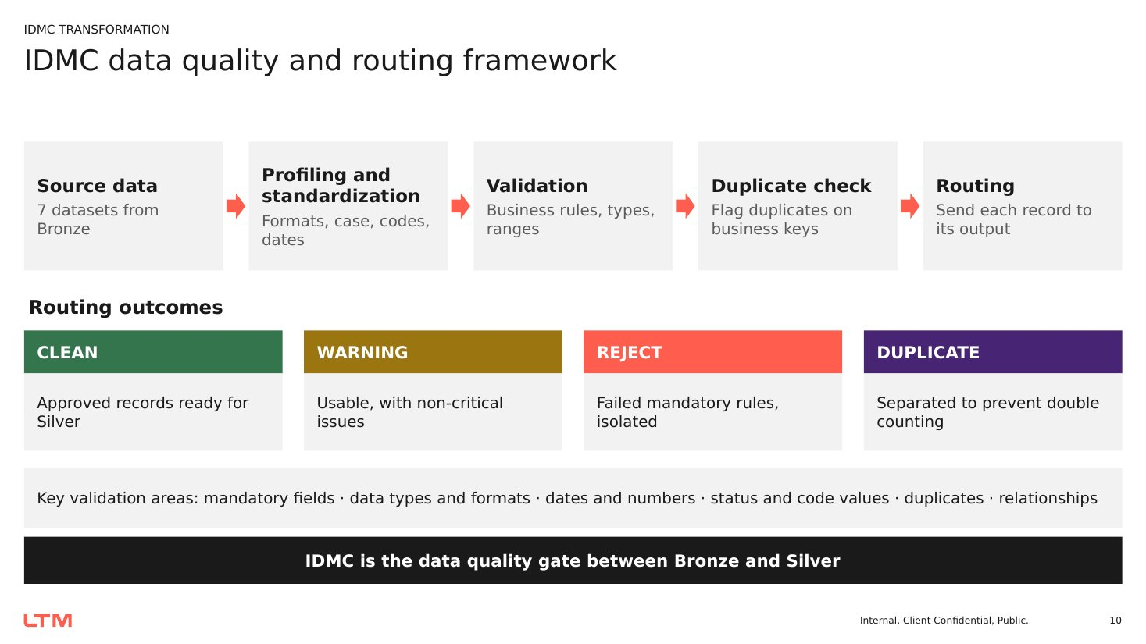
Figure 2: IDMC data quality and routing framework – CLEAN, WARNING, REJECT and DUPLICATE outcomes

6.1 Mapping workflow
- Configure and test the source (Snowflake Bronze) and target connections.
- Read the source dataset and apply Expression transformations to trim text, normalise case and standardise date and number formats.
- Apply validation expressions for mandatory fields, ranges, code values and patterns.
- Use Sorter / Rank / Aggregator logic to flag duplicates on the business key.
- For JSON grid events, parse and flatten the hierarchy before validation.
- Route records with a Router to the CLEAN, WARNING, REJECT and DUPLICATE targets, carrying a quality reason.
- Run the mapping, review the execution log and reconcile target row counts with the source.

6.2 Dataset-wise validation and routing
Dataset | Primary validations | Output datasets
Customers | Mandatory fields, email and phone format, connection date | Clean · Warning · Reject · Duplicate
Meters | Meter, customer and transformer IDs, install and retirement dates | Clean · Warning · Reject · Duplicate
Meter readings | Numeric kWh, kW, voltage, power factor, timestamp, duplicate meter + time | Clean · Warning · Reject · Duplicate
Grid assets | Capacity above zero, install date, type, status, criticality, parent link | Valid · Reject
Outage incidents | Start and restoration dates, customers affected, type, status, severity | Valid · Invalid
Asset maintenance | Asset lookup, numeric cost, scheduled and completion dates, status | Valid · Reject
Grid events (JSON) | Parse and flatten, event timestamp, severity, alarm code, duplicate ID | Valid · Reject

6.3 IDMC mapping screenshots
The seven IDMC mappings are documented below – one per source dataset. A placeholder is reserved for each mapping screenshot so the canvas exported from IDMC can be inserted directly (right-click the box → delete the placeholder text → Insert → Pictures).
Mapping 1: Customers
Trims and upper-cases text, validates email and phone patterns and the connection date, flags repeated CUSTOMER_IDs, and routes rows to SILVER_CUSTOMERS_CLEAN, _WARNING, _REJECT and _DUPLICATE.
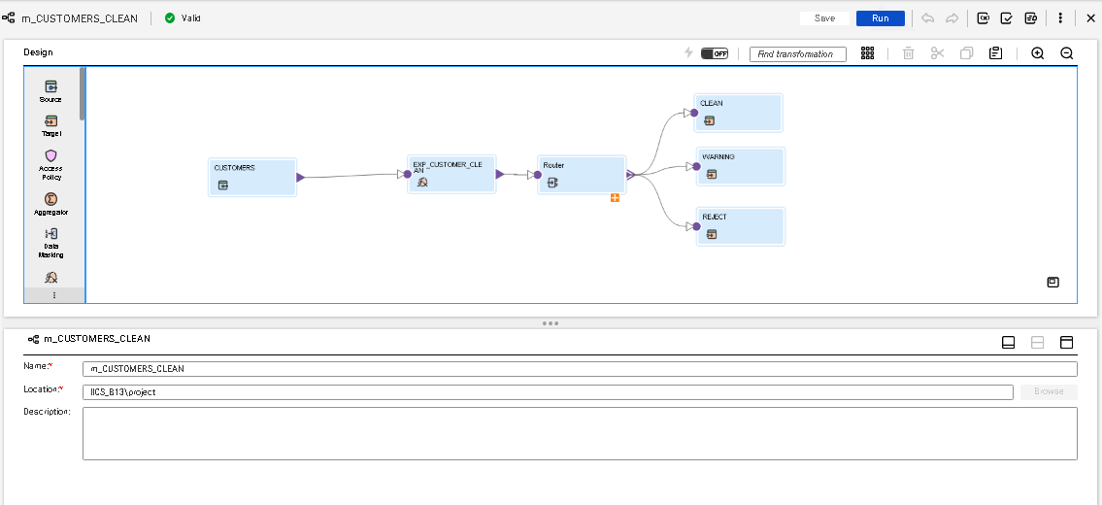 [ Insert IDMC mapping screenshot here ]
Source: customers.csv → BRONZE_CUSTOMERS
Figure 3: IDMC mapping – Customers
Mapping 2: Meters
Validates METER_ID, CUSTOMER_ID and TRANSFORMER_ID, converts installation and retirement dates, flags duplicate meters and routes rows to SILVER_METERS_CLEAN, _WARNING, _REJECT and _DUPLICATE.
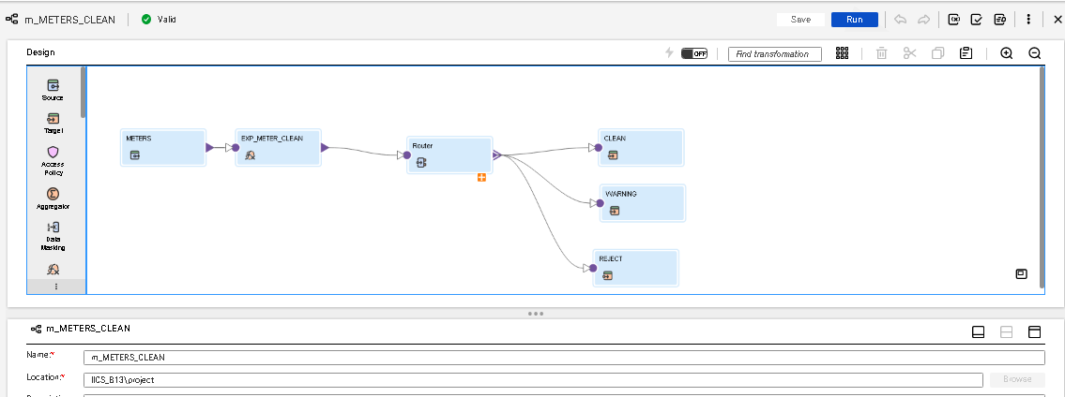
Figure 4: IDMC mapping – Meters
Mapping 3: Meter readings
Converts kWh, kW, voltage and power factor to numbers, parses the reading timestamp, detects duplicate meter + timestamp combinations and routes rows to the clean, warning, reject and duplicate targets.
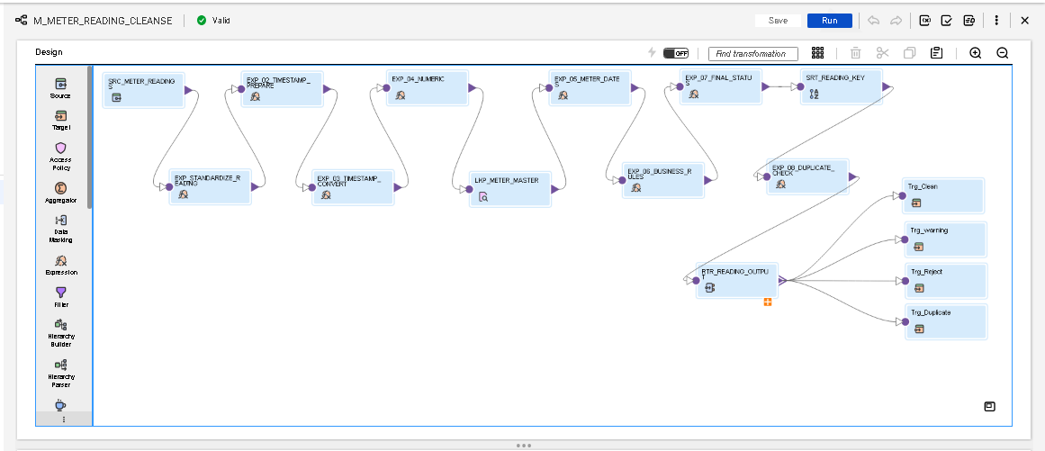
Figure 5: IDMC mapping – Meter readings
Mapping 4: Grid assets
Checks capacity > 0, installation date, asset type, status, criticality and the parent link (ROOT allowed for top-level assets) and routes rows to SILVER_GRID_ASSETS_CLEAN and _REJECT.
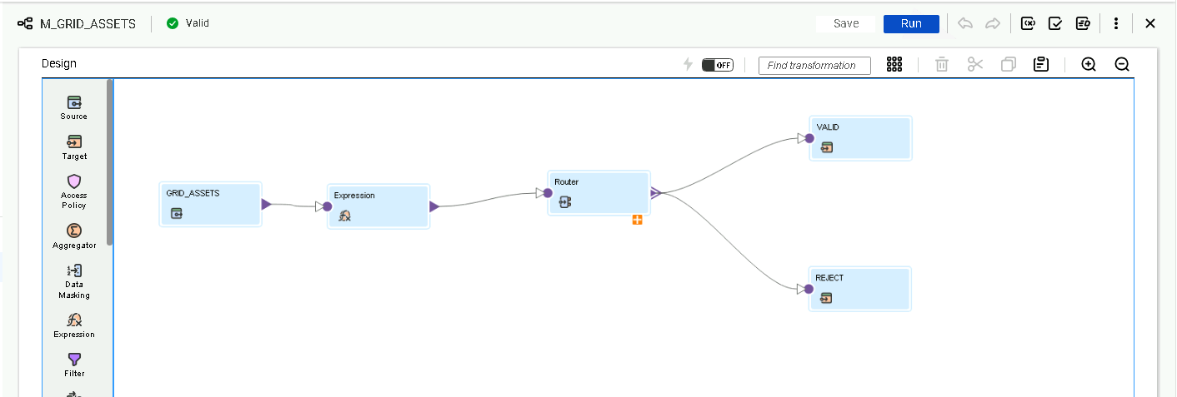
Figure 6: IDMC mapping – Grid assets
Mapping 5: Outage incidents
Standardises outage type, status, severity and cause, converts start/restoration time and customers affected, and routes rows to SILVER_OUTAGE_INCIDENTS_CLEAN and _INVALID.
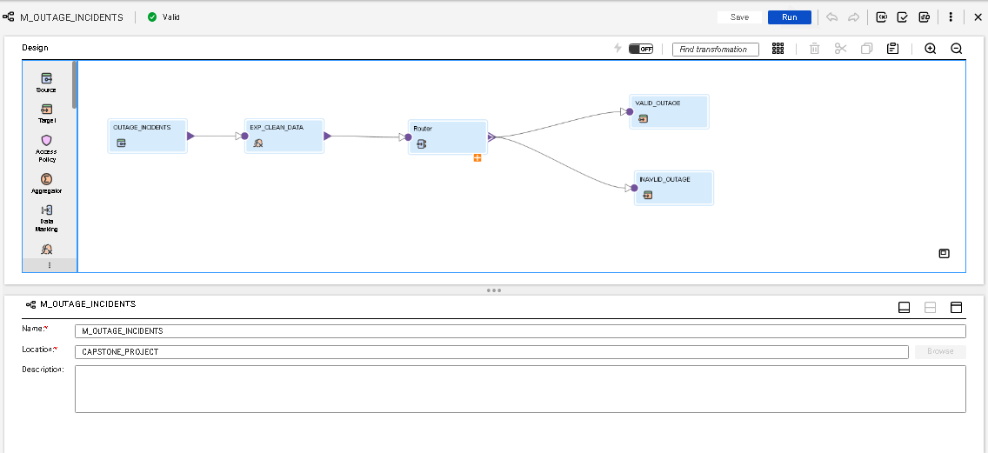
Figure 7: IDMC mapping – Outage incidents
Mapping 6: Asset maintenance
Looks up the grid asset, validates numeric cost, scheduled and completion dates and status (with ASSET/COST/DATE/STATUS check flags) and routes rows to SILVER_ASSET_MAINTENANCE_CLEAN and _REJECT.
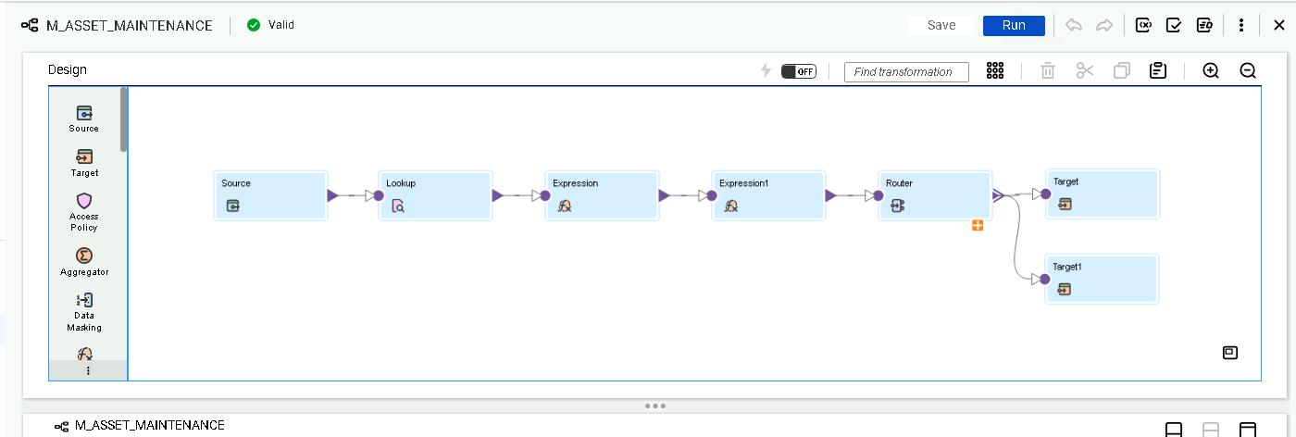
Figure 8: IDMC mapping – Asset maintenance
Mapping 7: Grid events (JSON)
Parses and flattens the JSON hierarchy, validates event timestamp, severity and alarm code, detects duplicate event IDs and routes rows to SILVER_GRID_EVENTS_VALID and _REJECT.
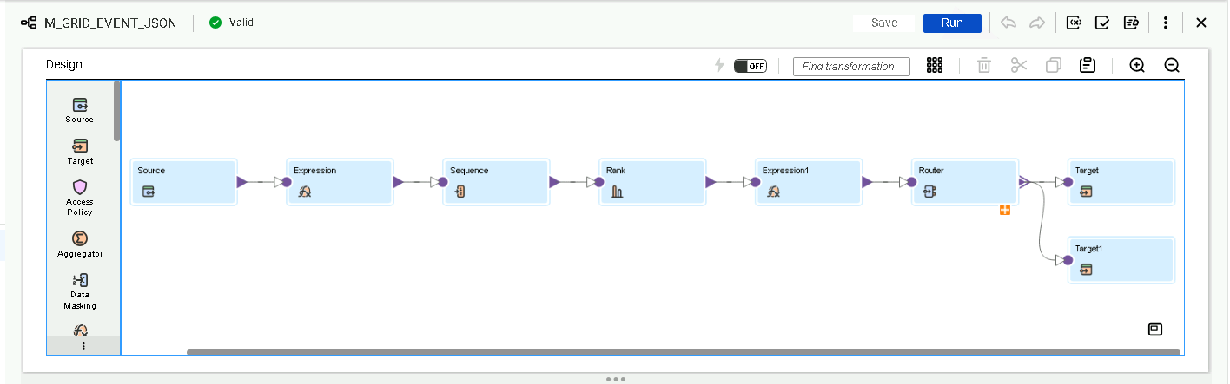
Figure 9: IDMC mapping – Grid events (JSON)

6.4 Data cleaning, quarantine and warning handling
Not every exception should be rejected. The design separates correctable issues, warnings and invalid records. A date in an alternate but parseable format is standardised and retained; a reading with a quality flag of WARNING is retained but kept in a separate warning dataset; a reading with negative consumption, or a maintenance record completed before it was scheduled, is a rule failure and is quarantined. Every quarantined record carries a REJECT_REASON so that the dataset, key and failed rule can be identified without re-running the pipeline.
Route | What goes there | Submission folder
CLEAN / VALID | Records passing all rules, including correctable formats after standardisation | 02_cleaned_datasets/
WARNING | Usable records with non-critical issues (e.g. QUALITY_FLAG = WARNING) | 04_warning_datasets/
REJECT / INVALID | Records failing a mandatory rule, quarantined with REJECT_REASON | 03_quarantine_datasets/
DUPLICATE | Repeated business keys, separated to prevent double counting | 03_quarantine_datasets/

6.5 Silver layer implementation
The Silver schema receives the IDMC outputs. Table structures are created up front so that IDMC can write to them consistently – for example customers have CLEAN, WARNING and REJECT tables with an added RECORD_STATUS column, and the maintenance reject table carries the individual ASSET_CHECK, COST_CHECK, DATE_CHECK and STATUS_CHECK flags together with the REJECT_REASON.
Code 7: Silver target tables (SILVER.sql – abbreviated)
CREATE OR REPLACE TABLE SMART_ENERGY.SILVER.SILVER_CUSTOMERS_CLEAN (
CUSTOMER_ID VARCHAR(255), CUSTOMER_NAME VARCHAR(255),
CUSTOMER_TYPE VARCHAR(100), REGION VARCHAR(100), CITY VARCHAR(100),
EMAIL VARCHAR(255), PHONE_NUMBER VARCHAR(50), CUSTOMER_STATUS VARCHAR(50),
CONNECTION_DATE VARCHAR(50), RECORD_STATUS VARCHAR(20),
INGEST_FILE_NAME VARCHAR(255), LOAD_TIMESTAMP TIMESTAMP_NTZ);
-- SILVER_CUSTOMERS_WARNING and SILVER_CUSTOMERS_REJECT share this structure

CREATE TABLE IF NOT EXISTS SMART_ENERGY.SILVER.SILVER_ASSET_MAINTENANCE_REJECT (
RECORD_STATUS VARCHAR(20), ASSET_CHECK VARCHAR(10), COST_CHECK VARCHAR(10),
DATE_CHECK VARCHAR(10), STATUS_CHECK VARCHAR(10), REJECT_REASON VARCHAR(500),
ASSET_ID VARCHAR(100), MAINTENANCE_ID VARCHAR(100),
MAINTENANCE_TYPE VARCHAR(100), MAINTENANCE_STATUS VARCHAR(100),
FINDING_CATEGORY VARCHAR(100), TECHNICIAN_TEAM VARCHAR(200),
MAINTENANCE_COST VARCHAR(50), SCHEDULED_DATE VARCHAR(50),
COMPLETION_DATE VARCHAR(50), INGEST_FILE_NAME VARCHAR(500),
LOAD_TIMESTAMP TIMESTAMP_NTZ(9), LOOKUP_ASSET_ID VARCHAR(100), ...);

Silver dataset | IDMC outputs available
Customers | SILVER_CUSTOMERS_CLEAN, _WARNING, _REJECT, _DUPLICATE
Meters | SILVER_METERS_CLEAN, _WARNING, _REJECT, _DUPLICATE
Meter readings | SILVER_METER_READINGS_CLEAN, _WARNING, _REJECT, _DUPLICATE
Grid assets | SILVER_GRID_ASSETS_CLEAN, _REJECT
Outage incidents | SILVER_OUTAGE_INCIDENTS_CLEAN, _INVALID
Asset maintenance | SILVER_ASSET_MAINTENANCE_CLEAN, _REJECT
Grid events | SILVER_GRID_EVENTS_VALID, _REJECT

Chapter 7 – Silver Validation Framework in Snowflake
Cleansing is done in IDMC, but the team did not assume that the IDMC output was correct. Every Silver CLEAN table was independently re-validated in Snowflake SQL before it was allowed into Gold. This second gate catches mapping defects, type drift and broken relationships at the first layer that can fix them.

7.1 Validation pattern
The same four-step pattern is used for all seven datasets, which makes the framework easy to read, extend and explain:
- BASE – normalise keys with UPPER(TRIM()), convert text with TRY_TO_NUMBER / TRY_TO_DATE / TRY_TO_DECIMAL and compute duplicate counts with COUNT(*) OVER (PARTITION BY key).
- MASTER join – LEFT JOIN to the parent master (customers, meters or grid assets) to test referential integrity.
- CHECKS – build one IFF() per rule inside ARRAY_CONSTRUCT_COMPACT and join the failing rule names into REJECT_REASON with ARRAY_TO_STRING; NULLIF turns an empty string into NULL.
- Split – VALIDATION_STATUS = REJECT when a reason exists, WARNING for readings flagged WARNING, otherwise VALID; CREATE … AS SELECT produces the VALID, WARNING and REJECT tables.
Because ARRAY_CONSTRUCT_COMPACT removes NULL elements, a record that fails three rules carries all three rule names (for example "NEGATIVE_CONSUMPTION; INVALID_VOLTAGE; INVALID_METER_REFERENCE"), which makes root-cause analysis straightforward.
Code 8: Meter-readings validation (data validation final.sql)
CREATE OR REPLACE TABLE SILVER_METER_READINGS_VALIDATION_RESULT AS
WITH METER_MASTER AS (
SELECT DISTINCT UPPER(TRIM(METER_ID)) AS METER_KEY
FROM SILVER_METERS_CLEAN WHERE METER_ID IS NOT NULL AND TRIM(METER_ID) <> ''),
BASE AS (
SELECT R.*,
COUNT(*) OVER (PARTITION BY UPPER(TRIM(R.READING_ID))) AS ID_COUNT,
M.METER_KEY AS MATCHED_METER
FROM SILVER_METER_READINGS_CLEAN R
LEFT JOIN METER_MASTER M ON UPPER(TRIM(R.METER_ID)) = M.METER_KEY),
CHECKS AS (
SELECT *, NULLIF(ARRAY_TO_STRING(ARRAY_CONSTRUCT_COMPACT(
IFF(READING_ID IS NULL OR TRIM(READING_ID) = '', 'MISSING_READING_ID', NULL),
IFF(ID_COUNT > 1, 'DUPLICATE_READING_ID', NULL),
IFF(METER_ID IS NOT NULL AND MATCHED_METER IS NULL, 'INVALID_METER_REFERENCE', NULL),
IFF(READING_TIMESTAMP IS NULL, 'MISSING_READING_TIMESTAMP', NULL),
IFF(CONSUMPTION_KWH < 0, 'NEGATIVE_CONSUMPTION', NULL),
IFF(PEAK_DEMAND_KW < 0, 'NEGATIVE_PEAK_DEMAND', NULL),
IFF(VOLTAGE IS NULL OR VOLTAGE <= 0, 'INVALID_VOLTAGE', NULL),
IFF(POWER_FACTOR IS NULL OR POWER_FACTOR < 0 OR POWER_FACTOR > 1,
'INVALID_POWER_FACTOR', NULL),
IFF(READING_TYPE IS NULL OR UPPER(TRIM(READING_TYPE))
NOT IN ('ACTUAL','CORRECTED','ESTIMATED'), 'INVALID_READING_TYPE', NULL),
IFF(QUALITY_FLAG IS NULL OR UPPER(TRIM(QUALITY_FLAG))
NOT IN ('VALID','WARNING'), 'INVALID_QUALITY_FLAG', NULL)
), '; '), '') AS REJECT_REASON
FROM BASE)
SELECT * EXCLUDE (ID_COUNT, MATCHED_METER),
CASE WHEN REJECT_REASON IS NOT NULL THEN 'REJECT'
WHEN UPPER(TRIM(QUALITY_FLAG)) = 'WARNING' THEN 'WARNING'
ELSE 'VALID' END AS VALIDATION_STATUS
FROM CHECKS;

CREATE OR REPLACE TABLE SILVER_METER_READINGS_VALID AS
SELECT * FROM SILVER_METER_READINGS_VALIDATION_RESULT WHERE VALIDATION_STATUS = 'VALID';
CREATE OR REPLACE TABLE SILVER_METER_READINGS_WARNING AS
SELECT * FROM SILVER_METER_READINGS_VALIDATION_RESULT WHERE VALIDATION_STATUS = 'WARNING';
CREATE OR REPLACE TABLE SILVER_METER_READINGS_VALIDATION_REJECT AS
SELECT * FROM SILVER_METER_READINGS_VALIDATION_RESULT WHERE VALIDATION_STATUS = 'REJECT';

7.2 Rules implemented per dataset
Dataset | Rule codes written to REJECT_REASON
Grid assets | MISSING_ASSET_ID, DUPLICATE_ASSET_ID, MISSING_ASSET_NAME, MISSING_ASSET_TYPE, MISSING_REGION, MISSING_CAPACITY, INVALID_CAPACITY_FORMAT, INVALID_CAPACITY_VALUE, MISSING_INSTALLATION_DATE, INVALID_INSTALLATION_DATE, FUTURE_INSTALLATION_DATE, ASSET_CANNOT_BE_OWN_PARENT, INVALID_PARENT_ASSET_ID (ROOT allowed)
Asset maintenance | MISSING_MAINTENANCE_ID, DUPLICATE_MAINTENANCE_ID, INVALID_ASSET_REFERENCE, MISSING_MAINTENANCE_TYPE / STATUS / FINDING_CATEGORY / TECHNICIAN_TEAM, INVALID_MAINTENANCE_COST, NEGATIVE_MAINTENANCE_COST, INVALID_SCHEDULED_DATE, INVALID_COMPLETION_DATE, MISSING_COMPLETION_DATE, COMPLETION_BEFORE_SCHEDULED_DATE
Customers | MISSING_CUSTOMER_ID, DUPLICATE_CUSTOMER_ID, MISSING_CUSTOMER_NAME / TYPE / REGION / CITY / EMAIL, INVALID_EMAIL, INVALID_PHONE_NUMBER, MISSING_CUSTOMER_STATUS, INVALID_CONNECTION_DATE, MISSING_INGEST_FILE_NAME, MISSING_LOAD_TIMESTAMP
Meters | MISSING_METER_ID, DUPLICATE_METER_ID, MISSING_CUSTOMER_ID, INVALID_CUSTOMER_REFERENCE, MISSING_TRANSFORMER_ID, MISSING_METER_TYPE, MISSING_MANUFACTURER, MISSING / INVALID_INSTALLATION_DATE, MISSING_READING_FREQUENCY, MISSING_METER_STATUS
Meter readings | MISSING_READING_ID, DUPLICATE_READING_ID, MISSING_METER_ID, INVALID_METER_REFERENCE, MISSING_READING_TIMESTAMP, MISSING / NEGATIVE_CONSUMPTION, MISSING / NEGATIVE_PEAK_DEMAND, INVALID_VOLTAGE, INVALID_POWER_FACTOR, INVALID_READING_TYPE, INVALID_QUALITY_FLAG
Grid events | MISSING_EVENT_ID, DUPLICATE_EVENT_ID, MISSING_ASSET_ID, INVALID_ASSET_REFERENCE, MISSING_EVENT_TIMESTAMP, MISSING_EVENT_TYPE, MISSING_ALARM_CODE, MISSING_SEVERITY, INVALID_SEVERITY (LOW/MEDIUM/HIGH), MISSING_INGEST_FILE_NAME, MISSING_LOAD_TIMESTAMP
Outage incidents | MISSING_OUTAGE_ID, DUPLICATE_OUTAGE_ID, MISSING_ASSET_ID, INVALID_ASSET_REFERENCE, INVALID_OUTAGE_TYPE (PLANNED/UNPLANNED), INVALID_SEVERITY (LOW–CRITICAL), MISSING_OUTAGE_STATUS, MISSING_CAUSE_CATEGORY, INVALID / NEGATIVE_CUSTOMERS_AFFECTED, INVALID_START_DATE, INVALID_RESTORATION_DATE, RESTORATION_BEFORE_START

7.3 Grid-asset hierarchy validation
Grid assets form a three-level hierarchy. Profiling showed that top-level substations use the literal value ROOT as their parent. The first version of the rule rejected these rows as INVALID_PARENT_ASSET_ID; after analysis the rule was corrected to accept ROOT and to reject only assets whose parent truly does not exist or that reference themselves.
Code 9: Grid-asset parent and date checks (data validation final.sql)
BASE AS (
SELECT A.*, UPPER(TRIM(A.ASSET_ID)) AS ASSET_KEY,
TRY_TO_NUMBER(A.RATED_CAPACITY_KVA, 12, 2) AS CAPACITY_NUM,
COALESCE(TRY_TO_DATE(A.INSTALLATION_DATE, 'YYYY-MM-DD'),
TRY_TO_DATE(A.INSTALLATION_DATE, 'DD-MM-YYYY'),
TRY_TO_DATE(A.INSTALLATION_DATE, 'DD/MM/YYYY')) AS INSTALL_DATE,
COUNT(*) OVER (PARTITION BY UPPER(TRIM(A.ASSET_ID))) AS ID_COUNT,
P.ASSET_KEY AS PARENT_MATCH
FROM SILVER_GRID_ASSETS_CLEAN A
LEFT JOIN MASTER P ON UPPER(TRIM(A.PARENT_ASSET_ID)) = P.ASSET_KEY)
...
IFF(CAPACITY_NUM IS NOT NULL AND CAPACITY_NUM <= 0, 'INVALID_CAPACITY_VALUE', NULL),
IFF(INSTALL_DATE > CURRENT_DATE(), 'FUTURE_INSTALLATION_DATE', NULL),
IFF(UPPER(TRIM(PARENT_ASSET_ID)) = ASSET_KEY, 'ASSET_CANNOT_BE_OWN_PARENT', NULL),
IFF(PARENT_ASSET_ID IS NOT NULL AND TRIM(PARENT_ASSET_ID) <> ''
AND UPPER(TRIM(PARENT_ASSET_ID)) <> 'ROOT'
AND PARENT_MATCH IS NULL, 'INVALID_PARENT_ASSET_ID', NULL)

7.4 Chronology checks for outages and maintenance
Code 10: Outage and maintenance chronology (DATA VALIDATION demo.sql)
-- Outages: restoration must not precede start
SELECT COUNT_IF(TRY_TO_DATE(START_TIME,'YYYY-MM-DD') IS NULL) AS INVALID_START_DATES,
COUNT_IF(TRY_TO_DATE(RESTORATION_TIME,'YYYY-MM-DD') IS NULL) AS INVALID_RESTORATION_DATES,
COUNT_IF(TRY_TO_DATE(RESTORATION_TIME,'YYYY-MM-DD')
< TRY_TO_DATE(START_TIME,'YYYY-MM-DD')) AS RESTORATION_BEFORE_START
FROM SILVER_OUTAGE_INCIDENTS_CLEAN;

-- Maintenance: completed work must have a completion date on/after schedule
SELECT MAINTENANCE_ID, MAINTENANCE_STATUS, SCHEDULED_DATE, COMPLETION_DATE
FROM SILVER_ASSET_MAINTENANCE_CLEAN
WHERE UPPER(TRIM(MAINTENANCE_STATUS)) = 'COMPLETED'
AND (COMPLETION_DATE IS NULL OR TRIM(COMPLETION_DATE) = '');

7.5 Consolidated validation summary
A single consolidated query returns one row per dataset with total, valid, warning and reject counts, and a second query breaks the rejects down by REJECT_REASON. These two result sets form the validation evidence stored in 06_validation_evidence/.
Code 11: Consolidated validation result (data validation final.sql – abbreviated)
SELECT 'GRID ASSETS' AS DATASET, COUNT(*) AS TOTAL_RECORDS,
COUNT_IF(VALIDATION_STATUS = 'VALID') AS VALID_RECORDS,
COUNT_IF(VALIDATION_STATUS = 'REJECT') AS REJECT_RECORDS,
0 AS WARNING_RECORDS
FROM SILVER_GRID_ASSETS_VALIDATION_RESULT
UNION ALL
SELECT 'METER READINGS', COUNT(*), COUNT_IF(VALIDATION_STATUS = 'VALID'),
COUNT_IF(VALIDATION_STATUS = 'REJECT'), COUNT_IF(VALIDATION_STATUS = 'WARNING')
FROM SILVER_METER_READINGS_VALIDATION_RESULT
UNION ALL ... -- ASSET MAINTENANCE, CUSTOMERS, METERS, GRID EVENTS, OUTAGE INCIDENTS
ORDER BY DATASET;

-- Rejection-reason breakdown
SELECT 'GRID ASSETS' AS DATASET, REJECT_REASON, COUNT(*) AS REJECTED_RECORDS
FROM SILVER_GRID_ASSETS_VALIDATION_RESULT WHERE VALIDATION_STATUS = 'REJECT'
GROUP BY REJECT_REASON
UNION ALL ...
ORDER BY DATASET, REJECTED_RECORDS DESC;

7.6 Hand-off to the SILVER1 schema
After validation, the final VALID tables were moved into a curated schema, SILVER1, and helper columns used only during validation (raw text dates, REJECT_REASON, VALIDATION_STATUS) were dropped. Gold therefore reads only typed, validated columns.
Code 12: Moving validated tables to SILVER1 (SILVER1.sql, schema_trnsprt.sql)
CREATE SCHEMA SILVER1;
ALTER TABLE silver.silver_meters_valid RENAME TO silver1.silver_meters_valid;
ALTER TABLE silver1.silver_meters_valid
DROP COLUMN INSTALLATION_DATE, RETIREMENT_DATE, REJECT_REASON, VALIDATION_STATUS;

ALTER TABLE silver.silver_grid_assets_valid RENAME TO silver1.silver_grid_assets_valid;
ALTER TABLE silver1.silver_grid_assets_valid
DROP COLUMN INSTALLATION_DATE, RATED_CAPACITY_KVA, REJECT_REASON, VALIDATION_STATUS;

ALTER TABLE silver.SILVER_OUTAGE_INCIDENTS_VALID RENAME TO silver1.SILVER_OUTAGE_INCIDENTS_VALID;
ALTER TABLE SILVER1.SILVER_OUTAGE_INCIDENTS_VALID
DROP COLUMN RESTORATION_TIME, START_TIME, CUSTOMERS_AFFECTED_CLEAN,
REJECT_REASON, VALIDATION_STATUS;

Chapter 8 – Gold Layer: Fact and Dimension Data Modelling
The Gold layer organises validated Silver data into a dimensional model. Because four separate business processes – metering, outages, maintenance and grid events – share the same customers, meters, assets and calendar, the project uses a fact constellation (galaxy) schema: four fact tables share four conformed dimensions.
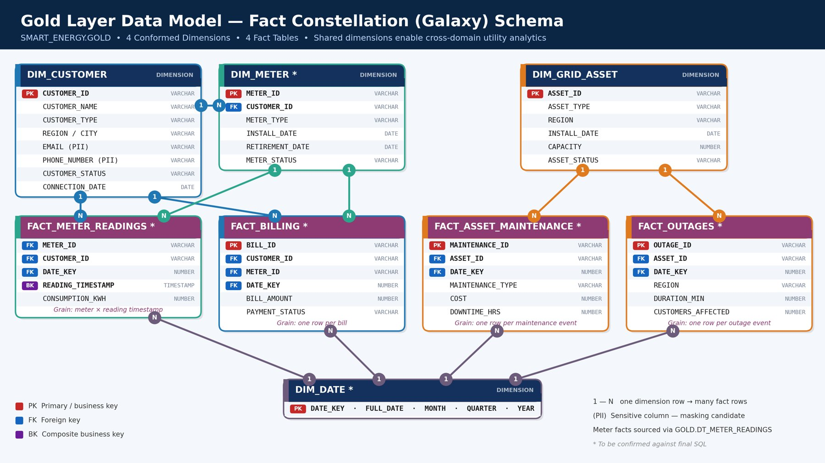
Figure 10: Gold layer fact constellation schema (4 dimensions, 4 facts)

8.1 Modelling goals
- Separate descriptive attributes (dimensions) from measurable events (facts) and declare the grain of every fact.
- Use business identifiers as keys and keep exactly one row per key with QUALIFY ROW_NUMBER().
- Preserve every valid fact row: LEFT JOIN to dimensions and expose *_MATCHED flags instead of dropping orphans.
- Build DIM_DATE only from dates that actually occur in the seven sources (no synthetic calendar), ignoring the 9999-12-31 sentinel.
- Keep customer history in a dedicated SCD Type 2 dimension without changing the existing DIM_CUSTOMER.

8.2 Dimension tables
Dimension | Source | Key | Main attributes
DIM_CUSTOMER | SILVER_CUSTOMERS_VALIDATION_VALID | CUSTOMER_ID | Name, type, region, city, email, phone, status, connection date
DIM_CUSTOMER_SCD2 | SILVER_CUSTOMERS_VALIDATION_VALID | CUSTOMER_SK (identity) | Customer attributes + EFFECTIVE_FROM, EFFECTIVE_TO, IS_CURRENT
DIM_METER | SILVER_METERS_VALID | METER_ID | Customer, transformer, type, manufacturer, dates, frequency, status, CUSTOMER_MATCHED, TRANSFORMER_MATCHED
DIM_GRID_ASSET | SILVER_GRID_ASSETS_VALID | ASSET_ID | Name, type, PARENT_ASSET_ID, region, capacity kVA, install date, status, criticality
DIM_DATE | All seven Silver sources | DATE_KEY (YYYYMMDD) | Day, weekday, week, month, quarter, year, YEAR_MONTH, IS_WEEKEND

Code 13: DIM_METER with relationship flags and DIM_DATE (SMART_ENERGY_GOLD_COMPLETE_VERIFIED.sql)
CREATE TABLE SMART_ENERGY.GOLD.DIM_METER AS
SELECT m.METER_ID, m.CUSTOMER_ID, m.TRANSFORMER_ID, m.METER_TYPE, m.MANUFACTURER,
m.INSTALLATION_DATE_CONVERTED AS INSTALLATION_DATE,
m.RETIREMENT_DATE_CONVERTED AS RETIREMENT_DATE,
m.READING_FREQUENCY, m.METER_STATUS,
(c.CUSTOMER_ID IS NOT NULL) AS CUSTOMER_MATCHED,
(m.TRANSFORMER_ID IS NULL OR a.ASSET_ID IS NOT NULL) AS TRANSFORMER_MATCHED
FROM SMART_ENERGY.SILVER.SILVER_METERS_VALID m
LEFT JOIN SMART_ENERGY.GOLD.DIM_CUSTOMER c ON m.CUSTOMER_ID = c.CUSTOMER_ID
LEFT JOIN SMART_ENERGY.GOLD.DIM_GRID_ASSET a
ON m.TRANSFORMER_ID = a.ASSET_ID AND UPPER(TRIM(a.ASSET_TYPE)) = 'TRANSFORMER'
WHERE m.METER_ID IS NOT NULL
QUALIFY ROW_NUMBER() OVER (PARTITION BY m.METER_ID
ORDER BY m.LOAD_TIMESTAMP DESC NULLS LAST, m.INGEST_FILE_NAME DESC NULLS LAST) = 1;

CREATE TABLE SMART_ENERGY.GOLD.DIM_DATE AS
WITH ALL_SOURCE_DATES AS (
SELECT CONNECTION_DATE_DT AS FULL_DATE FROM SILVER.SILVER_CUSTOMERS_VALIDATION_VALID
UNION SELECT INSTALLATION_DATE_CONVERTED FROM SILVER.SILVER_METERS_VALID
UNION SELECT READING_TIMESTAMP::DATE FROM SILVER.SILVER_METER_READINGS_CLEAN
UNION SELECT START_DATE FROM SILVER.SILVER_OUTAGE_INCIDENTS_VALID
UNION SELECT SCHEDULED_DATE_DT FROM SILVER.SILVER_ASSET_MAINTENANCE_VALIDATION_VALID
UNION SELECT CONVERT_TIMEZONE('UTC', EVENT_TIMESTAMP)::DATE FROM SILVER.SILVER_GRID_EVENTS_VALID
-- (plus retirement, restoration, completion and installation dates)
)
SELECT TO_NUMBER(TO_CHAR(FULL_DATE,'YYYYMMDD')) AS DATE_KEY, FULL_DATE,
DAY(FULL_DATE) AS DAY_NUMBER, DAYNAME(FULL_DATE) AS DAY_NAME,
WEEKISO(FULL_DATE) AS WEEK_NUMBER, MONTH(FULL_DATE) AS MONTH_NUMBER,
MONTHNAME(FULL_DATE) AS MONTH_NAME, QUARTER(FULL_DATE) AS QUARTER_NUMBER,
YEAR(FULL_DATE) AS YEAR_NUMBER, TO_CHAR(FULL_DATE,'YYYY-MM') AS YEAR_MONTH,
DAYOFWEEKISO(FULL_DATE) IN (6,7) AS IS_WEEKEND
FROM ALL_SOURCE_DATES
WHERE FULL_DATE IS NOT NULL AND FULL_DATE < '9999-01-01'::DATE;

8.3 Fact tables and grain
Fact table | Declared grain | Measures and context
FACT_METER_READING (dynamic) | One row per meter + reading timestamp | kWh, peak kW, voltage, power factor, reading type, quality flag, customer, asset, DATE_KEY, METER_MATCHED
FACT_OUTAGE | One row per outage | Outage type, start and restoration date, OUTAGE_DURATION_DAYS, cause, customers affected, status, severity, ASSET_MATCHED
FACT_ASSET_MAINTENANCE | One row per maintenance activity | Type, scheduled/completion date, status, finding, MAINTENANCE_COST (decimal), technician team, IS_COMPLETED, ASSET_MATCHED
FACT_GRID_EVENT | One row per grid event | Event type, alarm code, severity, event timestamp, ingest file, ASSET_MATCHED

Code 14: FACT_OUTAGE and FACT_ASSET_MAINTENANCE (SMART_ENERGY_GOLD_COMPLETE_VERIFIED.sql)
CREATE TABLE SMART_ENERGY.GOLD.FACT_OUTAGE AS
SELECT o.OUTAGE_ID_CLEAN AS OUTAGE_ID, o.ASSEST_ID AS ASSET_ID, d.DATE_KEY,
o.OUTAGE_TYPE_CLEAN AS OUTAGE_TYPE, o.START_DATE AS OUTAGE_START_DATE,
o.RESTORATION_DATE,
CASE WHEN o.RESTORATION_DATE >= o.START_DATE
THEN DATEDIFF('DAY', o.START_DATE, o.RESTORATION_DATE) END AS OUTAGE_DURATION_DAYS,
o.CAUSE_CATEGORY_CLEAN AS CAUSE_CATEGORY,
o.CUSTOMERS_AFFECTED_NUM AS CUSTOMERS_AFFECTED,
o.OUTAGE_STATUS_CLEAN AS OUTAGE_STATUS, o.SEVERITY_CLEAN AS SEVERITY,
(a.ASSET_ID IS NOT NULL) AS ASSET_MATCHED
FROM SMART_ENERGY.SILVER.SILVER_OUTAGE_INCIDENTS_VALID o
LEFT JOIN SMART_ENERGY.GOLD.DIM_GRID_ASSET a ON o.ASSEST_ID = a.ASSET_ID
LEFT JOIN SMART_ENERGY.GOLD.DIM_DATE d ON o.START_DATE = d.FULL_DATE
WHERE o.OUTAGE_ID_CLEAN IS NOT NULL
QUALIFY ROW_NUMBER() OVER (PARTITION BY o.OUTAGE_ID_CLEAN
ORDER BY o.RESTORATION_DATE DESC NULLS LAST, o.START_DATE DESC NULLS LAST) = 1;

CREATE TABLE SMART_ENERGY.GOLD.FACT_ASSET_MAINTENANCE AS
SELECT m.MAINTENANCE_ID, m.ASSET_ID, d.DATE_KEY, m.MAINTENANCE_TYPE,
m.SCHEDULED_DATE_DT AS SCHEDULED_DATE, m.COMPLETION_DATE_DT AS COMPLETION_DATE,
m.MAINTENANCE_STATUS, m.FINDING_CATEGORY,
TRY_TO_DECIMAL(TRIM(m.MAINTENANCE_COST), 12, 2) AS MAINTENANCE_COST,
m.TECHNICIAN_TEAM,
IFF(UPPER(TRIM(m.MAINTENANCE_STATUS)) = 'COMPLETED', 1, 0) AS IS_COMPLETED,
(a.ASSET_ID IS NOT NULL) AS ASSET_MATCHED
FROM SMART_ENERGY.SILVER.SILVER_ASSET_MAINTENANCE_VALIDATION_VALID m
LEFT JOIN SMART_ENERGY.GOLD.DIM_GRID_ASSET a ON m.ASSET_ID = a.ASSET_ID
LEFT JOIN SMART_ENERGY.GOLD.DIM_DATE d ON m.SCHEDULED_DATE_DT = d.FULL_DATE
WHERE m.MAINTENANCE_ID IS NOT NULL
QUALIFY ROW_NUMBER() OVER (PARTITION BY m.MAINTENANCE_ID
ORDER BY m.LOAD_TIMESTAMP DESC NULLS LAST) = 1;

8.4 Dynamic tables for incremental meter readings
Meter readings are the only high-volume, continuously arriving feed, so they are processed incrementally. Two chained dynamic tables replace a hand-written Stream + Task pipeline: DT_METER_READINGS keeps one row per meter and timestamp (a CORRECTED reading wins over other types, then the highest READING_ID), and FACT_METER_READING joins it to DIM_METER and DIM_DATE. Both use REFRESH_MODE = INCREMENTAL so only changed data is reprocessed.
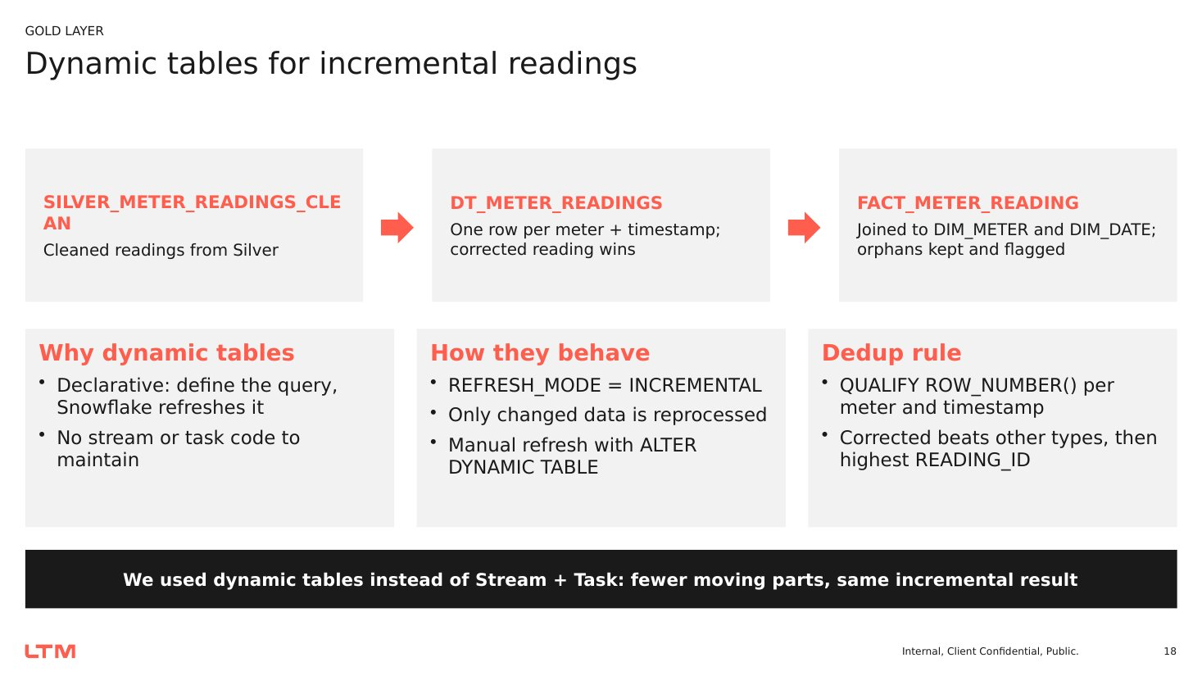
Figure 11: Dynamic tables for incremental readings – flow, behaviour and de-duplication rule
Code 15: Incremental dynamic tables (SMART_ENERGY_GOLD_COMPLETE_VERIFIED.sql)
CREATE DYNAMIC TABLE SMART_ENERGY.GOLD.DT_METER_READINGS
SCHEDULER = DISABLE WAREHOUSE = COMPUTE_WH
REFRESH_MODE = INCREMENTAL INITIALIZE = ON_CREATE
AS
SELECT r.READING_ID, r.METER_ID, r.READING_TIMESTAMP,
r.READING_TIMESTAMP::DATE AS READING_DATE, r.CONSUMPTION_KWH,
r.PEAK_DEMAND_KW, r.VOLTAGE, r.POWER_FACTOR, r.READING_TYPE,
r.QUALITY_FLAG, r.SOURCE_FILE_NAME
FROM SMART_ENERGY.SILVER.SILVER_METER_READINGS_CLEAN r
WHERE r.METER_ID IS NOT NULL AND r.READING_TIMESTAMP IS NOT NULL
QUALIFY ROW_NUMBER() OVER (PARTITION BY r.METER_ID, r.READING_TIMESTAMP
ORDER BY IFF(UPPER(TRIM(r.READING_TYPE)) = 'CORRECTED', 1, 0) DESC,
r.READING_ID DESC NULLS LAST) = 1;

CREATE DYNAMIC TABLE SMART_ENERGY.GOLD.FACT_METER_READING
SCHEDULER = DISABLE WAREHOUSE = COMPUTE_WH
REFRESH_MODE = INCREMENTAL INITIALIZE = ON_CREATE
AS
SELECT r.READING_ID, r.METER_ID, m.CUSTOMER_ID, m.TRANSFORMER_ID AS ASSET_ID,
d.DATE_KEY, r.READING_TIMESTAMP, r.READING_DATE, r.CONSUMPTION_KWH,
r.PEAK_DEMAND_KW, r.VOLTAGE, r.POWER_FACTOR, r.READING_TYPE,
r.QUALITY_FLAG, r.SOURCE_FILE_NAME,
(m.METER_ID IS NOT NULL) AS METER_MATCHED
FROM SMART_ENERGY.GOLD.DT_METER_READINGS r
LEFT JOIN SMART_ENERGY.GOLD.DIM_METER m ON r.METER_ID = m.METER_ID
LEFT JOIN SMART_ENERGY.GOLD.DIM_DATE d ON r.READING_DATE = d.FULL_DATE;

-- Manual refresh when the scheduler is disabled:
-- ALTER DYNAMIC TABLE SMART_ENERGY.GOLD.DT_METER_READINGS REFRESH;
-- ALTER DYNAMIC TABLE SMART_ENERGY.GOLD.FACT_METER_READING REFRESH;
SHOW DYNAMIC TABLES IN SCHEMA SMART_ENERGY.GOLD;

8.5 SCD Type 2 customer dimension
Customer attributes such as type, region, city, contact details and status can change. To keep history without disturbing the existing DIM_CUSTOMER used by the marts, a dedicated DIM_CUSTOMER_SCD2 table with an identity surrogate key was created. The stored procedure SP_LOAD_DIM_CUSTOMER_SCD2 identifies new or changed customers with IS DISTINCT FROM (which is NULL-safe), then – inside one transaction – expires the current version and inserts the new one. If anything fails, the procedure rolls back and re-raises the error.
Code 16: SP_LOAD_DIM_CUSTOMER_SCD2 (CUST_SCD2.sql – abbreviated)
CREATE OR REPLACE PROCEDURE SMART_ENERGY.GOLD.SP_LOAD_DIM_CUSTOMER_SCD2()
RETURNS VARCHAR LANGUAGE SQL EXECUTE AS OWNER AS
$$
DECLARE V_CHANGED_COUNT NUMBER DEFAULT 0;
BEGIN
-- STEP 1: new or modified customers
CREATE OR REPLACE TEMPORARY TABLE SMART_ENERGY.GOLD.TMP_CUSTOMER_SCD2_CHANGES AS
SELECT S.CUSTOMER_ID, S.CUSTOMER_NAME, S.CUSTOMER_TYPE, S.REGION, S.CITY,
S.EMAIL, S.PHONE_NUMBER, S.CUSTOMER_STATUS, NULL::DATE AS CONNECTION_DATE,
CURRENT_TIMESTAMP()::TIMESTAMP_NTZ AS CHANGE_TS
FROM SMART_ENERGY.SILVER.SILVER_CUSTOMERS_VALIDATION_VALID S
LEFT JOIN SMART_ENERGY.GOLD.DIM_CUSTOMER_SCD2 T
ON S.CUSTOMER_ID = T.CUSTOMER_ID AND T.IS_CURRENT = TRUE
WHERE T.CUSTOMER_ID IS NULL
OR S.CUSTOMER_NAME IS DISTINCT FROM T.CUSTOMER_NAME
OR S.CUSTOMER_TYPE IS DISTINCT FROM T.CUSTOMER_TYPE
OR S.REGION IS DISTINCT FROM T.REGION
OR S.CITY IS DISTINCT FROM T.CITY
OR S.EMAIL IS DISTINCT FROM T.EMAIL
OR S.PHONE_NUMBER IS DISTINCT FROM T.PHONE_NUMBER
OR S.CUSTOMER_STATUS IS DISTINCT FROM T.CUSTOMER_STATUS;
SELECT COUNT(*) INTO :V_CHANGED_COUNT FROM SMART_ENERGY.GOLD.TMP_CUSTOMER_SCD2_CHANGES;

BEGIN TRANSACTION;
-- STEP 3: expire old versions
UPDATE SMART_ENERGY.GOLD.DIM_CUSTOMER_SCD2 T
SET EFFECTIVE_TO = S.CHANGE_TS, IS_CURRENT = FALSE
FROM SMART_ENERGY.GOLD.TMP_CUSTOMER_SCD2_CHANGES S
WHERE T.CUSTOMER_ID = S.CUSTOMER_ID AND T.IS_CURRENT = TRUE;
-- STEP 4: insert new current versions
INSERT INTO SMART_ENERGY.GOLD.DIM_CUSTOMER_SCD2 (CUSTOMER_ID, ..., EFFECTIVE_FROM,
EFFECTIVE_TO, IS_CURRENT)
SELECT CUSTOMER_ID, ..., CHANGE_TS, '9999-12-31 00:00:00'::TIMESTAMP_NTZ, TRUE
FROM SMART_ENERGY.GOLD.TMP_CUSTOMER_SCD2_CHANGES;
COMMIT;
RETURN 'SCD TYPE 2 COMPLETED. NEW/CHANGED VERSIONS: ' || V_CHANGED_COUNT;
EXCEPTION
WHEN OTHER THEN ROLLBACK; RAISE;
END;
$$;

CALL SMART_ENERGY.GOLD.SP_LOAD_DIM_CUSTOMER_SCD2();
SELECT COUNT(*) AS TOTAL_RECORDS, COUNT_IF(IS_CURRENT) AS CURRENT_RECORDS,
COUNT_IF(NOT IS_CURRENT) AS HISTORICAL_RECORDS
FROM SMART_ENERGY.GOLD.DIM_CUSTOMER_SCD2;

8.6 Orphan data handling
Some valid records reference a parent that is not present in its dimension – for example a meter whose customer was rejected in Silver. Dropping these rows would silently understate consumption or outages, so the platform follows a four-step approach: Detect with LEFT JOINs that set *_MATCHED flags, Preserve the rows, Audit them in GOLD_ORPHAN_AUDIT with status PENDING, and Resolve by fixing the reference and re-running the checks.
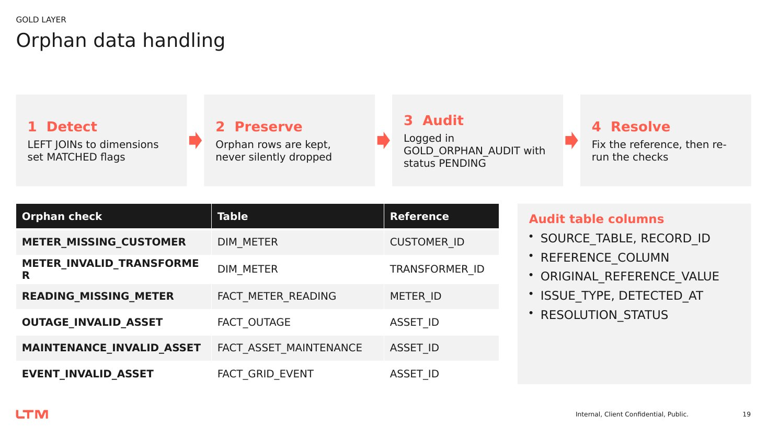
Figure 12: Orphan data handling – detect, preserve, audit and resolve
Code 17: Orphan detection and audit table (GOLD.sql)
SELECT 'METER_MISSING_CUSTOMER' AS ISSUE_TYPE, COUNT(*) AS ISSUE_COUNT
FROM SMART_ENERGY.GOLD.DIM_METER WHERE CUSTOMER_MATCHED = FALSE
UNION ALL SELECT 'METER_INVALID_TRANSFORMER', COUNT(*) FROM GOLD.DIM_METER WHERE TRANSFORMER_MATCHED = FALSE
UNION ALL SELECT 'READING_MISSING_METER', COUNT(*) FROM GOLD.FACT_METER_READING WHERE METER_MATCHED = FALSE
UNION ALL SELECT 'READING_MISSING_DATE', COUNT(*) FROM GOLD.FACT_METER_READING WHERE DATE_KEY IS NULL
UNION ALL SELECT 'OUTAGE_INVALID_ASSET', COUNT(*) FROM GOLD.FACT_OUTAGE WHERE ASSET_MATCHED = FALSE
UNION ALL SELECT 'MAINTENANCE_INVALID_ASSET', COUNT(*) FROM GOLD.FACT_ASSET_MAINTENANCE WHERE ASSET_MATCHED = FALSE
UNION ALL SELECT 'EVENT_INVALID_ASSET', COUNT(*) FROM GOLD.FACT_GRID_EVENT WHERE ASSET_MATCHED = FALSE;

CREATE TABLE IF NOT EXISTS SMART_ENERGY.GOLD.GOLD_ORPHAN_AUDIT (
SOURCE_TABLE VARCHAR(100), RECORD_ID VARCHAR(100), REFERENCE_COLUMN VARCHAR(100),
ORIGINAL_REFERENCE_VALUE VARCHAR(255), ISSUE_TYPE VARCHAR(100),
DETECTED_AT TIMESTAMP_NTZ, RESOLUTION_STATUS VARCHAR(50));

INSERT INTO SMART_ENERGY.GOLD.GOLD_ORPHAN_AUDIT
SELECT 'DIM_METER', METER_ID, 'CUSTOMER_ID', CUSTOMER_ID, 'MISSING_CUSTOMER',
CURRENT_TIMESTAMP()::TIMESTAMP_NTZ, 'PENDING'
FROM SMART_ENERGY.GOLD.DIM_METER WHERE CUSTOMER_MATCHED = FALSE
UNION ALL ... -- MISSING_TRANSFORMER, MISSING_METER

8.7 Grid hierarchy traversal
Because DIM_GRID_ASSET stores PARENT_ASSET_ID, the full substation → feeder → transformer path can be rebuilt with self-joins and linked to meters and customers. This answers impact questions such as "how many customers are connected under this substation?".
Code 18: Substation → feeder → transformer → meter traversal (GOLD.sql)
SELECT s.ASSET_ID AS SUBSTATION_ID, s.ASSET_NAME AS SUBSTATION_NAME,
f.ASSET_ID AS FEEDER_ID, t.ASSET_ID AS TRANSFORMER_ID,
t.ASSET_STATUS AS TRANSFORMER_STATUS, t.CRITICALITY,
COUNT(DISTINCT m.METER_ID) AS CONNECTED_METERS,
COUNT(DISTINCT m.CUSTOMER_ID) AS CONNECTED_CUSTOMERS
FROM SMART_ENERGY.GOLD.DIM_GRID_ASSET t
JOIN SMART_ENERGY.GOLD.DIM_GRID_ASSET f ON t.PARENT_ASSET_ID = f.ASSET_ID
JOIN SMART_ENERGY.GOLD.DIM_GRID_ASSET s ON f.PARENT_ASSET_ID = s.ASSET_ID
LEFT JOIN SMART_ENERGY.GOLD.DIM_METER m ON t.ASSET_ID = m.TRANSFORMER_ID
WHERE t.ASSET_TYPE = 'Transformer'
GROUP BY s.ASSET_ID, s.ASSET_NAME, f.ASSET_ID, t.ASSET_ID, t.ASSET_STATUS, t.CRITICALITY
ORDER BY s.ASSET_ID, f.ASSET_ID, t.ASSET_ID;

Chapter 9 – Gold Data Marts and Snowpark Asset Risk Score

9.1 Four Gold data marts
The marts provide the single source for KPI reporting. Three are SQL views, so they always reflect the latest Gold facts; the fourth (asset risk) is a table written by Snowpark. In the asset performance mart, each fact is aggregated independently in its own CTE before joining to DIM_GRID_ASSET, which prevents join fan-out and double counting.
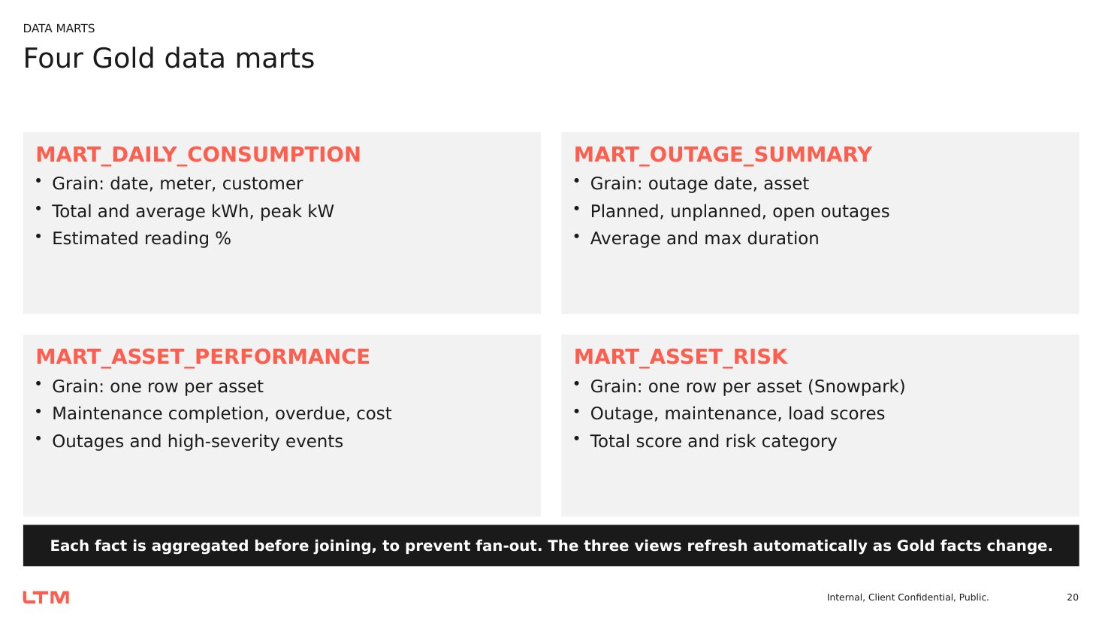
Figure 13: The four Gold data marts and their grain
Data mart | Grain | Key measures
MART_DAILY_CONSUMPTION | Reading date × meter × customer | Reading count, total and average kWh, peak kW, estimated reading count and %; customer type, region, city, meter type
MART_OUTAGE_SUMMARY | Outage start date × asset | Total, planned, unplanned, open and restored outages; average and maximum duration (days); customers affected
MART_ASSET_PERFORMANCE | One row per grid asset | Total, completed, overdue and corrective maintenance; cost; completion %; outages; unplanned outages; grid events; high-severity events
MART_ASSET_RISK | One row per grid asset | Outage, maintenance and load scores; total risk score; HIGH / MEDIUM / LOW category; scored timestamp

Code 19: MART_DAILY_CONSUMPTION (smart_energy_gold_marts.sql)
CREATE OR REPLACE VIEW SMART_ENERGY.GOLD.MART_DAILY_CONSUMPTION AS
SELECT r.READING_DATE, r.DATE_KEY, r.METER_ID,
COALESCE(r.CUSTOMER_ID, m.CUSTOMER_ID) AS CUSTOMER_ID,
c.CUSTOMER_TYPE, c.REGION, c.CITY, m.METER_TYPE,
COUNT(*) AS READING_COUNT,
SUM(r.CONSUMPTION_KWH) AS TOTAL_CONSUMPTION_KWH,
AVG(r.CONSUMPTION_KWH) AS AVG_CONSUMPTION_KWH_PER_READING,
MAX(r.PEAK_DEMAND_KW) AS PEAK_DEMAND_KW,
COUNT_IF(UPPER(COALESCE(r.READING_TYPE,'')) LIKE '%ESTIMAT%') AS ESTIMATED_READING_COUNT,
ROUND(100.0 * COUNT_IF(UPPER(COALESCE(r.READING_TYPE,'')) LIKE '%ESTIMAT%')
/ NULLIF(COUNT(*),0), 2) AS ESTIMATED_READING_PCT
FROM SMART_ENERGY.GOLD.FACT_METER_READING r
LEFT JOIN SMART_ENERGY.GOLD.DIM_METER m ON r.METER_ID = m.METER_ID
LEFT JOIN SMART_ENERGY.GOLD.DIM_CUSTOMER c ON COALESCE(r.CUSTOMER_ID, m.CUSTOMER_ID) = c.CUSTOMER_ID
GROUP BY r.READING_DATE, r.DATE_KEY, r.METER_ID, COALESCE(r.CUSTOMER_ID, m.CUSTOMER_ID),
c.CUSTOMER_TYPE, c.REGION, c.CITY, m.METER_TYPE;

Code 20: MART_ASSET_PERFORMANCE – aggregate before join (smart_energy_gold_marts.sql)
CREATE OR REPLACE VIEW SMART_ENERGY.GOLD.MART_ASSET_PERFORMANCE AS
WITH maintenance AS (
SELECT ASSET_ID, COUNT(*) AS TOTAL_MAINTENANCE,
COUNT_IF(COALESCE(IS_COMPLETED,0) = 1) AS COMPLETED_MAINTENANCE,
COUNT_IF(COALESCE(IS_COMPLETED,0) = 0 AND SCHEDULED_DATE < CURRENT_DATE())
AS OVERDUE_MAINTENANCE,
COUNT_IF(UPPER(MAINTENANCE_TYPE) LIKE '%CORRECTIVE%') AS CORRECTIVE_MAINTENANCE,
SUM(MAINTENANCE_COST) AS TOTAL_MAINTENANCE_COST
FROM SMART_ENERGY.GOLD.FACT_ASSET_MAINTENANCE GROUP BY ASSET_ID),
outages AS (
SELECT ASSET_ID, COUNT(*) AS TOTAL_OUTAGES,
COUNT_IF(UPPER(OUTAGE_TYPE) = 'UNPLANNED') AS UNPLANNED_OUTAGES,
AVG(OUTAGE_DURATION_DAYS) AS AVG_OUTAGE_DURATION_DAYS,
SUM(CUSTOMERS_AFFECTED) AS CUSTOMER_AFFECTED_INCIDENTS
FROM SMART_ENERGY.GOLD.FACT_OUTAGE GROUP BY ASSET_ID),
events AS (
SELECT ASSET_ID, COUNT(*) AS TOTAL_GRID_EVENTS,
COUNT_IF(UPPER(SEVERITY) IN ('HIGH','CRITICAL')) AS HIGH_SEVERITY_EVENTS
FROM SMART_ENERGY.GOLD.FACT_GRID_EVENT GROUP BY ASSET_ID)
SELECT a.ASSET_ID, a.ASSET_NAME, a.ASSET_TYPE, a.REGION, a.CRITICALITY,
a.ASSET_STATUS, a.RATED_CAPACITY_KVA,
COALESCE(m.TOTAL_MAINTENANCE,0) AS TOTAL_MAINTENANCE, ...,
ROUND(100.0 * COALESCE(m.COMPLETED_MAINTENANCE,0)
/ NULLIF(m.TOTAL_MAINTENANCE,0), 2) AS MAINTENANCE_COMPLETION_PCT,
COALESCE(o.TOTAL_OUTAGES,0) AS TOTAL_OUTAGES, ...,
COALESCE(e.HIGH_SEVERITY_EVENTS,0) AS HIGH_SEVERITY_EVENTS
FROM SMART_ENERGY.GOLD.DIM_GRID_ASSET a
LEFT JOIN maintenance m ON a.ASSET_ID = m.ASSET_ID
LEFT JOIN outages o ON a.ASSET_ID = o.ASSET_ID
LEFT JOIN events e ON a.ASSET_ID = e.ASSET_ID;

9.2 Explainable asset risk score with Snowpark
The asset risk score helps maintenance planners prioritise assets before they fail. It is computed in Snowpark Python inside Snowflake and is deliberately rule-based and transparent: every point awarded can be traced back to an outage count, a corrective-maintenance count, a peak load, the asset age or its criticality. The reporting date comes from the view V_AS_OF_DATE, and outages and grid-event loads are evaluated over a 90-day window ending on that date.
Component | Rule (90-day window) | Max points
Outages | Count 1 / 2 / 3+ = 10 / 20 / 30; average duration ≥ 1 day = +5, ≥ 2 days = +10 | 40
Corrective maintenance | Count 1 / 2 / 3+ = 10 / 15 / 20 | 20
Grid load | Maximum load % ≥ 70 / 85 / 95 = 10 / 18 / 25 | 25
Asset age | ≥ 10 years = 3; ≥ 20 years = 5 | 5
Criticality | Low / Medium / High = 1 / 3 / 5 | 5
Risk category | Total ≥ 60 = HIGH; ≥ 30 = MEDIUM; otherwise LOW | 95

Code 21: SP_BUILD_ASSET_RISK – Snowpark stored procedure (Stored_Procedure.sql – abbreviated)
CREATE OR REPLACE PROCEDURE SMART_ENERGY.GOLD.SP_BUILD_ASSET_RISK()
RETURNS STRING LANGUAGE PYTHON RUNTIME_VERSION = '3.11'
PACKAGES = ('snowflake-snowpark-python') HANDLER = 'main'
AS
$$
from snowflake.snowpark import functions as F
from datetime import timedelta
def main(session):
as_of_date = (session.table("SMART_ENERGY.GOLD.V_AS_OF_DATE")
.select("AS_OF_DATE").collect()[0]["AS_OF_DATE"])
window_start = as_of_date - timedelta(days=90)
assets = session.table("SMART_ENERGY.GOLD.DIM_GRID_ASSET")
outages = session.table("SMART_ENERGY.GOLD.FACT_OUTAGE")
maintenance = session.table("SMART_ENERGY.GOLD.FACT_ASSET_MAINTENANCE")
events = session.table("SMART_ENERGY.BRONZE.VW_BRONZE_GRID_EVENTS")

outage_agg = (outages.filter((F.col("OUTAGE_START_DATE") >= F.lit(window_start)) &
(F.col("OUTAGE_START_DATE") <= F.lit(as_of_date)))
.group_by("ASSET_ID")
.agg(F.count("*").alias("OUTAGE_COUNT"),
F.avg("OUTAGE_DURATION_DAYS").alias("AVG_OUTAGE_DAYS")))
maintenance_agg = (maintenance.filter(F.col("SCHEDULED_DATE") <= F.lit(as_of_date))
.group_by("ASSET_ID")
.agg(F.sum(F.when(F.upper(F.col("MAINTENANCE_TYPE")) == "CORRECTIVE", 1)
.otherwise(0)).alias("CORRECTIVE_COUNT")))
load_agg = (events.filter(F.to_date(F.col("EVENT_TIMESTAMP")).between(window_start, as_of_date))
.group_by("ASSET_ID").agg(F.max("LOAD_PERCENTAGE").alias("MAX_LOAD_PERCENTAGE")))

risk_df = (assets.join(outage_agg, on="ASSET_ID", how="left")
.join(maintenance_agg, on="ASSET_ID", how="left")
.join(load_agg, on="ASSET_ID", how="left"))
# ... NULL -> 0, OUTAGE_SCORE, MAINTENANCE_SCORE, LOAD_SCORE, AGE_SCORE,
# CRITICALITY_SCORE, TOTAL_RISK_SCORE ...
risk_df = risk_df.with_column("RISK_CATEGORY",
F.when(F.col("TOTAL_RISK_SCORE") >= 60, "HIGH")
.when(F.col("TOTAL_RISK_SCORE") >= 30, "MEDIUM").otherwise("LOW"))
final_df = risk_df.select("ASSET_ID", "OUTAGE_SCORE", "MAINTENANCE_SCORE",
"LOAD_SCORE", "TOTAL_RISK_SCORE", "RISK_CATEGORY",
F.current_timestamp().alias("SCORED_TIMESTAMP"))
final_df.write.mode("overwrite").save_as_table("SMART_ENERGY.GOLD.MART_ASSET_RISK")
return "Asset Risk Mart built successfully. Total assets: " + str(final_df.count())
$$;

CALL SMART_ENERGY.GOLD.SP_BUILD_ASSET_RISK();
SELECT COUNT(*) AS TOTAL_RECORDS, COUNT(DISTINCT ASSET_ID) AS DISTINCT_ASSETS
FROM SMART_ENERGY.GOLD.MART_ASSET_RISK;

The same logic was first developed and tested interactively in a Snowpark Python worksheet (MART_ASSET_RISK.py) and was then wrapped in the stored procedure so that it can be scheduled and called from the orchestration sequence. The final output always contains exactly seven columns, and the validation query confirms that the mart has one row per asset.

Chapter 10 – Workflow, Pipeline Orchestration and Governance
The platform combines an initial full load for all seven datasets with incremental processing for meter readings. Each stage depends on the previous one, so the execution order is fixed and every stage is followed by a count or validation check before the next stage starts.

10.1 End-to-end execution sequence
Step | Stage | Script / object | Check before continuing
1 | Create database, integration, stage, file formats | SMART_ENERGY.sql | Integration validated; LIST shows 7 files
2 | Create and load Bronze tables | BRONZE.sql | Bronze row counts recorded
3 | Flatten JSON grid events | VW_BRONZE_GRID_EVENTS | View returns typed columns
4 | Run the seven IDMC mappings | IDMC mappings 1–7 | Clean + warning + reject + duplicate = source
5 | Profile and validate Silver | DATA VALIDATION demo.sql, data validation final.sql | Consolidated summary and reason breakdown
6 | Hand off validated tables | SILVER1.sql, schema_trnsprt.sql | DESC TABLE shows final columns
7 | Build dimensions and facts | SMART_ENERGY_GOLD_COMPLETE_VERIFIED.sql | Object counts and relationship checks
8 | Load SCD Type 2 customers | CUST_SCD2.sql | Current vs historical counts
9 | Detect and audit orphans | GOLD.sql | Issue counts by type
10 | Create marts | smart_energy_gold_marts.sql | Fact-to-mart reconciliation
11 | Build asset risk mart | Stored_Procedure.sql | One row per asset, 7 columns
12 | Apply security | Security_Policies.sql | Role-switch test shows masking
13 | Deploy dashboard and Cortex | streamlit.app, cortex_questions.sql | KPIs match SQL; 16 questions answered

10.2 Task dependencies
The dependency chain is: storage integration → stage → Bronze → IDMC → Silver validation → SILVER1 → DIM_CUSTOMER and DIM_GRID_ASSET → DIM_METER (needs both) → DIM_DATE → DT_METER_READINGS → FACT_METER_READING (needs DIM_METER and DIM_DATE) → other facts → marts → asset risk → dashboard. Dimensions are always built before facts, and facts before marts, so every LEFT JOIN finds its target object.

10.3 Incremental processing
- New meter-reading files landed in S3 are appended to BRONZE_METER_READINGS with their own INGEST_FILE_NAME, so each load is traceable.
- After IDMC cleansing, DT_METER_READINGS and FACT_METER_READING refresh incrementally – only changed partitions are reprocessed.
- In the development account the scheduler is disabled and refresh is triggered with ALTER DYNAMIC TABLE … REFRESH; in production a TARGET_LAG (5 and 10 minutes in the first design) lets Snowflake schedule refreshes automatically.
- Because the three KPI marts are views, they reflect the refreshed facts immediately; the asset risk mart is rebuilt by calling SP_BUILD_ASSET_RISK.
- The SCD2 procedure is idempotent: re-running it without source changes inserts zero new versions.

10.4 Orchestration controls
- Run upstream stages before downstream stages; stop if an input object is missing.
- Record row counts at every layer and compare them with the previous layer.
- Use CREATE OR REPLACE for rebuildable objects and CREATE … IF NOT EXISTS for audit and history tables so history is never lost.
- Use transactions (BEGIN / COMMIT / ROLLBACK) where several statements must succeed together, as in the SCD2 load.
- Use Time Travel to recover from accidental drops or overwrites during development.

10.5 Security and data governance
Customer email and phone number are personal data. The platform applies role-based access control, dynamic masking and a secure view so that each role sees only what it is allowed to see.
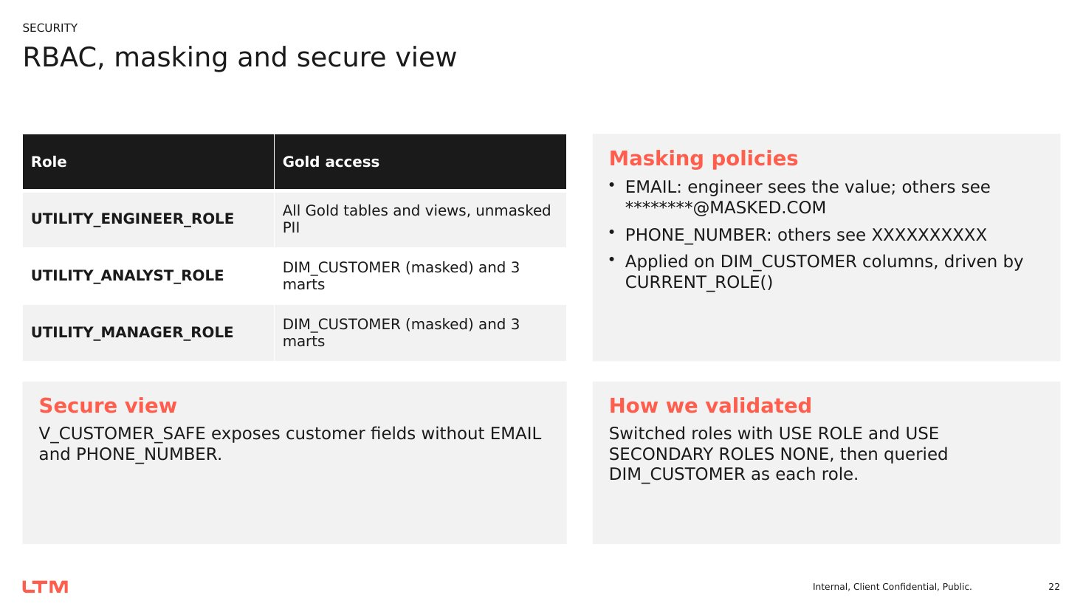
Figure 14: RBAC roles, masking policies and secure view
Role | Access granted | PII visibility
UTILITY_ENGINEER_ROLE | SELECT on all Gold tables and views | Unmasked email and phone
UTILITY_ANALYST_ROLE | DIM_CUSTOMER and the three KPI marts | Masked email and phone
UTILITY_MANAGER_ROLE | DIM_CUSTOMER and the three KPI marts | Masked email and phone
All roles via V_CUSTOMER_SAFE | Secure view without EMAIL and PHONE_NUMBER | PII columns not exposed

Code 22: Roles, masking policies and secure view (Security_Policies.sql – abbreviated)
CREATE OR REPLACE SECURE VIEW SMART_ENERGY.GOLD.V_CUSTOMER_SAFE AS
SELECT CUSTOMER_ID, CUSTOMER_NAME, CUSTOMER_TYPE, REGION, CITY,
CUSTOMER_STATUS, CONNECTION_DATE
FROM SMART_ENERGY.GOLD.DIM_CUSTOMER;

CREATE ROLE IF NOT EXISTS UTILITY_ENGINEER_ROLE;
CREATE ROLE IF NOT EXISTS UTILITY_ANALYST_ROLE;
CREATE ROLE IF NOT EXISTS UTILITY_MANAGER_ROLE;
GRANT USAGE ON DATABASE SMART_ENERGY TO ROLE UTILITY_ANALYST_ROLE; -- (all 3 roles)
GRANT USAGE ON SCHEMA SMART_ENERGY.GOLD TO ROLE UTILITY_ANALYST_ROLE;
GRANT USAGE ON WAREHOUSE COMPUTE_WH TO ROLE UTILITY_ANALYST_ROLE;
GRANT SELECT ON ALL TABLES IN SCHEMA SMART_ENERGY.GOLD TO ROLE UTILITY_ENGINEER_ROLE;
GRANT SELECT ON VIEW SMART_ENERGY.GOLD.MART_DAILY_CONSUMPTION TO ROLE UTILITY_ANALYST_ROLE;

CREATE MASKING POLICY IF NOT EXISTS SMART_ENERGY.GOLD.MASK_CUSTOMER_EMAIL
AS (VAL VARCHAR) RETURNS VARCHAR ->
CASE WHEN CURRENT_ROLE() IN ('ACCOUNTADMIN','UTILITY_ENGINEER_ROLE') THEN VAL
WHEN VAL IS NULL THEN NULL
ELSE '********@MASKED.COM' END;

CREATE MASKING POLICY IF NOT EXISTS SMART_ENERGY.GOLD.MASK_CUSTOMER_PHONE
AS (VAL VARCHAR) RETURNS VARCHAR ->
CASE WHEN CURRENT_ROLE() IN ('ACCOUNTADMIN','UTILITY_ENGINEER_ROLE') THEN VAL
WHEN VAL IS NULL THEN NULL
ELSE 'XXXXXXXXXX' END;

ALTER TABLE SMART_ENERGY.GOLD.DIM_CUSTOMER MODIFY COLUMN EMAIL
SET MASKING POLICY SMART_ENERGY.GOLD.MASK_CUSTOMER_EMAIL;
ALTER TABLE SMART_ENERGY.GOLD.DIM_CUSTOMER MODIFY COLUMN PHONE_NUMBER
SET MASKING POLICY SMART_ENERGY.GOLD.MASK_CUSTOMER_PHONE;

-- Validation: switch role and query
USE ROLE UTILITY_ANALYST_ROLE; USE SECONDARY ROLES NONE;
SELECT CURRENT_ROLE(), CUSTOMER_ID, EMAIL, PHONE_NUMBER
FROM SMART_ENERGY.GOLD.DIM_CUSTOMER LIMIT 10;

During testing the team found that the masking policies initially also masked values for ACCOUNTADMIN, which made administration difficult; the policy bodies were updated with ALTER MASKING POLICY … SET BODY to allow ACCOUNTADMIN alongside the engineer role. USE SECONDARY ROLES NONE was added to the test so that secondary roles did not unintentionally unmask data.

Chapter 11 – Dashboard Implementation, Business KPIs and Cortex Analyst

11.1 Business KPIs and definitions
KPI | Definition | Source mart
Total consumption (kWh) | Sum of CONSUMPTION_KWH across readings | MART_DAILY_CONSUMPTION
Average consumption per reading | Average kWh per meter reading | MART_DAILY_CONSUMPTION
Peak demand (kW) | Maximum PEAK_DEMAND_KW per date/meter (never summed as a system peak) | MART_DAILY_CONSUMPTION
Estimated reading % | Estimated readings ÷ all readings × 100 | MART_DAILY_CONSUMPTION
Total / planned / unplanned outages | Outage counts split by OUTAGE_TYPE | MART_OUTAGE_SUMMARY
Open and restored outages | Outages with status OPEN; outages with a restoration date | MART_OUTAGE_SUMMARY
Average / maximum outage duration | DATEDIFF(day) between start and restoration | MART_OUTAGE_SUMMARY
Customers affected | Sum of CUSTOMERS_AFFECTED | MART_OUTAGE_SUMMARY
Maintenance completion % | Completed ÷ total maintenance × 100 per asset | MART_ASSET_PERFORMANCE
Overdue maintenance | Not completed and scheduled before today | MART_ASSET_PERFORMANCE
Maintenance cost | Sum of MAINTENANCE_COST | MART_ASSET_PERFORMANCE
High-severity grid events | Events with severity HIGH or CRITICAL | MART_ASSET_PERFORMANCE
Asset risk category | HIGH / MEDIUM / LOW from the explainable score | MART_ASSET_RISK

11.2 Streamlit dashboard
The dashboard runs as Streamlit in Snowflake, so it uses the active Snowflake session and the viewer's role – masking and access rules therefore apply automatically. It reads the three KPI marts and the secure customer view V_CUSTOMER_SAFE (never the raw DIM_CUSTOMER), caches results for five minutes, and offers a Refresh Data button that clears the cache. A global multi-select region filter (Maharashtra selected by default) is applied to every page.
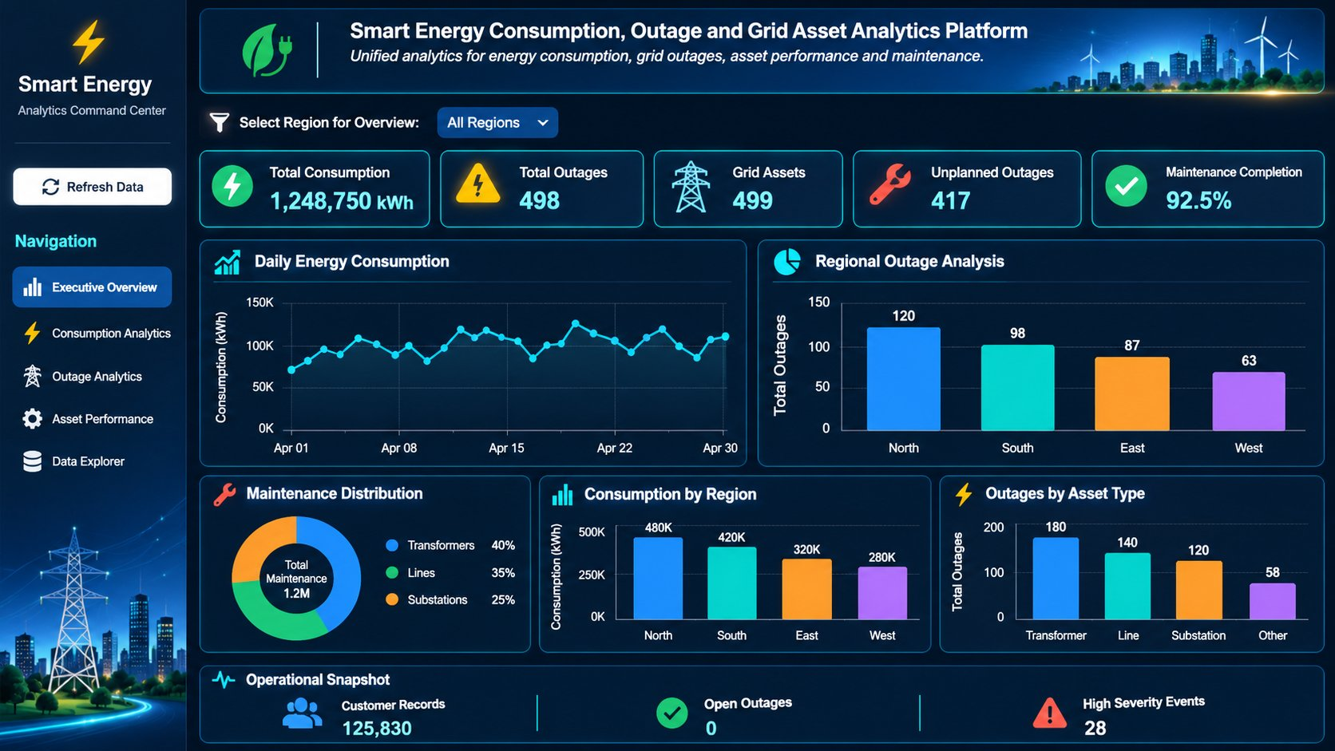
Figure 15: Streamlit dashboard – Smart Energy Analytics Command Center
Page | Purpose and visuals
Executive Overview | Five KPI cards (total consumption, total outages, grid assets, unplanned outages, maintenance completion); daily consumption trend; outages by region; maintenance treemap by asset type; consumption by region; outages by asset type; operational snapshot.
Consumption Analytics | Customer-type and date-range filters; KPI cards; daily trend; peak-demand histogram; consumption by region, customer type and meter type; record table with CSV download.
Outage Analytics | Date-range filter; planned vs unplanned donut; monthly outage trend; customers affected; outages by region and asset type; top-10 assets by outages.
Asset Performance | Asset type and status filters; maintenance by asset type; completed vs overdue; maintenance cost; outages by criticality; status distribution; top-10 overdue assets; maintenance vs outage scatter.
Data Explorer | Select any Gold mart or the secure customer view, choose columns, inspect data types, missing and unique values, and download CSV.

Code 23: Gold sources, cached loading and region filter (streamlit.app – abbreviated)
TABLES = {
"Daily Consumption": "SMART_ENERGY.GOLD.MART_DAILY_CONSUMPTION",
"Outage Summary": "SMART_ENERGY.GOLD.MART_OUTAGE_SUMMARY",
"Asset Performance": "SMART_ENERGY.GOLD.MART_ASSET_PERFORMANCE",
"Customer Details": "SMART_ENERGY.GOLD.V_CUSTOMER_SAFE"}

@st.cache_data(ttl=300, show_spinner=False)
def load_table(table_name, refresh_key):
data = session.table(table_name).to_pandas()
data.columns = [str(col).upper() for col in data.columns]
return data

try:
consumption = load_table(TABLES["Daily Consumption"], st.session_state.refresh_key)
outages = load_table(TABLES["Outage Summary"], st.session_state.refresh_key)
assets = load_table(TABLES["Asset Performance"], st.session_state.refresh_key)
customers = load_table(TABLES["Customer Details"], st.session_state.refresh_key)
except Exception as error:
st.error(f"Unable to load Gold layer data: {error}")
st.stop()

selected_regions = st.multiselect("Choose region(s)", options=all_regions,
default=default_regions, key="global_region_filter")
if not selected_regions:
st.info("Please select at least one region to view dashboard results.")
st.stop()

Defensive helpers (safe_sum, safe_mean, convert_numeric, convert_date, normalize_region) make every chart robust to empty filters, missing columns and NULL regions, so the dashboard shows an informative message instead of failing.

11.3 Cortex Analyst – plain-English analytics
Cortex Analyst lets business users ask questions in natural language and answers them from the governed Gold marts, so no SQL knowledge is needed and the answers use the same definitions as the dashboard. The team tested it with 16 business questions across four areas.
Area | Test questions
Consumption (8) | Total energy consumption in kWh; average consumption per reading; customer type with highest consumption; region with highest consumption; total number of readings; percentage of estimated readings; percentage of invalid readings; reading completeness percentage.
Outage (3) | Total number of outages; average outage duration; maximum outage duration.
Maintenance (2) | Number of completed maintenance records; total maintenance cost.
Grid events (3) | Number of grid events; number of high-severity events; number of critical-severity events.

Each Cortex answer was cross-checked against the equivalent direct SQL on the marts. Where the wording of a question was ambiguous, the generated SQL was inspected to confirm the metric and filter it used.

Chapter 12 – Data Validation, Reconciliation, Error Handling and Monitoring
The guiding principle is: validate the numbers before the business consumes them. Row counts, totals and orphan checks are re-run after every rebuild.

12.1 Layer-to-layer reconciliation
Check | Comparison | Expected result
Source → Bronze | File row count vs Bronze table count | Equal for every file
Bronze → Silver (IDMC) | Bronze count vs clean + warning + reject + duplicate | All records accounted for
Silver validation | VALIDATION_RESULT total vs VALID + WARNING + REJECT | Equal for every dataset
Bronze vs Silver customers | Customers in Bronze missing from Silver | Every missing ID explained by a reject/duplicate reason
Silver → Gold | VALID count vs dimension/fact count after QUALIFY | Equal, or difference explained by de-duplication
Fact → mart (consumption) | SUM(kWh) in FACT_METER_READING vs MART_DAILY_CONSUMPTION | Equal
Fact → mart (outages) | COUNT(*) in FACT_OUTAGE vs SUM(TOTAL_OUTAGES) in MART_OUTAGE_SUMMARY | Equal
Mart grain | COUNT(*) vs COUNT(DISTINCT ASSET_ID) in asset marts | Equal (one row per asset)
Dashboard → SQL | Streamlit KPI cards vs direct SQL on marts | Equal for the same filters

Code 24: Gold object counts and fact-to-mart reconciliation (verified scripts)
SELECT 'DIM_CUSTOMER' OBJECT_NAME, COUNT(*) ROW_COUNT FROM GOLD.DIM_CUSTOMER
UNION ALL SELECT 'DIM_GRID_ASSET', COUNT(*) FROM GOLD.DIM_GRID_ASSET
UNION ALL SELECT 'DIM_METER', COUNT(*) FROM GOLD.DIM_METER
UNION ALL SELECT 'DIM_DATE', COUNT(*) FROM GOLD.DIM_DATE
UNION ALL SELECT 'FACT_METER_READING', COUNT(*) FROM GOLD.FACT_METER_READING
UNION ALL SELECT 'FACT_OUTAGE', COUNT(*) FROM GOLD.FACT_OUTAGE
UNION ALL SELECT 'FACT_ASSET_MAINTENANCE', COUNT(*) FROM GOLD.FACT_ASSET_MAINTENANCE
UNION ALL SELECT 'FACT_GRID_EVENT', COUNT(*) FROM GOLD.FACT_GRID_EVENT
ORDER BY OBJECT_NAME;

-- Reconciliation 1: consumption totals must match
SELECT 'FACT' AS SOURCE, SUM(CONSUMPTION_KWH) AS TOTAL_KWH FROM GOLD.FACT_METER_READING
UNION ALL SELECT 'MART', SUM(TOTAL_CONSUMPTION_KWH) FROM GOLD.MART_DAILY_CONSUMPTION;

-- Reconciliation 2: outage counts must match
SELECT 'FACT' AS SOURCE, COUNT(*) AS OUTAGES FROM GOLD.FACT_OUTAGE
UNION ALL SELECT 'MART', SUM(TOTAL_OUTAGES) FROM GOLD.MART_OUTAGE_SUMMARY;

-- Reconciliation 3: one row per asset
SELECT COUNT(*) AS TOTAL_ROWS, COUNT(DISTINCT ASSET_ID) AS DISTINCT_ASSETS
FROM GOLD.MART_ASSET_PERFORMANCE;

12.2 Business-rule validation
- Peak demand is aggregated with MAX, never SUM, so a system peak is not overstated.
- Outage duration is only calculated when the restoration date is on or after the start date; otherwise it is NULL.
- A CORRECTED meter reading always takes precedence over an ACTUAL or ESTIMATED reading for the same meter and timestamp.
- Maintenance cost is converted with TRY_TO_DECIMAL so a malformed value cannot break the load.
- The SCD2 dimension must have exactly one IS_CURRENT = TRUE row per customer.
- The Silver customer VALID set must contain no duplicate and no NULL CUSTOMER_ID before the SCD2 load.
Code 25: Pre-SCD2 checks (CUST_SCD2.sql)
SELECT CUSTOMER_ID, COUNT(*) AS RECORD_COUNT
FROM SMART_ENERGY.SILVER.SILVER_CUSTOMERS_VALIDATION_VALID
GROUP BY CUSTOMER_ID HAVING COUNT(*) > 1; -- expect no rows

SELECT COUNT(*) AS NULL_CUSTOMER_IDS
FROM SMART_ENERGY.SILVER.SILVER_CUSTOMERS_VALIDATION_VALID
WHERE CUSTOMER_ID IS NULL; -- expect 0

12.3 Validation evidence collected
The following outputs are exported as screenshots or CSV files into 06_validation_evidence/ in the submission folder:
- Bronze row counts per table and the total Bronze record count.
- IDMC execution logs and target row counts for the seven mappings.
- Consolidated Silver validation summary and the rejection-reason breakdown.
- Gold object counts and relationship / orphan issue counts, plus GOLD_ORPHAN_AUDIT grouped by issue type.
- Fact-to-mart reconciliation results and asset-mart grain check.
- SCD2 current vs historical counts.
- Masking test results for each role.
- Streamlit KPI screenshots and Cortex Analyst answers for the 16 test questions.

12.4 Error handling and monitoring
Errors can occur in acquisition, cleansing, loading, transformation, incremental refresh, scoring, dashboard rendering or natural-language querying. The operating process records the failed component, the error message, the affected file or object, the time and the recovery action.
Failure area | Detection | Response
Storage integration / stage | SYSTEM$VALIDATE_STORAGE_INTEGRATION, LIST @stage | Fix IAM trust policy or allowed locations; re-run validation
File missing or malformed | LIST, COPY result, row counts | Stop dependent steps; report the missing input
COPY / Snowpipe errors | COPY_HISTORY, pipe status | Inspect first error message; correct file format and reload
IDMC mapping failure | IDMC monitor and session logs | Inspect data-type conversions and Router conditions; re-run mapping
Invalid business record | REJECT_REASON in validation tables | Quarantine; fix at source or correct the rule (e.g. ROOT parent)
Orphan reference | *_MATCHED flags, GOLD_ORPHAN_AUDIT | Keep row, log as PENDING, resolve reference and re-run
Dynamic table refresh | SHOW DYNAMIC TABLES, refresh history | Check warehouse and upstream changes; ALTER … REFRESH
SCD2 procedure failure | EXCEPTION block | Automatic ROLLBACK and RAISE; no partial versions written
Snowpark scoring failure | Procedure return message | Check V_AS_OF_DATE and input tables; re-call the procedure
Dashboard query error | try/except around load_table | Clear message in the app; verify mart and role grants
Masking not applied | Role-switch test query | Check policy body, CURRENT_ROLE and secondary roles

Chapter 13 – Challenges, Final Results and Team Contributions

13.1 Challenges faced and solutions implemented
Challenge | Solution implemented
Dates arrived in several formats (YYYY-MM-DD, DD-MM-YYYY, DD/MM/YYYY) | COALESCE of TRY_TO_DATE with each format; unparseable values rejected with a reason instead of failing the load.
All Bronze columns were text | Kept text in Bronze for safety; converted with TRY_TO_NUMBER / TRY_TO_DECIMAL / TRY_TO_DATE in Silver and Gold.
Top-level substations used ROOT as parent and were wrongly rejected | Profiled the hierarchy, updated the rule to allow ROOT and re-generated VALID/REJECT tables.
Semi-structured JSON grid events | Stored as VARIANT and flattened through VW_BRONZE_GRID_EVENTS with typed path extraction.
Records with no rejection reason were still marked REJECT | Wrapped ARRAY_TO_STRING in NULLIF(…, '') so an empty reason becomes NULL → VALID.
Column spelling in the outage source (ASSEST_ID) | Kept source spelling in Silver for traceability and renamed to ASSET_ID in FACT_OUTAGE.
Orphan meters and readings would be lost with INNER JOINs | Replaced INNER with LEFT JOINs, added *_MATCHED flags and GOLD_ORPHAN_AUDIT.
Duplicate / corrected meter readings | QUALIFY ROW_NUMBER per meter + timestamp with CORRECTED readings taking precedence.
Stream + Task code was complex to maintain | Used chained dynamic tables with REFRESH_MODE = INCREMENTAL.
Join fan-out when combining maintenance, outages and events | Aggregated each fact in its own CTE before joining to the asset dimension.
Customer history needed without breaking existing marts | Separate DIM_CUSTOMER_SCD2 loaded by a transactional stored procedure.
Masking hid data from ACCOUNTADMIN; secondary roles unmasked data in tests | Updated policy bodies; tested with USE SECONDARY ROLES NONE.
Dashboard failing on empty filters or NULL regions | safe_sum / safe_mean helpers, region normalisation and st.stop() guards.

Lesson learned: validate formats, keys and relationships at the first layer that touches the data, and never silently drop a record – flag it, explain it and audit it.

13.2 Final project results
- Seven-source smart-energy foundation across RAW, Bronze, Silver, SILVER1 and Gold schemas.
- IDMC cleansing and routing for all seven datasets (clean, warning, reject and duplicate outputs).
- Rule-based Snowflake validation framework producing VALID, WARNING and REJECT tables with explicit rejection reasons.
- Fact-constellation model with four dimensions, four facts and an SCD Type 2 customer dimension.
- Incremental meter-reading pipeline using two chained dynamic tables.
- Orphan detection, preservation and audit table.
- Four Gold data marts, including an explainable Snowpark asset risk score.
- Three RBAC roles, two masking policies and a secure customer view.
- Five-page Streamlit dashboard and Cortex Analyst tested with 16 business questions.
- Sprint completed: every Kanban card done by the end of Day 5.

13.3 Business insights enabled
- Consumption can be compared by region, city, customer type and meter type, with the share of estimated readings visible for each.
- Outage reliability is measurable by asset, asset type and region, split into planned and unplanned events with duration and customer impact.
- Maintenance backlog (overdue work), completion rate and cost are visible per asset, enabling targeted field-team planning.
- The explainable risk score ranks every asset as HIGH, MEDIUM or LOW so maintenance can be prioritised before failure.
- The substation → feeder → transformer → meter traversal quantifies how many customers depend on each asset.

13.4 Individual team member contributions
Contributions are taken from the team's sprint Kanban board (Figure in Chapter 15). Shared activities were completed jointly by all four members.
Day | Harshada Hirakant Shinde | Agalya Nagalingam
Day 1 – Domain, AWS & Bronze | Customer & meter analysis; IDMC mapping preparation | AWS S3 integration; Snowpipe configuration; asset & maintenance mapping
Day 2 – IDMC cleansing | Customer & meter cleansing; clean & reject handling | Asset & maintenance cleansing
Day 3 – Silver & validation | Customer & meter validation; duplicate & DQ checks | Asset & maintenance validation
Day 4 – Gold & analytics | DIM_CUSTOMER · FACT_GRID_EVENT; Daily Consumption Mart; Cortex Analyst; orphan-data handling; USP | DIM_GRID_ASSET · FACT_ASSET_MAINTENANCE; Asset Risk Mart (Snowpark); Snowpark stored procedure; USP
Day 5 – Incremental, test & demo | Validate Cortex Analyst; verify consumption analytics; final presentation | Verify Asset Risk Mart; validate stored-procedure run; final presentation

Day | Chikolu Pravallika | Rushikesh Raju Neelakantam
Day 1 – Domain, AWS & Bronze | Outage & grid-event analysis; IDMC mapping preparation | Meter-reading analysis; IDMC mapping preparation
Day 2 – IDMC cleansing | Outage & grid-event cleansing | Meter-reading cleansing
Day 3 – Silver & validation | Outage & grid-event validation | Meter-reading validation
Day 4 – Gold & analytics | DIM_DATE · FACT_OUTAGE; Outage Summary Mart; Streamlit dashboard; USP | DIM_METER · FACT_METER_READING; Asset Performance Mart; RBAC, masking & secure views; USP
Day 5 – Incremental, test & demo | Test Streamlit dashboard; verify outage analytics & filters; final presentation | Incremental meter-reading load; test dynamic-table refresh; verify RBAC, masking & views; final presentation

Shared team activity | Contributors
Silver layer development, DQ checks (duplicate, null & invalid), orphan handling in Gold (Day 3) | All four members
Gold layer development: dynamic tables, dimensional modelling, fact & dimension tables, analytical data marts (Day 4) | All four members
End-to-end testing, data reconciliation, final PPT, demo, documentation & handover (Day 5) | All four members

Each member is prepared to explain the code, processing logic, validation and business purpose of their assigned datasets, Gold objects and marts.

Chapter 14 – Conclusion, USP and Future Scope

14.1 Conclusion
The Smart Energy Consumption, Outage & Grid Asset Analytics Platform demonstrates an end-to-end approach to turning raw utility data into governed, trusted analytical outputs. Seven source files are landed from AWS S3 into a Snowflake Bronze layer with full lineage, cleansed and routed by IDMC, independently re-validated in Silver and modelled in Gold as a fact constellation of four dimensions and four facts. Four data marts, including an explainable Snowpark asset risk score, serve a five-page Streamlit dashboard and Cortex Analyst natural-language queries, while RBAC, masking and a secure view protect customer data.
The solution goes beyond static reporting: meter readings refresh incrementally through dynamic tables, customer history is preserved with SCD Type 2, orphan records are never silently lost, and every KPI is reconciled back to its fact table before it reaches a business user.

14.2 What makes this platform different (USP)
USP | Why it matters
Explainable risk scoring | Transparent point rules in Snowpark; every asset receives a score and category; maintenance can be prioritised before failure.
Natural-language analytics | Cortex Analyst on governed Gold marts; business users ask instead of coding; the same trusted numbers as the dashboard.
Trusted by design | Two-stage quality (IDMC then Snowflake); orphans preserved and audited; RBAC and masking on customer PII.
Digital-twin view of the grid | The asset hierarchy linked to meters, outages, maintenance and events gives a living model of grid health.

USP statement: from raw files to explainable asset risk and plain-English answers, on one governed, incremental Snowflake platform.
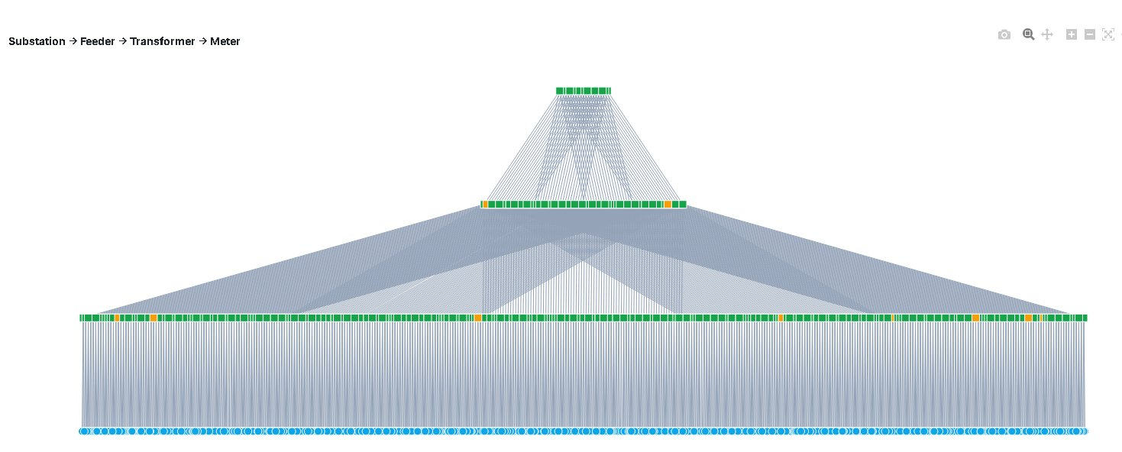
Figure 16: Digital Twin concept – the grid hierarchy linked to consumption, outages, maintenance and risk

14.3 Future enhancements
- Predictive asset risk: train an ML model on outage, maintenance and load history to forecast the future risk score per asset.
- Anomaly and demand forecasting: detect unusual meter and grid behaviour and forecast consumption and peak demand.
- Automated alerts: Streamlit and Cortex alerts on rising risk that trigger maintenance work orders automatically.
- Enable Snowpipe AUTO_INGEST with S3 event notifications and TARGET_LAG scheduling for fully hands-free refresh.
- Extend SCD Type 2 to meters and grid assets, and add weather and GIS enrichment.
- Introduce scheduled data-quality scorecards and exception trend analysis.
Roadmap: Gold data → feature engineering → ML model → prediction → Streamlit alert → automated action.

Chapter 15 – Delivery Tracking: Kanban Board and Burndown Chart

15.1 Five-day delivery plan
The project followed a five-day sprint with four team members. Work moved from domain analysis and ingestion, through IDMC cleansing and Silver validation, to Gold modelling and analytics, and finally to incremental loading, testing and the demo.
Day | Theme | Planned work | Status
Day 1 | Domain, AWS & Bronze | Dataset analysis, AWS S3 integration, Snowpipe configuration, IDMC mapping preparation | Done
Day 2 | IDMC data cleansing | Cleansing of customers, meters, readings, assets, maintenance, outages and events; clean & reject handling | Done
Day 3 | Silver & validation | Dataset validation, duplicate & DQ checks, Silver layer development, orphan handling | Done
Day 4 | Gold, modelling & analytics | Dimensions and facts, dynamic tables, four marts, Snowpark risk, RBAC & masking, Streamlit, Cortex | Done
Day 5 | Incremental load, test & demo | Incremental meter-reading load, end-to-end testing, reconciliation, final PPT, documentation & handover | Done

15.2 Chart 1 – Kanban board
The Kanban board allocates every task card to a team member and day and shows its status. All cards were marked Done at the end of the sprint.
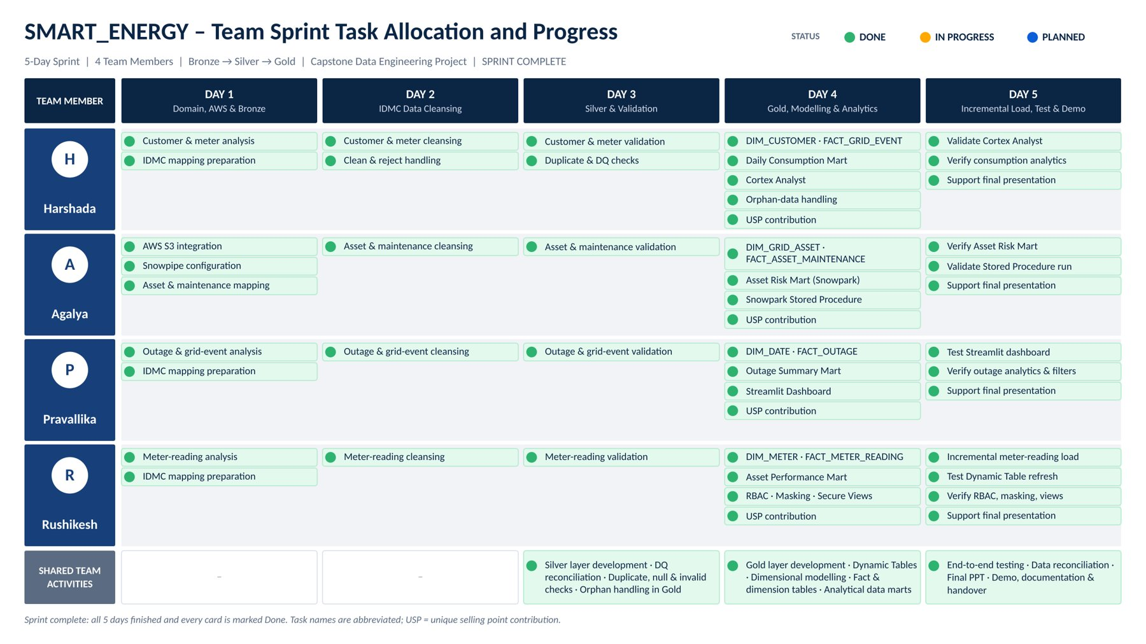
Figure 17: Chart 1: Team sprint task allocation and progress (Kanban board) – sprint complete

15.3 Chart 2 – Sprint burndown
The burndown chart is derived from the Kanban board (one card = one task unit, 49 task units in scope). Remaining work fell from 49 at the start to 40, 35, 30 and 20 at the end of Days 1 to 4, and to 0 at the end of Day 5. The burn ran behind the ideal line until Day 4; the remaining 20 units – 13 Day-5 cards plus 7 cards carried over from Day 4 – were completed on Day 5, giving 100% of scope delivered.
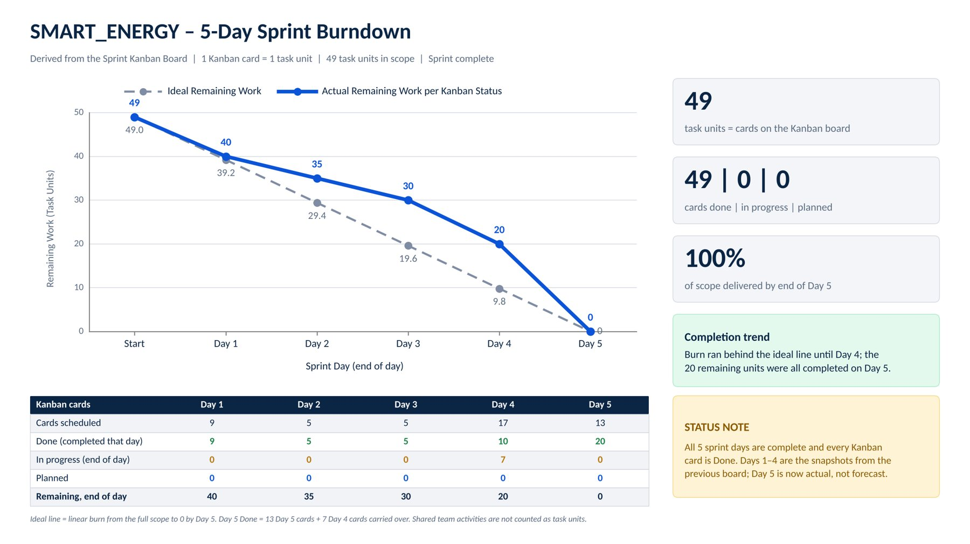
Figure 18: Chart 2: SMART_ENERGY 5-day sprint burndown – remaining task units per day

Appendix A – Submission Folder Structure and Execution Guide (README)

A.1 Solution folder structure
Project_Solution/
├── 01_source_capstone/ customers.csv, meters.csv, meter_readings.csv,
│ grid_assets.csv, outage_incidents.csv,
│ asset_maintenance.csv, grid_events.json
├── 02_cleaned_datasets/ *_CLEAN / *_VALID exports
├── 03_quarantine_datasets/ *_REJECT, *_INVALID, *_DUPLICATE exports (with REJECT_REASON)
├── 04_warning_datasets/ *_WARNING exports
├── 05_code/
│ ├── 01_ingestion/ SMART_ENERGY.sql
│ ├── 02_data_profiling/ DATA VALIDATION demo.sql
│ ├── 03_bronze_layer/ BRONZE.sql
│ ├── 04_silver_layer/ SILVER.sql, SILVER1.sql, schema_trnsprt.sql, IDMC exports
│ ├── 05_gold_layer/ SMART_ENERGY_GOLD_COMPLETE_VERIFIED.sql, CUST_SCD2.sql,
│ │ GOLD.sql, smart_energy_gold_marts.sql,
│ │ Stored_Procedure.sql, MART_ASSET_RISK.py
│ ├── 06_data_validation/ data validation final.sql, check_tables.sql, schema_Del.sql
│ ├── 07_workflows_orchestration/ run order (A.2), dynamic-table refresh commands
│ └── 08_analytics_dashboard/ streamlit_app.py, cortex_questions.sql, Security_Policies.sql
├── 06_validation_evidence/ count, reconciliation, orphan and masking screenshots/CSVs
├── 07_architecture_diagrams/ end-to-end architecture, fact constellation schema
├── 08_project_documentation/ Final_Project_Documentation.docx
├── 09_project_presentation/ Final_Project_Presentation.pptx
└── README.md

A.2 How to execute the solution
- Upload the seven source files to the S3 folder and update the role ARN and bucket path placeholders in SMART_ENERGY.sql (no credentials are stored in the code).
- Run SMART_ENERGY.sql, then BRONZE.sql; confirm Bronze row counts.
- Run the seven IDMC mappings and confirm the Silver CLEAN / WARNING / REJECT / DUPLICATE tables are populated (check_tables.sql).
- Run data validation final.sql and review the consolidated summary and rejection-reason breakdown.
- Run SILVER1.sql and schema_trnsprt.sql to hand off the validated tables.
- Set the warehouse name (COMPUTE_WH by default) and run SMART_ENERGY_GOLD_COMPLETE_VERIFIED.sql; then run CUST_SCD2.sql and GOLD.sql.
- Run smart_energy_gold_marts.sql, then CALL SP_BUILD_ASSET_RISK() from Stored_Procedure.sql.
- Run Security_Policies.sql and test each role.
- Create the Streamlit app from streamlit_app.py and configure Cortex Analyst; test with cortex_questions.sql.
- For new meter-reading files: load to Bronze, run the readings mapping, then ALTER DYNAMIC TABLE … REFRESH for DT_METER_READINGS and FACT_METER_READING.

A.3 Final submission verification
Checklist item | Where it is covered
All original source datasets included | 01_source_capstone/; Chapter 3
Cleaned, quarantine and warning datasets | 02_ / 03_ / 04_ folders; Chapter 6.4
Complete implementation code; Bronze, Silver and Gold logic | 05_code/; Chapters 4, 6, 7, 8, 9
Data-quality and validation results | 06_validation_evidence/; Chapters 5, 7, 12
Fact and dimension modelling documented | Chapter 8
Workflow and orchestration details | Chapter 10; Appendix A.2
Architecture and data-flow diagrams | 07_architecture_diagrams/; Chapter 3
Final documentation and PPT | 08_ and 09_ folders
README with execution instructions | README.md; Appendix A
Team member contributions documented | Chapter 13.4; Chapter 15

