Q1

Rainfall = [15.69, 5.68, 3.87, 5.79, 13.05, 4.30, 6.45, 8.33, 5.26, 4.36]

Table displaying amount added and profit for each year (and maybe soil nitrogen levels)

|  |  |  |
| --- | --- | --- |
| **Year** | **Apply (pounds/acre)** | **Profit ($/acre)** |
| 1 | 173 | 19.3194 |
| 2 | 155 | -1.9061 |
| 3 | 0 | 6.2238 |
| 4 | 0 | 13.1663 |
| 5 | 90 | 24.1412 |
| 6 | 148 | -7.1054 |
| 7 | 0 | 17.1082 |
| 8 | 0 | 18.6794 |
| 9 | 0 | 7.6954 |
| 10 | 0 | 5.1440 |
| **Total** | 566 | 102.4662 |

Q2

Separate graph for each year: x-axis is retained nitrogen level, y-axis is optimal amount to apply

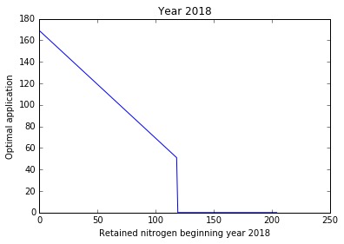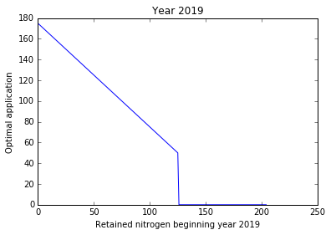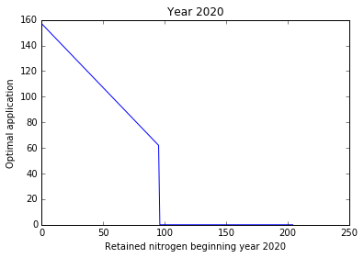2