一、引用JavaScript文件



<!--富文本编辑框所使用的js-->

<script src="../../assets/js/jquery.hotkeys.min.js"></script>

<script src="../../assets/js/bootstrap-wysiwyg.min.js"></script>

二、富文本编辑器JavaScript

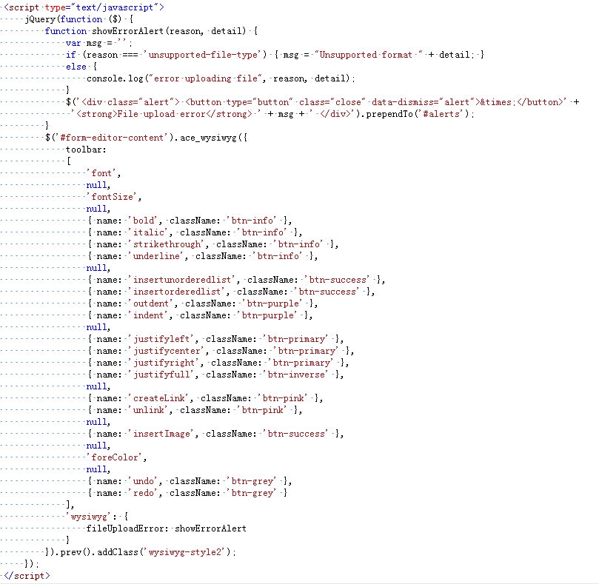

三、HTML

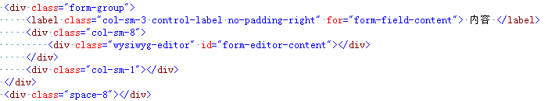

<div class="wysiwyg-editor" id="form-editor-content"></div>

<script type="text/javascript">

jQuery(function ($) {

function showErrorAlert(reason, detail) {

var msg = '';

if (reason === 'unsupported-file-type') { msg = "Unsupported format " + detail; }

else {

console.log("error uploading file", reason, detail);

}

$('<div class="alert"> <button type="button" class="close" data-dismiss="alert">&times;</button>' +

'<strong>File upload error</strong> ' + msg + ' </div>').prependTo('#alerts');

}

$('#form-editor-content').ace_wysiwyg({

toolbar:

[

'font',

null,

'fontSize',

null,

{ name: 'bold', className: 'btn-info' },

{ name: 'italic', className: 'btn-info' },

{ name: 'strikethrough', className: 'btn-info' },

{ name: 'underline', className: 'btn-info' },

null,

{ name: 'insertunorderedlist', className: 'btn-success' },

{ name: 'insertorderedlist', className: 'btn-success' },

{ name: 'outdent', className: 'btn-purple' },

{ name: 'indent', className: 'btn-purple' },

null,

{ name: 'justifyleft', className: 'btn-primary' },

{ name: 'justifycenter', className: 'btn-primary' },

{ name: 'justifyright', className: 'btn-primary' },

{ name: 'justifyfull', className: 'btn-inverse' },

null,

{ name: 'createLink', className: 'btn-pink' },

{ name: 'unlink', className: 'btn-pink' },

null,

{ name: 'insertImage', className: 'btn-success' },

null,

'foreColor',

null,

{ name: 'undo', className: 'btn-grey' },

{ name: 'redo', className: 'btn-grey' }

],

'wysiwyg': {

fileUploadError: showErrorAlert

}

}).prev().addClass('wysiwyg-style2');

});

</script>