**DFD Level 0**

**User**

**Object Master**

**Login**

**Admin**

**Design Master**

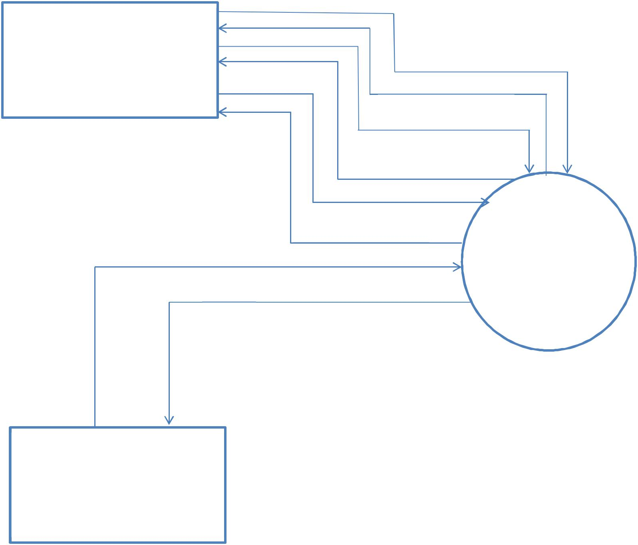

**Acknowledgment**

**Login**

**Acknowledgment**

**Register**

**Acknowledgment** **3D House**

**modeling In Virtual**

**Reality**

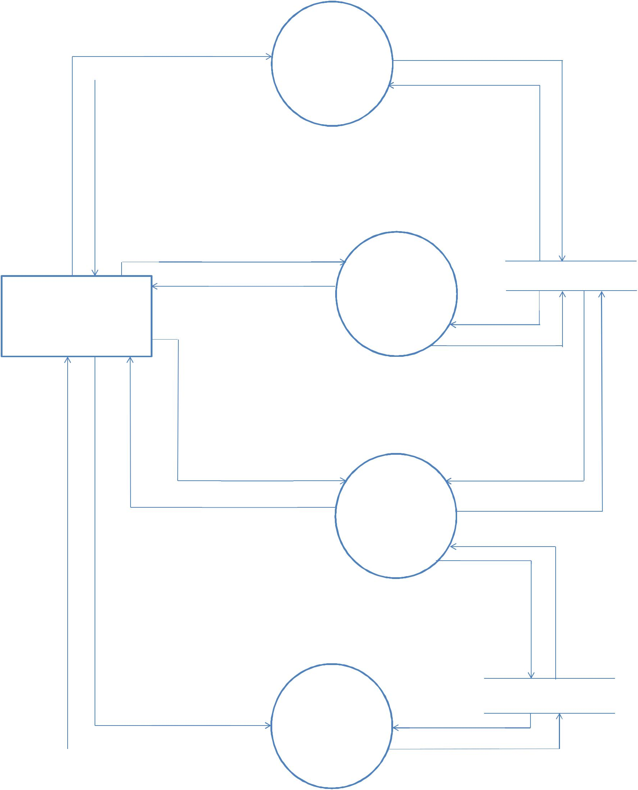

**DFD Level 1**

|  |  |
| --- | --- |
| **User Details** | **Register** |
| **Acknowledgment** |
|  |
|  |  |

**Username Password**

**Acknowledgment**

**User**

**Share Model**

**Acknowledgment**

|  |  |
| --- | --- |
| **Design Details** | **Design** |
| **Master** |
| **Acknowledgment** |
|  |

**User Details**

**Acknowledgment**

**User Master**

**Login**

**Acknowledgment**

**Username Password**

**Acknowledgment**

**Share Model**

**Share**

**Acknowledgment**

**Share Model**

**Design Master**

**Acknowledgment**

**Design Details**

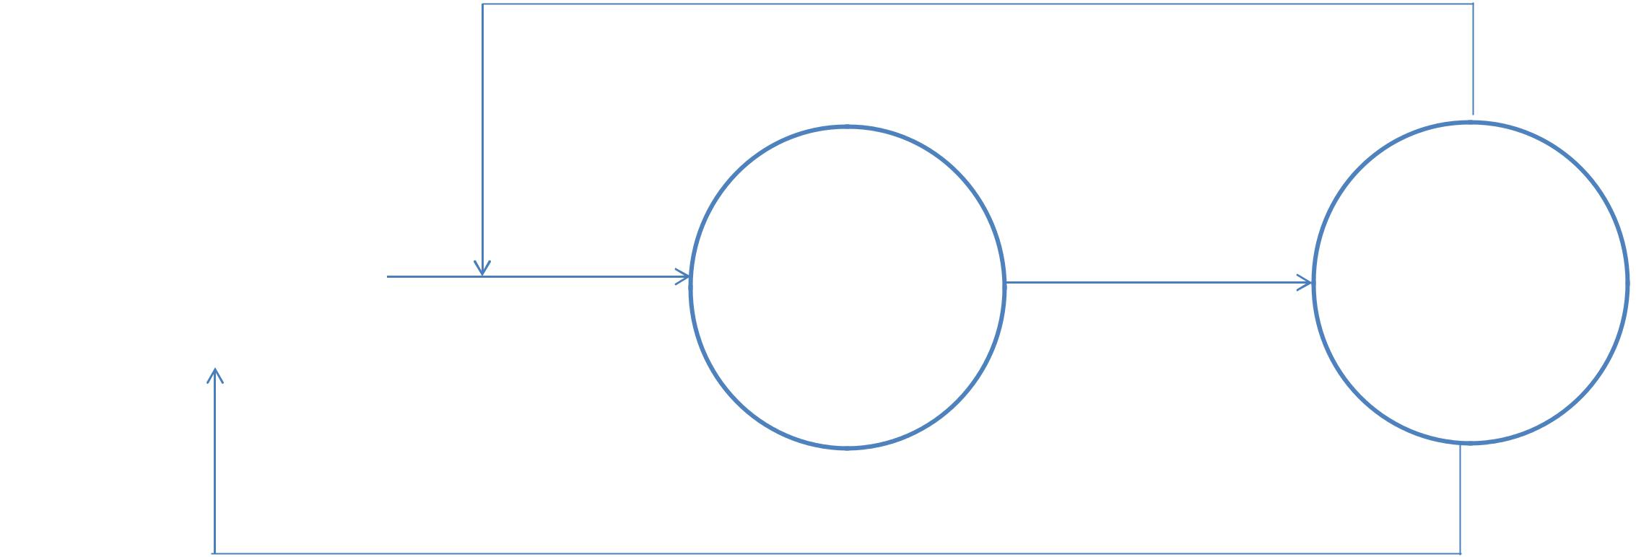

**DFD Level 2**

If false

|  |  |  |  |
| --- | --- | --- | --- |
|  | Username Password | 2.1 | 2.2 |
| User |  |
|  |  |  |
|  |  | Get | Validation |
|  |  | Credentials |
|  |  |  |
|  |  |  |  |

Acknowledgment

If true

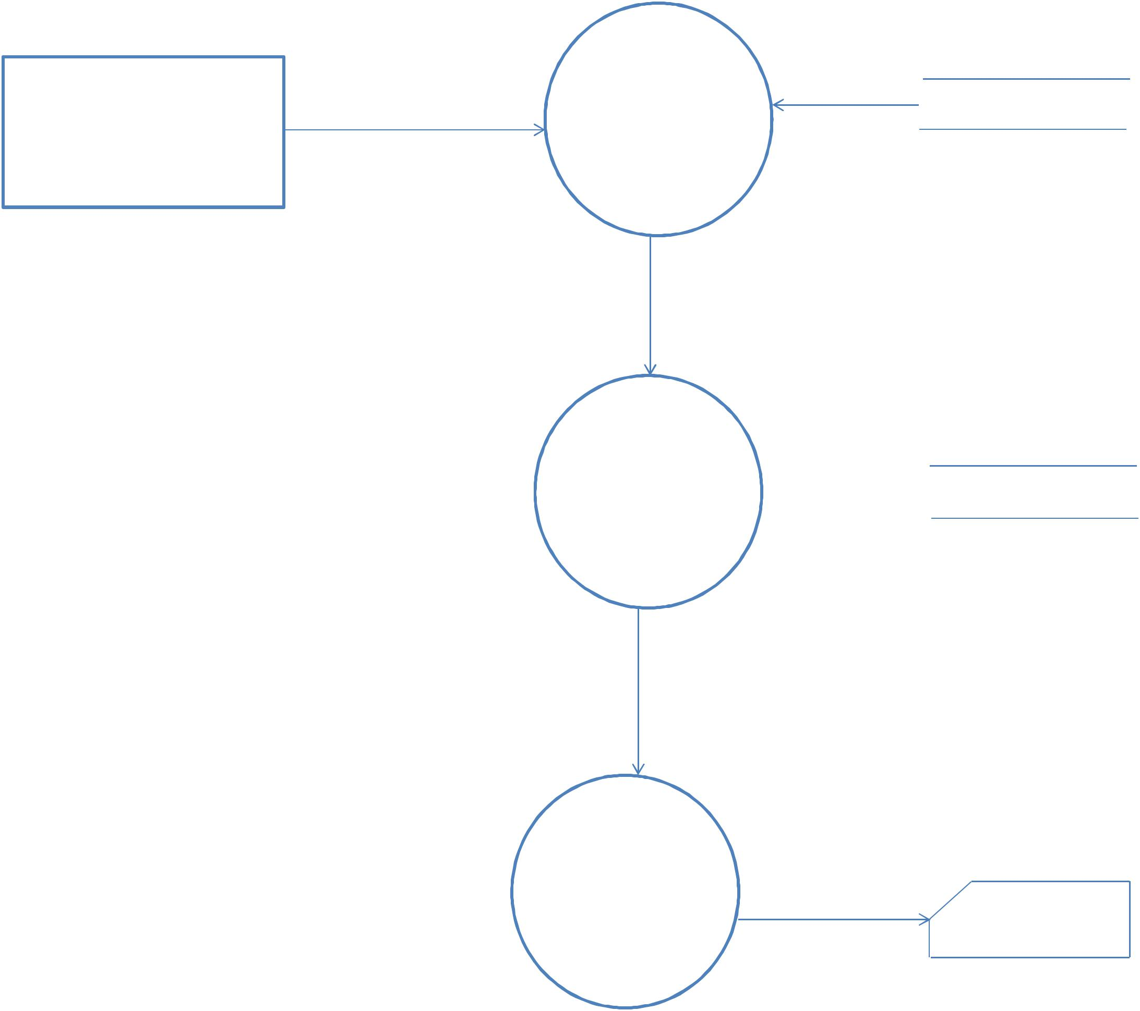

**DFD Level 3**

|  |  |  |
| --- | --- | --- |
|  | **3.1** |  |
| **User** | **Select** | **Design Model** |
|  |
|  | **Design** |  |

**3.2**

**Select User  User Master**

**3.3**

|  |  |
| --- | --- |
| **Share** | **Share** |
|  |

User

Design Object Properties

**DFD Level 4**

4.1

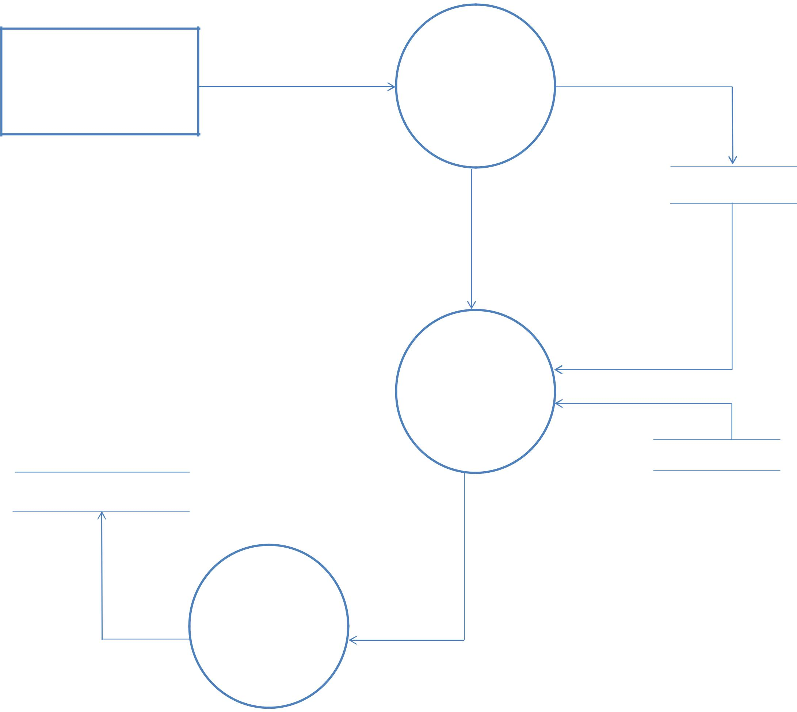

Save Design

4.2

Save Design

Object

4.3

Object

Properties

Design Master

ID

ID

Design Details