User

Object Master

Login

Admin

Design Master
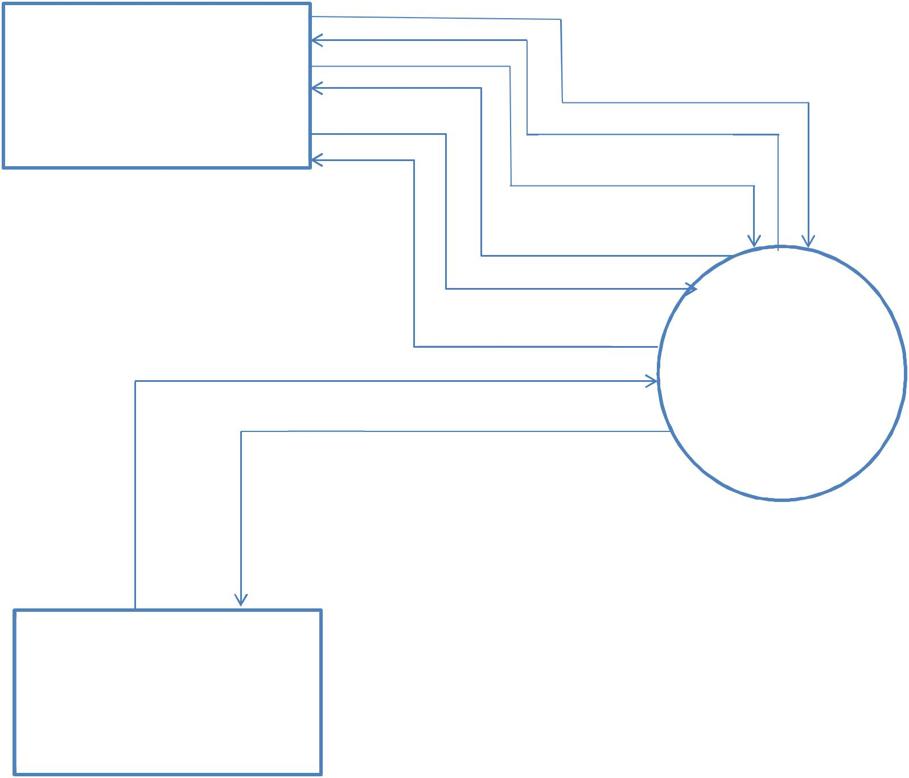

Acknowledgment

Login

Acknowledgment

Register

Acknowledgment 3D House

modeling In Virtual

Reality

