**ACKNOWLEDGEMENT**

We have taken efforts in this project. However, it would not have been possible without the kind support and help of many individuals and organizations. We would like to extend our sincere thanks to all of them.

We would like to appreciate Mr. Vinay Pandya for their guidance and constant supervision as well as for providing necessary information regarding the project & also for their support in completing the project. We would like to express my gratitude towards our parents & member of SSC for their kind co-operation and encouragement which help us in completion of this project. We would like to express my special gratitude and thanks to all professors for giving us such attention and time.

Our thanks and appreciations also go to our colleague in developing the project and people who have willingly helped us out with their abilities.

Smith Bhojak (156330307008)

Kishan Patel (156330307026)

Bhavin Panchasara (156330307047)

Kandarp Pandya (156330307049)

Pathik Shah (156330307104)

Megh Thakkar (156330307116)

I

## Table of Contents

ABSTRACT VI

Chapter 1 Introduction 1

1.1 Need for the New system 1

1.2 Detailed Problem Definition 1

1.3 Viability of the System 2

1.4 Presently Available Systems for the same 3

1.5 Future Prospects 4

Chapter 2 Analysis 5

2.1 Requirement Analysis 5

2.2 Project Model 5

2.3 Schedule Representation 6

2.4 Feasibility Study 7

Chapter 3 Design 9

3.1 Data Flow Diagram 9

3.2 ER-Diagram 16

Chapter 4 System Modeling 21

4.1 Database Design 21

Chapter 5 Technical Specification 31

5.1 Hardware Specification 31

5.1.1 RAM 31

5.1.2 Hard Drive Storage needed 31

5.1.3 Other Hardware requirement 31

5.2 Platform 32

5.2.1 Supported Operating System 32

5.2.2 Programming Server 32

II

5.2.3 Framework (if any) 32

5.3 Programming Languages used 32

5.3.1 Markup Language 32

5.3.2 Programming Language 33

5.3.3 Scripting Language (If any) 33

5.4 Technical Specification 33

5.4.1 Front-End 33

5.4.2 Back-End 33

5.4.3 IDE 34

5.4.4 UML Tools 34

5.4.5 SRS Tools 34

Conclusion 35

Bibliography 36

III

## Table INDEX

**1 SCHEDULE REPRESNETATION ….…………………………………….……………………………………….6**

2 USER_MASTER 22

3 DEVICE_MASTER 23

4 OBJECT_MASTER 24

5 MODEL_MASTER 25

6 MODEL_DETAILS 26

7 COLOR_MASTER 27

8 TYPE_MASTER 27

**9 PATTERN_MASTER ……………………………………………………………………………………………28**

10 TEXTURE_MASTER 28

11 NOTES_MASTER 29

12 MODEL_DESIGN 30

IV

**Figure INDEX**

1 PRESENTLY AVAILABLE SYSTEM …………………………………………………………………3

2 PRESENTLY AVAILABLE SYSTEM IN VR ……………………………………………………………3

**3 PROTOTYPE MODEL ………………………………………………………………………….5**

**4 SYMBOLS OF DATA FLOW DIAGRAM ……………………………………………………………….10**

5 LEVEL 0 DFD 11

6 LEVEL 1 DFD 12

7 LEVEL 2 DFD 13

8 LEVEL 2 DFD 14

9 LEVEL 2 DFD 15

10 ****SYMBOLS OF ENTITY RELATIONSHIP DIAGRAM**** ……..……………………………………………17

11 EXAMPLE OF RELATIONSHIPS 18

12 RELATIONSHIPS 19

13 ENTITY-RELATIONSHIP DIAGRAM 20

V

**ABSTRACT**

*3D House Modeling in Virtual Reality (VR) is an android application that allows Interior designer to create and design models using objects in 3D space. It is fully dynamic for developing 3D models, user can also modify at any time. It is Portable in the sense that after creating a model it can easily be shared and modified on other devices using the platform. Also the ability to create multiple models and work on them at same time is a feature that is not available on other existing products, and the system provides overall a better user experience and easy usability for the laymen.*

VI

**Chapter 1**

**INTRODUCTION**

* 1. **Need for new system**

The need of this system is to allow any interior designer or an architect to create a house model from the interior to the complete exterior. Users can create and design house models in 3D space using Virtual Reality Headset. Through this system user can have enhanced designing experience.

* 1. **Detailed Problem Definition**

Existing Systems have a Static Architecture, meaning the objects that are created in the environment can only be placed or removed from a specific location in the model, fixed numbers of objects are available and designing of the model is limited. User need to pay for additional functionalities. Their application lacks a user friendly experience. The cost increases gradually for creating multiple models as newer models are created from scratch and not from reusing resources.

1

* 1. **Viability of the system**

In this System we are providing Dynamic environment to user to create their particular own design model in it. Objects can be move from one place to another .User can Share their designed models from one system to another and that share model can also be edited .User can work with multiple models at a time .Best user experience so user can use it very easily in it .As it is free so it is affordable in terms of multiple systems development/designing so user do not have to pay to use for multiple systems.

* 1. **Presently Available Systems for the same**

Planner 5D (an android Application) is an existing system which allows a similar functionality.

2

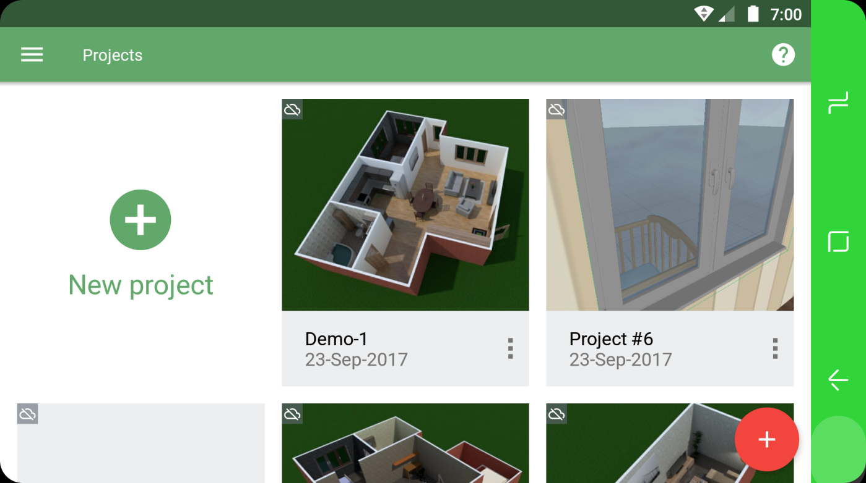

**FIG 1: PRESENTLY AVAILABLE SYSTEM**

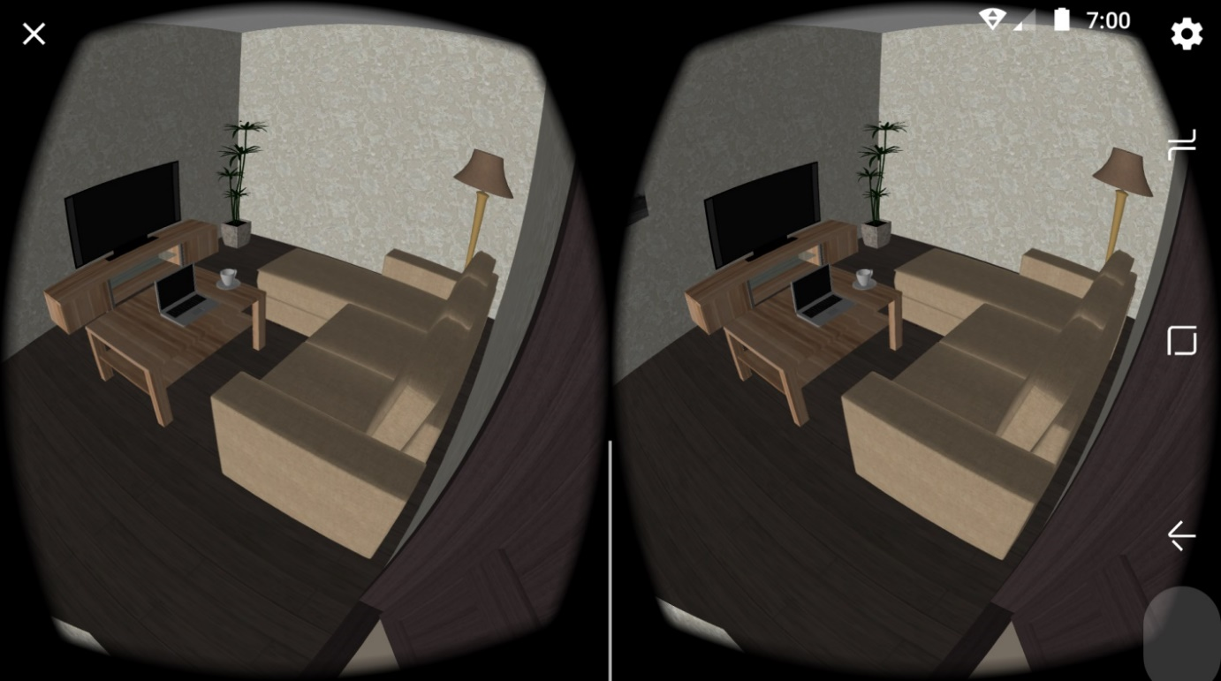

**FIG 2: PRESENTLY AVAILABLE SYSTEM IN VR**

3

* 1. **Future Prospects**

The main future prospect is user can use our application to design it will help to design building or skyscraper.

Future updates will allow user more options to create models using different objects in it.

We will provide very simple and easy user interface in it .Will allow to use it at very low costing rates

4

**Chapter 2**

**ANALYSIS**

**2.1 Requirement Analysis**

In [systems engineering](https://en.wikipedia.org/wiki/Systems_engineering) and [software engineering](https://en.wikipedia.org/wiki/Software_engineering), **requirements analysis** encompasses those tasks that go into determining the needs or conditions to meet for a new or altered product or project, taking account of the possibly conflicting [requirements](https://en.wikipedia.org/wiki/Requirement) of the various [stakeholders](https://en.wikipedia.org/wiki/Stakeholder_(corporate)), *analyzing, documenting, validating and managing* software or system requirements.

There is no such existing platform that provides exact functionalities which allows user to immerse into system for enhanced designing.

**2.2 Project Model**

Software Development Life Cycle (SDLC) is a process used by the software industry to design, develop and test high quality software. We will be using prototype model for the development of this system. In this model we will be creating the prototype of the system before creating the actual system.

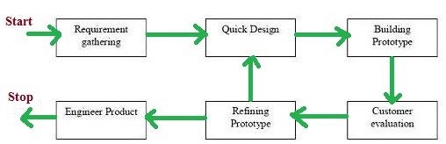

**FIG 3: PROTOTYPE MODEL**

5

**2.3 Schedule Representation**

Program evolution and review techniques (PERT) and critical path method (CPM) are two project scheduling method that can be applied to software development. Both techniques are driven by information already developed in earlier project planning activities:

* Estimate of effort.
* A decomposition of the product function.
* The selection of appropriate process model and task set.
* Decomposition of tasks.

**[Table:1 Schedule Representation]**

|  |  |  |
| --- | --- | --- |
| **ACTIVITY** | **START DATE** | **FINISH DATE** |
| Requirement Analysis |  |  |
| System Analysis |  |  |
| System Design |  |  |
| System Coding |  |  |
| Testing and Integration |  |  |

6

**2.4 Feasibility Study:**

The main objective of the feasibility study is to test the Technical, Operational and Economical feasibility for adding new modules and debugging old running system.

* + 1. **Technical Feasibility:**

The technical issue usually raised during the feasibility stage of the investigation includes the following:

Does the necessary technology exist to do what is suggested?

* Can the system be upgraded if developed?
* Are there technical guarantees of accuracy, reliability, ease of access and data security?
  + 1. **Operational Feasibility:**

Proposed projects are beneficial only if they can be turned out into information system. Operational feasibility aspects of the project are to be taken as an important part of the project implementation. Some of the important issues raised are to test the operational feasibility of a project includes the following:

* Is there sufficient support for the management from the users?
* Will the system be used and work properly if it is being developed and implemented?
* Will there be any resistance from the user that will undermine the possible application benefits

7

* + 1. **Economical Feasibility:**

A system can be developed technically and that will be used if installed must still be a good investment for the organization. In the economic feasibility, the development cost in creating the system is evaluated against the ultimate benefit derived from the new systems. Financial benefits must equal or exceed the costs. The system is economically feasible. It does not require any addition hardware or software. There is nominal expenditure and economic feasibility for certain**.**

8

**Chapter 3**

**DESIGN**

**3.1 Data flow diagram**

A data flow diagram (DFD) is a graphical representation of the "flow" of data such as customer names and transaction details through an [information system](https://en.wikipedia.org/wiki/Information_system) like the point of sale (POS) software that would be installed on a register. DFDs can also be used for the visualization [data processing](https://en.wikipedia.org/wiki/Data_processing) (structured design).

**3.1.1 Symbols for Data Flow Diagram**

1) **Process Notations:** A process transforms incoming data flow into outgoing data flow.

2) **Data store Notations.** Data stores are repositories of data in the system. They are sometimes also referred to as files.

3) **Dataflow Notations.** Dataflow is pipeline through which packets of information flow. Label the arrows with the name of the data that moves through it

4) **External Entity Notations.** External entities are objects outside the system, with which the system communicates. External entities are sources and destinations of the system's inputs and outputs.

9

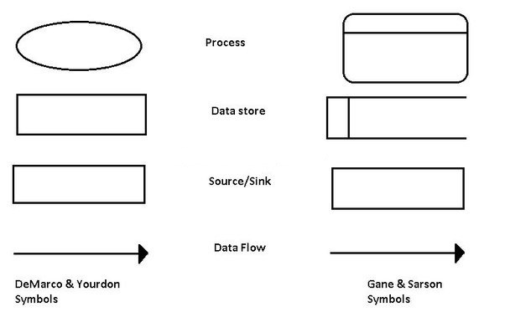

**FIG 4: SYMBOLS OF DATA-FLOW DIAGRAM**

10

**Level 0**

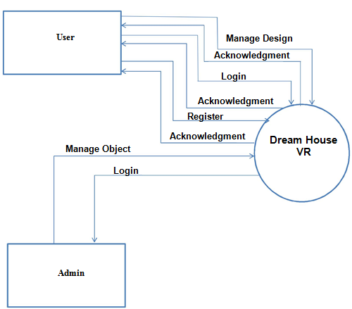

**FIG 5: LEVEL 0 DATA FLOW DIAGRAM**

11

**Level 1**

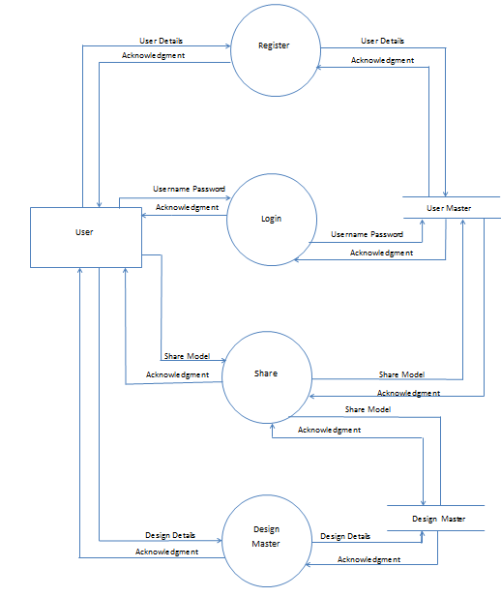

**FIG 6: LEVEL 1 DATA FLOW DIAGRAM**

12

**Level 2**

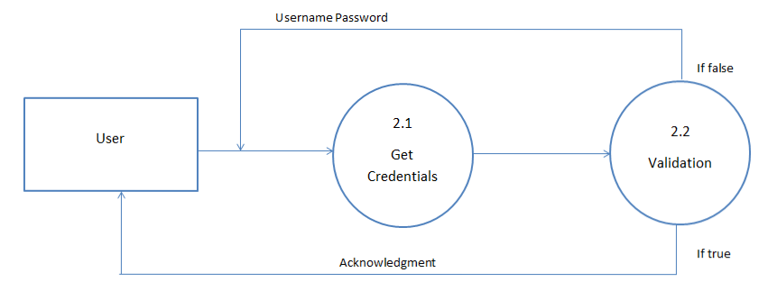

**FIG 7: LEVEL 2 DATA FLOW DIAGRAM**

13

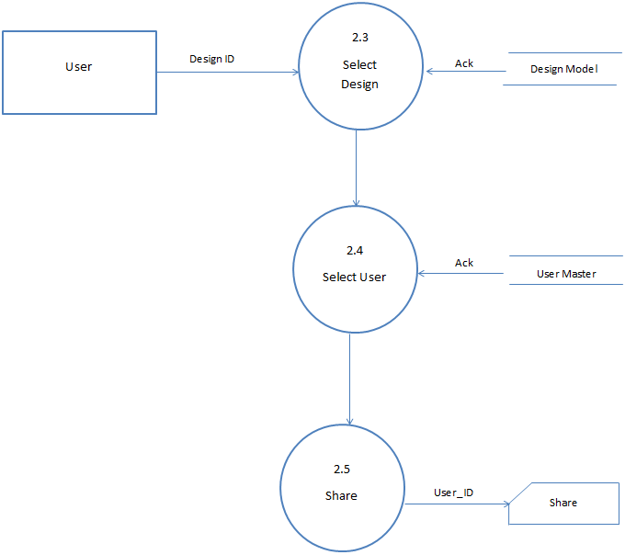

**FIG 8: LEVEL 2 DATA FLOW DIAGRAM**

14

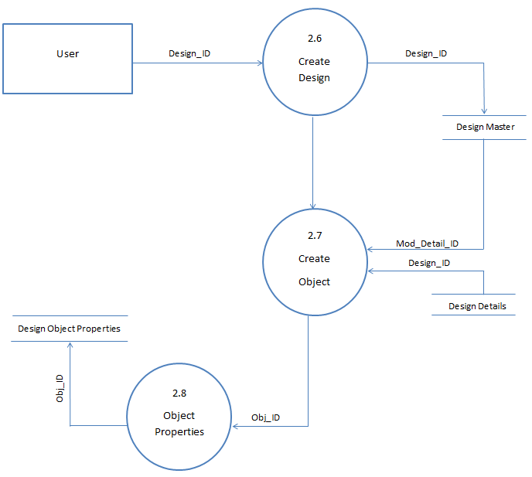

**FIG 9: LEVEL 2 DATA FLOW DIAGRAM**

15

**3.2 Entity Relationship Diagram**

An entity relationship diagram (ERD) shows the relationships of entity sets stored in a database. An entity in this context is a component of data. In other words, ER diagrams illustrate the logical structure of databases.

At first glance an entity relationship diagram looks very much like a [flowchart](https://www.smartdraw.com/flowchart/). It is the specialized symbols, and the meanings of those symbols, that make it unique.

**3.2.1 Symbols**

**Entities**: which are represented by rectangles .An entity is an object or concept about which you want to store information

A **weak entity** is an entity that must defined by a foreign key relationship with another entity as it cannot be uniquely identified by its own attributes alone.

**Actions**: which are represented by diamond shapes, show how two entities share information in the database.

**Attributes**: which are represented by ovals. A key attribute is the unique, distinguishing characteristic of the entity. For example, an employee's social security number might be the employee's key attribute.

**A multivalued attribute** can have more than one value. For example, an employee entity can have multiple skill values.

16

A **derived attribute** is based on another attribute. For example, an employee's monthly salary is based on the employee's annual salary.

**Connecting lines**: solid lines that connect attributes to show the relationships of entities in the diagram.

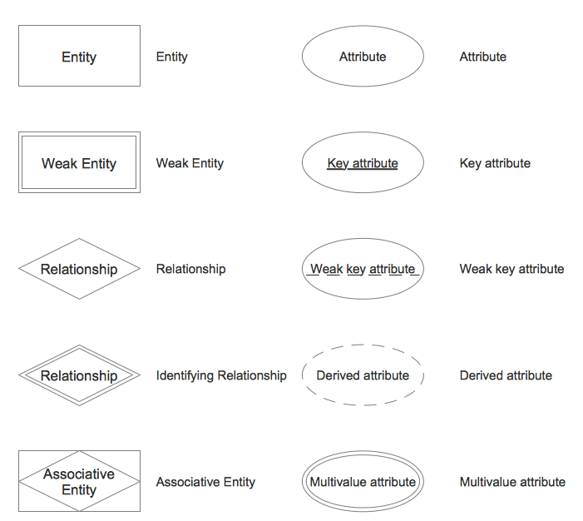

**FIG 10: SYMBOLS OF ENTITY RELATIONSHIP DIAGRAM**

**17**

**Cardinality:** specifies how many instances of an entity relate to one instance of another entity. Ordinality is also closely linked to cardinality. While cardinality specifies the occurrences of a relationship, ordinality describes the relationship as either mandatory or optional. In other words, cardinality specifies the maximum number of relationships and ordinality specifies the absolute minimum number of relationships.

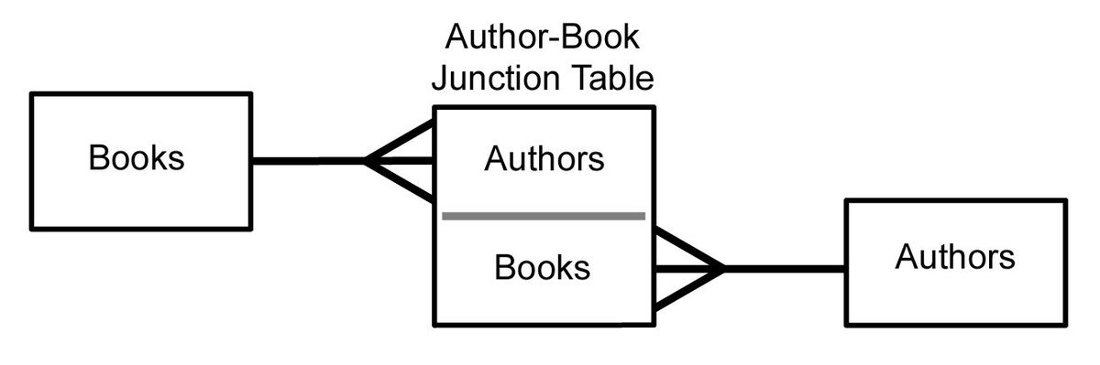

**FIG 11: EXAMPLE OF RELATIONSHIPS**

There are many notation styles that express cardinality.

**18**

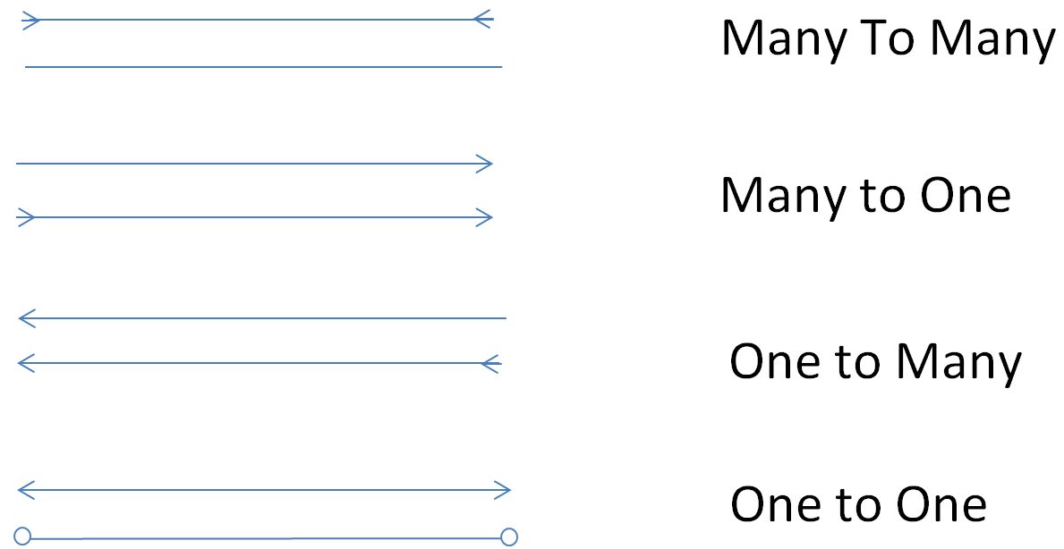

**FIG 12: RELATIONSHIPS**

19



**FIG 13: ENTITY-RELATIONSHIP DIAGRAM**

20

**Chapter 4**

**SYSTEM MODELING**

**4.1 Database Design**

**Database design** is the process of producing a detailed [data model](https://en.wikipedia.org/wiki/Data_model) of [database](https://en.wikipedia.org/wiki/Database). This data model contains all the needed logical and physical design choices and physical storage parameters needed to generate a design in a [data definition language](https://en.wikipedia.org/wiki/Data_definition_language), which can then be used to create a database. A fully attributed data model contains detailed attributes for each entity. The term database design can be used to describe many different parts of the design of an overall [database system](https://en.wikipedia.org/wiki/Database_system). Principally, and most correctly, it can be thought of as the logical design of the base data structures used to store the data.

21

1. **USER_MASTER**

**[USER_MASTER]**

|  |  |  |  |
| --- | --- | --- | --- |
| **FIELD** | **DATATYPE** | **CONSTRAINTS** | **DESCRIPTION** |
| User_Id | Number(4) | Primary Key | User_id must be required |
| U_name | Varchar2(20) | Not null | User name is required |
| Password | Varchar2(10) | Not null | Login password is must be required |
| Firstname | Char(10) | Not null | Firstname of user |
| Lastname | Char(10) | Not null | Lastname of user |
| Email_id | Varchar2(40) | Unique | Email_id of User |
| Gender | Char(6) | Null Accepted | Gender of user |
| Mobile_no | Number(10) | Unique | Contact Number of User |
| Device_id | Number(6) | Foreign key | Device_id from DEVICE_MASTER table |

22

1. **DEVICE_MASTER**

**[DEVICE_MASTER]**

|  |  |  |  |
| --- | --- | --- | --- |
| **FIELD** | **DATATYPE** | **CONSTRAINTS** | **DESCRIPTION** |
| Device_id | Number(6) | Primary key | Device_id must be required |
| Device_brand | Char(20) | Null accepted | Brand name of device |
| Device_type | Varchar2(10) | Not null | Device type of user |
| Device_model | Varchar2(10) | Null accepted | Model no. of device |
| Device_iemi_no | Varchar2(10) | Null accepted | IEMI no. of device |
| Internet_type | Varchar2(10) | Null accepted | Type of internet used in device |
| Device_OS | Char(30) | Not null | OS used in device |

23

1. **OBJECT_MASTER**

**[OBJECT_MASTER]**

|  |  |  |  |
| --- | --- | --- | --- |
| **FIELD** | **DATATYPE** | **CONSTRAINTS** | **DESCRIPTION** |
| Obj_Id | Number(6) | Primary key | Obj_Id must be required |
| Obj_name | Varchar2(10) | Not null | Name of the object |
| Img_path | Varchar2(100) | Not null | Path of the image saved |
| Obj_Height | Number(4) | Not null | Height of the object |
| Obj_Width | Number(4) | Not null | Width of the object |
| Obj_depth | Number(4) | Not null | Depth of the object |
| Obj_remark | Text | Null accepted | Remarks |

24

1. **MODEL_MASTER**

**[MODEL_MASTER]**

|  |  |  |  |
| --- | --- | --- | --- |
| **FIELD** | **DATATYPE** | **CONSTRAINTS** | **DESCRIPTION** |
| ID | Number(6) | Primary key | Model_id must be required |
| User_Id | Number(6) | Foreign key | Id of user from user_master table |
| Created_on | Date | Null accepted | Date of creation |
| Created_by | NUMBER(6) | Foreign Key | ID FROM USER_MASTER TABLE |
| Modify_on | Date | Null accepted | Date of modification |
| Modify_by | NUMBER(6) | Foreign Key | ID FROM USER_MASTER TABLE |
| Mod_Name | Char(10) | Primary Key | Name of the model |
| Mod_description | Text | Null accepted | Description given of model |

25

1. **MODEL_DETAILS**

**[MODEL_DETAILS]**

|  |  |  |  |
| --- | --- | --- | --- |
| **FIELD** | **DATATYPE** | **CONSTRAINTS** | **DESCRIPTION** |
| ID | NUMBER(6) | Primary Key | ID MUST BE REQUIRED |
| OBJ_ID | NUMBER(6) | Foreign Key | ID of object_ master table |
| Mod_Id | Number(6) | Foreign key | Id of model from MODEL_MASTER table |
| Pos_x | Number(3) | Not null | X-axis of model |
| Pos_y | Number(3) | Not null | y-axis of model |
| Pos_z | Number(3) | Not null | z-axis of model |
| Height_y | Number(3) | Not null | Height of y-axis |
| Width_x | Number(3) | Not null | Width of x-axis |
| Depth_z | Number(3) | Not null | Depth of z-axis |
| Mod_Opacity | Number(3) | Not null | Transparency of model(0 OR 1) |

26

1. **COLOR_MASTER**

**[COLOR_MASTER]**

|  |  |  |  |
| --- | --- | --- | --- |
| **FIELD** | **DATATYPE** | **CONSTRAINTS** | **DESCRIPTION** |
| Col_Id | Number(6) | Primary Key | Id of the color must be required |
| Col_Name | Char(10) | Not null | Name of color |
| Hex_code | Varchar2(6) | Not null | Hexadecimal code for color |

1. **TYPE_MASTER**

**[TYPE_MASTER]**

|  |  |  |  |
| --- | --- | --- | --- |
| **FIELD** | **DATATYPE** | **CONSTRAINTS** | **DESCRIPTION** |
| Type_Id | Number(6) | Primary Key | Id must be required |
| Type_Name | Char(10) | Not null | Type of object |
| Type_remark | Char(500) | Null accepted | Remarks |

27

1. **PATTERN_MASTER**

**[PATTERN_MASTER]**

|  |  |  |  |
| --- | --- | --- | --- |
| **FIELD** | **DATATYPE** | **CONSTRAINTS** | **DESCRIPTION** |
| Patn_Id | Number(6) | Primary Key | Pattern id must be required |
| Patn_Name | Char(10) | Not null | Pattern name |
| Patn_Img | Varchar2(100) | Not null | Image pattern path |

1. **TEXTURE_MASTER**

**[TEXTURE_MASTER]**

|  |  |  |  |
| --- | --- | --- | --- |
| **FIELD** | **DATATYPE** | **CONSTRAINTS** | **DESCRIPTION** |
| Tex_Id | Number(6) | Primary Key | Texture id must be required |
| Tex_Name | Char(10) | Not null | Texture name |
| Tex_Img | Varchar2(100) | Not null | Texture image path |

28

1. **NOTES_DES**

**[NOTES_DES]**

|  |  |  |  |
| --- | --- | --- | --- |
| **FIELD** | **DATATYPE** | **CONSTRAINTS** | **DESCRIPTION** |
| Note_Id | Number(6) | Primary Key | Id must be required |
| Note_Des | Char(40) | Null accepted | Description of the notes |
| Mod_Detail_Id | Number(6) | Foreign Key | Id of model from table MODEL_DETAILS |

29

1. **MODEL_DESIGN**

**[MODEL_DESIGN]**

|  |  |  |  |
| --- | --- | --- | --- |
| **FIELD** | **DATATYPE** | **CONSTRAINTS** | **DESCRIPTION** |
| ID | NUMBER(6) | Primary Key | ID MUST BE REQUIRED. |
| Design_Id | Number(6) | Unique | Id must be required |
| Mod_Detail_Id | Number(6) | Foreign Key | Id of model from table MODEL_DETAILS |
| Side_No | Number(2) | Unique | Different sides of object |
| Col_Id | Number(6) | Foreign Key | Id from table COLOR_MASTER |
| Pat_Id | Number(6) | Foreign Key | Id from table  PATTERN_MASTER |
| Tex_Id | Number(6) | Foreign Key | Id from table TEXTURE_MASTER |
| Type_Id | Number(6) | Foreign Key | Id of type from table TYPE_MASTER  TYPE_ID |

30

**Chapter 5**

**TECHNICAL SPECIFICATION**

**5.1 Hardware Specification**

**5.1.1 RAM**

-Minimum 2GB is required.

**5.1.2 Hard Drive Storage Required**

-Minimum 100 MB required.

**5.1.3 Other Hardware requirement**

-Virtual Reality headset.

31

**5.2 Platform**

**5.2.1 Supported Operating System**

-Minimum OS Android 5.1 LOLLIPOP.

**5.2.2 Programming Server**

-None.

**5.2.3 Framework (if any)**

-None

**5.3 Programming Languages used**

**5.3.1 Markup Language**

-eXtensible Markup Language (XML).

32

**5.3.2 Programming Language**

-Java.

**5.3.3 Scripting Language (If any)**

-None.

**5.4 Technical Specification**

**5.4.1 Front-End**

-Java.

**5.4.2 Back-End**

-SQLite

**5.4.3 IDE**

-Android Studio.

33

**5.4.4 UML Tools**

-Edrawmax

**5.4.5 SRS Tools**

**-**Microsoft Office 2016

34

**CONCLUSION:**

From this project we learnt about various technologies such as Core Java, Basics of Android, Database designing and various diagrams such Entity Relationship Diagram and Data Flow Diagrams, and basic of software engineering.

35

## BIBLIOGRAPHY

BOOK REFERENCE

[1] *Kathy Sierra and Bert Bates* “Working with Strings and Arrays”, *ORACLE OCA/OCP Java SE 7 Programmer I & II Study Guide, IZO-803 and IZO-804.*

[2] *Ed Burnette* “Android Fragments”, *Hello Android Introducing Google’s Development Platform, The Pragmatic Bookshelf, Third Edition*.

# [3] *Roger Pressman “*Software Engineering: A Practitioner's Approach”

*McGraw Hill Education; 7 edition*

36

WEB REFERENCE

[1] “Entity-Relationship Model Concepts”,

[*https://www.tutorialspoint.com/dbms/er_model_basic_concepts.htm*](https://www.tutorialspoint.com/dbms/er_model_basic_concepts.htm)

[2] “Entity-Relationship Model Representation”,

[*https://www.tutorialspoint.com/dbms/er_diagram_representation.htm*](https://www.tutorialspoint.com/dbms/er_diagram_representation.htm)*, <https://www.smartdraw.com/entity-relationship-diagram>*

[3] “Data Flow Diagrams”,

[*https://www.lucidchart.com/pages/data-flow-diagram/c?dfd=1*](https://www.lucidchart.com/pages/data-flow-diagram/c?dfd=1) *,*

[*https://www.smartdraw.com/data-flow-diagram*](https://www.smartdraw.com/data-flow-diagram)*,* [*https://www.tutorialspoint.com/programming_methodologies_training/data_flow_diagram.asp*](https://www.tutorialspoint.com/programming_methodologies_training/data_flow_diagram.asp)

[4] “JAVA”, <https://www.javatpoint.com/java-tutorial>,

<https://www.tutorialspoint.com/java/index.htm>

[5] “Android”, <https://www.tutorialspoint.com/android>,

<https://www.javatpoint.com/android-tutorial>

37