**Introduction to Open-Source Software**

B. Tech Integrated /Computer / Sem IV

**PART A**

(PART A: TO BE REFFERED BY STUDENTS)

**Experiment No.08**

**A.1—Aim:**

Introduction to Libre Office tools.

**A.2--- Prerequisite:**

LibreOffice - formerly known as OpenOffice.org – is a freely available suite of office applications that you can download and install for free without any copyright infringement.OpenOffice.org has been taken over by Oracle and is no longer open-source software. LibreOffice suite was developed in 2010 by The Document Foundation – a non-profit organisation that promotes open-source document handling software. LibreOffice suite is a fork of OpenOffice, meaning the underlying source code is the same, but the software

has gone in a different development direction. LibreOffice is a comprehensive, professional-quality office tool available in more than 114 languages and for all major operating systems, including Microsoft Windows, FreeBSD, Mac OSX and Linux (Debian, Ubuntu, Fedora, Mandriva, Suse, ...). LibreOffice is user-friendly. It offers a simple-to-use yet powerful interface that is easy to personalise. Its native file format is Open Document Format (ODF), an open standard format. Since it stores data in an international open standard format, it is therefore compatible with all major file formats.

**LibreOffice Components**

LibreOffice suite components include word process, spreadsheet, presentation graphics

and database, drawing and math tools.

Office Tools

* Writer: It is a word processor and a text editor, similar to Microsoft Word or

WordPerfect. Usually a file created by Writer is saved as ODT (Open Document

File Text Document) with an .ODT file format. Writer can also read and edit files

from other word processors with .DOC, .DOCX, .RTF, etc. file formats.

* Calc: It is a spreadsheet application, similar to Microsoft Excel or Lotus 1-2-3. It

is a tool for creating and editing data sheets. Based on data series, it can also

generate different charts. Usually, a file created by Calc is saved as ODS (Open

Document File Spreadsheet Document) with an .ODS file format. Calc can also

read and edit files from other spreadsheet applications with .XLS, .XLSX, .XLT,

etc. file formats.

* Impress: It is a presentation application, similar to Microsoft PowerPoint or Apple

Keynote. Usually, a file created by Impress is saved as ODP (Open Document

File Presentation Document) with an .ODP file format. Impress can also read and

edit files from other presentation applications with .PPT, .PPTX, .PPS, etc. file

formats.

* Base: It is a database management application, similar to Microsoft Access or

FoxPro.

* Draw: It is a drawing editor, similar to Microsoft Paint or CorelDraw.
* Math. It is a tool for creating and editing mathematical formulae

**A.3--- Tasks:**

1. An article, regarding the impacts of climate change is given in the same

folder in with the file name, Climate_Change.ott. Open this file in LibreOffice

Writer and create a new **heading style** with the name **style21** defining the following

features. (The new style has to be created under **Heading 2** in the **Heading styles**)

Font family - Bitstream Charter

Font Size - 105 % or 16pt

Font color - Purple

Add Shadow effect.

Add the style, **style21** to all the subheadings in the article. (Subheadings are marked

in green colour)

Save the modified file.

2. An article, describing the major freedom struggles of Indian Independence

Movement is given in the same folder with the file name,

Freedom_Struggle.ott. Open this file in LibreOffice Writer and add table of contents in

page 2. The table of contents has to be inserted using the **Table of Contents and**

**Index** option of LibreOffice Writer.

Hints:

• Use the style **Heading 1** to subheadings. (Subheadings are marked in blue

colour)

Save the modified file.

**(PART - B)**

(TO BE COMPLETED BY STUDENTS)

(Students must submit the soft copy as per following segments within two hours of the practical.

The soft copy must be uploaded on the Blackboard or emailed to the concerned lab in charge faculties at the end of the practical in case there is no Black board access available)

|  |  |
| --- | --- |
| Roll.No. : C109 | Name: Tanishq Nabar |
| Sem/Year : 4/2 | Batch: C2 |
| Date of Experiment : | Date of Submission: |
| Grade -- |  |

# B.1: Procedure of performed experiment

(students are expected to write the reason of the choice of topology and device)

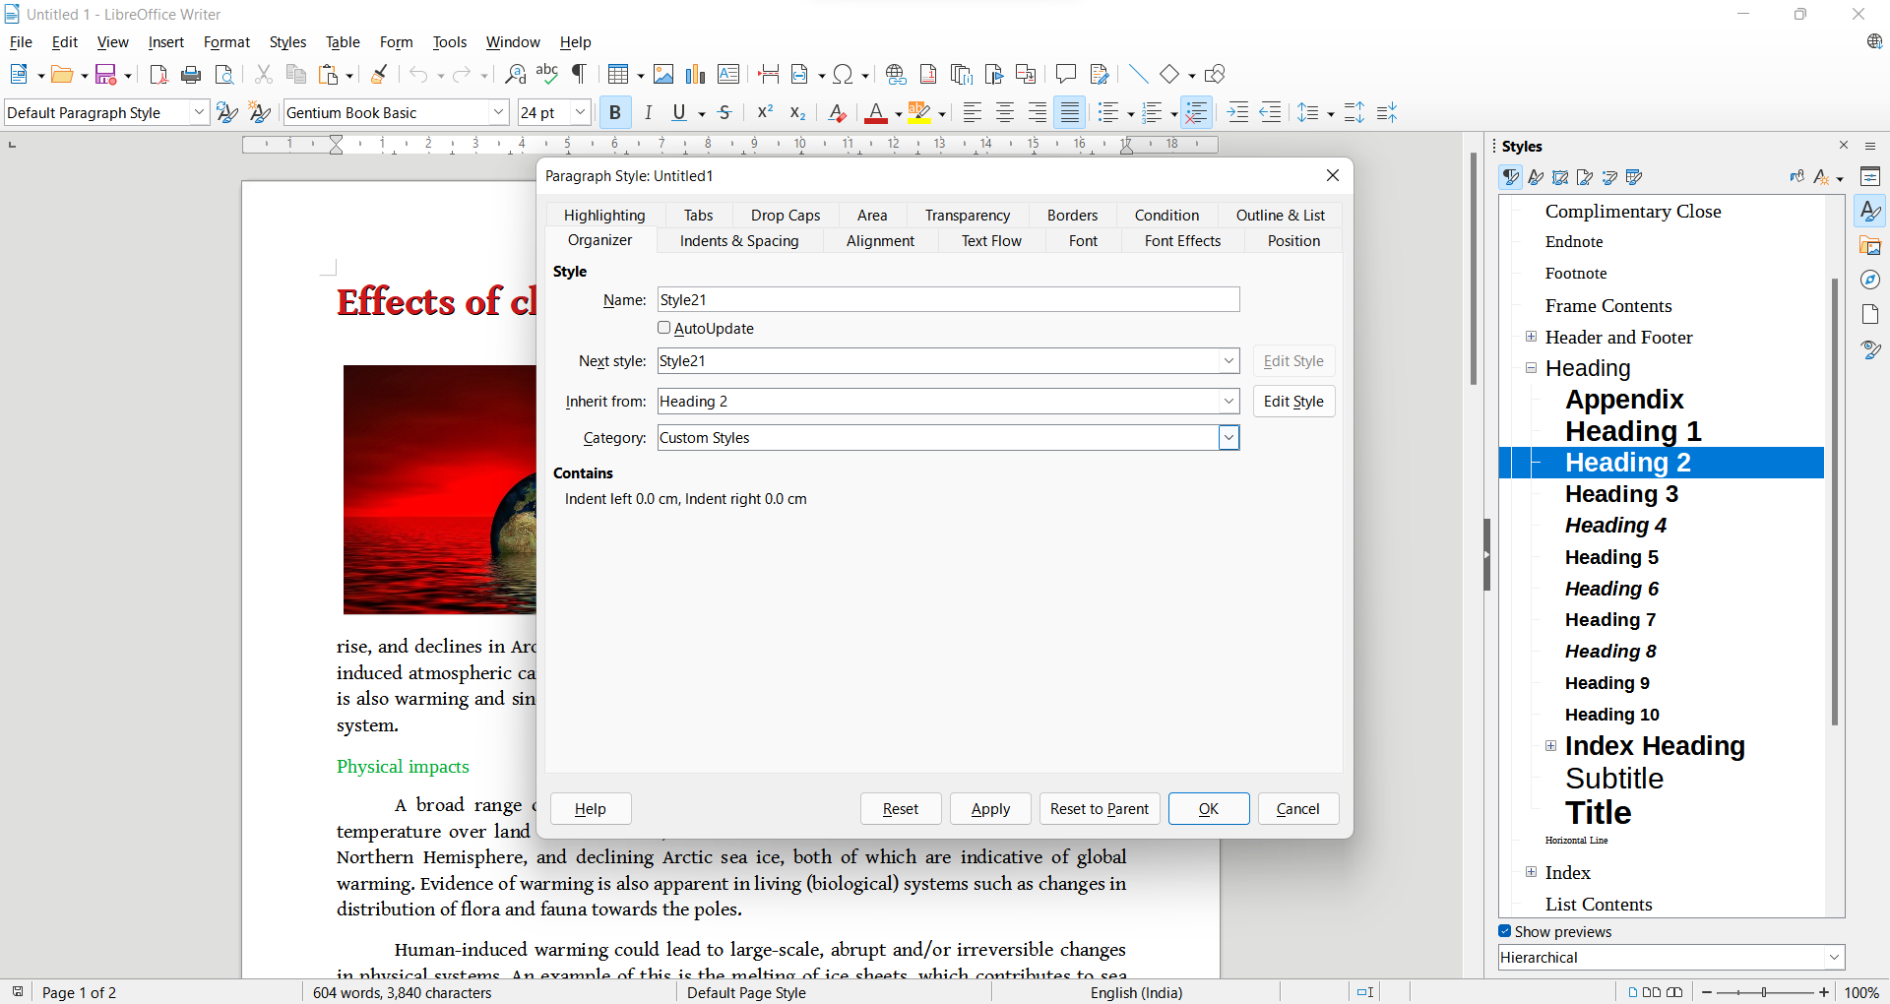

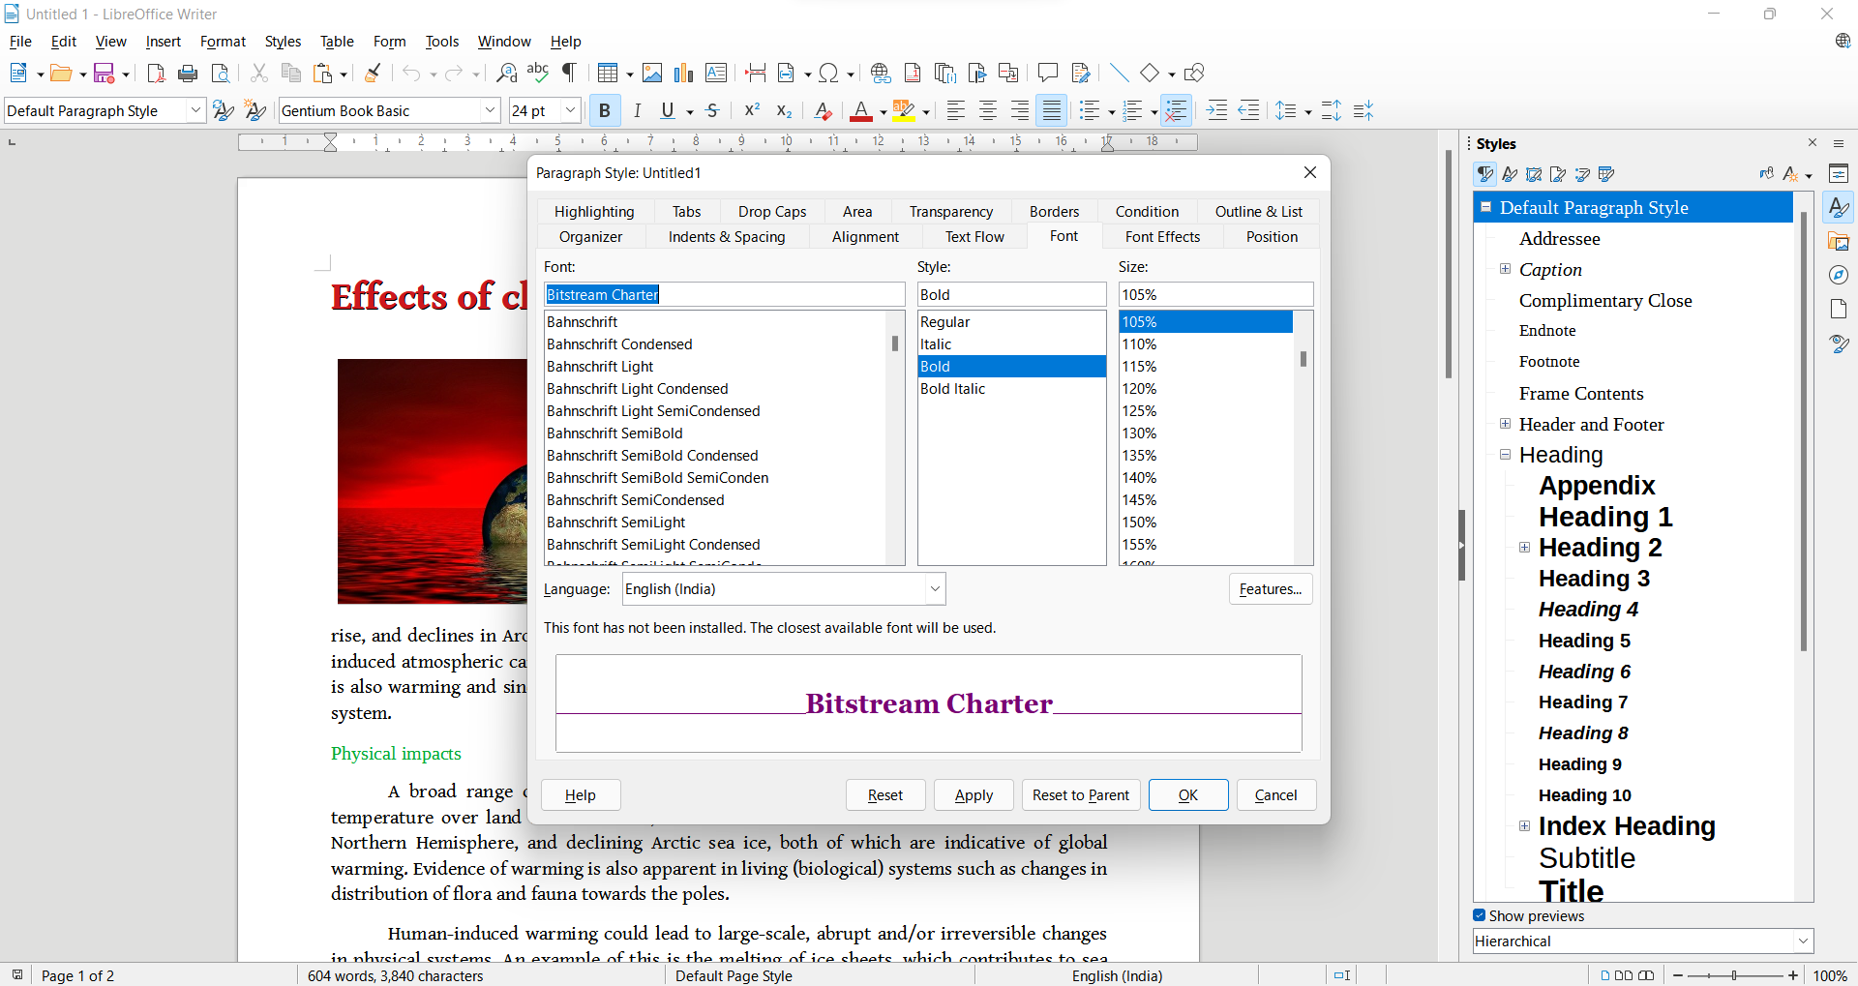

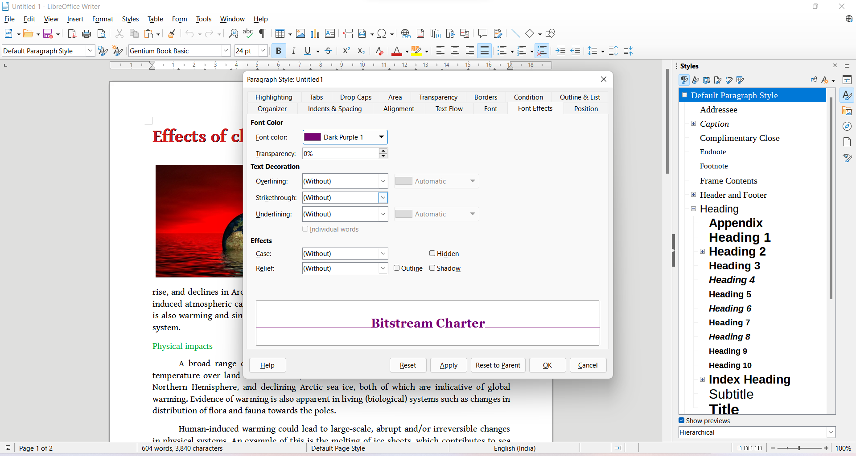

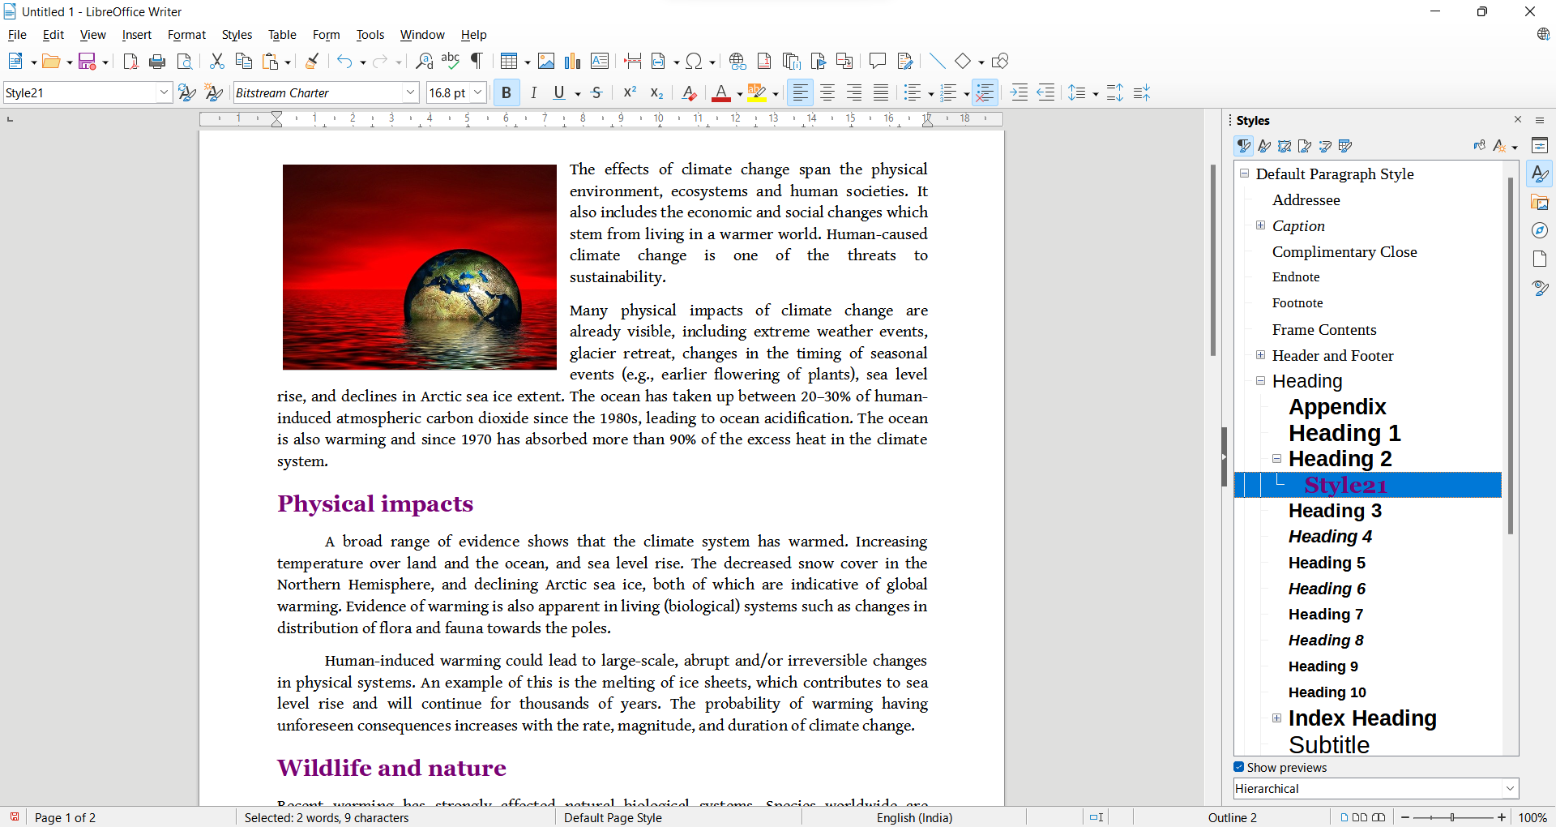

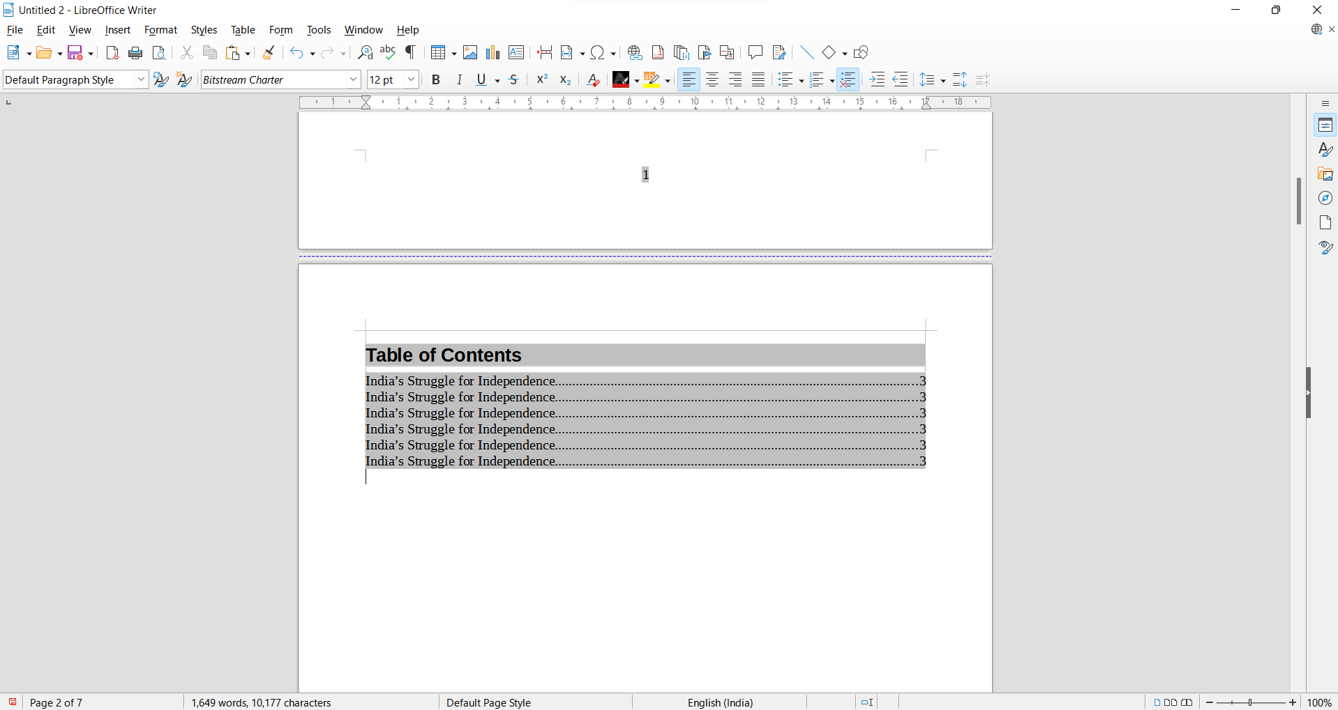

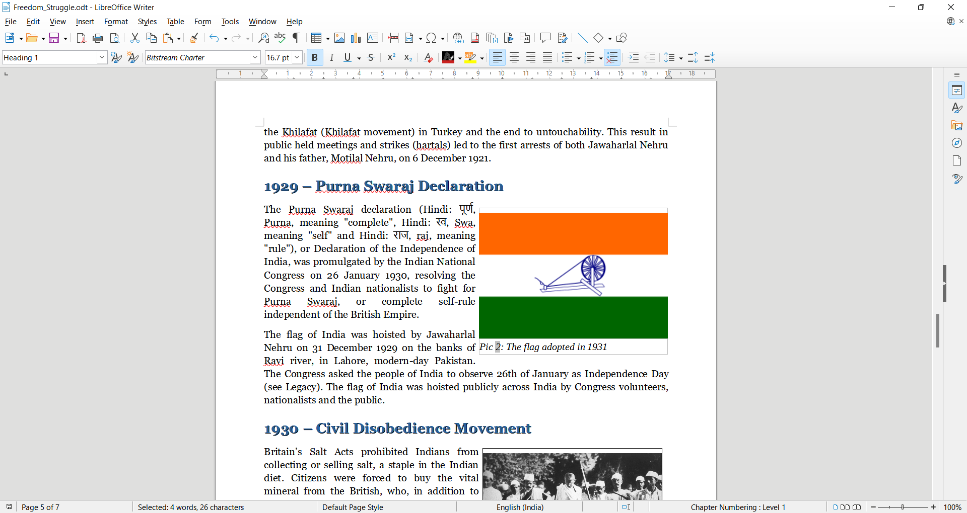

# B.2: Observations and Learning’s:

(Students are expected to comment on the output obtained with clear observations and learning for each task/ sub part assigned)

# I learnt various shortcuts and how to add new styles and use them to add different effects to the text.

# B.3: Conclusion:

(Students must write the conclusion as per the attainment of individual outcome listed above and learning/observation noted in section B.2)

Learnt how to use the Libre Office and its various tools which help editing doc files.