Implementation Plan
Team 3

Itopia

Inhoud
Outcomes and end goal 2
1.1 Outcomes 2
1.2 What to implement? 2
MoSCosW 3
Project organization, Roles and responsibilities 4
Project organization 4
Roles and responsibilities 4
The Implementation 5
Implementation scenario 5
Implementations costs 5
Implementation schedule 6
Fallback scenario 6

Outcomes and end goal

1.1 Outcomes
The outcome will be a website where Plaintech’s customers are able to order and manage a virtual platform. This Environment can be used by small and big companies that want to use Virtualization for their business.
Plaintech will have the following options in their new environment:

Website:
- Plaintech’s customers can register;
- Plaintech’s customers can login;
- Plaintech’s customers can manage their virtual machine(s);
- Plaintech’s customers can create a new virtual machine;
- Plaintech’s customers can edit their profile;
- Plaintech’s customers can choose the type of payment during the first logon;
- Administrator is able to view the usage information about different domains;
- Administrator can add and delete costs for the virtual machines;
- Administrator can download payment reports

1.2 What to implement?
To get an up and running environment we need to implement certain thing first:
- Implementation of the server which is running with KVM Hypervisor;
- Implementation of the back-up server;
- Implementation of all the hardware which are described in the technical design;
- Implementation of the protocols which will be running the network bases on the technical design.
- Implementation

MoSCosW
Must haves:
- A web interface for the customer to create, manage and upgrade virtual machines in a user-friendly environment. Technical knowledge is not required;
- The customer must be able to enter the virtual machine through a web based control panel and SSH;
The customer can choose different Operating Systems.

Should haves:
- Back-ups should be made automaticly, there should also be a webinterface showing the latest Backups which are made, and a way to remove or download these backups;
- Plaintech should have a web interface to monitor the amount of RAM and HDD space is being used by their customer’s virtual machines;
- The customer should be able to choose between basic pre-installed applications on a new server.

Could haves:
- Posibillity to investigate virtual networks;
- Alerts which will be sended to the administrators inbox;
- User interfaces for the different high en low context cultures.

Won’t haves:
- Windows-only or Linux only, platform;
- Dynamic Ram and CPU Management;

Project organization, Roles and responsibilities

Project organization

There are two organizations involved in this project: Itopia, the contractor, and Plaintech, the employees.
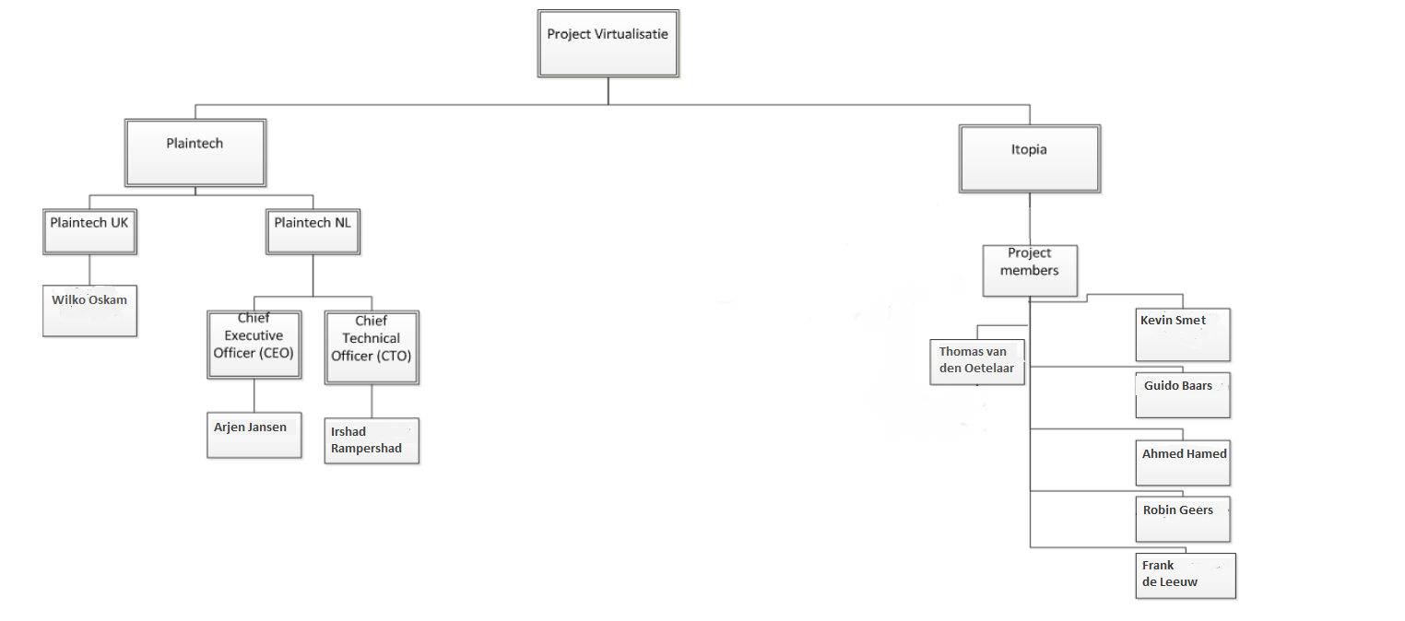

Roles and responsibilities

The contractor expects the following deliverables of Itopia:
1) Project Initiation Document
2) Functional Design Document
3) Technical Design Document
4) Implementation Plan
5) Proof of concept/Prototype of the requested virtualization platform including system documentation

The Implementation

Implementation scenario

Implementations costs

Implementation schedule
Phase 1:
This phase, Plaintech will order the necessary hardware needed to run the new cloud environment and the physical installation of the hardware. At the meantime Itopia will make the documentation and update Plaintech about their ideas. Two months will be needed to complete the first phase.

Phase 2:
This phase, Itopia will show Plaintech their decisions discuss the the “MoSCoW” and in phase will the actual implementation start.

Phase 3:
Step 1: Plaintech will implement the the website.
Step 2: Plaintech needs to start building the KVM.
Step 3: With the techniques learned in the second phase, Plaintech’s engineers will need to configure and install the platforms.
Step 4: When the platform is fully operational, Plaintech can start Connecting all the products.
Step 5: Once these tests have been successfully completed, Plaintech will be notified. A date will be arranged finalize the implementation.

Fallback scenario
If anything doesn’t go as plan and in the implementation, we will initiate the back-up plan:
Situation | Fall back scenario
System can unexpectedly been shutdown | We will troubleshoot the system.  And reboot the hardware
System can be hacked. | First close the netwerk.  Then bring the system back to a previous state.  Update the antivirus.  Check for any virus or malware.  Patch the system.  And open the network again.

