**Task-1**

**Aim:**Declare a variable using var, let, and const. Assign different data types to each variable and print their values.

**Description:** Declaration and initialization of variables using the keywords var, let, and const.

**Source Code:**

|  |
| --- |
| <!DOCTYPE html>  <html lang="en">  <head>      <meta charset="UTF-8">      <meta http-equiv="X-UA-Compatible" content="IE=edge">      <meta name="viewport" content="width=device-width, initial-scale=1.0">      <title>Document</title>  </head>  <body>      <script>          //var keyword          var a = 41          function f() {              console.log(a)          }          f();          console.log(a)             // let keyword          let aa = 10;          function f() {          let bb = 9          console.log(bb);          }          f()          console.log(bb)  //const keyword          const a = 10;          function f() {              a = 9              console.log(a)          }          f();      </script>  </body>  </html> |

**Output:**

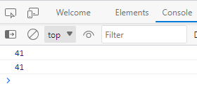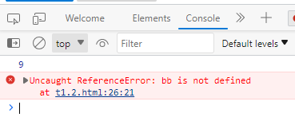

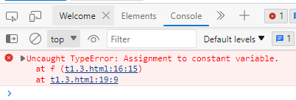

**Learning outcomes:**

The var keyword is used to declare variables with function scope or global scope. The let keyword is used to declare variables with block scope. The const keyword is used to declare variables with block scope, but their values cannot be reassigned once assigned

**Task-2**

**Aim:**

Write a function that takes two numbers as arguments and returns their sum, difference,

product, and quotient using arithmetic operators.

**Description:** with use of operator perform given operations.

**Source Code:**

|  |
| --- |
| <!DOCTYPE html>  <html>  <head>  <meta charset=utf-8 />  <title>JavaScript  oprasion two numbers </title>  </head>  <body>      <script>          function sum()          {                  num1 = parseInt(document.getElementById("firstNumber").value);                  num2 = parseInt(document.getElementById("secondNumber").value);                  document.getElementById("ans").innerHTML = num1 + num2;          }          function difference()          {                  num1 = document.getElementById("firstNumber").value;                  num2 = document.getElementById("secondNumber").value;                  document.getElementById("ans").innerHTML = num1 - num2;          }           function product()          {                  num1 = document.getElementById("firstNumber").value;                  num2 = document.getElementById("secondNumber").value;          document.getElementById("ans").innerHTML = num1 * num2;          }          function quotient()          {                  num1 = document.getElementById("firstNumber").value;                  num2 = document.getElementById("secondNumber").value;          document.getElementById("ans").innerHTML = num1 / num2;          }      </script>  <form>  1st Number : <input type="text" id="firstNumber" /><br><br>  2nd Number: <input type="text" id="secondNumber" /><br><br>  <input type="button" onClick="sum()" Value="sum" />&nbsp;&nbsp;  <input type="button" onClick="difference()" Value="difference" />&nbsp;&nbsp;  <input type="button" onClick="product()" Value="product" />&nbsp;&nbsp;  <input type="button" onClick="quotient()" Value="quotient" />&nbsp;&nbsp;  </form>  <p>The Result is : <div id = "ans"></div></p>  </body>  </html> |

**Output:**

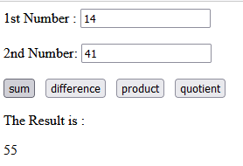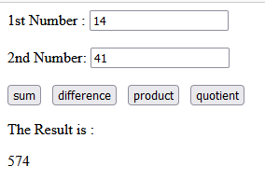

**Learning outcomes:**

By understanding variable declaration and arithmetic operations, you have gained knowledge of fundamental concepts in JavaScript programming

**Task-3**

**Aim:**

Write a program that prompts the user to enter their age. Based on their age, display

different messages:

○ If the age is less than 18, display "You are a minor."

○ If the age is between 18 and 65, display "You are an adult."

○ If the age is 65 or older, display "You are a senior citizen."

**Description:** use html structure and get input from user with prompt.

**Source Code:**

|  |
| --- |
| <!DOCTYPE html>  <html>  <head>    <title></title>    <script>      function check() {        var ageInput = prompt("Enter your age:");        var age = parseInt(ageInput);        var message;        if (age < 18) {          message = "You are a minor.";        } else if (age >= 18 && age <= 65) {          message = "You are an adult.";        } else {          message = "You are a senior citizen.";        }        alert(message);      }    </script>  </head>  <body>    <h1>Age Checker</h1>    <button onclick="check()">Check</button>  </body>  </html> |

**Output:**

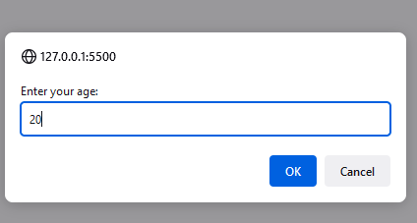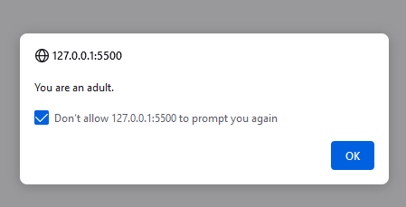

**Learning outcomes:**

This program uses the prompt function to display a dialog box to the user

**Task-4**

**Aim:**

Write a function that takes an array of salary as an argument and returns the min/max

salary in the array.

**Description:** Create Function for min and max salary

**Source Code:**

|  |
| --- |
| <!DOCTYPE html>  <html lang="en">  <head>      <meta charset="UTF-8">      <meta http-equiv="X-UA-Compatible" content="IE=edge">      <meta name="viewport" content="width=device-width, initial-scale=1.0">      <title>Document</title>  </head>  <body>      <script>          var salaryArray = [10000, 20000, 30000, 40000];          var result = findMinMaxSalary(salaryArray);          function findMinMaxSalary(salaries) {              if (salaries.length === 0) {                  return null; // Return null if the array is empty              }              var minSalary = salaries[0];              var maxSalary = salaries[0];              for (var i = 1; i < salaries.length; i++) {                  if (salaries[i] < minSalary) {                      minSalary = salaries[i];                  }                  if (salaries[i] > maxSalary) {                      maxSalary = salaries[i];                  }              }              return {                  minSalary: minSalary,                  maxSalary: maxSalary              };          }          console.log("Minimum Salary:", result.minSalary);          console.log("Maximum Salary:", result.maxSalary);      </script>  </body>  </html> |

**Ouput:**

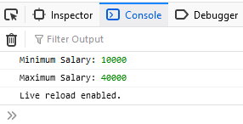

**Learning outcomes:**

This function provides a simple way to determine the minimum and maximum salaries from an array, allowing you to analyze and work with salary data effectively.

**Task-5**

**Aim:**

Create an array of your favorite books. Write a function that takes the array as an

argument and displays each book title on a separate line.

**Description:** use array of books and display it with new line

**Source Code:**

|  |
| --- |
| <!DOCTYPE html>  <html lang="en">  <head>      <meta charset="UTF-8">      <meta http-equiv="X-UA-Compatible" content="IE=edge">      <meta name="viewport" content="width=device-width, initial-scale=1.0">      <title>Document</title>  </head>  <body>      <script>          function Books(books) {              for (var book of books) {                  console.log(book);              }          }          // Example usage:          var favoriteBooks = ["DAA", "OS", "JAVA","DBMS"];        Books(favoriteBooks);      </script>  </body>  </html> |

**Output:**

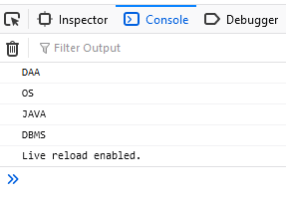

**Learning outcomes:**

This example demonstrates how to work with arrays and iterate over their elements to perform specific tasks.

**Task-6**

**Aim:**

Declare a variable inside a function and try to access it outside the function. Observe the

scope behavior and explain the results. [var vs let vs const]

**Description:** try to understand scope behavior.

**Source Code:**

|  |
| --- |
| function scopeWithVar() {              var myVariable = "Hey";          }          scopeWithVar();          console.log(myVariable);          function scopeWithLet() {              let myVariable = "Hey";          }          scopeWithLet();          console.log(myVariable);          function scopeWithConst() {              const myVariable = "Hey";          }          scopeWithConst();          console.log(myVariable); |

**Output:**

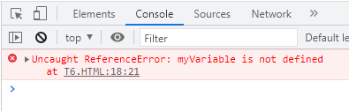

**Learning outcomes:**

The var keyword is used to declare variables with function scope or global scope. The let keyword is used to declare variables with block scope. The const keyword is used to declare variables with block scope, but their values cannot be reassigned once assigned

**Task-7**

**Aim:**

Create an HTML page with a button. Write JavaScript code that adds an event listener to

the button and changes its text when clicked.

**Description:** try to understand event listener.

**Source Code:**

|  |
| --- |
| <!DOCTYPE html>  <html>  <head>      <title>Button with Click Event Listener</title>  </head>  <body>      <h1>Button with Click Event Listener</h1>      <button id="myButton">Click Me!</button>      <script>          const myButton = document.getElementById("Button");          myButton.addEventListener("click", function () {              myButton.innerHTML = "click";          });      </script>  </body>  </html> |

**Output:**

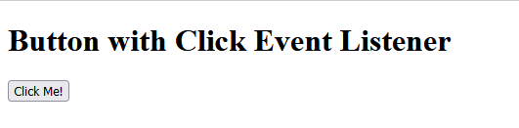

**Task-8**

**Aim:**

Write a function that takes a number as an argument and throws an error if the number

is negative. Handle the error and display a custom error message.

**Description:** try to understand error handling.

**Source Code:**

|  |
| --- |
| <!DOCTYPE html>  <html lang="en">  <head>      <meta charset="UTF-8">      <meta http-equiv="X-UA-Compatible" content="IE=edge">      <meta name="viewport" content="width=device-width, initial-scale=1.0">      <title>Document</title>  </head>  <body>      <script>          function validateNumber(number) {              "use strict";              if (number < 0) {                  throw new Error("not-negative");              }          }          try {              validateNumber(-1);          } catch (error) {              console.error(error.message);          }      </script>  </body>  </html> |

**Output:**

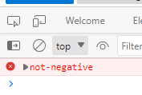

**Task-9**

**Aim:**

Write a function that uses setTimeout to simulate an asynchronous operation. Use a

callback function to handle the result.

**Description:** try to understand Set timeout function.

**Source Code:**

|  |
| --- |
| <!DOCTYPE html>  <html lang="en">  <head>      <meta charset="UTF-8">      <meta http-equiv="X-UA-Compatible" content="IE=edge">      <meta name="viewport" content="width=device-width, initial-scale=1.0">      <title>Document</title>  </head>  <body>      <script>          function simulateAsyncOperation(callback) {              "use strict";              setTimeout(function () {                  callback("The asynchronous completed");              }, 50000);          }          simulateAsyncOperation(function (result) {              console.log(result);          });      </script>  </body>  </html> |

**Output:**

