**Data Structures**

Prerequisites

* very often Data structures deals with recursion and pointers, so it is important to revise them.

What is recursion??????

* Recursion is a process in which a function calls itself as subroutine.This process continues when it meets with a specific condition(if ,else ,else if,etc) and if the base condition is satisfied the function loops back to the beginning of itself.

->Now we will revise recursion with an example.

Let us see the factorial problem.

è **Factorial Problem**

**int factorial (int n)**

**{**

**if (n == 1) // Base Case**

**{**

**return 1;**

**}**

**else // Recursive Case**

**{**

**return n * factorial(n-1);**

**}**

**}**

**int factorial (int n) {**

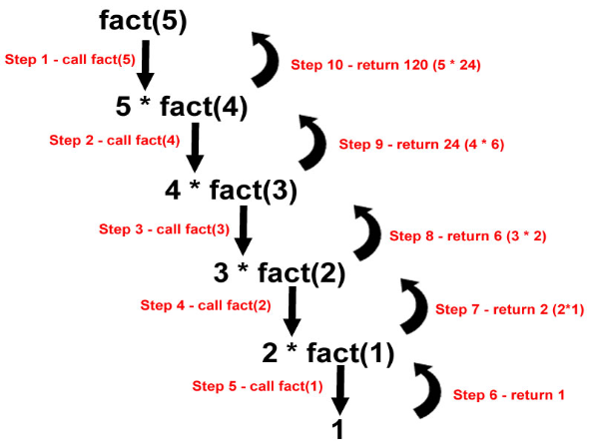**if (n == 1) // Base Case**

**return 1;**

**else // Recursive Case**

**return n * factorial(n-1);**

**}**

**Consider n = 5**

**Factorial (5) = 5 * Factorial (4)**

**= 5 * 4 * Factorial (3) … and so on**

è **Factorial (5) = 5 * 4 * 3 * 2 * 1 = 120**

5 * factorial (4) à 120

String Permutations

è **Input: “abc“**

è **begin: 0;**

è **end: 3**

è **Number of permutations = 1 x 2 x 3 = 6**

è **Output: abc,acb,bac,bca,cba,cab.**

How this occurs???

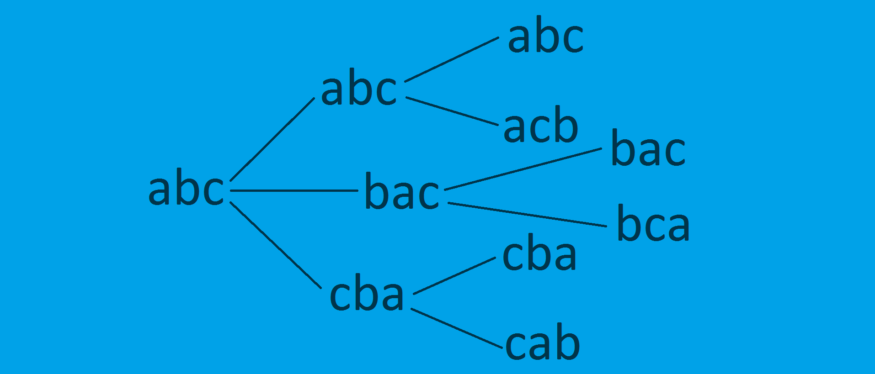

  
**void** swap(**char** *a,**char** *b) {  
 **char** temp;  
 temp = *a;  
 *a=*b;  
 *b=temp;  
}

**void** permute(**char** *str,**int** start,**int** end)

{  
 **int** i,range;  
 range=end-start;  
 **if**(range==1){  
 printf("%s\n",str);  
 }  
 **else** {  
 **for** (i = 0; i < range; i++) {  
 swap(&str[start], &str[start + i]);  
 permute(str, start + 1, end);  
 swap(&str[start], &str[start + i]);  
 }  
 }  
}

Pointers

What is a Pointer????

* A **pointer** is a variable whose value is the address of another variable(implies direct address of the memory location).Like any variable or constant, you must declare a pointer before using it to store any variable address.

Declaration of a pointer:

* Syntax -> datatype *variable name;
* It is good habit to point to NULL;
* Integer pointer array -> int *variablename[size of array];
* Character pointer array -> char *variablename={“string1”,”string”,”string3”}

**Example:**

**int** main() {  
 **char** string[]={'a','b','c','d','\0'};  
 **char** *str;  
 str=&string[1];  
 *str='z';  
 printf("%x ",str);  
 printf("%s ",str);  
 str++;  
 printf("%x ",str);  
 printf("%s ",str);  
 printf("%s ",string);  
 **return** 0;  
}

**Output:**

**60ff28 zcd 60ff29 cd azcd**