**Data Structures**

Triangle

**Contents:**

* Find the area of triangle .
* Find the interior angles of a triangle and print them.
* Print the generated triangles.
* Writing whole program.

**Finding the area of Triangle:**

* 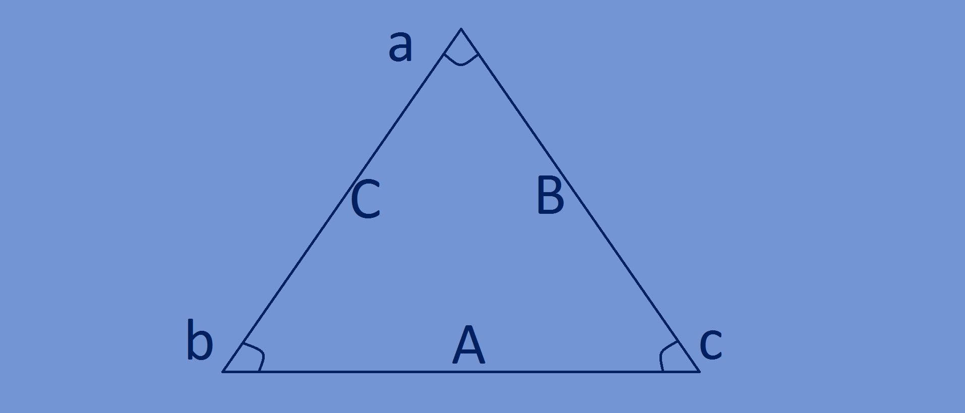Formulae for calculating area of triangle from

Its vertices is-

Area=1/2(x1(y2−y3)+x2(y3−y1)+x3(y1−y2))

Here x1=t[i].a.x,y1=t[i]a.y

X2=t[i].b.x,y2=t[i].b.y

X3=t[i].c.x,y3=y[i].c.y

**void** computeArea(TRIANGLE*t,**int** n)

{  
 **for**(**int** i=0;i<n;i++)

{  
 t[i].area=(1/2.0)*abs((t[i].a.x*(t[i].b.y-t[i].c.y)+t[i].b.x*(t[i].c.y-t[i].a.y)+t[i].c.x*(t[i].a.y-t[i].b.y)));  
 }  
}

**Finding the interior angles of generated triangles:**

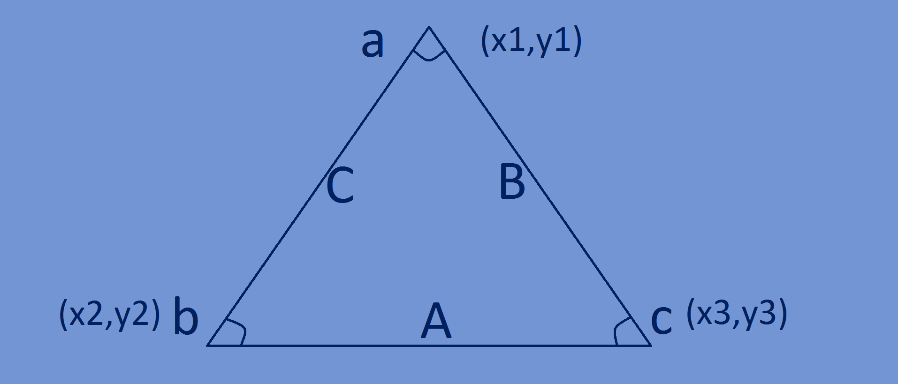

* From law of cosines we have

**C^2 = A^2 + B^2 – 2AB cos(c)**

**B^2 = A^2 + C^2 – 2AC cos(b)**

**cos(a) = B^2 + C^2 – A^2 /2BC**

* A=√((x3-x2)2+(y3-y2)2)

B=√((x3-x1)2+(y3-y1)2)

C=√((x2-x1)2+(y2-y1)2)

Here x1=t[i].a.x,y1=t[i]a.y

X2=t[i].b.x,y2=t[i].b.y

X3=t[i].c.x,y3=y[i].c.y



* **cos(b) = A^2 + C^2 – B^2 /2AC**
* **cos(c) = A^2 + B^2 – C^2 /2AC**
* **cos(a) = B^2 + C^2 – A^2 /2BC**

**void** findPrintInAngles(TRIANGLE *t, **int** n) {  
 **float** cosA1,cosA2,cosA3;  
 **float** a1,a2,a3;  
 **int** i;  
 **for**(i=0; i<n; i++) {  
 a1=sqrt(pow((t[i].b.x-t[i].c.x),2)+pow((t[i].b.y-t[i].c.y),2));  
 a2=sqrt(pow((t[i].c.x-t[i].a.x),2)+pow((t[i].c.y-t[i].a.y),2));  
 a3=sqrt(pow((t[i].a.x-t[i].b.x),2)+pow((t[i].a.y-t[i].b.y),2));  
 **float** num1=((pow(a2,2))+(pow(a3,2))-(pow(a1,2)));**float** den=(2*a2*a3);  
 cosA1=num1/den;  
 **float** num2=((pow(a3,2))+(pow(a1,2))-(pow(a2,2)));**float** den2=(2*a1*a3);  
 cosA2=num2/den2;  
 **float** num3=((pow(a1,2))+(pow(a2,2))-(pow(a3,2)));**float** den3=(2*a1*a2);  
 cosA3=num3/den3;  
 printf("The Angles Of A Triangle Are: %f ,%f ,%f degrees \n",(acos(cosA1)*57.295),(acos(cosA2)*57.295),(acos(cosA3)*57.295));  
 }  
}

**Printing the generated triangle coordinates and the area of generated triangle:**

**void** printTriangles(TRIANGLE *t, **int** n)  
{  
 **for**(**int** i=0;i<n;i++)  
 {  
 printf("(%f,%f),",t[i].a.x,t[i].a.y);  
 printf("(%f,%f),",t[i].b.x,t[i].b.y);  
 printf("(%f,%f)",t[i].c.x,t[i].c.y);  
 printf(" Area is:%f\n",t[i].area);  
 }  
}

**Complete program:**

#include <stdio.h>  
#include<stdlib.h>  
#include<time.h>  
#include<math.h>  
  
//vertex structure  
**typedef struct**{  
 **float** x;  
 **float** y;  
}point;  
  
//triangle structure  
**typedef struct**{  
 point a;  
 point b;  
 point c;  
 **float** area;  
}TRIANGLE;  
  
TRIANGLE* genTriangles(**int** n) {  
 srand(time(NULL));  
 TRIANGLE *t;  
 t=(TRIANGLE*) malloc((n)\***sizeof**(TRIANGLE));  
 **for**(**int** i=0;i<n;i++) {  
 t[i].a.x=rand()%30+10;  
 t[i].a.y=rand()%30+10;  
  
 t[i].b.x=rand()%30+10;  
 t[i].b.y=rand()%30+10;  
  
 t[i].c.x=rand()%30+10;  
 t[i].c.y=rand()%30+10;  
 }  
 **return** t;  
}  
**void** computeArea(TRIANGLE*t,**int** n) {  
 **for**(**int** i=0;i<n;i++) {  
 t[i].area=(1/2.0)*abs((t[i].a.x*(t[i].b.y-t[i].c.y)+t[i].b.x*(t[i].c.y-t[i].a.y)+t[i].c.x*(t[i].a.y-t[i].b.y)));  
 }  
}  
**void** printTriangles(TRIANGLE *t, **int** n)  
{  
 **for**(**int** i=0;i<n;i++)  
 {  
 printf("(%f,%f),",t[i].a.x,t[i].a.y);  
 printf("(%f,%f),",t[i].b.x,t[i].b.y);  
 printf("(%f,%f)",t[i].c.x,t[i].c.y);  
 printf(" Area is:%f\n",t[i].area);  
 }  
}  
**void** findPrintInAngles(TRIANGLE *t, **int** n) {  
 **float** cosA1,cosA2,cosA3;  
 **float** a1,a2,a3;  
 **int** i;  
 **for**(i=0; i<n; i++) {  
 a1=sqrt(pow((t[i].b.x-t[i].c.x),2)+pow((t[i].b.y-t[i].c.y),2));  
 a2=sqrt(pow((t[i].c.x-t[i].a.x),2)+pow((t[i].c.y-t[i].a.y),2));  
 a3=sqrt(pow((t[i].a.x-t[i].b.x),2)+pow((t[i].a.y-t[i].b.y),2));  
 **float** num1=((pow(a2,2))+(pow(a3,2))-(pow(a1,2)));**float** den=(2*a2*a3);  
 cosA1=num1/den;  
 **float** num2=((pow(a3,2))+(pow(a1,2))-(pow(a2,2)));**float** den2=(2*a1*a3);  
 cosA2=num2/den2;  
 **float** num3=((pow(a1,2))+(pow(a2,2))-(pow(a3,2)));**float** den3=(2*a1*a2);  
 cosA3=num3/den3;  
 printf("The Angles Of A Triangle Are: %f, %f ,%f degrees\n",(acos(cosA1)*57.295),(acos(cosA2)*57.295),(acos(cosA3)*57.295));  
 }  
}  
  
**int** main(){  
 **int** n=5;  
 TRIANGLE *t;  
 t=genTriangles(n);  
 computeArea(t,n);  
 printTriangles(t,n);  
 findPrintInAngles(t,n);  
}

(35.000000,36.000000),(37.000000,28.000000),(38.000000,31.000000) Area is:7.000000

(35.000000,35.000000),(38.000000,10.000000),(32.000000,11.000000) Area is:73.500000

(18.000000,28.000000),(28.000000,32.000000),(33.000000,11.000000) Area is:115.000000

The Angles Of A Triangle Are: 16.927287, 32.470751 ,130.599516 degrees

The Angles Of A Triangle Are: 13.967602, 73.693895 ,92.336058 degrees

The Angles Of A Triangle Are: 70.376782, 81.589982 ,28.030791 degrees