**Data Structures**

Introduction to Linked List,stack and Queue

**ARRAY:**

* Array is a linear data structure.
* The size of an array is constant and total size of the allocated memory is

Equal to the upperlimit of the array index.

* Elements in an array are stored in contiguous locations.
* Single dimensional and Multi dimensional arrays.
* Elements of an array can be accessed by using indices,means we can access

Any element of an array randomly.

* Static memory.

**Linked list:**

* What is a linked list?? Datapart pointer

A linked list is a linear collection of data elements which are actually called

as nodes(node is a structure which contains any datatype and a pointer

which always points to the next element) and it is a data structure in which

group of nodes are linked in a sequence.

* Like array linked list is also a linear data structure.
* Unlike array size of linked list is not fixed and memory is allocated Dynamically.
* Elements of linked list are not stored contiguously as address of node is

stored in previous node.

* Single,double and circular linked list.
* Elements of linked list can’t be accessed randomly but can be accessed

Sequentially.

**Representation of a linked list:**

**head**

 Data  pointer Data pointer Data NULL  

* Each node is a structure which contains a data part and a pointer to the

next node

* First node is called as head node and the last node pointer points to null.

Typedef struct linkedlist{

Int data;

struct linkedlist *next;

}linkedlist;

**Types of linked list:**

* **Singly linked list**
* only one pointer is maintained and only forward traversing is possible

Typedef struct linkedlist{

Int data;

struct linkedlist *next;

}linkedlist;

* **Doubly linked list**

• Two pointers are maintained,one will keep the address of previous node

And the other keeps the address of the next node.In doubly linked list

We can move in both forward and backward directions.

Typedef struct d_linkedlist{

Int data;

struct linkedlist *next;

struct linkedlist *previous;

}d_linkedlist;

* **Circular linked list**

• Circular linked list may be a single or a doubly linked list but in circular

Linked list we always point the last node to the head pointer(In normal

Linked list we point the last node to null).

**Disadvantages(drawbacks) of linked list:**

* Linked list needs extra memory compared to arrays because we use pointer

For storing the address of next node.

* Random accessing of an element is not possible,for accessing any element

We have to traverse the entire linked list.

* Nodes are stored incontiguously which increases the time for accessing

Individual elements in the linked list.

* Reverse traversing becomes difficult incase of singly linked list but in case

of doubly linked list it requires another pointer(more memory).

**STACK:**

* A stack is a container of objects that are inserted and removed according

To last-in first-out principle.

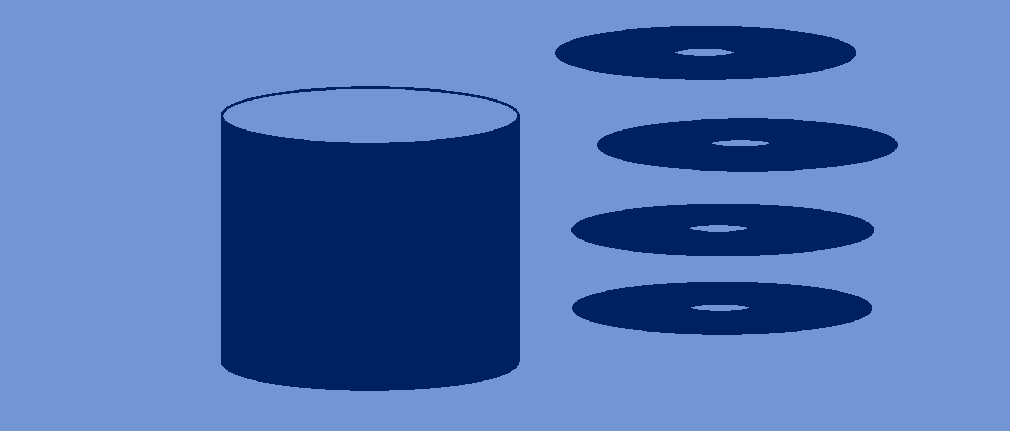

**QUEUE:**

* A queue is a container of objects that are inserted and removed according to the first-in first-out principle.