**Data Structures**

Implementing Stack and Queue using linked List

**STACK:**

* A stack is a container of objects that are inserted and removed according

To last-in first-out principle.

* Supports two operations push and pop.
* Push inserts the new elements at the top of the existing list.
* 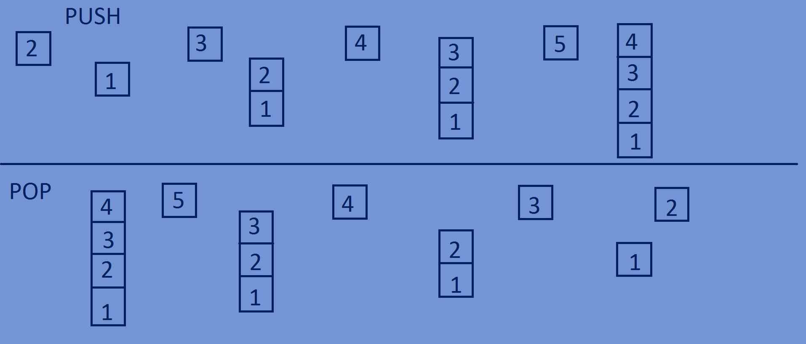Pop removes the top most element from the list(most recently added item).





**Implementation:**

* **Function for pushing elements into stack.**

lin_list *push(lin_list *head,**int** data){  
 lin_list *temp=(lin_list*)malloc(**sizeof**(lin_list));  
 temp->data=data;  
 temp->next=NULL;  
 temp->next=head;  
 head=temp;  
 **return** head;  
}

* **Function for poping of elements from stack.**

lin_list *pop(lin_list *head){  
 lin_list *temp=head;  
 head=head->next;  
 printf("Deleted the node containing data %d\n",temp->data);  
 free(temp);  
 **return** head;  
}

**Whole program:**

#include<stdio.h>  
#include<stdlib.h>  
//cresting a node.  
**typedef struct** lin_list{  
 **int** data;  
 **struct** lin_list *next;  
}lin_list;  
  
lin_list *push(lin_list *head,**int** data){  
 lin_list *temp=(lin_list*)malloc(**sizeof**(lin_list));  
 temp->data=data;  
 temp->next=NULL;  
 temp->next=head;  
 head=temp;  
 **return** head;  
}  
  
lin_list *pop(lin_list *head){  
 lin_list *temp=head;  
 head=head->next;  
 printf("Deleted the node containing data %d\n",temp->data);  
 free(temp);  
 **return** head;  
}  
  
**void** PrintElements(lin_list *head){  
 **while**(head!=NULL){  
 printf("%d ",head->data);  
 head=head->next;  
 }  
}  
**int** main(){  
 lin_list *head=NULL;  
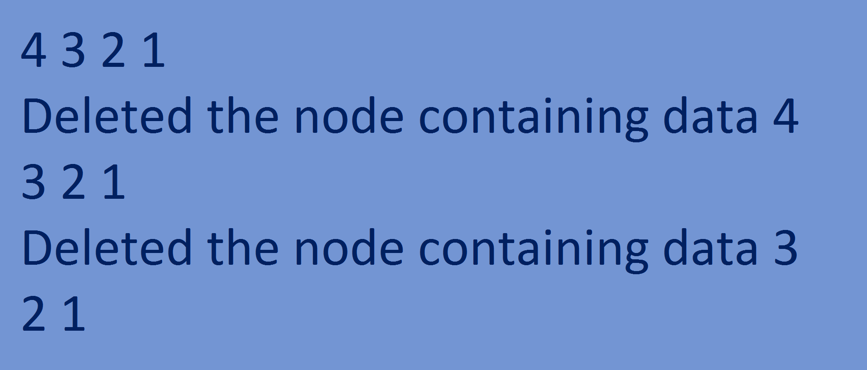 head=push(head,1);  
 head=push(head,2);  
 head=push(head,3);  
 head=push(head,4);   
 PrintElements(head);printf("\n");  
 head=pop(head);  
 PrintElements(head);printf("\n");  
 head=pop(head);  
 PrintElements(head);  
 **return** 0;  
}

**Queue:**

* A queue is a container of objects that are inserted and removed according to the first-in first-out principle.
* Supports operations enqueue and dequeue.
* enqueue Inserts the new elements at the end of the list.
* 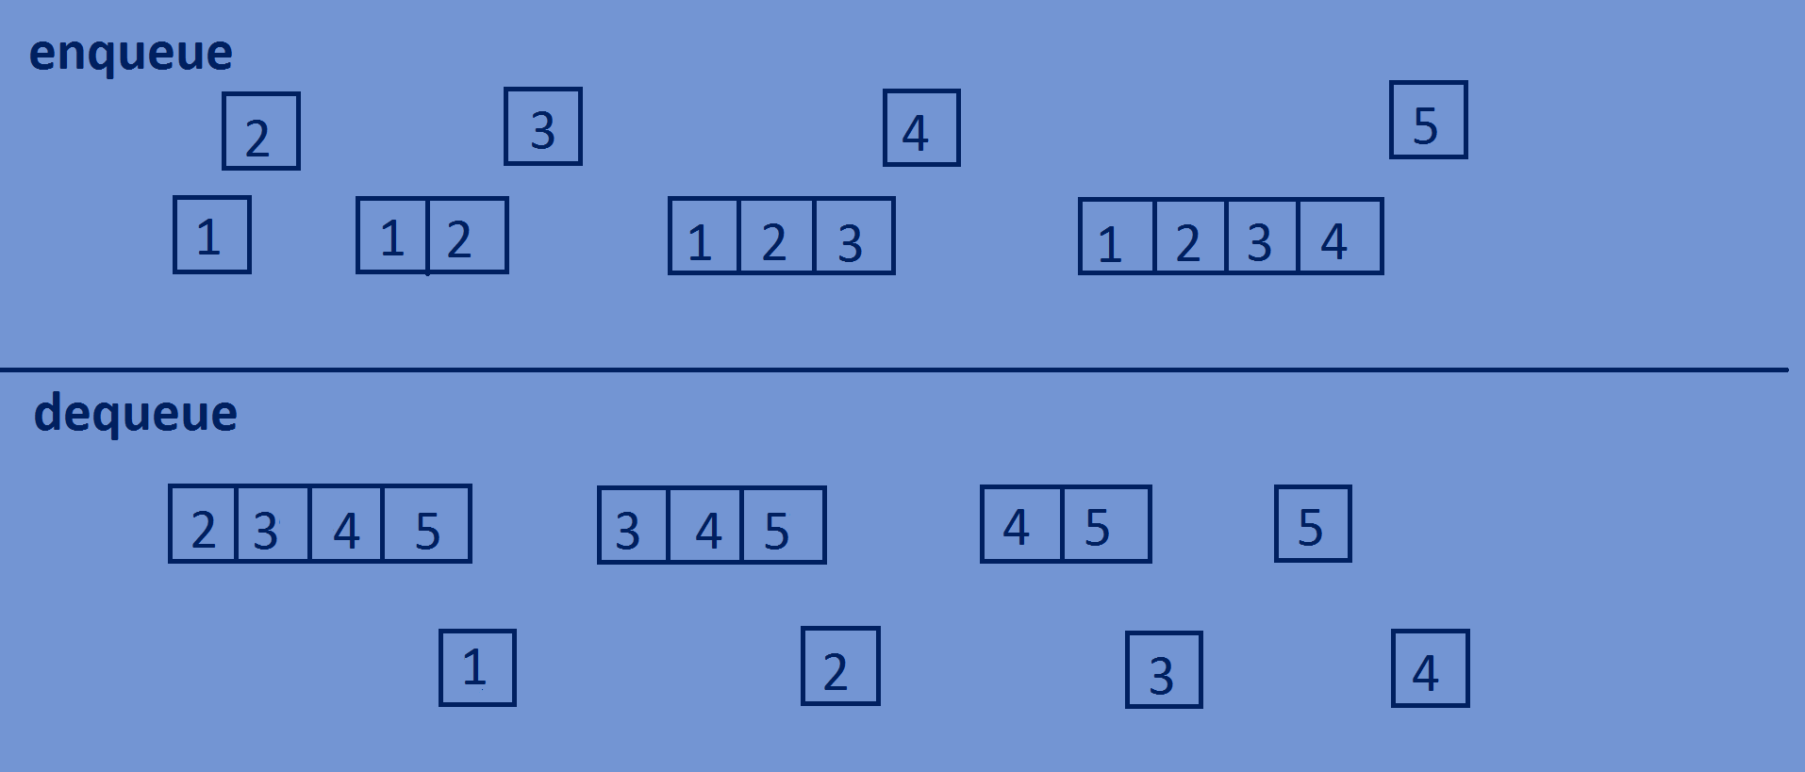 dequeue removes the top most element from the list.





**Implementation:**

* **Function for enqueue.**

lin_list *enqueue(lin_list *head,**int** data){  
 lin_list *newnode=(lin_list*)malloc(**sizeof**(lin_list));  
 newnode->data=data;  
 newnode->next=NULL;  
 lin_list *temp=head;  
 **if**(head==NULL){  
 head=newnode;  
 }  
 **else** {  
 **while** (temp->next != NULL) {  
 temp = temp->next;  
 }  
 temp->next = newnode;  
 }  
 **return** head;  
}

* **Function for dequeue.**

lin_list *dequeue(lin_list *head){  
 lin_list *temp=head;  
 head=head->next;  
 printf("deleted the node containing data %d",temp->data);printf("\n");  
 free(temp);  
 **return** head;  
}

**Whole program:**

#include<stdio.h>  
#include<stdlib.h>  
//creating a node.  
**typedef struct** lin_list{  
 **int** data;  
 **struct** lin_list *next;  
}lin_list;  
  
lin_list *enqueue(lin_list *head,**int** data){  
 lin_list *newnode=(lin_list*)malloc(**sizeof**(lin_list));  
 newnode->data=data;  
 newnode->next=NULL;  
 lin_list *temp=head;  
 **if**(head==NULL){  
 head=newnode;  
 }  
 **else** {  
 **while** (temp->next != NULL) {  
 temp = temp->next;  
 }  
 temp->next = newnode;  
 }  
 **return** head;  
}  
  
lin_list *dequeue(lin_list *head){  
 lin_list *temp=head;  
 head=head->next;  
 printf("deleted the node containing data %d\n",temp->data);  
 free(temp);  
 **return** head;  
}  
  
**void** PrintElements(lin_list *head){  
 **while**(head!=NULL){  
 printf("%d ",head->data);  
 head=head->next;  
 }  
}  
**int** main(){  
 lin_list *head=NULL;  
 head=enqueue(head,1);  
 head=enqueue(head,2);  
 head=enqueue(head,3);  
 head=enqueue(head,4);  
 PrintElements(head);printf("\n");  
 head=dequeue(head);  
 PrintElements(head);printf("\n");  
 head=dequeue(head);  
 PrintElements(head);  
 **return** 0;  
}

**Output:**

1 2 3 4

deleted the node containing data 1

2 3 4

deleted the node containing data 2

3 4