**Data Structures**

Deleting a node from Binary Search Tree

**Deleting a node from a binary search tree:**

* A Binary Search tree is a binary tree in which value of left sub-tree node is

Less than or equal to its parent nodes value and the value of right sub-tree

Node is greater than its parent nodes value.

* After deleting a node from a binary search tree, the obtained binary tree

Must also be a binary search tree.

* When we want to delete a node from a binary search tree we have to consider

Three cases.

1)when the node to be deleted is the leaf node.

2)when the node to be deleted has only one child(left or right).

3)when the node to be deleted has both left and right child.

* Write a recursive function to delete a node of BST considering these three cases.

**The node to be deleted is the leaf node:**

* If the node to be deleted is the leaf node(leaf node doesn’t have any children)

Simple delete the node from the binary search tree.

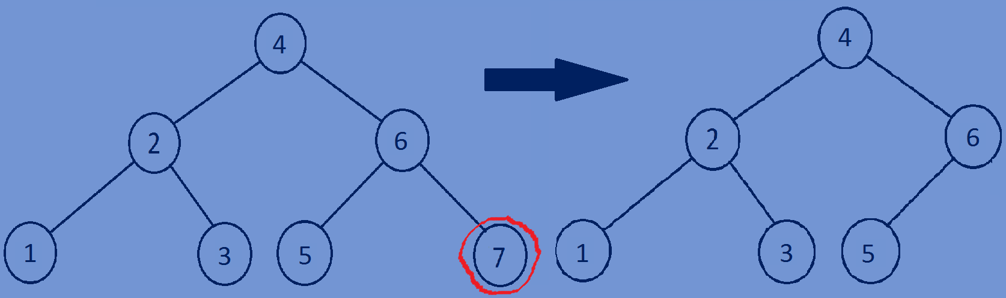**if** (root->left == NULL && root->right == NULL)   
 free(root);  
 root = NULL;  
 **return** root;

**The node to be deleted has only one child(left or right):**

* If the node to be deleted has only one child then store the address of left child

(If right subtree is equal to NULL) in temp pointer or store the address of

Right child(if left subtree of node is equal to NULL)in temp pointer and

Return temp.

temp = root->right(or)temp=root->left;

free(root);

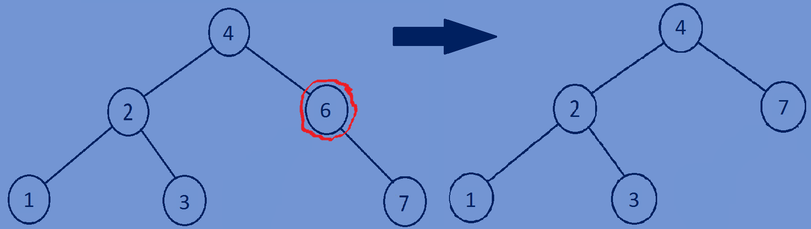 return temp;

**The node to be deleted has both left and right child(two children):**

* Find the minimum value node in the right subtree.
* replace the data of node to be deleted with the data of minimum value node.

So now,the right subtree contains a duplicate node having same data of the node.

* Now call the delete function with the right subtree as an argument to delete the

Duplicate node in the right subtree.

temp = FindMin(root->right);

root->data = temp->data;

root->right = deleteNodeInBstree(root->right, root->data);

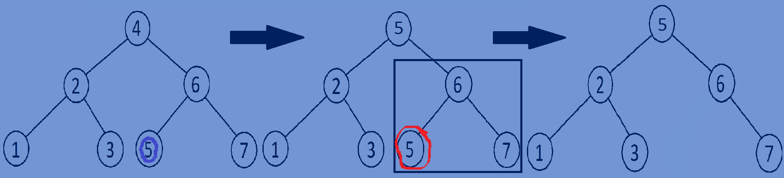

**Function for deleting a node from binary search tree:**

//function for deleting a node from binary search tree.

Bstree *deleteNodeInBstree(Bstree *root,**int** data){  
 **if**(root==NULL){  
 **return** root;  
 }  
 **if**(root->data > data){  
 root->left=deleteNodeInBstree(root->left,data);  
 }  
 **else if**(root->data < data){  
 root->right=deleteNodeInBstree(root->right,data);  
 }  
 **else** {  
 Bstree *temp=NULL;  
 **if** (root->left == NULL && root->right == NULL) {  
 free(root);  
 root = NULL;  
 **return** root;  
 }  
 **else if** (root->left == NULL){  
 temp=root->right;  
 free(root);  
 **return** temp;  
 }  
 **else if**(root->right==NULL){  
 temp=root->left;  
 free(root);  
 **return** temp;  
 }  
 temp=FindMin(root->right);  
 root->data=temp->data;  
 root->right=deleteNodeInBstree(root->right,root->data);  
 }  
 **return** root;  
}

//finding minimum value node of a binary search tree  
Bstree *FindMin(Bstree *root){  
 **if**(root->left==NULL){  
 **return** root;  
 }  
 **return** FindMin(root->left);  
}

**Whole program:**

#include<stdio.h>  
#include<stdlib.h>  
//creating a node  
**typedef struct** Bstree{  
 **int** data;  
 **struct** Bstree *left;  
 **struct** Bstree *right;  
}Bstree;  
//creating new node  
Bstree *createnewnode(**int** data){  
 Bstree *newnode=(Bstree*)malloc(**sizeof**(Bstree));  
 newnode->data=data;  
 newnode->left=NULL;  
 newnode->right=NULL;  
 **return** newnode;  
}

//function for inserting node into binary search tree  
Bstree *InsertNodeintoBStree(Bstree *root,**int** data){  
 **if**(root==NULL){  
 **return** createnewnode(data);  
 }  
 **if**(data<=root->data){  
 root->left=InsertNodeintoBStree(root->left,data);  
 }  
 **else if**(data>root->data){  
 root->right=InsertNodeintoBStree(root->right,data);  
 }  
 **return** root;  
}  
//function for finding minimum value node of a binary search tree  
Bstree *FindMin(Bstree *root){  
 **if**(root->left==NULL){  
 **return** root;  
 }  
 **return** FindMin(root->left);  
}  
//function for deleting a node from binary search tree  
Bstree *deleteNodeInBstree(Bstree *root,**int** data){  
 **if**(root==NULL){  
 **return** root;  
 }  
 **if**(root->data > data){  
 root->left=deleteNodeInBstree(root->left,data);  
 }  
 **else if**(root->data < data){  
 root->right=deleteNodeInBstree(root->right,data);  
 }  
 **else** {  
 Bstree *temp=NULL;  
 **if** (root->left == NULL && root->right == NULL) {  
 free(root);  
 root = NULL;  
 **return** root;  
 }  
 **else if** (root->left == NULL){  
 temp=root->right;  
 free(root);  
 **return** temp;  
 }  
 **else if**(root->right==NULL){  
 temp=root->left;  
 free(root);  
 **return** temp;  
 }  
 temp=FindMin(root->right);  
 root->data=temp->data;  
 root->right=deleteNodeInBstree(root->right,root->data);  
 }  
 **return** root;  
}  
//print all the nodes of a tree in preorder fashion  
**void** preorder(Bstree *root){  
 **if**(root){  
 printf("%d ",root->data);  
 preorder(root->left);  
 preorder(root->right);  
 }  
}  
//main function  
**int** main(){  
 Bstree *tree=NULL;  
 tree=InsertNodeintoBStree(tree,4);  
 tree=InsertNodeintoBStree(tree,2);  
 tree=InsertNodeintoBStree(tree,6);  
 tree=InsertNodeintoBStree(tree,1);  
 tree=InsertNodeintoBStree(tree,3);  
 tree=InsertNodeintoBStree(tree,5);  
 tree=InsertNodeintoBStree(tree,7);  
 preorder(tree);printf("\n");

//calling the deleteNodeInBstree function  
 tree=deleteNodeInBstree(tree,4);  
 preorder(tree);  
 **return** 0;  
}

**Output**:

4 2 1 3 6 5 7

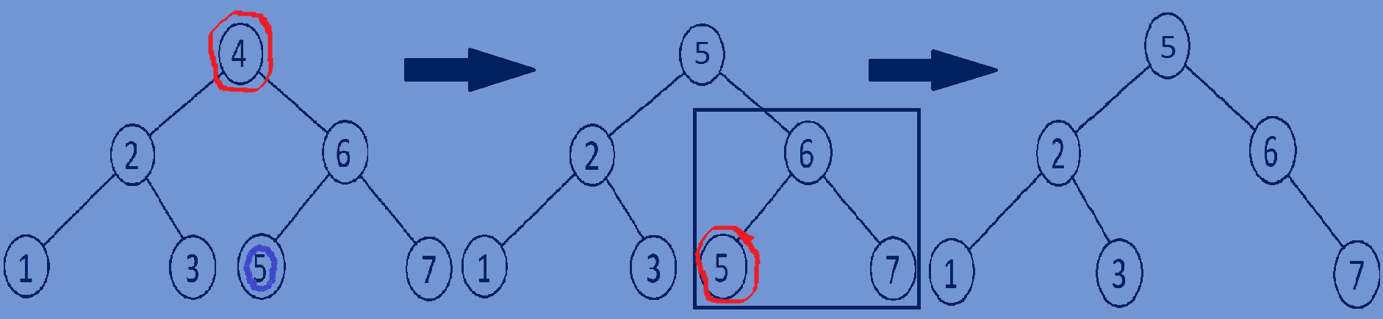5 2 1 3 6 7