**Data Structures**

Finding height of a given Binary Tree.

**Height of a binary Tree:**

* height of a node is equal to the total no of edges in the longest path from node to a leaf(furthest leaf) ,height of a tree is equal to height of the root node.
* Height of a tree is equal to the total no of edges in the longest path from

Root node to the leaf node(furthest leaf).

* 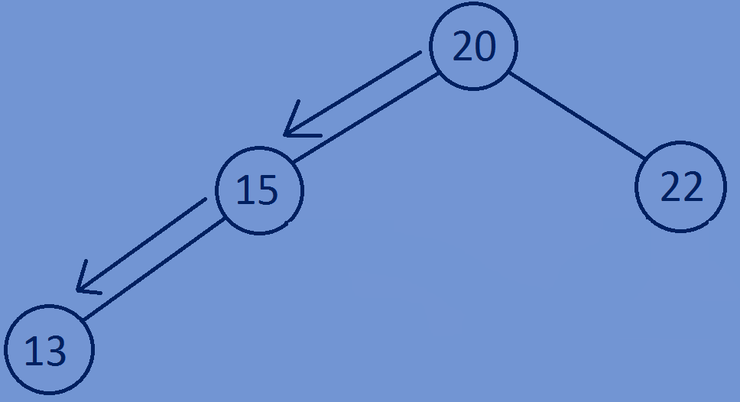Height of a leaf node is equal to zero and height of empty tree is equal to -1.

**Finding Height of a binary tree:**

* If root is equal to NULL (if tree is empty) then return -1.
* Calculate the height of left subtree and right subtree of a node and the

Height of the node will be equal to the maximum of height of left subtree

And height of right subtree +1.

**1+maximum(height(root->left),height(root->right))**



**Function for calculating the height of a Binary Tree:**

//function for calculating height of a binary tree  
**int** height(Btree* root) {  
 **if**(root==NULL) {  
 **return** -1;  
 }  
 **else** {  
 **return** 1+maximum(height(root->left),height(root->right));  
 }  
  
}  
//function for calculating maximum of two integers  
**int** maximum(**int** a,**int** b) {  
 **if**(a>b) {  
 **return** a;  
 }  
 **else** {  
 **return** b;  
 }  
}

**Whole program:**

#include<stdio.h>  
#include<stdlib.h>  
//creating a node  
**typedef struct** Btree{  
 **int** data;  
 **struct** Btree *left;  
 **struct** Btree *right;  
}Btree;  
//creating new nodes  
Btree *createnewnode(**int** data){  
 Btree *newnode=(Btree*)malloc(**sizeof**(Btree));  
 newnode->data=data;  
 newnode->left=NULL;  
 newnode->right=NULL;  
 **return** newnode;  
}

//function for calculating height of a binary tree  
**int** height(Btree* root) {  
 **if**(root==NULL) {  
 **return** -1;  
 }  
 **else** {  
 **return** 1+maximum(height(root->left),height(root->right));  
 }  
  
}  
//function for calculating maximum of two integers  
**int** maximum(**int** a,**int** b) {  
 **if**(a>b) {  
 **return** a;  
 }  
 **else** {  
 **return** b;  
 }  
}  
//main function  
**int** main(){  
 Btree *tree=NULL;  
 tree=createnewnode(1);  
 tree->left=createnewnode(2);  
 tree->right=createnewnode(3);  
 tree->left->left=createnewnode(4);  
 tree->left->right=createnewnode(5);  
 tree->right->left=createnewnode(6);  
 tree->right->right=createnewnode(7);  
 printf(" %d",height(tree));  
 **return** 0;  
}

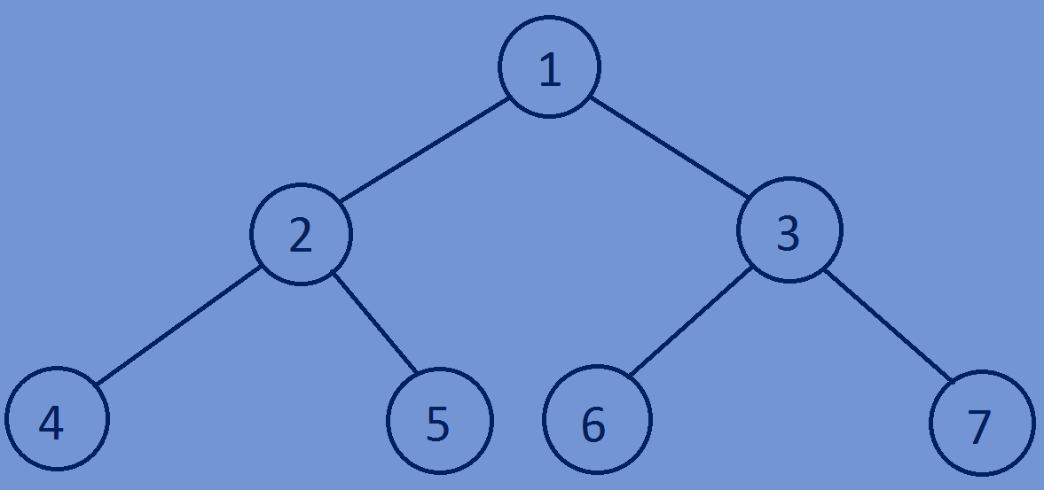**Output:**

2