**Data Structures**

Implementation of Binary Search Tree

**Binary Search Tree:**

* A Binary Search tree is a binary tree in which value of left sub-tree node is

Less than or equal to its parent nodes value and the value of right sub-tree

Node is greater than its parent nodes value,here for each node,value of all

the nodes in left subtree is lesser and value of all the nodes in right subtree

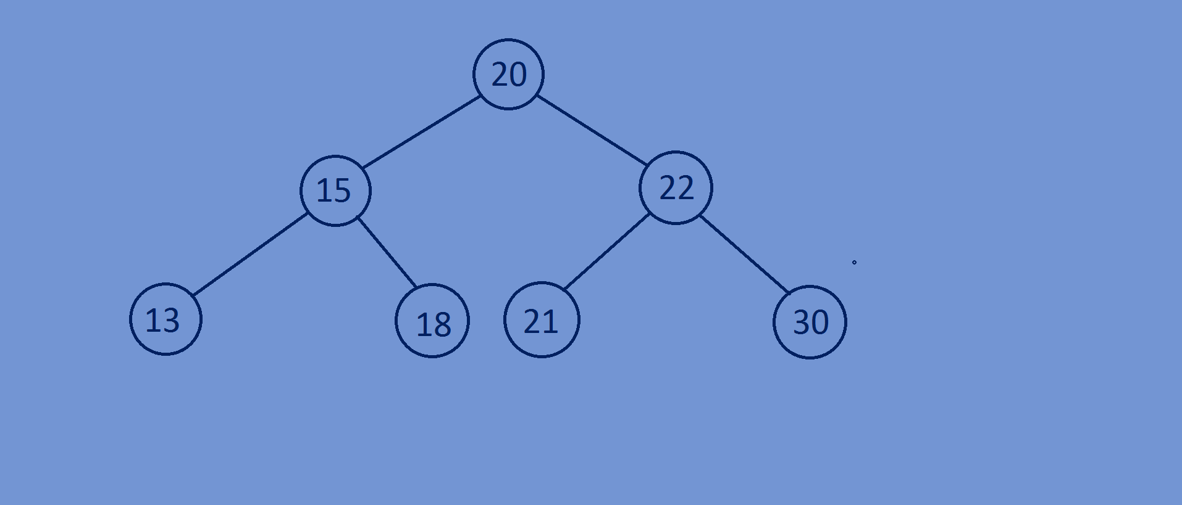is greater.

**Implementation of Binary Search Tree:**

* If root is equal to NULL we make the newly created node(newnode) as the root.
* If the data in the newnode is less than or equal to the data of the root node then

We make a recursive call of the function to insert the newnode in the left

Subtree and then set the new root of the left subtree in root->left.

root->left=InsertNodeintoBStree(root->left,newnode).

* If the data in the newnode is greater than the data of the root node then

We make a recursive call of the function to insert the newnode in the right

Subtree and then set the new root of the right subtree in root->right.

 root->right=InsertNodeintoBStree(root->right,newnode).

**Function for Creating of a Binary Search Tree:**

BStree *InsertNodeintoBStree(BStree *root,BStree *newnode){  
 **if**(root==NULL){  
 root=newnode;  
 **return** root;  
 }  
 **if**(newnode->data<=root->data){  
 root->left=InsertNodeintoBStree(root->left,newnode);  
 }  
 **else if**(newnode->data>root->data){  
 root->right=InsertNodeintoBStree(root->right,newnode);  
 }  
 **return** root;  
}  
BStree *implementBStree(BStree *root,**int** n){  
 **for**(**int** i=1;i<=n;i++){  
 BStree *newnode=(BStree*)malloc(**sizeof**(BStree));  
 newnode->data=i*2;  
 newnode->left=NULL;  
 newnode->right=NULL;  
 root=InsertNodeintoBStree(root,newnode);  
 }  
 **return** root;  
}

**Whole Program:**

#include<stdio.h>  
#include<stdlib.h>  
//creating a node  
**typedef struct** BStree{  
 **int** data;  
 **struct** BStree *left;  
 **struct** BStree *right;  
}BStree;  
//Function for inserting nodes into a binary search tree.  
BStree *InsertNodeintoBStree(BStree *root,BStree *newnode){  
 **if**(root==NULL){  
 root=newnode;  
 **return** root;  
 }  
 **if**(newnode->data<=root->data){  
 root->left=InsertNodeintoBStree(root->left,newnode);  
 }  
 **else if**(newnode->data>root->data){  
 root->right=InsertNodeintoBStree(root->right,newnode);  
 }  
 **return** root;  
}  
//creating new nodes  
BStree *implementBStree(BStree *root,**int** n){  
 **for**(**int** i=1;i<=n;i++){  
 BStree *newnode=(BStree*)malloc(**sizeof**(BStree));  
 newnode->data=i*2;  
 newnode->left=NULL;  
 newnode->right=NULL;  
 root=InsertNodeintoBStree(root,newnode);  
 }  
 **return** root;  
}  
//printing the data in ascending order(inorder traversal)  
**void** printAscendingorder(BStree *root){  
 **if**(root){  
 printAscendingorder(root->left);  
 printf("%d ",root->data);  
 printAscendingorder(root->right);  
 }  
}  
//main function  
**int** main(){  
 BStree *root=NULL;  
 root=implementBStree(root,8);  
 printAscendingorder(root);  
 **return** 0;  
}

**Output:**

2 4 6 8 10 12 14 16