**Data Structures**

Introduction to heap Data Structure

**Complete Binary Tree:**

* A binary is said to be a complete binary tree if all levels except the last level are completely filled and all nodes in the last level are as left as possible.

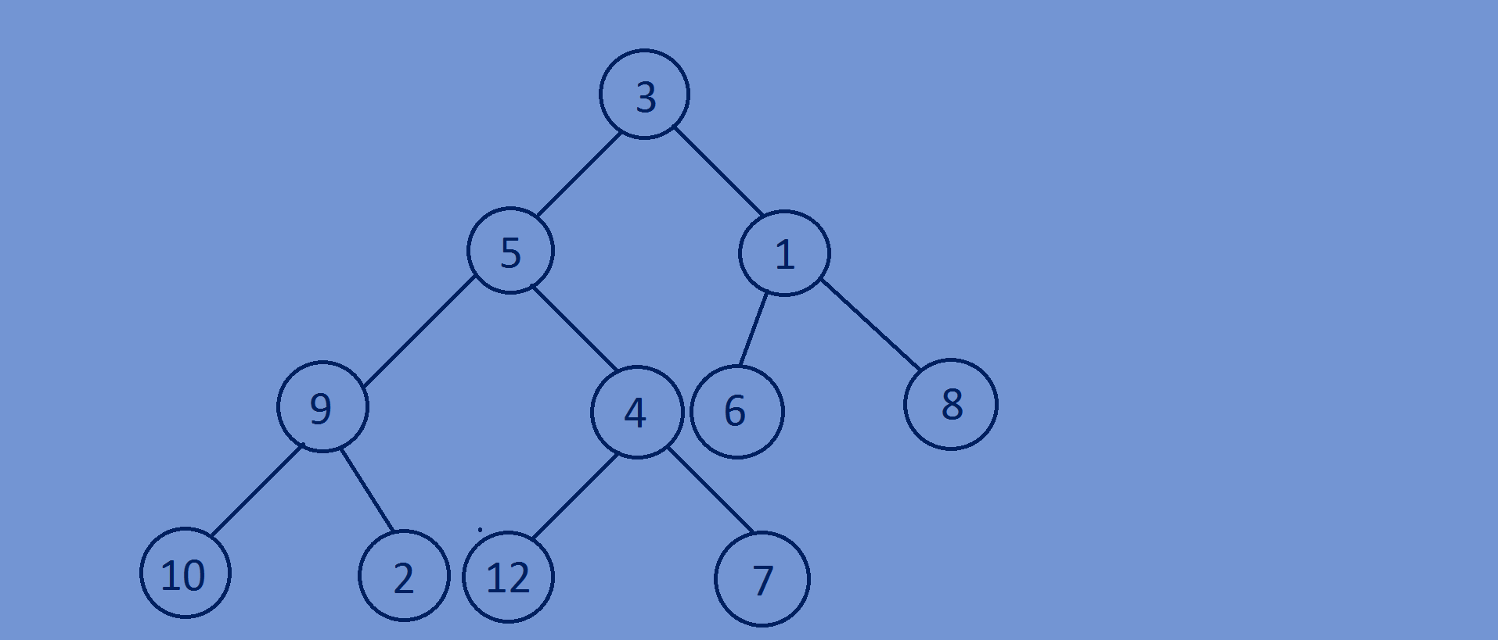

**What is a heap???**

* Binary tree.
* A binary heap is actually a complete binary tree with some special properties.
* A binary heap is of two types.

->Min heap

->Max heap.

* In a min heap the data of the root node must be less than or equal to its children

Nodes data and this property holds for all the nodes of the min binary heap.

* In a max heap the data of the root node must be greater than or equal to its

Children nodes data and this property holds for all the nodes of the max

Binary heap.

**Min binary heap:**

* In a min heap the data of the root node must be less than or equal to its children

Nodes data and this property holds for all the nodes of the min binary heap.

* 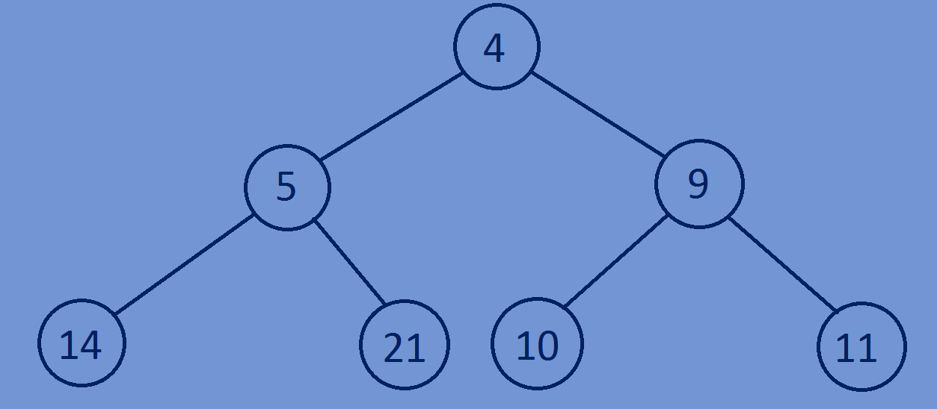In case of min heap the root node will have the smallest element compared to all other Nodes.

**Max binary heap:**

* In a max heap the data of the root node must be greater than or equal to its

Children nodes data and this property holds for all the nodes of the max

Binary heap.

* In case of max heap, the root node will have the largest value compared to

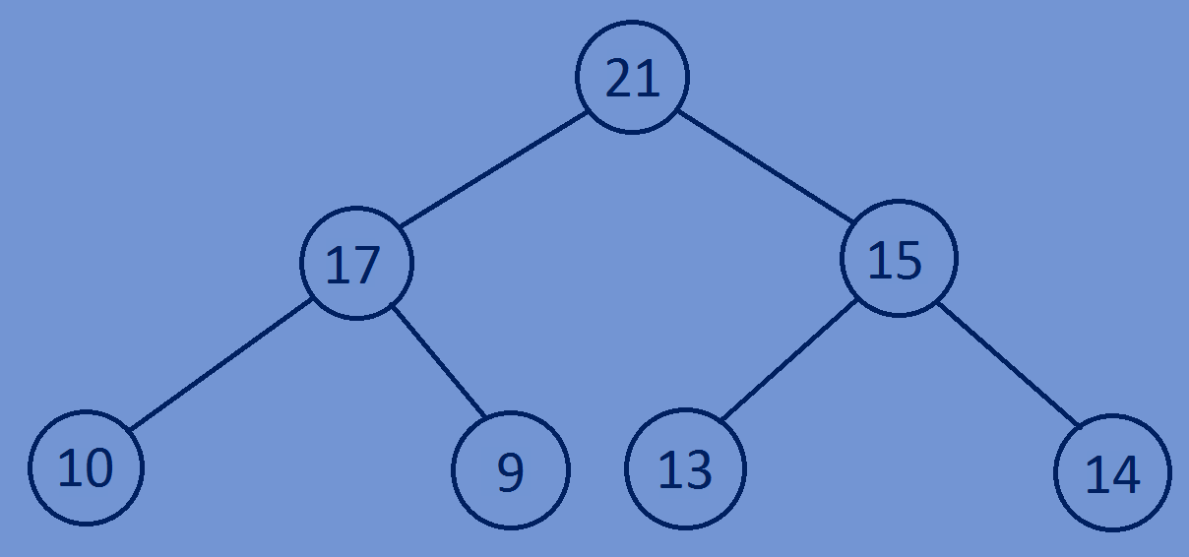All other nodes.

**Assignment:**

* 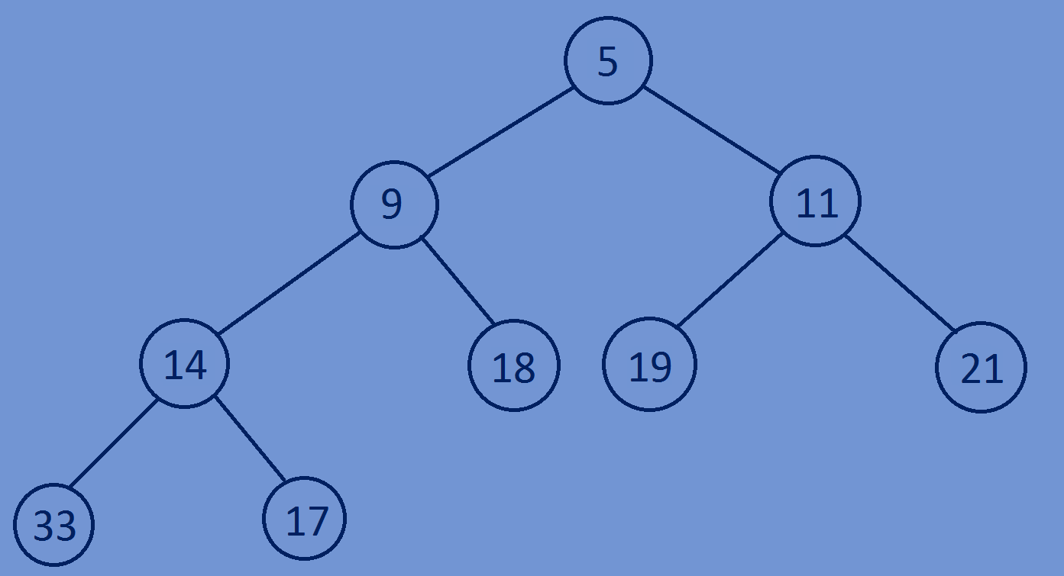Check whether the following complete binary tree is min binary heap or max binary heap.

**Applications of heaps:**

->heaps are used for sorting of data ex:heapsort is one of the best methods for

Sorting of data and time complexity of heap sort is in o(nlog(n)).

->heaps are used in selection algorithms,they are used to find the minimum

And maximum element in constant time.

->implementation of priority queue.

->heaps are used in graph algorithms like Dijkstras shortest path algorithm and

Prim’s minimal-spanning-tree algorithm.

->heaps are used to find the nth smallest element or nth largest element in an array.