**Data Structures**

Introduction to Trees

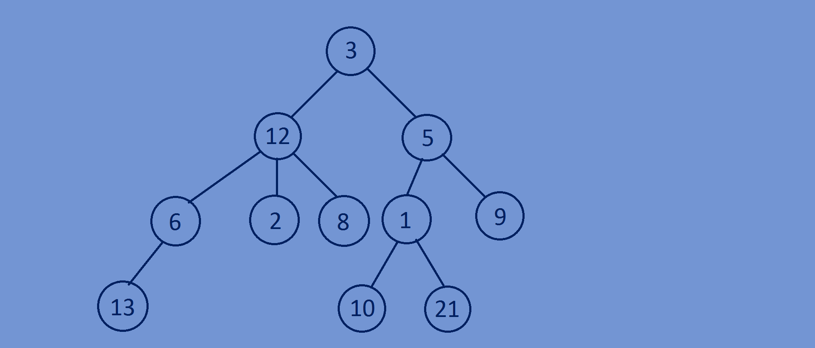

**What is a tree??**

* A tree is a data structure which has a collection of

Nodes organised in a hierarchical structure,here

Collection of nodes are linked together to form

To form a hierarchical structure.

* A tree is a non-linear data structure,here

A node is connected to several other nodes so that there are many possible ways for traversing.

* A node have some data and may contain links to some other nodes.
* Trees are used to represent hierarchical relationships.
* Edge is defined as the connection between two nodes.
* Top most node of a tree is called as root node.
* We can traverse through a tree only in forward traversing=>traversing is not

Bidirectional.

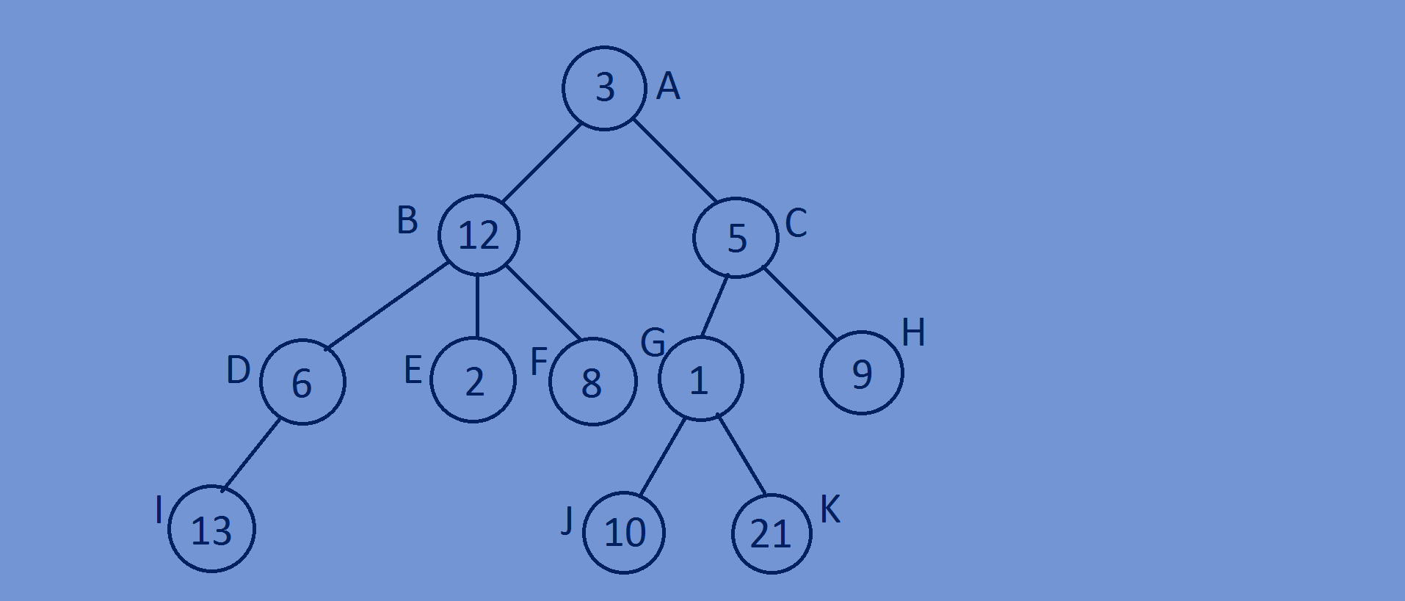**Tree Vocubalary :**

**Root:** Top most node of tree is called as node.

**Child:**the node which is directly under the other

Node,connected by an edge.two or more than two

Child are called as children.

**Parent:**The node which has an edge from

It to any other node is called as parent.

**Siblings:**Nodes with same parent are called as siblings.

**Leaf:**Node which doesn’t have any child is called as leaf node.

* A tree with n nodes will have n-1 edges.
* Every node will have one incoming edge except the first node.

**Path:**Sequence of nodes along the edges of a tree is called as a path.

**Depth:**Depth of a node is defined as The total no of edges from root node to the

Node and the depth of root node is equal to zero.

**Height:** height of a node is equal to the total no of edges in the longest path from node to a leaf ,height of leaf is always zero and height of a tree is equal to height

of the root node.



* Suppose we are traversing from node A(root node)

To node D,then node B and node A are called

Ancestor of D and node B and node D are

Called as descendent of A.

* Each child forms a subtree.

**Binary tree:**

* A tree in which each node can have at most two children is called as a binary tree.
* 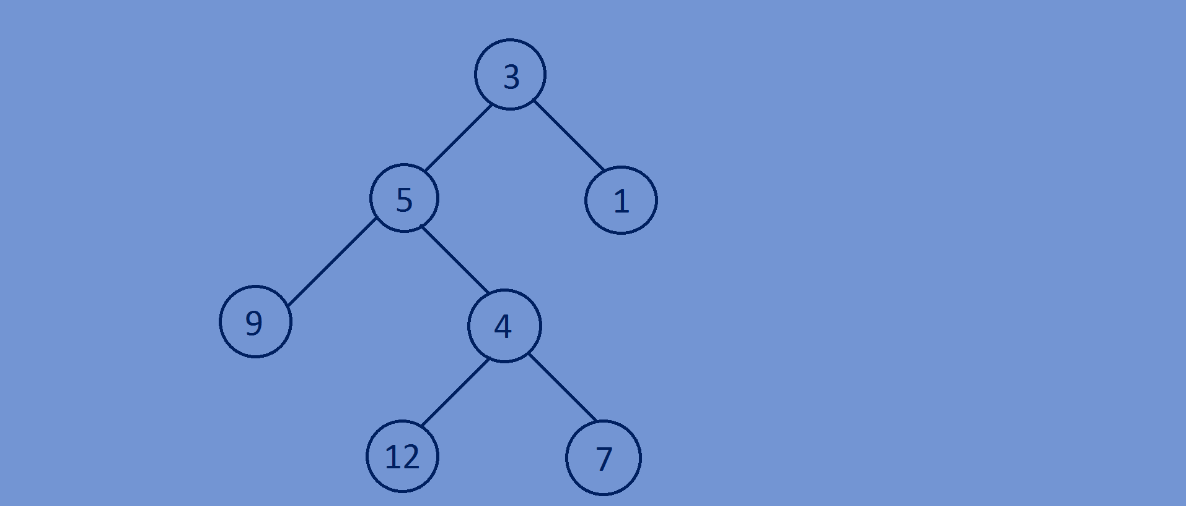The left node below a node is called as left child and the right node is called

Right child.

* Maximum no of nodes at a level is equal to 2i,where

I is the level.

**Strict Binary Tree:**

* A binary tree is said to be a strict

Binary tree if each node of a tree

Has two or zero children.

**Complete Binary Tree:**

* A binary is said to be a complete binary tree if all levels except the last level are completely filled and all nodes are left as possible.

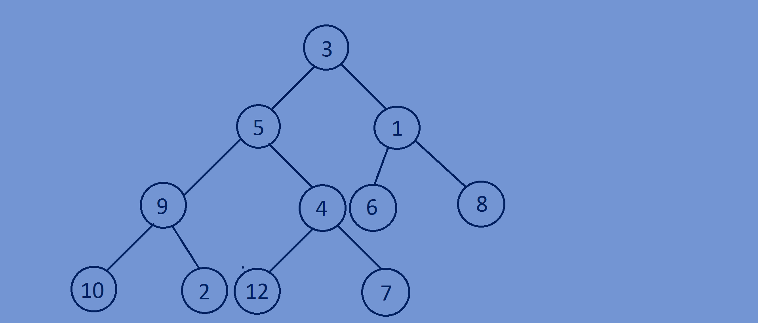

**Perfect Binary Tree:**

* A binary tree is said to be a perfect binary tree, if all the levels are completely filled (complete binary tree with all the leaf nodes at same level).

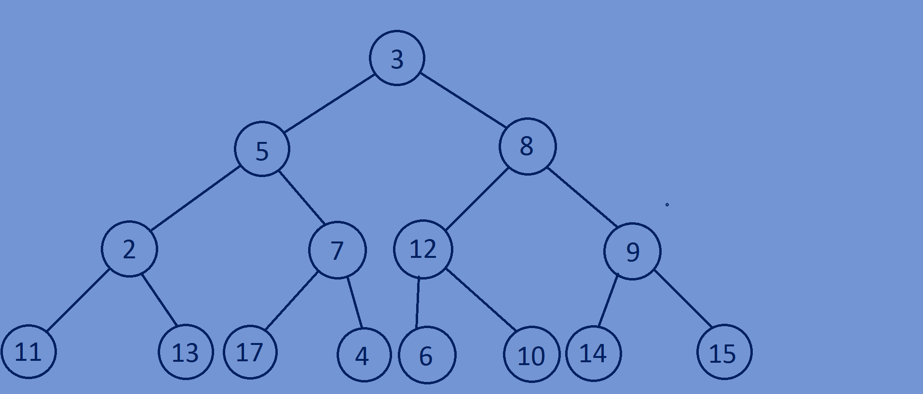

**Binary Search Tree:**

* A Binary Search tree is a binary tree in which value of left sub-tree node is

Less than or equal to its parent nodes value and the value of right sub-tree

Node is greater than its parent nodes value,here for each node,value of all

the nodes in left subtree is lesser and value of all the nodes in right subtree

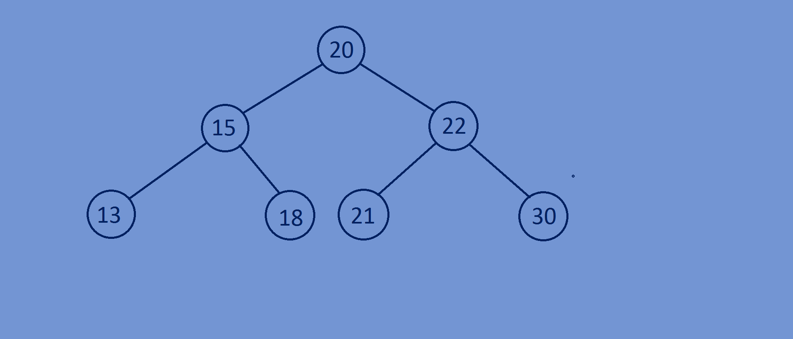is greater.