**Data Structures**

Tree traversals

**Binary Tree Traversal:**

* In linear data structure like linked list ,there would be a logical start and logical

End so that there is only one possible way of traversing the linked list.

* A tree is a non-linear data structure,so it may be traversed in many possible

Ways.

* Tree traversal is Process of visiting each node in the tree exactly once in some order.
* Tree traversal is divide into two types.

1)Breadth first traversal(level order traversal).

2)Depth first traversal.

* There are three ways of traversing in case of depth first traversal.

1)preorder traversal.

2)Inorder traversal.

3)postorder traversal.

**Bredth-first traversal:**

* Breadth first traversal is also called as level order traversal.
* In breadth first traversal we travers all the nodes of tree level by level
* First visit the root node and then the nodes in the level(1) and then nodes in

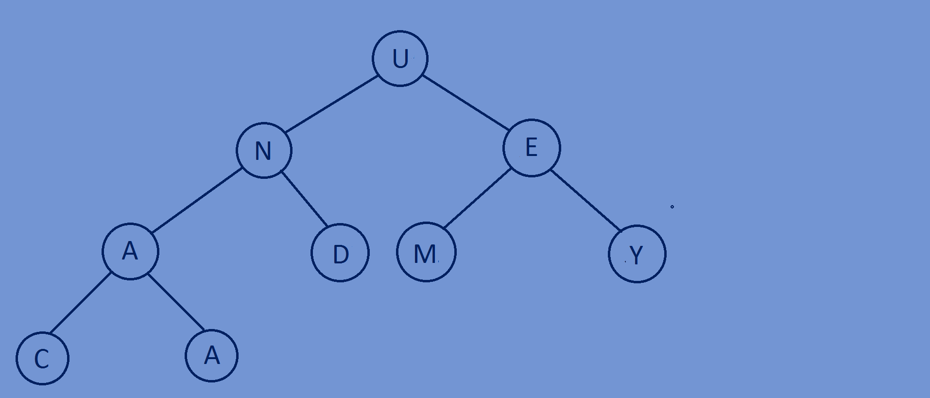level(2) and so on.

* Breadth first traversal for the Following tree is U N E A D M Y C A.

**Deapth-first traversal:**

* Here the relative order of preorder,inorder and postorder may differ but the

Core idea is that visiting a child is visiting the complete subtree in that path.

**Preorder traversal:**

* In this traversal the root node is visited first and then the left subtree and

Finally the right subtree,remember that every node represent a subtree itself.

* Root->left->right.
* Preorder traversal for the following binary tree is U N A C A D E M Y.

**Inorder traversal:**

* In this traversal the left subtree is visited first and then the root node and finally

The Right subtree .

* Left->root->right.
* Inorder traversal for the following binary tree is C A A N D U M E Y



**Post order traversal:**

* In this traversal the left subtree is visited first and then the right subtree and

Finally the root node.

* Left->right->root.
* Post order traversal for the following tree is C A A D N M Y E U

