**Data Structures**

Finding Degree of each vertex of a Graph

Adjacency List

**Degree of a vertex of undirected graph:**

**Degree of a Vertex:**Total no of edges connected to a vertex is called as Degree of

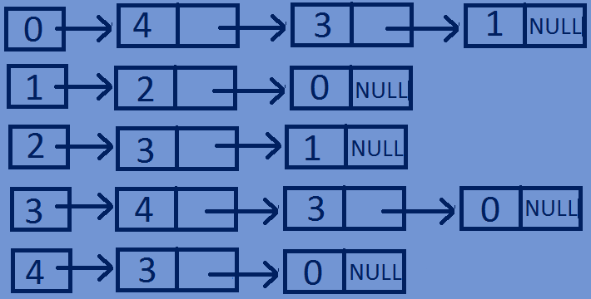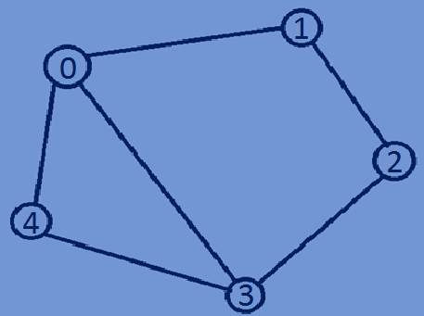That vertex.

Degree(0)=3

Degree(1)=2

Degree(2)=2

Degree(3)=3

Degree(4)=2

* In case of an undirected graph,the degree of a vertex is equal to the total no of

Nodes in the adjacency list corresponding to that vertex.

**Function for finding the degree of each vertex in an Undirected graph:**

**void** FindDegree(Graph *graph){  
 **for**(**int** i=0;i<graph->totVertices;i++){  
 Node *head=graph->array[i].Head;  
 **int** degree=0;  
 **while**(head){  
 degree++;  
 head=head->next;  
 }  
 printf("degree of vertex %d is:%d\n",i,degree);  
 }  
}

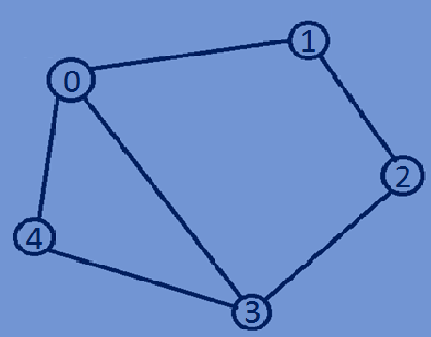 Degree(0)=3

Degree(1)=2

Degree(2)=2

Degree(3)=3

Degree(4)=2

**Finding indegree and outdegree of a directed graph:**

* For a directed graph each vertex has indegree and outdegree.

**Indegree:**The total no of incoming edges of a vertex is called as indegree of the vertex.

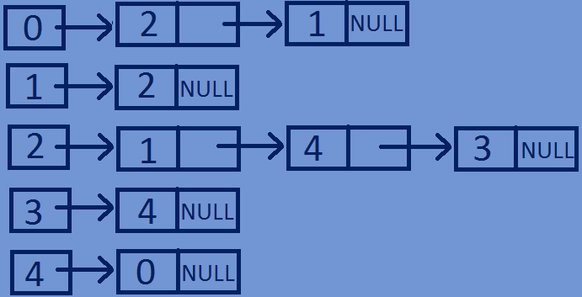**Outdegree:**The total no of Outgoing edges of a vertex is called as outdegree of the

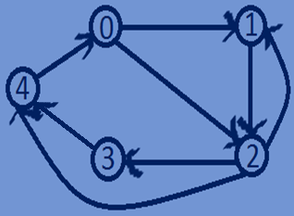vertex.

Indegree(0)=1,Outdegree(0)=2

Indegree(1)=2,Outdegree(1)=1

I Indegree(2)=2,Outdegree(2)=3

I Indegree(3)=1,Outdegree(3)=1

Indegree(4)=2,Outdegree(4)=1

* In case of directed graph outdegree of a vertex is equal to the total no of Nodes in the adjacency list corresponding to that vertex and indegree of a vertex is Equal to the total no of occurrences of that vertex in the adjacency list of all the vertices.

**Function for finding outdegree of each vertex of a directed graph :**

//function for finding outdegree of a vertex  
**void** findOutDegree(Graph *graph){  
 **for**(**int** i=0;i<graph->totVertices;i++){  
 Node *head=graph->array[i].Head;  
 **int** degree=0;  
 **while**(head){  
 degree++;  
 head=head->next;  
 }  
 printf("outdegree of vertex %d is:%d\n",i,degree);  
 }  
}

**Function for finding indegree of each vertex of a directed graph:**

//function for finding indegree of a vertex  
**void** findindegree(Graph *graph,**int** vertex){  
 **int** indegree=0;  
 **for**(**int** i=0;i<graph->totVertices;i++){  
 Node *head=graph->array[i].Head;  
 **while**(head!=NULL){  
 **if**(head->dest==vertex){  
 indegree++;  
 }  
 head=head->next;  
 }  
 }  
 printf("indegree of vertex %d is:%d\n",vertex,indegree);  
}

**Whole program:**

#include<stdio.h>  
#include<stdlib.h>  
//Structure for representing a NODE in the Adjacency List  
**typedef struct** Node{  
 **int** dest;  
 **int** weight;  
 **struct** Node *next;  
}Node;  
//structure for representing an adjacency liat  
**typedef struct** List{  
 Node *Head;  
}List;  
// A structure to represent a graph - here graph is an array of Adjacency lists  
// size of the array will be equal to the number of vertices in graph  
**typedef struct** Graph{  
 **int** totVertices;  
 List *array;  
}Graph;  
//function To create a new node in the adjacency list  
Node *createNewNode(**int** dest,**int** weight){  
 Node *newnode=(Node*)malloc(**sizeof**(Node));  
 newnode->dest=dest;  
 newnode->weight=weight;  
 newnode->next=NULL;  
 **return** newnode;  
}  
//Function To creates a graph of n vertices  
Graph *createGraph(**int** n){  
 Graph *graph=(Graph*)malloc(**sizeof**(Graph));  
 graph->totVertices=n;  
 graph->array=(List*)malloc(n\***sizeof**(List));  
 //Initialise each adjacency list as empty by making head as NULL  
 **for**(**int** i=0;i<n;i++){  
 graph->array[i].Head=NULL;  
 }  
 **return** graph;  
}  
//function for Adding an edge to a directed graph  
**void** addedge(Graph *graph,**int** src,**int** dest,**int** weight){  
 Node *newnode=createNewNode(dest,weight);  
 newnode->next=graph->array[src].Head;  
 graph->array[src].Head=newnode;  
}  
//Function for printing Adjacency list corresponding to each vertex  
**void** printGraph(Graph *graph){  
 **for**(**int** i=0;i<graph->totVertices;i++){  
 Node *Headnode=graph->array[i].Head;  
 printf("connected vertices of vertex %d are:head",i);  
 **while**(Headnode){  
 printf("->%d",Headnode->dest);  
 Headnode=Headnode->next;  
 }  
 printf("\n");  
 }  
}  
//function for finding outdegree of a vertex  
**void** findOutDegree(Graph *graph){  
 **for**(**int** i=0;i<graph->totVertices;i++){  
 Node *head=graph->array[i].Head;  
 **int** degree=0;  
 **while**(head){  
 degree++;  
 head=head->next;  
 }  
 printf("outdegree of vertex %d is:%d\n",i,degree);  
 }  
}  
//function for finding indegree of a vertex  
**void** findindegree(Graph *graph,**int** vertex){  
 **int** indegree=0;  
 **for**(**int** i=0;i<graph->totVertices;i++){  
 Node *head=graph->array[i].Head;  
 **while**(head!=NULL){  
 **if**(head->dest==vertex){  
 indegree++;  
 }  
 head=head->next;  
 }  
 }  
 printf("indegree of vertex %d is:%d\n",vertex,indegree);  
}  
//main function  
**int** main(){  
 **int** n=5;  
 Graph *graph=createGraph(n);  
 addedge(graph,0,1,2);  
 addedge(graph,0,2,1);  
 addedge(graph,1,2,3);  
 addedge(graph,2,3,1);  
 addedge(graph,2,4,7);  
 addedge(graph,2,1,1);  
 addedge(graph,3,4,5);  
 addedge(graph,4,0,4);  
 printGraph(graph);  
 findOutDegree(graph);  
 findindegree(graph,2);

findindegree(graph,0);  
 **return** 0;  
}

**Output:**

connected vertices of vertex 0 are:head->2->1

connected vertices of vertex 1 are:head->2

connected vertices of vertex 2 are:head->1->4->3

connected vertices of vertex 3 are:head->4

connected vertices of vertex 4 are:head->0

outdegree of vertex 0 is:2

outdegree of vertex 1 is:1

outdegree of vertex 2 is:3

outdegree of vertex 3 is:1

outdegree of vertex 4 is:1

indegree of vertex 2 is:2

indegree of vertex 0 is:1