**Data Structures**

Finding Degree of each vertex of a Graph

Adjacency Matrix

**Degree of a vertex of undirected graph:**

**Degree of a Vertex:**Total no of edges connected to a vertex is called as Degree of

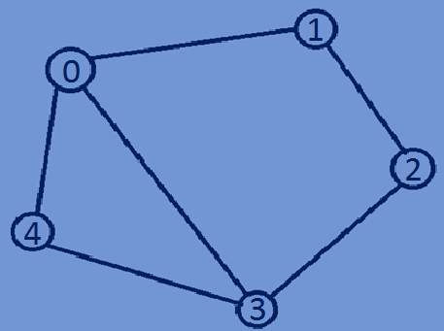That vertex.

Degree(0)=3 0 1 2 3 4

|  |  |  |  |  |
| --- | --- | --- | --- | --- |
| 0 | 1 | 0 | 1 | 1 |
| 1 | 0 | 1 | 0 | 0 |
| 0 | 1 | 0 | 1 | 0 |
| 1 | 0 | 1 | 0 | 1 |
| 1 | 0 | 0 | 1 | 0 |

Degree(1)=2 0

Degree(2)=2 1

Degree(3)=3 2

Degree(4)=2 3

4

* In case of an undirected graph,the degree of a vertex is equal to the total no of

Integers that are greater than zero in the vertex row of an adjacent matrix.

**Function for finding the degree of each vertex in an Undirected graph:**

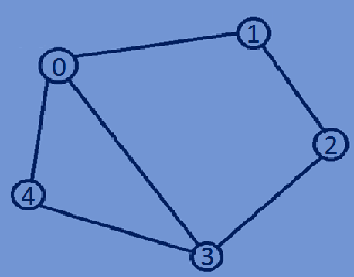**void** findDegreeUndirectedgraph(graph *array,**int** n){  
 **int** count=0,i,j;  
 **for** (i = 0; i < n; i++) {  
 count=0;  
 **for** (j = 0; j < n; j++) {  
 **if**(*(array + i*n + j)>0)  
 count++;  
 }  
 printf("degree of vertex %d is ->%d\n",i,count);  
 }  
}

Degree(0)=3 0 1 2 3 4

|  |  |  |  |  |
| --- | --- | --- | --- | --- |
| 0 | 1 | 0 | 1 | 1 |
| 1 | 0 | 1 | 0 | 0 |
| 0 | 1 | 0 | 1 | 0 |
| 1 | 0 | 1 | 0 | 1 |
| 0 | 0 | 0 | 1 | 0 |

Degree(1)=2 0

Degree(2)=2 1

Degree(3)=3 2

Degree(4)=2 3

4

**Finding indegree and outdegree of a directed graph:**

* For a directed graph each vertex has indegree and outdegree.

**Indegree:**The total no of incoming edges of a vertex is called as indegree of the vertex.

**Outdegree:**The total no of Outgoing edges of a vertex is called as outdegree of the

vertex.

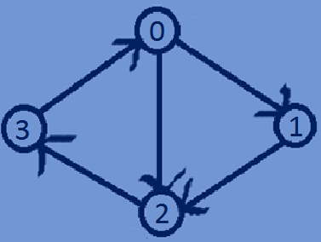Indegree(0)=1,Outdegree(0)=2 0 1 2 3

|  |  |  |  |
| --- | --- | --- | --- |
| 0 | 1 | 1 | 0 |
| 0 | 0 | 1 | 0 |
| 0 | 0 | 0 | 1 |
| 1 | 0 | 0 | 0 |

Indegree(1)=1,Outdegree(1)=1 0

Indegree(2)=2,Outdegree(2)=1 1

Indegree(3)=1,Outdegree(3)=1 2

3

* In case of directed graph indegree of a vertex is equal to the total no of integers

Greater than zero in the vertex column and outdegree of a vertex is equal to the total No of integers greater than zero in the vertex row of Adjacency matrix.

**Function for finding indegree and outdegree of a directed graph using Adjacency matrix:**

**void** findDegreeDirectedgraph(graph *array,**int** n){  
 **int** indegree=0,outdegree=0;  
 **for**(**int** i=0;i < n;i++){  
 indegree=0;outdegree=0;  
 **for**(**int** j=0;j < n;j++){  
 **if**(*(array + i +j*n)>0){  
 indegree++;  
 }  
 **if**(*(array + i*n +j)>0){  
 outdegree++;  
 }  
 }  
 printf("indegree and outdegree of vertex %d is -> %d,%d\n",i,indegree,outdegree);  
 }  
}

**Whole program:**

#include<stdio.h>  
#include<stdlib.h>  
#include<time.h>  
**typedef int** graph;  
//constructing a weighted undirectedgraph  
graph *buildUndirectedGraph (**int** n) {  
 **int** i,j;  
 graph *array = (graph *) malloc(n * n * **sizeof**(graph));  
 srand((**unsigned**)time(NULL));  
 **for** (i = 0; i < n; i++) {  
 **for** (j = 0; j < n; j++) {  
 **if** (i == j) {  
 *(array + i * n + j) = 0;  
 } **else if** (i != j) {  
 **int** temp=rand()%2;  
 *(array + i * n + j) =temp;  
 *(array + j * n + i) =temp;  
 }  
 }  
 }  
 **return** array;  
}  
//constructing a weighted directed graph  
graph *buildDirectedGraph(**int** n){  
 **int** i,j;  
 graph *array = (graph *) malloc(n * n * **sizeof**(graph));  
 srand((**unsigned**)time(NULL));  
 **for** (i = 0; i < n; i++) {  
 **for** (j = 0; j < n; j++) {  
 **if** (i == j) {  
 *(array + i * n + j) = 0;  
 } **else if** (i != j) {  
 **int** temp=rand()%2;  
 *(array + i * n + j) =temp;  
 }  
 }  
 }  
 **return** array;  
}  
//Finding indegree and outdegree of a directed graph  
**void** findDegreeUndirectedgraph(graph *array,**int** n){  
 **int** count=0,i,j;  
 **for** (i = 0; i < n; i++) {  
 count=0;  
 **for** (j = 0; j < n; j++) {  
 **if**(*(array + i*n + j)>0)  
 count++;  
 }  
 printf("degree of vertex %d is ->%d\n",i,count);  
 }  
}  
//Function for finding indegree and outdegree of a directed graph using Adjacent matrix  
**void** findDegreeDirectedgraph(graph *array,**int** n){  
 **int** indegree=0,outdegree=0;  
 **for**(**int** i=0;i < n;i++){  
 indegree=0;outdegree=0;  
 **for**(**int** j=0;j < n;j++){  
 **if**(*(array + i +j*n)>0){  
 indegree++;  
 }  
 **if**(*(array + i*n +j)>0){  
 outdegree++;  
 }  
 }  
 printf("indegree and outdegree of vertex %d is -> %d,%d\n",i,indegree,outdegree);  
 }  
}  
//printing adjacent matrix of a graph  
**void** printAdjacencyMatrix(graph *array,**int** n){  
 **for** (**int** i = 0; i < n; i++) {  
 **for** (**int** j = 0; j < n; j++) {  
 printf("%d ", *(array + i*n + j));  
 }  
 printf("\n");  
 }  
}  
**int** main(){  
 **int** n=5;  
 graph *array;  
 array=buildUndirectedGraph(n);  
 printAdjacencyMatrix(array,n);  
 findDegreeUndirectedgraph(array,n);  
 array=buildDirectedGraph(n);printf("\n\n");  
 printAdjacencyMatrix(array,n);  
 findDegreeDirectedgraph(array,n);  
 **return** 0;  
}

**Output:**

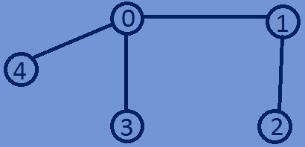0 1 0 1 1

1 0 1 0 0

1. 1 0 0 0
2. 0 0 0 0

1 0 0 0 0

degree of vertex 0 is ->3

degree of vertex 1 is ->2

degree of vertex 2 is ->1

degree of vertex 3 is ->1

degree of vertex 4 is ->1

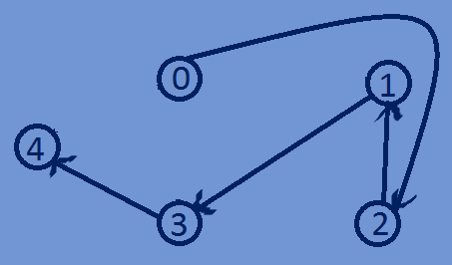0 0 1 0 0

0 0 0 1 0

1. 1 0 0 0
2. 0 0 0 1

0 0 0 0 0

indegree and outdegree of vertex 0 is -> 0,1

indegree and outdegree of vertex 1 is -> 1,1

indegree and outdegree of vertex 2 is -> 1,1

indegree and outdegree of vertex 3 is -> 1,1

indegree and outdegree of vertex 4 is -> 1,0