**Data Structures**

Introduction to Graphs

**What is a graph???**

* A graph ‘G’ is collection of vertices ‘V’ and edges ‘E’ => a graph is a pair of sets(V,E)

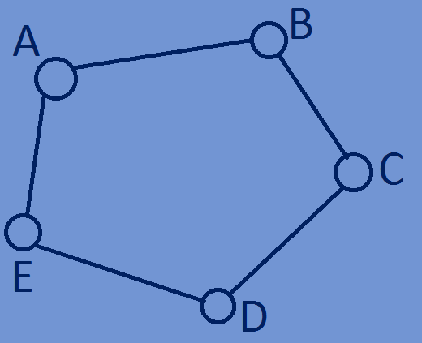G=(V,E)

V={A,B,C,D,E}

E={(A,B),(B,C),(C,D),(D,E),(E,A)}

* A graph is a collection of objects called as nodes and these nodes are connected

to each other through edges.

**Graph terminology:**

**Edge:-**Edge is the connecting link between two vertices of a graph,edge is represented

As (origin vertex,destination vertex),for example in the below figure the connection

Between two nodes(A and B) is represented by (A,B).

E={(A,B),(B,C),(C,D),(D,E),(E,A)}

**Directed Edge:**A directed edge has connection only in

one direction which means it is unidirectional. If there is an directed edge from A to B,then we can that there is path between A and B,but we cant say that there is a path

between B and A.Here edge (A,B)!=(B,A)

**Undirected Edge:**An undirected edge has connection in both directions which means

it is bidirectional.If there is an undirected edge from A to B,then we can say that there

is a path between vertices A and B as well as B and A.Here (A,B)=(B,A).



**Weighted Edge:**A weighted edge is an edge having some weight on it,weight of an

Edge is often referred as “cost” of the edge.In applications weight of an edge

Represents length of a route,capacity of a line etc.

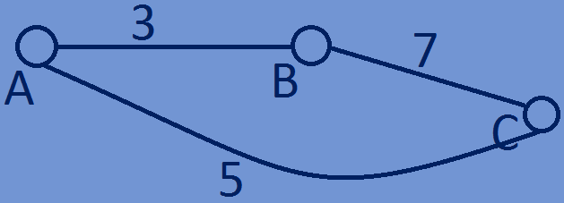

**Directed Graph:**A Graph with all directed edges is called as a Directed Graph.

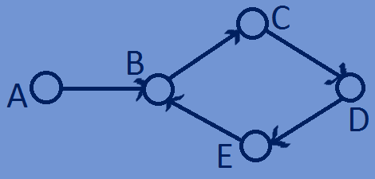

**Undirected Graph:**A Graph with all undirected edges is called as Undirected Graph.

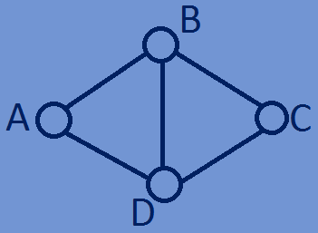

**Degree of a Node:**Total no of edges connected to a vertex is called as Degree of

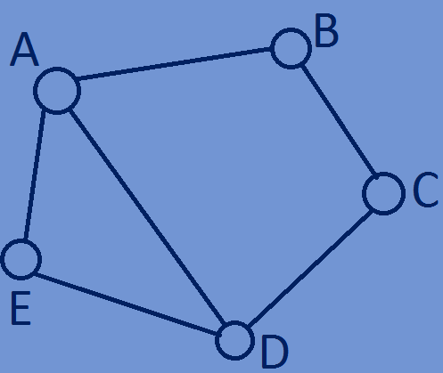That vertex.

Degree(A)=3

Degree(B)=2

Degree(C)=2

Degree(D)=3

Degree(E)=2

* For a directed graph each vertex has indegree and outdegree.

**Indegree:**The total no of incoming edges of a vertex is called as indegree of the vertex.

**Outdegree:**The total no of Outgoing edges of a vertex is called as outdegree of the

vertex.

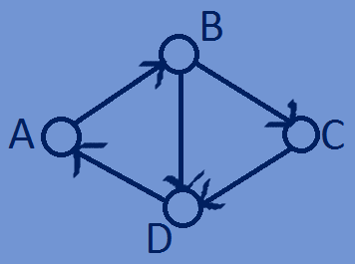

Indegree(A)=1,Outdegree(A)=1

Indegree(B)=1,Outdegree(B)=2

Indegree(C)=1,Outdegree(C)=1

Indegree(D)=2,Outdegree(D)=1

**Difference between Tree and Graph:**

* Tree is a special form of graph that have only one path between any two nodes,

But a graph can have more than one path between any two nodes.

* A tree doesn’t have any loops or circuits,but a graph can have loops and circuits.
* In a tree every node can have at most two children, but in a graph a node can

Have any no of connections to other nodes.

* Trees are categorised into binary trees,Binary search trees,AVL Trees,Heaps etc

But graphs are only of two types->directed and undirected graphs.

* Tree has a hierarchal structure whereas a graph has network structure.

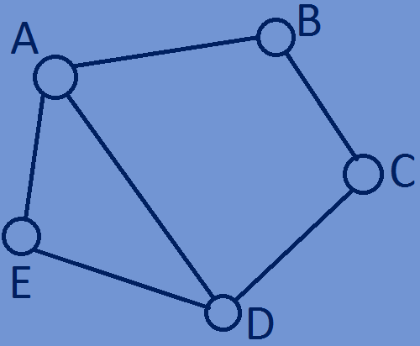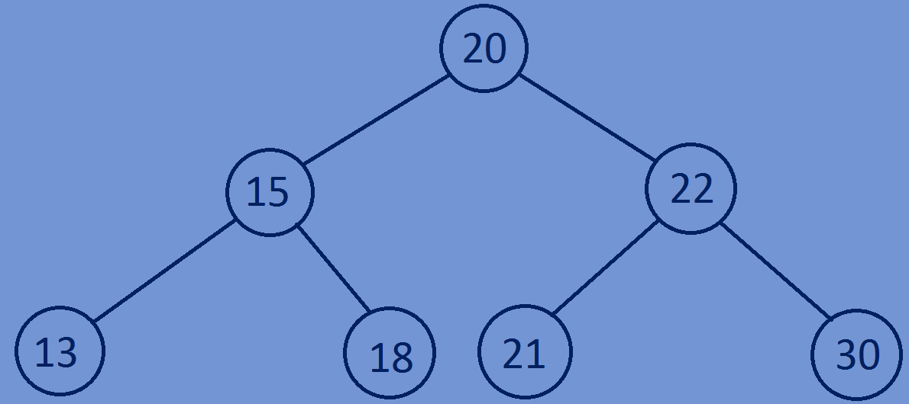

**Applications of Graphs:**

* Graphs are used to represent network communication,data organisation and computational devices.
* In mathematics graphs are used in geometry.
* Some graph algorithms are used to find the shortest distance between two points.
* Graphs are used in maps to find shortest,cheapest path between two cities .
* Facebook is based on graphs here each user is represented by a vertex and if two

Vertices are connected by an edge that means these two users are friends

* 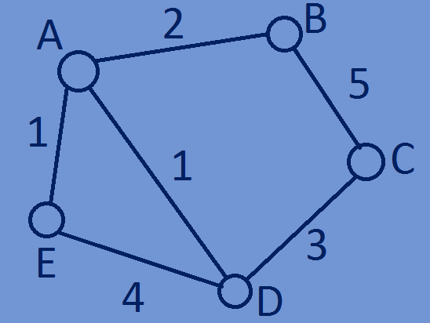Graph theory is used to study molecules in chemistry.
* Graphs are used to link web pages in internet.