PROJECT REPORT FOR

Foundations of Artificial Intelligence

Adversarial Game-Theoretic Security Patrol Planner

A PROJECT REPORT

Submitted by
2116240701600 - Vishal S
2116240701595 – Vishaali R


October, 2026

BONAFIDE CERTIFICATE

Certified that this project report “Adversarial Game-Theoretic Security Patrol Planner using Stackelberg Security Games” is the bonafide work of “ Vishal S (240701600) and Vishaali R (240701595)” who carried out the project work under my supervision.

SIGNATURE OF THE FACULTY INCHARGE

Submitted for the Practical Examination held on

SIGNATURE OF THE INTERNAL EXAMINER

TABLE OF CONTENTS

CHAPTER NO. | TITLE | PAGE NO.
 | ABSTRACT | 4
1 | INTRODUCTION | 5
2 | LITERATURE REVIEW | 7
3 | PROPOSED SYSTEM | 9
 | 3.1 ARCHITECTURE DIAGRAM | 12
4 | MODULES DESCRIPTION | 13
 | 4.1 MODULE 1 | 13
 | 4.2 MODULE 2 | 14
5 | IMPLEMENTATION AND RESULTS | 16
 | 5.1 EXPERIMENTAL SETUP | 16
 | 5.2 RESULTS | 19
6 | CONCLUSION AND FUTURE WORK | 30
7 | REFERENCES | 31

ABSTRACT:
The Adversarial Game-Theoretic Security Patrol Planner is an AI-based decision-support system that computes randomized security patrol strategies for a campus or building when an intruder is able to observe the patrol and exploit its habits. A fixed patrol schedule is easy to learn and avoid, so the problem is modelled as a Stackelberg security game: the defender (leader) commits to a probability distribution over patrol routes, and the attacker (follower) observes it and attacks the target with the highest expected payoff. This is the formulation behind deployed systems such as ARMOR at Los Angeles International Airport.
The campus is represented as a weighted graph whose nodes are targets with reward and penalty values and whose edges carry travel times. A depth-first search with backtracking enumerates every feasible patrol route within a shift-time and checkpoint limit (36 routes for the default 30-minute shift). A linear-programming solver then computes the Strong Stackelberg Equilibrium with the multiple-LPs method, solving one LP per candidate attacker target and keeping the best. Two attacker models are supported: a perfectly rational attacker and a bounded-rational attacker that follows a quantal-response (softmax) rule with parameter λ.
The computed policy is compared with a fixed schedule and a uniform random schedule using Monte Carlo simulation and a multi-trial benchmark with synchronized seeds, 95% Wilson confidence intervals and normalized Shannon entropy as an unpredictability measure. Against a rational attacker on the default campus, the game-theoretic policy intercepted 72.4% of attacks and earned a defender payoff of +4.48, compared with 30.8% (−3.85) for uniform random and 0.0% (−10.00) for the fixed schedule. A web dashboard visualizes the campus graph, the equilibrium, the attacker's response, the simulation and the benchmark, and the whole system is covered by 64 automated tests.
The payoff values and campus layout are sample values for academic demonstration and do not represent real security data.

1. INTRODUCTION
Security patrols protect locations such as campuses, airports, ports and data centers. Resources are always limited: a small number of guards cannot watch every location at every moment, so some targets are unprotected at any given time. If the patrol follows a fixed schedule, an observant intruder can learn it and attack exactly where and when no one is present. Purely random patrolling removes the predictability, but it ignores the fact that targets differ in value and spends as much effort on a parking lot as on a server room.
Game theory gives a principled way to resolve this. In a Stackelberg security game the defender moves first and commits to a randomized strategy. The attacker then observes that strategy and chooses the best target in response. Because the defender anticipates this reaction, the randomization is not blind: coverage is concentrated where an attack would otherwise be most profitable. The approach has been put into practice in systems such as ARMOR for airport checkpoints at Los Angeles International Airport, in air-marshal scheduling, and in PROTECT for port patrols.
The Adversarial Game-Theoretic Security Patrol Planner reproduces this idea on a small campus. The campus is stored as a graph in which each node is a target with an asset value and each edge is a corridor with a travel time. The system generates every feasible patrol route for a shift, computes the optimal probability of running each route using linear programming, and then tests the result against an intruder, both a perfectly rational one and a bounded-rational one, through simulation.
Several Artificial Intelligence techniques are combined in the project:
- State representation: a NetworkX graph encodes targets, payoffs and travel times.
- Search with constraints: depth-first search with backtracking finds all routes that fit the shift-time and checkpoint limits.
- Adversarial reasoning: a Stackelberg game formulation anticipates the attacker's best response.
- Mathematical optimization: one linear program per candidate target yields the Strong Stackelberg Equilibrium.
- Probabilistic modelling: a quantal-response (softmax) model represents an imperfectly rational attacker.
- Empirical evaluation: Monte Carlo simulation with confidence intervals and an entropy-based unpredictability measure.
The project is intended for academic and demonstration purposes. The target values, rewards, penalties and campus layout are sample data and do not describe any real facility.
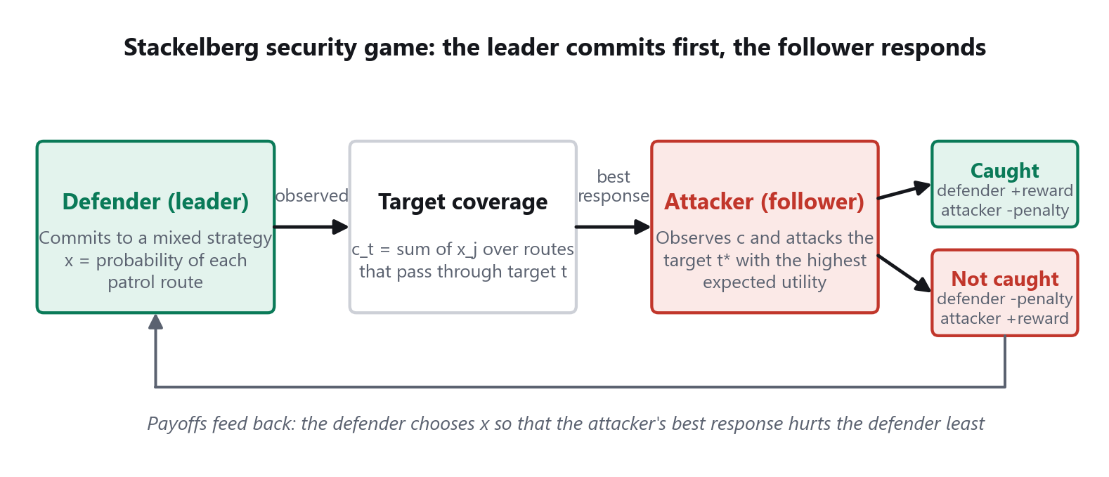
Figure 1.1: Stackelberg Security Game

2. LITERATURE REVIEW

Stackelberg Security Games and Deployed Systems:
Tambe (2011) consolidated the theory and practice of security games in a single volume. The book describes how a defender with limited resources commits to a randomized allocation, how attackers are assumed to observe it and respond, and how the framework was applied in real deployments. This formulation is the basis of the proposed planner, which uses the same leader-follower structure and the same vocabulary of targets, coverage and best response.
Pita et al. (2008) reported ARMOR, a system deployed at Los Angeles International Airport that randomizes the placement of vehicle checkpoints and the scheduling of canine patrols using a game-theoretic model so that adversaries cannot predict security activity. This result motivated the central goal of the proposed system: to replace a predictable schedule with a randomized one that is computed rather than guessed.
Shieh et al. (2012) described PROTECT, which schedules randomized patrols for the United States Coast Guard at ports and extends the basic model with a more realistic model of the adversary. This influenced the decision to evaluate the proposed policy against both rational and bounded-rational attackers.

Computing Optimal Commitments:
Conitzer and Sandholm (2006) showed that the optimal mixed strategy for a leader to commit to can be found by solving one linear program for each pure strategy of the follower, each program requiring that strategy to be the follower's best response. The best of these solutions is the optimal commitment. The solver in the proposed system follows exactly this multiple-LPs construction, with one program per target.
Paruchuri et al. (2008) introduced DOBSS, a single mixed-integer program for Bayesian Stackelberg games in which the attacker may be one of several types, and showed that it outperformed the multiple-LPs approach in that setting. Kiekintveld et al. (2009) presented a compact representation for security games with very large numbers of patrol assignments, avoiding explicit enumeration of joint schedules. These two works shaped the future-work directions of the project, namely multiple attacker types and multiple patrol units.

Bounded Rationality in Adversary Modelling:
McKelvey and Palfrey (1995) proposed quantal response equilibrium, in which players choose better actions with higher probability rather than always choosing the best one, and a parameter controls how sharply choices follow payoffs. As the parameter grows, behaviour approaches perfect rationality. This is the model used for the bounded-rational attacker in the proposed system, with the parameter λ.
Yang et al. (2011) studied how human adversaries behave in security games and found that a defender strategy computed with a quantal-response model performed better against human subjects than one that assumed a perfectly rational attacker. This is why the project also reports how the policy behaves when the attacker deviates from perfect rationality.

Search, Optimization and Statistical Evaluation:
Russell and Norvig (2020) present systematic search, including depth-first search with backtracking, as a standard way to enumerate states that satisfy constraints. This is the technique used to generate every simple route that fits within the shift duration and the checkpoint limit. For the optimization step, the linear programs are solved with the HiGHS solver (Huangfu and Hall, 2018) through SciPy (Virtanen et al., 2020), and the graph is handled with NetworkX (Hagberg et al., 2008).
Wilson (1927) proposed a confidence interval for a binomial proportion that remains well behaved when the observed proportion is close to 0 or 1, which is the case for a fixed schedule whose detection rate is 0%. Shannon (1948) defined entropy as a measure of uncertainty in a probability distribution. Together they supply the interval estimates and unpredictability measure used in the benchmark.

3. PROPOSED SYSTEM
The proposed system is an Adversarial Game-Theoretic Security Patrol Planner that automatically computes, tests and explains a randomized patrol policy. The campus is modelled as a graph, all feasible patrol routes are enumerated, and a linear-programming solver finds the probability of running each route that is optimal for the defender against an attacker who observes those probabilities. The result is compared with baseline policies through simulation and presented in a web dashboard.
Problem formulation. Let T be the set of targets and R the set of feasible routes. A route covers the targets on its path. The defender chooses a probability x_{j} for each route j, with the probabilities summing to 1. The coverage of target t is the probability that the patrol passes through it:
c_{t} = Σ_{j ∈ R: t ∈ route j} x_{j}
Each target has an attacker reward R_{a}(t) if the attack succeeds, an attacker penalty P_{a}(t) if the attacker is caught, a defender reward R_{d}(t) if the attack is caught and a defender penalty P_{d}(t) if it succeeds. The expected payoffs are:
U_{a}(t) = c_{t} P_{a}(t) + (1 − c_{t}) R_{a}(t)
U_{d}(t) = c_{t} R_{d}(t) + (1 − c_{t}) P_{d}(t)
In the Strong Stackelberg Equilibrium (SSE) the attacker chooses the target t* with the highest U_{a}, and if several targets tie, chooses the one that is best for the defender. The defender selects x so that U_{d}(t*) is as large as possible.
Multiple-LPs solution. For each candidate target k the system solves a linear program that maximizes the defender's payoff assuming k is the attacker's best response:
maximize c_{k} (R_{d}(k) − P_{d}(k)) + P_{d}(k)
subject to U_{a}(k) ≥ U_{a}(t) + ε for every t ≠ k, Σ x_{j} = 1, x_{j} ≥ 0
The program with the highest defender payoff gives the SSE. A very small margin ε = 10⁻⁶ is required so that the intended target is strictly preferred. Without it, the equilibrium leaves the attacker exactly indifferent and a tiny numerical rounding error can make the attacker switch to another target.
Bounded-rational attacker. Instead of always choosing the best target, this attacker chooses target t with probability:
P(t) = exp(λ U_{a}(t)) / Σ_{s} exp(λ U_{a}(s))
A small λ approaches random choice and a large λ approaches the rational attacker. Unpredictability of a policy is measured by the normalized Shannon entropy H / ln N of its route probabilities, which is 0 for a fixed schedule and 1 for a uniform random one.
Major Components
- Campus Graph Model
  - NetworkX graph whose nodes are targets and whose edges are corridors.
  - Each target stores its value and attacker and defender rewards and penalties.
  - Each corridor stores its travel time in minutes.
- Strategy Generator
  - Depth-first search with backtracking from every start node.
  - Keeps simple paths whose total travel time fits the shift duration.
  - Limits the number of checkpoints per route.
- Stackelberg Solver
  - Builds the target coverage matrix for all routes.
  - Solves one linear program per target using SciPy and HiGHS.
  - Returns route probabilities, target coverage, the attacker's best response and both utilities.
- Attacker Models
  - Rational attacker with ties broken in the defender's favour.
  - Bounded-rational attacker with a softmax over expected utilities and parameter λ.
- Baseline Policies
  - Fixed schedule that always runs one selected route.
  - Uniform random schedule that gives every route equal probability.
- Simulation Engine
  - Samples a patrol route each round from the chosen policy.
  - Lets the attacker choose a target and records whether it was intercepted.
  - Accumulates detection rate and both players' average payoffs.
- Evaluation Module
  - Runs several independent trials with synchronized seeds.
  - Reports 95% Wilson confidence intervals for detection probability.
  - Computes normalized entropy and identifies the best policy for each metric.
- REST API and Dashboard
  - FastAPI endpoints expose every step of the pipeline.
  - Interactive map, tables and charts with light and dark themes.
  - Pipeline progress, a patrol sampler and a recommendation derived from the benchmark.
Default Campus
The demonstration campus contains six targets and five corridors. Each attacker reward equals the target value, the defender reward equals the value if the attack is caught, and the defender penalty equals the negative of the value if it succeeds.
Table 3.1: Targets and Payoff Values of the Default Campus
Target | Value | Attacker reward | Attacker penalty | Defender reward | Defender penalty
Main Gate | 9 | 9 | −2 | 9 | −9
Corridor | 2 | 2 | 0 | 2 | −2
Laboratory | 8 | 8 | −2 | 8 | −8
Admin Office | 6 | 6 | −2 | 6 | −6
Server Room | 10 | 10 | −2 | 10 | −10
Parking Area | 4 | 4 | −1 | 4 | −4

Table 3.2: Corridors of the Default Campus
Corridor | Travel time (min)
Main Gate ↔ Corridor | 2
Corridor ↔ Laboratory | 3
Corridor ↔ Admin Office | 4
Laboratory ↔ Server Room | 2
Admin Office ↔ Parking Area | 3

3.1 ARCHITECTURE DIAGRAM
The system follows a three-part architecture. The dashboard in the browser sends JSON requests to a FastAPI backend, and the backend modules cooperate to generate routes, solve the game, model the attacker, simulate and evaluate. The solver alone decides the patrol probabilities; the simulation and evaluation modules only measure how well they perform.
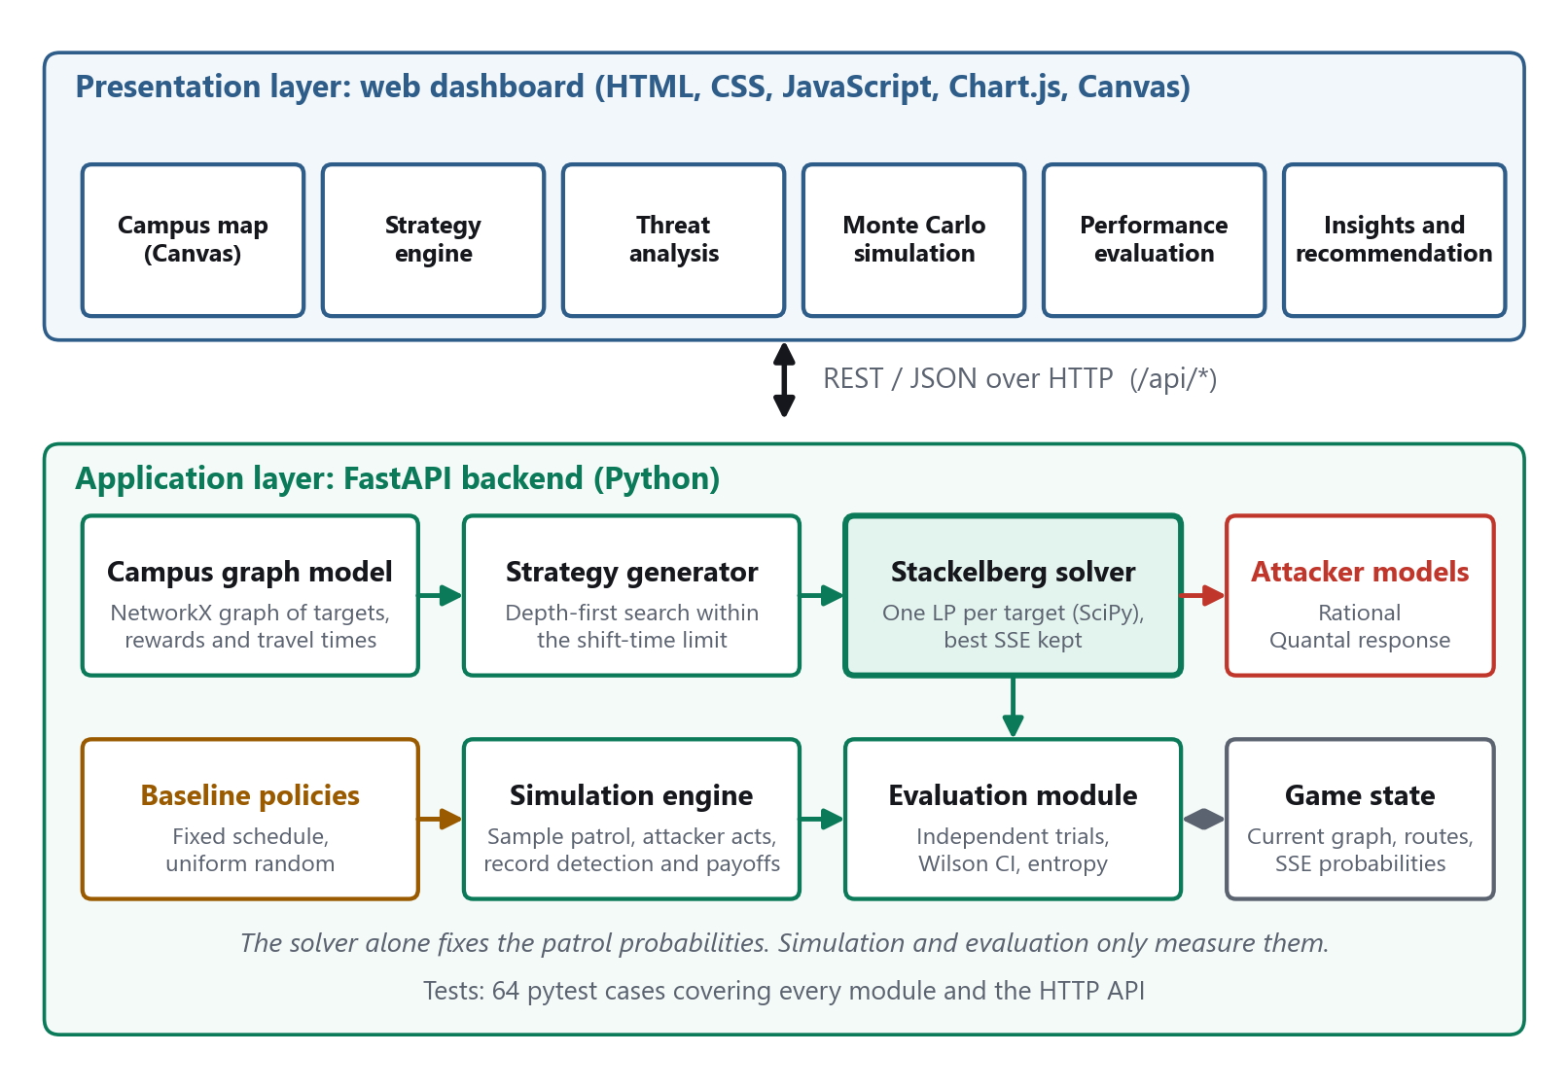
Figure 3.1: System Architecture of the Security Patrol Planner

4. MODULES DESCRIPTION
The Adversarial Game-Theoretic Security Patrol Planner is organized into two major modules that work together. The first module is the web dashboard, which lets the user configure the shift, run each step and inspect the results. The second module is the game-theoretic engine and backend, which generates routes, solves the Stackelberg game, models the attacker and runs the simulation and evaluation. Together they allow a user to move from a campus description to a justified patrol policy and to see why that policy is effective.

4.1 MODULE 1 – DASHBOARD AND VISUALIZATION MODULE
The dashboard is the interaction layer of the system. It is a single-page application written in HTML, CSS and JavaScript, with Chart.js for charts and an HTML canvas for the campus map. It communicates with the backend through REST APIs and is served by the same FastAPI process, so the whole system starts with a single command.
The campus map draws the graph with travel times on each corridor. After the equilibrium is solved, every node shows a ring and a percentage that indicate how often the patrol covers it. A selected route is highlighted with a moving marker, and the attacker's best response is circled. A Sample a patrol button draws a route from the optimal policy to show how the randomization behaves.
A progress bar tracks the five steps of the pipeline. The Strategy section generates routes and shows the equilibrium, the Threat section profiles the attacker and compares coverage by policy, the Simulation section replays the game, and the Evaluation section runs the benchmark. The Insights section states a recommendation that is computed from the benchmark numbers rather than written in advance.
Main functions:
- Configuration of shift duration and maximum checkpoints per route.
- Route generation with a selectable, sortable route table.
- Equilibrium display with route probabilities, utilities and chart.
- Rational and bounded-rational attacker analysis with adjustable λ.
- Coverage-by-policy table and chart for the fixed, uniform and game-theoretic policies.
- Monte Carlo simulation controls and an encounter log.
- Multi-trial benchmark with confidence intervals and four charts.
- Data-driven recommendation and trade-off summary.
- Light and dark themes, empty and loading states, and a responsive layout.

4.2 MODULE 2 – GAME-THEORETIC ENGINE AND BACKEND MODULE
The engine is written in Python and exposed through FastAPI. Requests are validated with Pydantic models. The module first loads the campus graph, then calls the strategy generator to enumerate routes with a depth-first search that tracks elapsed travel time and backtracks when the shift duration or the checkpoint limit would be exceeded.
The Stackelberg solver converts the routes into a coverage matrix and solves one linear program for every target, as described in Chapter 3. It prefers solutions in which the intended target is strictly better for the attacker by a margin of 10⁻⁶, and falls back to the exact tie-breaking formulation only if no target admits a strict best response. The attacker module evaluates each target's expected utility and returns either the best response or the softmax distribution.
The simulation engine computes target coverage from the chosen policy, determines the attacker's response once for the run, and then repeats the rounds: a route is sampled, the attacker's target is taken (sampled from the softmax for a bounded-rational attacker), and the attack is counted as intercepted if the target lies on the sampled route. The evaluation module repeats this over independent trials with seeds derived from a base seed, so that all policies face identical conditions.
The system produces one of the following outcomes for every simulated round:
- INTERCEPTED: the attacked target was on the patrol route and the defender earns the target's reward.
- BREACHED: the attacked target was not on the patrol route and the defender suffers the target's penalty.
The module exposes its functions through the following REST endpoints.
Table 4.1: REST Endpoints of the Backend
Method and path | Purpose
GET /api/campus | Return the campus graph
POST /api/strategies/generate | Enumerate feasible routes for a shift
POST /api/stackelberg/solve | Solve the SSE and store the game state
POST /api/attacker/evaluate | Rational or bounded-rational response
GET /api/baselines | Route probabilities of the three policies
POST /api/policy/sample | Sample one route from a policy
POST /api/simulation/run | Run the Monte Carlo simulation
POST /api/evaluation/compare | Benchmark both attacker models
GET /api/dashboard/summary | Report whether a solved game exists
POST /api/dashboard/reset | Clear the stored game state

Main functions:
- REST request handling and input validation.
- Campus graph construction from the JSON description.
- Depth-first route generation with time and checkpoint constraints.
- Coverage matrix construction.
- Linear-programming solution of the Strong Stackelberg Equilibrium.
- Rational and quantal-response attacker evaluation.
- Fixed, uniform and game-theoretic policy definition and sampling.
- Seeded Monte Carlo simulation.
- Wilson confidence intervals and normalized entropy.
- Serving the dashboard files.

5. IMPLEMENTATION AND RESULTS
The Adversarial Game-Theoretic Security Patrol Planner was implemented as a web-based decision-support application that combines a game-theoretic planning engine with an interactive dashboard. The backend was written in Python with FastAPI, the optimization uses SciPy, and the frontend uses plain HTML, CSS and JavaScript with Chart.js. The system runs with one command and needs no database.
For the default scenario the strategy generator produced 36 feasible routes, the solver found an equilibrium in which 4 routes have non-zero probability, and the benchmark compared the equilibrium policy with the fixed and uniform baselines under both attacker models. The following sections describe the setup and the results.

5.1 EXPERIMENTAL SETUP
The backend uses Python 3.13, FastAPI and Uvicorn for the REST layer, Pydantic for validation, NetworkX for the graph, NumPy for numerical work and SciPy with the HiGHS solver for linear programming. The frontend uses HTML, CSS, JavaScript, Chart.js for charts and the canvas API for the map. Automated tests are written with pytest.
The experiments use the default campus of Chapter 3. The attacker is evaluated in two forms, and every policy is run under identical conditions. The parameters of the main benchmark are listed below.
Table 5.1: Benchmark Parameters
Parameter | Value
Shift duration | 30 minutes
Maximum checkpoints per route | 5
Feasible routes | 36
Simulation rounds per trial | 1000
Independent trials | 10
Base random seed | 42 (trial i uses 42 + 100 i)
Bounded-rational parameter λ | 1.0
Fixed-schedule route | S1 (Admin Office only) unless stated
Confidence level | 95% (Wilson interval)

The experimental scenarios are:
- Default shift with a rational attacker → equilibrium, simulation and benchmark.
- Default shift with a bounded-rational attacker → behaviour when the attacker is imperfect.
- Shorter shifts → effect of the time limit on the achievable payoff.
- Different values of λ → sensitivity of the policy to the attacker's rationality.
Verification. The project is covered by 64 automated tests that exercise the graph model, route generation, the solver, both attacker models, the baselines, the simulation, the evaluation statistics, the dashboard endpoints and the full HTTP flow. The solver was also checked independently against a random search over 80 000 mixed strategies; it matched or exceeded the best value found for each of three shift lengths.
End-to-end testing also exposed four defects, which were fixed and are now protected by regression tests:
- The route-generation response omitted node identifiers, so the dashboard sent route names to the solver. The coverage matrix was then all zeros and the equilibrium was meaningless. The response now includes identifiers and the solver accepts names as well.
- Rounding the probabilities to five decimals changed the attacker's best response, so the simulated payoff was 3.63 instead of the solver's 4.43. The solver now uses a strict margin and no longer rounds.
- The bounded-rational attacker always chose its most likely target, which made it identical to the rational attacker. It now samples from the softmax distribution.
- The choice of route for the fixed schedule was ignored by the simulation and the benchmark. It is now passed through the API.
Note: the target values, payoffs and campus layout used in the experiments are demonstration values for academic purposes only and do not represent real security data.

5.2 RESULTS
Figure 5.2.1 shows the top of the dashboard after the full pipeline has run. The progress bar shows all five steps completed, and the section links on the left lead to each stage. The interface follows the system colour scheme and has a light and a dark theme.
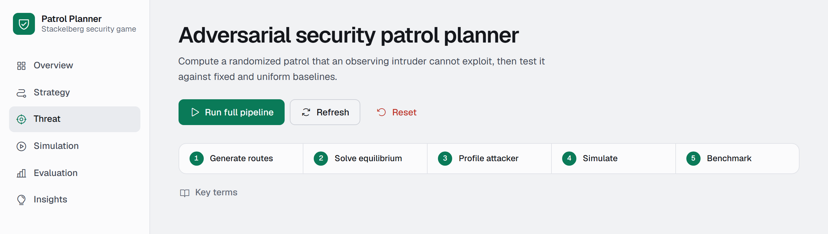
Figure 5.2.1: Dashboard Header and Pipeline Progress
Campus Map and Coverage
In Figure 5.2.2 each node carries a ring and a percentage that show how often the optimal policy covers it. The selected route S35 is highlighted and the Server Room, which the attacker targets, is circled. Coverage is highest for the Corridor (100%), because every route to or from the other areas passes through it, and for the valuable targets Laboratory (72%), Server Room (72%) and Main Gate (70%).
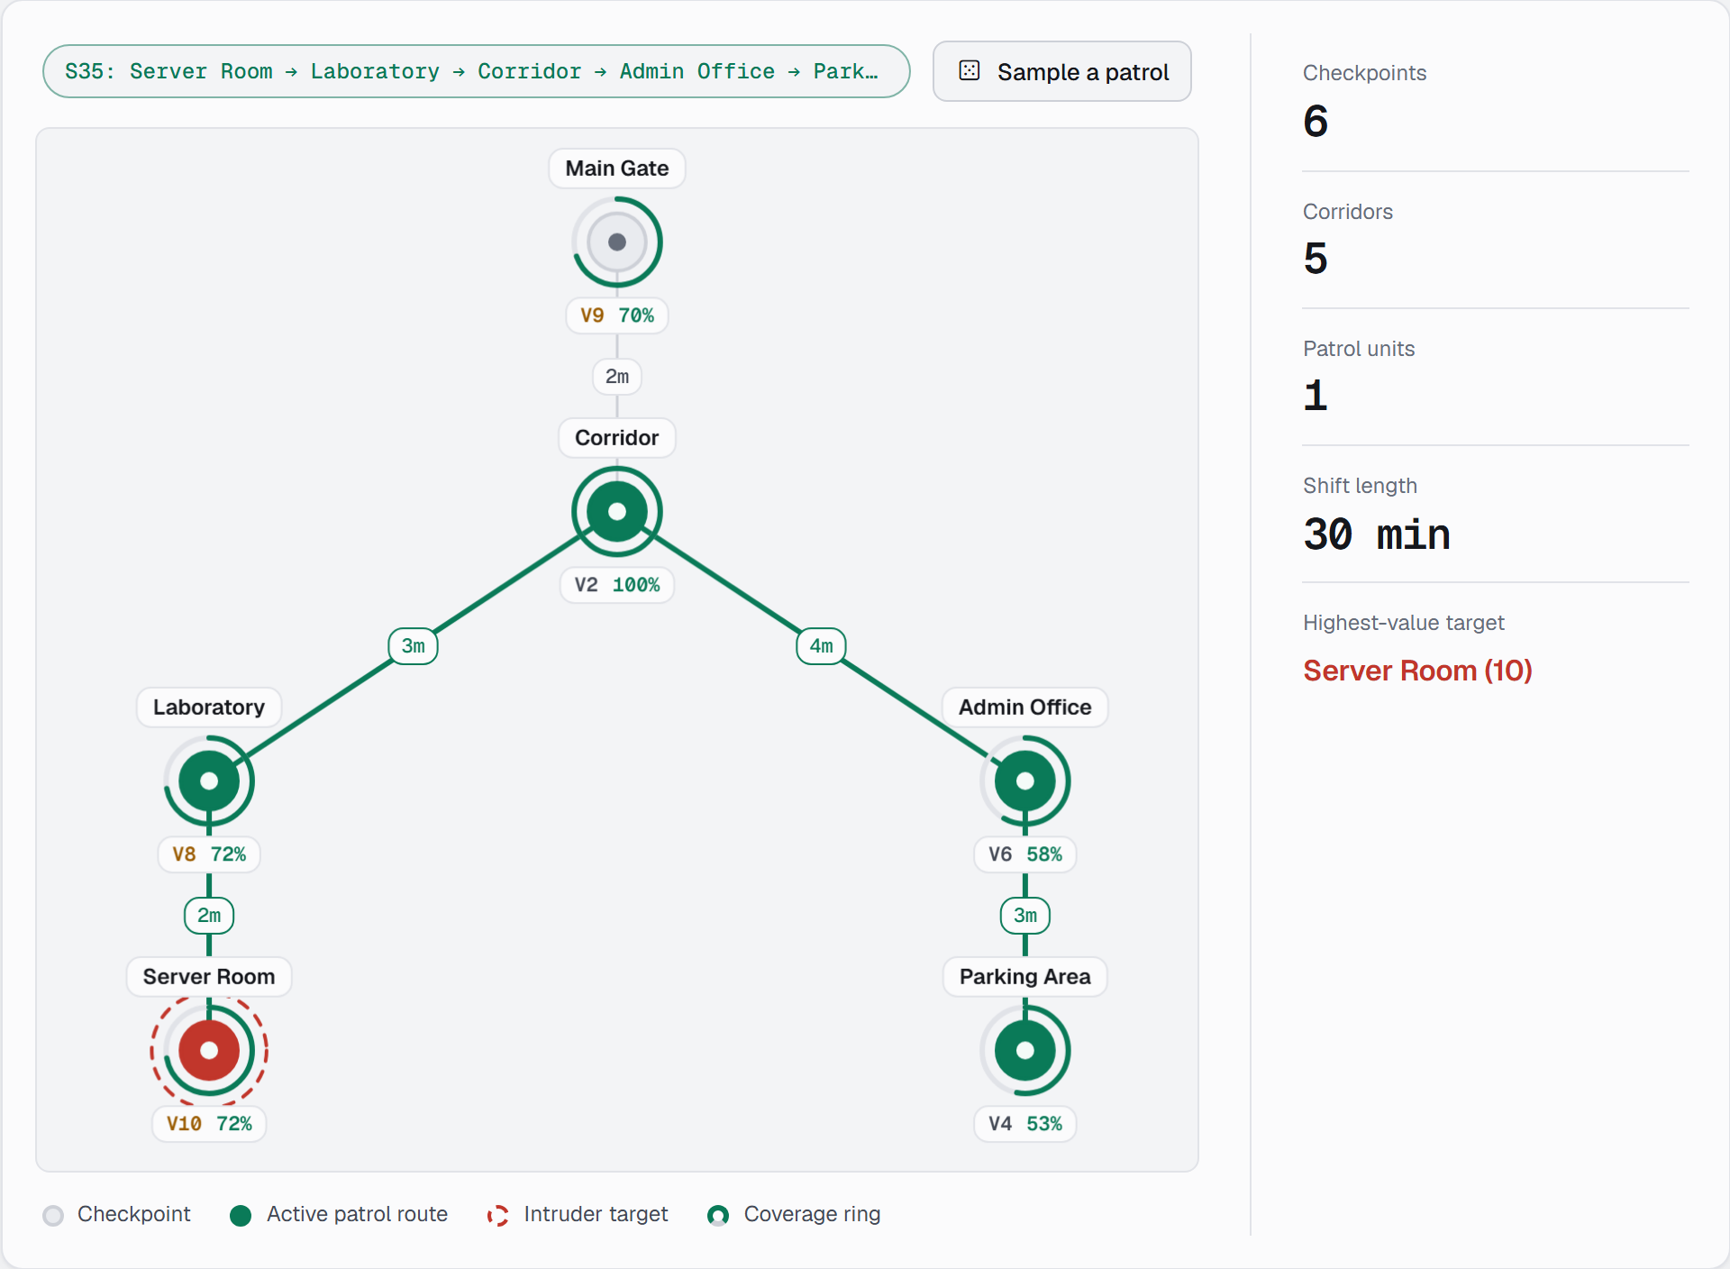
Figure 5.2.2: Campus Map with Coverage Rings and a Selected Patrol Route
Route Generation and Equilibrium
Figure 5.2.3 shows the generated routes and the equilibrium. The solver's best response for the attacker is the Server Room. The defender's expected utility is +4.43 and the attacker's is +1.34. Only 4 of the 36 routes are used, as listed in Table 5.2.
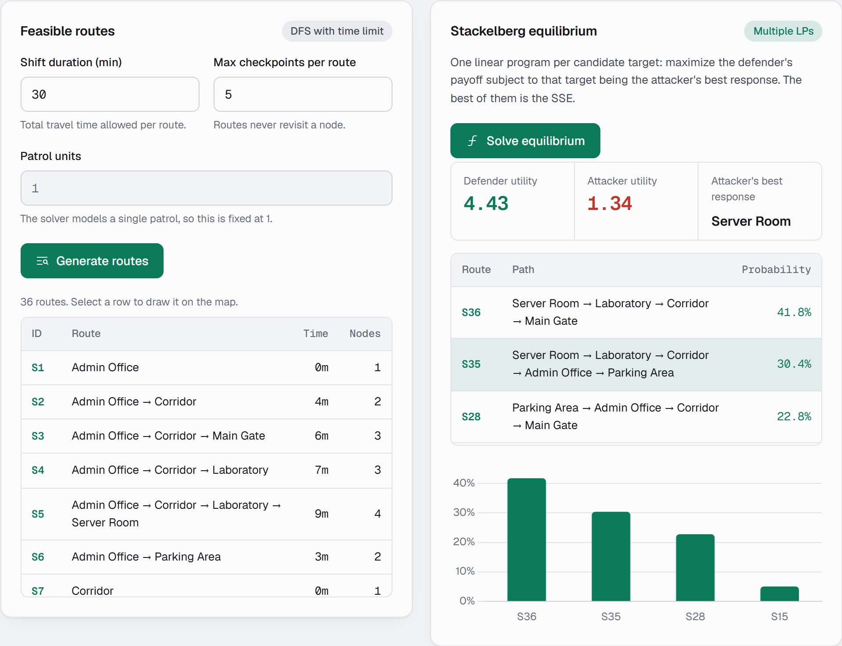
Figure 5.2.3: Route Generation and Stackelberg Equilibrium
Table 5.2: Routes Used by the Equilibrium Policy
Route | Path | Travel time (min) | Probability
S36 | Server Room → Laboratory → Corridor → Main Gate | 7 | 41.8%
S35 | Server Room → Laboratory → Corridor → Admin Office → Parking Area | 12 | 30.4%
S28 | Parking Area → Admin Office → Corridor → Main Gate | 9 | 22.8%
S15 | Main Gate → Corridor → Admin Office | 6 | 5.1%

Table 5.3 shows why the policy works. The equilibrium sets coverage so that the attacker's utility is the same, 1.34, for the Server Room, Main Gate, Admin Office and Parking Area. High-value targets receive more coverage and low-value targets less, so no target is a much better choice than the others. The Corridor and Laboratory are less attractive, which is why the attacker has no incentive to move there.
Table 5.3: Coverage and Attacker Utility under the Equilibrium Policy
Target | Value | Coverage | Attacker utility
Server Room | 10 | 72.2% | 1.34
Main Gate | 9 | 69.6% | 1.34
Laboratory | 8 | 72.2% | 0.78
Admin Office | 6 | 58.2% | 1.34
Parking Area | 4 | 53.2% | 1.34
Corridor | 2 | 100.0% | 0.00

Threat Analysis
Figure 5.2.4 shows the rational attacker's evaluation. The Server Room is the primary threat, and the bar chart shows that several targets have the same expected utility. The table at the bottom of the panel compares the coverage that each policy gives to every target: the game-theoretic policy covers all valuable targets at roughly 70%, the uniform policy spreads about 31% to 75% evenly over targets, and the fixed schedule covers only the targets on its single route.
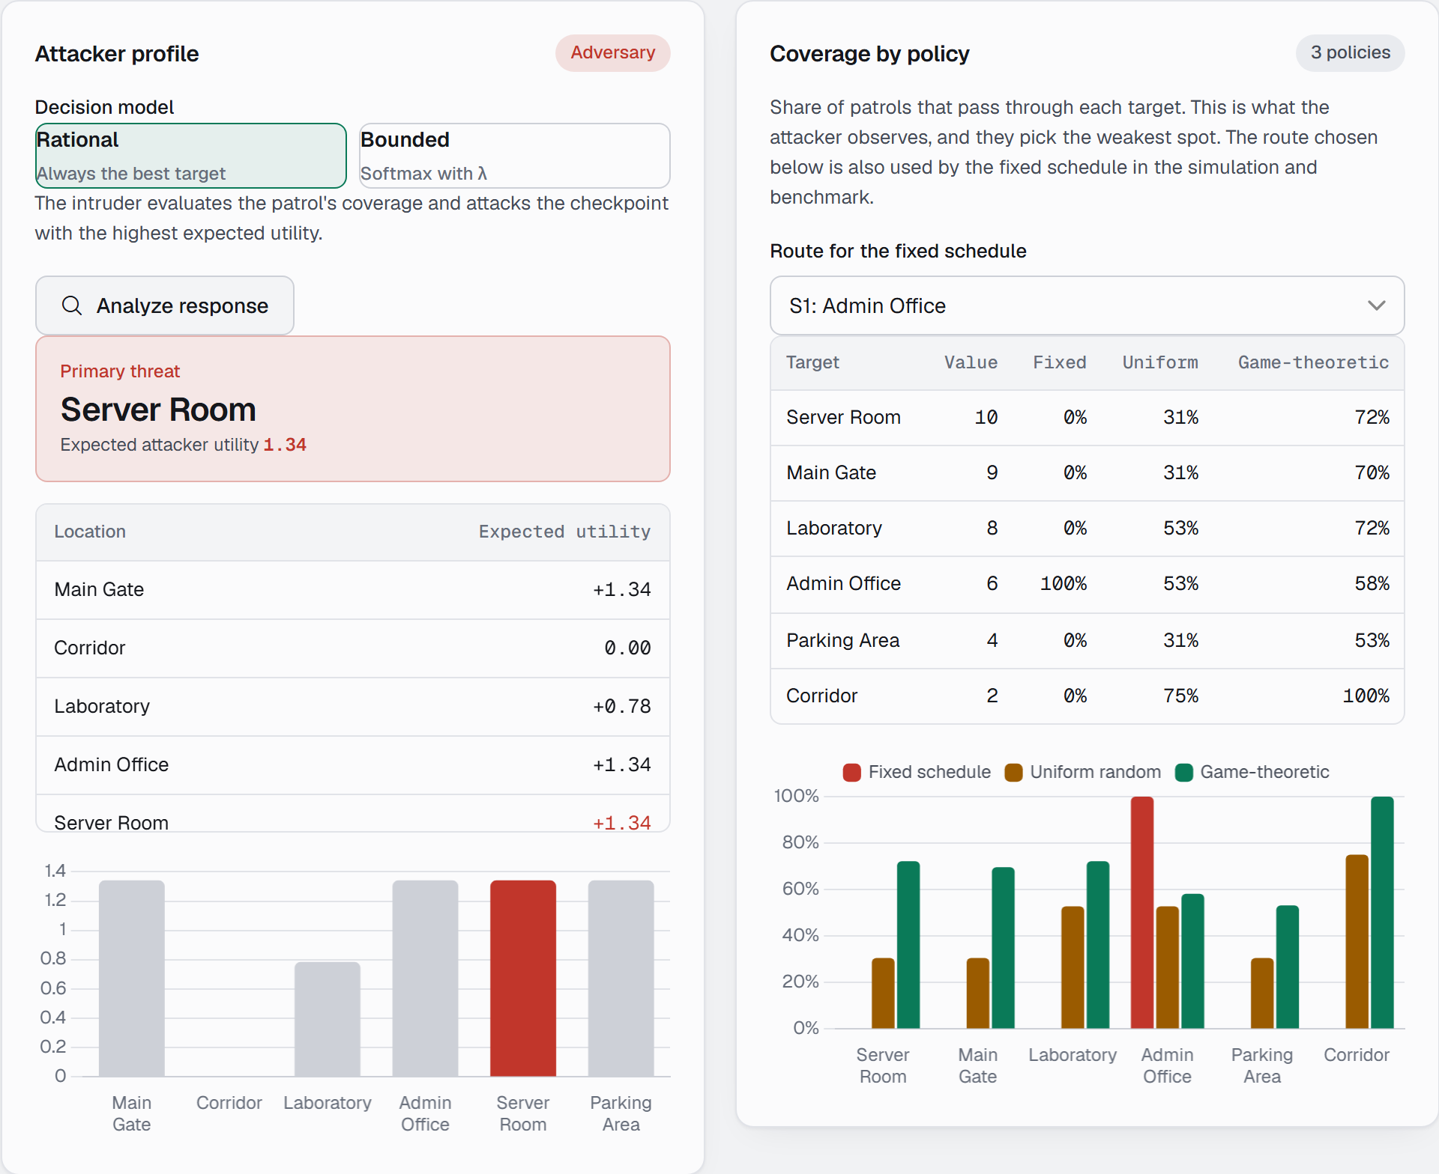
Figure 5.2.4: Rational Attacker Analysis and Coverage by Policy
Figure 5.2.5 shows the bounded-rational attacker with λ = 1. Instead of one target, the attack probability is spread over targets in proportion to their expected utility, and the map shades each target by this probability.

Figure 5.2.5: Bounded-Rational Attacker Analysis
Monte Carlo Simulation
Figure 5.2.6 shows a simulation of 1000 rounds of the game-theoretic policy against a rational attacker. About 70% of attacks are intercepted, the defender's average payoff is positive and the attacker's is small. The log lists the last ten encounters, and each row can be selected to draw its route on the map.
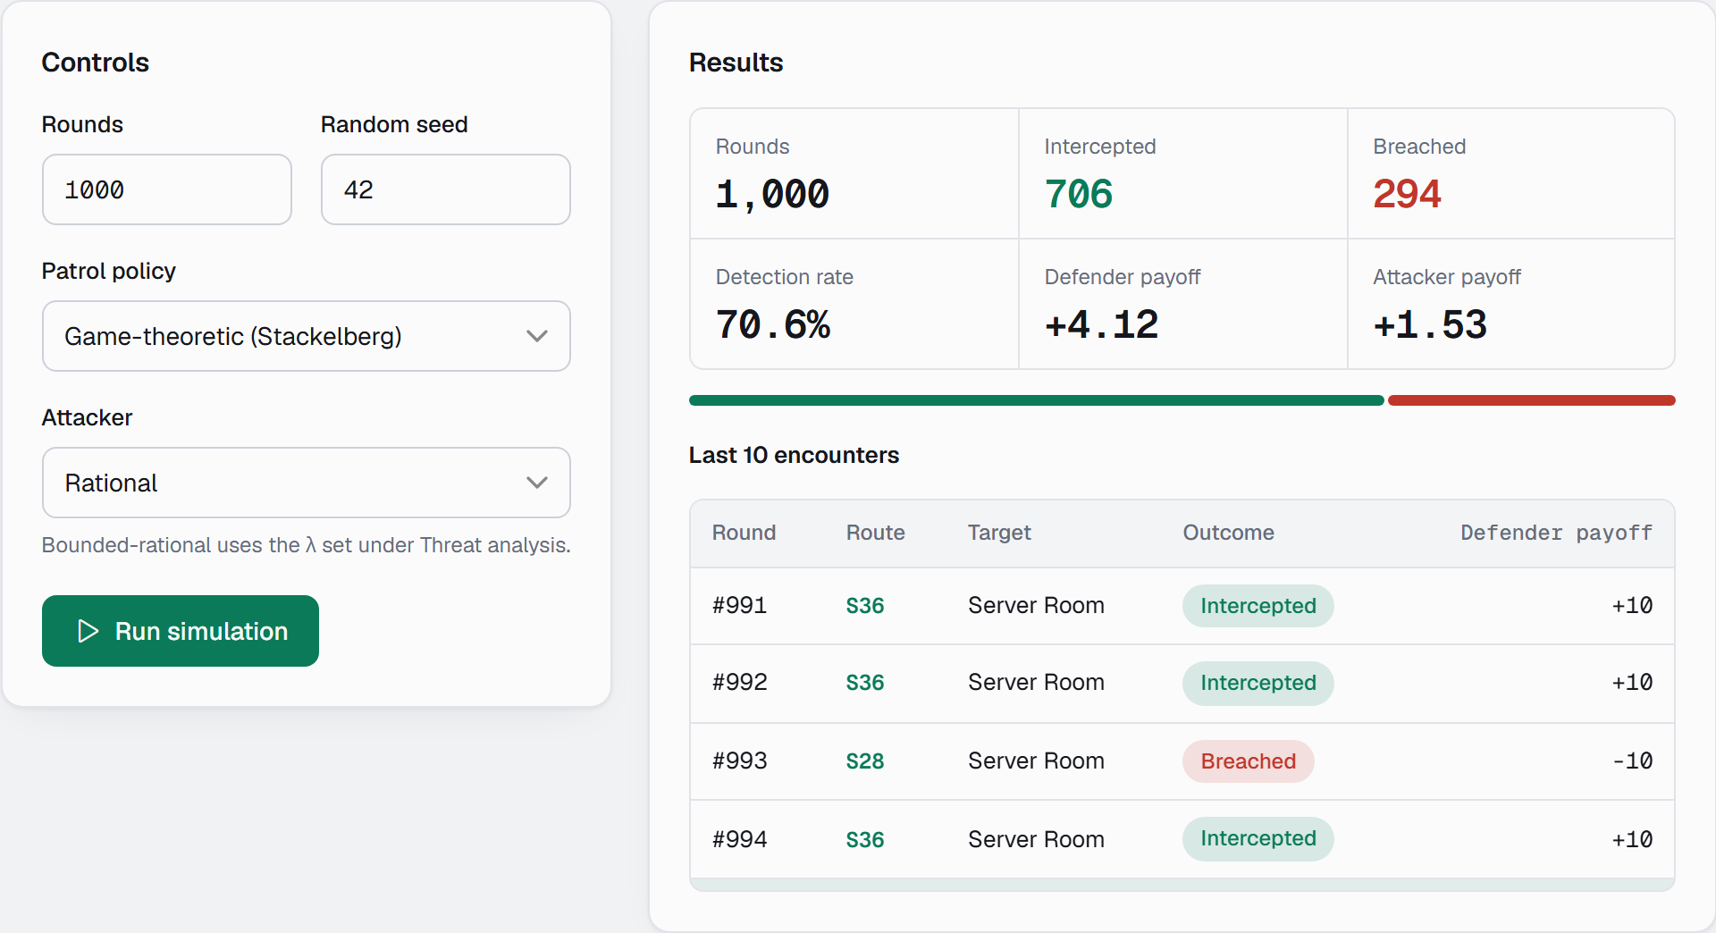
Figure 5.2.6: Monte Carlo Simulation Results
Benchmark Results
Figure 5.2.7 and Table 5.4 give the benchmark results with a rational attacker, using ten trials of 1000 rounds each. The game-theoretic policy intercepts 72.4% of attacks, with a 95% interval of 71.5% to 73.3%. This is more than twice the 30.8% of uniform random patrolling, and the defender payoff improves from −3.85 to +4.48. The fixed schedule is never successful, because a rational attacker simply avoids the route it knows will be patrolled.
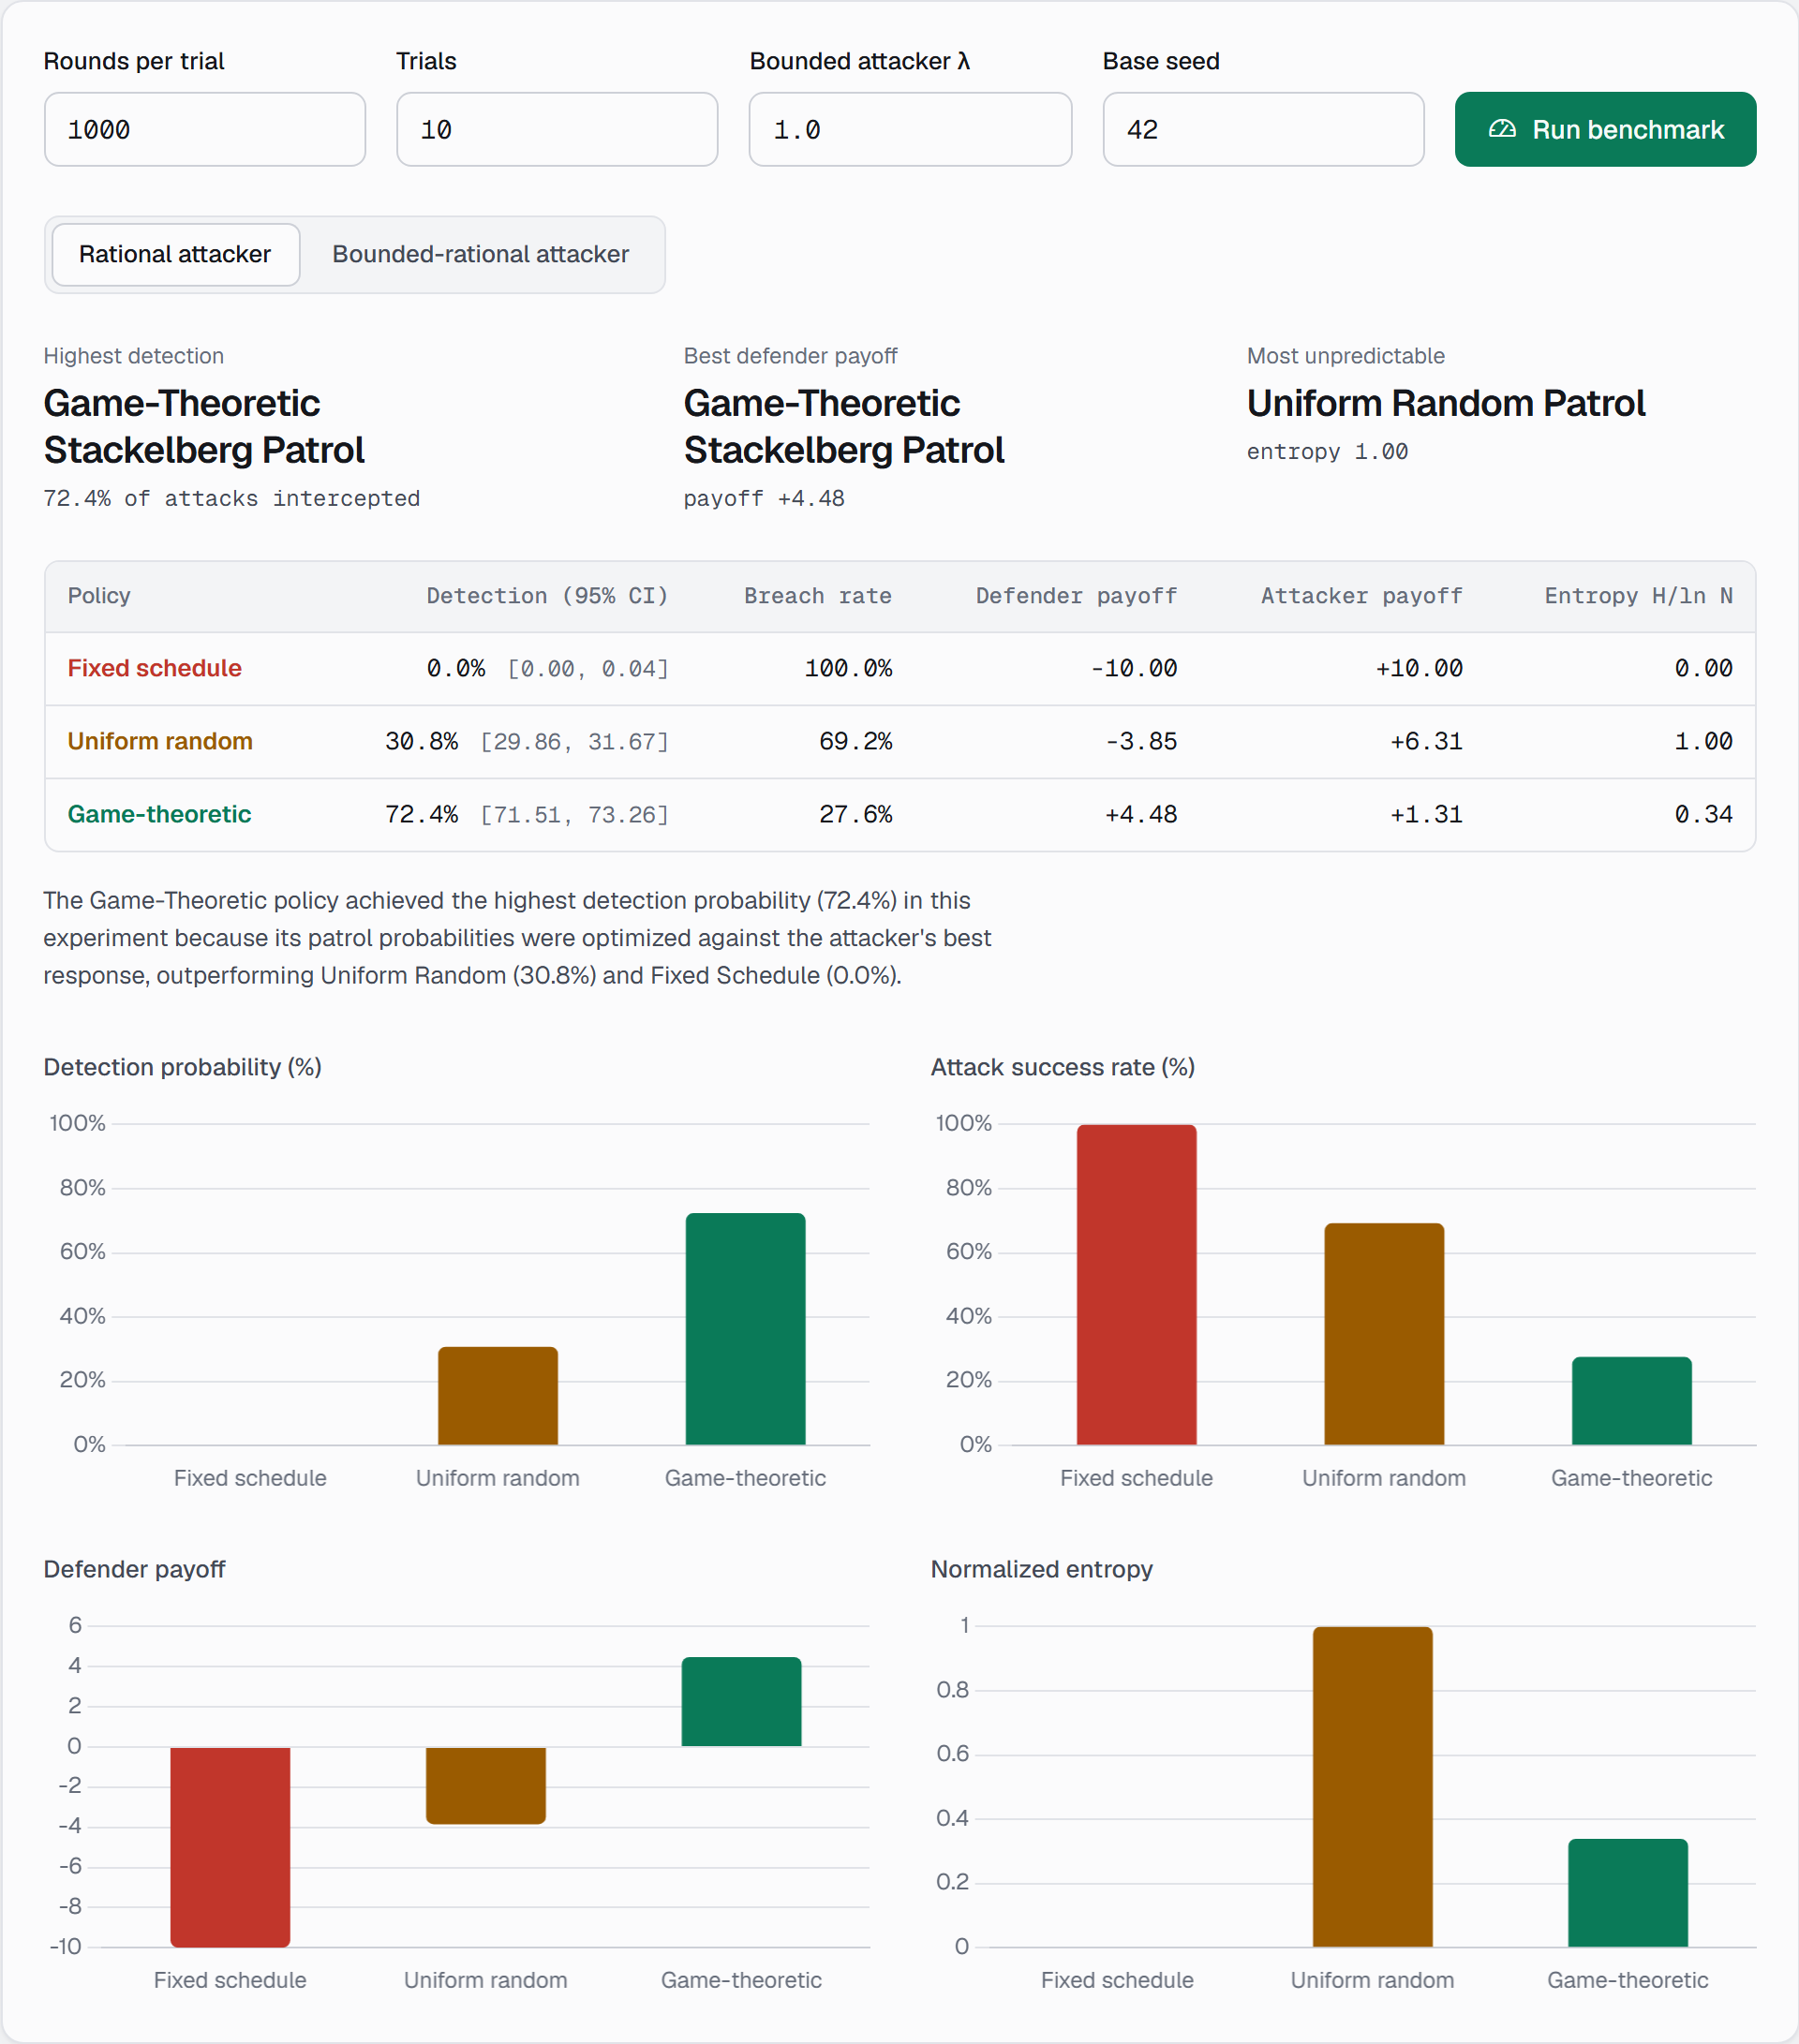
Figure 5.2.7: Benchmark Results for the Rational Attacker
Table 5.4: Benchmark Results with a Rational Attacker
Policy | Detection (95% CI) | Breach rate | Defender payoff | Attacker payoff | Entropy
Fixed schedule | 0.0% [0.0, 0.0] | 100.0% | −10.00 | +10.00 | 0.00
Uniform random | 30.8% [29.9, 31.7] | 69.2% | −3.85 | +6.31 | 1.00
Game-theoretic | 72.4% [71.5, 73.3] | 27.6% | +4.48 | +1.31 | 0.34

Table 5.5 repeats the benchmark with a bounded-rational attacker (λ = 1). The game-theoretic policy still gives the best detection (65.5%) and payoff (+2.36), but its payoff is lower than against the rational attacker (+4.48). The uniform policy does slightly better against the imperfect attacker (−3.61 instead of −3.85), because the attacker no longer always finds the weakest target.
Table 5.5: Benchmark Results with a Bounded-Rational Attacker
Policy | Detection (95% CI) | Breach rate | Defender payoff | Attacker payoff | Entropy
Fixed schedule | 0.0% [0.0, 0.0] | 100.0% | −9.57 | +9.57 | 0.00
Uniform random | 31.2% [30.3, 32.1] | 68.8% | −3.61 | +5.95 | 1.00
Game-theoretic | 65.5% [64.6, 66.4] | 34.5% | +2.36 | +1.25 | 0.34

The entropy column shows the trade-off between the policies. Uniform random is perfectly unpredictable (1.00) but pays for it with a much lower payoff. The game-theoretic policy has an entropy of 0.34: it is randomized, but over only 4 routes, concentrating on the routes that protect the most valuable targets.
Fairness of the Fixed Baseline
The default fixed schedule runs route S1, which visits only the Admin Office, so it is a weak baseline. To check that the conclusion does not depend on this choice, the benchmark was repeated with the fixed schedule set to route S36 (Server Room → Laboratory → Corridor → Main Gate), which covers four of the six targets. The detection rate stayed at 0.0%, and the defender payoff improved only from −10.00 to −6.00 against the rational attacker. A deterministic route cannot be effective against an attacker who observes it, whichever route is chosen.
Effect of the Shift Duration
Table 5.6 shows how the equilibrium changes with the length of the shift, with the checkpoint limit fixed at 5. A longer shift allows longer routes and so more coverage per patrol, and the defender's payoff rises from −2.52 when only single targets can be visited to +4.43 at 15 minutes. Beyond 15 minutes the number of routes stays at 36 because the checkpoint limit, not time, is the binding constraint, so the payoff no longer changes.
Table 5.6: Equilibrium Payoff for Different Shift Durations
Shift (min) | Feasible routes | Routes used | Defender payoff | Attacker payoff
0 (single targets) | 6 | 4 | −2.52 | +5.51
5 | 20 | 4 | −1.14 | +4.68
8 | 28 | 5 | +2.00 | +2.80
10 | 34 | 5 | +2.94 | +2.24
15 | 36 | 4 | +4.43 | +1.34
30 | 36 | 4 | +4.43 | +1.34

Effect of the Attacker's Rationality
Table 5.7 varies λ with 20 000 rounds per setting. The game-theoretic policy outperforms uniform random for every λ. Its payoff against a bounded-rational attacker (+2.36 at λ = 20) is clearly below its payoff against the rational attacker (+4.36 in the same experiment), even though a very large λ should behave like a rational attacker. The reason is the tie-breaking assumption of the Strong Stackelberg Equilibrium. The equilibrium makes four targets equally attractive (Table 5.3) and assumes the attacker picks the one that is best for the defender. A softmax attacker instead divides its attacks among all four, including targets for which the defender's payoff is lower.
Table 5.7: Effect of the Attacker Parameter λ (20 000 Rounds)
λ | Game-theoretic payoff | Detection | Uniform payoff | Detection
0.1 | +2.53 | 70.8% | −1.62 | 42.5%
0.5 | +2.52 | 68.7% | −3.07 | 33.9%
1 | +2.53 | 67.0% | −3.74 | 30.6%
2 | +2.47 | 65.2% | −3.86 | 30.3%
5 | +2.38 | 64.0% | −3.88 | 30.5%
20 | +2.36 | 63.8% | −3.92 | 30.4%

Recommendation
The dashboard converts the benchmark into a recommendation. Figure 5.2.8 shows the Insights section, where the game-theoretic policy is recommended because it has the highest expected defender payoff, and the supporting numbers and trade-offs are taken from the benchmark that was just run.
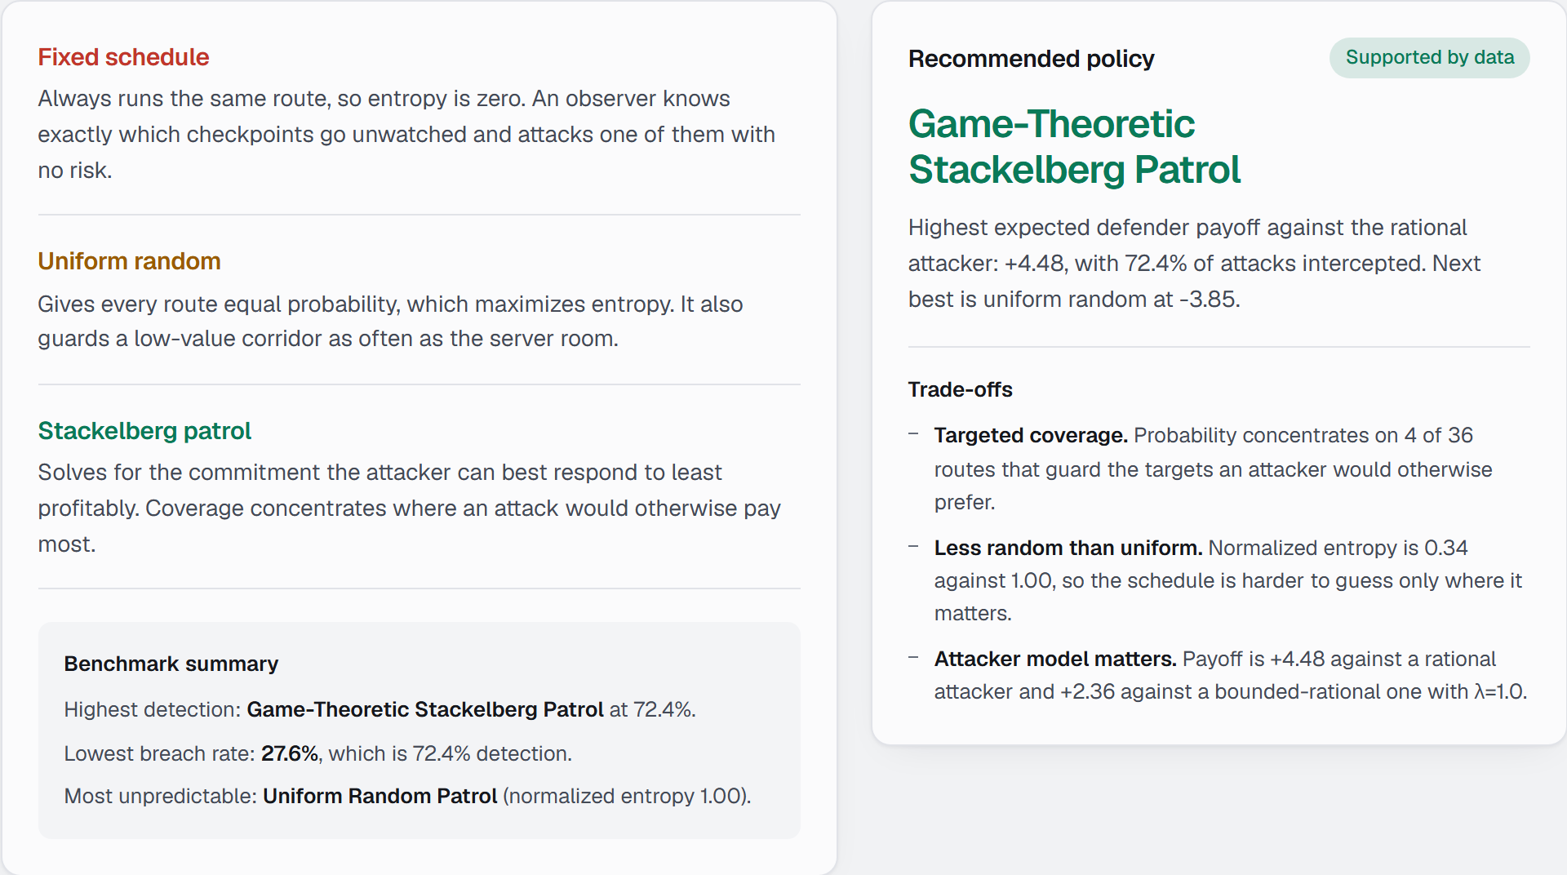
Figure 5.2.8: Policy Insights and Data-Driven Recommendation

6. CONCLUSION AND FUTURE WORK
The Adversarial Game-Theoretic Security Patrol Planner is an intelligent system that models a security patrol as a Stackelberg security game. It represents the campus as a graph, enumerates feasible routes with a constrained depth-first search, and computes the optimal randomized patrol with linear programming. It evaluates the result against rational and bounded-rational attackers using simulation, confidence intervals and an entropy measure.
On the default campus the game-theoretic policy intercepted 72.4% of attacks against a rational attacker, compared with 30.8% for uniform random and 0% for a fixed schedule, and it improved the defender's payoff from −3.85 to +4.48. The analysis also showed a limit of the approach: the equilibrium assumes a favourable tie-break, so its advantage is smaller against an attacker who does not break ties that way. The rules, payoffs and thresholds are demonstration values for academic purposes and do not represent real security data.

FUTURE WORK
The system can be extended in several directions. Multiple patrol units would require choosing joint schedules, for which a compact coverage-based formulation such as that of Kiekintveld et al. (2009) avoids enumerating every combination. Several attacker types, each with its own payoffs and probability, can be handled with a Bayesian Stackelberg formulation such as DOBSS. A tie-robust equilibrium could protect against attackers who do not break ties in the defender's favour, which was the main weakness found in the results.
The model could also be made richer by adding patrol timing, so that the intruder cannot predict when as well as where the patrol will be, by learning the attacker's behaviour from observed incidents instead of fixing λ, and by importing real building maps and asset values. A production version would also need authentication and persistent storage, since the demonstration server keeps its state in memory for one user.

7. REFERENCES
- Conitzer, V. and Sandholm, T. (2006) ‘Computing the Optimal Strategy to Commit to’, Proceedings of the 7th ACM Conference on Electronic Commerce, pp. 82–90.
- Hagberg, A.A., Schult, D.A. and Swart, P.J. (2008) ‘Exploring Network Structure, Dynamics, and Function using NetworkX’, Proceedings of the 7th Python in Science Conference (SciPy 2008), pp. 11–15.
- Huangfu, Q. and Hall, J.A.J. (2018) ‘Parallelizing the Dual Revised Simplex Method’, Mathematical Programming Computation, Vol. 10, No. 1, pp. 119–142.
- Kiekintveld, C., Jain, M., Tsai, J., Pita, J., Ordóñez, F. and Tambe, M. (2009) ‘Computing Optimal Randomized Resource Allocations for Massive Security Games’, Proceedings of the 8th International Conference on Autonomous Agents and Multiagent Systems (AAMAS), pp. 689–696.
- McKelvey, R.D. and Palfrey, T.R. (1995) ‘Quantal Response Equilibria for Normal Form Games’, Games and Economic Behavior, Vol. 10, No. 1, pp. 6–38.
- Paruchuri, P., Pearce, J.P., Marecki, J., Tambe, M., Ordóñez, F. and Kraus, S. (2008) ‘Playing Games for Security: An Efficient Exact Algorithm for Solving Bayesian Stackelberg Games’, Proceedings of the 7th International Conference on Autonomous Agents and Multiagent Systems (AAMAS), pp. 895–902.
- Pita, J., Jain, M., Marecki, J., Ordóñez, F., Portway, C., Tambe, M., Western, C., Paruchuri, P. and Kraus, S. (2008) ‘Deployed ARMOR Protection: The Application of a Game Theoretic Model for Security at the Los Angeles International Airport’, Proceedings of the 7th International Conference on Autonomous Agents and Multiagent Systems (AAMAS), Industry Track, pp. 125–132.
- Russell, S. and Norvig, P. (2020) Artificial Intelligence: A Modern Approach, 4th edn. Pearson.
- Shannon, C.E. (1948) ‘A Mathematical Theory of Communication’, Bell System Technical Journal, Vol. 27, No. 3, pp. 379–423.
- Shieh, E., An, B., Yang, R., Tambe, M., Baldwin, C., DiRenzo, J., Maule, B. and Meyer, G. (2012) ‘PROTECT: A Deployed Game Theoretic System to Protect the Ports of the United States’, Proceedings of the 11th International Conference on Autonomous Agents and Multiagent Systems (AAMAS), pp. 13–20.
- Tambe, M. (2011) Security and Game Theory: Algorithms, Deployed Systems, Lessons Learned. Cambridge University Press.
- Virtanen, P. et al. (2020) ‘SciPy 1.0: Fundamental Algorithms for Scientific Computing in Python’, Nature Methods, Vol. 17, pp. 261–272.
- Wilson, E.B. (1927) ‘Probable Inference, the Law of Succession, and Statistical Inference’, Journal of the American Statistical Association, Vol. 22, No. 158, pp. 209–212.
- Yang, R., Kiekintveld, C., Ordóñez, F., Tambe, M. and John, R. (2011) ‘Improving Resource Allocation Strategy against Human Adversaries in Security Games’, Proceedings of the 22nd International Joint Conference on Artificial Intelligence (IJCAI), pp. 458–464.
- FastAPI (2025) ‘FastAPI Documentation’, FastAPI, Available at: https://fastapi.tiangolo.com.
- Chart.js Contributors (2025) ‘Chart.js Documentation’, Chart.js, Available at: https://www.chartjs.org/docs.
- Python Software Foundation (2025) ‘Python Documentation’, Python Software Foundation, Available at: https://docs.python.org.

