CC-1

NAME:VISHAL.M

ROLL_NO:727722EUCS181

1.

package codingcontest;

import org.openqa.selenium.By;

import org.openqa.selenium.WebDriver;

import org.openqa.selenium.WebElement;

import org.openqa.selenium.chrome.ChromeDriver;

import org.openqa.selenium.chrome.ChromeOptions;

import io.github.bonigarcia.wdm.WebDriverManager;

public class CC_1 {

public static void main(String[] args) throws InterruptedException {

WebDriver driver;

ChromeOptions co=new ChromeOptions();

co.addArguments("--remote-allow-origins=*");

WebDriverManager.chromedriver().setup();

driver=new ChromeDriver();

driver.get("https://www.saucedemo.com/");

driver.manage().window().maximize();

WebElementu_name= driver.findElement(By.name("user-name"));

u_name.sendKeys("standard_user");

WebElement pass = driver.findElement(By.name("password"));

pass.sendKeys("secret_sauce");

Thread.sleep(4000);

WebElement button = driver.findElement(By.xpath("//*[@id=\"login-button\"]"));

button.click();

Thread.sleep(3000);

WebElement back = driver.findElement(By.xpath("//*[@id=\"add-to-cart-sauce-labs-backpack\"]"));

back.click();

Thread.sleep(4000);

WebElement cart = driver.findElement(By.xpath("//*[@id=\"shopping_cart_container\"]/a"));

cart.click();

Thread.sleep(4000);

WebElement check = driver.findElement(By.xpath("//*[@id=\"checkout\"]"));

check.click();

Thread.sleep(4000);

WebElementf_name = driver.findElement(By.name("firstName"));

f_name.sendKeys("Ashwin");

WebElementl_name = driver.findElement(By.name("lastName"));

l_name.sendKeys("S");

WebElementZcode = driver.findElement(By.name("postalCode"));

Zcode.sendKeys("642126");

Thread.sleep(4000);

WebElement con = driver.findElement(By.xpath("//*[@id=\"continue\"]"));

con.click();

WebElement prints=driver.findElement(By.className("inventory_item_name"));

System.out.println("ProductName: "+prints.getText());

WebElement print1=driver.findElement(By.xpath("//*[@id=\"checkout_summary_container\"]/div/div[2]/div[8]"));

System.out.println(print1.getText());

String t1="Swag Labs";

String t2="";

t2=driver.getTitle();

if(t1.equals(t2))

System.out.println("Correct title");

else

System.out.println("incorrect title");

String url1="https://www.saucedemo.com/checkout-step-two.html";

String url2="";

url2=driver.getCurrentUrl();

if(url1.equals(url2))

System.out.println("Correct URL");

else

{

System.out.println("incorrect URL");

}

}

}

OUTPUT:

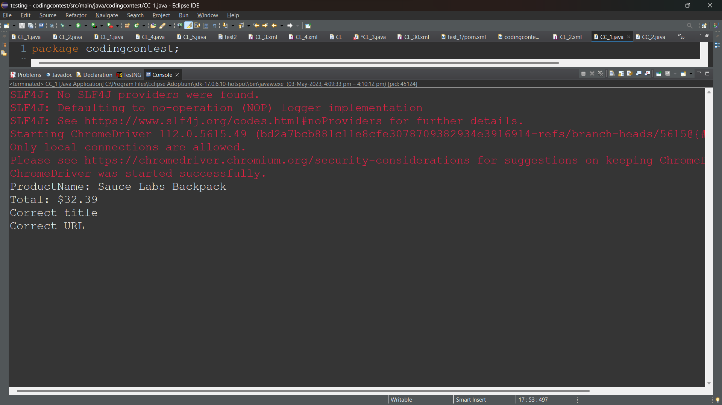

2.

package codingcontest;

import org.openqa.selenium.By;

import org.openqa.selenium.WebDriver;

import org.openqa.selenium.WebElement;

import org.openqa.selenium.chrome.ChromeDriver;

import org.openqa.selenium.chrome.ChromeOptions;

import io.github.bonigarcia.wdm.WebDriverManager;

public class CC_2 {

public static void main(String[] args) throws InterruptedException {

// TODO Auto-generated method stub

WebDriver driver;

ChromeOptions co=new ChromeOptions();

co.addArguments("--remote-allow-origins=*");

WebDriverManager.chromedriver().setup();

driver=new ChromeDriver();

driver.get("https://www.saucedemo.com/");

driver.manage().window().maximize();

WebElementu_name= driver.findElement(By.name("user-name"));

u_name.sendKeys("standard_user");

WebElement pass = driver.findElement(By.name("password"));

pass.sendKeys("secret_sauce");

Thread.sleep(4000);

WebElement button = driver.findElement(By.xpath("//*[@id=\"login-button\"]"));

button.click();

Thread.sleep(3000);

WebElement prints = driver.findElement(By.xpath("//*[@id=\"item_4_title_link\"]/div"));

System.out.println(prints.getText());

WebElement drop = driver.findElement(By.xpath("//*[@id=\"header_container\"]/div[2]/div/span/select"));

drop.click();

WebElement drop2 = driver.findElement(By.xpath("//*[@id=\"header_container\"]/div[2]/div/span/select/option[2]"));

drop2.click();

WebElement print2 = driver.findElement(By.xpath("//*[@id=\"item_3_title_link\"]/div"));

System.out.println(print2.getText());

WebElement drop3 = driver.findElement(By.xpath("//*[@id=\"header_container\"]/div[2]/div/span/select/option[3]"));

drop3.click();

WebElement print3 = driver.findElement(By.xpath("//*[@id=\"item_2_title_link\"]/div"));

System.out.println(print3.getText());

WebElement drop4 = driver.findElement(By.xpath("//*[@id=\"header_container\"]/div[2]/div/span/select/option[4]"));

drop4.click();

WebElement print4 = driver.findElement(By.xpath("//*[@id=\"item_5_title_link\"]/div"));

System.out.println(print4.getText());

}

}

OUTPUT:

