DOCUMENTATION

1) Home.php is main page, use xampp or any other local host to open these files and all other webpages are linked

2) Simple php is used all the images to be used are uploaded along with php files in the folder

3) Only array is used to store any kind of data server side database no created.

4)Bootstrap is used to make website reposnive.

5) Basic functionality of page is to show type of flats in the building which are to be given on rent to random people

6) Person can select type of apartment, can view who is already living their e.g in 3BHK who are the other two people already living there.

7) Person can contact dealer using his contact info or can fill online form and set meeting.

SOME SCREENHOTS:-

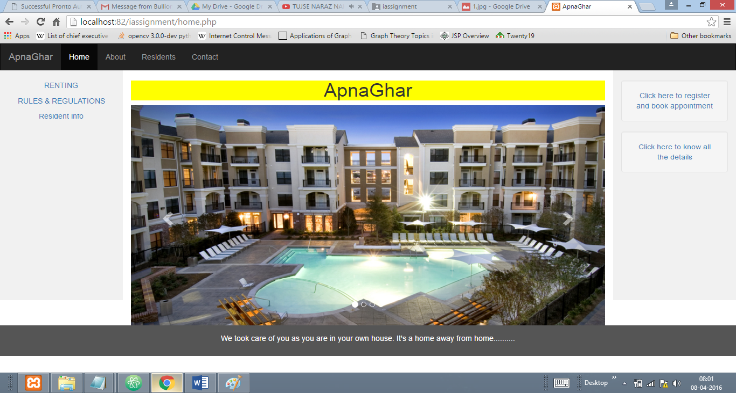

2. 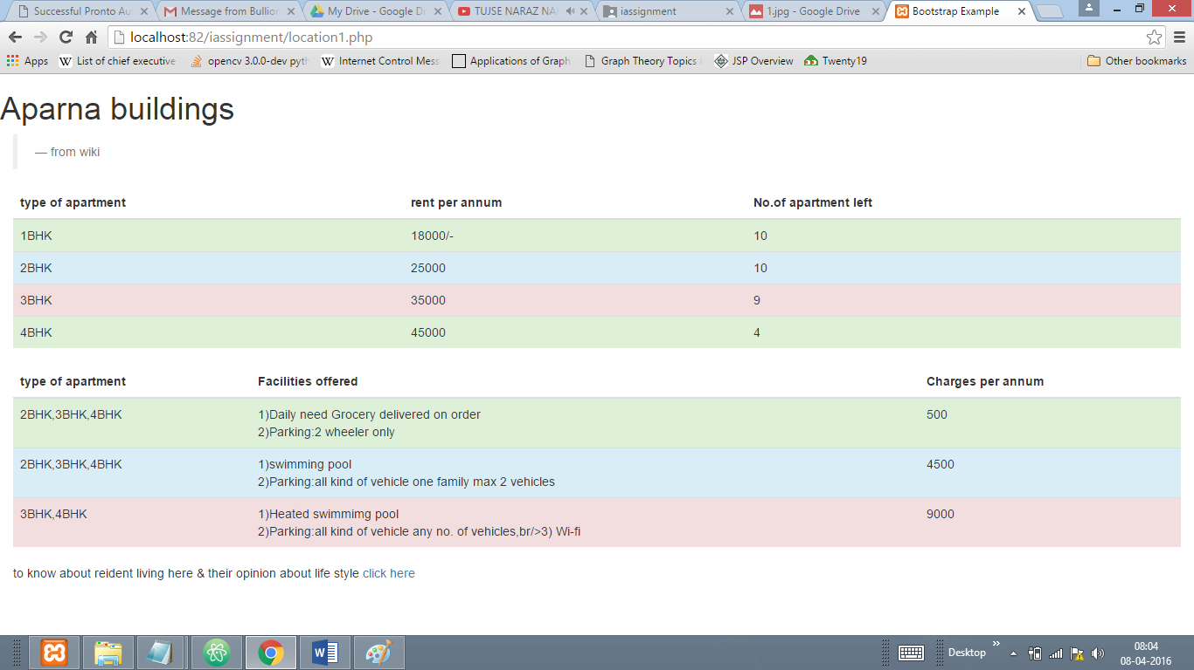

3)

