Lab_Assignment_1.3
AI Assisted Coding B37 2303A52077

Lab 1: Environment Setup – GitHub Copilot and VS Code Integration + Understanding AI-assisted Coding Workflow
Lab Objectives:
- To install and configure GitHub Copilot in Visual Studio Code.
- To explore AI-assisted code generation using GitHub Copilot.
- To analyze the accuracy and effectiveness of Copilot's code suggestions.
- To understand prompt-based programming using comments and code context
Task 0 : Install and configure GitHub Copilot in VS Code
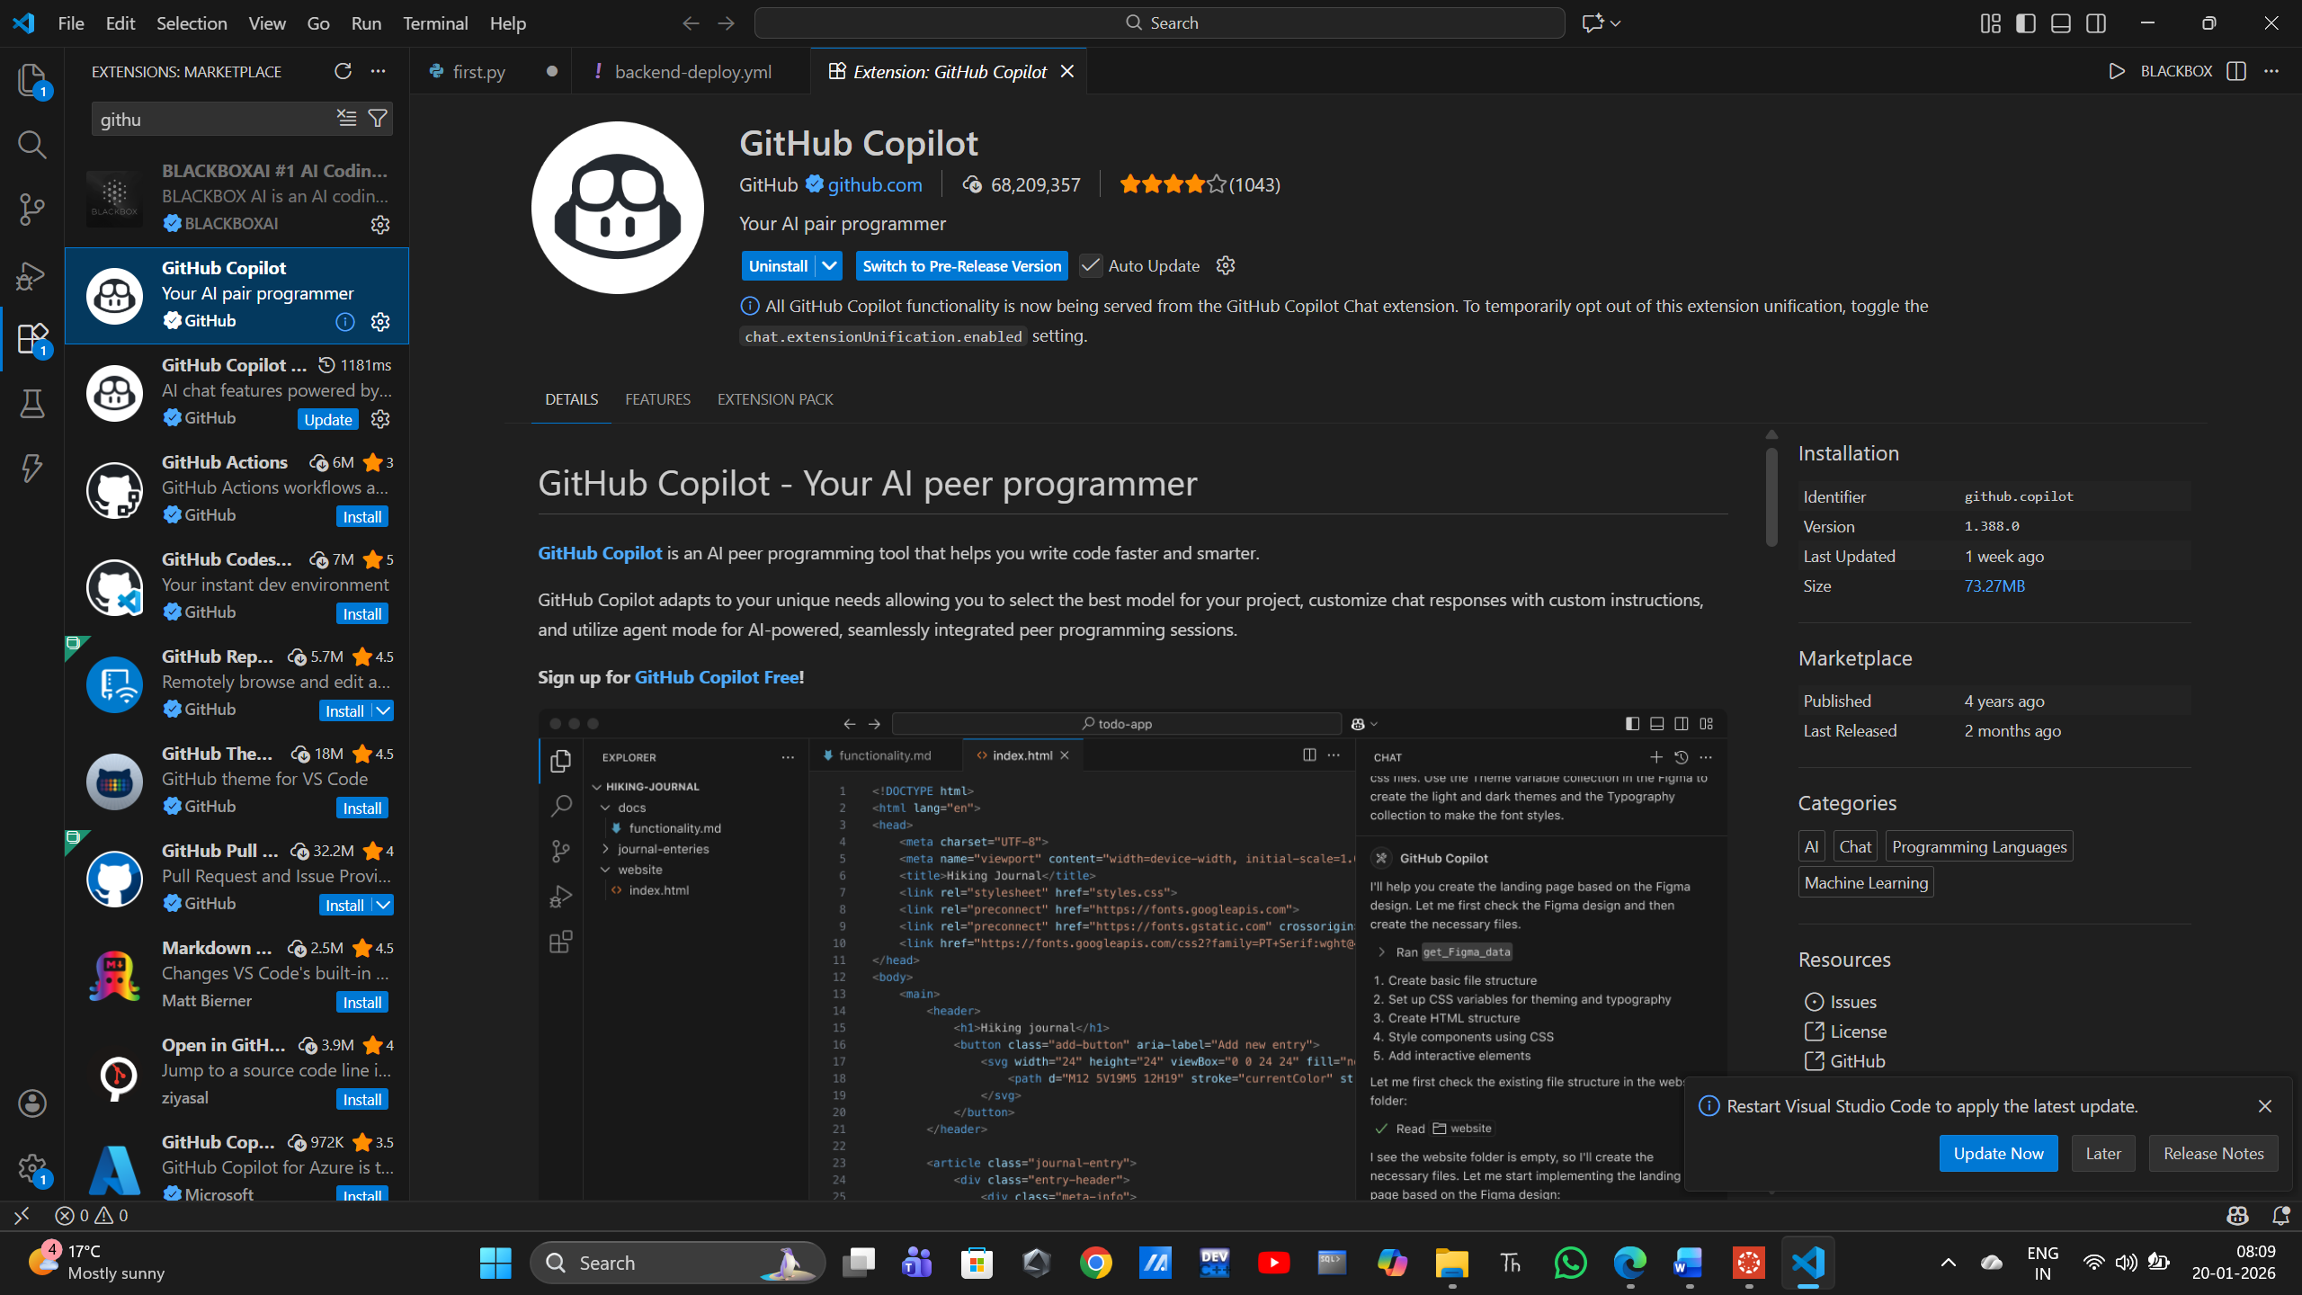
Task 1: AI-Generated Logic Without Modularization (Fibonacci Sequence Without Functions)
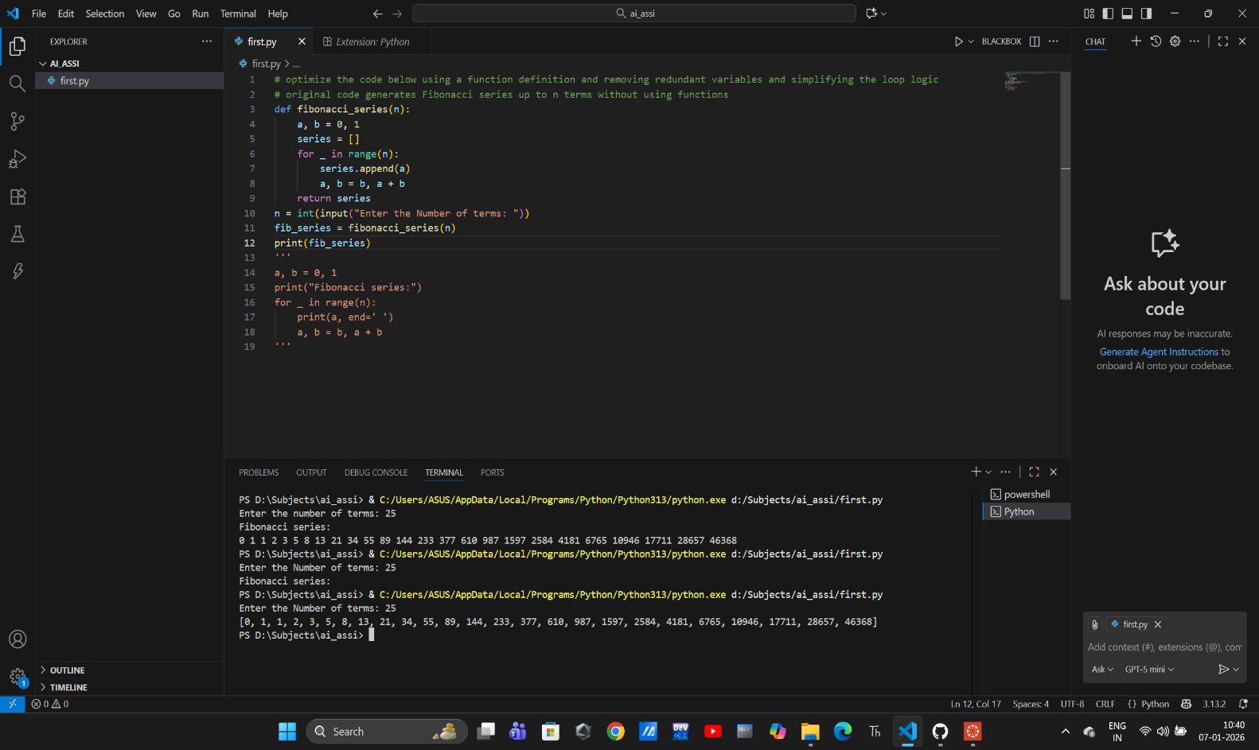
Task 2: AI Code Optimization & Cleanup (Improving Efficiency)
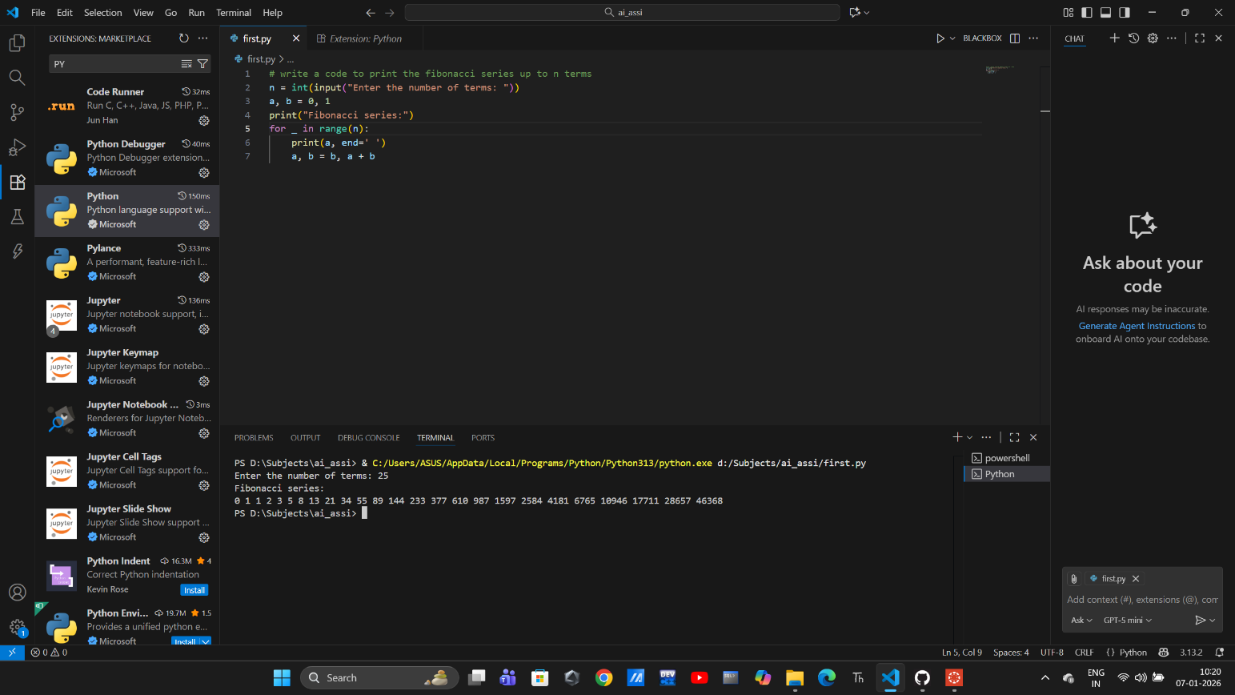
The code was optimal at task 1 itself

Task 3: Modular Design Using AI Assistance (Fibonacci Using Functions)
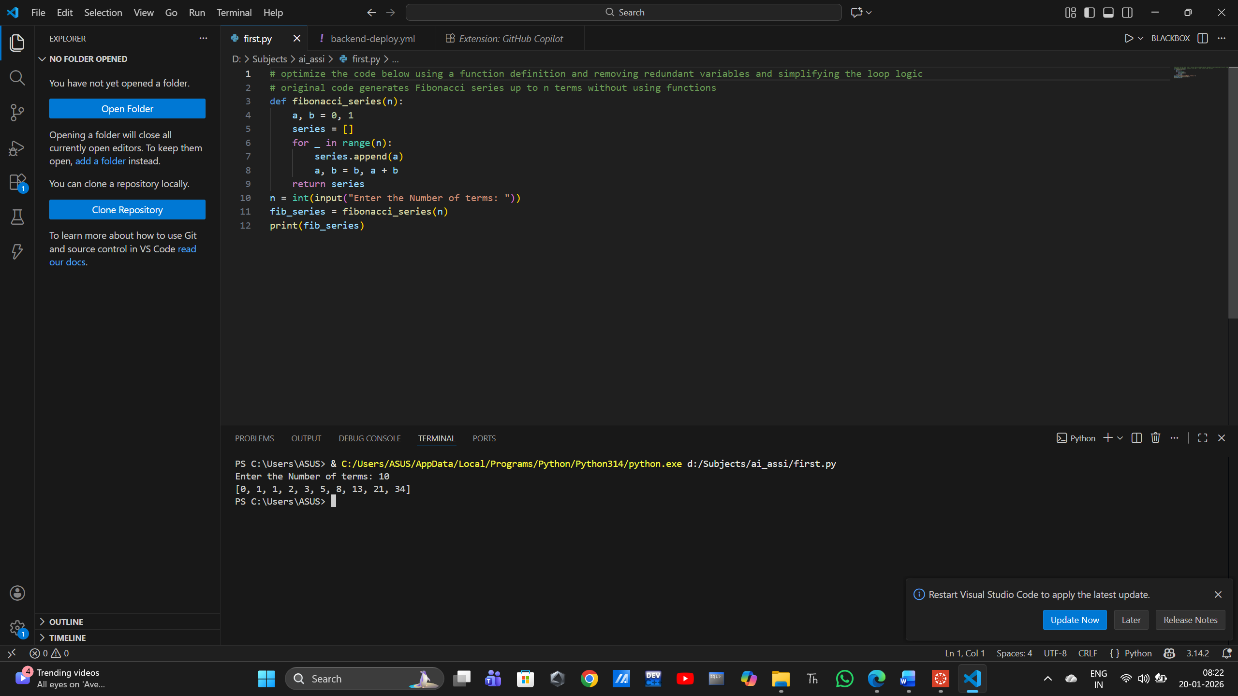
Sample i/p & o/p :
Enter the Number of terms: 10
[0, 1, 1, 2, 3, 5, 8, 13, 21, 34]

Task 4: Comparative Analysis – Procedural vs Modular Fibonacci Code

Code 1: Procedural Fibonacci Code (Task 1)
a, b = 0, 1
print("Fibonacci series:")
for _ in range(n):
print(a, end=' ')
a, b = b, a + b

Code 2: Modular Fibonacci Code (Task 3)

def fibonacci_series(n):
a, b = 0, 1
series = []
for _ in range(n):
series.append(a)
a, b = b, a + b
return series
n = int(input("Enter the Number of terms: "))
fib_series = fibonacci_series(n)
print(fib_series)

 | Code 1 | Code 2
  Criteria
Code Clarity | Moderate | High
Reusability | Low | High
Debugging Ease | Low | High
Larger System Use | Not Suitable | Highly Suitable

Task 5: AI-Generated Iterative vs Recursive Fibonacci Approaches (Different Algorithmic Approaches for Fibonacci Series)
An iterative Fibonacci implementation

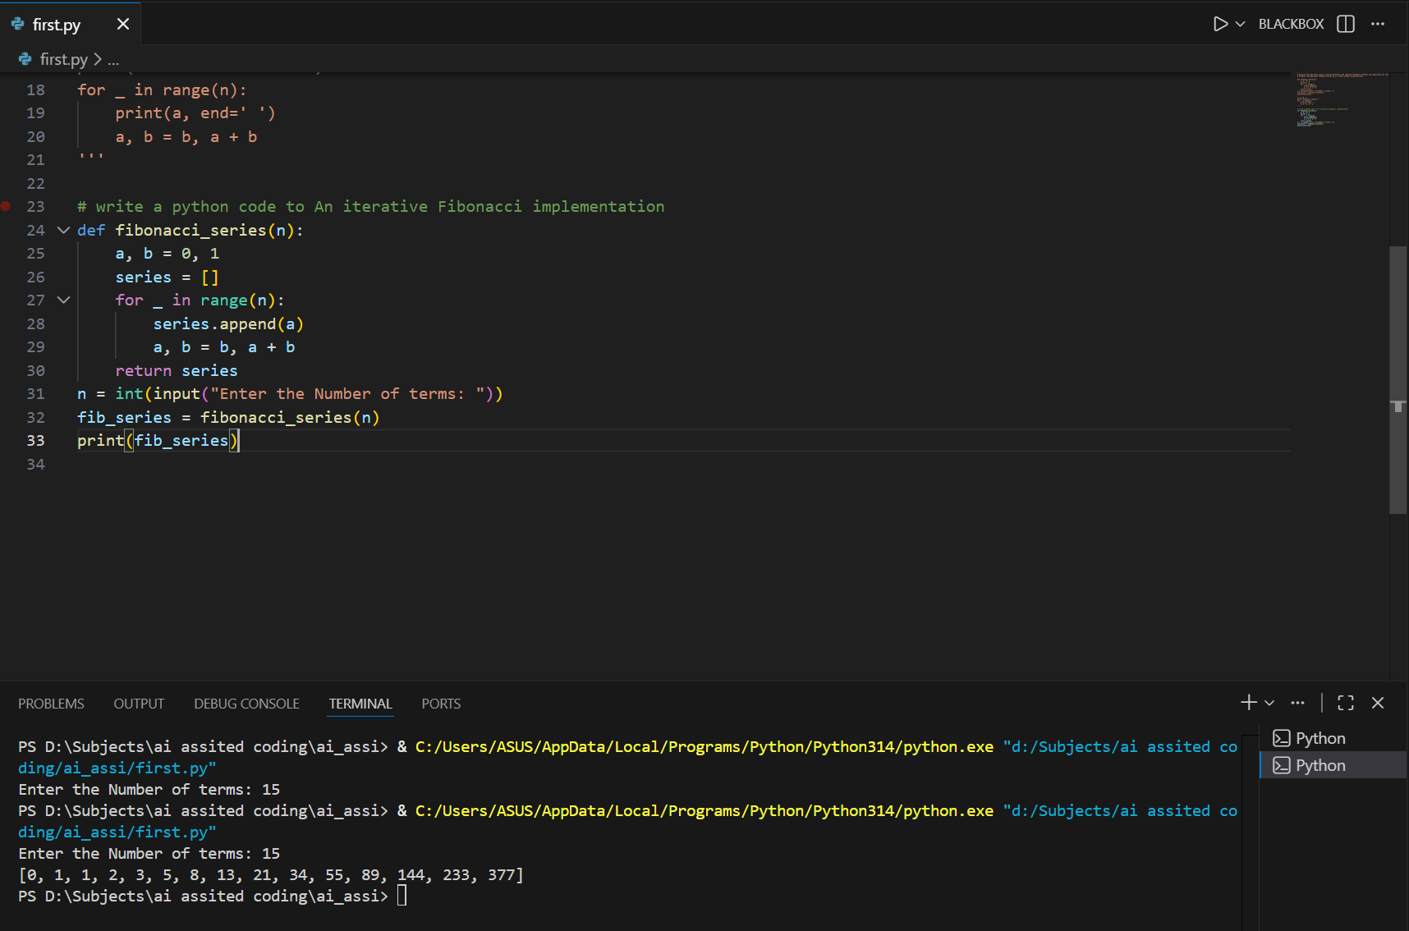

Execution Flow
- Function is defined
- User input is taken
- Function is called
- Fibonacci numbers are calculated
- Result is returned
- Output is displayed

A recursive Fibonacci implementation
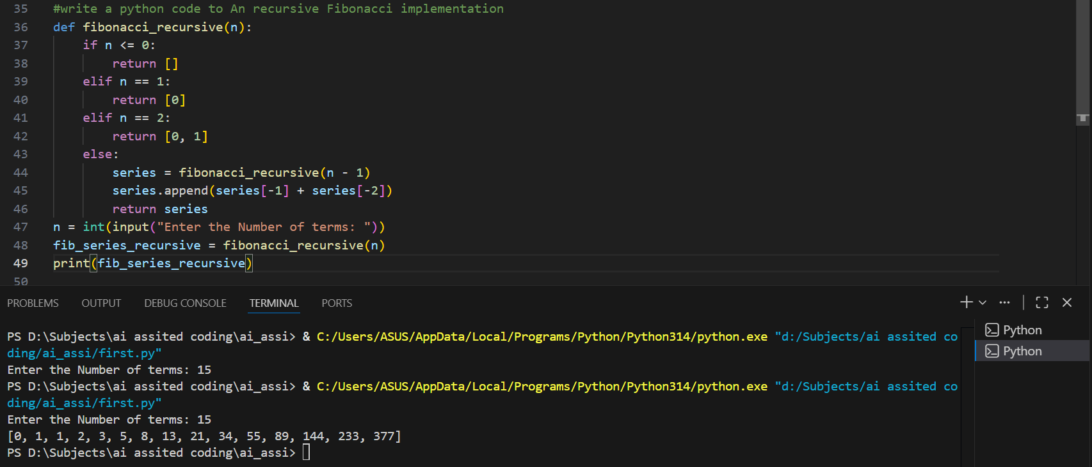

Execution Flow
- Function is defined
- User input is taken
- Recursive function calls itself until base case
- Results are built during backtracking
- Final list is returned
- Output is printed

Aspect | Iterative Fibonacci | Recursive Fibonacci
Time Complexity | O(n) | O(n)
Space Complexity | O(1) | O(n)
Speed | Fast | Slower
Stack Overflow Risk | No | Yes
Suitable for Large n | ✅ Yes | ❌ No
Code Simplicity | Moderate | High
Recommended | ✅ Best Choice | ❌ Avoid

