
NETAJI SUBHAS UNIVERSITY OF TECHNOLOGY
Department of Computer Science and Engineering — B.Tech. Project
A 2.5D CNN–Transformer Framework with Attention and Progressive Pruning for Lung Nodule Detection
Project Understanding Guide
What was built, how it works, what was measured and what it means — Phases 0 to 9
Submitted by | Supervisor
Vishal Kumar — 2023UCA1854  Rydham Bansal — 2023UCS1599  Kushagra Sabharwal — 2023UCA1851 | Dr. Surendra Nagar  Assistant Professor

Status of this document
Covers the project through Phase 9 of 17 (data, preprocessing, baselines, 2.5D input, Transformer, attention and pruning). The final-model selection, ablation write-up, error analysis and final experiments (Phases 10–17) are still to come.
Every number in this guide is read from the saved result files in the repository (results/tables, data/metadata, experiments/); the research code and notebooks are the source of truth. This is a research prototype and not a clinical tool.

How to read this document
This guide is written so that someone who has not followed the project day by day can understand the whole of it: the problem, the data, every method and model, every experiment and what was found. It is organised from the big picture down to the details.
Table 1: Contents of this guide
# | Section | What you will find
1 | Executive summary | One-page answer: what was done, headline numbers, what we can and cannot claim.
2 | Background and research question | The clinical problem, why 2.5D + CNN–Transformer + attention + pruning, and the revised approach (NFD removed).
3 | Data and evaluation protocol | LUNA16, the train/validation/test split, the FROC/CPM metric, and how results are made trustworthy (seeds, bootstrap).
4 | Roadmap and status | The 18 phases and which are finished.
5 | Phase-by-phase account (0–9) | For each phase: goal, method, results, figures and findings.
6 | Catalogue of models | Every model that was built, side by side (architecture, size, accuracy).
7 | Ablation chain | The central scientific question — what does each component add?
8 | Have we built a research benchmark? | An honest answer, including what we can and cannot claim against the literature.
9 | Limitations and risks | Threats to validity and how each was handled.
10 | What remains | Phases 10–17 and the decisions waiting for the researchers.
A–D | Appendices | Repository map, how to reproduce, glossary, per-run result tables.

Conventions used throughout
- CPM is the single summary score (0–1, higher is better): the average detection sensitivity at 1/8, 1/4, 1/2, 1, 2, 4 and 8 false alarms per scan (Section 3.4).
- “Validation” numbers are used to make decisions; “test” numbers are reported but never used to choose anything.
- “±” after a CPM is the standard deviation across three training runs with different random seeds (42, 43, 44). A single-seed result is marked as such.
- “Slices” means CT slices stacked as input channels. “5 slices” = the slice of interest plus two above and two below, each 1 mm apart.
- Experiment identifiers: EXP-001 (2D baseline), EXP-002 (1/3/5-slice CNN), EXP-003 (Transformer), EXP-003c (control), EXP-004 (attention), EXP-005 (pruning).

1. Executive summary
The project. Lung cancer is detected early by finding small nodules in low-dose chest CT scans, a slow task for radiologists. This project builds and studies a deep-learning pipeline that scores candidate nodule locations in the public LUNA16 dataset. The input is a 2.5D patch (several neighbouring CT slices stacked as channels), the model is a CNN, optionally combined with a Transformer and attention, and the study then prunes the model to make it smaller and faster. The aim is not to assume any component helps, but to measure the contribution of each one in controlled experiments.
Where we are. Phases 0–9 of 17 are complete: environment, dataset validation, CT preprocessing, a 2D baseline, the 2.5D pipeline, a 2.5D CNN baseline, a CNN–Transformer, attention modules, and progressive pruning of all five model variants. About 75 automated tests pass, and every experiment is reproducible from configuration files.
Table 2: Headline results (official LUNA16 FROC/CPM protocol; mean ± std over 3 seeds unless noted)
Model | Parameters | Validation CPM | Test CPM | Verdict
E0 2D CNN (1 slice) | 302,228 | 0.619 ± 0.012 | 0.668 ± 0.024 | Reference baseline
E1 2.5D CNN (5 slices) | 302,804 | 0.799 ± 0.019 | 0.869 ± 0.013 | Clear gain (+0.18 CPM, CI +0.12…+0.24)
E2 + Transformer | 570,068 | 0.774 ± 0.005 | 0.842 ± 0.027 | No measurable gain
E3a + SE attention | 313,984 | 0.785 ± 0.006 | 0.852 ± 0.019 | No measurable gain
E3b + CBAM attention | 314,380 | 0.800 ± 0.008 | 0.849 ± 0.005 | No measurable gain; +89% latency
E4 Pruned CNN, unstructured 70% (seed 42) | 91,701 non-zero | 0.772 | 0.846 | 70% fewer weights, accuracy within noise, no speed-up
E4 Pruned CNN, structured ~27% (seed 42) | 220,191 | 0.746 | 0.852 | 9% faster; small loss unresolved

Five findings to remember
- 1. Stacking neighbouring CT slices is what matters. Going from 1 slice to 5 slices raised validation CPM from 0.620 to 0.799. The gain is concentrated in small nodules (<6 mm: sensitivity at 1 false positive per scan 0.58 → 0.84).
- 2. A Transformer on top did not help. 0.774 vs 0.799; the 95% interval of the difference (−0.061 … +0.009) includes zero, and a parameter-matched plain-convolution control did equally well. Part of the usual “Transformer gain” may simply be extra parameters.
- 3. Attention (SE, CBAM) did not help either, at 3.7% extra parameters and up to +89% measured latency (CBAM).
- 4. Sparsity is not speed. Removing 95% of the weights (unstructured pruning) left latency unchanged because standard hardware still multiplies the zeros. Only structured pruning (removing whole channels) made the network genuinely faster: −28% latency at −50% parameters.
- 5. Negative results are results. All three “extra” components (Transformer, attention, unstructured pruning speed) failed to deliver what the literature suggests in this setting. They are reported as such, with the evidence.

Have we built a research benchmark?
We have built a rigorous, reproducible evaluation setup and a set of controlled baselines — but not a publishable benchmark, and no state-of-the-art claim is justified. The evaluation follows the official LUNA16 FROC/CPM rules (re-implemented and checked against the organisers’ own example output) with a leakage-free split, multiple seeds and bootstrap confidence intervals. But our setting (scoring the provided candidate list, one fixed split, 105 test nodules) is not the same as the standard 10-fold full-detection benchmark, so our numbers cannot be compared directly with published LUNA16 results. Details in Section 8.

2. Background and research question

2.1 The clinical problem
Lung cancer remains one of the leading causes of cancer death, and low-dose CT screening finds it earlier. A single chest scan contains hundreds of two-dimensional slices, and a radiologist must search all of them for pulmonary nodules — small round or irregular spots, often only 3–10 mm across. This is slow and varies from one reader to another, which motivated three decades of Computer-Aided Detection (CAD) research and, more recently, deep learning.

2.2 Why 2.5D, CNN–Transformer, attention and pruning?
Idea | What it is | Why we consider it | What we test
2.5D input | Stack a few neighbouring slices (z−2 … z+2) as input channels. | 2D loses the information above/below a nodule; full 3D is too heavy for an 8 GB laptop. 2.5D is the compromise. | 1 vs 3 vs 5 slices (Phase 6)
CNN | Convolutional network: finds local patterns (edges, textures, shapes). | Strong, efficient baseline for images. | The backbone of every model
Transformer | Self-attention between feature-map positions: relates distant regions. | May add wider context on top of local CNN features. | CNN vs CNN + Transformer, with a capacity-matched control (Phase 7)
Attention (SE / CBAM) | Learned gates that re-weight feature channels (and positions). | Cheap way to emphasise nodule-relevant features. | CNN vs CNN + SE / CBAM (Phase 8)
Progressive pruning | Repeatedly remove unimportant weights/channels, then fine-tune to recover. | Smaller, faster models; also tests whether the model is over-sized. | Unstructured and structured pruning of every model (Phase 9)

2.3 Research question and objectives
Central research question
Can a 2.5D CNN–Transformer lung nodule detection framework, enhanced with attention and progressive pruning, achieve a useful balance between detection performance and computational efficiency on LUNA16?

- Primary objective: design and evaluate an end-to-end nodule detection model using a 2.5D CT representation with CNN–Transformer feature extraction.
- Secondary objectives: a reproducible baseline; the effect of Transformer context modelling; the role of attention; a progressive pruning method; LUNA16 metrics (FROC, CPM, sensitivity, false positives per scan); efficiency (parameters, FLOPs, memory, latency, sparsity, throughput); and controlled single-variable ablations.
- Guiding principle (rules.md): no component is assumed to help, nothing is declared novel without evidence, and negative results are kept.

2.4 The revised approach (what changed in the final report)
An earlier project plan included a fifth component, Nodule Feature Diversity (NFD) regularisation, a feature-diversity loss term inspired by a super-resolution paper (LightSeNet). The revised report removed it: the training objective is now simply the detection loss, and the ablation chain ends with progressive pruning. All project documents were synchronised to this revised approach.
Table 3: Original plan versus the revised approach implemented
Aspect | Earlier plan | Revised approach (this work)
Components studied | 2.5D, CNN–Transformer, attention, progressive pruning, NFD regularisation | 2.5D, CNN–Transformer, attention, progressive pruning
Training loss | L_total = L_det + λ_NFD · L_NFD | L_total = L_det = λ_cls · L_focal + λ_loc · L_loc
Ablation chain | E0 … E5 (… + pruning + NFD) | E0 2D CNN → E1 2.5D CNN → E2 + Transformer → E3 + attention → E4 + progressive pruning
Phases | 19 (0–18) including an NFD phase | 18 (0–17); the NFD phase was removed
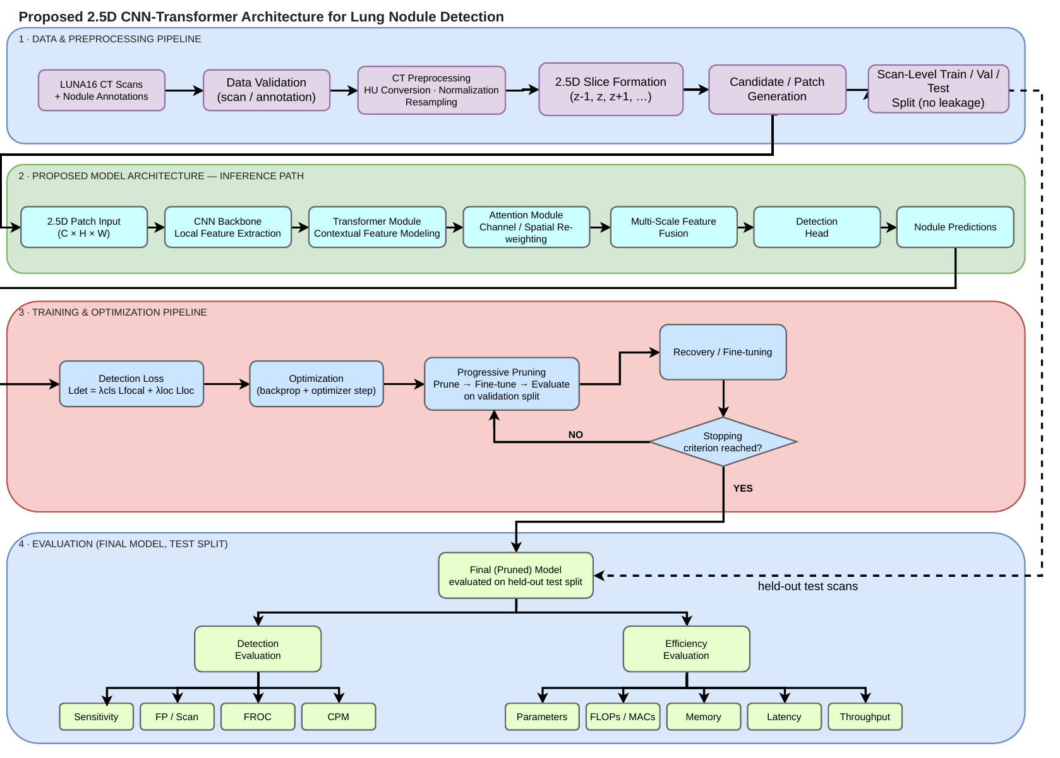
Figure 1: Proposed framework from the revised project report (its Figure 5.1): data and preprocessing, model, training with progressive pruning, and evaluation of the final pruned model on the held-out test split.
Implementation note — “detection” here means scoring candidates
The report describes a detection head. In the implementation, each candidate location supplied by LUNA16 is cropped into a 64×64 patch and the model produces (i) a nodule probability and (ii) a box (centre offset and diameter). The official FROC/CPM protocol is then applied to the scored candidate list. Finding candidates in a whole scan (a full detector) is not implemented. This is an important scope decision and is discussed under limitations (Section 9).

3. Data and evaluation protocol

3.1 The LUNA16 dataset
LUNA16 (LUng Nodule Analysis 2016) is a standard public benchmark of 888 low-dose chest CT scans from the LIDC-IDRI collection, with nodule annotations (agreed by at least three of four radiologists) and an official evaluation protocol. The data files were validated before any modelling (Phase 2).
Table 4: LUNA16 as measured in this project (data/metadata/dataset_stats.json)
Property | Value
CT scans | 888 (all 512 × 512 pixels per slice; 10 subsets of 88–89 scans)
Slices per scan | 95–764 (median 237.5)
In-plane pixel spacing | 0.46–0.98 mm
Slice spacing (z) | 0.45–2.50 mm (median 1.25) — highly variable
Annotated nodules | 1,186 in 601 scans (287 scans have none); up to 12 per scan
Nodule diameter | 3.3–32.3 mm (median 6.4 mm, mean 8.3 mm)
Candidate locations (V2) | 754,975, of which 1,557 are true nodules (0.21%)
Lung masks | Provided for all 888 scans (labels: left lung, right lung, trachea)
Integrity | All 10 data archives pass checksum tests; 0 validation issues after the orientation fix (Phase 2)

3.2 Candidates, patches and the class imbalance
LUNA16 supplies a list of candidate locations per scan (generated by earlier detection algorithms). Only about 0.2% are real nodules, so the task is a needle-in-a-haystack problem. This extreme imbalance is why the training loss uses a focal loss (Section 5, Phase 4), which down-weights the huge number of easy negatives.

3.3 Train / validation / test split (no leakage)
LUNA16’s ten subsets are already disjoint at scan (patient) level. We split by subset, so all data from one scan stays together — slices or patches of the same scan never appear in two partitions (a classic source of inflated results). No randomness is involved.
Table 5: Scan-level split (data/splits, data/candidates)
Partition | LUNA16 subsets | Scans | Nodules | Candidates | True nodule candidates | Use
Train | 0 – 7 | 712 | 963 | 604,563 | 1,218 | Fit the model
Validation | 8 | 88 | 118 | 74,488 | 195 | Choose epochs, levels, designs
Test | 9 | 88 | 105 | 75,924 | 144 | Final reporting only

Why this matters: with only 118 validation and 105 test nodules, differences of a few CPM points can be pure chance. This is why every conclusion in this guide uses several seeds and bootstrap confidence intervals (Section 3.5).

3.4 The metric: FROC and CPM
Plain accuracy is meaningless here (a model that says “no nodule” everywhere is 99.8% “accurate”). LUNA16 instead uses the FROC curve: for every possible decision threshold, plot sensitivity (fraction of real nodules found) against the average number of false positives per scan. The single summary number is the Competition Performance Metric (CPM):
CPM = average of the sensitivity at 1/8, 1/4, 1/2, 1, 2, 4 and 8 false positives per scan.
The official matching rules are followed exactly: a candidate counts as a hit if it lies within the nodule’s radius; extra candidates on an already-found nodule are ignored (not counted as false positives); candidates on “irrelevant” findings are ignored; nodules that have no nearby candidate still count as misses; and at most 100 marks per scan are scored.
How the metric was verified
The organisers’ evaluation script (Python 2) was re-implemented in Python 3 and run on their own example submission. All counts match the official output exactly (1,120 true positives, 548,420 false positives, 66 misses, 1,294 ignored on irrelevant findings, 231 double detections) and CPM agrees to six decimals. The shipped script differs slightly from the one that produced the bundled example (5 mm vs 0.5 mm radius for irrelevant findings; 100-mark cap); the shipped behaviour is used by default and the legacy behaviour is available for checking.

3.5 Making results trustworthy
Source of doubt | How it is handled
Random training noise (different seeds give different models) | Key comparisons use 3 seeds (42, 43, 44); results shown as mean ± std. Seeds are fixed and recorded; a re-run reproduces the first-epoch loss exactly.
Small evaluation sets (118 / 105 nodules) | Paired scan-level bootstrap: resample the evaluation scans 1,000 times and recompute CPM for every model on the same resamples; report the 95% interval of the CPM difference. If it contains 0, the difference is not established.
Choosing things on the test set | Forbidden. Epochs, designs and pruning levels are chosen on validation; test is reported alongside but never used for choosing.
Researcher bias when selecting a pruning level | The selection rule was written down before any pruning result existed (Section 5, Phase 9).
Wins by chance among many comparisons | Differences under about 0.03 CPM are treated as unresolved; every finding states its interval.
Extra parameters mistaken for a better idea | A capacity-matched control and a no-pruning fine-tune control were added (Phases 7 and 9).

4. Roadmap and status
The project follows an 18-phase plan (phases.md). The principle is to progress from simple and measurable to complex, validating each step before the next.
Table 6: Phase roadmap and status
Phase | Title | Status | Main outcome
0 | Project initialisation | Done | Documentation system (PRD, architecture, rules, phases, design, memory), Git, README
1 | Environment and repository | Done | Reproducible conda environment, repository skeleton, config system, CPU + Apple MPS verified
2 | Dataset understanding and validation | Done | 888 scans / 1,186 nodules validated; 14 scans with flipped axes found and handled; leak-free split
3 | CT preprocessing | Done | Pipeline from raw scan to normalised 1 mm volume + 2.5D patches; image–annotation alignment verified
4 | 2D baseline | Done | End-to-end training/evaluation; official FROC/CPM re-implemented and validated
5 | 2.5D data pipeline | Done | 5-slice input verified bit-exactly; 2D vs 2.5D input analysis
6 | 2.5D CNN baseline | Done | 5 slices >> 1 slice (+0.18 CPM); gain concentrated in small nodules
7 | CNN–Transformer | Done | No measurable gain over the CNN (negative result, with control)
8 | Attention module | Done | SE and CBAM: no measurable gain; latency cost measured
9 | Progressive pruning | Done | All 5 models pruned two ways; sparsity ≠ speed demonstrated
10 | Complete model | Next | Integrate the validated components; choose the final pruned model
11 | Ablation study | Planned | Final ablation table E0 … E4
12 | Efficiency evaluation | Planned | Final efficiency comparison under documented conditions
13 | Error analysis | Planned | Where and why the model fails
14 | Final experiments | Planned | Frozen configuration, final runs
15 | Research analysis | Planned | Scientifically defensible conclusions
16 | Final documentation | Planned | Report / paper draft
17 | Reproducibility and finalisation | Planned | Check everything can be rebuilt from the repository

5. Phase-by-phase account
Each phase below states its goal, what was done and how, what it produced, and what was found. Figures are taken directly from the repository’s results/figures folder.

Phase 0 — Project initialisation
Goal | Define the research direction, rules and documentation before writing code.
Input | The project report and supervisor’s direction.
Output | Six project documents, a README, a Git repository.
Result | Complete. The documents were later synchronised with the revised report (NFD removed).

Table 7: Project documents (all in the repository root)
File | Purpose
prd.md | Product requirements: problem, objectives, scope, evaluation requirements, ablation structure.
architecture.md | Software architecture: repository layout, module boundaries, loss formulation, technology stack.
rules.md | The development and research rules (below).
phases.md | The 18-phase roadmap with objectives, tasks, deliverables and completion criteria.
design.md | Standards for figures, tables and reports.
memory.md | Persistent project state: decisions, results and next steps, updated after every phase.
README.md | Entry point: objective, how to set up and run.

The rules that shaped everything that followed
- Evidence before claims; experiments before conclusions. No component is assumed to help, and novelty is never assumed.
- One major change at a time, against a working baseline, so each component’s effect can be isolated.
- No data leakage; the test set is isolated from every design decision.
- Detection metrics (FROC, CPM), not classification accuracy.
- Reproducibility: configuration files, fixed seeds, recorded experiments, never overwriting results.
- Negative results are recorded; nothing is cherry-picked; AI assistance never invents results or citations.

Phase 1 — Environment and repository setup
Goal | A reproducible Python environment and repository skeleton.
Input | MacBook Pro (Apple M3, 8 GB RAM), macOS.
Output | Conda environment btp-lung, folder structure, configs/base.yaml, environment check script, tests.
Result | Complete. PyTorch verified on CPU and on the Apple GPU (MPS backend).

Table 8: Software environment (versions recorded for reproducibility)
Component | Version | Component | Version
Python | 3.11.16 | scikit-learn | 1.9.1
PyTorch (conda-forge) | 2.10.0 | SimpleITK | 2.5.6
NumPy | 2.4.6 | nibabel | 5.4.2
SciPy | 1.17.1 | matplotlib | 3.11.2
pandas | 3.0.6 | PyYAML / pytest / tqdm | 6.0.3 / 9.1.1 / 4.70.1

- Device policy: use the Apple GPU (MPS) when available, otherwise CPU; CUDA is never assumed.
- Lesson learned: installing PyTorch with pip crashed on import (two copies of the OpenMP library collided with conda’s NumPy). Installing PyTorch from conda-forge fixed it; this is recorded in environment.yml.
- Memory discipline: the machine has 8 GB, so the 62 GB dataset is never loaded fully; archives are read in place and one scan is processed at a time.

Phase 2 — Dataset understanding and validation
Goal | Understand and verify LUNA16 before training anything.
Input | subset0–9 archives, annotations, candidates, lung masks, official evaluation files.
Output | data/metadata/ (scan table, statistics, validation report), data/splits/, exploration notebook.
Result | Complete; 0 validation issues after fixing one real data problem (below).

What was checked
- Every scan’s header (size, voxel spacing, origin, orientation) read directly from the archives, and the raw file size compared with what the header implies.
- Every annotation and candidate matched to a scan; annotation coordinates converted from millimetres (world) to voxel positions and checked to lie inside the volume.
- Integrity (checksums) of all ten data archives.
Finding: 14 scans are stored with flipped x/y axes
A first validation run reported 24 annotations outside their scan volume. The cause: 14 scans have a direction matrix with −1 on the x and y axes (they are stored mirrored). Converting coordinates without the direction matrix places those nodules in the wrong place. The coordinate conversion now applies each scan’s direction matrix (and preprocessing flips these scans back to a standard orientation), after which every annotation lies inside its scan. This would have silently corrupted training labels and is exactly why validation precedes modelling.
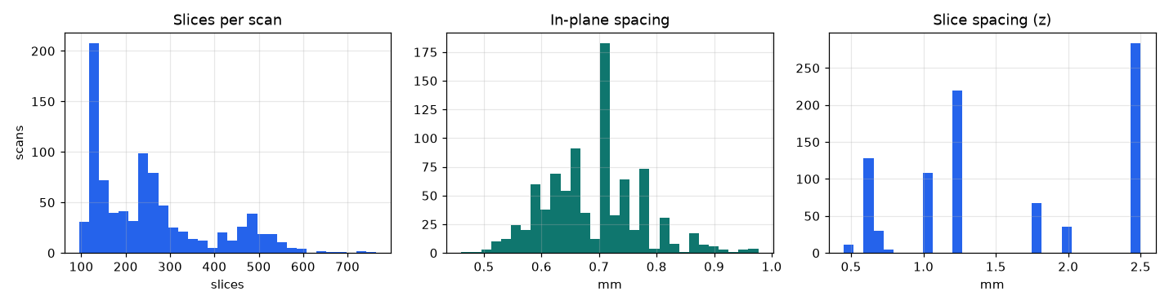
Figure 2: Scan geometry. All scans are 512×512 per slice, but the number of slices (left) and especially the slice spacing in z (right) vary widely (0.45–2.5 mm) — which is why resampling is needed.
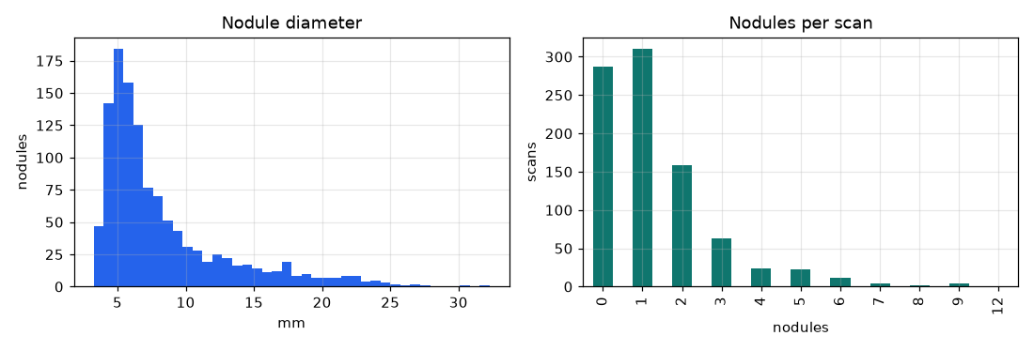
Figure 3: Nodule diameter (left) and nodules per scan (right). Most nodules are small (median 6.4 mm); 287 of 888 scans contain none.

Phase 3 — CT preprocessing pipeline
Goal | Turn a raw scan into model-ready input while keeping image and annotations perfectly aligned.
Input | Raw CT scan, lung mask, candidate list.
Output | Normalised isotropic volume, lung mask, 2.5D patches, candidate index (split + voxel coordinates + inside-lung flag).
Result | Complete. Alignment verified quantitatively and visually.

Table 9: The preprocessing pipeline (configs/preprocessing.yaml)
Step | What happens | Parameters | Why
1 Load | Read the scan straight from its archive (no extraction). | — | The dataset is 62 GB; disk and RAM are limited.
2 Orientation | Flip the 14 mirrored scans back; store as (z, y, x) with identity orientation. | Direction-matrix check | World→voxel conversion must be correct for every scan.
3 Hounsfield units | Raw values are already HU; clip to remove scanner padding. | [−1024, 3071] HU | Removes artefact values such as −2000.
4 Resample | Interpolate to 1 × 1 × 1 mm voxels (linear for CT, nearest for masks), keeping the physical origin. | 1.0 mm isotropic | Slice spacing ranges 0.45–2.5 mm; neighbouring slices must mean the same physical distance.
5 Window + normalise | Clip to a lung window and scale to [0, 1] with fixed constants. | [−1000, 400] HU | Fixed constants avoid leaking dataset statistics between train and test.
6 Lung mask | Left + right lung from the official masks (trachea excluded). | labels 3, 4 | Lung region of interest; used to check candidates.
7 Patches | Crop 64×64 pixels × 5 slices around each candidate’s world coordinate; pad with air outside the volume; replicate edge slices at scan ends. | 64×64×5 | The model input.

The full preprocessed volumes (over 100 GB) are not stored; each scan is preprocessed on demand (about 2 s, 1.7 GB peak memory). Later, the patches needed for training were cached once (Phase 4).
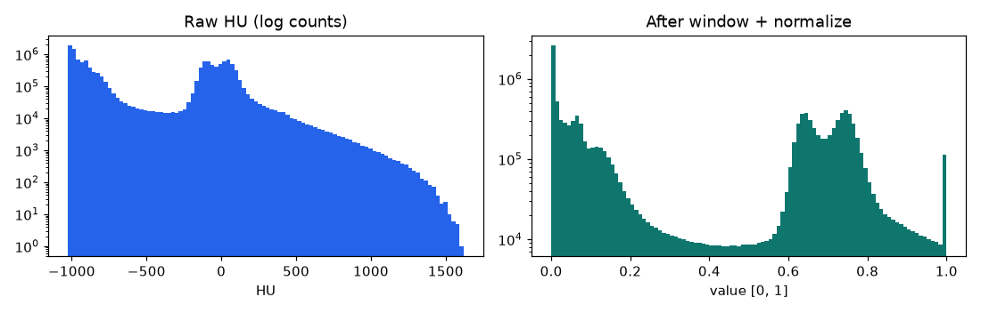
Figure 4: Intensity histograms before (raw HU) and after windowing and normalising to [0, 1] (log scale).

Does preprocessing preserve the link between image and annotation?
Table 10: Alignment check on 41 scans / 79 nodules (data/metadata/preprocessing_validation.json)
Check | Result | Interpretation
Annotated site brighter than −500 HU (mean in a 1.5 mm sphere) | 91.1% | Nodules are denser than lung tissue; the rest are probably ground-glass nodules (less dense).
Same test at a random lung voxel (control) | 3.8% | Chance level is low, so the test discriminates.
Flipped scans, annotation location | 100% | Correct after the orientation fix.
Flipped scans, mirrored location (negative control) | 58.3% | Wrong location would score much lower.
Annotations inside the (5 mm-dilated) lung mask | 100% | Consistent with the lung segmentation.
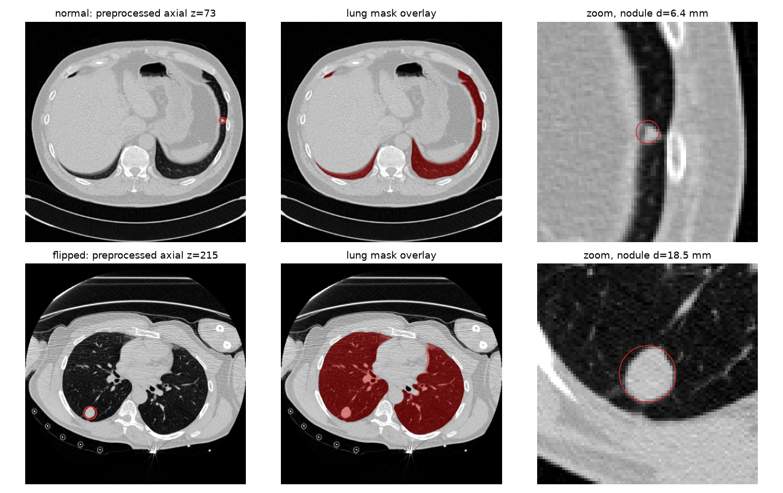
Figure 5: Visual verification on a normal scan (top) and a flipped-axis scan (bottom): the red circle (annotated diameter) sits on the nodule; the lung mask follows the lungs.
Candidate index. Every candidate was given its split, voxel coordinates and an inside-lung flag. 99.7% of candidates (and all but 4 of 1,557 true nodules) lie inside the 5 mm-dilated lung mask. A bug found during this step — a coordinate shift applied to all scans instead of only the flipped ones, which marked every candidate as outside the lung — was fixed and covered by a regression test.

Phase 4 — 2D baseline and the evaluation machinery
Goal | A complete, simple end-to-end system to measure every later idea against.
Input | Cached candidate patches, official FROC/CPM rules.
Output | Training and evaluation code, EXP-001, a patch cache (4.1 GB), validated FROC/CPM implementation.
Result | Complete. Validation CPM 0.632, test CPM 0.675 (single seed, centre slice only).

Task formulation
Each candidate location becomes a 64×64 patch. The model outputs a nodule probability and a box (centre offset dx, dy and diameter d, in pixels, where 1 pixel = 1 mm). The score of each candidate is its probability, and the official FROC protocol ranks all candidates in a scan. To save time, the cache holds all 1,218 training positives plus 60,000 randomly chosen training negatives (seeded), and all validation and test candidates (needed for exact FROC).

The baseline CNN (“SimpleCNN”)
Table 11: Architecture of the baseline CNN (5-slice version: 302,804 parameters, 109.7 MFLOPs per patch)
Part | Operations | Output size
Input | Stack of slices (1, 3 or 5 channels) | C × 64 × 64
Stage 1 | 2 × [conv 3×3 → batch-norm → ReLU] (16 channels) → max-pool 2×2 | 16 × 32 × 32
Stage 2 | same, 32 channels | 32 × 16 × 16
Stage 3 | same, 64 channels | 64 × 8 × 8
Stage 4 | same, 128 channels | 128 × 4 × 4
Head | Global average pool → linear 128→64 → ReLU → dropout 0.2 → two outputs: objectness logit (1) and box (3) | 1 + 3 numbers

In plain words: four stages of small convolutions progressively look at larger and larger areas of the patch (the final features have a 76-pixel receptive field, larger than the 64-pixel patch, so every output position already “sees” the whole patch — relevant to Phase 7). The head then decides “nodule or not” and where.

Training objective
L_total = L_det = λ_cls · L_focal + λ_loc · L_loc (λ_cls = λ_loc = 1)
- Focal loss L_focal = −α_t (1 − p_t)^γ log p_t with α = 0.25, γ = 2: down-weights the very many easy negatives so the rare positives drive learning.
- Localisation loss L_loc = 1 − IoU(B, B*) between the predicted and true square boxes (computed only for positives that have a box).
- No additional regularisation term (the NFD term of the earlier plan was removed).
Table 12: Training setup shared by all CNN-family experiments
Setting | Value
Optimiser / schedule | AdamW, learning rate 1e-3, weight decay 1e-4, cosine decay
Batch / epochs | 256 / 20
Augmentation | Random flips and 90° rotations (box offsets transformed consistently); positives repeated ×10 per epoch
Model selection | Epoch with the best validation CPM (the test set is not used)
Hardware | Apple M3 GPU (MPS); about 40–120 s per epoch depending on the model
Reproducibility | Seed fixed; configuration, history and checkpoint saved per experiment; existing experiment folders are never overwritten

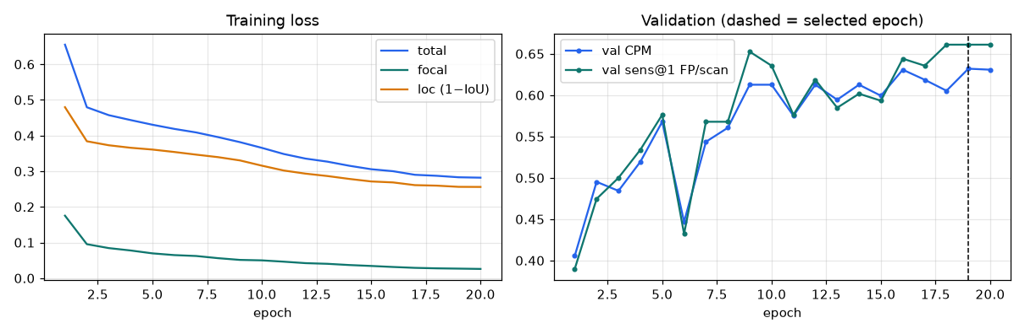
Figure 6: Training curves of the 2D baseline (EXP-001): loss and validation CPM per epoch.
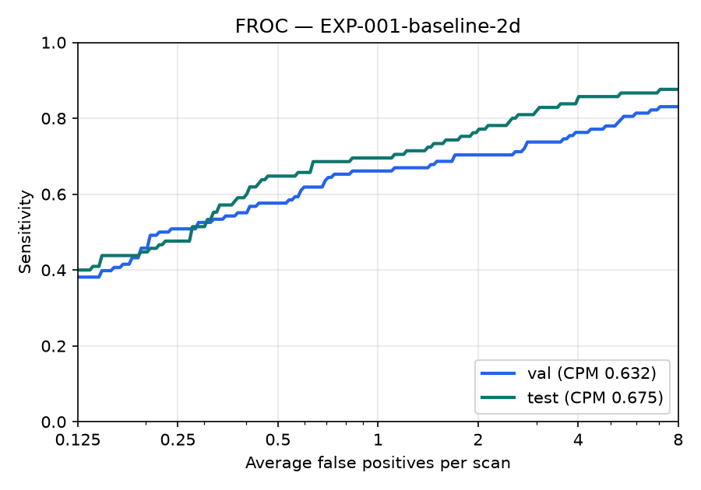
Figure 7: FROC curves of the 2D baseline on the validation and test splits (sensitivity vs. average false positives per scan, log axis).
Table 13: 2D baseline result (EXP-001, seed 42)
Split | CPM | Sensitivity @ 1 FP/scan | Max sensitivity (candidate ceiling) | Random-score CPM
Validation | 0.632 | 0.661 | 0.958 | 0.007
Test | 0.675 | 0.695 | 0.962 | 0.005

Two reference points frame these numbers: scoring candidates at random gives CPM ≈ 0.005, and no model can find a nodule that has no candidate nearby, which caps sensitivity at ≈ 0.96. A bug caught by a unit test in this phase — flips/rotations shifted the image by one pixel relative to its box target — was fixed.

Phase 5 — The 2.5D data pipeline
Goal | Make the 2.5D input correct and understand what extra slices add.
Input | Preprocessed volumes and the patch cache.
Output | Five-slice patches (z−2 … z+2, 1 mm apart), a configurable slice count and stride, validation report, notebook.
Result | Complete. Cache verified bit-exactly against an independent re-extraction.

Design decision. After resampling to 1 mm, neighbouring slices are 1 mm apart, so three slices (z−1, z, z+1) span only 2 mm — barely more than one slice for a 3–6 mm nodule. The researchers chose five slices at 1 mm (z−2 … z+2, 4 mm in total). The slice count and stride remain configurable, and the effect of 1 vs 3 vs 5 slices was then measured rather than assumed (Phase 6).
Table 14: Verification of the 2.5D pipeline (scripts/validate_25d.py)
Check | Result
Cached patches vs. independent pad-and-crop re-extraction | 37 of 37 bit-for-bit identical
Control: patches with channel order reversed | differ in 37 of 37 (so the check detects ordering errors)
Candidates within 2 slices of a scan end | 19 of 19 match the reference; edge slices replicated correctly (none are true nodules)
True nodules with a box fully inside the patch | 100% of 1,557
Nodule core brighter than its surrounding ring (centre slice) | 99.2%
Nodule centre inside the 5-slice window | 84% (the rest are large nodules whose candidate is off-centre in z)
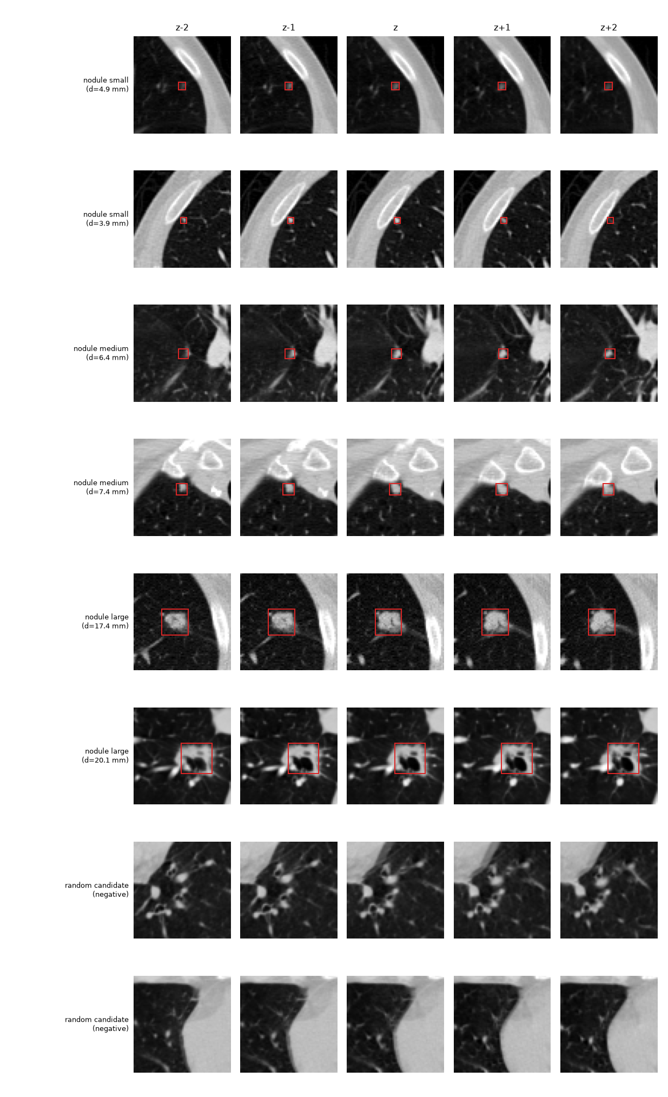
Figure 8: Five-channel inputs (columns: z−2 … z+2) for small, medium and large nodules (red box = box target) and two random negatives.

What do the extra slices add?
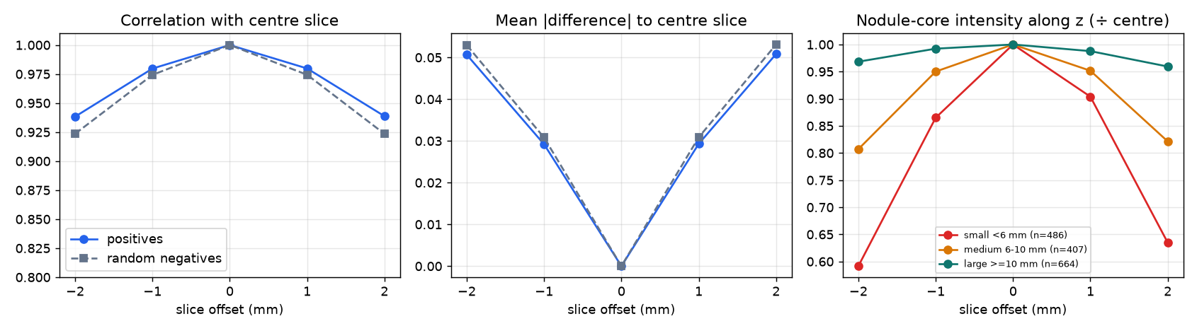
Figure 9: Left/middle: neighbouring slices are highly correlated, so the channels are redundant for most structure. Right: for small nodules the core intensity falls to roughly 60% of its centre value by ±2 mm, for medium nodules to about 80%, while large nodules barely change.
Takeaway (a hypothesis, tested next)
Adjacent 1 mm slices look almost identical (correlation 0.98 at ±1, 0.94 at ±2) — so the 5-slice input is not “five different pictures”. But a small nodule appears and disappears across those 4 mm, which is information a single slice cannot contain. Phase 6 tests whether this helps.

Phase 6 — The 2.5D CNN baseline: how many slices?
Goal | Measure whether the 2.5D representation beats 2D, and how many slices are worthwhile.
Input | The cached 5-slice patches; the same CNN, loss, optimiser and splits.
Output | EXP-002: CNNs with 1, 3 and 5 centre slices, multiple seeds.
Result | 5 slices beat 1 slice by +0.18 CPM (95% interval +0.12 … +0.24); this is the largest effect found in the project.

Only the number of input channels (1, 3 or 5, always centred on the candidate) changes; everything else is identical. The 1-slice and 5-slice models were trained with three seeds each (the 1-slice seed-42 run is EXP-001); the 3-slice model with one seed.
Table 15: Phase 6 results (validation is used for decisions; mean ± std over seeds)
Input | Seeds | Validation CPM | Test CPM | Sens. @1 FP (val) | Parameters | MFLOPs
1 slice | 3 | 0.619 ± 0.012 | 0.668 ± 0.024 | 0.650 | 302,228 | 105.0
3 slices | 1 | 0.707 | 0.800 | 0.746 | 302,516 | 107.4
5 slices | 3 | 0.799 ± 0.019 | 0.869 ± 0.013 | 0.828 | 302,804 | 109.7
Table 16: Paired bootstrap of the CPM difference (95% interval; the interval excluding 0 means the difference is established)
Comparison | Validation ΔCPM [95% CI] | Test ΔCPM [95% CI]
3 slices − 1 slice | +0.090 [+0.034, +0.152] | +0.140 [+0.076, +0.208]
5 slices − 1 slice | +0.179 [+0.117, +0.244] | +0.204 [+0.140, +0.278]
5 slices − 3 slices | +0.089 [+0.045, +0.130] | +0.065 [+0.020, +0.112]
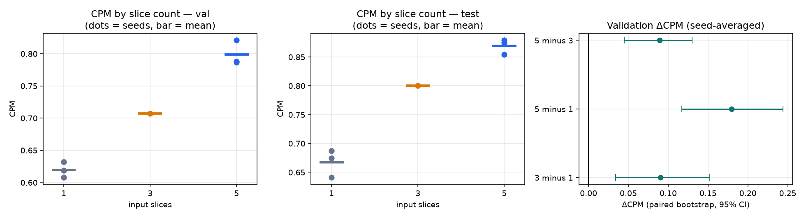
Figure 10: CPM by number of input slices on validation (left) and test (middle); dots are individual seeds. Right: paired-bootstrap differences with 95% intervals.
Table 17: Sensitivity at 1 false positive per scan, by nodule size (validation, mean over seeds)
Nodule size | Nodules | 1 slice | 3 slices | 5 slices
<6 mm | 45 | 0.578 | 0.711 | 0.844
6-10 mm | 34 | 0.520 | 0.618 | 0.745
≥10 mm | 39 | 0.846 | 0.897 | 0.880
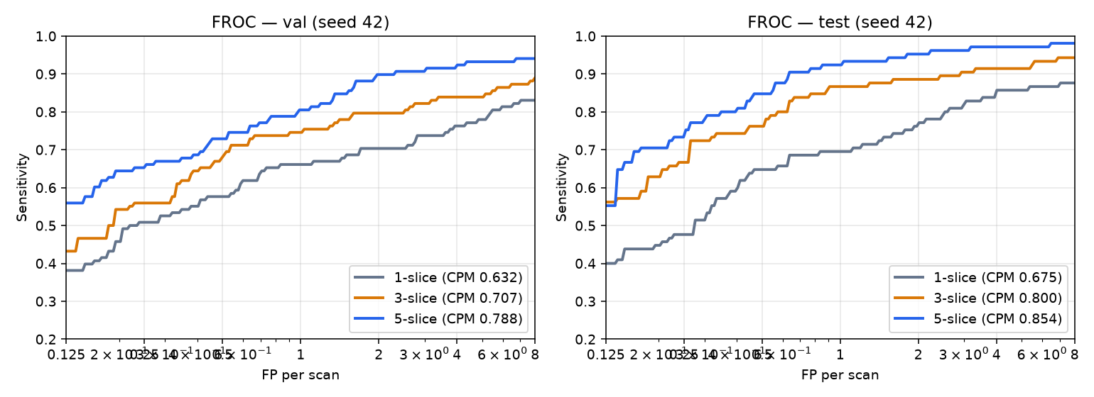
Figure 11: FROC curves (seed 42) of the 1-, 3- and 5-slice CNNs on validation and test.
Findings — Gate 2 passed
- Every 5-slice run beats every 1-slice run. The improvement is monotone (1 < 3 < 5), established by the bootstrap, and confirmed on the test split (+0.20).
- It is concentrated in small and medium nodules (<6 mm: 0.58 → 0.84; 6–10 mm: 0.52 → 0.75); large nodules are found equally well by all (≈ 0.85–0.88) — exactly what the Phase 5 analysis predicted.
- It costs almost nothing: +576 parameters (+0.2%) and +4.5% FLOPs, because only the first convolution grows.
- Because the trend is still rising at 5 slices, even wider context (7 slices, or a larger spacing between slices) might help; this was not tested (it needs a new patch cache).

Phase 7 — Adding a Transformer
Goal | Test whether Transformer-based context modelling improves on the 5-slice CNN.
Input | The 5-slice CNN’s final feature map.
Output | EXP-003 (CNN + Transformer) and EXP-003c (capacity-matched control), 3 seeds each.
Result | No measurable gain (validation 0.774 vs 0.799); the control does equally well.

How the Transformer is attached
The CNN’s last feature map (128 channels, 4×4 positions) is turned into 16 tokens of 128 numbers (one per position). Learned position embeddings tell the model where each token came from. Two standard pre-norm Transformer encoder layers (4 attention heads, MLP ratio 2, dropout 0.1) let every token look at every other token. The result is reshaped back to a 4×4 map and the unchanged detection head is applied. Only the Transformer is added — nothing else differs from the 5-slice CNN (training settings identical).
Why a control was needed
The Transformer adds about 267,000 parameters — nearly doubling the model (302,804 → 570,068). If it had helped, we would not know whether the attention mechanism or simply the extra capacity was responsible. The control (EXP-003c) replaces the Transformer by two plain residual 3×3 convolution blocks with a similar parameter count (598,228).

Table 18: Phase 7 results (3 seeds each; mean ± std)
Model | Validation CPM | Test CPM | Parameters | MFLOPs | MPS latency, batch 256 (ms)
CNN (5 slices) | 0.799 ± 0.019 | 0.869 ± 0.013 | 302,804 | 109.7 | 25.1
CNN + Transformer | 0.774 ± 0.005 | 0.842 ± 0.027 | 570,068 | 118.4 | 31.5
CNN + extra conv (control) | 0.791 ± 0.003 | 0.839 ± 0.015 | 598,228 | 119.2 | 27.0
Table 19: Paired bootstrap differences in CPM (95% interval)
Comparison | Validation ΔCPM [95% CI] | Test ΔCPM [95% CI]
Transformer − CNN | -0.024 [-0.061, +0.009] | -0.025 [-0.059, +0.007]
Transformer − control | -0.019 [-0.052, +0.011] | +0.003 [-0.025, +0.028]
Control − CNN | -0.005 [-0.032, +0.019] | -0.028 [-0.055, -0.002]
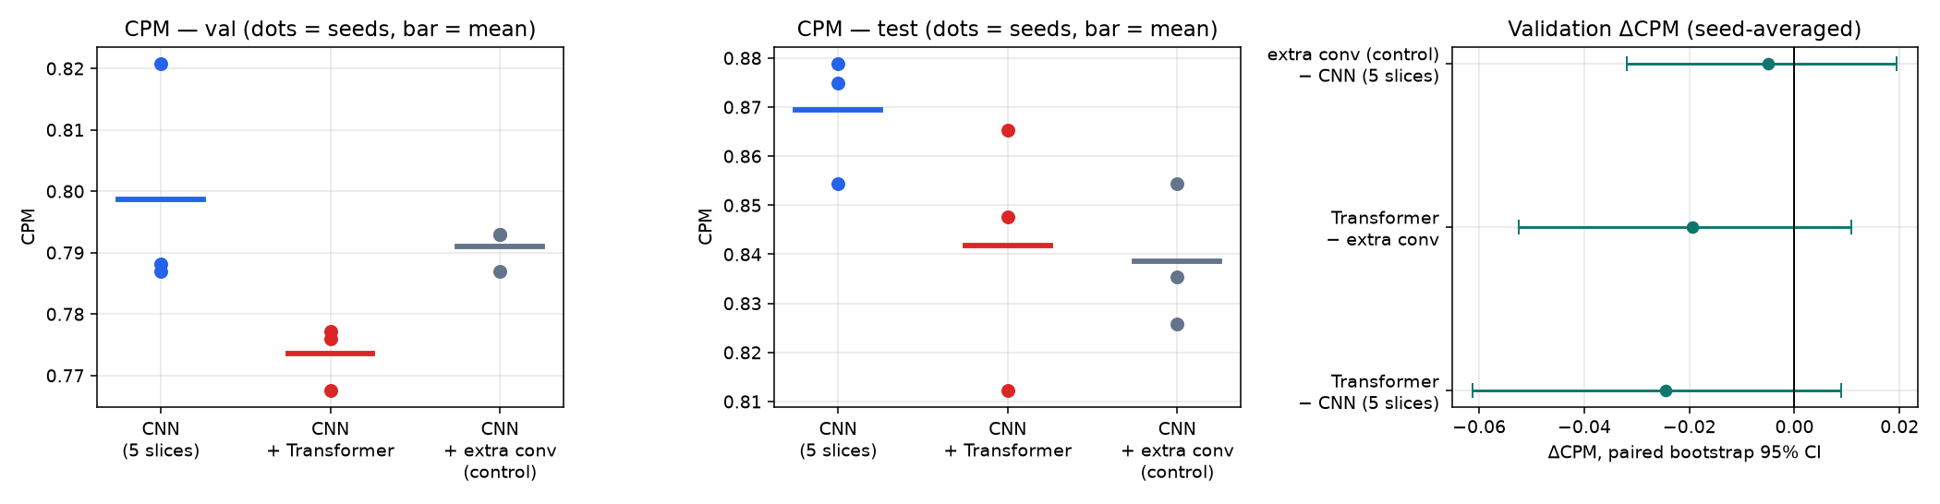
Figure 12: CPM of the CNN, CNN + Transformer and the capacity-matched control (validation, test) and the paired differences.
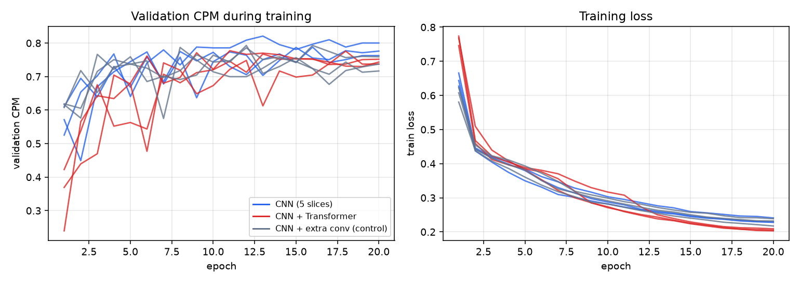
Figure 13: Validation CPM (left) and training loss (right) for all runs. The Transformer starts slowly but catches up by epoch ~5; it ends with the lowest training loss yet no better validation score.
Findings — Gate 3: not shown to be useful
- The Transformer is not better than the CNN (Δ = −0.024, interval includes 0) and not better than the control; extra parameters at this size do not help either.
- It costs +88% parameters and about +25% measured latency for no gain.
- Why might this be? (hypotheses — not tested): (1) the CNN’s receptive field (76 px) already covers the whole 64-px patch, leaving little long-range context to add; (2) a 4×4 grid gives only 16 tokens; (3) the task is classifying small centred patches, unlike the full-slice problems where Transformer gains are usually reported; (4) about 1,200 positives is little data for a model with fewer built-in image priors, and a learning rate tuned for the CNN with no warm-up may disadvantage it; (5) part of reported Transformer gains in the literature may be capacity, which the control exposes.
- Untested variants that could change this: attention on a finer (8×8) feature map from an earlier stage, a lower learning rate with warm-up, longer training.

Phase 8 — Attention modules (SE and CBAM)
Goal | Test whether lightweight attention improves the 5-slice CNN.
Input | The 5-slice CNN.
Output | EXP-004: CNN + SE and CNN + CBAM, 3 seeds each; attention-map analysis; first memory measurements.
Result | No measurable accuracy gain; CBAM adds up to +89% latency.

Table 20: The two attention types (both inserted after every CNN stage, before pooling)
Module | How it works | Extra parameters
SE (Squeeze-and-Excitation, channel attention) | Average each feature channel over the whole patch, pass the numbers through a small two-layer network, and multiply every channel by a learned 0–1 gate. | +11,180 (+3.7%)
CBAM (channel + spatial attention) | A channel gate (from both average- and max-pooled descriptors) followed by a spatial gate: a 7×7 convolution produces a 0–1 map over positions that multiplies the features. | +11,576 (+3.8%)

Table 21: Phase 8 results (3 seeds each; mean ± std; the Transformer is shown for context)
Model | Validation CPM | Test CPM | Sens. @1 FP (val)
CNN (5 slices) | 0.799 ± 0.019 | 0.869 ± 0.013 | 0.828
CNN + SE | 0.785 ± 0.006 | 0.852 ± 0.019 | 0.814
CNN + CBAM | 0.800 ± 0.008 | 0.849 ± 0.005 | 0.825
CNN + Transformer | 0.774 ± 0.005 | 0.842 ± 0.027 | 0.816
Table 22: Paired bootstrap differences in CPM (95% interval)
Comparison | Validation ΔCPM [95% CI] | Test ΔCPM [95% CI]
SE − CNN | -0.014 [-0.035, +0.009] | -0.014 [-0.041, +0.012]
CBAM − CNN | +0.002 [-0.021, +0.029] | -0.019 [-0.053, +0.014]
CBAM − SE | +0.016 [-0.008, +0.038] | -0.005 [-0.029, +0.021]
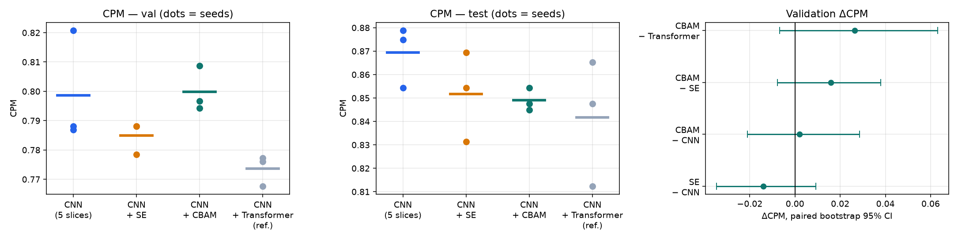
Figure 14: CPM of the CNN, +SE, +CBAM and the Transformer reference (validation and test; dots are seeds) and paired differences.

The cost of attention (measured on an otherwise idle machine)
Table 23: Efficiency of the models (per 64×64×5 patch; latency = median of 3 interleaved rounds)
Model | Parameters | MFLOPs | Activation memory (MB) | CPU, batch 1 (ms) | CPU, batch 256 (ms) | MPS, batch 256 (ms)
CNN (5 slices) | 302,804 | 109.7 | 3.07 | 2.03 | 166.8 | 24.5
CNN + SE | 313,984 | 109.7 | 3.08 | 2.05 | 175.5 | 31.5
CNN + CBAM | 314,380 | 110.8 | 3.10 | 2.53 | 198.1 | 46.3
CNN + Transformer | 570,068 | 118.4 | 3.32 | 2.52 | 183.1 | 30.9

FLOPs barely change, yet CBAM nearly doubles GPU latency (24.5 → 46.3 ms): many tiny pooling and gating operations are slow on the Apple GPU. This is a direct example of FLOPs ≠ latency.

What does attention attend to?
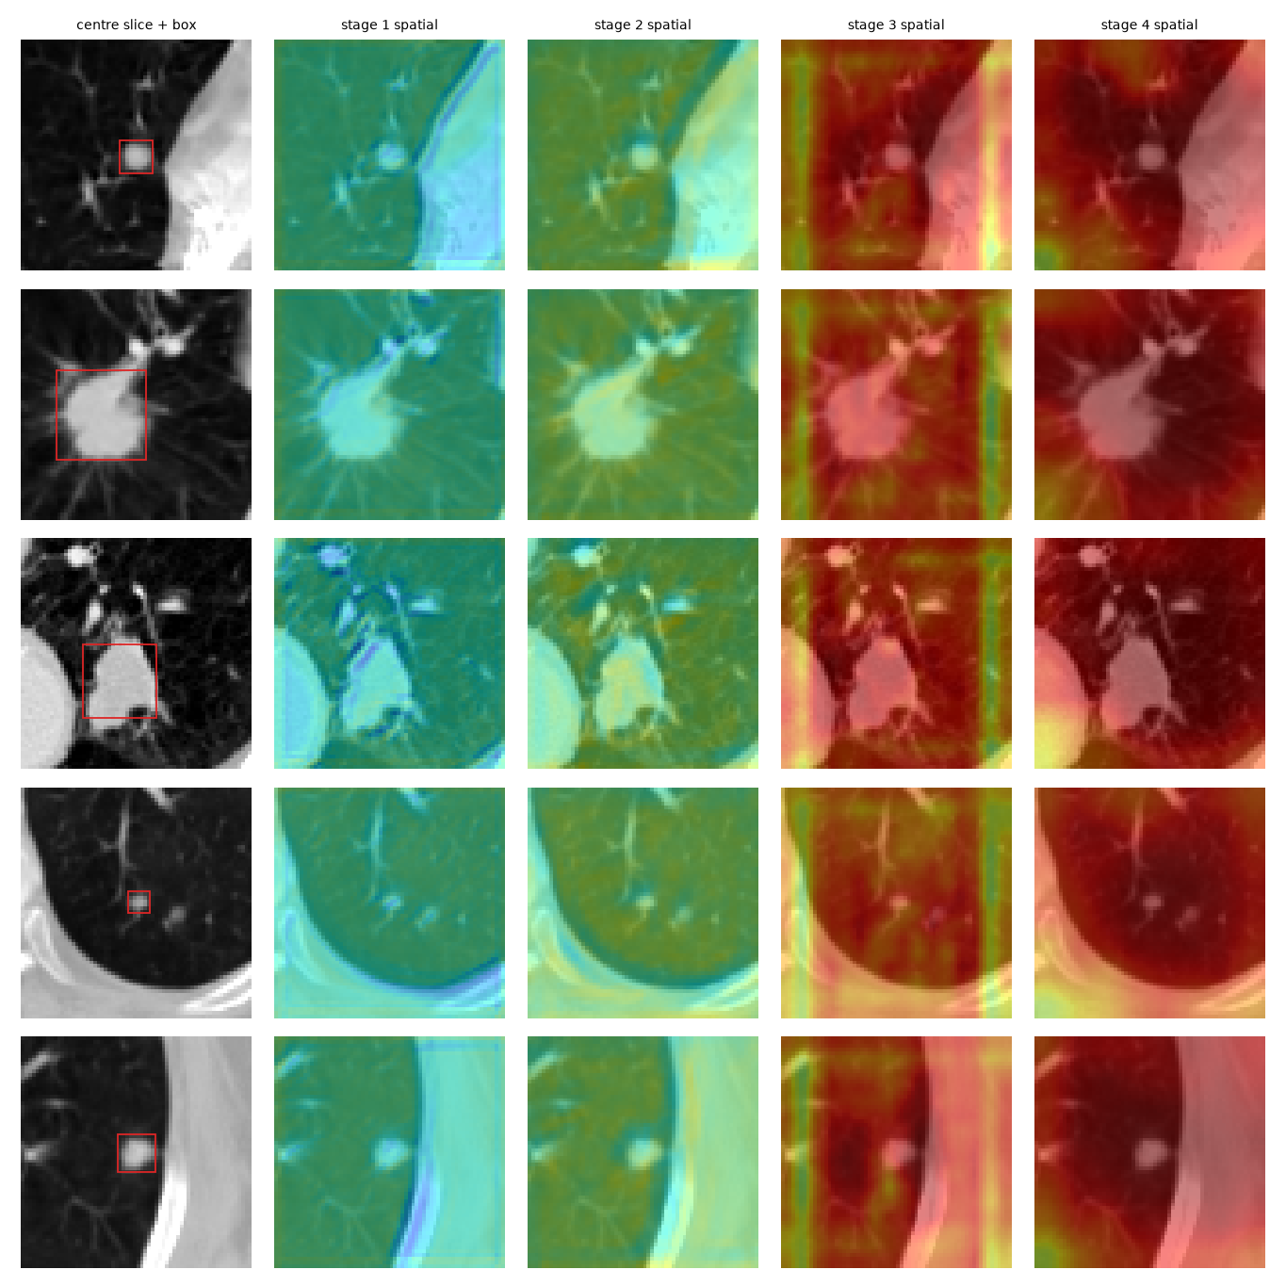
Figure 15: CBAM spatial-attention maps (stages 1–4, overlaid on the centre slice) for five validation nodules (red box = nodule). Early stages follow tissue density; later stages are nearly saturated.
Findings — Gate 4: no measurable value in this configuration
- Neither SE (−0.014, interval −0.035 … +0.009) nor CBAM (+0.002, interval −0.021 … +0.029) is distinguishable from the plain CNN on validation; on test both are slightly lower.
- The spatial attention mostly follows tissue density (chest wall and mediastinum light up as much as the nodule); deeper stages are almost saturated with only 8–11% more weight inside the nodule box. Channel gates differ between nodules and non-nodules mainly at the deepest stage. This is descriptive evidence, not proof of mechanism.
- The plain CNN already captures what these gates could add; the cost is parameters and, for CBAM, latency.

Phase 9 — Progressive pruning of every model
Goal | Study whether the models can be made smaller and faster without losing accuracy — separately for each of the five variants — and check whether “fewer weights” really means “faster”.
Input | The trained seed-42 checkpoint of each model (CNN, +SE, +CBAM, +Transformer, +extra-conv control).
Output | EXP-005: 11 pruning runs (5 models × 2 methods + a no-pruning control), 55 pruned-and-fine-tuned networks, measured latency of each.
Result | Unstructured pruning keeps accuracy to ~85% sparsity but gives no speed-up; structured pruning gives real speed-ups at a larger accuracy cost.

The two pruning methods
Table 24: Unstructured versus structured pruning
 | Unstructured (weight) pruning | Structured (channel) pruning
What is removed | Individual weights with the smallest magnitude, chosen with one global threshold across all convolution/linear layers; a mask keeps them at zero. | Whole convolution channels, ranked by importance (filter L1 norm × batch-norm scale); the network is then physically rebuilt smaller.
Levels (progressive, cumulative) | Sparsity 30 / 50 / 70 / 85 / 95% | Channels removed 20 / 40 / 55 / 70 / 80% (≈ 27 / 50 / 65 / 78 / 85% fewer parameters in the CNN)
Network shape afterwards | Unchanged (most weights are zero) | Genuinely smaller and cheaper
Expected hardware effect | None on dense kernels (needs sparse kernels to help) | Fewer operations → faster
Not pruned | Final output layers, biases, batch-norm | The last CNN stage, the Transformer / extra-conv module, the head (so these two models cannot shrink as far)
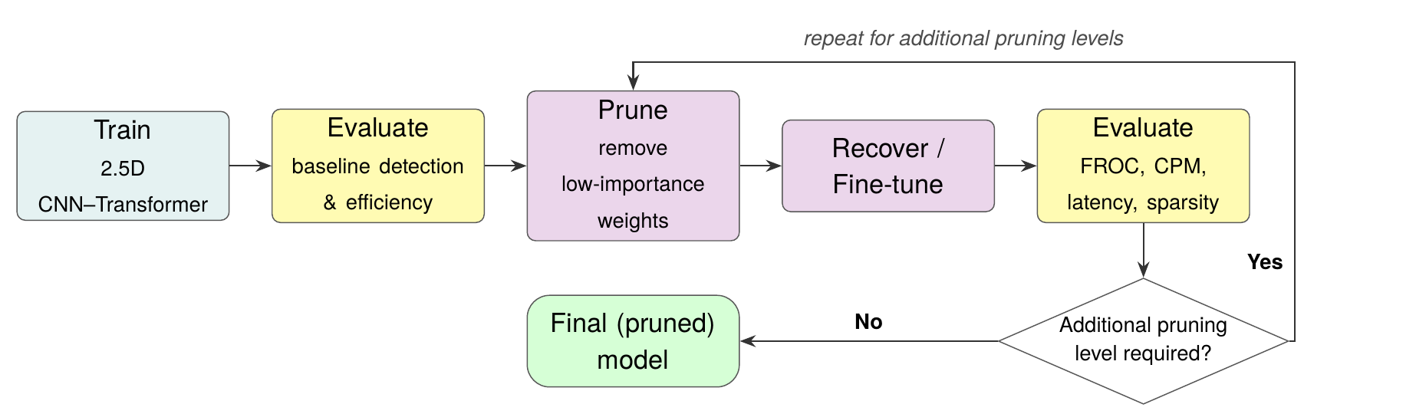
Figure 16: The progressive pruning cycle from the project report: prune low-importance parts, recover by fine-tuning, evaluate, and repeat for further levels.

Protocol (fixed before any result was seen)
- Per level: prune → fine-tune for 4 epochs (AdamW, learning rate 3e-4, cosine; the best-validation epoch is kept) → evaluate on validation and test. Each level starts from the previous one, which makes it progressive. The same settings are used for every model and method.
- Control: the plain CNN is also fine-tuned for the same 5 × 4 epochs with no pruning, to separate the effect of pruning from the effect of extra training.
- Selection rule (written before the results): the final model for a method is the most-pruned level whose validation CPM is within 0.02 of the unpruned model’s. The test split is never used to choose.
- Latency of all 66 checkpoints was re-measured afterwards on an idle machine (median of three interleaved rounds); unstructured zeros run on ordinary dense kernels.
Table 25: Plain 5-slice CNN, seed 42: every pruning level (effective MFLOPs for unstructured = if zeros were skipped by a perfect sparse kernel)
Method / level | Target | Non-zero parameters | Reduction | Eff. MFLOPs | Val CPM | Test CPM | MPS-256 (ms) | CPU-1 (ms)
Dense (unpruned) | — | 302,762 | — | 109.7 | 0.788 | 0.854 | 24.4 | 1.56
Unstructured L1 | 30% sparse | 212,306 | 30% | 81.8 | 0.772 | 0.844 | 24.4 | 1.67
Unstructured L2 | 50% sparse | 152,002 | 50% | 62.5 | 0.758 | 0.829 | 24.7 | 1.52
Unstructured L3 | 70% sparse | 91,701 | 70% | 41.8 | 0.772 | 0.846 | 24.7 | 1.57
Unstructured L4 | 85% sparse | 46,479 | 85% | 24.2 | 0.759 | 0.845 | 24.5 | 1.57
Unstructured L5 | 95% sparse | 16,339 | 95% | 10.2 | 0.741 | 0.790 | 24.5 | 1.56
Structured L1 | 20% channels | 220,191 | 27% | 75.1 | 0.746 | 0.852 | 22.1 | 1.43
Structured L2 | 40% channels | 149,993 | 50% | 45.9 | 0.723 | 0.829 | 17.6 | 1.29
Structured L3 | 55% channels | 105,625 | 65% | 27.9 | 0.706 | 0.762 | 13.0 | 1.00
Structured L4 | 70% channels | 65,975 | 78% | 15.4 | 0.614 | 0.641 | 10.1 | 0.89
Structured L5 | 80% channels | 44,955 | 85% | 9.1 | 0.573 | 0.619 | 7.2 | 0.73

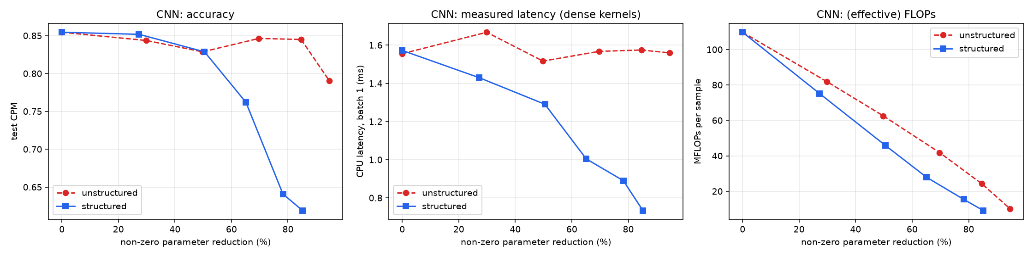
Figure 17: Plain CNN, both methods. Left: test CPM. Middle: measured CPU latency — flat for unstructured (red), falling for structured (blue). Right: (effective) FLOPs — falls for both, but only structured pruning turns FLOPs into speed.
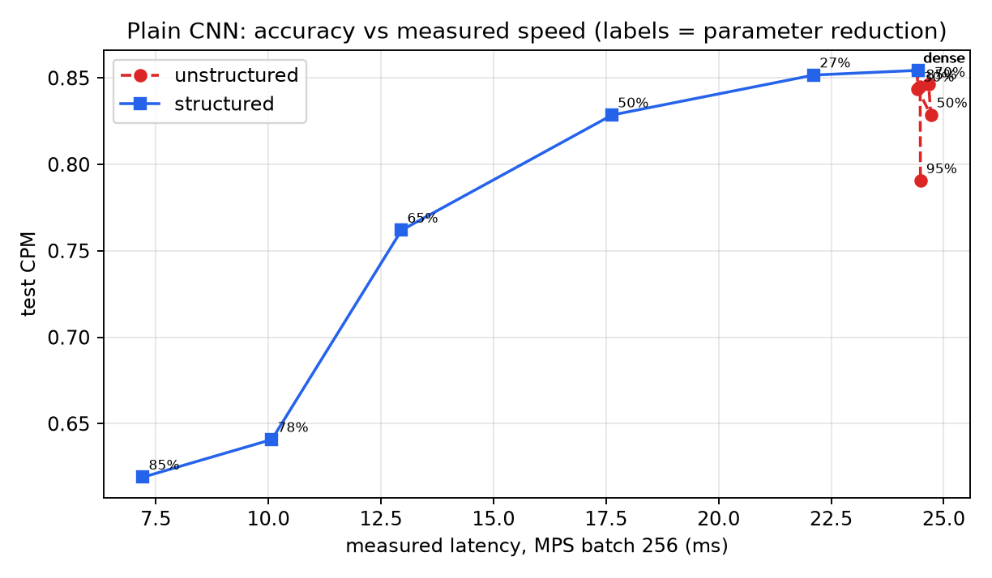
Figure 18: The trade-off in one picture for the plain CNN: test CPM against measured GPU latency. Unstructured pruning moves straight down in accuracy only at the extreme; structured pruning buys speed at an increasing accuracy price.

Do all models behave the same?
Table 26: Test CPM by model across unstructured levels (L1…L5 = 30 / 50 / 70 / 85 / 95% sparsity)
Model | Dense | L1 | L2 | L3 | L4 | L5
CNN | 0.854 | 0.844 | 0.829 | 0.846 | 0.845 | 0.790
+ CBAM | 0.854 | 0.824 | 0.852 | 0.784 | 0.819 | 0.751
+ SE | 0.869 | 0.864 | 0.844 | 0.829 | 0.850 | 0.709
+ Transformer | 0.848 | 0.852 | 0.848 | 0.831 | 0.808 | 0.732
+ extra conv | 0.826 | 0.823 | 0.822 | 0.790 | 0.820 | 0.803

Table 27: Test CPM by model across structured levels (L1…L5 = 20 / 40 / 55 / 70 / 80% channels removed; in brackets the parameter reduction achieved)
Model | Dense | L1 | L2 | L3 | L4 | L5
CNN | 0.854 | 0.852  (−27%) | 0.829  (−50%) | 0.762  (−65%) | 0.641  (−78%) | 0.619  (−85%)
+ CBAM | 0.854 | 0.823  (−27%) | 0.763  (−49%) | 0.786  (−63%) | 0.657  (−76%) | 0.639  (−83%)
+ SE | 0.869 | 0.845  (−27%) | 0.799  (−49%) | 0.718  (−63%) | 0.623  (−76%) | 0.521  (−83%)
+ Transformer | 0.848 | 0.835  (−14%) | 0.773  (−27%) | 0.754  (−35%) | 0.680  (−42%) | 0.563  (−45%)
+ extra conv | 0.826 | 0.797  (−14%) | 0.773  (−26%) | 0.737  (−33%) | 0.648  (−40%) | 0.622  (−43%)

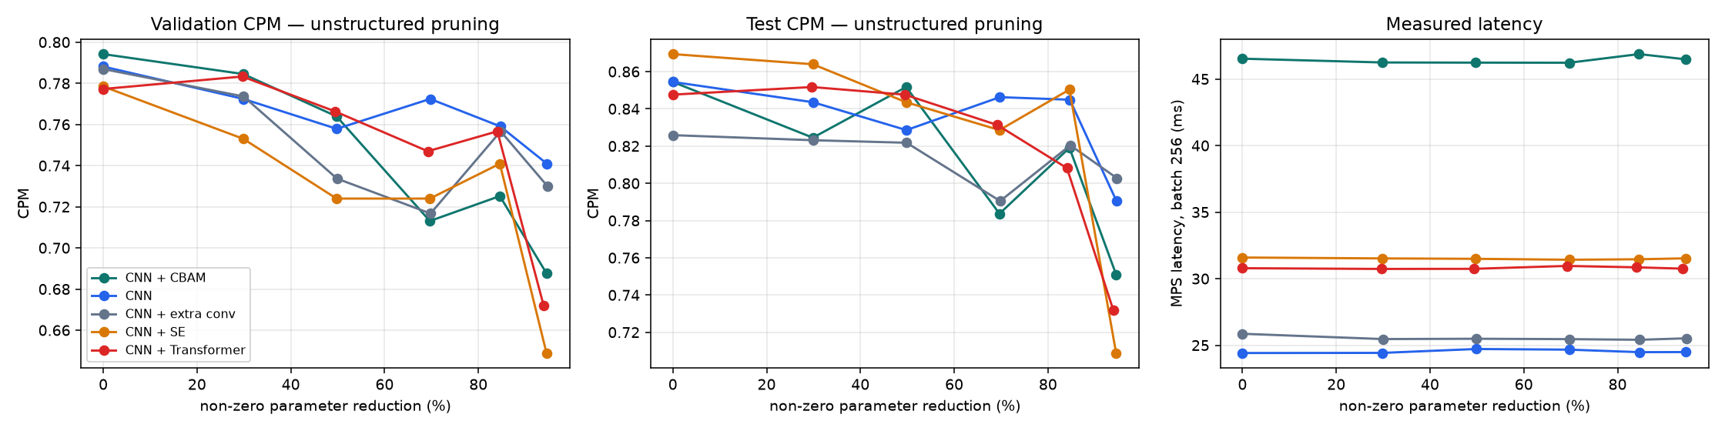
Figure 19: All five models, unstructured pruning: validation CPM (left), test CPM (middle) and measured latency (right) against non-zero parameter reduction. Latency is flat.
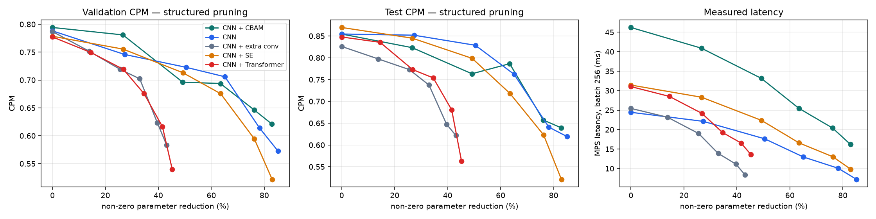
Figure 20: All five models, structured pruning. Latency falls steadily with parameter reduction; the Transformer and extra-conv models stop at ≈45% because their unpruned module holds much of their parameters.

The pre-registered selection
Table 28: Selected level per model and method (rule fixed in advance; validation only). “—” = no level met the rule
Model | Method | Selected | Param. reduction | Val CPM (ref → pruned) | Test CPM (ref → pruned) | Test ΔCPM [95% CI]
+ CBAM | structured | L1 (20%) | 27% | 0.794 → 0.781 | 0.854 → 0.823 | -0.029 [-0.061, +0.001]
+ CBAM | unstructured | L1 (30%) | 30% | 0.794 → 0.785 | 0.854 → 0.824 | -0.035 [-0.064, -0.005]
CNN | structured | — | — | — | — | —
CNN | unstructured | L3 (70%) | 70% | 0.788 → 0.772 | 0.854 → 0.846 | -0.018 [-0.050, +0.018]
+ extra conv | structured | — | — | — | — | —
+ extra conv | unstructured | L1 (30%) | 30% | 0.787 → 0.774 | 0.826 → 0.823 | +0.000 [-0.031, +0.035]
+ SE | structured | — | — | — | — | —
+ SE | unstructured | — | — | — | — | —
+ Transformer | structured | — | — | — | — | —
+ Transformer | unstructured | L2 (50%) | 49% | 0.777 → 0.766 | 0.848 → 0.848 | -0.004 [-0.047, +0.032]

A caveat about the selection rule — the control
The rule compares each pruned level with the unpruned model, whose checkpoint was picked as the best of 20 epochs on validation — a built-in selection advantage that any later training cannot match. The no-pruning control shows this clearly:
Table 29: Plain CNN: each pruned level versus the no-pruning fine-tune control at the same stage (post-hoc analysis; NOT part of the pre-registered rule)
Method | Level | Val CPM | Control val | Val Δ vs control [95% CI] | Test CPM | Control test | Test Δ vs control [95% CI]
unstructured | L1 | 0.772 | 0.783 | -0.007 [-0.024, +0.009] | 0.844 | 0.833 | +0.007 [-0.008, +0.022]
unstructured | L2 | 0.758 | 0.776 | -0.030 [-0.059, -0.002] | 0.829 | 0.822 | +0.003 [-0.021, +0.024]
unstructured | L3 | 0.772 | 0.781 | -0.008 [-0.030, +0.015] | 0.846 | 0.842 | +0.002 [-0.029, +0.034]
unstructured | L4 | 0.759 | 0.755 | +0.012 [-0.024, +0.050] | 0.845 | 0.831 | +0.010 [-0.026, +0.046]
unstructured | L5 | 0.741 | 0.753 | -0.014 [-0.064, +0.034] | 0.790 | 0.824 | -0.033 [-0.093, +0.022]
structured | L1 | 0.746 | 0.783 | -0.028 [-0.059, +0.000] | 0.852 | 0.833 | +0.007 [-0.020, +0.037]
structured | L2 | 0.723 | 0.776 | -0.059 [-0.099, -0.022] | 0.829 | 0.822 | +0.004 [-0.031, +0.038]
structured | L3 | 0.706 | 0.781 | -0.074 [-0.126, -0.023] | 0.762 | 0.842 | -0.082 [-0.130, -0.032]
structured | L4 | 0.614 | 0.755 | -0.138 [-0.201, -0.071] | 0.641 | 0.831 | -0.199 [-0.268, -0.131]
structured | L5 | 0.573 | 0.753 | -0.182 [-0.250, -0.115] | 0.619 | 0.824 | -0.202 [-0.278, -0.116]

Findings — Gate 5
- Unstructured pruning is almost free in accuracy up to ~85% sparsity (plain CNN test CPM 0.854 → 0.846 at 70%, 0.845 at 85%) and collapses at 95% for every model. Against the control the differences are within noise through 85%.
- It gives no speed-up. At 95% sparsity the CNN has 95% fewer non-zero weights and ~10× fewer effective FLOPs, yet runs in 24.4 ms (GPU, batch 256) and ~1.6 ms (CPU, batch 1) — the same as the dense model. Real gains would need sparse kernels/hardware, which were not evaluated.
- Structured pruning is genuinely faster: −9% latency at −27% parameters, −28% at −50%, −47% at −65%, −70% at −85%. But accuracy falls sooner: clear loss versus the control from about −65% parameters, and an unresolved small loss at 20–40% (validation and test disagree).
- Models differ in how far structured pruning can go (CNN family −85%; Transformer and extra-conv ≈ −45%). No model is a consistent winner under unstructured pruning.
- The pre-registered rule selects: CNN unstructured 70% (test 0.846 vs 0.854, Δ −0.018, interval includes 0); CBAM, extra-conv and Transformer at lighter unstructured levels; no level for SE nor for structured CNN / Transformer / extra-conv. The rule proved stricter than intended (the unpruned control would itself fail it at later levels); it was kept as pre-registered and the control analysis is reported separately and labelled post-hoc.
- One seed per model and method; differences below ≈ 0.03 CPM are not resolved.

6. Catalogue of models
All models share the same patches, splits, loss and training recipe; only the named component differs. The block diagram below shows how each variant is built from the same pieces.
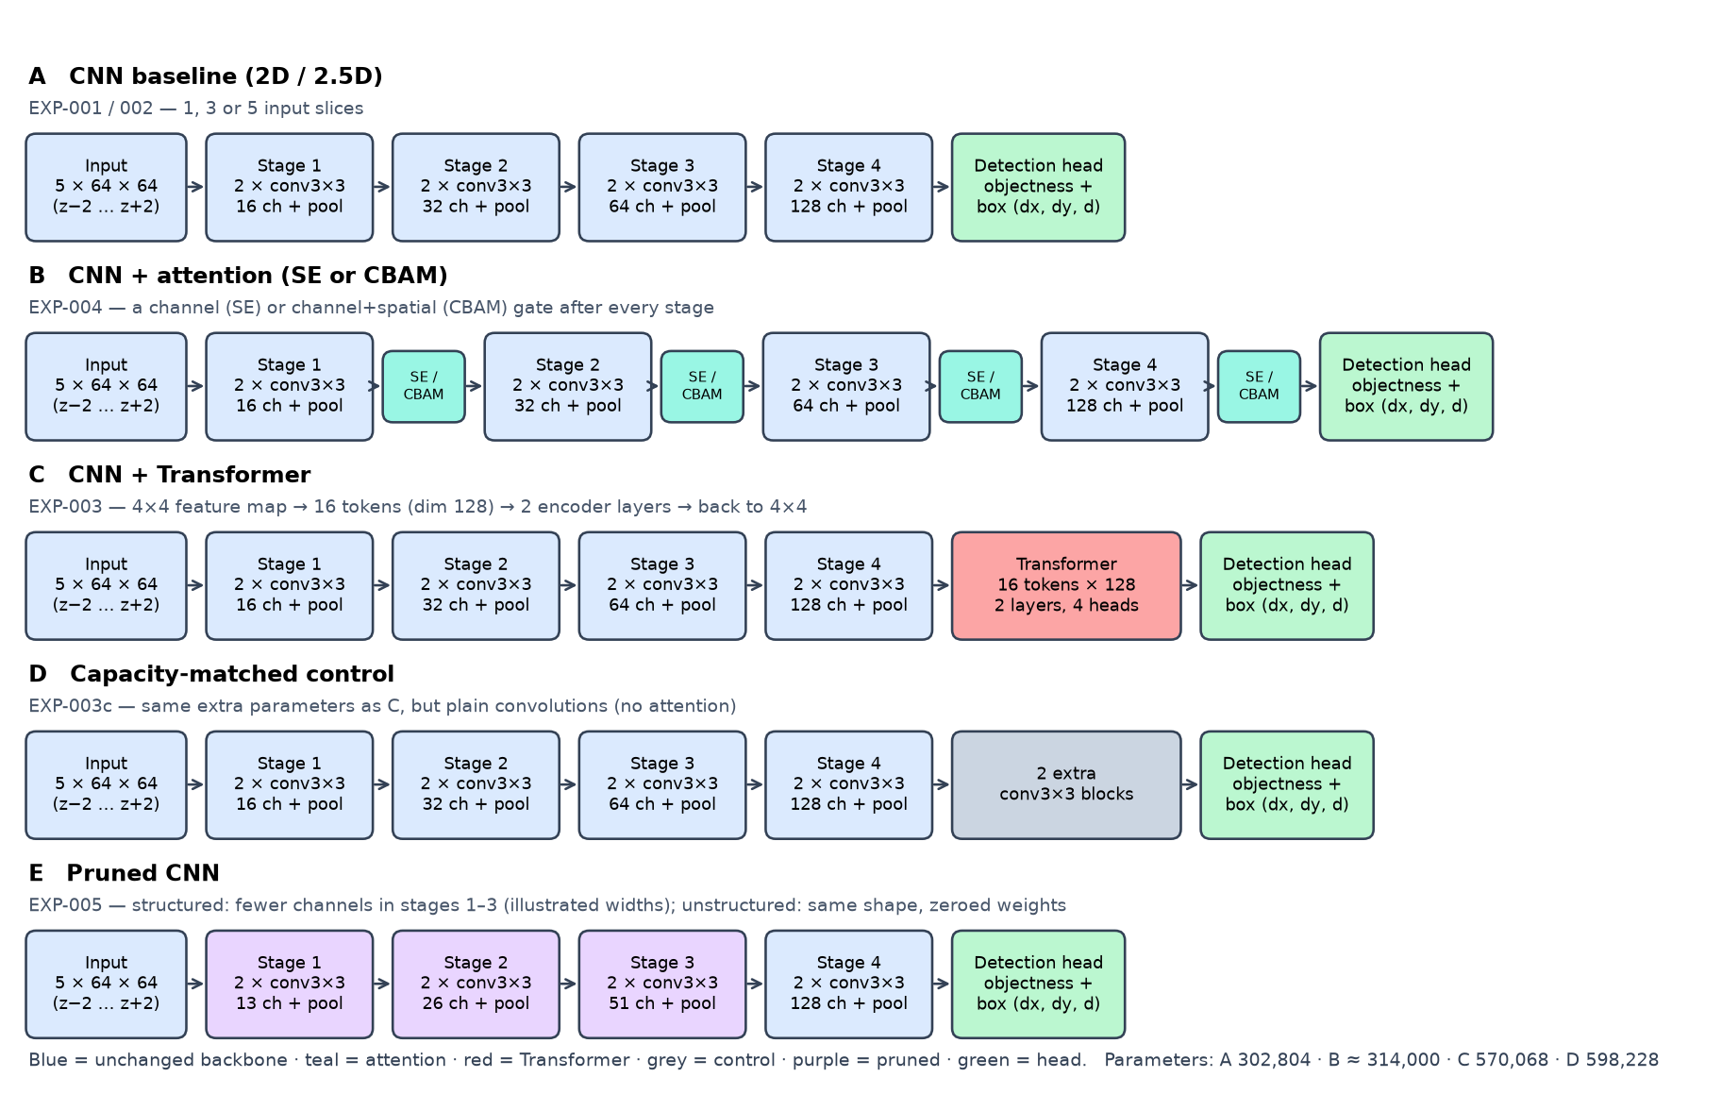
Figure 21: The model variants. A: CNN baseline (1, 3 or 5 input slices). B: attention gates after every stage. C: Transformer on the final feature map. D: capacity-matched plain-convolution control. E: pruned CNN.
Table 30: Every model built in Phases 4–9 (validation chooses; test is reported; mean ± std over 3 seeds unless noted)
Experiment | Model | Input slices | Parameters | MFLOPs | Val CPM | Test CPM | Role
EXP-001/002 | 2D CNN | 1 | 302,228 | 105.0 | 0.619 ± 0.012 | 0.668 ± 0.024 | E0: 2D reference
EXP-002 | 2.5D CNN | 3 | 302,516 | 107.4 | 0.707 (1 seed) | 0.800 (1 seed) | Slice-count study
EXP-002 | 2.5D CNN | 5 | 302,804 | 109.7 | 0.799 ± 0.019 | 0.869 ± 0.013 | E1: main reference
EXP-003 | CNN + Transformer | 5 | 570,068 | 118.4 | 0.774 ± 0.005 | 0.842 ± 0.027 | E2
EXP-003c | CNN + extra conv | 5 | 598,228 | 119.2 | 0.791 ± 0.003 | 0.839 ± 0.015 | Capacity control for E2
EXP-004 | CNN + SE | 5 | 313,984 | 109.7 | 0.785 ± 0.006 | 0.852 ± 0.019 | E3a
EXP-004 | CNN + CBAM | 5 | 314,380 | 110.8 | 0.800 ± 0.008 | 0.849 ± 0.005 | E3b
EXP-005 | Pruned CNN, unstructured 70% | 5 | 91,701 non-zero | 41.8 (effective) | 0.772 (seed 42) | 0.846 (seed 42) | E4 candidate: compression
EXP-005 | Pruned CNN, structured ≈ 27% | 5 | 220,191 | 75.1 | 0.746 (seed 42) | 0.852 (seed 42) | E4 candidate: speed

Pruned versions of the SE, CBAM, Transformer and extra-conv models also exist (EXP-005); see Phase 9 and results/tables/phase9_levels.csv.

7. The ablation chain
The core scientific question — “what does each component add?” — is answered by adding one component at a time. The chain planned in the report is E0 → E1 → E2 → E3 → E4. Because the Transformer gave no gain, attention and pruning were applied to the plain 2.5D CNN (E1) rather than stacked on E2; the Transformer remains in the table as a measured negative result.
Table 31: Ablation table — validation CPM and the paired change from the previous/base model
Step | Component added | Val CPM | Change vs base [95% CI] | Parameters | Verdict
E0 | 2D CNN (1 slice) | 0.619 | — | 302,228 | Reference
E1 | + 4 more slices (2.5D, 5 slices) | 0.799 | +0.179 [+0.117, +0.244] vs E0 | 302,804 | Established gain
E2 | + Transformer (on E1) | 0.774 | -0.024 [-0.061, +0.009] vs E1 | 570,068 | No measurable gain; +88% parameters
E3a | + SE attention (on E1) | 0.785 | -0.014 [-0.035, +0.009] vs E1 | 313,984 | No measurable gain
E3b | + CBAM attention (on E1) | 0.800 | +0.002 [-0.021, +0.029] vs E1 | 314,380 | No measurable gain; +89% latency
E4a | + unstructured pruning 70% (on E1, seed 42) | 0.772 | -0.017 [-0.043, +0.006] vs dense | 91,701 non-zero | Accuracy within noise; no speed-up
E4b | + structured pruning ≈ 27% (on E1, seed 42) | 0.746 | −0.042 vs dense (did not meet the rule) | 220,191 | 9% faster; small loss unresolved
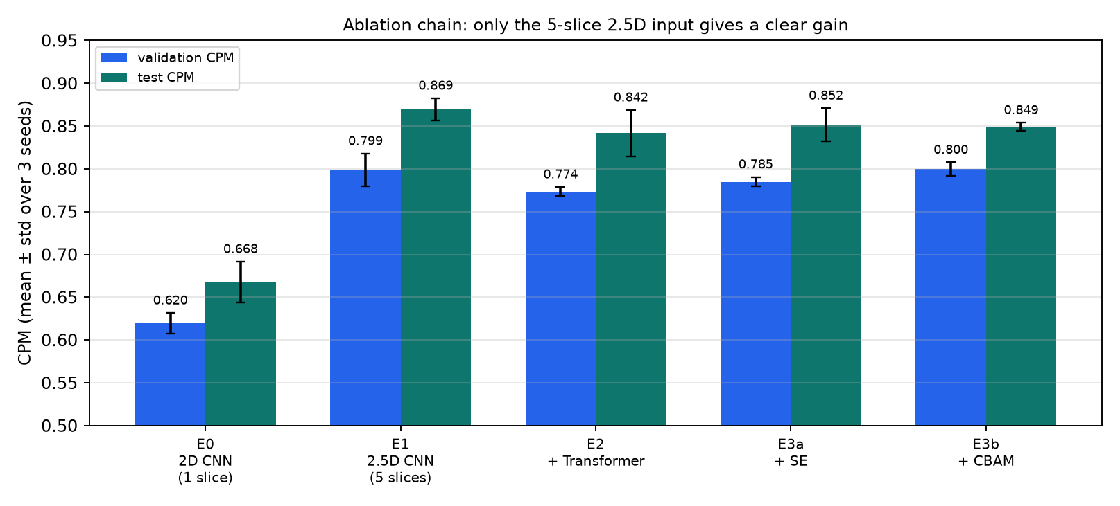
Figure 22: Validation and test CPM along the ablation chain (mean ± std over 3 seeds). The 5-slice input is the only step with a clear gain.
Reading the chain
- What the 2.5D input adds is large and well established. What the Transformer and attention add is not detectable in this setting, and they cost parameters and speed. Pruning trades size or speed against a small, partly unresolved accuracy loss.
- A simple model (a 300k-parameter CNN on five slices) is therefore the strongest and most efficient base found so far. This is a legitimate and publishable-style finding, but it is a finding about this setup (small 64×64 candidate patches, a 300k CNN, one dataset).

8. Have we built a research benchmark?
Short answer
Not yet in the sense of a published benchmark. We have built a careful, reproducible evaluation setup with controlled baselines — a good foundation — but its results cannot be placed on a leaderboard or compared with published LUNA16 numbers, and no “better than state of the art” claim is supported.

8.1 What we do have
- A fixed, leakage-free evaluation protocol (scan-level split, validation for decisions, test for reporting).
- The official LUNA16 FROC/CPM scoring, re-implemented in Python 3 and verified against the organisers’ own example output.
- Controlled baselines for the 2D input, 2.5D input (1/3/5 slices), CNN + Transformer, CNN + attention and pruned models — each with multiple seeds, bootstrap confidence intervals, and the efficiency measurements (parameters, FLOPs, activation memory, measured latency).
- Full reproducibility: configuration files, seeds, per-experiment folders, scripts and ~75 automated tests.
- Controls that most studies omit: a capacity-matched control for the Transformer, a no-pruning fine-tune control for pruning, a pre-registered pruning selection rule, and measured (not assumed) latency.

8.2 What we do not have — and why numbers are not comparable with the literature
Table 32: Differences between this study and a standard LUNA16 benchmark entry
Aspect | This study | Typical published LUNA16 entry
Task evaluated | Re-scoring the provided candidate list (classification + box per candidate patch) | Often a full detection pipeline that finds candidates itself, then reduces false positives
Data split | One fixed split: train subsets 0–7, validation 8, test 9 | Official 10-fold cross-validation over all subsets
Evaluation size | 105 test nodules in 88 scans | All 1,186 nodules across the folds
Candidate ceiling | Candidates V2: maximum sensitivity ≈ 0.96 on our test set | Depends on their own candidate generation
Confidence | 3 seeds + bootstrap; intervals ≈ ±0.03–0.05 CPM | Frequently a single run without intervals

Because of these differences, even a high CPM in this guide (0.87 on our test split for the 5-slice CNN) must not be quoted next to published LUNA16 scores. It is only meaningful relative to the other models evaluated under exactly this protocol.

8.3 What can and cannot be claimed today
Table 33: Claims and the evidence behind them
Claim | Supported? | Evidence / reason
Stacking 5 neighbouring slices improves candidate scoring over 1 slice in this setup | Yes | 3 seeds each; paired-bootstrap ΔCPM +0.18 [+0.12, +0.24] (validation), +0.20 on test; concentrated in small nodules
The gain is largest for small nodules | Yes (this setup) | Sensitivity @1 FP, <6 mm: 0.58 → 0.84; ≥10 mm: 0.85 → 0.88
A Transformer improves detection | No | Δ −0.024 [−0.061, +0.009]; matched control equal; +88% parameters
Attention (SE / CBAM) improves detection | No | Δ −0.014 / +0.002, both intervals include 0
Unstructured pruning removes 70–85% of weights at no resolvable accuracy cost | Yes (one seed) | CNN test 0.854 → 0.846 / 0.845; within noise of the control
Unstructured pruning makes inference faster | No — shown false | Latency identical at every sparsity (dense kernels)
Structured pruning gives real speed-ups | Yes | −28% GPU latency at −50% parameters; accuracy cost grows
This pipeline beats published LUNA16 methods | No claim possible | Different task definition, split and evaluation size (Section 8.2)
Any component is novel | No claim | All components are existing techniques; novelty requires literature review plus evidence (rules.md)
The model is clinically useful | No | Academic research prototype; no clinical validation

8.4 What could become a research contribution
If the remaining phases confirm them with more seeds and a stronger evaluation, the project’s defensible contributions would be empirical findings, not a new architecture: (1) a controlled, uncertainty-quantified study of how much each of four commonly combined components adds for 2.5D nodule candidate scoring; (2) evidence that, at small-patch scale, 2.5D context matters mainly for small nodules while Transformer and attention add nothing beyond capacity; (3) a measured demonstration that sparsity does not translate into speed without structured pruning or sparse kernels. Whether this is publishable is a question for the supervisor and for a literature review.

8.5 How to turn this into a benchmark
- Evaluate with the official 10-fold cross-validation and report the standard CPM so results can sit beside the literature.
- Add a candidate-generation stage to evaluate full detection, or clearly state that the benchmark is candidate re-scoring.
- Add more seeds and an external test set (for example another public CT dataset) to check generalisation.
- Release the configuration files, split definitions and scoring code (already structured for this).

9. Limitations and risks
Table 34: Threats to validity and how each was handled
Limitation | Effect | Mitigation / status
Candidate re-scoring instead of full-scan detection | Not comparable to full detectors; cannot find nodules missed by candidate generation (ceiling ≈ 0.96 sensitivity) | Stated clearly; full detection is future work
One split, small evaluation sets (118 / 105 nodules) | Differences under ~0.03 CPM are not resolvable; validation and test sometimes disagree | Seeds + paired bootstrap; conclusions limited to established differences
3 seeds (1 for the 3-slice model; 1 for each pruning run) | Seed noise is only roughly estimated; pruning results are single-run | Flagged in every table; repeat pruning with more seeds in Phase 14
Transformer: coarse 16-token grid, learning rate tuned for the CNN, 20 epochs | The negative Transformer result may reflect this integration, not Transformers in general | Listed as untested variants; a decision is pending
Best-of-20-epoch checkpoint selection on validation | Validation scores are slightly optimistic; the pruning rule is stricter than intended | Test reported separately; control analysis added (labelled post-hoc)
Latency measured on one machine (Apple M3, MPS and CPU) | Speed conclusions may differ on other hardware (e.g., sparse-capable accelerators) | Hardware and conditions documented; interleaved repeated rounds
Wider context (7 slices / larger stride) untested | The 1 < 3 < 5 trend may continue | Needs a new patch cache; candidate Phase 6 follow-up
Structured pruning excludes the last stage and the Transformer / extra-conv module | Those models shrink less (≈45% vs 85%) | Stated; fully pruning attention layers is a larger task
Single dataset | No evidence of generalisation across scanners or hospitals | External validation is future work
Not a clinical tool | Predictions must not guide diagnosis | Stated in rules.md and the report

10. What remains

10.1 Decisions waiting for the researchers
Table 35: Open decisions
Decision | Options | Recommendation
Final pruned model for Phase 10 (the report’s “final pruned model”) | (A) plain CNN, unstructured 70% sparsity — 70% fewer weights, accuracy within noise, no speed-up; (B) plain CNN, structured ≈ 20–27% — 27% fewer parameters, 9% faster, small loss; (C) combine both (untested) | Report both A and B; use the plain 5-slice CNN as the base. Consider a gentler structured level (~10%) or longer recovery
Whether to try to rescue the Transformer | Test a lower learning rate with warm-up and a finer 8×8 token grid (three single-seed runs ≈ 1.5 h) versus accepting the negative result | Run the three diagnostics before the final report if time permits; otherwise report as is
Evaluation scope | Keep candidate re-scoring, or extend to full detection / 10-fold cross-validation | Keep for the B.Tech. report; list the extension as future work
Wider context | Build a cache with 7 slices or stride 2 and test | Worth testing — the strongest effect found

10.2 Remaining phases
Phase | What it will deliver
10 Complete model | Integrate the validated components into one configuration; train and evaluate the final candidate(s).
11 Ablation study | The final ablation table E0–E4 (Section 7) with more seeds where needed.
12 Efficiency evaluation | Final comparison of parameters, FLOPs, memory, latency, throughput, sparsity under one documented protocol.
13 Error analysis | Missed nodules, false positives, size/location breakdowns, true/false positive examples, confidence distributions.
14 Final experiments | Frozen configuration, final multi-seed runs, preserved logs and checkpoints.
15 Research analysis | Defensible conclusions: what helped, what failed, limitations.
16 Final documentation | Complete report / paper draft, figures, tables.
17 Reproducibility | Verify the whole project can be rebuilt from the repository (environment, data setup, splits, seeds, scripts).

Appendix A — Repository map
Table 36: Where things are (project root: Desktop/BTP)
Path | Contents
prd.md, architecture.md, rules.md, phases.md, design.md, memory.md, README.md | Project documentation (kept in sync with the revised report)
Project_Report.pdf / .docx | The revised project report
configs/ | base.yaml, preprocessing.yaml, experiments/*.yaml (one per experiment family)
data/ | LUNA16 archives (not in Git); metadata/ and splits/ (tracked); processed/ (patch cache, ignored); candidates/ (index, ignored)
src/data, src/preprocessing | Dataset reading, validation, splits; CT preprocessing, 2.5D slicing, patch extraction, candidate index
src/models, src/losses | Backbone (CNN, Transformer, control), attention (SE, CBAM), detection head, detector; detection loss
src/pruning | Unstructured masks, structured channel pruning, schedules, the pre-registered selection rule
src/training, src/evaluation, src/efficiency | Trainer; FROC/CPM, bootstrap; parameters, FLOPs (dense and effective), memory, latency
scripts/ | validate_dataset, build_candidate_index, build_patch_cache, train, evaluate, run_sweep, run_phase7/8/9, prune, compare_*
experiments/ | One folder per experiment: config, history, metrics, FROC curves (checkpoints and logs are git-ignored)
results/ | figures/, tables/, predictions/ (ignored)
notebooks/ | 01 data exploration · 02 preprocessing validation · 03 baseline analysis (Phases 4 and 6) · 04 2.5D validation · 05 model analysis (Phases 7–8) · 06 pruning analysis
tests/ | About 75 automated tests

Appendix B — How to reproduce
All commands are run from the project root after conda activate btp-lung. Large steps are resumable.
Step | Command | Approx. time
Create environment | conda env create -f environment.yml | 10 min
Check environment (CPU + GPU) | python scripts/check_env.py | seconds
Validate the dataset, build splits | python scripts/validate_dataset.py (add --crc for full archive check) | < 1 min (≈ 30 min with --crc)
Build candidate index | python scripts/build_candidate_index.py | ≈ 6 min
Build the patch cache (4.1 GB) | python scripts/build_patch_cache.py | ≈ 18 min
Verify evaluation against the official output | python scripts/validate_evaluation.py | seconds
Verify the 2.5D pipeline | python scripts/validate_25d.py | ≈ 1 min
Train / evaluate one experiment | python scripts/train.py configs/experiments/baseline.yaml baseline  python scripts/evaluate.py experiments/baseline/<EXP> | ≈ 15–40 min
Phase 6 / 7 / 8 / 9 sweeps | python scripts/run_sweep.py · run_phase7.py · run_phase8.py · run_phase9.py | 2 h · 2.7 h · 3.5 h · 5.9 h
Comparison tables and figures | python scripts/compare_experiments.py · compare_phase7.py · compare_phase8.py · compare_phase9.py | minutes
Tests | pytest | < 5 s

Training progress is shown as live progress bars in a terminal and is written as text bars to experiments/<group>/<EXP>/training.log (follow a running job with tail -f).

Appendix C — Glossary
Term | Meaning
CT, slice, voxel | Computed tomography: a 3-D X-ray volume made of 2-D slices; a voxel is a 3-D pixel.
Hounsfield unit (HU) | CT intensity scale: air ≈ −1000, lung ≈ −800, water 0, bone > 300.
LUNA16 | Public lung nodule benchmark: 888 CT scans with annotations and an official evaluation protocol.
Nodule / candidate | A nodule is a small lung lesion. A candidate is a location proposed as a possible nodule; most are false.
2D / 2.5D / 3D | Input of one slice / a few neighbouring slices as channels / a full volume.
CNN | Convolutional neural network: learns local image patterns.
Transformer, self-attention | A network that lets every position look at every other position and weigh them.
SE, CBAM | Squeeze-and-Excitation (channel gating) and Convolutional Block Attention Module (channel + spatial gating).
Focal loss | Classification loss that down-weights easy examples; useful for extreme class imbalance.
IoU | Intersection over Union: overlap between a predicted and a true box.
Sensitivity, false positive (FP) | Fraction of real nodules found; a candidate reported as a nodule that is not one.
FROC, CPM | Sensitivity-versus-false-positives-per-scan curve; the average sensitivity at 1/8, 1/4, 1/2, 1, 2, 4, 8 FP per scan.
Seed | Number that fixes the random start of training; different seeds give slightly different models.
Bootstrap, 95% confidence interval | Resampling the evaluation scans many times to see how much a result varies; a difference is established if its interval excludes 0.
Ablation | Adding or removing one component at a time to see what it contributes.
Pruning (unstructured / structured) | Removing weights / whole channels from a trained network; sparsity = fraction of weights that are zero.
FLOPs / MACs, latency, throughput | Number of arithmetic operations; time per inference; samples per second.
Receptive field | The area of the input that influences one output value.
MPS | Apple’s GPU backend for PyTorch (used on the M3 laptop).
NFD | Nodule Feature Diversity regularisation — part of the earlier plan, removed in the revised report.

Appendix D — Per-run results
Table 37: Phase 6 runs (EXP-001/002)
Experiment | Slices | Seed | Best epoch | Val CPM | Test CPM | Val sens@1
EXP-001-baseline-2d | 1 | 42 | 19 | 0.632 | 0.675 | 0.661
EXP-002-slices1-s43 | 1 | 43 | 16 | 0.619 | 0.687 | 0.653
EXP-002-slices1-s44 | 1 | 44 | 13 | 0.608 | 0.641 | 0.636
EXP-002-slices3-s42 | 3 | 42 | 16 | 0.707 | 0.800 | 0.746
EXP-002-slices5-s42 | 5 | 42 | 16 | 0.788 | 0.854 | 0.805
EXP-002-slices5-s43 | 5 | 43 | 13 | 0.821 | 0.879 | 0.864
EXP-002-slices5-s44 | 5 | 44 | 15 | 0.787 | 0.875 | 0.814

Table 38: Phase 7 runs (EXP-003 / 003c)
Experiment | Seed | Best epoch | Val CPM | Test CPM | Params
EXP-002-slices5-s42 | 42 | 16 | 0.788 | 0.854 | 302,804
EXP-002-slices5-s43 | 43 | 13 | 0.821 | 0.879 | 302,804
EXP-002-slices5-s44 | 44 | 15 | 0.787 | 0.875 | 302,804
EXP-003-cnn-transformer-s42 | 42 | 11 | 0.777 | 0.848 | 570,068
EXP-003-cnn-transformer-s43 | 43 | 13 | 0.768 | 0.812 | 570,068
EXP-003-cnn-transformer-s44 | 44 | 18 | 0.776 | 0.865 | 570,068
EXP-003c-cnn-extraconv-s42 | 42 | 8 | 0.787 | 0.826 | 598,228
EXP-003c-cnn-extraconv-s43 | 43 | 16 | 0.793 | 0.835 | 598,228
EXP-003c-cnn-extraconv-s44 | 44 | 12 | 0.793 | 0.854 | 598,228

Table 39: Phase 8 runs (EXP-004)
Experiment | Seed | Best epoch | Val CPM | Test CPM
EXP-004-attention-se-s42 | 42 | 13 | 0.778 | 0.869
EXP-004-attention-se-s43 | 43 | 10 | 0.788 | 0.854
EXP-004-attention-se-s44 | 44 | 10 | 0.788 | 0.831
EXP-004-attention-cbam-s42 | 42 | 12 | 0.794 | 0.854
EXP-004-attention-cbam-s43 | 43 | 9 | 0.797 | 0.845
EXP-004-attention-cbam-s44 | 44 | 10 | 0.809 | 0.848

