**To connect Oracle/ MySQL for Table creation and Data Manipulation --JDBC**

**Aim :**

Write a simple for connect Oracle for Data Manipulation.

**Procedure**

Step1: Open the notepad.

Step2. Then type the program in the notepad and save in our own folder <mainclassname>.java

Step3. Set the path: set path=” C:\Program Files\Java\jdk1.6.0_20\bin”;

Step4. Set the classpath: set classpath=”C:\Program Files\Java\jdk1.6.0_20\lib”;

Step4. Compile the source progam using javac <mainclassname.java>

Step5. Run the program using applet viewer or Internet Explorer <mainclassname>

**Program**

import java.sql.*;

import java.awt.*;

import java.awt.event.*;

import javax.swing.*;

public class addcus extends JFrame implements ActionListener

{

JTextField id;

JTextField name;

JTextField addr;

JTextField pno;

JTextField job;

JButton next;

JButton addnew;

JPanel p;

static Result res;

static Connection conn;

static Statement stat;

public addcus()

{

Super("our application");

Container c=getContentPane();

c.setLayout(new GridLayout(8,1));

id=new JTextField(20);

name=new JTextField(20);

addr=new JTextField(25);

pno=new JTextField(10);

job=new JTextField(15);

next=new JButton("Next");

p=new JPanel();

c.add(new JLabel("customer id",JLabel.CENTER));

c.add(id);

c.add(new JLabel("Customer name",JLabel.CENTER));

c.add(name);

c.add(new JLabel("Customer address",JLabel.CENTER));

c.add(addr);

c.add(new JLabel(" phone num",JLabel.CENTER));

c.add(pno);

c.add(new JLabel("Job",JLabel.CENTER));

c.add(job);

c.add(p);

p.add(next);

next.addActionListener(this);

setSize(500,500);

setVisible(true);

addWindowListener(new WIN());

}

public static void mian(string args[])

{

addcus c=new addcus();

try

{

Class.forName("sun.jdbc.odbc.jdbcodbcDriver");

conn=DriverManager.getConnection("jdbc:odbc:data1");

stat=conn.CreateStatement();

res=stat.executeQuery("select *from customer");

res.next();

}

catch(Exception e)

{

System.out.println("Error"+e);

}

c.showRecord(res);

}

public void actionPerformed(ActionEvent e)

{

if(e.getSource()==next)

{

try

{

res.next();

}

catch(Exception ee)

{}

showRecord(res0;

}

}

public void showRecord(ResultSet res)

{

try

{

id.setText(res.getString(1));

name.setText(res.getString(2));

addr.setText(res.getString(3));

pno.setText(res.getString(4));

job.setText(res.getString(5));

}

catch(Exception e)

{}

}

class WIN extends WindowAdapter

{

public void windowClosing(windowEvent w)

{

JOptionPane jop=new JOptionPane();

jop.showMessageDialog(null,"Database","thanks",JOptionPane.QUESTION_MESSAGE);

}

}

}

Output:

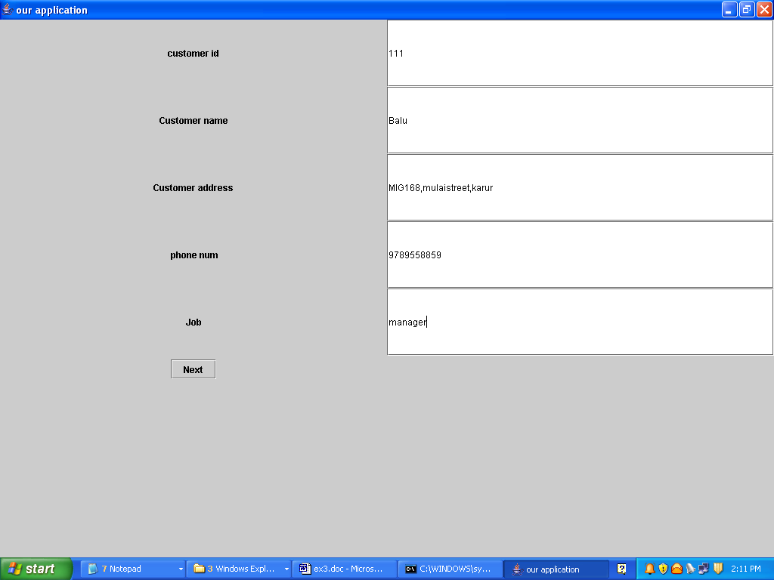

**Conclusion**

Thus the java program was successfully complied and executed and result also verified.