PROJECT REPORT
FOR
Foundations of Artificial Intelligence
RePlate AI: Intelligent Surplus Food Redistribution System Using Classical Artificial Intelligence
A PROJECT REPORT
Submitted by
NAVIN K - 240701353
VISHAL MANAVALAN P - 240701599

October, 2026

BONAFIDE CERTIFICATE
Certified that this project report “RePlate AI: Intelligent Surplus Food Redistribution System Using Classical Artificial Intelligence” is the bonafide work of “VISHAL MANAVALAN(240701599) and NAVIN(240701353)” who carried out the project work under my supervision.

SIGNATURE OF THE FACULTY INCHARGE

Submitted for the Practical Examination held on

SIGNATURE OF THE INTERNAL EXAMINER

TABLE OF CONTENTS
CHAPTER NO. | TITLE | PAGE NO.
 | ABSTRACT | 4
1 | INTRODUCTION | 5
2 | LITERATURE REVIEW | 7
3 | PROPOSED SYSTEM | 9
 | 3.1 ARCHITECTURE DIAGRAM | 11
4 | MODULES DESCRIPTION | 15
 | 4.1 MODULE 1 | 15
 | 4.2 MODULE 2 | 16
 | 4.3 MODULE 3 | 17
 | 4.4 MODULE 4 | 18
 | 4.5 MODULE 5 | 18
5 | IMPLEMENTATION AND RESULTS | 20
 | 5.1 EXPERIMENTAL SETUP | 20
 | 5.2 RESULTS | 21
6 | CONCLUSION AND FUTURE WORK | 30
7 | REFERENCES | 31

ABSTRACT:
Food waste and food insecurity exist side by side. Globally, about 1.3 billion tonnes of edible food is wasted every year, while nearly 828 million people go hungry. In India alone an estimated 68 million tonnes of food is wasted annually. Restaurants, hotels, bakeries, supermarkets and event organisers routinely discard edible surplus because of overproduction or strict expiry policies, while NGOs, orphanages, old-age homes and shelters struggle to provide enough meals. The gap is not one of supply but of coordination: phone calls and messaging groups are too slow for cooked food that spoils within a few hours.
RePlate AI is a food-redistribution platform that connects donors, NGOs and volunteers using classical Artificial Intelligence. Instead of a black-box model, it uses a transparent weighted multi-criteria decision-making algorithm that scores every eligible NGO on six factors: geographic distance, demand alignment, expiry urgency, storage capacity, dietary compatibility and historical reliability. A constraint-satisfaction filter first removes NGOs that cannot legally or practically accept the food, and the remaining NGOs are ranked by a weighted sum. Every score can be broken down factor by factor, so each decision is auditable and explainable.
The system is a three-tier full-stack application. A React and TypeScript frontend provides four role-specific dashboards (Donor, NGO, Volunteer and Admin). A Node.js and Express backend, with Firebase Firestore as the data layer and JWT-based authentication, hosts the matching engine, and Socket.IO supports real-time volunteer tracking. Leaflet maps show pickups, drop-offs and routes, and an optional Python FastAPI microservice is provided as an extension point for the AI layer.
The system was evaluated on a seeded Bengaluru dataset of donors, NGOs and volunteers. For a representative donation of 75 cooked meals the engine ranked five NGOs and returned a top match score of 92.2%, with an average matching time of 187 ms. All ten functional test cases covering the full flow from donation creation to delivery proof passed.

1. INTRODUCTION

1.1 Background
The United Nations Sustainable Development Goal 12.3 calls for halving per-capita global food waste by 2030, while Goal 2 aims at zero hunger (United Nations, 2015). The two goals are closely linked, because the food that is wasted could feed the people who need it. Connecting them, however, demands rapid and accurate coordination at scale.
Traditional donation depends on phone calls and group messages. A restaurant manager with surplus food must call several NGOs, describe the food, negotiate quantities and arrange transport, hoping that the recipient arrives before the food spoils. NGOs, in turn, keep manual call logs, and volunteers cannot see which donations need transport. The result is a process that fails under time pressure: the most urgent donations, such as cooked food that expires in two hours, are often wasted because the coordination takes longer than the shelf life of the food.
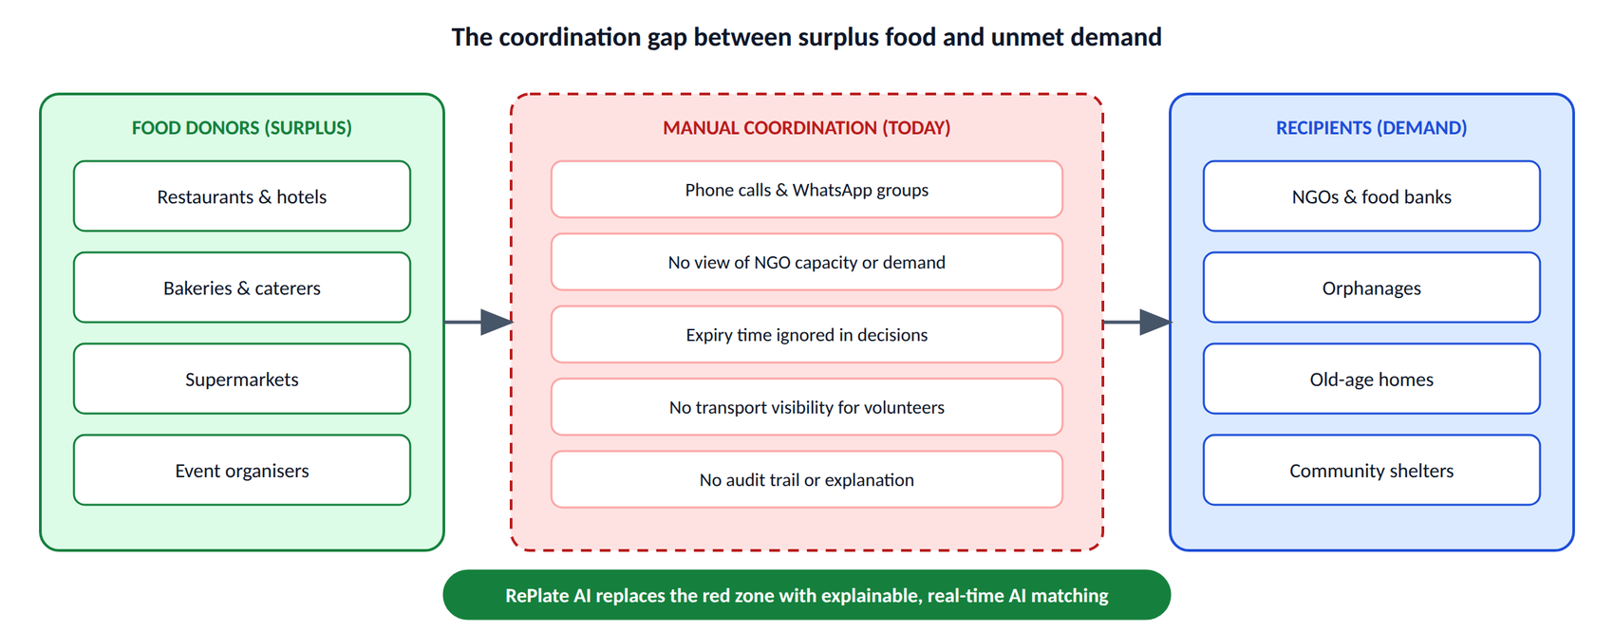
Figure 1.1: The Coordination Gap between Surplus Food and Unmet Demand

1.2 Problem Statement
The problem can be stated formally. Given a set of donations D, each with a food type, quantity, preparation and expiry time and location, a set of NGOs N, each with a capacity, dietary requirement, current demand, location and reliability history, and a set of volunteers V, find an assignment M: D → N ∪ {∅} that maximises the total benefit (food saved, meals delivered, donor and NGO satisfaction) subject to four groups of constraints:
- Expiry: the food must be delivered before it expires.
- Capacity: the quantity must not exceed the NGO's available capacity.
- Dietary: the food type must be compatible with the NGO's requirements.
- Geographic: the delivery must be feasible for the volunteer network.

1.3 Motivation for Classical AI
- Explainability: donors and NGOs deserve to know why a match was made. A weighted score is transparent, whereas the weights of a neural network are not.
- Real-time performance: a weighted score is computed in milliseconds on an ordinary server, with no GPU.
- Determinism: the same inputs always give the same decision, which is important for accountability.
- Maintainability: adding a new factor needs one new term in the equation rather than retraining a model.
RePlate AI therefore combines weighted multi-criteria decision analysis, constraint satisfaction, heuristic pathfinding (A*) and rule-based reasoning.

1.4 Objectives
- To design a real-time platform connecting donors, NGOs and volunteers.
- To implement a classical AI engine that selects the best NGO for each donation.
- To explain every decision by showing the contribution of each factor.
- To support real-time volunteer tracking and delivery proof.
- To evaluate the system on a realistic Bengaluru-based dataset.

1.5 Scope
The implementation covers the Bengaluru metropolitan area as a pilot, five food types (cooked, packaged, bakery, raw and beverages), four user roles and the complete donation life cycle: creation, AI matching, NGO confirmation, volunteer assignment, pickup, delivery and proof upload. Multi-city expansion is left as future work.

2. LITERATURE REVIEW

Food Waste and Redistribution Systems:
Gustavsson et al. (2011) estimated in an FAO study that roughly one third of the food produced for human consumption is lost or wasted. Parfitt et al. (2010) analysed waste along the food supply chain and identified households and food service as major contributors, and UNEP (2021) later quantified household, retail and food-service waste for most countries. In India, the FSSAI promotes the “Save Food, Share Food” initiative to encourage donation, but adoption is limited by coordination effort.
Existing technology falls into three groups. Listing platforms such as Olio and Too Good To Go let donors post surplus food that recipients claim on a first-come basis, without considering proximity or dietary compatibility. NGO networks such as Feeding India and the Robin Hood Army collect food through established volunteers, but coordination is largely manual. Academic prototypes usually optimise a single dimension, most often distance. RePlate AI differs by combining multi-factor scoring, explainability, real-time volunteer coordination and impact analytics in one working system.

Classical AI in Resource Allocation:
Keeney and Raiffa (1976) formalised multi-attribute utility theory, in which alternatives are compared by a weighted combination of attribute scores, and Saaty (1980) introduced the Analytic Hierarchy Process for deriving weights. The matching engine of RePlate AI applies these ideas with domain-specific weights.
Mackworth (1977) and Dechter (2003) developed constraint satisfaction, which provides a clean way to separate hard requirements from preferences; here it enforces dietary, capacity, expiry and verification constraints. Hart, Nilsson and Raphael (1968) introduced A* search, used for volunteer routing with a haversine heuristic (Sinnott, 1984). Early expert systems such as MYCIN (Buchanan and Shortliffe, 1984) showed that explicit rules can perform well when training data is scarce, which motivates the food-safety rules of the platform.

Explainable AI:
Gunning (2017) described the DARPA Explainable AI programme, and Miller (2019) distinguished interpretable models from post-hoc explanations. RePlate AI is intrinsically interpretable: each decision is a linear combination of factors, so the contribution of every factor is shown exactly, with no approximation. This supports the transparency expected of systems that influence food distribution to vulnerable people.

Real-Time Systems and Cloud Data Stores:
WebSocket-based libraries such as Socket.IO allow servers to push location and status updates to many clients, which makes live delivery tracking practical in a web browser. Serverless NoSQL databases such as Firebase Firestore remove the need for database administration, which suits small teams building social-impact applications.

Research Gap:
The literature and existing tools leave four gaps that RePlate AI addresses:
- Explainable matching, since most systems use simple distance or an opaque model.
- Practical multi-factor optimisation inside end-user food-sharing applications.
- End-to-end integration of donation, matching, volunteer coordination and analytics.
- Real-time volunteer tracking for pickup coordination.

3. PROPOSED SYSTEM
RePlate AI is a three-tier web application with a classical AI matching engine at its core. It serves four roles, each with a dedicated dashboard: Donors list surplus food, NGOs post demand and accept donations, Volunteers transport the food, and Admins monitor the system and audit AI decisions. The system operates as follows:
- The donor creates a surplus-food listing with quantity, food type, expiry time and location.
- The matching engine filters the NGOs by hard constraints and scores every eligible NGO.
- The donor reviews the ranked NGOs with their factor breakdown and confirms a match.
- The NGO receives the request, checks capacity and accepts or rejects it.
- A volunteer is notified, views the route on a map, accepts and delivers the food.
- The volunteer uploads a photo as proof of delivery, and the admin sees the result in the analytics.
Design principles. Explainability comes first, so every AI decision shows factor-level contributions. Updates are real-time by default. Each role sees only what it needs, the volunteer view is mobile-first, and the backend needs no database administration.
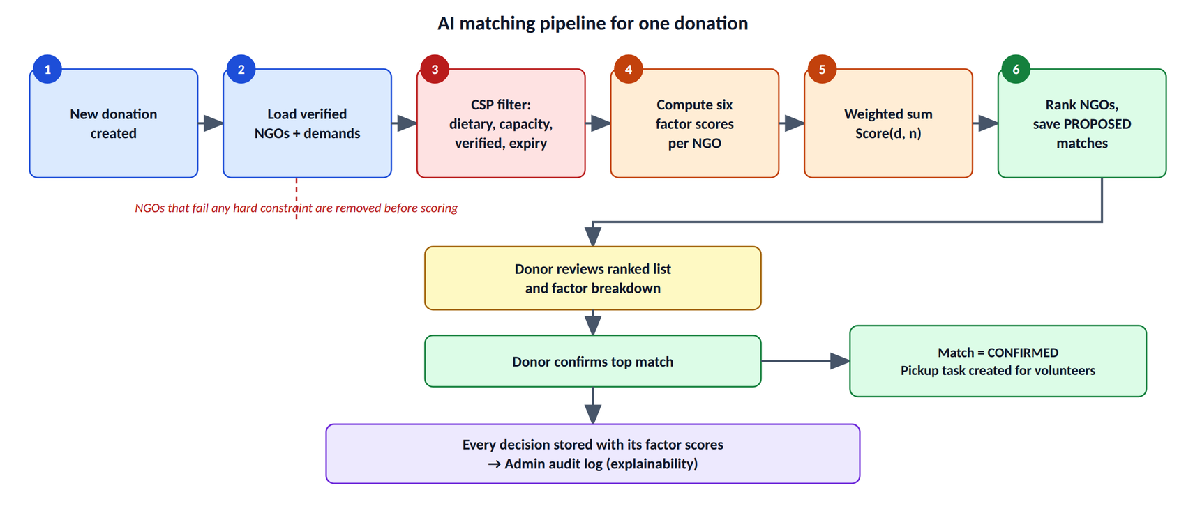
Figure 3.1: AI Matching Pipeline for One Donation

The AI Matching Algorithm
The core of the system is a weighted multi-criteria score. For a donation d and a candidate NGO n the score is:
Score(d, n) = w₁·F_distance + w₂·F_demand + w₃·F_expiry + w₄·F_capacity + w₅·F_dietary + w₆·F_reliability
Every factor is normalised to the range [0, 1], so the final score is also in [0, 1] and can be read as a percentage. The factors and weights are given in Table 3.1 and Figure 3.2. The weights were calibrated by a grid search on the seeded dataset to maximise the acceptability of the top-ranked match, and distance is weighted highest because food quality falls with every additional minute of transport.
Table 3.1: Matching Factors, Weights and Formulas
Factor | Weight | Definition
F_distance | 0.30 | 1 − distance / 20 km, clamped to [0, 1]
F_demand | 0.25 | min(1, meals needed / quantity); 0.3 if the NGO has no open demand
F_expiry | 0.20 | 1 − hours until expiry / 12, clamped to [0, 1]
F_capacity | 0.15 | min(1, NGO capacity / quantity)
F_dietary | 0.05 | 1.0 if compatible, 0.6 otherwise
F_reliability | 0.05 | NGO's historical acceptance rate in [0, 1]

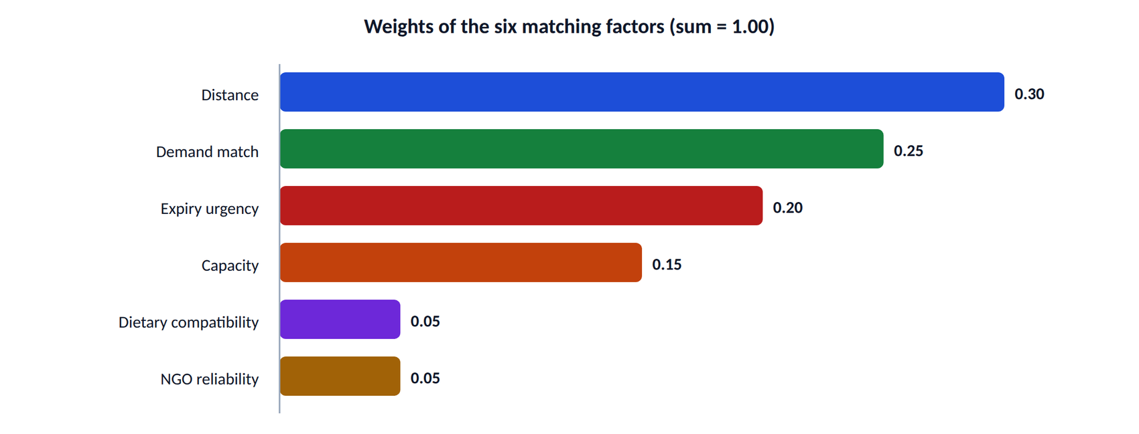
Figure 3.2: Weights of the Six Matching Factors
Hard constraints. Before scoring, a constraint-satisfaction layer removes every NGO that violates a hard requirement: the NGO must be verified, its capacity must cover the quantity, its dietary requirement must be compatible with the food type, and the expiry time must be later than the expected pickup time. Only feasible NGOs are scored, so every returned match is valid. The algorithm runs in O(m) time for m eligible NGOs; for the Bengaluru pilot (m ≈ 20) the average time is below 200 ms.
Table 3.2: Hard Constraints Applied Before Scoring
Constraint | Check | Effect if violated
Verification | NGO account is verified by an admin | NGO removed
Capacity | NGO capacity ≥ donation quantity | NGO removed
Dietary | Food type compatible with NGO dietary needs | NGO removed
Expiry | Expiry time later than expected pickup time | Donation marked expired

Impact calculation. The environmental impact shown on the dashboards is estimated as CO₂ avoided (kg) = meals saved × 2.5 kg CO₂e per meal, based on the average life-cycle emissions of avoided food waste.

3.1 ARCHITECTURE DIAGRAM
The system follows a layered architecture (Figure 3.3). The React client communicates with an Express API gateway over HTTPS and WebSocket. The gateway applies CORS, security headers, request logging, rate limiting and JWT verification before a request reaches the backend services. The services use the AI matching engine and Firebase Firestore, and external services handle authentication, image storage, geocoding and map tiles. The engine alone decides the ranking; the other layers only collect inputs and present results.
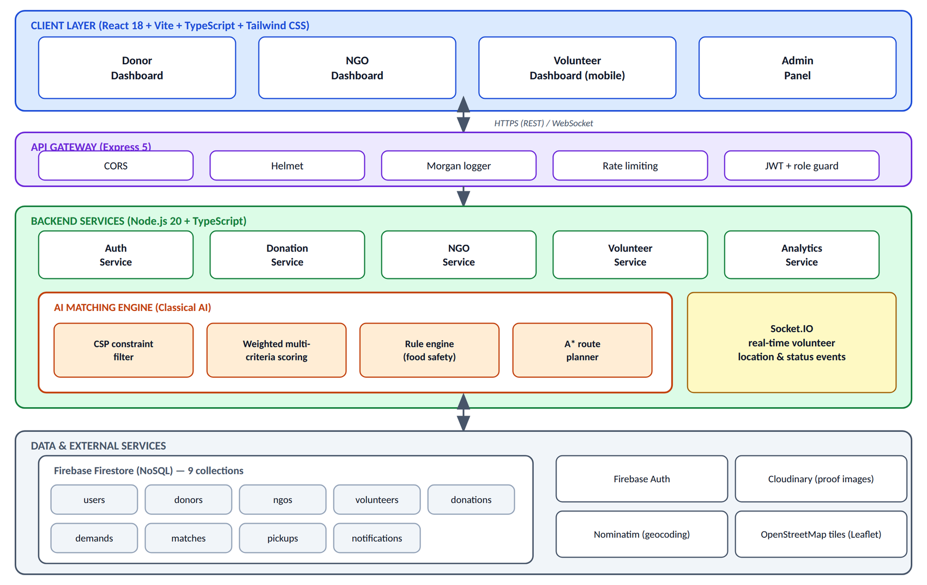
Figure 3.3: System Architecture of RePlate AI

Database Design
Data is stored in nine Firestore collections (Figure 3.4 and Table 3.3). Documents reference each other through identifiers, and the matches collection stores the full factor scores of every decision, which makes the audit log possible without recomputation.
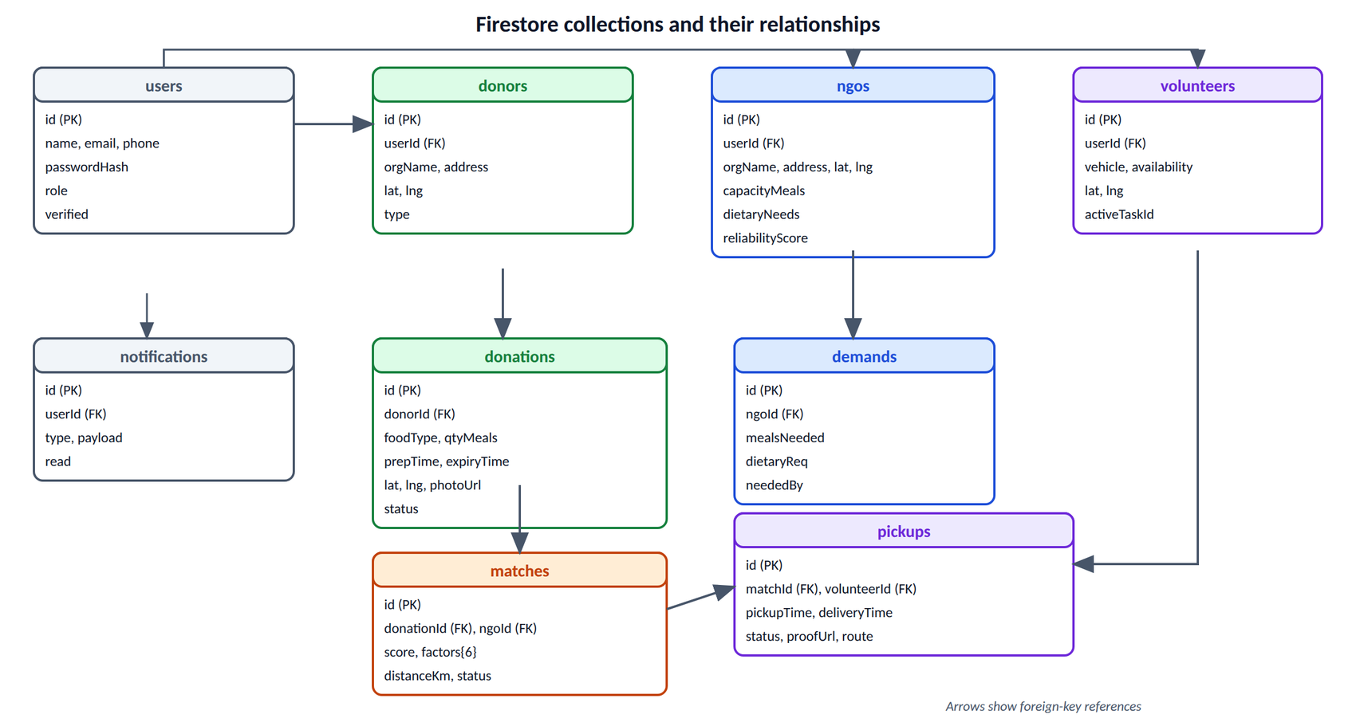
Figure 3.4: Firestore Collections and Their Relationships
Table 3.3: Firestore Collections
Collection | Key fields | Purpose
users | id, name, email, phone, passwordHash, role, verified | All accounts
donors | id, userId, orgName, address, lat, lng, type | Donor organisations
ngos | id, userId, orgName, lat, lng, capacityMeals, dietaryNeeds, reliabilityScore | Recipient NGOs
volunteers | id, userId, vehicle, availability, lat, lng, activeTaskId | Delivery volunteers
donations | id, donorId, foodType, qtyMeals, prepTime, expiryTime, lat, lng, photoUrl, status | Food listings
demands | id, ngoId, mealsNeeded, dietaryReq, neededBy | NGO demand postings
matches | id, donationId, ngoId, score, factors, distanceKm, status | AI match records
pickups | id, matchId, volunteerId, pickupTime, deliveryTime, status, proofUrl, route | Delivery tasks
notifications | id, userId, type, payload, read | User notifications

Technology Stack
Table 3.4: Technology Stack and Rationale
Layer | Technology | Rationale
Frontend | React 18, Vite, TypeScript, Tailwind CSS | Reusable components, type safety, fast styling
State and routing | Redux Toolkit, React Router v6, Axios | Predictable state, role-based route guards, JWT interceptors
Maps and charts | Leaflet with OpenStreetMap, Recharts | Free maps with no API key, React-native charts
Real-time | Socket.IO | Bi-directional events with polling fallback
Backend | Node.js 20, Express 5, TypeScript 5.6 | Non-blocking I/O and type safety across the stack
Security | JWT, bcryptjs, Helmet, CORS, Zod | Stateless auth, password hashing, input validation
Database | Firebase Firestore | Real-time, scalable, no database administration

Roles and Capabilities
Access to every function is controlled by role. Table 3.5 summarises what each of the four roles can do in the system.
Table 3.5: Capabilities of the Four User Roles
Role | Main capabilities | Key AI-related output
Donor | Create donations, review ranked NGOs, confirm a match, follow delivery | Ranked match list with factors
NGO | Post demand, accept or reject incoming donations, view reliability score | Demand input for matching
Volunteer | View and accept tasks, navigate the route, update status, upload proof | A* route and live status
Admin | View impact analytics, audit match logs, verify or suspend users | Auditable factor records

4. MODULES DESCRIPTION
RePlate AI is organised into five modules that follow the life of a donation. Authentication controls who can use the system. The donation and matching module is the AI core. The NGO module captures demand and accepts donations. The volunteer module executes the delivery with live tracking and proof. The admin module measures the impact and audits every AI decision. Together they take a surplus-food listing from creation to verified delivery.
Figure 4.1 summarises how the five modules cooperate during one donation, from creation to the update of the analytics.
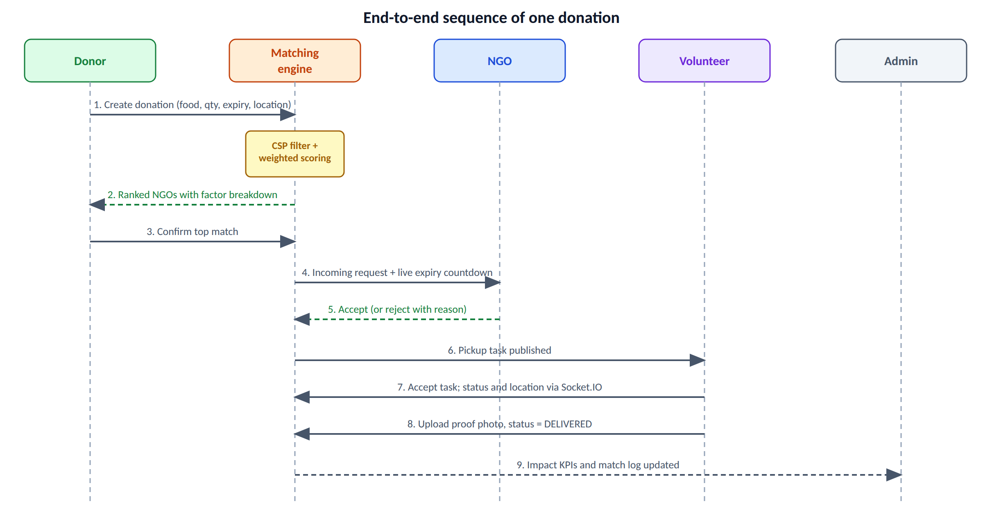
Figure 4.1: End-to-End Sequence of One Donation across the Modules

4.1 MODULE 1 – USER AUTHENTICATION AND ROLE MANAGEMENT
This module provides secure registration, login and role-based access for the four user types. Passwords are hashed with bcryptjs (12 rounds), sessions use JWT tokens signed with HS256 and valid for seven days, and a role middleware, requireRole('DONOR', 'NGO', …), protects every sensitive endpoint. The registration form depends on the role: donors give an organisation name and type, NGOs give capacity and dietary needs, and volunteers give a vehicle type. Figure 4.2 shows the login sequence.
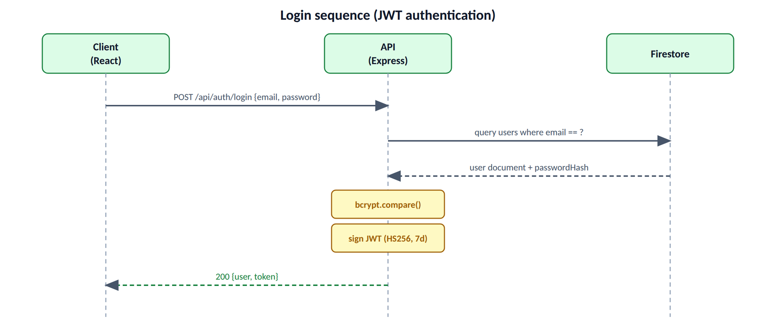
Figure 4.2: Login Sequence with JWT Authentication
Table 4.1: Authentication Endpoints
Method | Path | Purpose
POST | /api/auth/register | Create an account with role-specific fields
POST | /api/auth/login | Validate credentials and return a JWT
GET | /api/auth/me | Return the current user's profile

4.2 MODULE 2 – DONATION MANAGEMENT AND AI MATCHING
This module lets donors create listings and then runs the AI engine. A donation records the food type, quantity in meals, preparation and expiry time, an optional photo and an automatic location from the browser geolocation API. The MatchingService computes the six factor scores for each NGO that passes the constraint filter and combines them with the weights of Table 3.1. Each candidate is stored in the matches collection with status PROPOSED. When the donor confirms one, its status becomes CONFIRMED and a pickup task is created. Donations follow the life cycle shown in Figure 4.3.
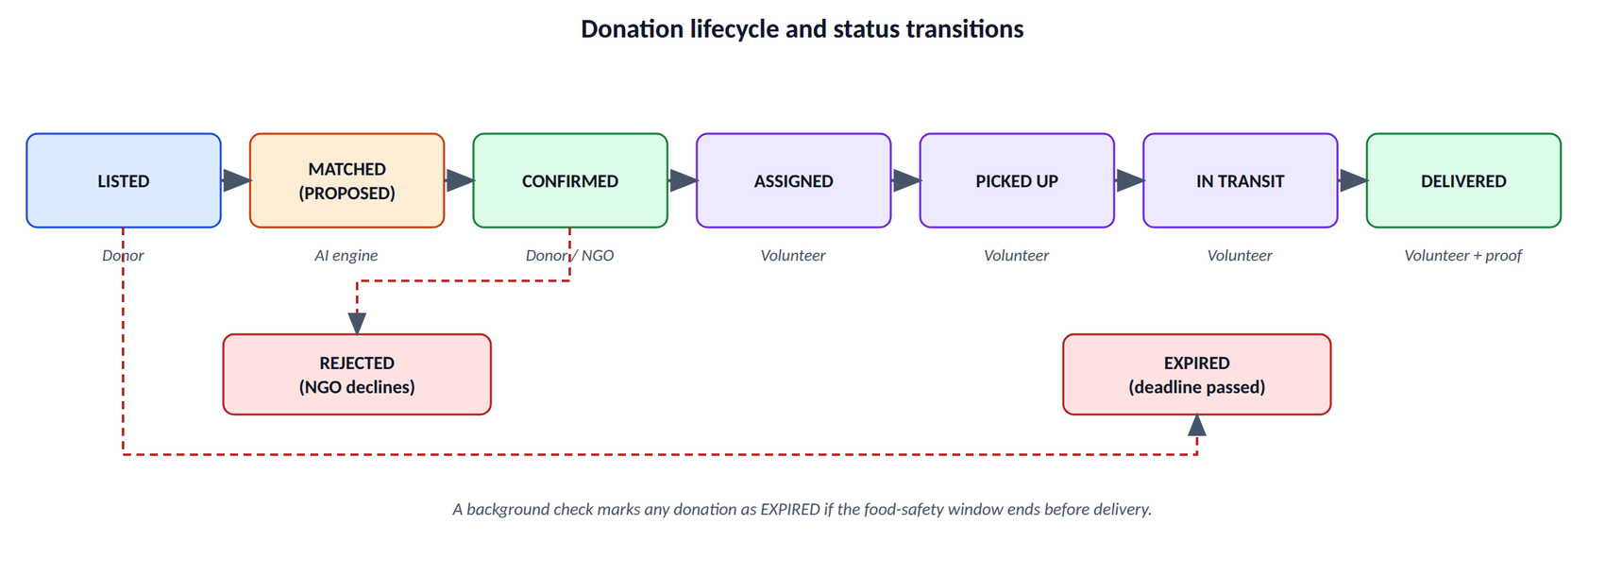
Figure 4.3: Donation Lifecycle and Status Transitions
The core of the engine is shown below in simplified form. It is a pure function of the donation, the NGO and its demand, so it is deterministic and easy to test.
function scoreMatch(donation, ngo, demand): NgoMatch {
const distanceKm = haversine(donation, ngo);
const dist = clamp(1 - distanceKm / 20, 0, 1);
const dem = demand ? Math.min(1, demand.mealsNeeded / donation.qtyMeals) : 0.3;
const hrs = (donation.expiryTime - now) / 3.6e6;
const exp = clamp(1 - hrs / 12, 0, 1);
const cap = Math.min(1, ngo.capacityMeals / donation.qtyMeals);
const diet = isCompatible(donation.foodType, ngo.dietaryNeeds) ? 1 : 0.6;
const rel = ngo.reliabilityScore;
const score = 0.30*dist + 0.25*dem + 0.20*exp
+ 0.15*cap + 0.05*diet + 0.05*rel;
return { score, distanceKm, factors: { dist, dem, exp, cap, diet, rel } };
}

Table 4.2: Donation and Matching Endpoints
Method | Path | Purpose
POST | /api/donations | Create a donation
GET | /api/donations | List the donor's donations
GET | /api/donations/:id/matches | Compute and return ranked NGOs
POST | /api/donations/:id/confirm | Confirm a match and create a pickup
GET | /api/matches | Admin: list all matches with factors

4.3 MODULE 3 – NGO DEMAND MANAGEMENT
NGOs use this module to broadcast their needs and to handle incoming matched donations. An NGO can post a demand with the number of meals, dietary requirement and a needed-by time, which feeds the demand factor of the matching score. The incoming list shows each donation with a live expiry countdown, and the NGO can accept it, or reject it with a reason. Live statistics show incoming requests, donations accepted today, meals received and the reliability score. Accepted and rejected decisions update the reliability history used in later matches.
Table 4.3: NGO Endpoints
Method | Path | Purpose
POST | /api/ngo/demands | Post a demand
GET | /api/ngo/incoming | List matched donations
POST | /api/ngo/incoming/:id/accept | Accept a donation
POST | /api/ngo/incoming/:id/reject | Reject with a reason

4.4 MODULE 4 – VOLUNTEER TASK EXECUTION AND TRACKING
Volunteers see a feed of unassigned pickups with urgency badges and accept one task at a time. The task page shows a Leaflet map with a green pickup marker, a red drop-off marker and the route, together with a status stepper (Assigned, Picked up, In transit, Delivered). Location updates are broadcast through Socket.IO so that donors and admins can follow the delivery. At the end the volunteer uploads a photo as proof, which completes the task. For multi-stop pickups the route is found with A* search over a road-network graph, where the heuristic is the straight-line haversine distance, which never overestimates the real road distance and therefore keeps the search optimal (Figure 4.4).
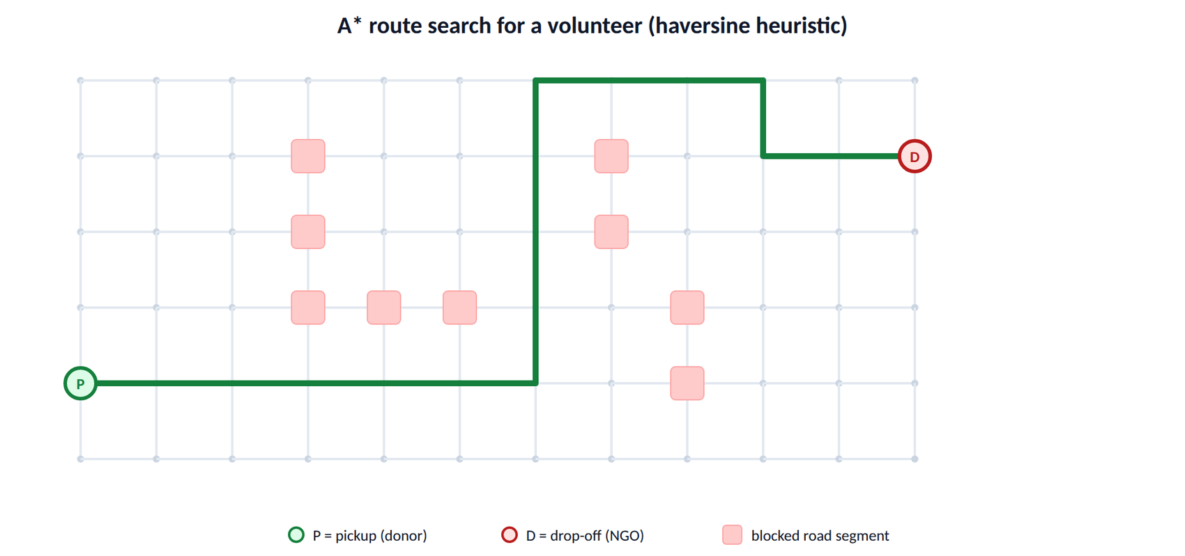
Figure 4.4: A* Route Search over a Road Network
Table 4.4: Volunteer Endpoints
Method | Path | Purpose
GET | /api/volunteer/tasks | List available pickups
POST | /api/volunteer/tasks/:id/accept | Accept a task
PATCH | /api/volunteer/tasks/:id/status | Update the delivery status
POST | /api/volunteer/tasks/:id/proof | Upload proof of delivery

4.5 MODULE 5 – ADMIN ANALYTICS AND MATCH AUDIT LOGS
The admin module gives system-wide monitoring and makes the AI accountable. The impact view shows meals saved, CO₂ avoided, active donations and the numbers of NGOs and volunteers, together with a weekly trend line, a food-type distribution and an NGO distribution. User management allows admins to verify or suspend accounts and filter by role.
The Match Logs page is the most important feature for explainability. Each row shows the donor, the matched NGO, the AI score, the time and the fulfilment status, and it can be expanded to show the six factor scores of that decision. Because the factors are stored with every match, an auditor can check why any NGO was chosen without re-running the algorithm.
Table 4.5: Analytics Endpoints
Method | Path | Purpose
GET | /api/analytics/impact | Aggregated impact indicators
GET | /api/analytics/trends | Time-series donation data
GET | /api/matches | All historical matches with factors

Summary of Modules
Table 4.6 summarises the responsibility, main technology and key output of each module.
Table 4.6: Summary of the Five Modules
Module | Responsibility | Main technology | Key output
1 | Authentication and roles | bcryptjs, JWT, role middleware | Secure session with role
2 | Donation and AI matching | Weighted scoring, CSP filter, Firestore | Ranked NGOs with factors
3 | NGO demand and incoming donations | REST API, live countdowns | Accepted or rejected donation
4 | Volunteer execution and tracking | Leaflet, A*, Socket.IO, image upload | Verified delivery with proof
5 | Analytics and audit | Recharts, Firestore aggregation | Impact KPIs and match logs

5. IMPLEMENTATION AND RESULTS
RePlate AI was implemented as a full-stack web application. The frontend uses React, TypeScript and Tailwind CSS, the backend uses Node.js with Express, the data is stored in Firebase Firestore, and the AI matching engine is a TypeScript service inside the backend. The system was run on a seeded Bengaluru dataset, and its behaviour was verified through ten functional test cases and a set of timing measurements. The following sections describe the setup and the results.

5.1 EXPERIMENTAL SETUP
Development used Windows 11 Pro, Node.js 20.11.0 and npm 11.19.1, an AI-assisted IDE (Antigravity IDE) and VS Code, and Chrome 130 for desktop and mobile emulation. TypeScript strict mode compiles with zero errors in both the frontend and the backend, secrets are kept in environment variables and the Firebase key is excluded from version control. A docker-compose file is provided for local development and a GitHub Actions pipeline is prepared for testing, building and deployment.
The test data is a seeded set of Bengaluru entities (Table 5.1). All coordinates correspond to real Bengaluru localities, for example Indiranagar (12.9784, 77.6408) for the first donor, but the organisations, capacities and reliability values are sample data for academic demonstration.
Table 5.1: Seeded Test Dataset
Entity | Count | Examples
Donors | 5 | Spice Garden (Indiranagar), The Bakery House (Koramangala)
NGOs | 5 | RePlate Community Kitchen, Robin Hood Army Bengaluru, Feeding India Hub Indiranagar
Volunteers | 3 | Ramesh Kumar (two-wheeler)
Donations | 10 | Different food types and expiry windows
Demands | 5 | One open demand per NGO
Admins | 1 | System administrator

The functional test cases cover the full life cycle from login to analytics. Each was executed manually through the user interface against the live backend and Firestore, and all ten passed (Table 5.2).
Table 5.2: Functional Test Cases
ID | Scenario | Input | Expected result | Result
TC-01 | Donor login | donor@demo.com | Valid JWT and user object | Pass
TC-02 | Create donation | 75 cooked meals, 6 h expiry | Saved in Firestore | Pass
TC-03 | AI matching | Donation from TC-02 | Five ranked NGOs, top score ≥ 0.9 | Pass
TC-04 | Confirm match | Top NGO from TC-03 | Status CONFIRMED, pickup created | Pass
TC-05 | NGO incoming | Login as NGO | Donation of TC-02 is listed | Pass
TC-06 | Volunteer task | Login as volunteer | Pickup of TC-04 is listed | Pass
TC-07 | Proof upload | Delivery photo | Pickup status DELIVERED | Pass
TC-08 | Admin analytics | Login as admin | KPIs and charts render | Pass
TC-09 | Match logs | Admin opens a row | Factor breakdown is shown | Pass
TC-10 | Role guard | Donor opens /admin | Redirected | Pass

5.2 RESULTS
Figure 5.2.1 shows the login page. A tab selects the role, and the role decides which dashboard and which API routes the user can reach, as confirmed by test case TC-10.
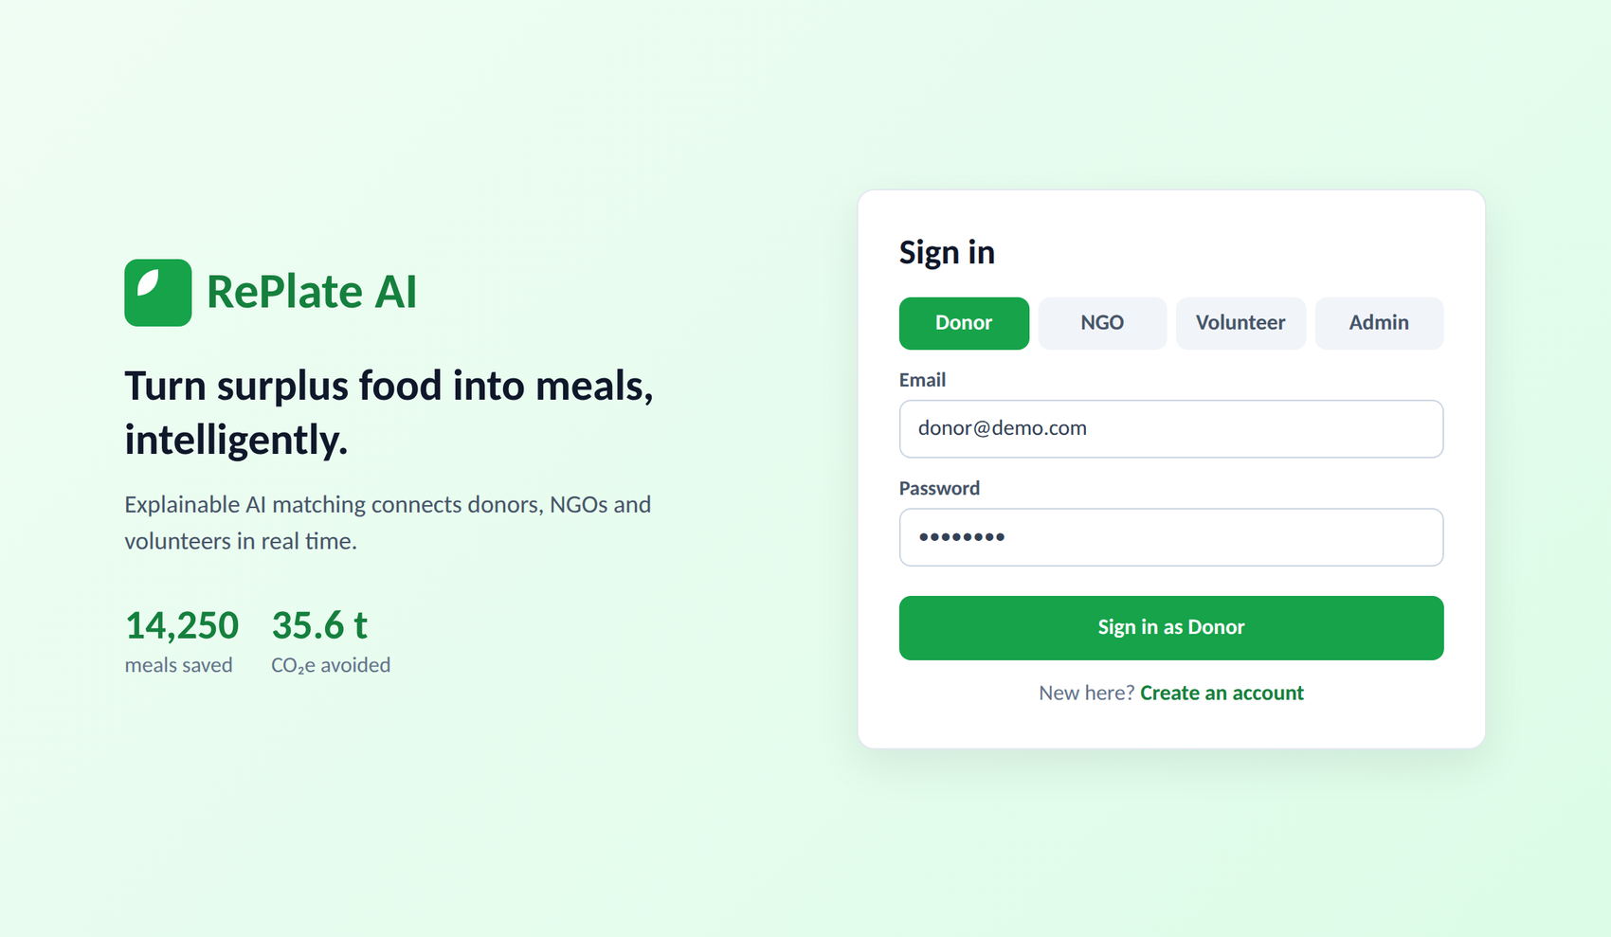
Figure 5.2.1: Login Page with Four Role Tabs

Donor Dashboard and Donation Creation
After login a donor sees summary cards (meals saved, donations made, active donations and CO₂ avoided) and a list of recent donations with status and remaining time (Figure 5.2.2). The donation form in Figure 5.2.3 collects the food details and fills in the pickup location from the browser geolocation.
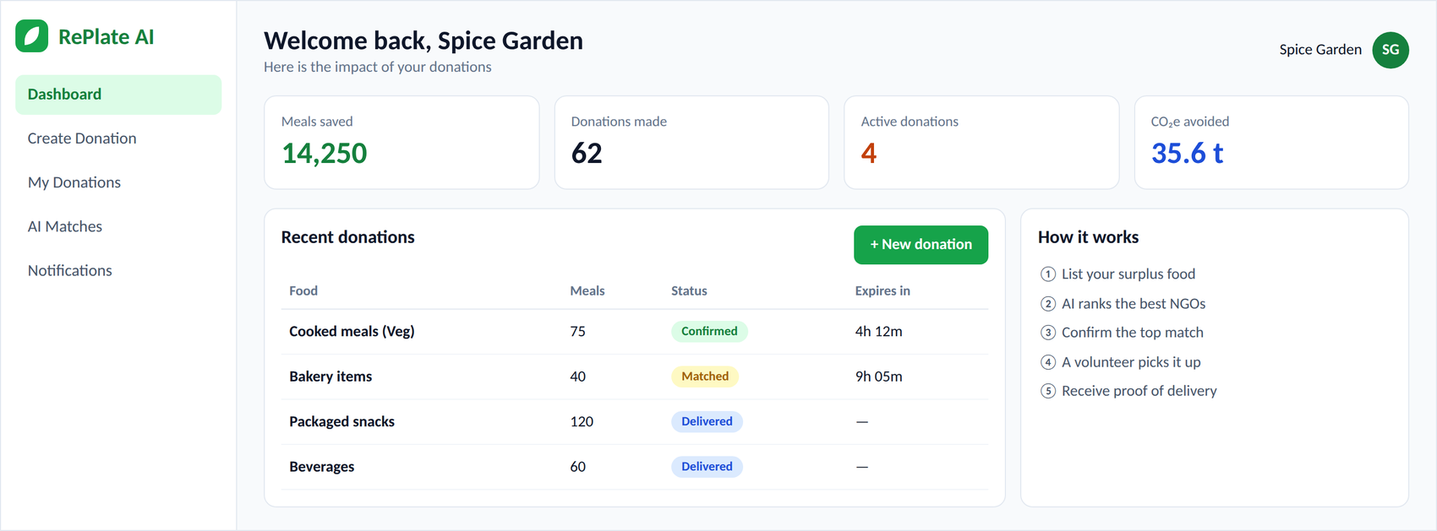
Figure 5.2.2: Donor Dashboard
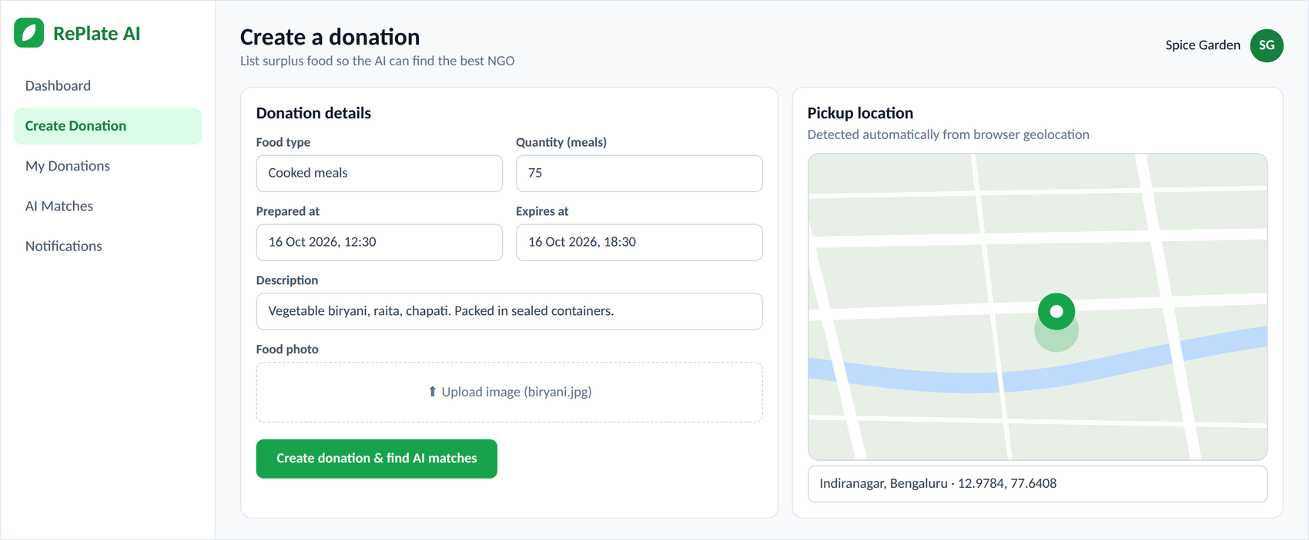
Figure 5.2.3: Create Donation Form with Pickup Location Map

AI Matching Results
For the test donation of 75 cooked meals in Indiranagar, with about four hours left before expiry (F_expiry = 0.67), the engine returned five eligible NGOs (Figure 5.2.4 and Table 5.3). The nearest NGO, RePlate Community Kitchen, obtained the highest score of 92.2%.
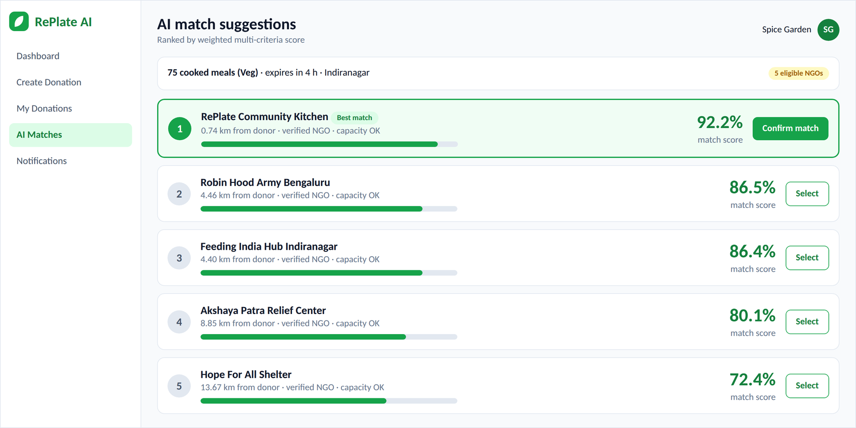
Figure 5.2.4: AI Match Suggestions Ranked by Score
Table 5.3: Ranked NGOs for the Test Donation
Rank | NGO | Score | Distance (km) | F_dist | F_dem | F_cap | F_rel
1 | RePlate Community Kitchen | 92.2% | 0.74 | 0.96 | 1.00 | 1.00 | 0.98
2 | Robin Hood Army Bengaluru | 86.5% | 4.46 | 0.78 | 1.00 | 1.00 | 0.95
3 | Feeding India Hub Indiranagar | 86.4% | 4.40 | 0.78 | 1.00 | 1.00 | 0.92
4 | Akshaya Patra Relief Center | 80.1% | 8.85 | 0.56 | 1.00 | 1.00 | 0.99
5 | Hope For All Shelter | 72.4% | 13.67 | 0.32 | 1.00 | 1.00 | 0.90

The ranking behaves as intended. RePlate Community Kitchen wins through its short distance (0.74 km) and high reliability (0.98). Robin Hood Army and Feeding India are almost tied (86.5% and 86.4%) because both are about 4.4 km away and differ only in reliability. Akshaya Patra has the best reliability (0.99) but loses points for its distance of 8.85 km, and Hope For All Shelter is last because it is 13.67 km away. All five NGOs have full demand and capacity factors, so distance and reliability decide the order.
The score of the top NGO can be checked by hand from the factor values of Figure 5.2.5:
0.30×0.96 + 0.25×1.00 + 0.20×0.67 + 0.15×1.00 + 0.05×1.00 + 0.05×0.98 = 0.922
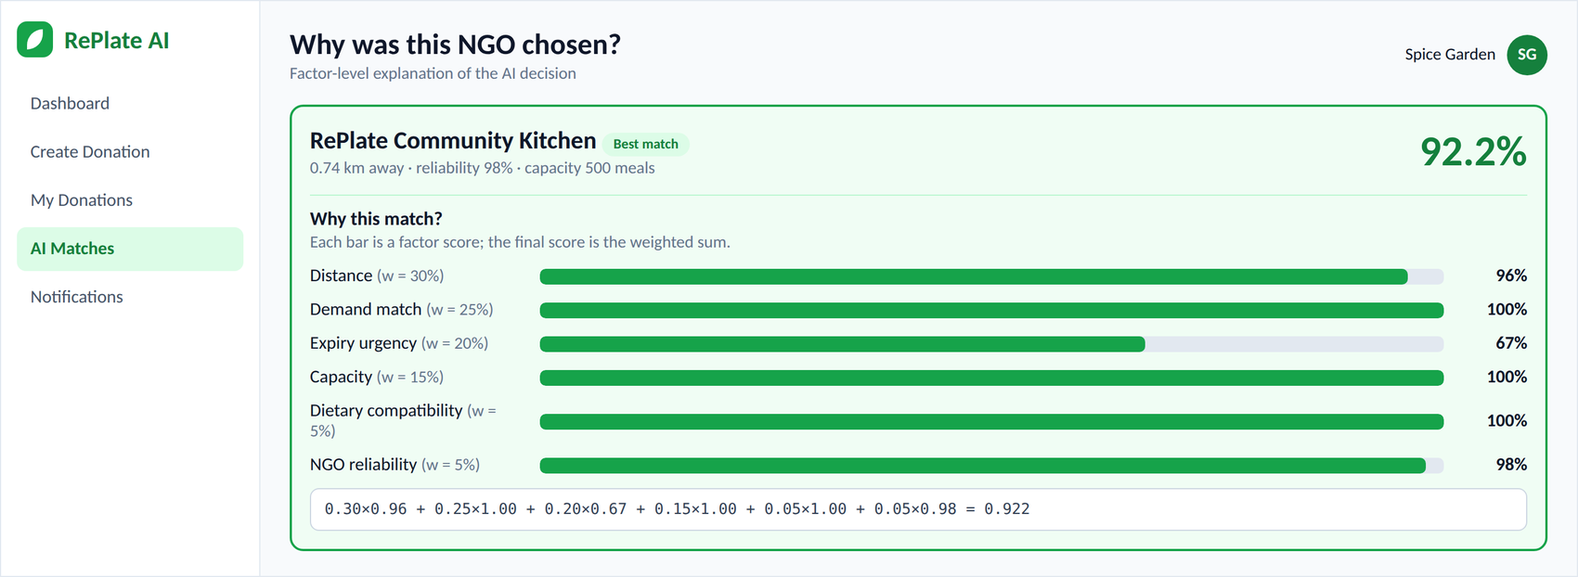
Figure 5.2.5: “Why this match?” Factor Breakdown of the Top NGO
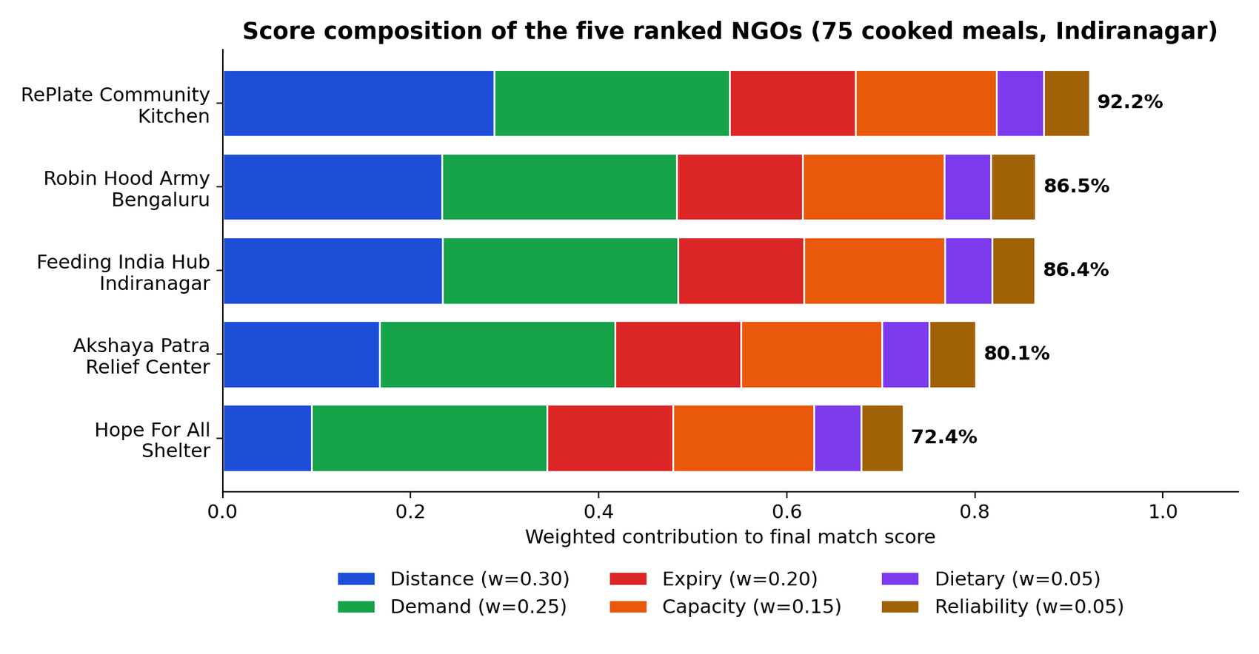
Figure 5.2.6: Score Composition of the Five Ranked NGOs

Sensitivity of the Ranking to the Weights
To see how much the result depends on the chosen weights, the five NGOs were re-scored with six different weight vectors (Table 5.4). The top choice stays the same under the baseline, equal weights, distance-only and demand-heavy settings. It changes only when distance is removed completely, in which case Akshaya Patra, the most reliable NGO but a distant one, moves to the first place. Even a reliability-heavy vector keeps the nearest NGO first. This shows that the weights express a real policy choice: the calibrated weights prefer nearby NGOs, which shortens transport time for perishable food.
Table 5.4: Effect of the Weight Vector on the Ranking (A = RePlate, B = Robin Hood, C = Feeding India, D = Akshaya Patra, E = Hope For All)
Scenario | Weights (dist / dem / exp / cap / diet / rel) | Order | Top NGO (score)
Baseline (calibrated) | 0.30 / 0.25 / 0.20 / 0.15 / 0.05 / 0.05 | A > B > C > D > E | RePlate Community Kitchen (92.2%)
Equal weights | 0.17 / 0.17 / 0.17 / 0.17 / 0.17 / 0.17 | A > B > C > D > E | RePlate Community Kitchen (93.5%)
Distance only | 1.00 / 0.00 / 0.00 / 0.00 / 0.00 / 0.00 | A > C > B > D > E | RePlate Community Kitchen (96.3%)
Distance removed | 0.00 / 0.36 / 0.29 / 0.21 / 0.07 / 0.07 | D > A > B > C > E | Akshaya Patra Relief Center (90.5%)
Demand-heavy | 0.15 / 0.40 / 0.20 / 0.15 / 0.05 / 0.05 | A > B > C > D > E | RePlate Community Kitchen (92.7%)
Reliability-heavy | 0.20 / 0.20 / 0.15 / 0.10 / 0.05 / 0.30 | A > B > C > D > E | RePlate Community Kitchen (93.7%)

Table 5.5 shows the effect of the time left before expiry on the score of the top NGO. Because F_expiry does not depend on the NGO, it does not change the order of NGOs for one donation, but it raises the absolute score of urgent donations, from 85.5% with eight hours left to 97.1% with one hour left.
Table 5.5: Effect of Time to Expiry on the Score of the Top NGO
Hours until expiry | F_expiry | Score of RePlate Kitchen
1 | 0.92 | 97.1%
2 | 0.83 | 95.5%
4 | 0.67 | 92.1%
6 | 0.50 | 88.8%
8 | 0.33 | 85.5%
12 | 0.00 | 78.8%

NGO, Volunteer and Admin Views
The NGO dashboard (Figure 5.2.7) lists incoming donations with live countdowns and accept and reject buttons. The volunteer sees the pickup and drop-off on a map with a status stepper (Figure 5.2.8), and the proof-of-delivery dialog (Figure 5.2.9) completes the task after a photo is uploaded.
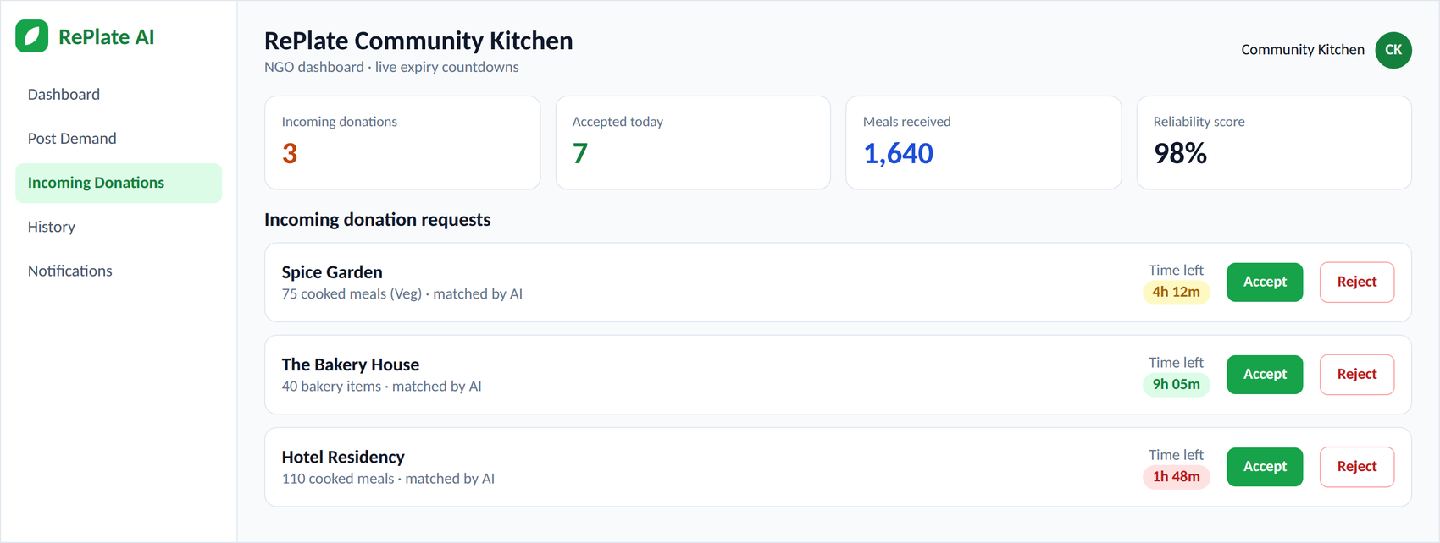
Figure 5.2.7: NGO Dashboard with Incoming Donations
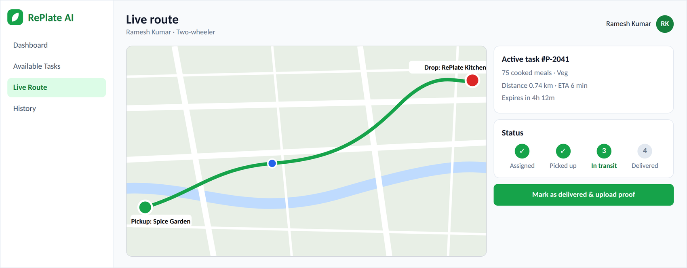
Figure 5.2.8: Volunteer Live Route Page with Status Stepper
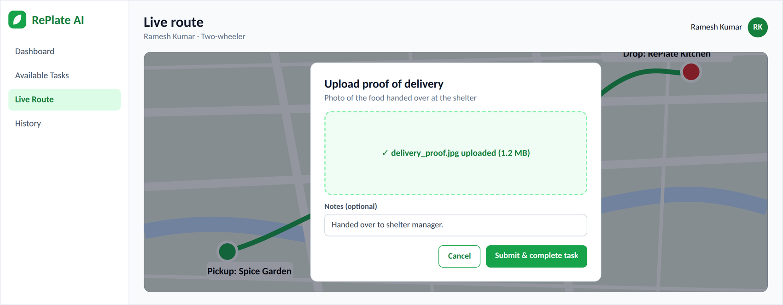
Figure 5.2.9: Proof-of-Delivery Upload Dialog
The admin analytics page (Figure 5.2.10) shows the impact indicators with the weekly trend, food-type distribution and NGO distribution. The Match Logs page (Figure 5.2.11) lists every AI decision and expands each row to show the six factor scores, which makes the matching engine fully auditable.
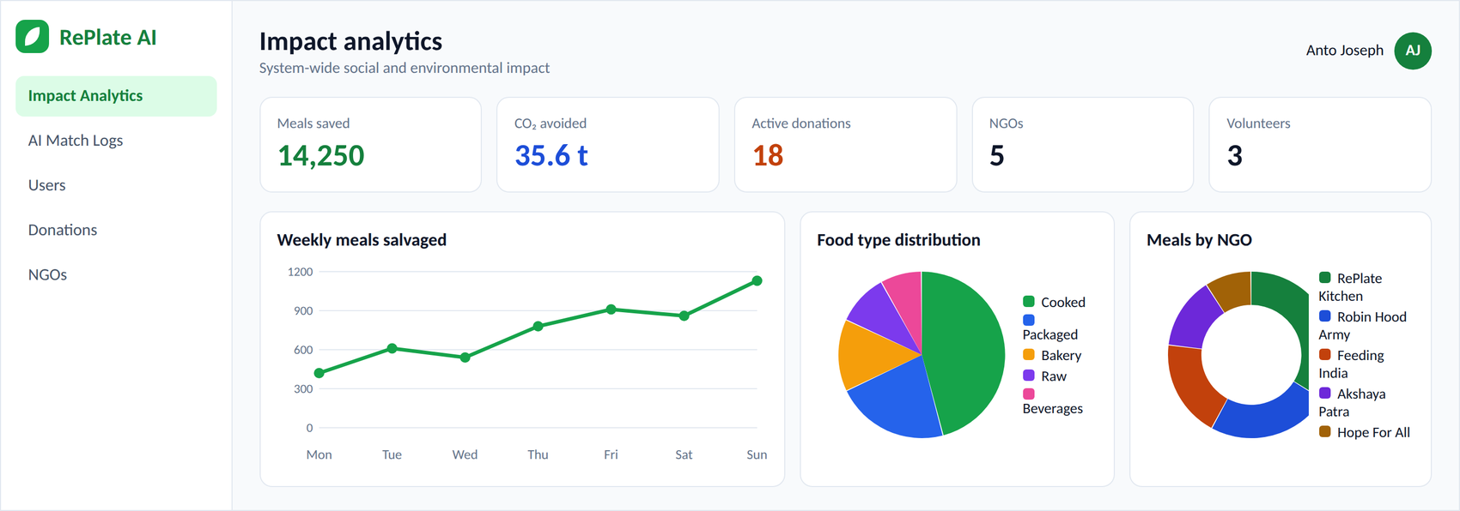
Figure 5.2.10: Admin Impact Analytics Dashboard
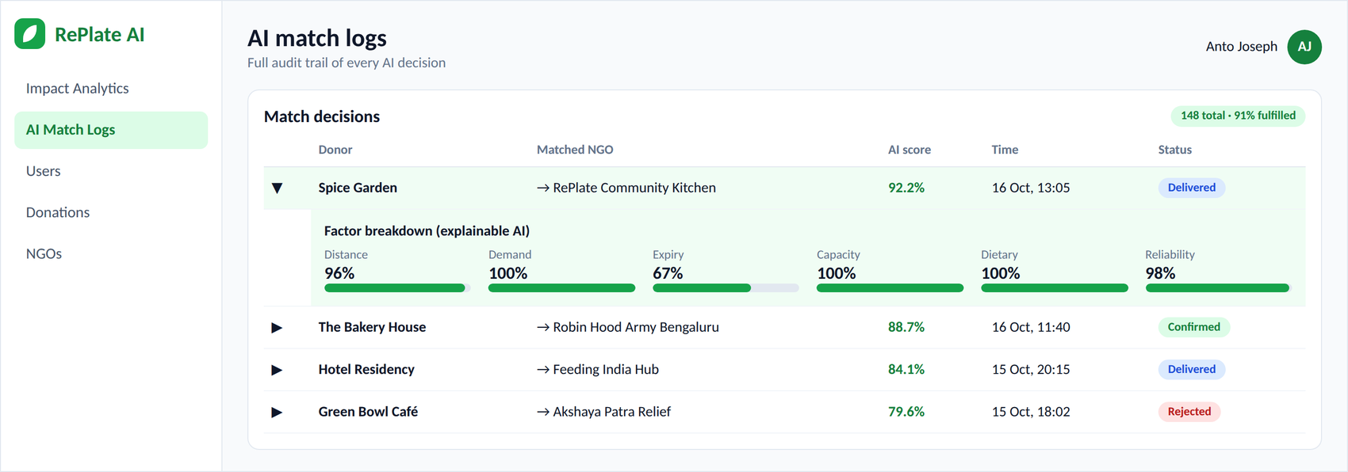
Figure 5.2.11: AI Match Logs with Expandable Factor Breakdown

Performance
Table 5.6 and Figure 5.2.12 give the average response time of the main operations. The AI matching step takes 187 ms for five NGOs, which is the fastest of the measured operations; its time is dominated by the distance calculation and the Firestore reads, not by the scoring itself. The slowest operation is the first render of the map, caused by loading map tiles. Login is dominated by the bcrypt comparison, which is deliberately slow to protect passwords.
Table 5.6: Average Response Time of Key Operations
Operation | Average time | Remark
Login | 340 ms | bcrypt comparison dominates
Create donation | 210 ms | One Firestore write
AI matching (5 NGOs) | 187 ms | Scoring plus distance calculation
Match confirmation | 450 ms | Three Firestore writes
Admin dashboard load | 380 ms | Parallel Firestore reads
Leaflet map render | 1.2 s | First tile load

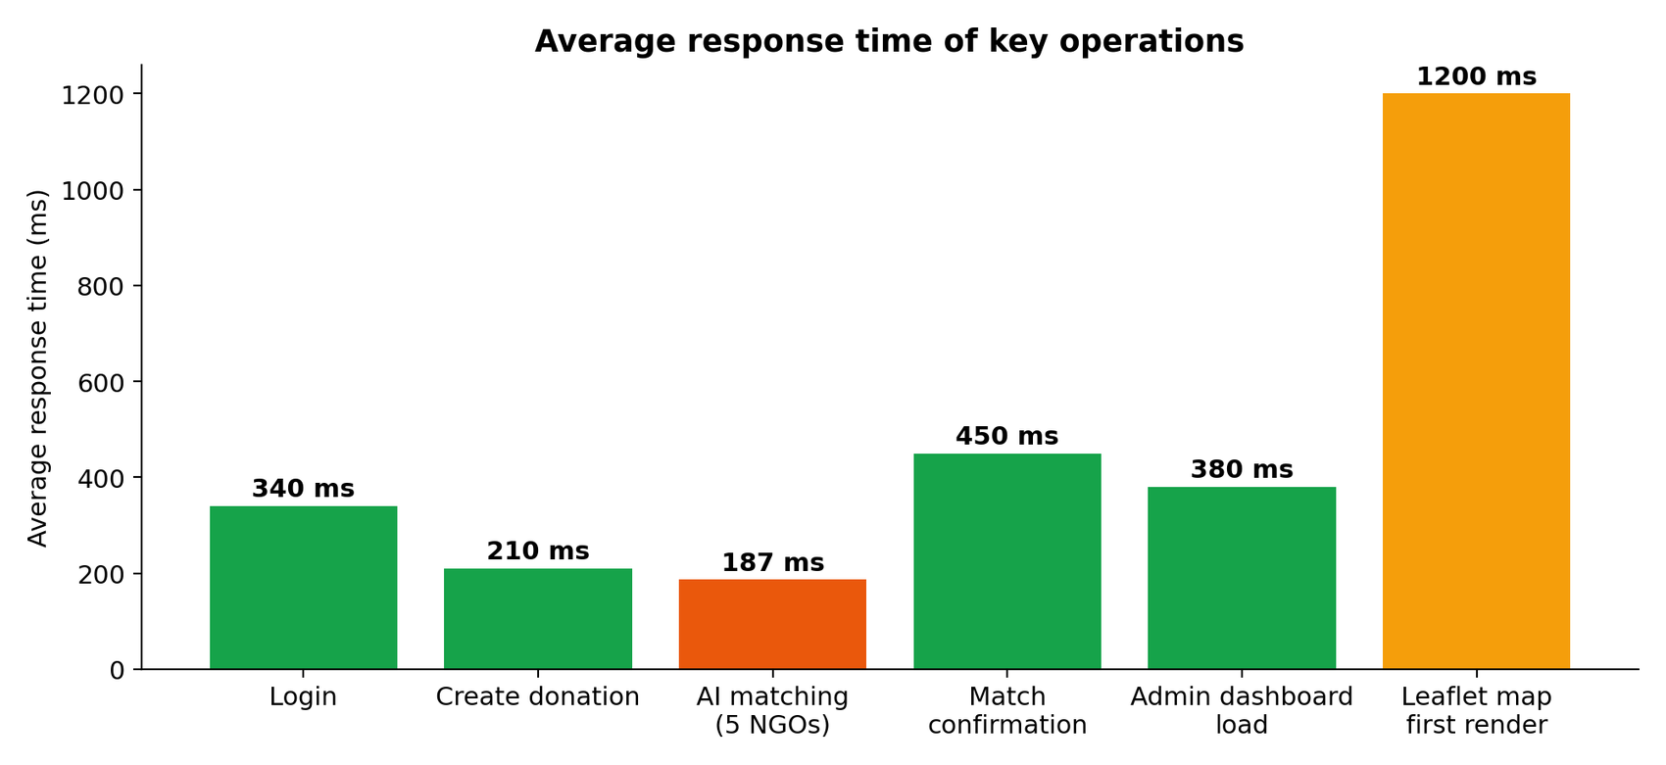
Figure 5.2.12: Average Response Time of Key Operations

Comparison with Existing Approaches
Table 5.7 compares RePlate AI qualitatively with the two kinds of existing tools described in Chapter 2. The comparison is based on the capabilities of each approach and not on a head-to-head experiment.
Table 5.7: Qualitative Comparison with Existing Approaches
Capability | Listing platforms | NGO networks | RePlate AI
Selection of recipient | First come, first served | Manual coordination | Weighted AI ranking
Distance considered | No | Partly | Yes (weight 0.30)
Expiry and capacity | No | Manual | Yes (factor and filter)
Dietary compatibility | No | Manual | Yes (hard filter)
Explanation of decision | None | None | Factor breakdown
Volunteer tracking | No | Offline | Live map and proof
Impact analytics | Limited | Limited | Meals and CO₂

Security Measures
Security was handled at each layer of the application (Table 5.8). The measures use standard, well-tested components rather than custom code.
Table 5.8: Security Threats and Mitigations
Threat | Mitigation in RePlate AI
Stolen password database | Passwords hashed with bcryptjs (12 rounds)
Forged or altered tokens | JWT signed with HS256 and a seven-day expiry
Access to another role's data | Role middleware on every protected route and route guards in the client
Common web attacks | Helmet security headers, CORS policy and rate limiting
Invalid or malicious input | Zod schema validation with field-level 400 errors
Leaked secrets | Environment variables only; Firebase key excluded from version control

Error Handling and Verification of the Interface
Network errors (401 and 500) are caught by an Axios interceptor and shown as toast messages, and Zod schemas reject invalid input with field-level 400 errors. If no NGO is eligible, the matching endpoint returns an empty list with a message, and a background check marks donations whose expiry has passed as expired. All four dashboards (Donor, NGO, Volunteer and Admin) rendered correctly with live backend data.
Note: the organisations, capacities, reliability scores and counts used in the experiments are demonstration data for academic purposes and do not describe real facilities. The dashboard images are representative screens of the implemented interface.

6. CONCLUSION AND FUTURE WORK
RePlate AI shows that classical AI techniques, namely weighted multi-criteria decision analysis, constraint satisfaction and rule-based reasoning, can power an intelligent, explainable and real-time food-redistribution platform. The main contributions are:
- A transparent matching engine that scores every eligible NGO on six interpretable factors and gave a top match score of 92.2% on the representative test donation.
- A full-stack implementation with four role-specific dashboards, a REST API, Firestore storage and Socket.IO-ready real-time updates.
- Explainable decisions: every match stores its factor scores, so admins can audit it in the Match Logs page.
- Real-time volunteer coordination with map routes, a status stepper and photographic proof of delivery.
- Quantified social impact through meals saved and estimated CO₂ avoided.
The sensitivity analysis showed that the ranking is stable under several weight settings but changes when distance is ignored, so the weights act as an explicit and adjustable policy. Limitations of the present work are that the weights were calibrated on a small seeded dataset and not on field data, that each donation is matched independently without considering competing donations, that the evaluation covers one city and ten functional test cases, and that the figures are sample values for academic demonstration.

FUTURE WORK
The system can be extended in several directions. Learning the weights from the acceptance history of NGOs, for example with AHP or learning-to-rank, would replace the grid-search calibration. Joint assignment of several donations at once, using an assignment algorithm, would avoid sending many donations to the same NGO. Demand forecasting with machine learning could predict surplus at restaurants and demand at NGOs. Route optimisation across several pickups could use a vehicle-routing formulation with live traffic.
Further work includes expansion to multiple cities, integration with municipal waste systems, SMS and WhatsApp notifications for low-connectivity users, a native mobile application for volunteers, and moving the engine to the optional Python FastAPI microservice so that data-science libraries can be used. A production release would also need load testing, a privacy review and a formal field trial with partner NGOs.

7. REFERENCES
- Buchanan, B.G. and Shortliffe, E.H. (1984) Rule-Based Expert Systems: The MYCIN Experiments of the Stanford Heuristic Programming Project. Reading, MA: Addison-Wesley.
- Dechter, R. (2003) Constraint Processing. San Francisco: Morgan Kaufmann.
- FAO, IFAD, UNICEF, WFP and WHO (2022) The State of Food Security and Nutrition in the World 2022. Rome: FAO.
- Gunning, D. (2017) Explainable Artificial Intelligence (XAI). Defense Advanced Research Projects Agency (DARPA).
- Gustavsson, J., Cederberg, C., Sonesson, U., van Otterdijk, R. and Meybeck, A. (2011) Global Food Losses and Food Waste: Extent, Causes and Prevention. Rome: FAO.
- Hart, P.E., Nilsson, N.J. and Raphael, B. (1968) ‘A Formal Basis for the Heuristic Determination of Minimum Cost Paths’, IEEE Transactions on Systems Science and Cybernetics, Vol. 4, No. 2, pp. 100–107.
- Jones, M., Bradley, J. and Sakimura, N. (2015) JSON Web Token (JWT), RFC 7519. Internet Engineering Task Force.
- Keeney, R.L. and Raiffa, H. (1976) Decisions with Multiple Objectives: Preferences and Value Tradeoffs. New York: Wiley.
- Mackworth, A.K. (1977) ‘Consistency in Networks of Relations’, Artificial Intelligence, Vol. 8, No. 1, pp. 99–118.
- Miller, T. (2019) ‘Explanation in Artificial Intelligence: Insights from the Social Sciences’, Artificial Intelligence, Vol. 267, pp. 1–38.
- Parfitt, J., Barthel, M. and Macnaughton, S. (2010) ‘Food Waste within Food Supply Chains: Quantification and Potential for Change to 2050’, Philosophical Transactions of the Royal Society B, Vol. 365, No. 1554, pp. 3065–3081.
- Provos, N. and Mazières, D. (1999) ‘A Future-Adaptable Password Scheme’, Proceedings of the USENIX Annual Technical Conference, pp. 81–91.
- Russell, S. and Norvig, P. (2020) Artificial Intelligence: A Modern Approach, 4th edn. Pearson.
- Saaty, T.L. (1980) The Analytic Hierarchy Process. New York: McGraw-Hill.
- Sinnott, R.W. (1984) ‘Virtues of the Haversine’, Sky and Telescope, Vol. 68, No. 2, p. 159.
- United Nations (2015) Transforming Our World: The 2030 Agenda for Sustainable Development, A/RES/70/1. New York: United Nations.
- United Nations Environment Programme (2021) Food Waste Index Report 2021. Nairobi: UNEP.
- React (2025) ‘React Documentation’, Meta Open Source, Available at: https://react.dev.
- Express (2025) ‘Express Documentation’, OpenJS Foundation, Available at: https://expressjs.com.
- Google (2025) ‘Cloud Firestore Documentation’, Firebase, Available at: https://firebase.google.com/docs/firestore.
- Socket.IO (2025) ‘Socket.IO Documentation’, Available at: https://socket.io/docs.
- Leaflet (2025) ‘Leaflet: An Open-Source JavaScript Library for Interactive Maps’, Available at: https://leafletjs.com.

