**CYCLE=1**

**1. Define a class ‘product’ with data members pcode, pname and price. Create 3 objects of the class and find the product having the lowest price.**

**ANS:**

class Product

{

int pcode;

String pname;

double price;

}

public class Main

{

public static void main(String[] args)

{

System.out.println("Name : Vishal P S \nReg No : SJC22MCA-2056 \nDate : 24/03/2023 \nCourse code : 20MCA132");

System.out.println("----------------------");

Product p1 = new Product();

p1.pcode = 1;

p1.pname = "Product 1";

p1.price = 10.0;

Product p2 = new Product();

p2.pcode = 2;

p2.pname = "Product 2";

p2.price = 20.0;

Product p3 = new Product();

p3.pcode = 3;

p3.pname = "Product 3";

p3.price = 5.0;

Product lowestPriceProduct = p1;

Product[] products = {p1, p2, p3};

for (Product product : products)

{

if (product.price < lowestPriceProduct.price)

{

lowestPriceProduct = product;

}

}

System.out.println("Product with lowest price:");

System.out.println("Product code: " + lowestPriceProduct.pcode);

System.out.println("Product name: " + lowestPriceProduct.pname);

System.out.println("Product price: " + lowestPriceProduct.price);

}

}

**OUTPUT**

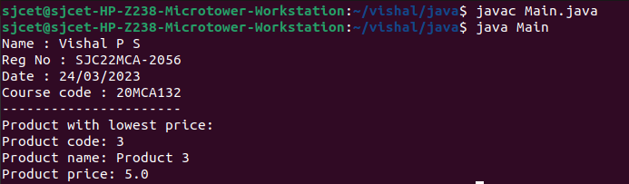

**2. Read 2 matrices from the console and perform matrix addition.**

**ANS:**

import java.util.Scanner;

public class MatrixAdd

{

public static void main(String[] args)

{

System.out.println("Name : Vishal P S \nReg No : SJC22MCA-2056 \nDate : 24/03/2023 \nCourse code : 20MCA132");

System.out.println("----------------------");

Scanner input = new Scanner(System.in);

// Read the dimensions of the matrices

System.out.print("Enter the number of rows: ");

int rows = input.nextInt();

System.out.print("Enter the number of columns: ");

int cols = input.nextInt();

// Create the matrices

int[][] matrix1 = new int[rows][cols];

int[][] matrix2 = new int[rows][cols];

// Read the values of the matrices

System.out.println("Enter the values of matrix 1:");

for (int i = 0; i < rows; i++)

{

for (int j = 0; j < cols; j++)

{

matrix1[i][j] = input.nextInt();

}

}

System.out.println("Enter the values of matrix 2:");

for (int i = 0; i < rows; i++)

{

for (int j = 0; j < cols; j++)

{

matrix2[i][j] = input.nextInt();

}

}

// Perform matrix addition

int[][] result = new int[rows][cols];

for (int i = 0; i < rows; i++)

{

for (int j = 0; j < cols; j++)

{

result[i][j] = matrix1[i][j] + matrix2[i][j];

}

}

// Print the result

System.out.println("The sum of the matrices is:");

for (int i = 0; i < rows; i++)

{

for (int j = 0; j < cols; j++)

{

System.out.print(result[i][j] + " ");

}

System.out.println();

}

}

}

**OUTPUT**

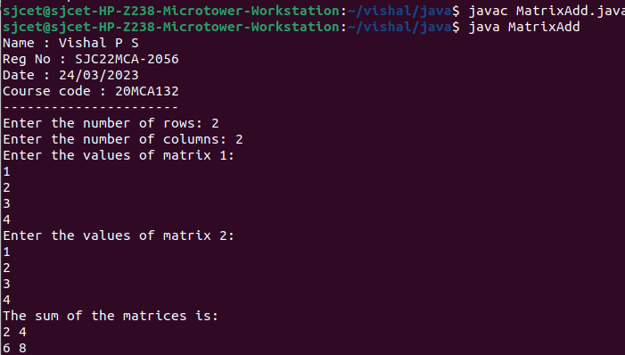

**3. Add complex numbers**

**ANS:**

public class ComplexNumber

{

private double real;

private double imaginary;

public ComplexNumber(double real, double imaginary)

{

this.real = real;

this.imaginary = imaginary;

}

public ComplexNumber add(ComplexNumber other)

{

double newReal = this.real + other.real;

double newImaginary = this.imaginary + other.imaginary;

return new ComplexNumber(newReal, newImaginary);

}

public String toString()

{

if (imaginary >= 0)

{

return real + " + " + imaginary + "i";

} else

{

return real + " - " + (-imaginary) + "i";

}

}

public static void main(String[] args)

{

System.out.println("Name : Vishal P S \nReg No : SJC22MCA-2056 \nDate : 24/03/2023 \nCourse code : 20MCA132");

System.out.println("----------------------");

ComplexNumber num1 = new ComplexNumber(3, 4);

ComplexNumber num2 = new ComplexNumber(1, -2);

ComplexNumber sum = num1.add(num2);

System.out.println("Sum: " + sum);

}

}

**OUTPUT**

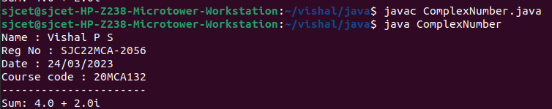

**4. Read a matrix from the console and check whether it is symmetric or not.**

**ANS:**

public class ComplexNumber

{

private double real;

private double imaginary;

public ComplexNumber(double real, double imaginary)

{

this.real = real;

this.imaginary = imaginary;

}

public ComplexNumber add(ComplexNumber other)

{

double newReal = this.real + other.real;

double newImaginary = this.imaginary + other.imaginary;

return new ComplexNumber(newReal, newImaginary);

}

public String toString()

{

if (imaginary >= 0)

{

return real + " + " + imaginary + "i";

} else

{

return real + " - " + (-imaginary) + "i";

}

}

public static void main(String[] args)

{

System.out.println("Name : Vishal P S \nReg No : SJC22MCA-2056 \nDate : 24/03/2023 \nCourse code : 20MCA132");

System.out.println("----------------------");

ComplexNumber num1 = new ComplexNumber(3, 4);

ComplexNumber num2 = new ComplexNumber(1, -2);

ComplexNumber sum = num1.add(num2);

System.out.println("Sum: " + sum);

}

}

**OUTPUT**

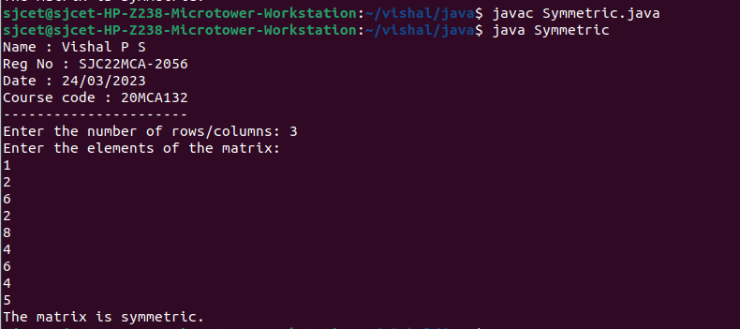

**5. Create CPU with attribute price. Create inner class Processor (no. of cores, manufacturer)and static nested class RAM (memory, manufacturer). Create an object of CPU and print information of Processor and RAM.**

**ANS:**

public class cpu

{

int price;

class processor

{

int cores;

String producer;

processor(int noC, String manu)

{

cores=noC;

producer=manu;

}

void display()

{

System.out.println("\nProcessor info");

System.out.println("No. of Cores = "+cores);

System.out.println("Manufacturer = "+producer+"\n");

}

}

static class ram

{

int mem;

String manuf;

ram(int memory,String producer )

{

mem=memory;

manuf=producer;

}

void display()

{

System.out.println("\nRAM info");

System.out.println("Memory = "+mem+" GB");

System.out.println("Manufacturer = "+manuf+"\n");

}

}

public static void main(String[] args)

{

System.out.println("Name : Vishal P S \nReg No : SJC22MCA-2056 \nDate : 24/03/2023 \nCourse code : 20MCA132");

System.out.println("----------------------");

cpu.ram obj1= new cpu.ram(8,"Intel");

cpu obj2 = new cpu();

cpu.processor obj3 = obj2.new processor(8,"Samsung");

obj1.display();

obj3.display();

}

}

**OUTPUT**

