ARMSTRONG

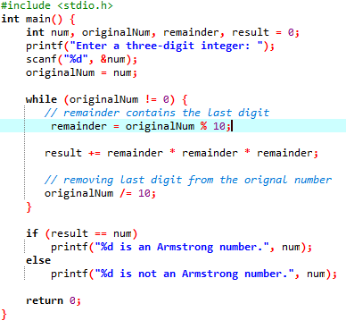

OUTPUT

