SUBTRACTION

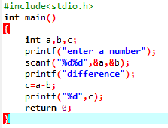

OUTPUT

