Experiment-1A: Date: 13-07-2026
****
Aim: Write a HTML program, to explain the working of lists.
Source Code:
<!doctype html>
<html>
<head>
<title>Document</title>
</head>
<body>
<h1>Roll No: 249XA33161, Name: Y KALPANA</h1>
<h1>----OUTPUT----</h1>
<br />
<h2>1.Ordered List</h2>
<ol>
<li>MPC</li>
<li>BIPC</li>
<li>HEC</li>
<li>CEC</li>
</ol>
<h2>2.Unordered List</h2>
<ul>
<li>BLue</li>
<li>Green</li>
<li>Black</li>
<li>White</li>
</ul>
<h2>Nested List</h2>
<ul>
<li>
Frontend
<ul>
<li>HTML</li>
<li>CSS</li>
<li>Javascript</li>
<li>React</li>
</ul>
</li>
<li>
Backend
<ul>
<li>Nodejs</li>
<li>MySQL</li>
<li>MongoDB</li>
</ul>
</li>
</ul>
<h2>4.Ordered List inside an Unordered List</h2>
<ol>
<li>Languages
<ol>
<li>English</li>
<li>Telugu</li>
<li>Hindi</li>
</ol>
</li>
</ol>
<h2>5.Definition List</h2>
<dl>
<dt>CPU
<dd>Central Processing Unit</dd>
</dt>
<dt>HTTP
<dd>Hyper Text Transfer Protocol</dd>
</dt>
<dt>GPS
<dd>Global positioning System</dd>
</dt>
</dl>
<h1>----End of the Output--</h1>
<h1>Roll No: 249XA33161, Name: Y KALPANA</h1>
</body>
</html>

Snapshot of the Output Webpage:
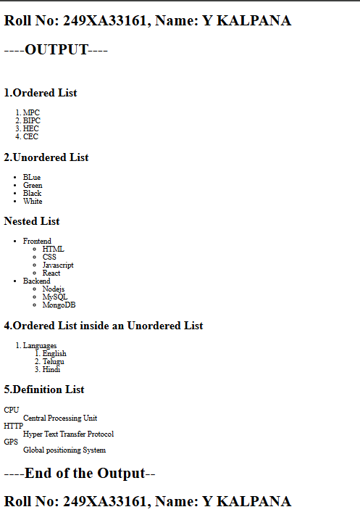


Signature of the Faculty

Experiment-1B: Date: 13-07-2026
****
Aim: Write a HTML program to explain the working of hyperlinks using <a> tag and href, target attributes.
Source Code:
<!doctype html>
<html lang="en">
<head>
<title>Document</title>
</head>
<body>
<h1>Roll No: 249XA33161, Name: Y KALPANA</h1>
<h1>----OUTPUT----</h1>
<h2>Working of Hyperlinks</h2>
<p>To visit Linkedin: <a href="https://in.linkedin.com/">Linkedin</a></p>
<p>To vist Flipcart: <a href="https://www.flipkart.com/">Flipcart</a></p>
<p>
To visit Learnvern: <a href="https://www.learnvern.com/">LearnVern</a>
</p>
<h1>----End of the Output--</h1>
<h1>Roll No: 249XA33161, Name: Y KALPANA</h1>
</body>
</html>

Snapshot of the Output Webpage: 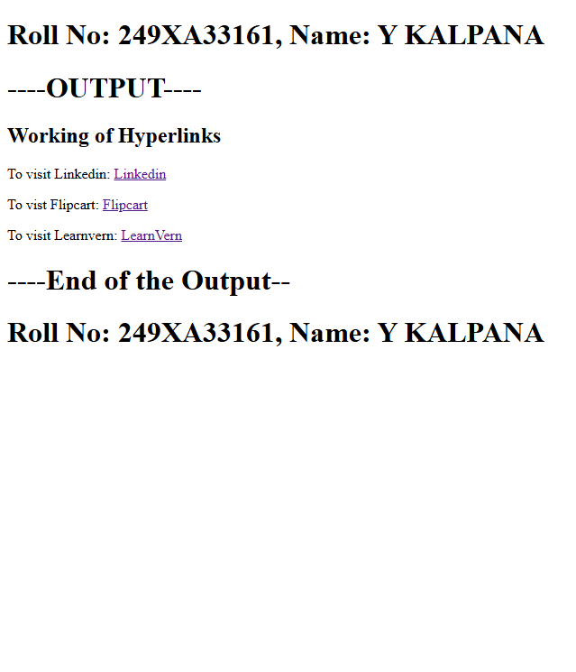

Signature of the Faculty

Experiment-1C: Date: 13-07-2026
****
Aim: Write a HTML program to create a HTML document that has your image and your friend’s image with a specific height and width. Also, when clicked on the images it should navigate to their respective profiles.
Source Code:
<!doctype html>
<html lang="en">
<head>
<meta charset="UTF-8" />
<meta name="viewport" content="width=device-width, initial-scale=1.0" />
<title>Document</title>
</head>
<body>
<h2>Roll No: 249XA33161 , Name: Kalpana</h2>
<h2>---OUTPUT---</h2>
<h1>Clickable Images</h1>
<h2>Linkdin Photo</h2>
<a href="https://in.linkedin.com/" target="_blank">
<img src="images.png" alt="Linkedin photo" width="250" height="250" />
</a>
<br /><br />
<h2>Flipcart Photo</h2>
<a href="https://www.flipkart.com/" target="_blank">
<img src="flipcart.png" alt="Flipcart photo" width="250" height="250" />
</a>
<h2>Roll No: 249XA33161 , Name: Kalpana</h2>
<h2>---END OF THE OUTPUT---</h2>
</body></html>
Snapshot of the Output Webpage: 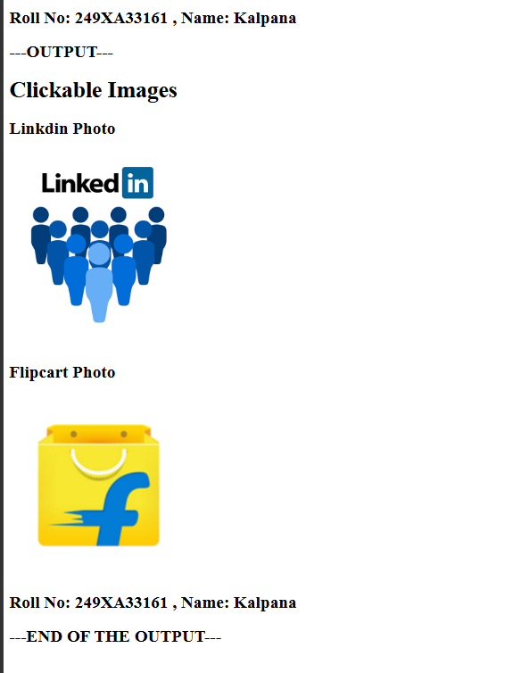

Signature of the Faculty

Experiment-1D: Date: 13-07-2026
****
Aim: Write a HTML program to create a HTML document that has your image and your friend’s image with a specific height
Source Code:
<!doctype html>
<html lang="en">
<head>
<meta charset="UTF-8" />
<meta name="viewport" content="width=device-width, initial-scale=1.0" />
<title>Image Gallery</title>
</head>
<body align="center">
<h2>Roll No: 249XA33161 , Name: Kalpana</h2>
<h2>---OUTPUT---</h2>
<h1>Image Gallery</h1>
<p>Click any thumbnail to view the Full- size Image</p>
<br />
<a href="Instagram.webp" target="_blank">
<img src="Instagram.webp" alt="Linkedin photo" width="150" height="150" />
</a>
<a href="whatsapp.png" target="_blank">
<img src="whatsapp.png" alt="Linkedin photo" width="150" height="150" />
</a>
<a href="youtube.png" target="_blank">
<img src="youtube.png" alt="Linkedin photo" width="150" height="150" />
</a>
<a href="Twitter.jpeg" target="_blank">
<img src="Twitter.jpeg" alt="Flipcart photo" width="150" height="150" />
</a>
<br />
<h2>Roll No: 249XA33161 , Name: Kalpana</h2>
<h2>---END OF THE OUTPUT---</h2>
</body>
</html>
Snapshot of the Output Webpage: 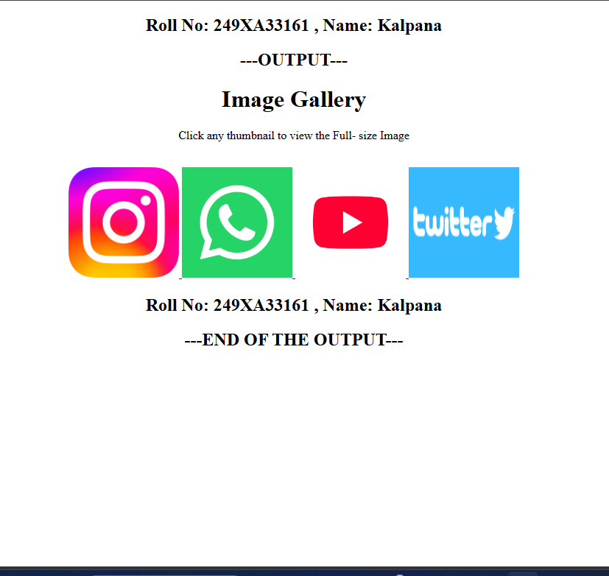

Signature of the Faculty

Experiment-2A: Date: 20-07-2026
****
Aim: Write a HTML program to create a HTML document that has your image and your friend’s image with a specific height
Source Code:
<!doctype html>
<html lang="en">
<head>
<meta charset="UTF-8" />
<meta name="viewport" content="width=device-width, initial-scale=1.0" />
<title>HTML Table Example</title>
</head>
<body>
<h2>Roll No: 249XA33161 , Name: Kalpana</h2>
<h2>---OUTPUT---</h2>
<h2>Student Course Result Table</h2>
<table border="2" cellpadding="10" cellspacing="0">
<tr>
<th>S.No</th>
<th>Name</th>
<th>Year</th>
<th>Course Name</th>
<th>Percentage</th>
</tr>
<tr>
<td>1</td>
<td>Kalpana</td>
<td>III</td>
<td>Python</td>
<td>90</td>
</tr>
<tr>
<td>2</td>
<td>Dhana</td>
<td>II</td>
<td>Java</td>
<td>80</td>
</tr>
<tr>
<td rowspan="2">3</td>
<td rowspan="2">Ramya</td>
<td>III</td>
<td>ML</td>
<td>65</td>
</tr>
<tr>
<td>III</td>
<td>SQL</td>
<td>70</td>
</tr>
<tr>
<td colspan="5" align="center">Total Students : 3</td>
</tr>
</table>
<h2>Roll No: 249XA33161 , Name: Kalpana</h2>
<h2>---END OF THE OUTPUT---</h2>
</body>
</html>

Snapshot of the Output Webpage:

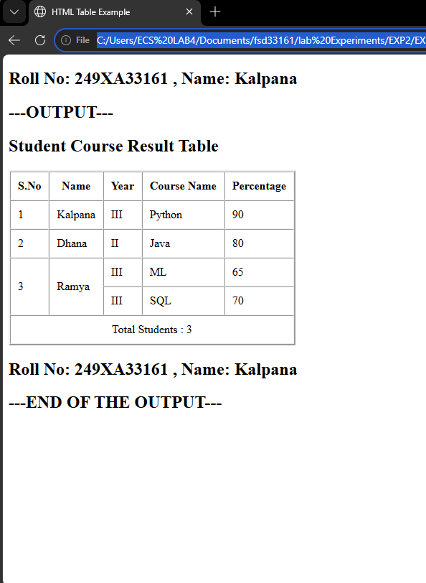



Experiment-2B: Date: 20-07-2026
****
Aim: Write a HTML program, to explain the working of tables by preparing a timetable.
Source Code:
<!doctype html>
<html>
<head>
<title>Class Time Table</title>
</head>
<body>
<h2 align="center">Roll No: 249XA33161 , Name: Kalpana</h2>
<h2 align="center">---OUTPUT---</h2>
<br /><br />
<table border="2" cellpadding="10" cellspacing="5" align="center">
<caption>
<h2>III B.Tech CSE (AI & ML) Sec-C Time Table</h2>
</caption>

<tr bgcolor="lightgray">
<th>Day</th>
<th>9:00-10:00</th>
<th>10:00-11:00</th>
<th>11:00-11:20</th>
<th>11:20-12:20</th>
<th>12:20-1:20</th>
<th>1:20-2:00</th>
<th>2:00-3:00</th>
<th>3:00-4:00</th>
<th>4:00-5:00</th>
</tr>
<tr>
<td><b>Monday</b></td>
<td>NLP</td>
<td>OSSP</td>
<td rowspan="6" align="center"><b>BREAK</b></td>
<td>TPR</td>
<td>DVT</td>
<td rowspan="6" align="center"><b>LUNCH</b></td>
<td colspan="3" align="center">AI & System Programming Lab</td>
</tr>
<tr>
<td><b>Tuesday</b></td>
<td>OS</td>
<td>IQTA</td>
<td>NLP</td>
<td>DVT</td>
<td colspan="3" align="center">Full Stack Web Development-1 Lab</td>
</tr>
<tr>
<td><b>Wednesday</b></td>
<td>AI</td>
<td>IQTA</td>
<td>OS</td>
<td>TPR</td>
<td>DVT</td>
<td>IQTA</td>
<td>Mentoring</td>
</tr>
<tr>
<td><b>Thursday</b></td>
<td>NLP</td>
<td>CN</td>
<td>DVT</td>
<td>OSSP</td>
<td colspan="3" align="center">ITCA</td>
</tr>
<tr>
<td><b>Friday</b></td>
<td>DVT</td>
<td>NLP</td>
<td>OSSP</td>
<td>AI</td>
<td colspan="3" align="center">ITCA</td>
</tr>
<tr>
<td><b>Saturday</b></td>
<td>DVT</td>
<td>TPW</td>
<td colspan="2" align="center">ITCA</td>
<td>IQTA</td>
<td colspan="2" align="center">Practice Session</td>
</tr>
</table>
<br />
<br />
<h2 align="center">Roll No: 249XA33161 , Name: Kalpana</h2>
<h2 align="center">---END OF THE OUTPUT---</h2>
</body>
</html>

Snapshot of the Output Webpage:

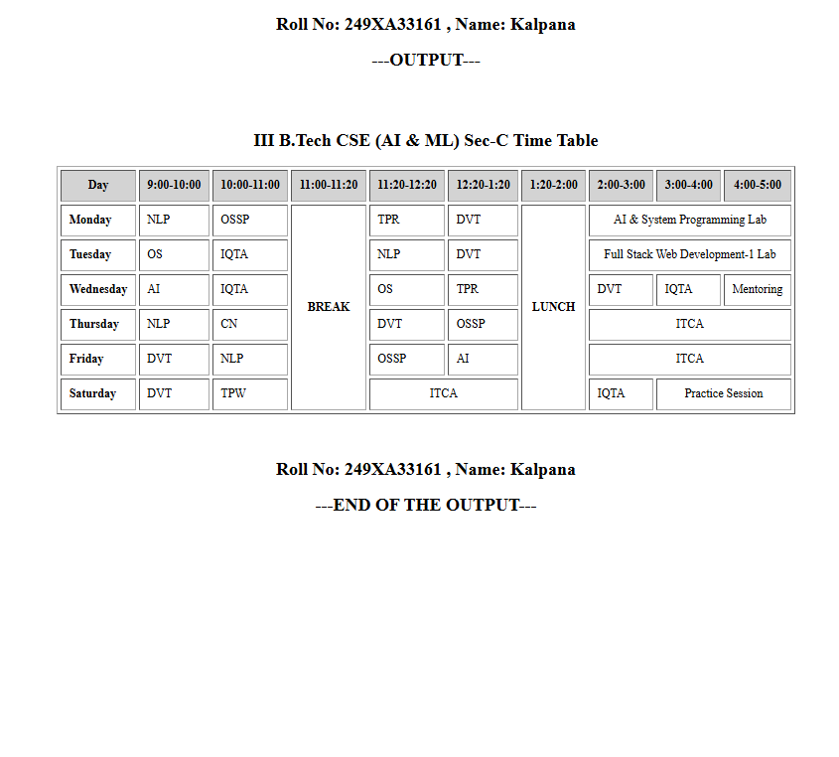

Experiment-2C: Date: 20-07-2026
****
Aim: Write a HTML program to explain the working of forms by designing Registration form.
Source Code:
<!doctype html>
<html lang="en">
<head>
<meta charset="UTF-8" />
<meta name="viewport" content="width=device-width, initial-scale=1.0" />
<title>Document</title>
</head>
<body>
<h2 align="center">Roll No: 249xa33161 , Name: Y.Kalpana</h2>
<h2 align="center">---OUTPUT---</h2>
<h2 align="center">Student Registration Form</h2>

<form>
<table border="1" cellpadding="10" align="center">
<tr>
<td>First Name</td>
<td><input type="text" name="name" /></td>
</tr>
<tr>
<td>Last Name</td>
<td><input type="text" name="name" /></td>
</tr>
<tr>
<td>Password</td>
<td><input type="password" name="password" /></td>
</tr>

<tr>
<td>Age</td>
<td><input type="number" name="age" /></td>
</tr>
<tr>
<td>Phone number</td>
<td><input type="phone number" name="phone number" /></td>
</tr>
<tr>
<td>Date of Birth</td>
<td><input type="date" name="dob" /></td>
</tr>

<tr>
<td>Gender</td>
<td>
<input type="radio" name="gender" /> Male
<input type="radio" name="gender" /> Female
<input type="radio" name="gender" /> Other
</td>
</tr>

<tr>
<td>Hobbies</td>
<td>
<input type="checkbox" /> Reading <input type="checkbox" /> Sports
<input type="checkbox" /> Music <input type="checkbox" /> Coding
</td>
</tr>

<tr>
<td>Branch</td>
<td>
<select>
<option>CSE</option>
<option>CSE (AI & ML)</option>
<option>ECE</option>
<option>EEE</option>
<option>Mechanical</option>
<option>Civil</option>
</select>
</td>
</tr>

<tr>
<td>Address</td>
<td>
<textarea rows="4" cols="30"></textarea>
</td>
</tr>

<tr>
<td colspan="2" align="center">
<input type="submit" value="Submit" />
<input type="reset" value="Reset" />
</td>
</tr>
</table>
</form>
<h2 align="center">Roll No: 249XA33161 , Name: Kalpana</h2>
<h2 align="center">---END OF THE OUTPUT---</h2>
</body>
</html>

Snapshot of the Output Webpage:
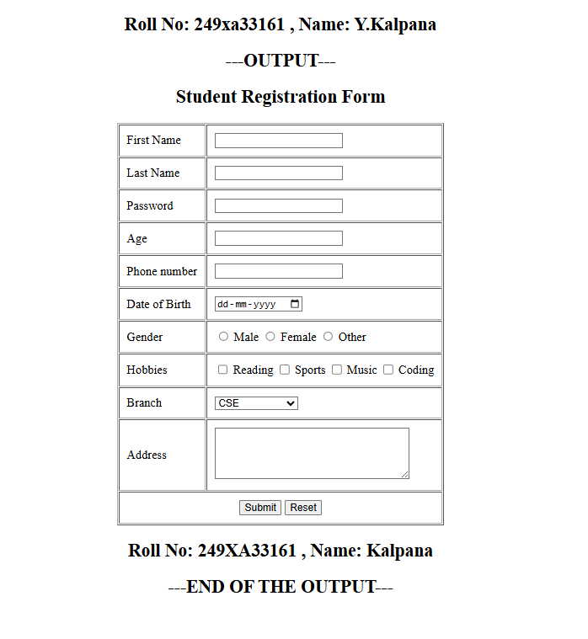

Experiment-2D: Date: 20-07-2026
****
Aim: Write a HTML program to explain the working of frames, such that page is to be divided into 3 parts on either direction.
Source Code:
<!doctype html>
<html lang="en">
<head>
<meta charset="UTF-8" />
<meta name="viewport" content="width=device-width, initial-scale=1.0" />
<title>Document</title>
</head>
<frameset cols="30%,40%,30%">
<frame src="image.html" noresize></frame>
<frame src="paragraph.html" noresize></frame>
<frame src="links.html" noresize></frame>
<noframes>
<body>
<h2>Roll No: 249XA33161 , Name: Kalpana</h2>
<h2>---OUTPUT---</h2>
Your browser does not support frames.
<h2>Roll No: 249XA33161 , Name: Kalpana</h2>
<h2>---END OF THE OUTPUT---</h2>
</body>
</noframes>
</frameset>
</html>
Snapshot of the Output Webpage:
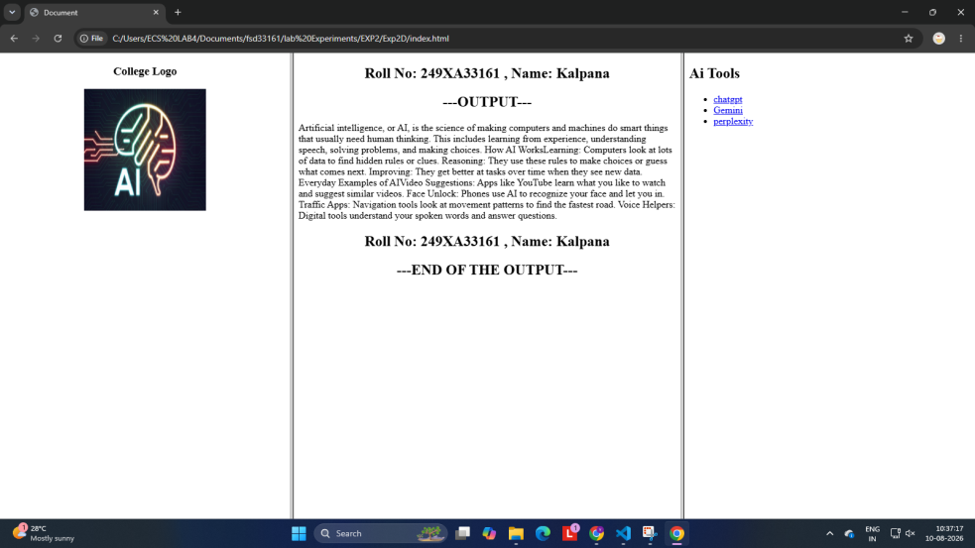

Experiment-3A: Date: 27-07-2026
****
Aim: Write a HTML program, that makes use of <article>, <aside>, <figure>, <figcaption>, <footer>, <header>, <main>, <nav>, < section>, <div>, <span> tags.
Source Code:
<!doctype html>
<html>
<head>
<title>Frontend Development</title>
</head>
<body>
<h2>Roll No: 249XA33161, Name: Y KALPANA</h2>
<h2>----Output--</h2>
<br />
<header>
<h1>Full Stack Web Development Lab</h1>
<p>These are the parts of Full Stack</p>
</header>

<nav>
<a href="#">HTML</a> | <a href="#">CSS</a> | <a href="#">JavaScript</a>
</nav>

<section>
<article>
<h2>HTML,CSS,JS</h2>
<p></p>
</article>

<aside>
<h3>Did You Know?</h3>
<p>
Frontend development is the client-side part of a website or app that
users directly see and interact with.
</p>
</aside>
</section>

<figure>
<img src="Front-End-Development.jpg” width="250" height="180”alt="logos"
/>
<figcaption>Figure 1: Frontend</figcaption>
</figure>
<details>
<summary>Click to Know More</summary>
<p>
HTML provides the skeleton and structural content of the page. It is
a programming language; it is a markup language that uses "tags" to
the browser what the content CSS controls the visual presentation and
layout of the HTML elements. It transforms a plain text document into
beautiful, designed webpage. JavaScript is a full programming language
that brings the webpage to life by adding interactivity and logic.
</p>
</details>

<footer>
<p>G. Pulla Reddy Engineering College</p>
</footer>
<br />
<h2>----End of the Output--</h2>
<h2>Roll No: 249XA33161, Name: Y KALPANA</h2>
</body>
</html>

Snapshot of the Output Webpage:

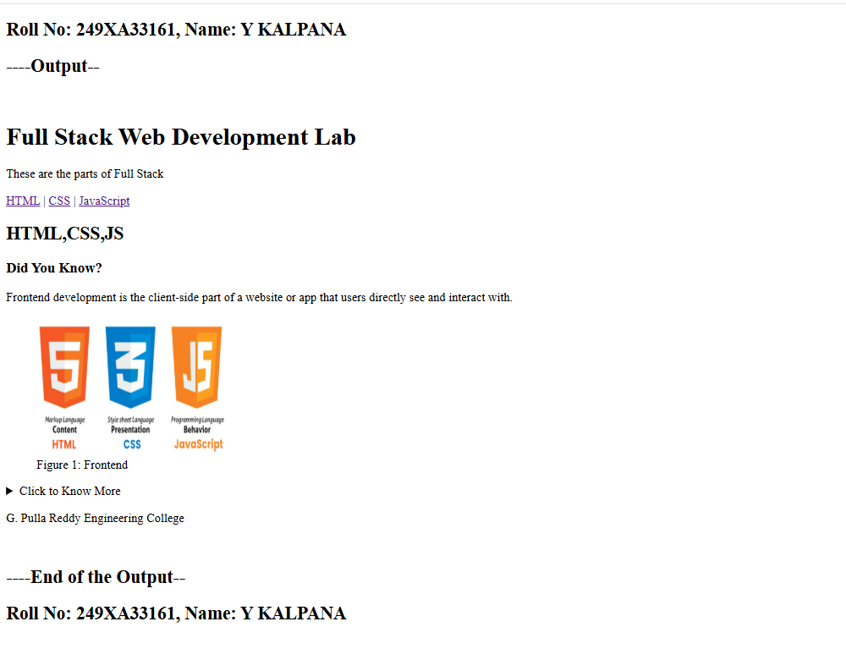
Experiment-3B: Date: 27-07-2026
****
Aim: Write a HTML program, to embed audio and video into HTML web page.
Source Code: (HTML)
<!doctype html>
<html>
<head>
<title>Audio and Video</title>
</head>
<body>
<h2>Roll No: 249XA33161, Name: Y KALPANA</h2>
<h2>----Output--</h2>
<h2>Embedding Audio</h2>
<audio controls>
<source src="national.mp3" type="audio/mpeg" />
Your browser does not support the audio element.
</audio><br /><br />
<h2>Embedding Video</h2>
<video width="500" height="300" controls>
<source src="yoga.mp4" type="video/mp4" />
Your browser does not support the video tag.
</video>
<h2>----End of the Output--</h2>
<h2>Roll No: 249XA33161, Name: Y KALPANA</h2>
</body>
</html>

Snapshot of the Output Webpage:

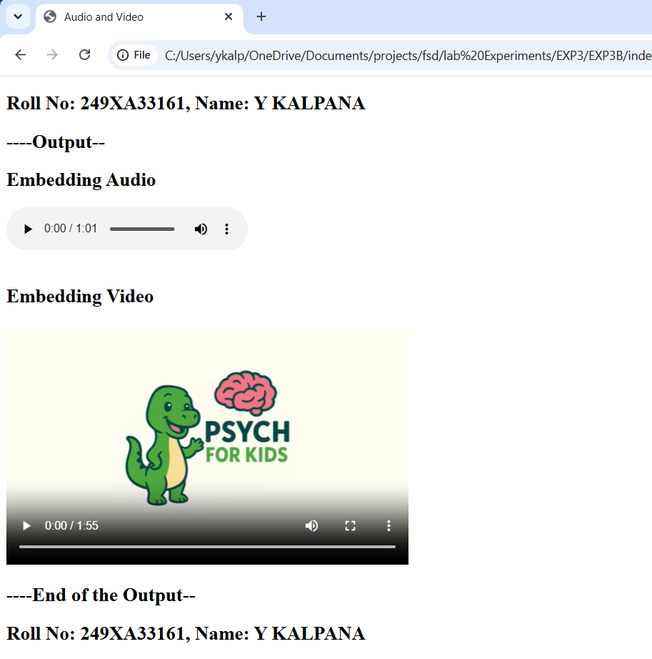

Experiment-3C: Date: 27-07-2026
****
Aim: Write a program to apply different types (or levels of styles or style specification formats) - inline, internal, external styles to HTML elements (identify selector, property and value).
Source Code: (HTML)
<!doctype html>
<html>
<head>
<title>Types of CSS</title>
<link rel="stylesheet" href="style.css" />
<style>
h2 {
color: black;
text-align: center;
}
p {
color: purple;
font-size: 20px;
text-align: center;
}
</style>
</head>
<body>
<h2>Roll No: 249XA33161, Name: Y KALPANA</h2>
<h2>----Output--</h2>
<br /><br />
<h2>Internal CSS Example</h2>
<p>This paragraph uses Internal CSS.</p>
<h3 style="color: rgb(218, 39, 39); text-align: center">
This heading uses Inline CSS.
</h3>
<h1>This heading uses External CSS.</h1>
<br /><br />
<h2>----End of the Output--</h2>
<h2>Roll No: 249XA33161, Name: Y KALPANA</h2>
</body>
</html>

Source Code: (CSS):
h1 {
color: purple;
text-align: center;
background-color: rgb(135, 212, 212);
border: 2px solid black;
padding: 10px;
}

Snapshot of the Output Webpage:

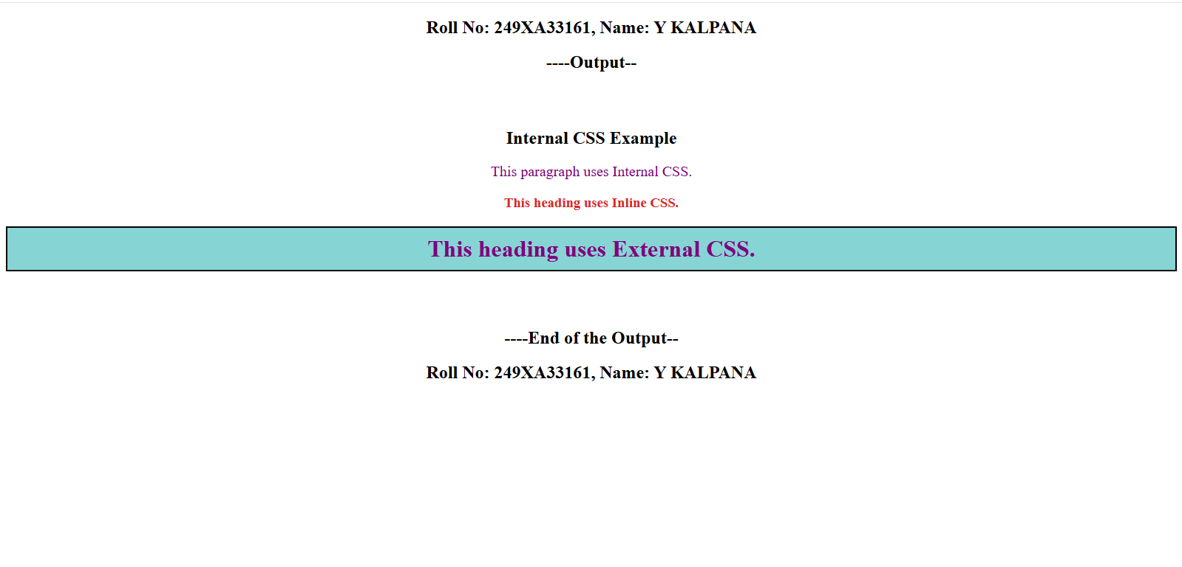

Experiment-4A: Date: 03-08-2026
****
Aim: Write a program to apply different types of selector forms Simple selector (element, id, class, group, universal)
Source Code: (HTML)
<!doctype html>
<html>
<head>
<title>Simple Selectors</title>
<link href="style.css" rel="stylesheet" />
</head>
<body>
<h2>Roll No: 249XA33161, Name: Y KALPANA</h2>
<h2>----OUTPUT----</h2> <br />
<h1 id="heading">ID Selector Example</h1>
<h1>Element Selector</h1>
<p class="note">This line uses Class Selector.</p>
<h3>Group Selector</h3>
<p>This paragraph is styled using Group Selector.</p> <br />
<h2>----End of the Output--</h2>
<h2>Roll No: 249XA33161, Name: Y KALPANA</h2>
</body>
</html>

Source Code: (CSS)
/* Element Selector */
h1 {
color: rgb(235, 10, 122);
}
/* ID Selector */
#heading {
color: rgb(55, 19, 216);
text-align: center;
}
/* Class Selector */
.note {
color: rgb(130, 17, 223);
font-size: 20px;
background-color: rgb(238, 193, 161);
}
/* Group Selector */
h3,
p {
background-color: rgb(96, 230, 174);
}
/* Universal Selector */
* {
font-family: Arial;
}

Snapshot of the Output Webpage:
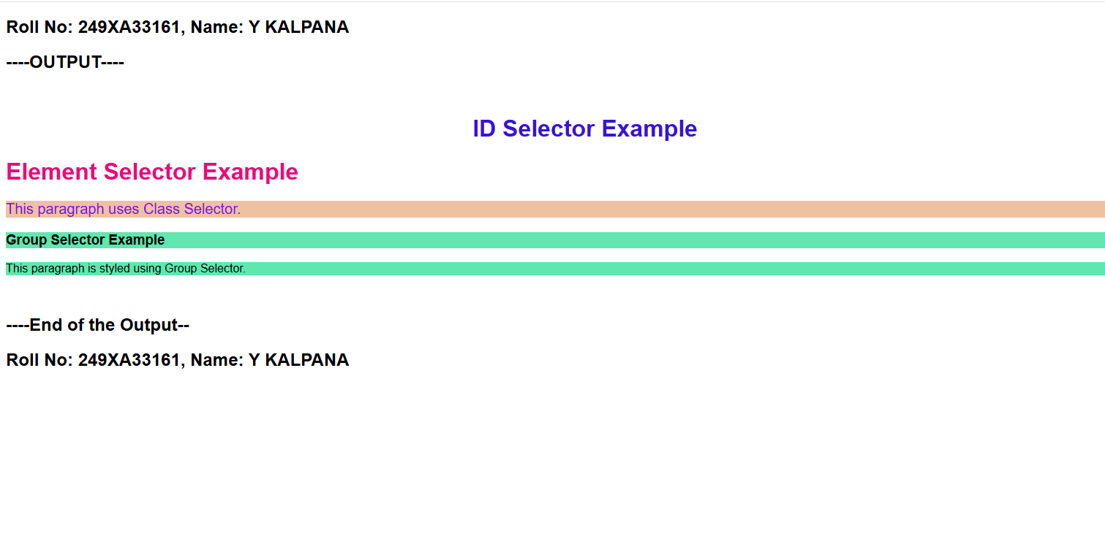

Experiment-4B: Date: 03-08-2026
****
Aim: Write a program to apply different types of selector forms. Combinator selector (descendant, child, adjacent sibling, general sibling)
Source Code: (HTML)
<!doctype html>
<html>
<head>
<title>Combinator Selectors</title>
<link href="style.css" rel="stylesheet" />
</head>
<body>
<h2>Roll No: 249XA33161, Name: Y KALPANA</h2>
<h2>----OUTPUT----</h2> <br />
<div>
<p>Descendant Selector Example</p>
<p>WELCOME</p>
</div>
<section>
<h1>Child Selector Example</h1>
<h2>GPREC</h2>
<h1>KURNOOL</h1>
</section>
<h3>Adjacent Sibling</h3>
<p>this came after h3</p>
<p>Kalpana</p>
<h4>General Sibling</h4>
<p>I am passionate in Machine Learning</p>
<p>So i want to learn Machine Learning</p> <br />
<h2>----End of the Output--</h2>
<h2>Roll No: 249XA33161, Name: Y KALPANA</h2>
</body>
</html>
Source Code: (CSS)
/* Descendant Selector */
div p {
color: rgb(166, 36, 218);
}

/* Child Selector */
section > h1 {
color: red;
}

/* Adjacent Sibling Selector */
h3 + p {
background-color: rgb(188, 223, 228);
}

/* General Sibling Selector */
h4 ~ p {
color: blue;
}

Snapshot of the Output Webpage:

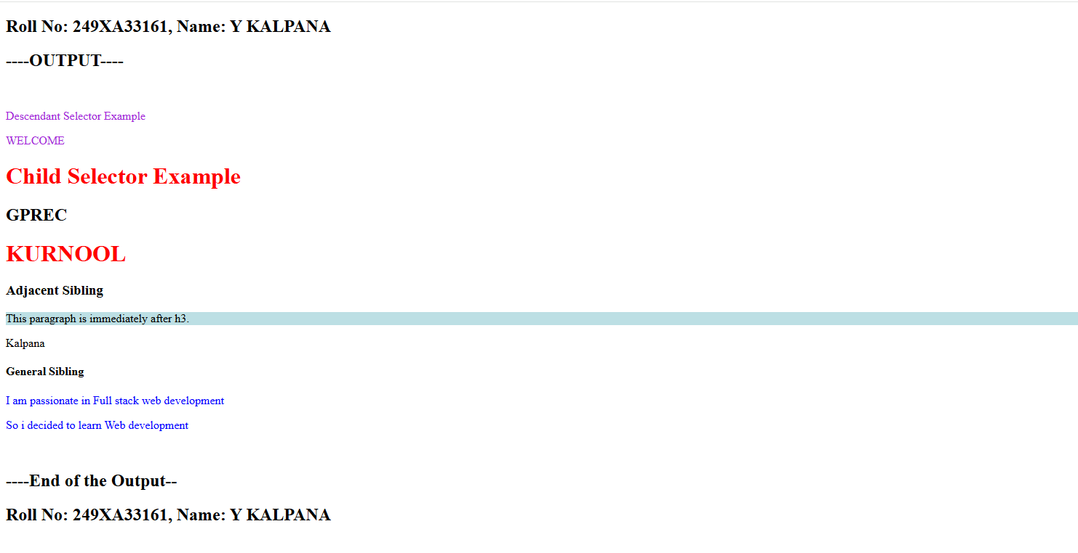

Experiment-4C: Date: 03-08-2026
****
Aim: Write a program to apply different types of selector forms. Pseudo-class selector.
Source Code: (HTML)
<!doctype html>
<html>
<head>
<title>Pseudo-class Selector</title>
<link href="style.css" rel="stylesheet" />
</head>
<body>
<h2>Roll No: 249XA33161, Name: Y KALPANA</h2>
<h2>----Output--</h2>
<h2>Pseudo-class Example</h2>
<a href="https://chatgpt.com/"> Chatgpt </a>
<br /><br />
Enter Name:
<input type="text" /><br /><br />
Enter Branch:
<input type="text" />
<br />
<br />
<h2>----End of the Output--</h2>
<h2>Roll No: 249XA33161, Name: Y KALPANA</h2>
</body>
</html>

Source Code: (CSS)
a:link {
color: rgb(145, 230, 65);
}

a:visited {
color: blue;
}

a:hover {
color: rgb(100, 97, 230);
font-size: 20px;
}

a:active {
color: green;
}

input:focus {
background-color: rgb(98, 222, 231);
}

Snapshot of the Output Webpage:

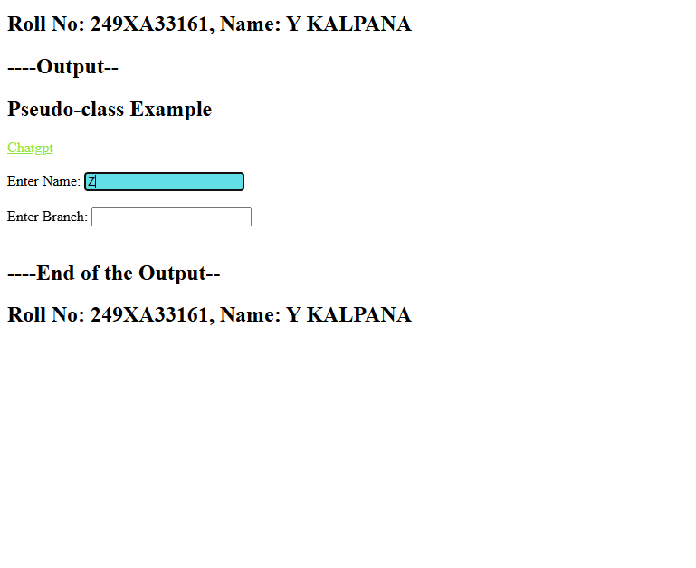

Experiment-4D: Date: 03-08-2026
****
Aim: Write a program to apply different types of selector forms. Pseudo-element selector.
Source Code: (HTML)
<!doctype html>
<html lang="en">
<head>
<meta charset="UTF-8" />
<meta name="viewport" content="width=device-width, initial-scale=1.0" />
<title>Pseudo-element Selector</title>
<link href="style.css" rel="stylesheet" />
</head>
<body>
<h1>Roll No: 249XA33161, Name: Y KALPANA</h1>
<h1>----Output--</h1>
<h2>Pseudo-element Example</h2>
<p>
HTML, CSS, and JavaScript are the three foundational technologies used to
build everything you see and interact with on the web. They work together
as a team to create modern, functional websites.
</p>
<br />
<br />
<h1>----End of the Output--</h1>
<h1>Roll No: 249XA33161, Name: Y KALPANA</h1>
</body>
</html>
Source Code: (CSS)
p::first-letter {
font-size: 35px;
color: red;
}

p::first-line {
color: blue;
}

h2::before {
content: "* ";
}

h2::after {
content: " *";
}

::selection {
background: yellow;
color: red;
}

Snapshot of the Output Webpage:
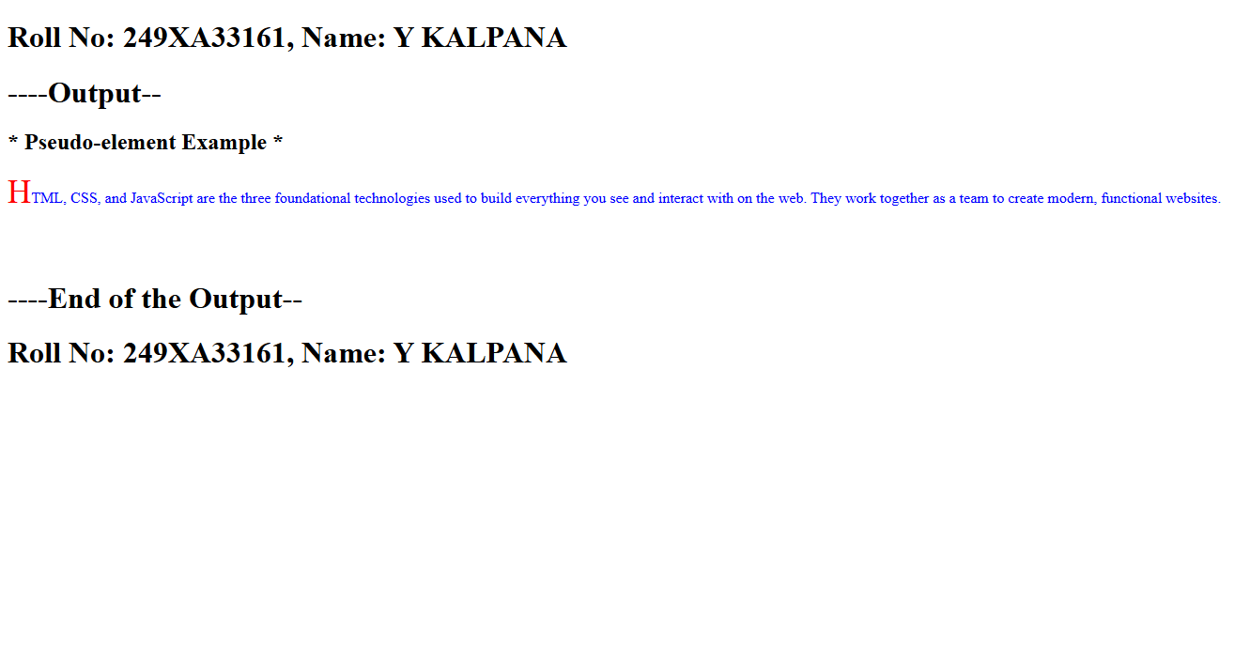

Experiment-4E: Date: 03-08-2026
****
Aim: Write a program to apply different types of selector forms. Attribute selector.
Source Code: (HTML)
<!doctype html>
<html>
<head>
<title>Attribute Selector</title>
<link href="style.css" rel="stylesheet" />
</head>
<body>
<h2>Roll No: 249XA33161, Name: Y KALPANA</h2>
<h2>----Output--</h2>
<br />
<h2>Attribute Selector Example</h2>
Name:
<input type="text" />
<br /><br />
Password:
<input type="password" />
<br /><br />
<a href="https://chatgpt.com/" target="_blank"> Chatgpt </a>
<br />
<br /><br />
<a href="home.html"> Home Page </a>
<br />
<h2>----End of the Output--</h2>
<h2>Roll No: 249XA33161, Name: Y KALPANA</h2>
</body>
</html>

Source Code: (CSS)
input[type="text"] {
background-color: rgb(134, 224, 139);
}

input[type="password"] {
background-color: rgb(117, 180, 182);
}

a[target] {
color: green;
font-weight: bold;
}

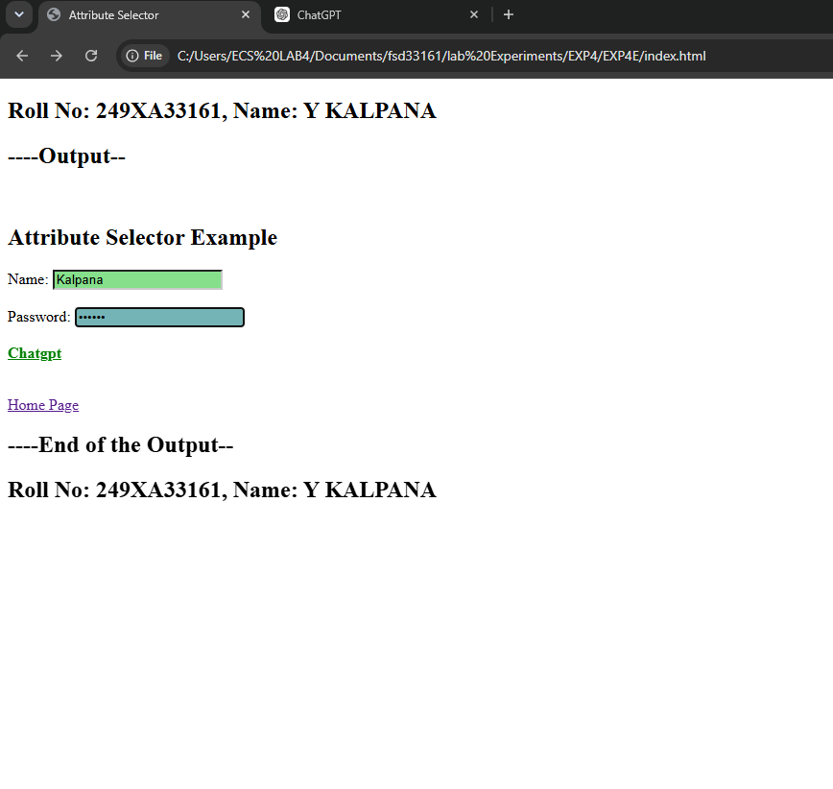
Snapshot of the Output Webpage:

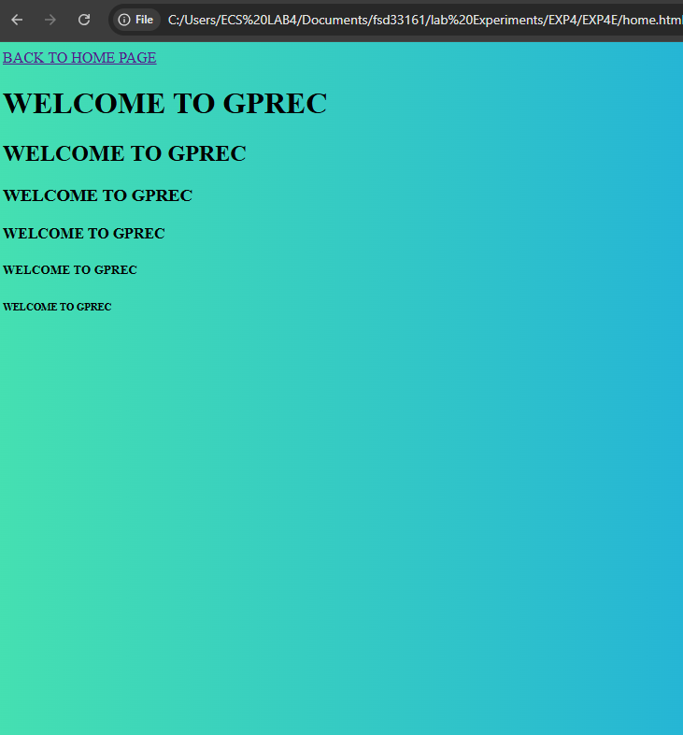

Experiment-5A: Date: 10-08-2026
****
Aim: Write a program to demonstrate the various ways you can reference a color in CSS.
Source Code: (HTML)
<!doctype html>
<html>
<head>
<title>CSS Colors</title>
<link href="style.css" rel="stylesheet" />
</head>
<body>
<p>Roll No: 249XA33161, Name: Y KALPANA</p>
<p style="color: rgb(0, 0, 0)"></p>
<p>----Output--</p> <br />
<h1>Color using Name</h1>
<h2>Color using HEX Code</h2>
<h3>Color using RGB</h3>
<h4>Color using RGBA</h4>
<h5>Color using HSL</h5>
<h6>Color using HSLA</h6> <br />
<p>----End of the Output--</p>
<p>Roll No: 249XA33161, Name: Y KALPANA</p>
</body>
</html>

Source Code: (CSS)
h1 {
color: rgb(223, 43, 193);
}
h2 {
color: #0000ff;
}
h3 {
color: rgb(0, 128, 0);
}
h4 {
color: rgba(230, 116, 23, 0.5);
}
h5 {
color: hsl(300, 100%, 40%);
}
h6 {
color: hsla(210, 100%, 40%, 0.7);
}

Snapshot of the Output Webpage:

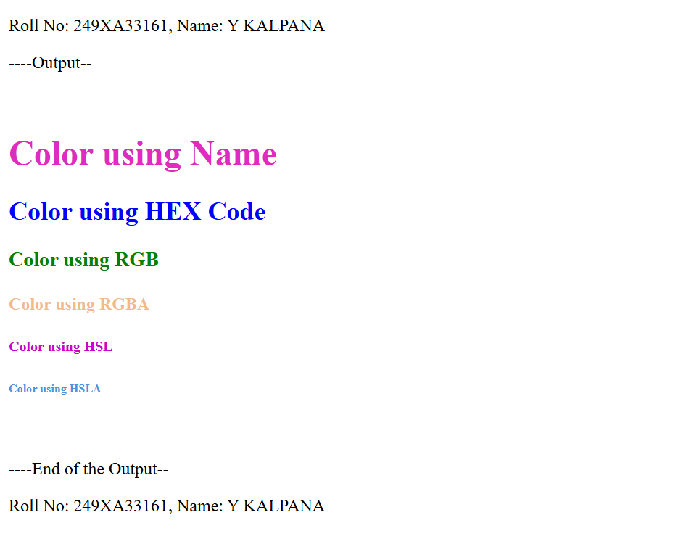

Experiment-5B: Date: 10-08-2026
****
Aim: Write a CSS rule that places a background image halfway down the page, tilting it horizontally. The image should remain in place when the user scrolls up or down.
Source Code: (HTML)
<!doctype html>
<html>
<head>
<title>Background Image</title>
<link href="style.css" rel="stylesheet" />
</head>
<body>
<h2>Name: Kalpana , Roll No:249xa33161</h2>
<h2>---OUTPUT---</h2> <br />
<h1>CSS Background Image</h1>
<p>
This page demonstrates a fixed background image. Scroll down to observe
that the image remains fixed while the page content moves.
</p>
<p>
Nature is the physical world and everything in it that is not made by
humans
</p>
<br /><br /><br /><br /><br /><br />
<h2>Welcome to Nature world</h2>
<br /><br /><br /><br /><br /><br />
<h2>Welcome to the world</h2>
<br /><br /><br /><br /><br /><br />
<br />
<h2>Name: Kalpana , Roll No:249xa33161</h2>
<h2>---END OF THE OUTPUT---</h2>
</body>
</html>

Source Code: (CSS)
body {
background-image: url("image.webp");
background-repeat: no-repeat;
background-position: center 50%;
background-attachment: fixed;
background-size: 400px 300px;
}
h1 {
text-align: center;
}
p {
font-size: 20px;
line-height: 35px;
}

Snapshot of the Output Webpage:

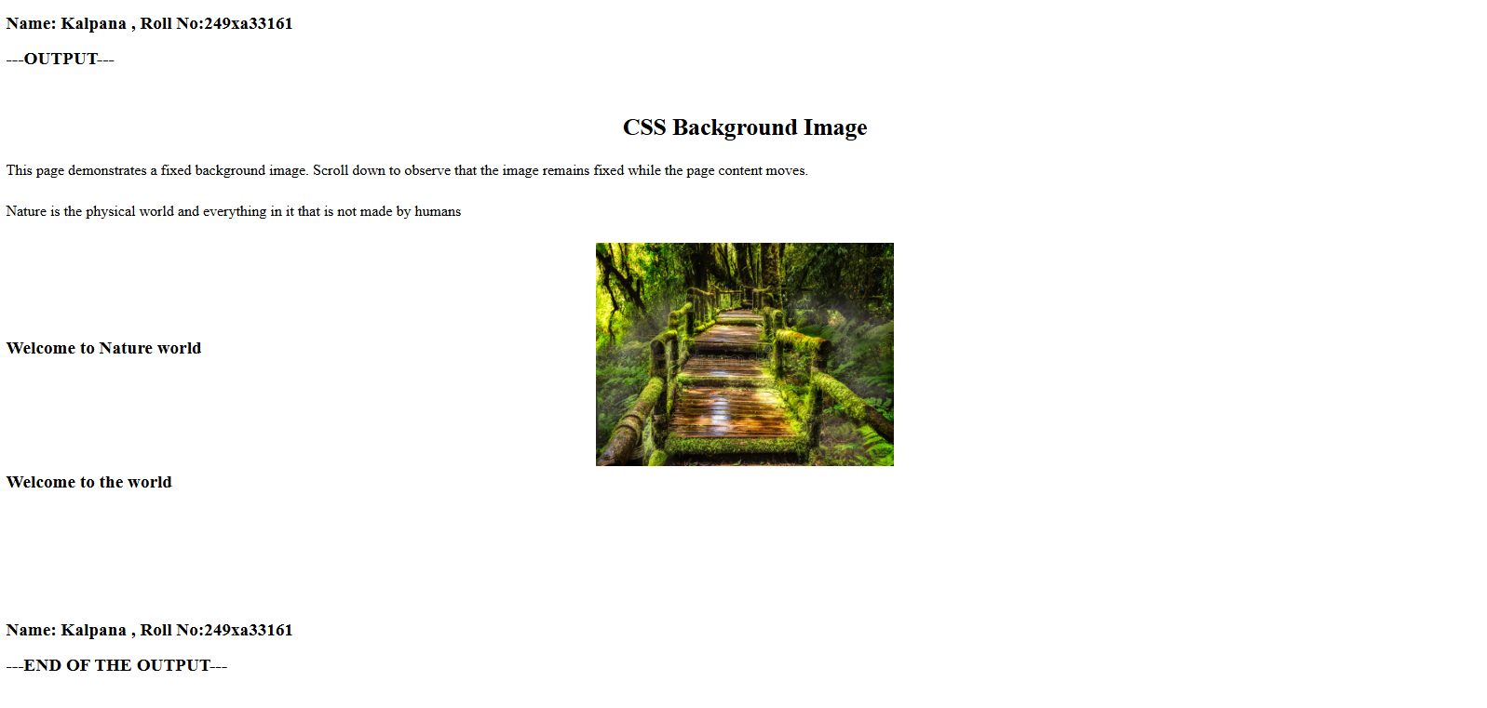

Experiment-5C: Date: 10-08-2026
****
Aim: Write a program using the following terms related to CSS font and text: i.font-size ii. font-weight iii. font-style iv. text-decoration v. text-transformation vi.
text-alignment.
Source Code: (HTML)
<!doctype html>
<html>
<head>
<title>Font and Text</title>
<link href="style.css" rel="stylesheet" />
</head>
<body>
<h2>Name: Kalpana , Roll No:249xa33161</h2>
<h2>---OUTPUT---</h2><br>
<h1 class="heading">CSS Font Properties</h1>
<p class="italic">This is the example for italic style.</p>
<p class="underline">This is the example for underlined.</p>
<p class="upper">This is the example for uppercase.</p>
<p class="center">This is the example for center aligned.</p><br>
<h2>Name: Kalpana , Roll No:249xa33161</h2>
<h2>---END OF THE OUTPUT---</h2>
</body>
</html>

Source Code: (CSS)
.heading {
font-size: 32px;
font-weight: bold;
text-align: center;
}
.italic {
font-style: italic;
font-size: 22px;
}
.underline {
text-decoration: underline;
font-size: 20px;
}
.upper {
text-transform: uppercase;
font-size: 22px;
}
.center {
text-align: center;
color: rgb(219, 53, 31);
}

Snapshot of the Output Webpage:

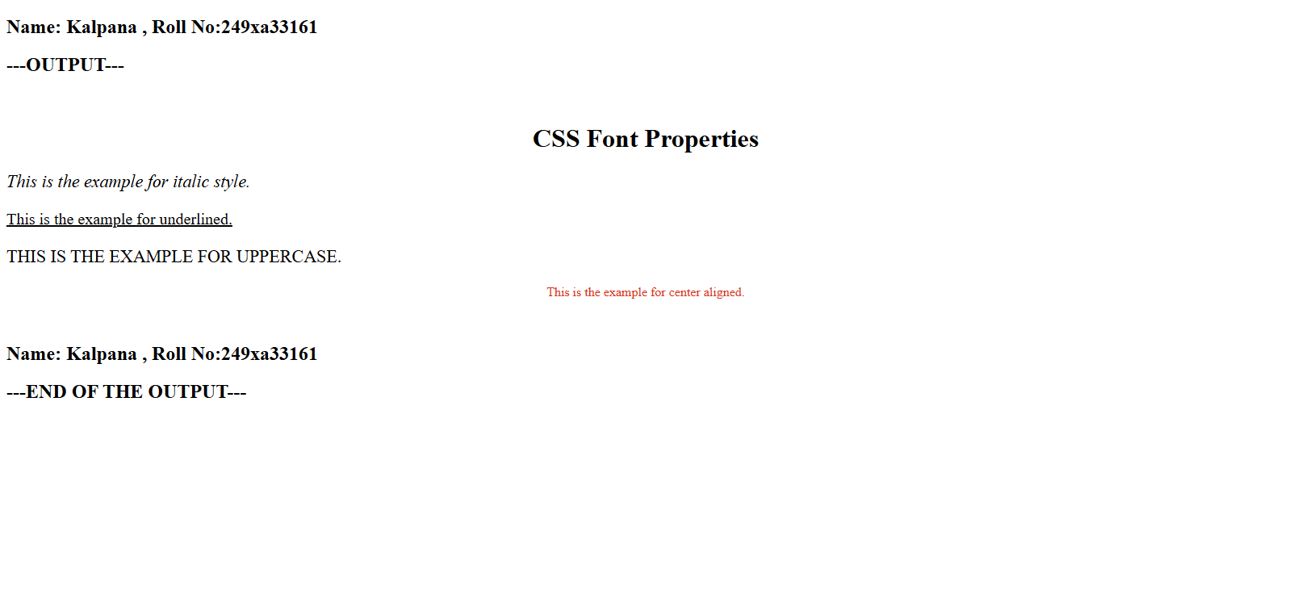

Experiment-5D: Date: 10-08-2026
****
Aim: Write a program, to explain the importance of CSS Box model using i. Content ii. Border iii. Margin iv. Padding
Source Code: (HTML)
<!doctype html>
<html>
<head>
<title>CSS Box Model</title>
<link href="style.css" rel="stylesheet" />
</head>
<body>
<h2>Name: Kalpana , Roll No:249xa33161</h2>
<h2>---OUTPUT---</h2><br>
<h1>CSS Box Example</h1>
<div class="box">
<b>Content Area</b>
<p>This box demonstrates the CSS Box Model.</p>
<ul>
<li>Content</li>
<li>Padding : 30px</li>
<li>Border : 5px Solid brown</li>
<li>Margin : 40px</li>
</ul>
</div><br>
<h2>Name: Kalpana , Roll No:249xa33161</h2>
<h2>---END OF THE OUTPUT---</h2>
</body>
</html>

Source Code: (CSS)
.box {
width: 350px;
background-color: lightyellow;
padding: 30px;
border: 5px solid brown;
margin: 40px;
font-size: 20px;
}

Snapshot of the Output Webpage:

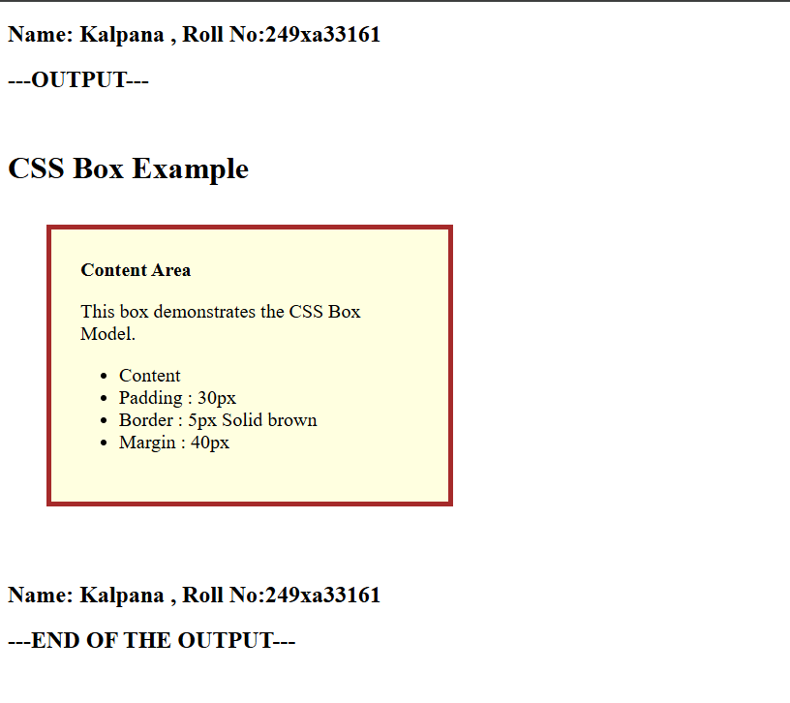

Experiment-6A: Date: 17-08-2026
****
Aim: Write a program to embed internal andexternal JavaScript in a web page.
Source Code: (HTML)
<!doctype html>
<html>
<head>
<title>Internal and External JavaScript</title>
<script src="script.js"></script>
<script>
function internalMessage() {
alert("This message is from Internal JavaScript.");
}
</script>
</head>
<body>
<h2>Roll No: 249XA33161, Name: Y KALPANA</h2>
<h2>----Output--</h2> <br />
<h2>JavaScript Example</h2>
<button onclick="internalMessage()">Internal JavaScript</button>
<br /><br />
<button onclick="externalMessage()">External JavaScript</button>
<br /><br />
<h2>----End of the Output--</h2>
<h2>Roll No: 249XA33161, Name: Y KALPANA</h2>
</body>
</html>
Source Code: (JavaScript)
function externalMessage() {
alert("External JavaScript.");
}

Snapshot of the Output Webpage:

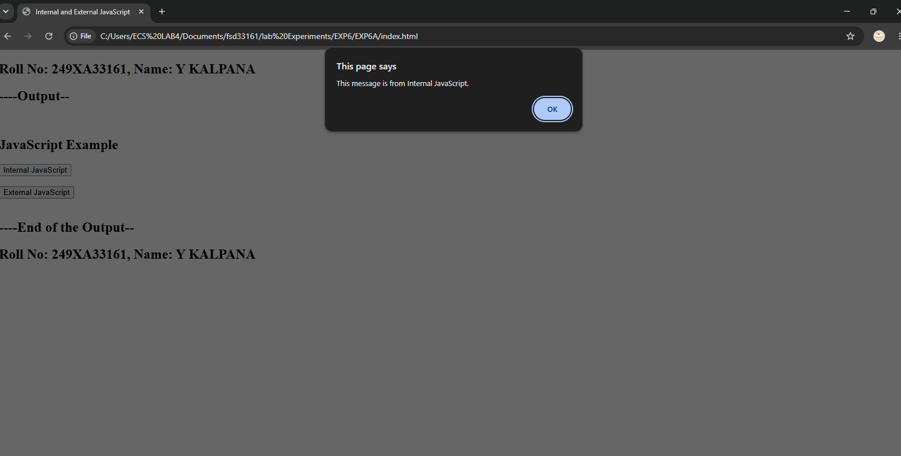

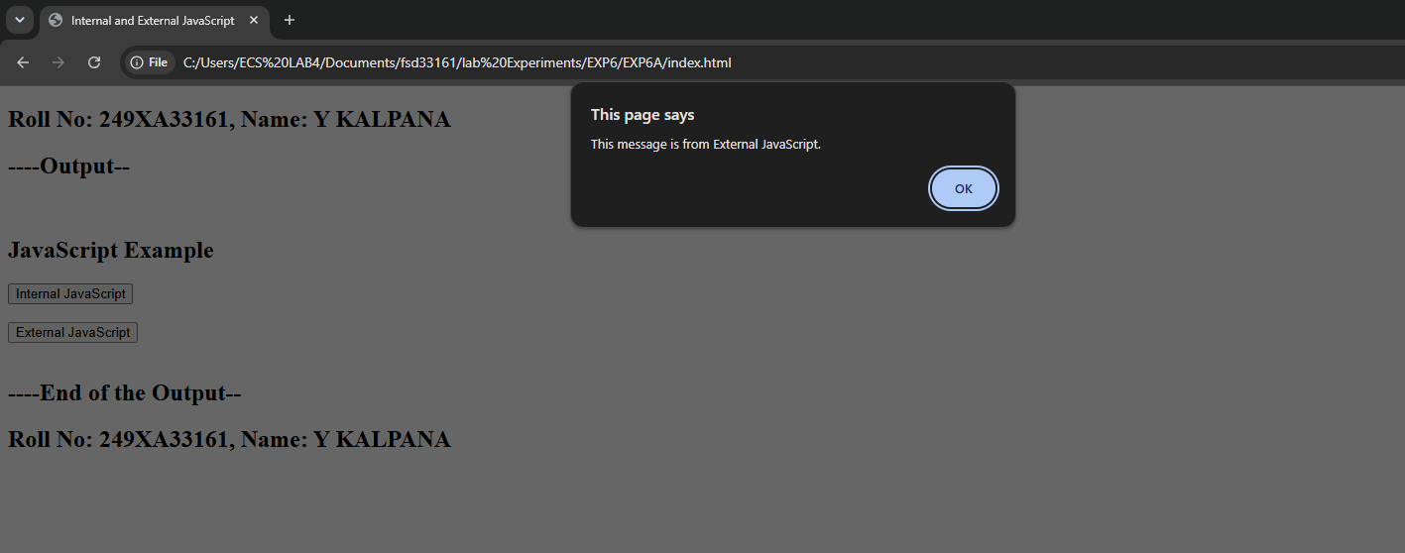

Experiment-6B: Date: 17-08-2026
****
Aim: Write a program to explain the different ways for displaying output.
Source Code: (HTML)
<!doctype html>
<html>
<head>
<title>JavaScript Output Methods</title>
<script src="script.js"></script>
</head>
<body>
<h2>Roll No: 249XA33161, Name: Y KALPANA</h2>
<h2>----Output--</h2>
<br /><br />
<h2>JavaScript Output Methods</h2>
<button onclick="showOutput()">Show Output</button>
<script>
document.write("<h2>This Output is by using document.write()</h2>");
</script>
<p id="result"></p>
<br /><br />
<h2>----End of the Output--</h2>
<h2>Roll No: 249XA33161, Name: Y KALPANA</h2>
</body>
</html>

Source Code: (JavaScript)
function showOutput() {
alert("Output using Alert Box");
console.log("Output using Console");
document.getElementById("result").innerHTML = "Output using innerHTML";
}

Snapshot of the Output Webpage:
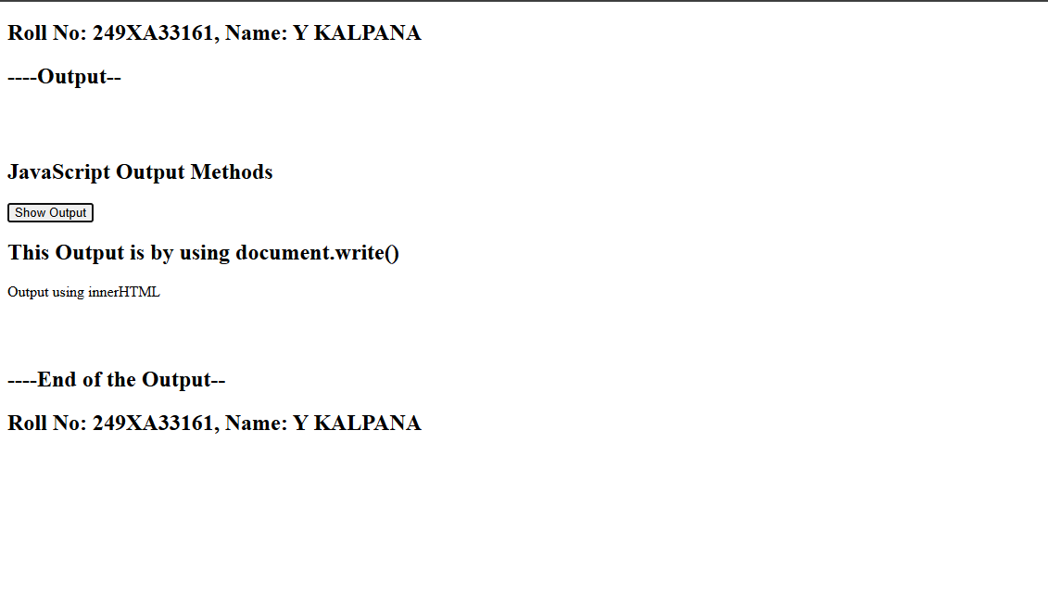
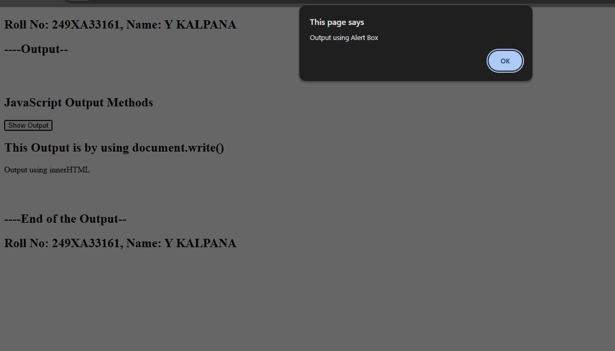

Experiment-6C: Date: 17-08-2026
****
Aim: Write a program to explain the different ways for taking input.
Source Code: (HTML)
<!doctype html>
<html>
<head>
<title>JavaScript Input Methods</title>
<script src="script.js"></script>
</head>
<body>
<h2>Roll No: 249XA33161, Name: Y KALPANA</h2>
<h2>----Output--</h2>
<br /><br />
<h2>JavaScript Input Methods</h2>
Enter Age :
<input type="number" id="age" />
<br /><br />
<button onclick="getInput()">Submit</button>
<p id="display"></p>
<br /><br />
<h2>----End of the Output--</h2>
<h2>Roll No: 249XA33161, Name: Y KALPANA</h2>
</body>
</html>

Source Code: (JavaScript)
function getInput() {
let name = prompt("Enter your Name");
let age = document.getElementById("age").value;
alert("Name : " + name);
document.getElementById("display").innerHTML = "Age : " + age;
}

Snapshot of the Output Webpage:
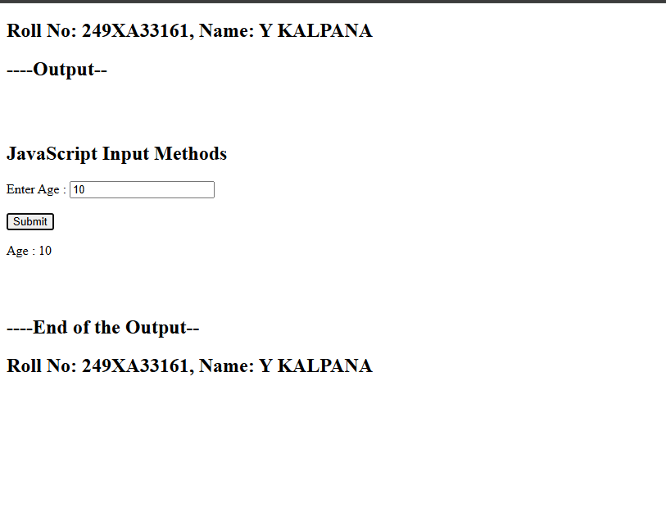
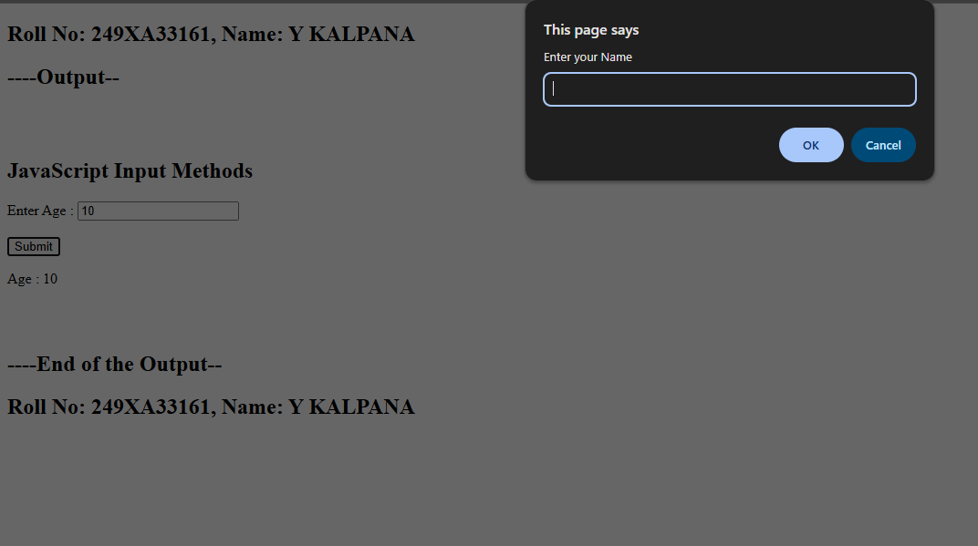

Experiment-6D: Date: 17-08-2026
****
Aim: Create a webpage which uses prompt dialogue box to ask a voter for his name and age. Display the information in table format along with either the voter can vote or not.
Source Code: (HTML)
<!doctype html>
<html>
<head>
<title>Document</title>
<script src="script.js"></script>
</head>
<body>
<h2>Roll No: 249XA33161, Name: Y KALPANA</h2>
<h2>----Output--</h2>
<br />
<h2>Voter Eligibility Checker</h2>
<button onclick="checkVote()">Check Eligibility</button>
<br /><br />
<div id="result"></div>
<br />
<h2>----End of the Output--</h2>
<h2>Roll No: 249XA33161, Name: Y KALPANA</h2>
</body>
</html>

Source Code: (JavaScript)
function checkVote() {
let name = prompt("Enter Your Name");
let age = Number(prompt("Enter Your Age"));
let status;
if (age >= 18) status = "Eligible to Vote";
else status = "Not Eligible to Vote";
document.getElementById("result").innerHTML = "<table border='2'
cellpadding='10'>" + "<tr><th>Name</th><th>Age</th><th>Status</th></tr>" +
"<tr><td>" +name +"</td><td>" + age + "</td><td>" +status+"</td></tr></table>";
}
Snapshot of the Output Webpage:
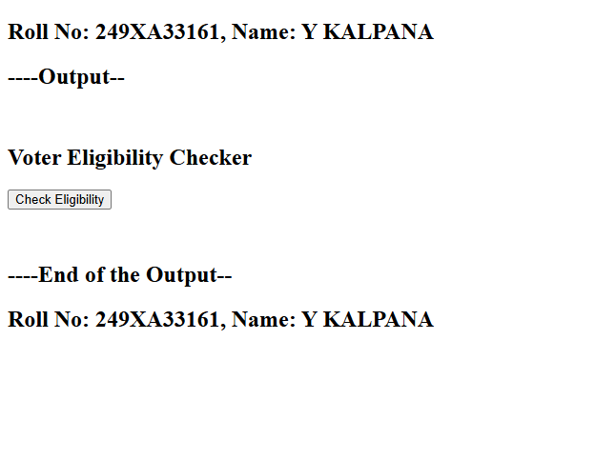

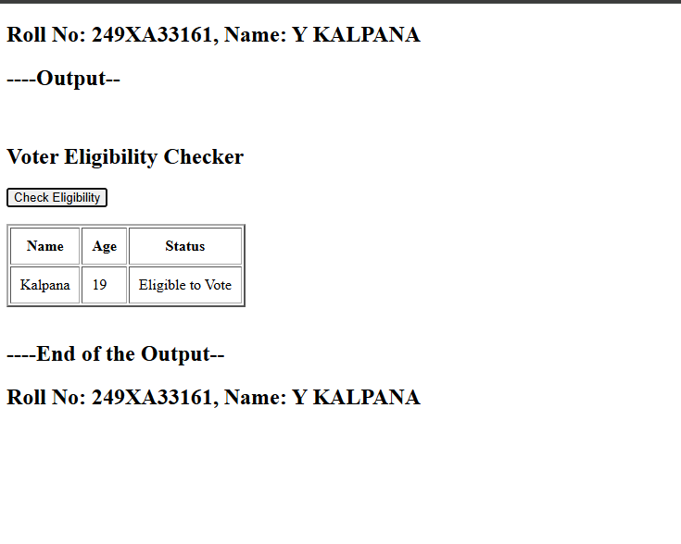

Experiment-7A: Date: 24-08-2026
****
Aim: Write a program using document object properties and methods.
Source Code: (HTML)
<!doctype html>
<html>
<head>
<title>Document Object Example</title>
<script src="script.js"></script>
</head>
<body>
<h2>Roll No: 249XA33161, Name: Y KALPANA</h2>
<h2>----Output--</h2>
<h2 id="demo">Document Object Example</h2>
<button onclick="changeContent()">Click Here</button>
<br></br>
<h2>----End of the Output--</h2>
<h2>Roll No: 249XA33161, Name: Y KALPANA</h2>
</body>
</html>
Source Code: (JavaScript)
function changeContent() {
document.title = "Document Object Demo";
document.getElementById("demo").innerHTML = "Content Changed Successfully.";
document.body.style.backgroundColor = "lightgreen";
}

Snapshot of the Output Webpage:

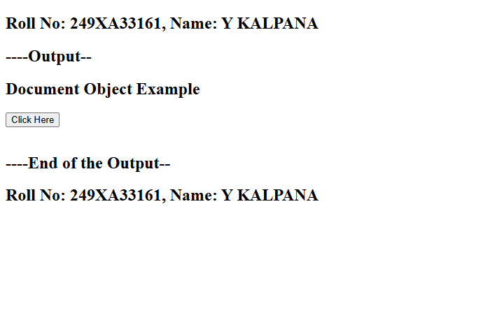
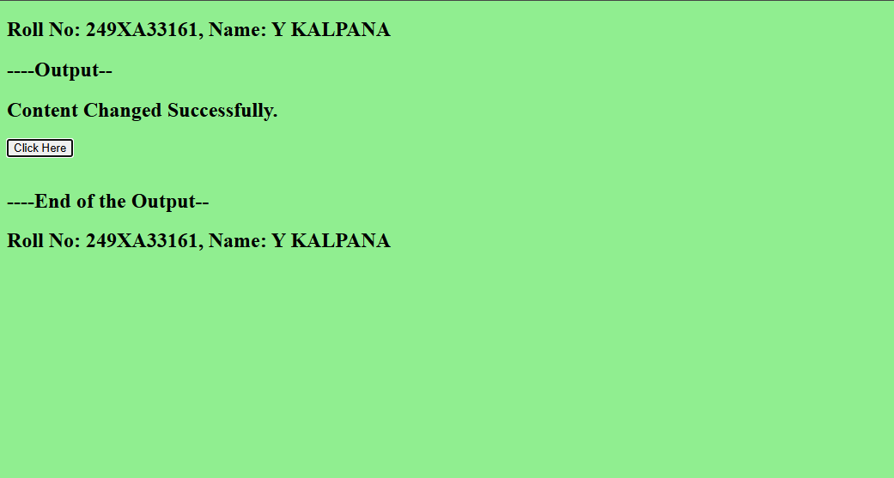

Experiment-7B: Date: 24-08-2026
****
Aim: Write a program using window object properties and methods.
Source Code: (HTML)
<!doctype html>
<html>
<head>
<title>Window Object Example</title>
<script src="script.js"></script>
</head>
<body>
<h2>Roll No: 249XA33161, Name: Y KALPANA</h2>
<h2>----Output--</h2>
<br />
<h2>Window Object Example</h2>
<button onclick="windowDemo()">Click Here</button>
<p id="result"></p>
<br />
<br />
<h2>----End of the Output--</h2>
<h2>Roll No: 249XA33161, Name: Y KALPANA</h2>
</body>
</html>

Source Code: (JavaScript)
function windowDemo() {
alert("Welcome to JavaScript");
let name = prompt("Enter Your Name");
let choice = confirm("Do you want to continue?");
document.getElementById("result").innerHTML =
"Name : " + name + "<br>Confirmation : " + choice;
}

Snapshot of the Output Webpage:

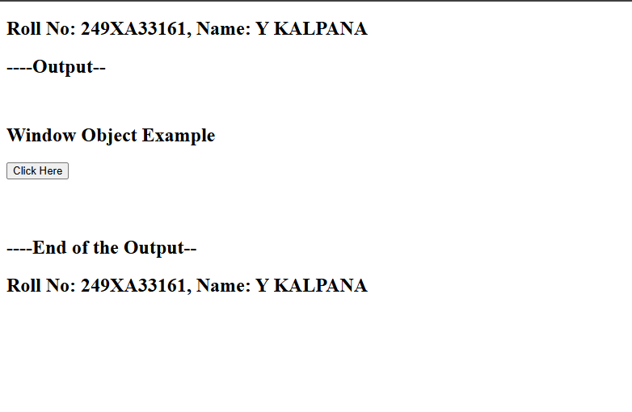
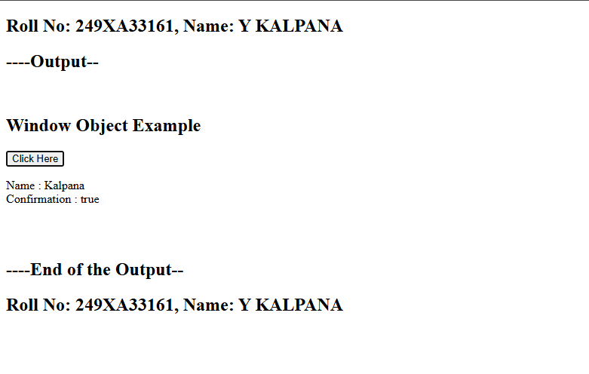

Experiment-7C: Date: 24-08-2026
****
Aim: Write a program using array object properties and methods.
Source Code: (HTML)
<!doctype html>
<html>
<head>
<title>Array Object</title>
<script src="script.js"></script>
</head>

<body>
<h2>Roll No: 249XA33161, Name: Y KALPANA</h2>
<h2>----Output--</h2>
<br />
<h2>Array Object Example</h2>

<button onclick="arrayDemo()">Display Array</button>

<p id="demo"></p>
<br />
<h2>----End of the Output--</h2>
<h2>Roll No: 249XA33161, Name: Y KALPANA</h2>
</body>
</html>
Source Code: (JavaScript)
function arrayDemo() {
let names = ["Kalpana", "Ramya", "Dhana"];
names.push("Kavya");
names.sort();
document.getElementById("demo").innerHTML ="Array Elements : " +names +
"<br><br>Length : " + names.length +
"<br><br>First Element : " +
names[0];
}

Snapshot of the Output Webpage:
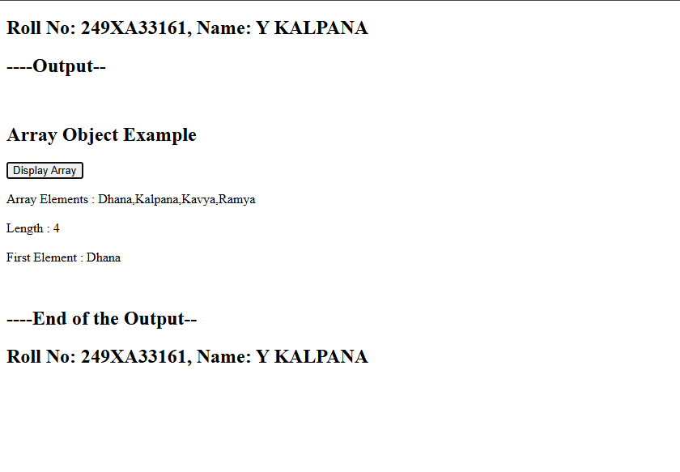
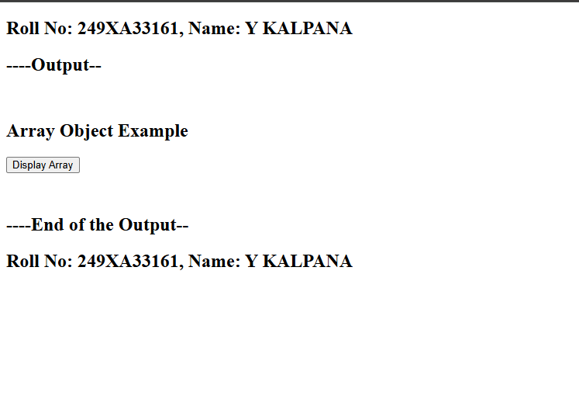

Experiment-7D(1): Date: 24-08-2026
****
Aim: Write a program using math object properties and methods.
Source Code: (HTML)
<!doctype html>
<html>
<head>
<title>Math Object</title>
<script src="script.js"></script>
</head>
<body>
<h2>Roll No: 249XA33161 , Name: Kalpana</h2>
<h2>---OUTPUT---</h2>
<h2>Math Object Example</h2>
<button onclick="mathDemo()">Show Result</button>
<p id="result"></p><br />
<h2>Roll No: 249XA33161 , Name: Kalpana</h2>
<h2>---END OF THE OUTPUT---</h2>
</body>
</html>
Source Code: (JavaScript)
function mathDemo() {
document.getElementById("result").innerHTML =
"PI = " +
Math.PI +
"<br>Square Root of 64 = " +
Math.sqrt(64) +
"<br>2 Power 5 = " +
Math.pow(2, 5) +
"<br>Maximum = " +
Math.max(20, 30, 10) +
"<br>Minimum = " +
Math.min(20, 30, 10) +
"<br>Random Number = " +
Math.random();
}

Snapshot of the Output Webpage:

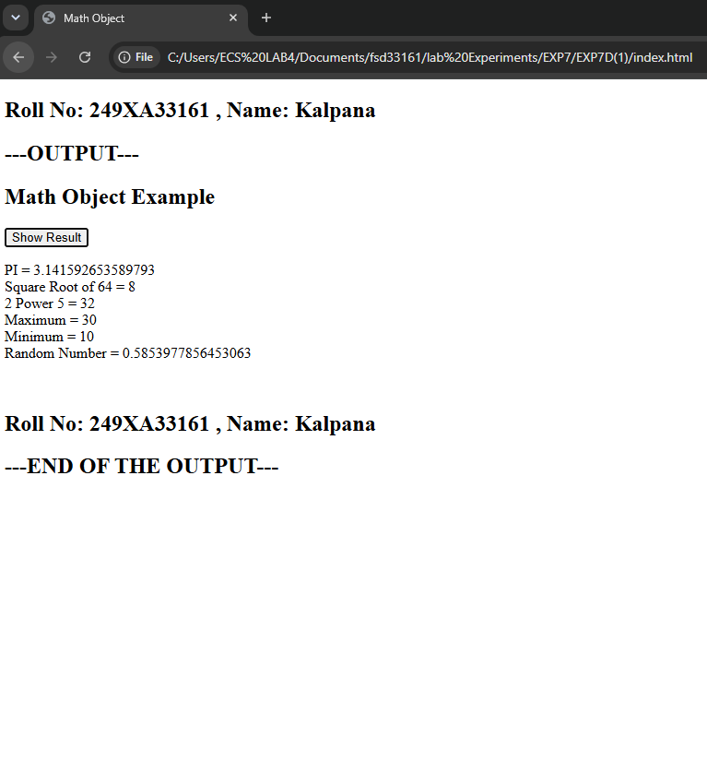

Experiment-7D(2): Date: 24-08-2026
****
Aim: Write a program using string object properties and methods.
Source Code: (HTML)
<!doctype html>
<html>
<head>
<title>String Object</title>
<script src="script.js"></script>
</head>
<body>
<h2>Roll No: 249XA33161 , Name: Kalpana</h2>
<h2>---OUTPUT---</h2>
<br />
<h2>String Object Example</h2>
<button onclick="stringDemo()">Display</button>
<p id="demo"></p>
<h2>Roll No: 249XA33161 , Name: Kalpana</h2>
<h2>---END OF THE OUTPUT---</h2>
</body>
</html>
Source Code: (JavaScript)
function stringDemo() {
let str = "Web Development";

document.getElementById("demo").innerHTML =
"GIVEN STRING : " +
str +
"<br> " +
"Length : " +
str.length +
"<br>Uppercase : " +
str.toUpperCase() +
"<br>Lowercase : " +
str.toLowerCase() +
"<br>Substring : " +
str.substring(0, 3) +
"<br>Replace : " +
str.replace("Web", "JavaScript");
}

Snapshot of the Output Webpage:
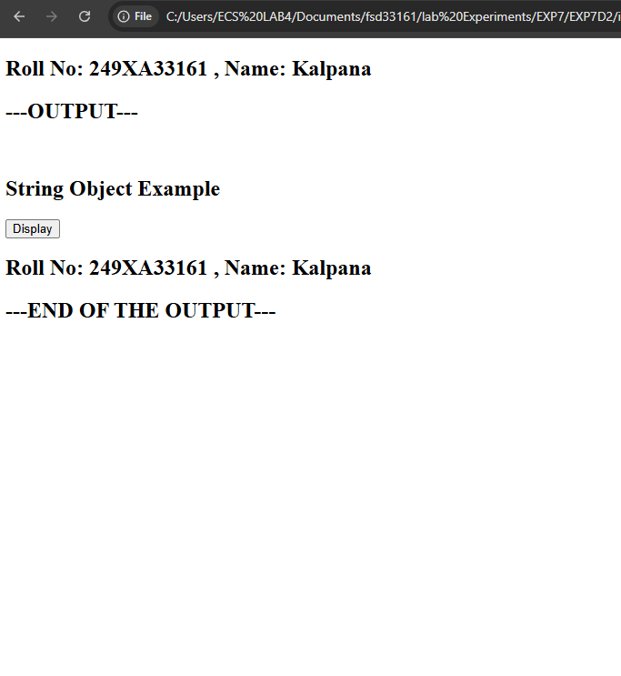

Experiment-7E: Date: 24-08-2026
****
Aim: Write a program using regex object properties and methods.
Source Code: (HTML)
<!doctype html>
<html>
<head>
<title>RegEx Object</title>
<script src="script.js"></script>
</head>
<body>
<h2>Roll No: 249XA33161 , Name: Kalpana</h2>
<h2>---OUTPUT---</h2><br>
<h2>Regular Expression Example</h2>
<button onclick="regexDemo()">Check Pattern</button>
<p id="demo"></p> <br>
<h2>Roll No: 249XA33161 , Name: Kalpana</h2>
<h2>---END OF THE OUTPUT---</h2>
</body>
</html>
Source Code: (JavaScript)
function regexDemo() {
let text = "JavaScript Programming";
let pattern = /Script/;
let result = pattern.test(text);
document.getElementById("demo").innerHTML =
"Text : " +
text +
"<br> Pattern:" +
pattern +
"<br>Pattern Found : " +
result;
}

Snapshot of the Output Webpage:

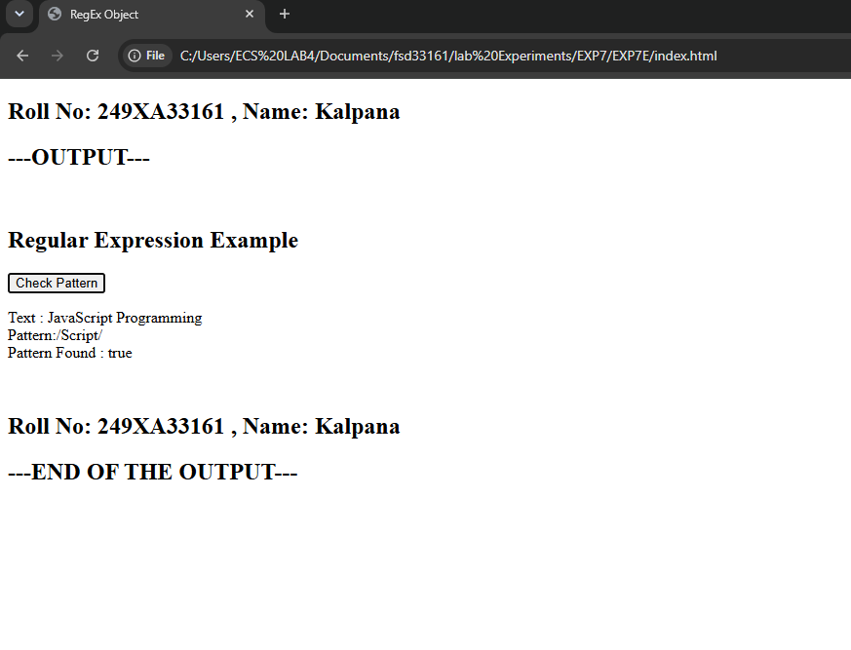

Experiment-7F: Date: 24-08-2026
****
Aim: Write a program using date object properties and methods..
Source Code: (HTML)
<!doctype html>
<html>
<head>
<title>Date Object</title>
<script src="script.js"></script>
</head>
<body>
<h2>Roll No: 249XA33161 , Name: Kalpana</h2>
<h2>---OUTPUT---</h2><br />
<h2>Date Object Example</h2>
<button onclick="dateDemo()">Show Date</button>
<p id="demo"></p><br />
<h2>Roll No: 249XA33161 , Name: Kalpana</h2>
<h2>---END OF THE OUTPUT---</h2>
</body>
</html>

Source Code: (JavaScript)
function dateDemo() {
let today = new Date();

document.getElementById("demo").innerHTML =
"Current Date : " +
today +
"<br>Day : " +
today.getDate() +
"<br>Month : " +
(today.getMonth() + 1) +
"<br>Year : " +
today.getFullYear() +
"<br>Hours : " +
today.getHours() +
"<br>Minutes : " +
today.getMinutes();
}

Snapshot of the Output Webpage:

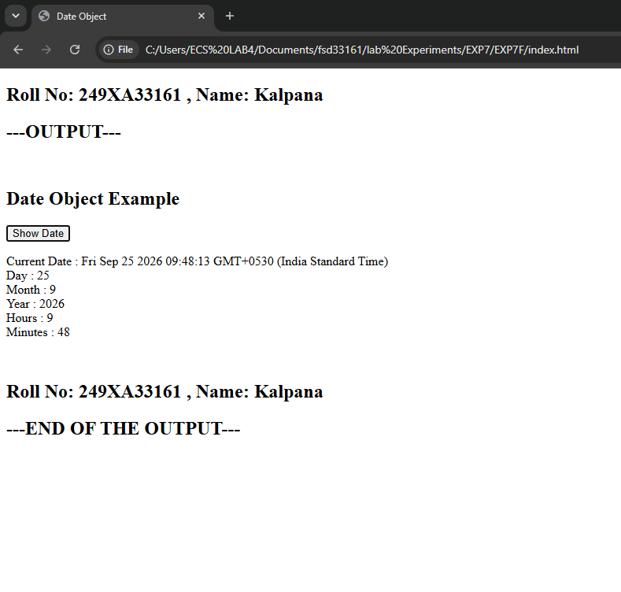

Experiment-7G: Date: 24-08-2026
****
Aim: Write a program to explain user-defined object by using properties, methods,
accessors, constructors and display.
Source Code: (HTML)
<!doctype html>
<html>
<head>
<title>User Defined Object</title>
<script src="script.js"></script>
</head>
<body>
<h2>Roll No: 249XA33161 , Name: Kalpana</h2>
<h2>---OUTPUT---</h2>
<br />
<h2>User Defined Object Example</h2>
<button onclick="showStudent()">Display Object</button>
<p id="demo"></p><br />
<h2>Roll No: 249XA33161 , Name: Kalpana</h2>
<h2>---END OF THE OUTPUT---</h2>
</body>
</html>

Source Code: (JavaScript)
function Student(name, roll, branch) {
this.name = name;
this.roll = roll;
this.branch = branch;

// Method
this.display = function () {
return (
"Name : " + this.name +
"<br>Roll No : " + this.roll +
"<br>Branch : " + this.branch
);
};
}
Object.defineProperty(Student.prototype, "details", {
get: function () {
return this.name + " (" + this.branch + ")";
},
});
function showStudent() {
let s1 = new Student("Kalpana", 161, "CSM");
document.getElementById("demo").innerHTML = s1.display() +"<br><br><b>Accessor:</b> " + s1.details;
}

Snapshot of the Output Webpage:
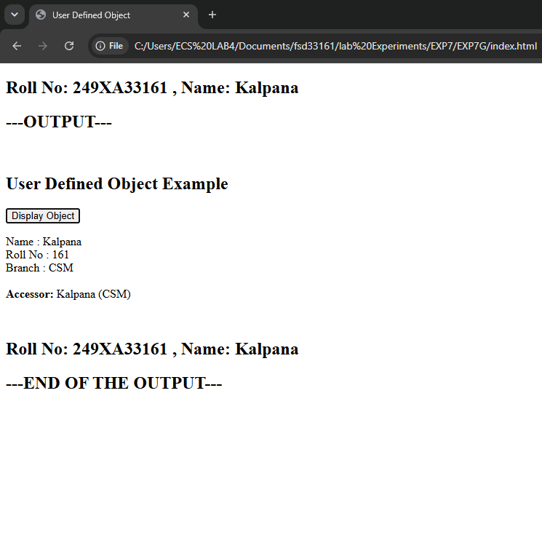

Experiment-8A: Date: 21-09-2026
****
Aim: Write a program which asks the user to enter three integers, obtain the numbers from the user and output HTML text that displays the larger number followed by the words “LARGER NUMBER” in an information message dialog. If
the numbers are equal, output HTML text as “EQUAL NUMBERS”.
Source Code: (HTML)
<!doctype html>
<html>
<head>
<title>Largest Number</title>
<script src="script8a.js"></script>
</head>
<body>
<h2>Roll No: 249XA33161, Name: Y KALPANA</h2>
<h2>----Output--</h2>
<br />
<h2>Largest of Three Numbers</h2>
<button onclick="largest()">Find Largest</button>
<div id="result"></div> <br />
<h2>----End of the Output--</h2>
<h2>Roll No: 249XA33161, Name: Y KALPANA</h2>
</body>
</html>

Source Code: (JavaScript)
function largest() {
let a = Number(prompt("Enter First Number"));
let b = Number(prompt("Enter Second Number"));
let c = Number(prompt("Enter Third Number"));
if (a == b && b == c) {
document.getElementById("result").innerHTML = "<h2>EQUAL NUMBERS</h2>";
alert("EQUAL NUMBERS");
} else {
let large = Math.max(a, b, c);
document.getElementById("result").innerHTML ="<h2>" + large + " LARGER NUMBER</h2>";
alert(large + " LARGER NUMBER");
}
}
Snapshot of the Output Webpage:
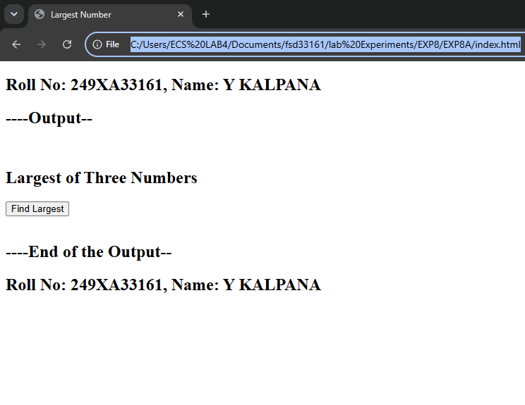
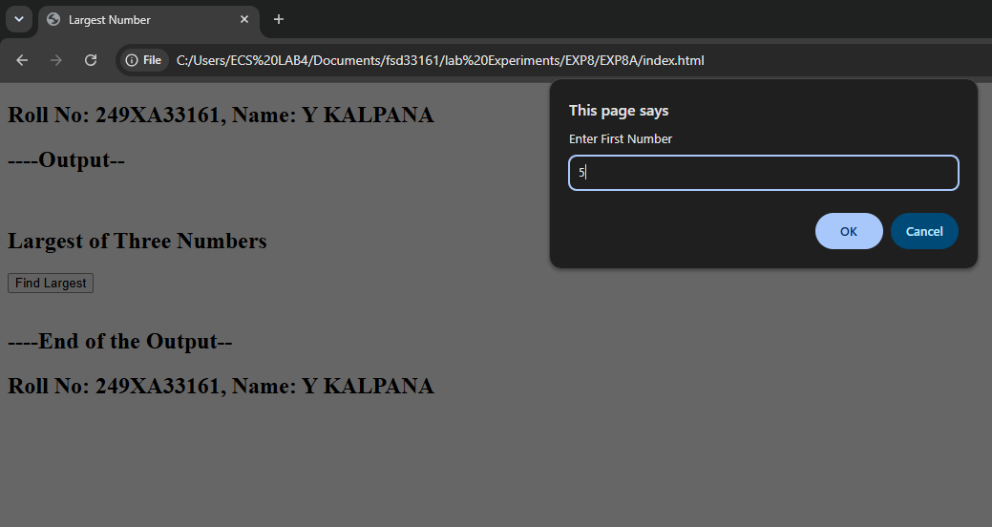

Experiment-8B: Date: 21-09-2026
****
Aim: Write a program to display week days using switch case.
Source Code: (HTML)
<!doctype html>
<html>
<head>
<title>Week Days</title>
<script src="script8b.js"></script>
</head>
<body>
<h2>Roll No: 249XA33161, Name: Y KALPANA</h2>
<h2>----Output--</h2> <br />
<h2>Week Days</h2>
<button onclick="showDay()">Display</button>
<p id="demo"></p>
<br />
<h2>----End of the Output--</h2>
<h2>Roll No: 249XA33161, Name: Y KALPANA</h2>
</body>
</html>

Source Code: (JavaScript)
function showDay() {
let day = Number(prompt("Enter Day Number (1-7)"));
let name;
switch (day) {
case 1:
name = "Sunday";
break;
case 2:
name = "Monday";
break;
case 3:
name = "Tuesday";
break;
case 4:
name = "Wednesday";
break;
case 5:
name = "Thursday";
break;
case 6:
name = "Friday";
break;
case 7:
name = "Saturday";
break;
default:
name = "Invalid Day";
}

document.getElementById("demo").innerHTML = name;
}
Snapshot of the Output Webpage:
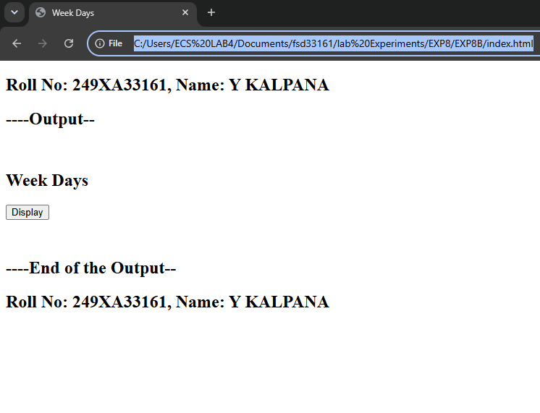
Experiment-8C: Date: 21-09-2026
****
Aim: Write a program to print 1 to 10 numbers using for, while and do-while loops..
Source Code: (HTML)
<!doctype html>
<html>
<head>
<title>Loops</title>
<script src="script8c.js"></script>
</head>
<body>
<h2>Roll No: 249XA33161, Name: Y KALPANA</h2>
<h2>----Output--</h2>
<br />
<button onclick="printNumbers()">Print 1 to 10 Numbers</button>
<div id="demo"></div>
<br />
<h2>----End of the Output--</h2>
<h2>Roll No: 249XA33161, Name: Y KALPANA</h2>
</body>
</html>

Source Code: (JavaScript)
function printNumbers() {
let output = "<h3>For Loop</h3>";
for (let i = 1; i <= 10; i++) output += i + " ";
output += "<h3>While Loop</h3>";
let j = 1;
while (j <= 10) {
output += j + " ";
j++;
output += "<h3>Do While Loop</h3>";
let k = 1;
do {
output += k + " ";
k++;
} while (k <= 10);
document.getElementById("demo").innerHTML = output;
}
Snapshot of the Output Webpage:
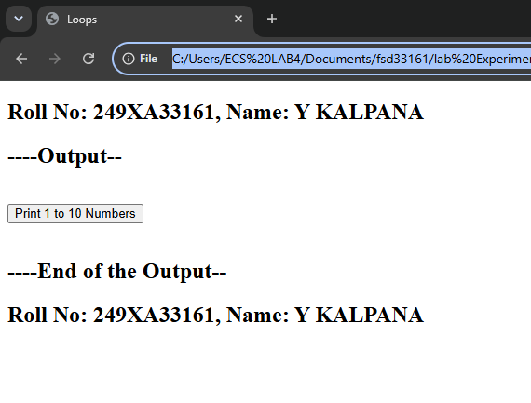

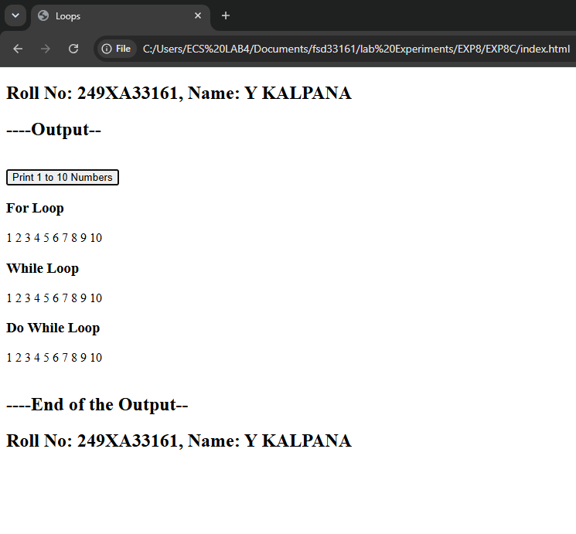

Experiment-8D: Date: 21-09-2026
****
Aim: Write aprogram to print data in object using for-in, for-each and for-of loops
Source Code: (HTML)
<!doctype html>
<html>
<head>
<title>JavaScript Loops</title>
<script src="script8d.js"></script>
</head>
<body>
<h2>Roll No: 249XA33161, Name: Y KALPANA</h2>
<h2>----Output--</h2>
<br />
<button onclick="displayData()">Display Data</button>
<div id="demo"></div>
<br />
<h2>----End of the Output--</h2>
<h2>Roll No: 249XA33161, Name: Y KALPANA</h2>
</body>
</html>

Source Code: (JavaScript)
function displayData() {
let student = {
Name: "Kalpana",
Roll: 161,
Branch: "CSM",
};
let output = "<h3>for-in</h3>";
for (let key in student) output += key + " : " + student[key] + "<br>";
let subjects = ["Python", "Java", "HTML"];
output += "<h3>forEach</h3>";
subjects.forEach(function (item) {
output += item + "<br>";
})
output += "<h3>for-of</h3>";
for (let sub of subjects) output += sub + "<br>";
document.getElementById("demo").innerHTML = output;
}
Snapshot of the Output Webpage:
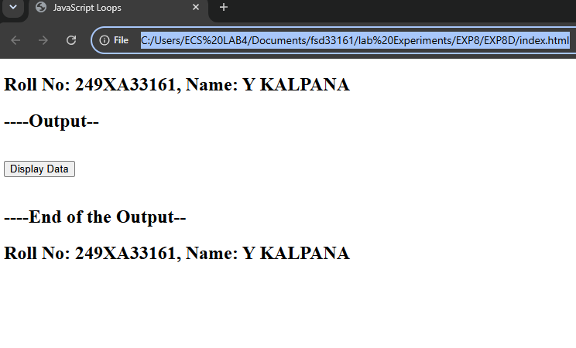
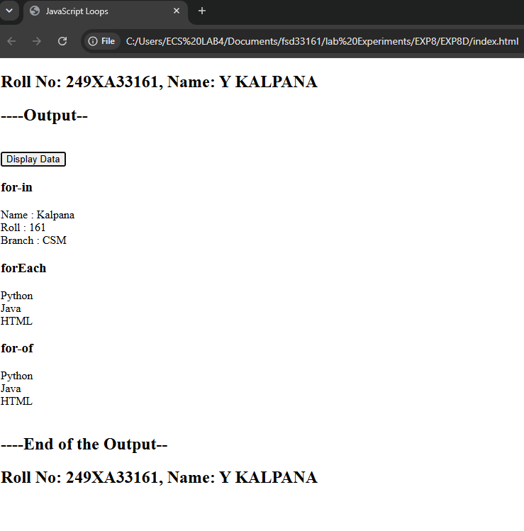
Experiment-8E: Date: 21-09-2026
****
Aim: Develop a program to determine whether a given number is an ‘ARMSTRONG NUMBER’ or not. [Eg: 153 is an Armstrong number, since sum of the cube of the digits is equal to the number i.e.,1^3 + 5^3+ 3^3 = 153]
Source Code: (HTML)
<!doctype html>
<html>
<head>
<title>Armstrong Number</title>
<script src="script8e.js"></script>
</head>
<body>
<h2>Roll No: 249XA33161, Name: Y KALPANA</h2>
<h2>----Output--</h2>
<br />
<button onclick="checkArmstrong()">Check Armstrong</button>
<p id="demo"></p>
<br />
<h2>----End of the Output--</h2>
<h2>Roll No: 249XA33161, Name: Y KALPANA</h2>
</body>
</html>

Source Code: (JavaScript)
function checkArmstrong() {
let num = Number(prompt("Enter Number"));
let temp = num;
let sum = 0;
while (temp > 0) {
let digit = temp % 10;
sum += digit * digit * digit;
temp = Math.floor(temp / 10);
}
if (sum == num)
document.getElementById("demo").innerHTML = num + " is an Armstrong Number";
else
document.getElementById("demo").innerHTML =
num + " is NOT an Armstrong Number";
}
Snapshot of the Output Webpage:
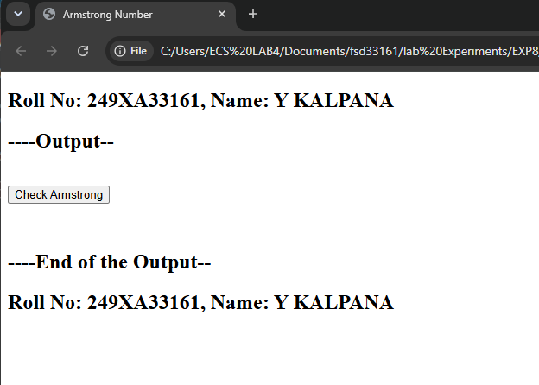
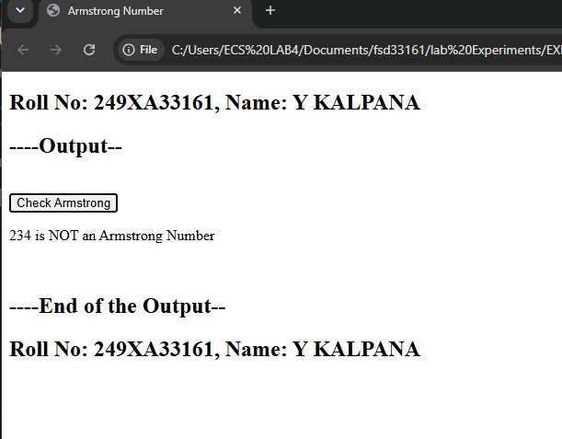

Experiment-8F: Date: 21-09-2026
****
Aim: Write a program to display the denomination of the amount deposited in the bank in terms of 100’s, 50’s, 20’s, 10’s, 5’s, 2’s &amp; 1’s. (Eg: If deposited amount is Rs.163, the output should be 1-100’s, 1-50’s, 1- 10’s, 1-2’s &amp; 1-1’s)
Source Code: (HTML)
<!doctype html>
<html>
<head>
<title>Bank Denomination</title>
<script src="script8f.js"></script>
</head>
<body>
<h2>Roll No: 249XA33161, Name: Y KALPANA</h2>
<h2>----Output--</h2>
<br />
<button onclick="denomination()">Calculate</button>
<div id="demo"></div>
<br />
<h2>----End of the Output--</h2>
<h2>Roll No: 249XA33161, Name: Y KALPANA</h2>
</body>
</html>
Source Code: (JavaScript)
function denomination() {
let amount = Number(prompt("Enter Amount"));
let notes = [100, 50, 20, 10, 5, 2, 1];
let output = "<h2>Denomination</h2>";
for (let note of notes) {
let count = Math.floor(amount / note);

if (count > 0) {
output += count + " - " + note + "'s <br>"
amount %= note;
}
}
document.getElementById("demo").innerHTML = output;
}
Snapshot of the Output Webpage:
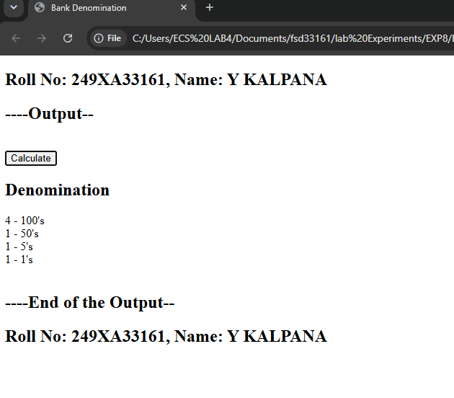
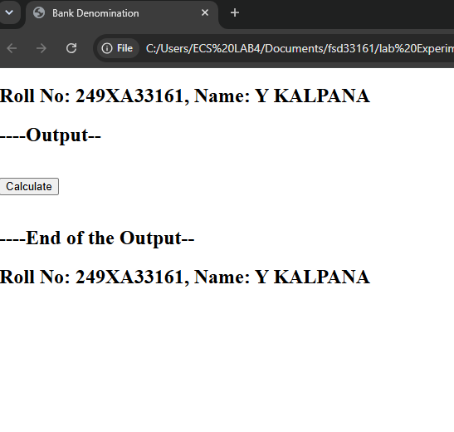

Experiment-9A: Date: 25-09-2026
****
Aim: Design a appropriate function should be called to display
i. Factorial of that number
ii. Fibonacci series up to that number
iii. Prime numbers up to that number
iv. Is it palindrome or not
Source Code: (HTML)
<!doctype html>
<html>
<head>
<title>JavaScript Functions</title>
<script src="script.js"></script>
</head>
<body>
<h2>Roll No: 249XA33161, Name: Y KALPANA</h2>
<h2>----Output--</h2> <br />
<h2>JavaScript Functions</h2>
<button onclick="display()">Display Result</button>
<p id="demo"></p> <br />
<h2>----End of the Output--</h2>
<h2>Roll No: 249XA33161, Name: Y KALPANA</h2>
</body>
</html>

Source Code: (JavaScript)
function factorial(n) {
let fact = 1;
for (let i = 1; i <= n; i++) fact *= i;
return fact;
}
function fibonacci(n) {
let a = 0,
b = 1,
result = "";
while (a <= n) {
result += a + " ";
let c = a + b;
a = b;
b = c;
}
return result;
}
function prime(n) {
let result = "";
for (let i = 2; i <= n; i++) {
let flag = true;
for (let j = 2; j <= Math.sqrt(i); j++) {
if (i % j == 0) {
flag = false;
break;
}
}
if (flag) result += i + " ";
}
return result;
}
function palindrome(n) {
let rev = 0,
temp = n;

while (temp > 0) {
rev = rev * 10 + (temp % 10);
temp = Math.floor(temp / 10);
}
if (rev == n) return "Palindrome";
else return "Not Palindrome";
}
function display() {
let n = Number(prompt("Enter Number"));

document.getElementById("demo").innerHTML =
"<b>Factorial :</b> " +
factorial(n) +
"<br><br><b>Fibonacci :</b> " +
fibonacci(n) +
"<br><br><b>Prime Numbers :</b> " +
prime(n) +
"<br><br><b>Palindrome :</b> " +
palindrome(n);
}
Snapshot of the Output Webpage:
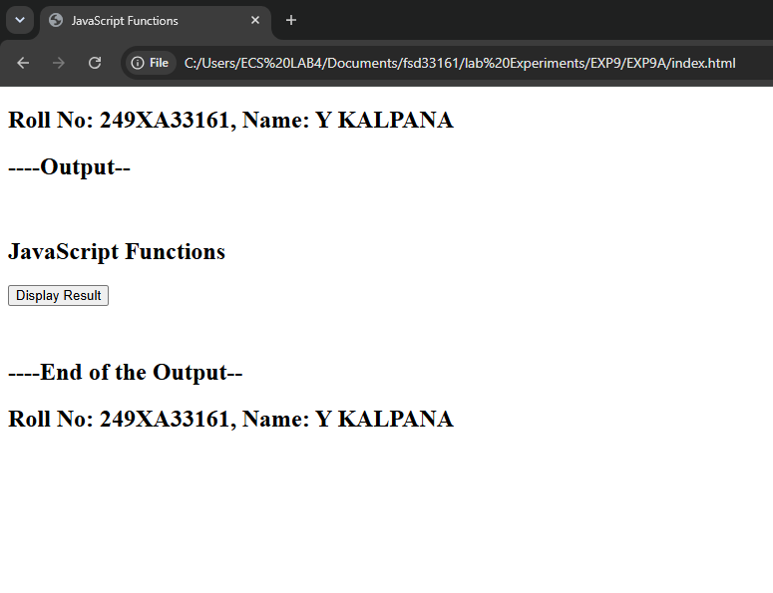
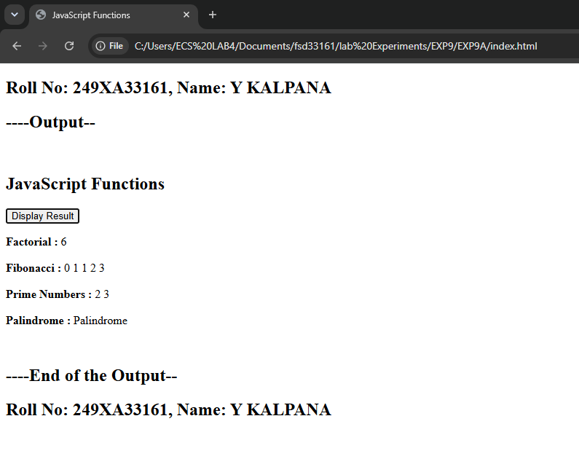

Experiment-9B: Date: 25-09-2026
****
Aim: Design a HTML having a text box and four buttons named Factorial, Fibonacci, Prime, and Palindrome. When a button is pressed an appropriate function should be called to display i. Factorial of that number ii. Fibonacci series up to that number iii. Prime numbers up to that number iv. Is it palindrome or not.
Source Code: (HTML)
<!doctype html>
<html>
<head>
<title>Functions and Events</title>
<script src="script9b.js"></script>
</head>
<body>
<h2>Roll No: 249XA33161, Name: Y KALPANA</h2>
<h2>----Output--</h2> <br />
<h2>Functions Using Buttons</h2>
Enter Number :
<input type="number" id="num" />
<br /><br />
<button onclick="factorial()">Factorial</button>
<button onclick="fibonacci()">Fibonacci</button>
<button onclick="prime()">Prime</button>
<button onclick="palindrome()">Palindrome</button>
<br /><br />
<div id="result"></div><br>
<h2>----End of the Output--</h2>
<h2>Roll No: 249XA33161, Name: Y KALPANA</h2>
</body>
</html>
Source Code: (JavaScript)
function getNumber() {
return Number(document.getElementById("num").value);
}
function factorial() {
let n = getNumber();
let fact = 1;
for (let i = 1; i <= n; i++) fact *= i;
document.getElementById("result").innerHTML = "Factorial = " + fact;
}
function fibonacci() {
let n = getNumber();
let a = 0,
b = 1,
str = "";
while (a <= n) {
str += a + " ";
let c = a + b;
a = b;
b = c;
}
document.getElementById("result").innerHTML = "Fibonacci Series : " + str;
}
function prime() {
let n = getNumber();
let str = "";
for (let i = 2; i <= n; i++) {
let flag = true;
for (let j = 2; j <= Math.sqrt(i); j++) {
if (i % j == 0) {
flag = false;
break;
}
}
if (flag) str += i + " ";
}
document.getElementById("result").innerHTML = "Prime Numbers : " + str;
}
function palindrome() {
let n = getNumber();
let temp = n;
let rev = 0;
while (temp > 0) {
rev = rev * 10 + (temp % 10)
temp = Math.floor(temp / 10);
}
if (rev == n)
document.getElementById("result").innerHTML = n + " is Palindrome";
else document.getElementById("result").innerHTML = n + " is Not Palindrome";
}
Snapshot of the Output Webpage:
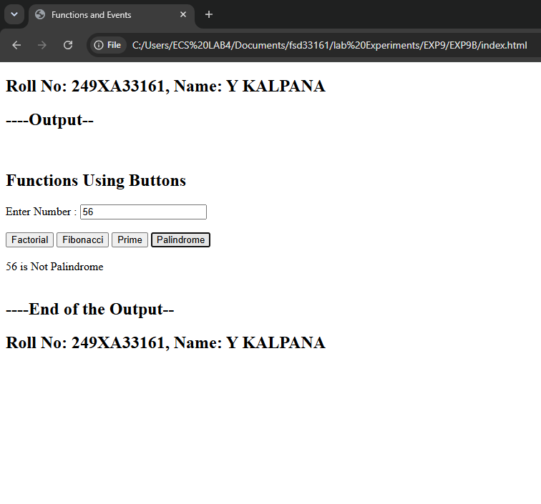

Experiment-9C: Date: 25-09-2026
****
Aim: Write a program to validate the following fields in a registration page i. Name (start with alphabet and followed by alphanumeric and the length should not be less
than 6 characters) ii. Mobile (only numbers and length 10 digits) iii. E-mail (should contain format like xxxxxxx@xxxxxx.xxx).
Source Code: (HTML)
<!doctype html>
<html>
<head>
<title>Registration Validation</title>
<script src="script9c.js"></script>
</head>
<body>
<h2>Roll No: 249XA33161, Name: Y KALPANA</h2>
<h2>----Output--</h2>
<br />
<h2>Registration Form</h2>
<form onsubmit="return validateForm();">
<table>
<tr>
<td>Name</td>
<td>
<input type="text" id="name" />
</td>
</tr>
<tr>
<td>Mobile</td>

<td>
<input type="text" id="mobile" />
</td>
</tr>
<tr>
<td>Email</td>
<td>
<input type="text" id="email" />
</td>
</tr>
<tr>
<td></td>
<td>
<input type="submit" value="Register" />
<input type="reset" value="Reset" />
</td>
</tr>
</table>
</form>
<br />
<h2>----End of the Output--</h2>
<h2>Roll No: 249XA33161, Name: Y KALPANA</h2>
</body>
</html>

Source Code: (JavaScript)
function validateForm() {
let name = document.getElementById("name").value;
let mobile = document.getElementById("mobile").value;
let email = document.getElementById("email").value;
let namePattern = /^[A-Za-z][A-Za-z0-9]{5,}$/;
let mobilePattern = /^[0-9]{10}$/;
let emailPattern = /^[A-Za-z0-9._%+-]+@[A-Za-z0-9.-]+\.[A-Za-z]{2,}$/;
if (!namePattern.test(name)) {
alert("Invalid Name");
return false;
}
if (!mobilePattern.test(mobile)) {
alert("Invalid Mobile Number");
return false;
}
if (!emailPattern.test(email)) {
alert("Invalid Email");
return false;
}
alert("Registration Successful");
return true;
}

Snapshot of the Output Webpage:
