Vel Tech Rangarajan Dr. Sagunthala R&D Institute of Science and Technology

(Deemed to be University Estd. u/s 3 of UGC Act, 1956)

School of Computing
B.Tech. – Computer Science and Engineering
VTR UGE2021- (CBCS)

Academic Year: 2025–2026
SUMMER SEMESTER - SS2526
Course Code : 10211CS207
Course Name : Database Management Systems
Slot No : S6L15

DBMS TASKS REPORT
Title: Conceptual Design through FTR
Submitted by:
VTUNO | REGISTER NUMBER | STUDENT NAME
VTU29886 | 24UECS0063 | C. VISHNU VARDHAN REDDY

METRO RAILWAY TICKET BOOKING MANAGEMENT

Abstract: The Metro Railway Ticket Booking System is a database management project designed to simplify and automate the process of purchasing metro tickets. This system allows passengers to book, cancel, and check ticket details efficiently using a digital platform instead of manual ticket counters. The main objective is to maintain accurate passenger, route, and payment records within a structured database to ensure data consistency, reliability, and quick retrieval.
The database stores essential information such as passenger details, train schedules, routes, ticket fares, and booking transactions. SQL queries are used to manage and retrieve data effectively. By implementing this system, the overall ticket booking process becomes faster, reduces human error, and provides an easy-to-use interface for both passengers and administrators. This project demonstrates the use of key DBMS concepts like normalization, relationships, constraints, and queries to build a reliable and efficient metro ticket booking database system.

TASK 1: Conceptual Design through FTR
Aim:
Using basic database design methodology and ER modeler, design Entity Relationship Diagram by satisfying the following sub tasks:
  - 1.a Construction of ER diagram
- 1.b Converting design after FTR into RDBMSD.

1.a Identifying the entities
1.a.1 users
1.a.2 logins
1.a.3 routes
1.a.4 payment
1.a.5 metros

1.b Identifyingtheattributes
1.b.1 USER (user_ id, name, Dob, address, mob no, Age)
1.b.2 LOGINS (login_ role, login user, login_ id, Password)
1.b.3 ROUTES (Stop_ no , stop name)
1.b.4 PAYMENT ( payment mode, acc no, transaction id )
1.b.5 METRO ( met_ id, met tck,met num)

1.c Identification of relationships, cardinality, type of relationship.

Relationship | Description | Type
User — Ticket | One passenger can book many tickets | 1 : M
Metro — Ticket | One train can have many tickets booked | 1 : M
Metro — Route | One train follows one or more routes | 1 : M
Station — Route | One station can appear in many routes | 1 : M
Ticket — Payment | Each ticket has one payment | 1 : 1

1.e. Using creately, develop ER/EER diagram

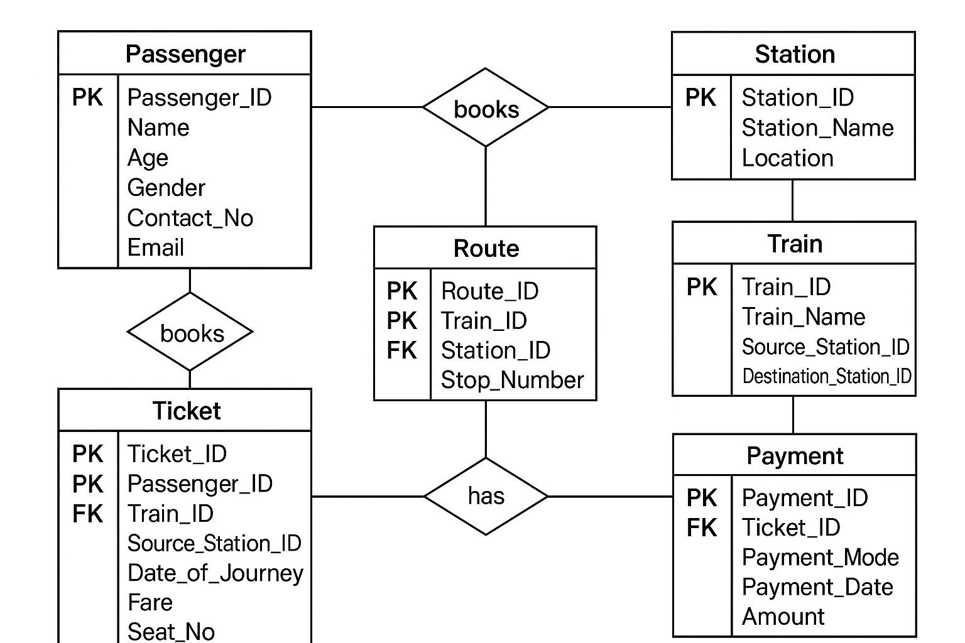

1.b Converting design after FTR into RDBMSD.

FTR :
A Formal Technical Review (FTR) is a structured and systematic process used to evaluate the design, code, or database schema of a project before it is finalized.
It’s a quality assurance activity where developers, database designers, or team members check the work for errors, standards, and consistency.

Comverthing into RDBMS :
This involves in mapping the approved conceptual design into relational schema

Passangers table

CREATE TABLE Passenger (
Passenger_ID INT PRIMARY KEY,
Name VARCHAR(100),
Age INT,
Gender VARCHAR(10),
Contact_No VARCHAR(15),
Email VARCHAR(100)
);

Station table
CREATE TABLE Station (
Station_ID INT PRIMARY KEY,
Station_Name VARCHAR(100),
Location VARCHAR(100)
);

Train table
CREATE TABLE Train (
Train_ID INT PRIMARY KEY,
Train_Name VARCHAR(100),
Source_Station_ID INT,
Destination_Station_ID INT,
Departure_Time TIME,
Arrival_Time TIME,
FOREIGN KEY (Source_Station_ID) REFERENCES Station(Station_ID),
FOREIGN KEY (Destination_Station_ID) REFERENCES Station(Station_ID)
);

Route table
CREATE TABLE Route (
Route_ID INT PRIMARY KEY,
Train_ID INT,
Station_ID INT,
Stop_Number INT,
FOREIGN KEY (Train_ID) REFERENCES Train(Train_ID),
FOREIGN KEY (Station_ID) REFERENCES Station(Station_ID)
);

Ticket table

CREATE TABLE Ticket (
Ticket_ID INT PRIMARY KEY,
Passenger_ID INT,
Train_ID INT,
Source_Station_ID INT,
Destination_Station_ID INT,
Date_of_Journey DATE,
Fare DECIMAL(10,2),
Seat_No VARCHAR(10),
FOREIGN KEY (Passenger_ID) REFERENCES Passenger(Passenger_ID),
FOREIGN KEY (Train_ID) REFERENCES Train(Train_ID),
FOREIGN KEY (Source_Station_ID) REFERENCES Station(Station_ID),
FOREIGN KEY (Destination_Station_ID) REFERENCES Station(Station_ID)
);

Payment table

CREATE TABLE Payment (
Payment_ID INT PRIMARY KEY,
Ticket_ID INT UNIQUE,
Payment_Mode VARCHAR(20),
Payment_Date DATE,
Amount DECIMAL(10,2),
FOREIGN KEY (Ticket_ID) REFERENCES Ticket(Ticket_ID)
);

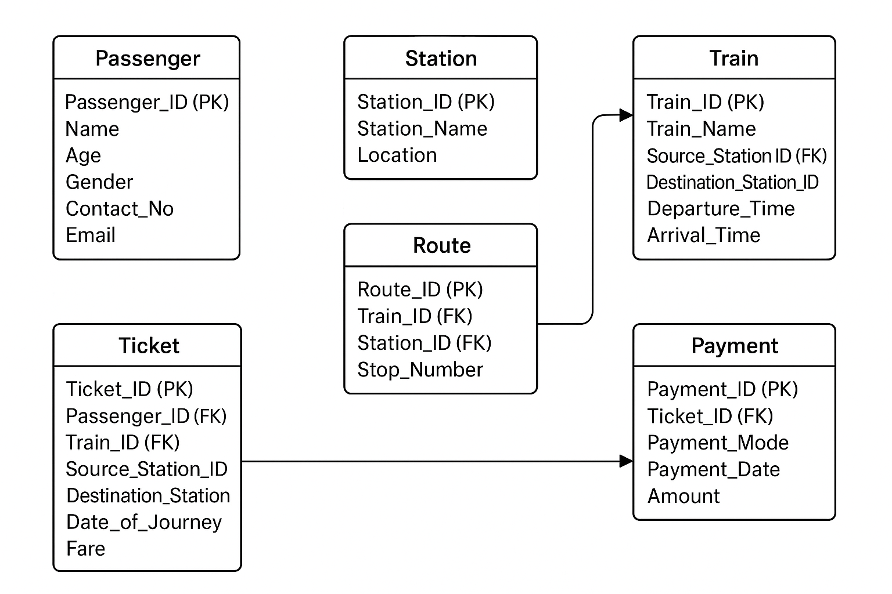

Result:
Thus the database design methodology and ER Model design diagram and converting the ER diagram into RDBMS was done successfully

TASK 2 : Generating design or other traditional data base models
Aim:
To perform SQL relations using DDL,DCL,DML,DRL Command and operations like create ,insert ,delete ,update basic select

a) Class Table
CREATE TABLE class (
class_id INT PRIMARY KEY,
class_code VARCHAR(10) UNIQUE,
class_name VARCHAR(10) NOT NULL
);
b) Zone Table
CREATE TABLE zone (
zone_id INT,
zone_name VARCHAR(10),
zone_code VARCHAR(10)
);
c) Student Table
CREATE TABLE student (
vtu CHAR(4),
name VARCHAR(10),
address VARCHAR(10),
dept CHAR(3),
age INT
);
🟢 2. INSERT Operation
Syntax:
INSERT INTO table_name (col1, col2, ...) VALUES (data1, data2, ...);

Examples:
INSERT INTO zone VALUES (1, 'North Zone', 'NZ');
INSERT INTO zone VALUES (2, 'South Zone', 'SZ');

🟣 3. SELECT Operation
Syntax:
SELECT * FROM table_name;
Example:
SELECT * FROM zone;

🔵 4. DELETE Operation

Syntax:

DELETE FROM table_name WHERE condition;

Example:

DELETE FROM zone WHERE zone_name = 'North Zone';

---

🟠 5. UPDATE Operation

Syntax:

UPDATE table_name
SET column_name = value
WHERE condition;

Example:
UPDATE zone SET zone_id = 20 WHERE zone_code = 'SZ';

🟡 6. ALTER TABLE Commands

a) Add Primary Key
ALTER TABLE zone ADD PRIMARY KEY (zone_name);
b) Add Foreign Key
ALTER TABLE zone
ADD FOREIGN KEY (zone_name)
REFERENCES em_zone (zone_name);

⚪ 7. DESCRIBE Command

Syntax:

DESC zone;

Result : Thus, to perform SQL relations using DDL, DCL, DML, and DQL commands & operations are done successfully.

TASK 3 :developing queries with DML single row function and operation

Table Creation and Data Insertion

create table employee (
emp_id int,
emp_name varchar(50),
salary data,
department varchar(20)
);

Example

insert into employee values
(1, 'Gopi', 76000, '2019-10-10', 'IT'),
(2, 'Kumar', 30000, '2022-08-12', 'HR'),
(3, 'Venkata', 50000, '2021-02-12', 'IT'),
(4, 'Anu', 55000, '2022-08-12', 'Sales'),
(5, 'Ankit', 45000, '2021-02-01', 'Finance');

We see some queries
select * from employee;

Aggregate and Group By Queries

select avg(salary), max(salary), min(salary) from employee;

Avg Salary | Max Salary | Min Salary
50000 | 76000 | 45000

select avg(salary), max(salary), min(salary) from employee group by department;

Department | Avg Salary | Max Salary | Min Salary
IT | 63000 | 76000 | 50000
HR | 30000 | 30000 | 30000
Sales | 55000 | 55000 | 55000
Finance | 45000 | 45000 | 45000

select emp_name, hire_date from employee where hire_date='2019-10-10';

Emp Name | Hire Date
Ankit | 2021-02-01
Venkata | 2021-02-12

select emp_name, salary from employee where salary > 50000;​

- select emp_name, salary from employee where department='IT' and salary > 50000;​

- select emp_name from employee where emp_name like 'A%';
- ​
- select emp_name, length(emp_name) from employee;

Result
Thus the process of executing of queries is successfully done

TASK 4 :Developing queries with DML multi row functions and operations

DML: A data manipulation language is a computer language use for inserting, deleting data in database.

Create table employee_details (
employeeIINT PRIMARY KEY,
firstname varchar(50),
lastname varchar(50),
department varchar(50),
salary DECIMAL(10,2),
hiredate date
);

Inserting sample data
INSERT INTO employee_details (emp values)
(1, 'John', 'Doe', 'sales', 50000, '2020-01-01'),
(2, 'Jane', 'Smith', 'marketing', 60000, '2019-06-01'),
(3, 'Alice', 'Johnson', 'sales', 55000, '2021-03-01'),
(4, 'Bob', 'Brown', 'IT', 70000, '2018-01-01'),
(5, 'Charlie', 'Davis', 'marketing', 65000, '2020-08-01');

Queries using DML & DRL
- Aggregate Functions:
SUM: calculate the total salary of all employee

SELECT SUM(salary) AS total_salary FROM employee_details;

AVG: find average salary of employee in the sales department

SELECT AVG(salary) AS average_salary FROM employee_details WHERE department='sales';

MAX and MIN: find the highest and lowest salary

SELECT MAX(salary) AS highest_salary, MIN(salary) AS lowest_salary FROM employee_details;

- Date Function:

EXTRACT: Extract the year from the hiredate
SELECT employeeID, firstname, lastname, EXTRACT(YEAR FROM hiredate) AS year FROM employee_details;
DATE_ADD: Find employee who have been working for more than 2 years
SELECT * FROM employee_details WHERE hiredate <= (CURRENT_DATE - INTERVAL 2 YEAR);

Output:
Highest salary: 70000
Lowest salary: 50000
Hire years:
John Doe: 2020
Jane Smith: 2019
Alice Johnson: 2021
Bob Brown: 2018
Charlie Davis: 2020

String Functions:

CONCAT: Combine first name and last name into full name
SELECT employeeID, CONCAT(firstname, ' ', lastname) AS fullname FROM employee_details;
UPPER and LOWER: Convert department names to upper or lower case respectively
SELECT UPPER(department) AS dept_upper FROM employee_details;
SELECT LOWER(department) AS dept_lower FROM employee_details;
Example:
Full Names:
- John Doe
- Jane Smith
- Alice Johnson
- Bob Brown
- Charlie Davis
- Indent Functions:
a) Padded Employee IDs:
SELECT LPAD(employeeID, 6, '0') AS padded_employeeID FROM employee_details;
Output:
000001 John Doe
000002 Jane Smith
000003 Alice Johnson
000004 Bob Brown
000005 Charlie Davis
b) Set Clause and Department Employee:
Sales and Marketing employee
- John Doe (Sales)
- Alice Johnson (Sales)
- Jane Smith (Marketing)
- Charlie Davis (Marketing)

- Union: Combine employee from sales & marketing department
SELECT employeeID, firstname, department FROM employee_details WHERE department='sales'
UNION
SELECT employeeID, firstname, department FROM employee_details WHERE department='marketing';
INTERSECT: Not directly supported in all SQLs
Example using INNER JOIN:
SELECT e1.employeeID, e1.firstname, e1.department
FROM employee_details e1
INNER JOIN employee_details e2
ON e1.department = e2.department
WHERE e1.department='marketing';

Result:
Thus, performed the queries processing on database are executed.

TASK 5: WRITING JOIN QUERIES EQUIVALENT & RECRUSIVE FUNCTIONS

1) Student Table

std_id sname course marks Admission date

201 Ajay CSE 85 2020-07-12
202 Manoj ECE 78 2021-08-17
203 Shashi CSE 91 2024-03-28
204 Pandhu CSE 90 2024-02-02
205 Sai CSE 81 2020-01-03

Course Table
course dept head credits
CSE Dr.Rao 3
ECE Dr.Anita 4
CSE Dr.Vikram 3

2) Inner Join → Students with Dept Head

select s.name, s.course, c.dept_head
from student s
join course_details c on s.course = c.course;

name course dept head
Ajay CSE Dr.Rao
Manoj ECE Dr.Anita
Shashi CSE Dr.Rao
Pandhu CSE Dr.Rao
Sai CSE Dr.Vikram

3) Right Join: All dept with their students

select s.name, c.course, c.dept_head
from students s
right join course_details c on s.course = c.course;
name course dept head
Ajay CSE Dr.Rao
Shashi CSE Dr.Rao
Pandhu CSE Dr.Vikram
Manoj ECE Dr.Anita
Sai CSE Dr.Vikram

4) Full Outer Join: All student and department

select s.name, c.course, c.dept_head
from student s
full outer join course_details c on s.course = c.course;

name course dept head
Ajay CSE Dr.Rao
Manoj ECE Dr.Anita
Shashi CSE Dr.Vikram
Pandhu CSE Dr.Rao
Sai CSE Dr.Vikram

5) Equivalent Queries – Student in CSE

select name from student where course = 'CSE';

Name
Ajay
Shashi
Pandhu
Sai
6) Course Credits of Each Student
select s.name, s.course, c.credits
from students s
join course_details c on s.course = c.course;

Name Course Credits
Ajay CSE 3
Manoj ECE 4
Shashi | CSE | 3
Pandhu | CSE | 3
Sai | CSE | 3

7) Dept Head with ≥ 2 Students

select c.dept_head, count(*) as student_count
from student s
join course_details c on s.course = c.course
group by dept_head
having count(*) >= 2;

Dept Head Student Count

Dr.Rao 2
Dr.Vikram 2

8) Student Admitted After 2020
select s.name, s.admission_date, c.dept_head
from student s
join course_details c on s.course = c.course
where s.admission_date > '2020-12-31';

Name Admission Date Dept Head
Manoj 2021-08-17 Dr.Anita
Shashi 2024-03-28 Dr.Vikram
Pandhu 2024-02-02 Dr.Rao

9) Optimized Query: CSE with Marks > 80
select s.name
from student s
join course_details c on s.course = c.course
where s.course = 'CSE' and s.marks > 80;

Name
Ajay
Shashi
Pandhu

10) Recursive CSE–CSE Students by Admission Date
with recursive cse_student as (
select studentid, name, course, admission_date
from student
where course = 'CSE'
union all
select s.std_id, s.name, s.course, s.admission_date
from student s
join cse_student cs on s.course = cs.course
where s.admission_date < cs.admission_date
)
select * from cse_student;

Std ID Name Course Admission Date
201 Ajay CSE 2020-07-12
204 Pandhu CSE 2024-02-02
203 Shashi CSE 2024-03-28
205 Sai CSE 2020-01-03

11) Self Join

select A.name as Student1, B.name as Student2, year(A.admission_date) as Year_Admitted
from student A, student B
where year(A.admission_date) = year(B.admission_date)
and A.stdid < B.stdid;

Student 1 Student 2 Year Admitted
Ajay Sai 2020
Shashi Pandhu 2024

Result:
Thus, writing join queries, equivalent and recursive queries are done successfully.

TASK 6 : Procedure function and loop
Aim:
Writing PL/SQL using procedures, functions and programming using PL/SQL procedural language and loops.

Create procedure a (a in out number) is
begin
a := a + 1;
end;
Output – 1:
The factorial of the given number is 8000

2.Factorial of a number using FUNCTION
create function facto(a number) return number is
b number := 1;
begin
for i in 1..a loop
b := b * i;
end loop;
return(b);
end;
Create Table Items:

create table items (
itemid int primary key,
product_name varchar(10),
price int
);

Insert Data:
insert into items values (101, 'Chair', 2000);
insert into items values (102, 'Table', 3000);
insert into items values (103, 'Board', 5000);

commit;
Select Data:
select * from items;
ITEMID PRICE PRODUCT_NAME
101 2000 CHAIR
102 3000 TABLE
103 5000 BOARD

create or replace procedure u_items
(id number, total number) is price number;
begin
select price into a price from items
where itemid = id;
if a price is null then
dbms_output.put_line('price is null');
else
update items set price = a price + total
where itemid = id;
end if;
end;

select * from items;
ITEMID PRICE PRODUCT_NAME
101 2500 CHAIR
102 3000 TABLE
103 5000 BOARD

Result:
Therefore, coding PL/SQL using procedures & function was successfully completed

TASK 7 :Triggers,views and exceptions
Aim:
To Conduct events, views, exceptions on CRUD operations for restricting phenomenon.
a) To create a trigger in PL/SQL that automatically inserts a new record in the match_result table when a new record is inserted into the match table.
b) To create a view that displays the details of players along with their team details.
c) To write a non-recursive PL/SQL procedure to retrieve even-numbered PlayerIDs registered for any tournament.

To create a trigger in PL/SQL that automatically inserts a new record in the match_result table when a new record is inserted into the match table.

CREATE OR REPLACE TRIGGER insert_match_result
AFTER INSERT ON match
FOR EACH ROW
BEGIN
INSERT INTO match_result (MatchID, TeamID, Result)
VALUES (:new.MatchID, :new.TeamID, 'Pending'); -- Assuming a default value of 'Pending' for Result
END;
To create a view that displays the details of players along with their team details.
SQL> CREATE VIEW PlayerTeamDetails AS SELECT p.playerID, p.fname AS PlayerName, p.teamID, p.coach AS PlayerCoach, p.captain AS PlayerCaptain, (SELECT t.name FROM team t WHERE t.teamID = p.teamID) AS TeamName, (SELECT t.coach FROM team t WHERE t.teamID = p.teamID) AS TeamCoach, (SELECT t.captain FROM team t WHERE t.teamID = p.teamID) AS TeamCaptain FROM player p;
SQL> Select * from PlayerTeamDetails;
To write a non-recursive PL/SQL procedure to retrieve even-numbered PlayerIDs registered for any tournament.
CREATE OR REPLACE PROCEDURE GetEvenPlayerIDsForTournament(in_tournament_id NUMBER, out_even_player_ids SYS.ODCINUMBERLIST) AS
BEGIN
out_even_player_ids := SYS.ODCINUMBERLIST(); -- Initialize the collection

-- Populate the collection with even-numbered PlayerIDs for the specified tournament
FOR player_rec IN (SELECT PlayerID FROM Player WHERE TournamentID = in_tournament_id AND MOD(PlayerID, 2) = 0) LOOP
out_even_player_ids.EXTEND;
out_even_player_ids(out_even_player_ids.COUNT) := player_rec.PlayerID;
END LOOP;
END;
/

DECLARE
tournament_id NUMBER := 123; -- Replace with the desired tournament ID
even_player_ids SYS.ODCINUMBERLIST;
BEGIN
GetEvenPlayerIDsForTournament(tournament_id, even_player_ids);

-- You can now use the even_player_ids collection as needed.
-- For example, to print the even PlayerIDs:
FOR i IN 1..even_player_ids.COUNT LOOP
DBMS_OUTPUT.PUT_LINE('Even PlayerID: ' || even_player_ids(i));
END LOOP;
END;

RESULT : Thus the Triggers, Views and Exceptions experiment was successfully completed results are verified

TASK 8 : Normalizing databases using functional dependencies upto BCNF
(Tool: GU/ Table Normalization Tool, ALM:Jigsaw)
Upon relational tables created in task-2, perform normalization up to BCNF based on given Dependencies as following for the assumed relations specified below.
Employee Database:
1. Identify employee attributes: Employee_ID, Name, Department, Job_Title, Manager_ID, Hire_Date, Salary.
2. Define relational schema: Employee (Employee_ID, Name, Department, Job_Title, Manager_ID, Hire_Date, Salary).
3. Determine functional dependencies (FDs) between attributes:
- Employee_ID -> Name, Department, Job_Title, Manager_ID, Hire_Date, Salary
- Department -> Manager_ID
- Manager_ID -> Name

Step 2: Convert to 1NF
1. Eliminate repeating groups or arrays (none in this example).
2. Create separate tables for each repeating group (none in this example).

Step 3: Convert to 2NF
1. Ensure each non-key attribute depends on the entire primary key.
2. Move non-key attributes to separate tables if they depend on only part of the primary key.
- Create Department table: Department (Department_ID, Manager_ID, Name).
- Create Employee table: Employee (Employee_ID, Name, Department_ID, Job_Title, Hire_Date, Salary).

Step 4: Convert to 3NF
1. Ensure there are no transitive dependencies.
2. Move non-key attributes to separate tables if they depend on another non-key attribute.
- Create Manager table: Manager (Manager_ID, Name).
- Update Department table: Department (Department_ID, Manager_ID).

Step 5: Convert to BCNF
1. Ensure every determinant is a candidate key.
2. Check for overlapping candidate keys.
3. Decompose relations to eliminate redundancy.

- No further decomposition needed.

Using Griffith Tool
1. Input relational schema and functional dependencies.
2. Griffith tool generates a dependency graph.
3. Analyze the graph to identify normalization issues.
4. Apply normalization rules to transform the schema.
5. Verify the resulting schema meets BCNF criteria.

Griffith Tool Steps
1. Create a new project in Griffith.
2. Define the relational schema and FDs.
3. Run the "Dependency Graph" tool.
4. Analyze the graph for normalization issues.
5. Apply transformations using the "Normalize" tool.
6. Verify BCNF compliance using the "BCNF Check" tool
Normalized Schema
1. Employee (Employee_ID, Name, Department_ID, Job_Title, Hire_Date, Salary).
2. Department (Department_ID, Manager_ID).
3. Manager (Manager_ID, Name).

RESULT :
Thus the normalization database using functional dependencies upto BCNF has successful

TASK 9: Backing up and recovery in databases CO4, K3
Perform following backup and recovery scenarios.
- Recovering a NOARCHIVELOG Database with Incremental Backups
- Restoring the Server Parameter File
- Performing Recovery with a Backup Control File
AIM:
To devise, implement, and manage a backup and recovery strategy.
PROCEDURE:

Typically, backup administration tasks include the following:
• Planning and testing responses to different kinds of failures
• Configuring the database environment for backup and recovery
• Setting up a backup schedule
• Monitoring the backup and recovery environment • Troubleshooting backup problems
• Recovering from data loss if the need arises

Data archival,
IT is although related to data protection, serves a different purpose. An archival backup is exempted from the normal backup and recovery strategy. These backups are typically archived onto separate storage media and retained for long periods.
RMAN provides a convenient way to create a backup and exempt it from your backup retention policy. This type of backup is known as an archival backup.

•Recovery Manager (RMAN)
Recovery Manager is fully integrated with the Oracle Database to perform a range of backup and recovery activities, including maintaining an RMAN repository of historical data about backups. You can access RMAN through the command line or through Oracle Enterprise Manager.
The following solutions are available when implementing a backup and recovery strategy:
A)To recover a NOARCHIVELOG database with incremental backups:
1. After connecting to the target database and the recovery catalog, place the database in a mounted state:
STARTUP FORCE MOUNT
2. Restore and recover the database.
For example, you can perform incomplete recovery with the following commands:
RESTORE DATABASE
FROM TAG "consistent_whole_backup";
RECOVER DATABASE NOREDO;
RESETLOGS
3. Open the database with the For example, enter the following command:
ALTER DATABASE OPEN RESETLOGS;

B)To restore the server parameter file from autobackup:
1. Start RMAN and do one of the following:
• If the database instance is started at the time of the loss of the server
parameter file, then connect to the target database.
• If the database instance is not started when the server parameter file is lost,
and if you are not using a recovery catalog, then run the
SET DBID

2. Shut down the database instance and restart it without mounting the database.
When the server parameter file is not available, RMAN starts the instance with a
dummy parameter file. For example, enter the following command:
STARTUP FORCE NOMOUNT;
3. Execute a
RUN
command to restore the server parameter file.
Depending on the situation, you may need to execute multiple commands in the
RUN
command. Note the following considerations:
• If restoring from tape, then use
ALLOCATE CHANNEL
to allocate an SBT channel manually. If restoring from disk, then RMAN uses the default disk channel.
• If the autobackups were not produced with the default format (
the
SET CONTROLFILE AUTOBACKUP FOR DEVICE TYPE
%F
), then use
command to specify the
format in effect when the autobackup was performed.
• If the most recent autobackup was not created today, then use
specify the date from which to start the search.
• If RMAN is not connected to a recovery catalog, then use
DBID for the target database.
SET UNTIL
SET DBID

4.You can use the following RMAN command to restart the instance with the restored server parameter file: STARTUP FORCE PFILE=/tmp/init.ora;
C)To recover the database with a control file autobackup in NOCATALOG mode:
1. Start RMAN and connect to a target database, as described in "Making Database
Connections with RMAN".
2. Start the target database instance without mounting the database. For example:
STARTUP NOMOUNT;
3. Set the database identifier for the target database with the
SET DBID
command.
RMAN displays the DBID whenever you connect to a target database.
4. Write an RMAN command file to restore the autobackup control file and perform
recovery.
The command file contains the following steps:
a. Optionally, specify the most recent backup time stamp that RMAN can use
when searching for a control file autobackup to restore.
b. If you know that a different control file autobackup format was in effect when
the control file autobackup was created, then specify a nondefault format for
the restore of the control file.
c. If an SBT channel created the control file autobackup, then allocate one or
more SBT channels. Because no recovery catalog is available, you cannot use
preconfigured channels.
d. Restore the autobackup of the control file, optionally setting the maximum
number of days backward that RMAN can search and the initial sequence
number that it uses in its search for the first day.
e. If you know that the control file contains information about configured channels
that is useful to you in the rest of the restore process, then you can exit RMAN
to clear manually allocated channels from
f.This step depends on whether the online redo logs are available. The option
OPEN RESETLOGS
is always required after recovery with a backup control file,regardless of whether logs are available.
If the online redo logs are usable, then RMAN can find and apply these logs.
Perform a complete restore and recovery as described in "Performing
Complete Database Recovery".
If the online redo logs are unusable, then perform DBPITR as described in
"Performing Database Point-in-Time Recovery". An
UNTILclause is required to specify a target time, SCN, or log sequence number for the recovery before the first SCN of the online redo logs .
5.If recovery was successful, then open the database and reset the online logs: ALTER DATABASE OPEN RESETLOGS

RESULT :Thus the backing up and recovery in database is completed

TASK 10- CRUD OPERATIONS IN DOCUMENT DATABASES

AIM:
To Perform Mongoose using NPM design on MongoDB designing document database and performing CRUD operations like creating, inserting, querying, finding and removing operations.

STEPS:
Step 1)install Mongo db using following link
https://www.mongodb.com/try/download/community

Step 2)install Mongosh using the below link
https://www.mongodb.com/docs/mongodb-shell/#download-and-install-mongosh

Step 3)To add the MongoDB Shell binary's location to your PATH environment variable:
Open the Control Panel.
In the System and Security category, click System.
Click Advanced system settings. The System Properties modal displays.
Click Environment Variables.
In the System variables section, select path and click Edit. The Edit environment variable modal displays.
Click New and add the filepath to your mongosh binary.
Click OK to confirm your changes. On each other modal, click OK to confirm your changes.
To confirm that your PATH environment variable is correctly configured to find mongosh, open a command prompt and enter the mongosh --help command.
If your PATH is configured correctly, a list of valid commands displays.

Step 4)Open mongo shell 4.0 from c:\programfiles\mongoDB\server\bin\mongod.exe

Step 5)Type the CRUD(CREATE READ UPDATE DELETE) COMMANDS GIVEN IN TEXT FILE.

CRUD OPERATIONS
db.createCollection("mylab")
{ "ok" : 1 }
> db.mylab.insertOne({item:"canvas",qty:100,tags:["cotton"],size:{h:28,w:35.5,uom:"cm"}})
{
"acknowledged" : true,
"insertedId" : ObjectId("627d13acc73990c074e6397c")
}
> db.mylab.find({item:"canvas"})
{ "_id" : ObjectId("627d13acc73990c074e6397c"), "item" : "canvas", "qty" : 100, "tags" : [ "cotton" ], "size" : { "h" : 28, "w" : 35.5, "uom" : "cm" } }
> db.mylab.insertMany([{item:"journal",qty:25,tags:["blank","red"],size:{h:14,w:21,uom:"cm"}},{item:"mat",qty:85,tags:["gray"],size:{h:27.9,w:35.5,uom:"cm"}},{item:"mousepad",qty:25,tags:["gel","blue"],size:{h:19,w:22.85,uom:"cm"}}])
{
"acknowledged" : true,
"insertedIds" : [
ObjectId("627d1598c73990c074e6397d"),
ObjectId("627d1598c73990c074e6397e"),
ObjectId("627d1598c73990c074e6397f")
]
}
> db.mylab.find({},{item:1,qty:1})
{ "_id" : ObjectId("627d13acc73990c074e6397c"), "item" : "canvas", "qty" : 100 }
{ "_id" : ObjectId("627d1598c73990c074e6397d"), "item" : "journal", "qty" : 25 }
{ "_id" : ObjectId("627d1598c73990c074e6397e"), "item" : "mat", "qty" : 85 }
{ "_id" : ObjectId("627d1598c73990c074e6397f"), "item" : "mousepad", "qty" : 25 }
> db.mylab.find({},{item:1,qty:1}).pretty()
{
"_id" : ObjectId("627d13acc73990c074e6397c"),
"item" : "canvas",
"qty" : 100
}
{
"_id" : ObjectId("627d1598c73990c074e6397d"),
"item" : "journal",
"qty" : 25
}
{ "_id" : ObjectId("627d1598c73990c074e6397e"), "item" : "mat", "qty" : 85 }
{
"_id" : ObjectId("627d1598c73990c074e6397f"),
"item" : "mousepad",
"qty" : 25
}
> db.mylab.find({item:"canvas"}).pretty().sort({item:-1})
{
"_id" : ObjectId("627d13acc73990c074e6397c"),
"item" : "canvas",
"qty" : 100,
"tags" : [
"cotton"
],
"size" : {
"h" : 28,
"w" : 35.5,
"uom" : "cm"
}
}
> db.mylab.deleteOne({item:"journal"}
...
...
> db.mylab.find({},{item:1,qty:1}).pretty()
{
"_id" : ObjectId("627d13acc73990c074e6397c"),
"item" : "canvas",
"qty" : 100
}
{
"_id" : ObjectId("627d1598c73990c074e6397d"),
"item" : "journal",
"qty" : 25
}
{ "_id" : ObjectId("627d1598c73990c074e6397e"), "item" : "mat", "qty" : 85 }
{
"_id" : ObjectId("627d1598c73990c074e6397f"),"item" : "mousepad","qty" : 25}

Result:
The implementation of CRUD operations like creating, inserting, finding and removing operations using MongoDB is successfully executed

TASK 11- CRUD OPERATIONS IN GRAPH DATABASES

AIM:
To perform CRUD operations like creating, inserting, querying, finding, deleting operations on graph spaces.

- Create Node with Properties
Properties are the key-value pairs using which a node stores data. You can create a node with properties using the CREATE clause. You need to specify these properties separated by commas within the flower braces “{ }”.

Syntax
Following is the syntax to create a node with properties.
CREATE (node:label { key1: value, key2: value, . . . . . . . . . })

- Returning the Created Node
To verify the creation of the node, type and execute the following query in the dollar prompt.
MATCH (n) RETURN n

- Creating Relationships
We can create a relationship using the CREATE clause. We will specify relationship within the square braces “[ ]” depending on the direction of the relationship it is placed between hyphen “ - ” and arrow “ → ” as shown in the following syntax.

Syntax
Following is the syntax to create a relationship using the CREATE clause.
CREATE (node1)-[:RelationshipType]->(node2)

- Creating a Relationship Between the Existing Nodes
You can also create a relationship between the existing nodes using the MATCH clause.

Syntax
Following is the syntax to create a relationship using the MATCH clause.
MATCH (a:LabeofNode1), (b:LabeofNode2)
WHERE a.name = "nameofnode1" AND b.name = " nameofnode2"
CREATE (a)-[: Relation]->(b)
RETURN a,b

- Deleting a Particular Node
To delete a particular node, you need to specify the details of the node in the place of “n” in the above query.

Syntax
Following is the syntax to delete a particular node from Neo4j using the DELETE clause.
MATCH (node:label {properties . . . . . . . . . . })
DETACH DELETE node

Create a graph database for student course registration, create student and dept node and insert values of properties.

create(n:student{Sid: "VTU14500",
Sname:"John",
deptname:"CSE" }
)
OUTPUT
Added 1 label, created 1 node, set 3 properties, completed after 232 ms.

Create(n:student {Sid: "VTU14501",
Sname:"Dharsana",
deptname:"EEE"})

OUTPUT
Added 1 label, created 1 node, set 3 properties, completed after 16 ms.

Create(w:student { Sid: "VTU14502",
Sname:"vijay",
deptname:"CSE"
})

OUTPUT
Added 1 label, created 1 node, set 3 properties, completed after 12 ms.

Create(n:dept{deptname:"cse",deptid:"d001"})

OUTPUT:
Added 1 label, created 1 node, set 2 properties, completed after 72 ms.

Select all the nodes in your database using match command

- match(n) return(n)

OUTPUT
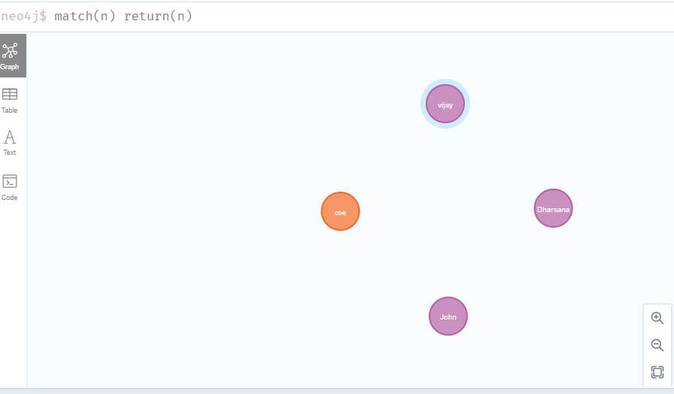

- match(n:student) return(n)

OUTPUT:

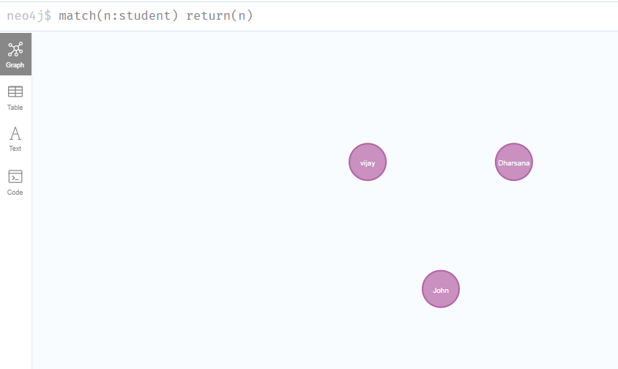

- Create relationship between student and cse .

MATCH(s:student),(d:dept) WHERE s.Sname ='vijay' AND d.deptname='cse'
CREATE(s)-[st:STUDIED_AT]->(d)
return s,d

OUTPUT:
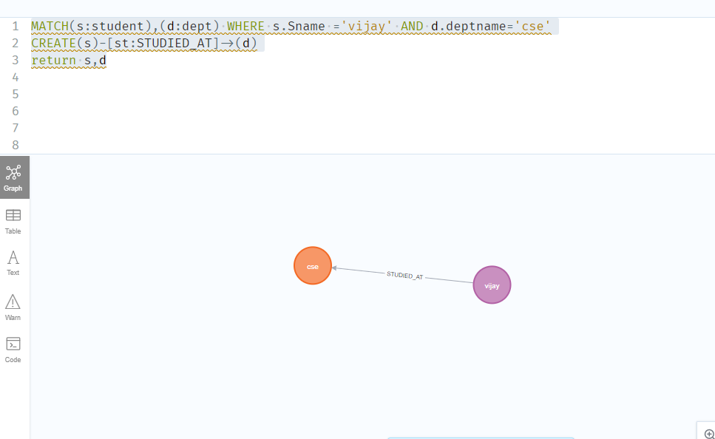

MATCH(s:student),(d:dept) WHERE s.Sname ='John' AND d.deptname='cse'
CREATE(s)-[st:STUDIED_AT]->(d)
return s,d

OUTPUT:

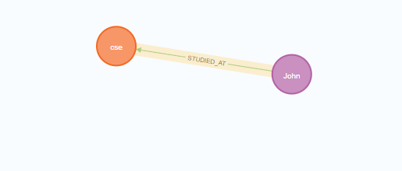

match(n) return(n)
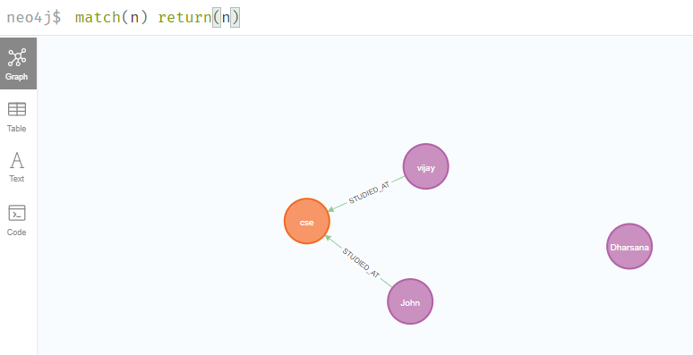

- Delete a node from student

match(n:student{Sname:'Dharsana'}) DELETE(n)

OUTPUT:
Deleted 1 node, complaeted after 10834 ms.
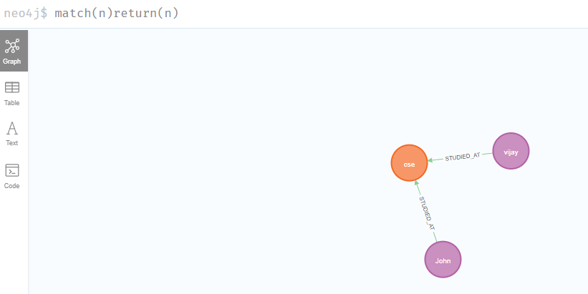

Result
The implementation of CRUD operations like creating, inserting, finding and removing operations using GraphDB is successfully executed.

Vel Tech Rangarajan Dr. Sagunthala R&D Institute of Science and Technology
(Deemed to be University Estd. u/s 3 of UGC Act, 1956)
School of Computing
B.Tech. – Computer Science and Engineering
VTR UGE2021- (CBCS)

Academic Year: 2025–2026
SDG 4: Quality Education
Course Code : 10211CS207
Course Name : Database Management Systems
Slot No : s6/L15
DBMS PROJECT REPORT
Title: Online Learning Platform Management System (OLPMS)
Submitted by:
VTUNO | REGISTER NUMBER | STUDENT NAME
27489 | 24UECS0873 | R.NAVYA SREE REDDY
28240 | 24UECS1461 | R.JHANSI
29918 | 24UECS0962 | T. SRIMAHA LAKSHMI
29613 | 24UECS1154 | C.SHALIKA SREE
27602 | 24UECS0964 | U.VENKATA SAI KUMAR
29383 | 24UECS0653 | K. KRISHNA SANDEEP REDDY
29886 | 24UECS0063 | C.VISHNU VARDHAN REDDY

Under the guidance of:
HANNAH.S
Professor

INDEX PAGE
1. Introduction …………………………………………… 3
2. Problem Statement …………………………………………… 4
3. Objectives …………………………………………… 5
4. System Requirements …………………………………………… 6
5. System Analysis and Design……………………………………… 6
6. ER Diagram (Conceptual Design) ..……………………………… 7
7. Schema Design (Oracle)…………………………………………… 9
8. Normalization …………………………………………… 11
9. Implementation (SQL Queries)…………………………………… 12
10. Input and Output …………………………………………… 14
11. Integration with MongoDB (NoSQL)…………………………… 15
12. Results and Discussion ..…………………………………… 18
13. Conclusion …………………………………………… 19
14. References …………………………………………… 19

- Introduction

In today’s digital era, music streaming platforms play a vital role in shaping how people discover and enjoy music. With millions of tracks available online, helping users find songs that match their preferences has become an essential feature for any modern music system. A Music Recommendation System aims to suggest songs, artists, or playlists based on user listening history, and preferences.
This project focuses on designing and implementing a Recommendation Database using SQL (Structured Query Language). The system stores and manages information about users, songs, artists, genres, and user interactions—such as ratings or listening history. SQL queries are used to analyze this data and generate personalized recommendations.
By leveraging SQL’s powerful data manipulation and querying capabilities, this system can efficiently retrieve relevant music suggestions, uncover patterns in user behavior, and enhance the overall listening experience. The goal is to create a scalable and optimized database that supports intelligent recommendation logic and ensures quick access to user-specific content
Music has always been an integral part of human culture and emotion. With the growth of technology and the internet, the way people consume music has changed drastically—from physical media to digital platforms and personalized streaming services. In this digital landscape, music recommendation systems play a crucial role in enhancing user experience by suggesting songs, albums, or artists that align with the listener’s tastes and preferences.
The Music System Recommendation using SQL serves as a foundation for understanding how database design and query optimization contribute to building efficient and personalized digital music platforms. This project not only emphasizes the importance of structured data management but also highlights the role of SQL in delivering smart and interactive user experiences.
2. Problem Statement
In the modern digital era, music consumption has evolved from traditional methods such as CDs and radio broadcasts to online streaming platforms and cloud-based music services. With millions of tracks available across different genres, artists, and moods, users often struggle to find music that matches their personal preferences. This overwhelming abundance of musical data creates a significant challenge in delivering personalized recommendations that enhance user satisfaction and engagement.
Most existing music applications rely on advanced recommendation algorithms powered by machine learning and big data analytics. However, before such complex systems can be implemented, a well-designed and efficient database must exist to organize and manage all relevant information about users, songs, artists, genres, and listening behaviors. Without a properly structured database and effective data retrieval mechanisms, the recommendation process becomes inaccurate, slow, and inefficient.
The core problem addressed in this project is how to design and implement a music recommendation system using SQL that can effectively store, process, and analyze musical data to generate meaningful recommendations. The system should be capable of handling a wide range of functionalities, such as maintaining user profiles, tracking user interactions (like song plays, likes, and ratings), and providing song suggestions based on user preferences or similarities in listening patterns.
Currently, many small-scale or educational music applications lack a strong SQL-based backend capable of performing advanced data analysis for personalized recommendations

3. Objectives

- To design a normalized relational database structure
- To implement SQL-based data storage and retrieval mechanisms
- To manage and analyze user interaction data
- To develop a recommendation logic using SQL queries
- To ensure database efficiency and performance optimization
- To demonstrate the integration of SQL in decision-making and recommendation systems
- To provide a user-friendly and data-driven foundation for future system expansion

4. System Requirements
Hardware Requirements:
- Processor: Intel i5 or higher
- RAM: 8 GB or more
- Hard Disk: 250 GB
Software Requirements:
- OS: Windows 10 or Linux
- Database: Oracle 12c or above
- Front-End: Java / Web Interface
- NoSQL: MongoDB 6.0
- Tools: Oracle SQL Developer, MongoDB Compass
5. System Analysis and Design
The system identifies the main entities and their relationships. Major entities include:
- User
-Artist
-Album
-Song
-Genre
-User_Rating
-Listening_History
6. ER Diagram (Conceptual Design)
Relationships:
-A user can rate many songs, and a song can be rated by many users

-A user can listen to many songs, and a song can be listened to by many users.
-An artist can perform many songs, but each song belongs to one artist.
-An artist can release multiple albums.
-Each album contains multiple songs, but each song belongs to one album
-Each genre can include many songs, but a song belongs to one genre.
-Each genre can include multiple artists, but an artist typically belongs to one main genre.

ER DIAGRAM :

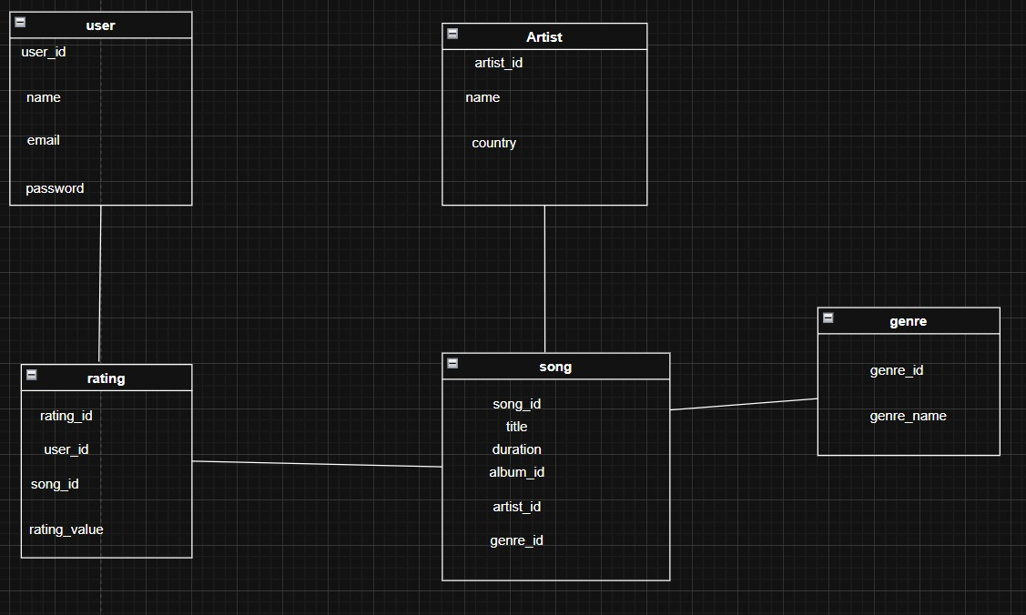

Entities and Attributes
- USER ( User_ID ,Name,Email,PassworD,Date_of_Birth,Country,Subscription_Type )
- song(Song_ID,title,duration,release_date,language,genre_id,)
- Artist(Artist_ID, Artist_Name, Country, Debut_Year)
- Album(Album_ID, Album_Name, Release_Year, Artist_ID)
- Genre(Genre_ID, Genre_Name, Description)
- Playlist(Playlist_ID, Playlist_Name, Creation_Date, User_ID)
- Recommendation(Recommendation_ID, User_ID, Song_ID)
Relationships
- User ↔Playlist → (one-to-Many)
- Playlist ↔ Song (Many-to-Many)
- Artist ↔ Album→ (One-to-Many)
- Album – Song → (One-to-Many)
- User – Song → (Many-to-Many)

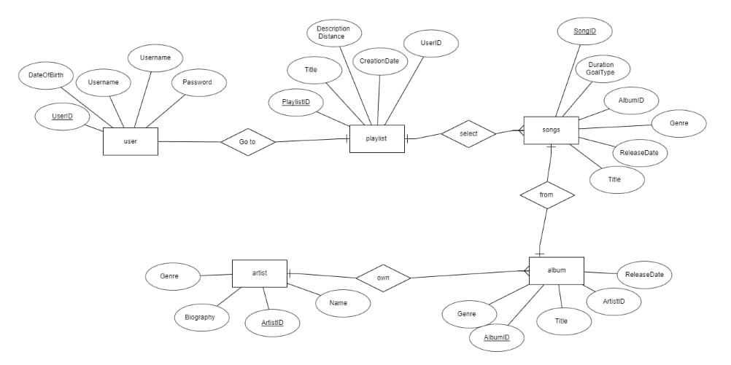
7. Schema Design (Oracle)
CREATE TABLE Users0 (
UserID NUMBER PRIMARY KEY,
UserName VARCHAR2(50) NOT NULL,
Email VARCHAR2(100) UNIQUE NOT NULL,
JoinDate DATE DEFAULT SYSDATE
);
OUTPUT:
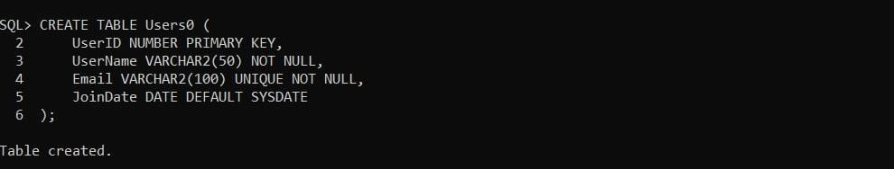
CREATE TABLE Artists (
ArtistID NUMBER PRIMARY KEY,
ArtistName VARCHAR2(100) NOT NULL
);
Output:
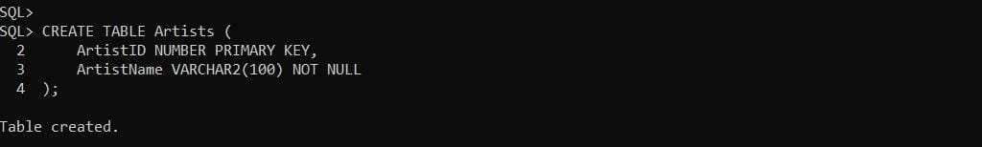
CREATE TABLE Genres (
GenreID NUMBER PRIMARY KEY,
GenreName VARCHAR2(50) NOT NULL
);

OUTPUT :
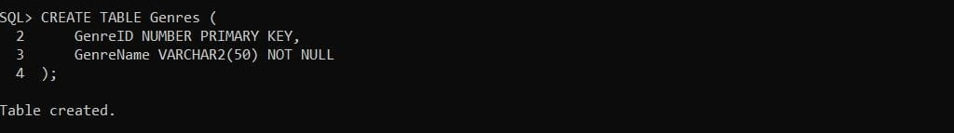
CREATE TABLE Albums0 (
Album0ID NUMBER PRIMARY KEY,
Album0Name VARCHAR2(100) NOT NULL,
ArtistID NUMBER,
ReleaseDate DATE
);
OUTPUT:
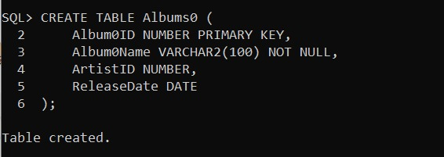
CREATE TABLE Songs0 (
SongID NUMBER PRIMARY KEY,
SongName VARCHAR2(100) NOT NULL,
AlbumID NUMBER,
GenreID NUMBER,
Duration NUMBER(5,2)
);
Output:
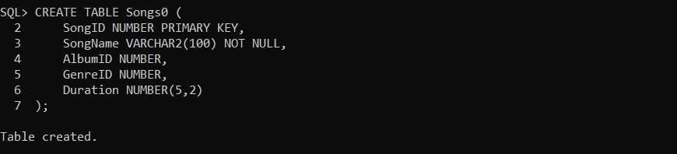
CREATE TABLE Ratings (
RatingID NUMBER PRIMARY KEY,
UserID NUMBER,
SongID NUMBER,
Rating NUMBER(2,1) CHECK (Rating BETWEEN 1 AND 5),
RatingDate DATE DEFAULT SYSDATE
);

OUTPUT:
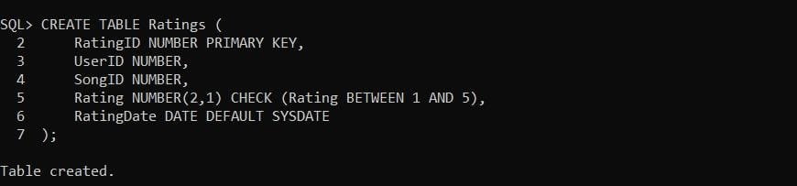
8. Normalization
The schema design follows normalization principles up to 3NF:
1NF: All attributes contain atomic values.
2NF: All non-key attributes are fully functionally dependent on the primary key.
3NF: No transitive dependencies exist.
This ensures data consistency and minimizes redundancy.
9. Implementation (SQL Queries)
INSERT INTO Users0 (UserID, UserName, Email, JoinDate)
VALUES (1, 'Alice', 'alice@email.com', SYSDATE);
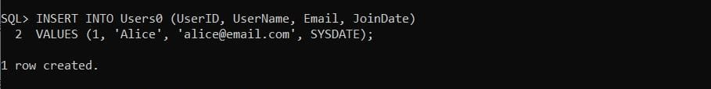
INSERT INTO Users0 (UserID, UserName, Email, JoinDate)
VALUES (2, 'Bob', 'bob@email.com', SYSDATE);
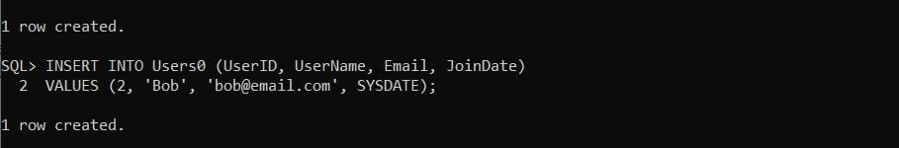
INSERT INTO Artists (ArtistID, ArtistName) VALUES (1, 'Taylor Swift');
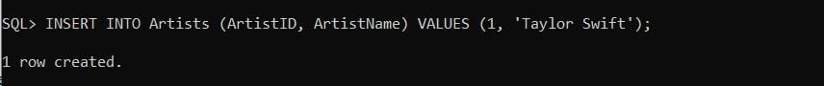
INSERT INTO Artists (ArtistID, ArtistName) VALUES (2, 'Ed Sheeran');
INSERT INTO Genres (GenreID, GenreName) VALUES (1, 'Pop')
INSERT INTO Genres (GenreID, GenreName) VALUES (2, 'Rock');
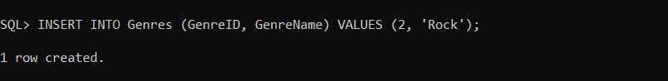
INSERT INTO Albums0 (Album0ID, Album0Name, ArtistID, ReleaseDate)
VALUES (1, '1989', 1, TO_DATE('2014-10-27','YYYY-MM-DD'))
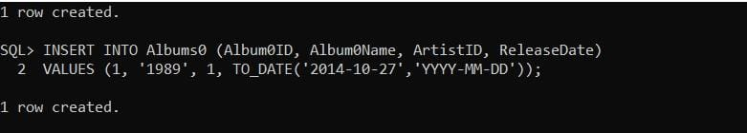
INSERT INTO Albums0 (Album0ID, Album0Name, ArtistID, ReleaseDate)
VALUES (2, 'Divide', 2, TO_DATE('2017-03-03','YYYY-MM-DD'));
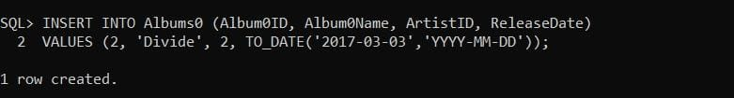

INSERT INTO Songs0 (SongID, SongName, AlbumID, GenreID, Duration)
VALUES (1, 'Blank Space', 1, 1, 3.51);
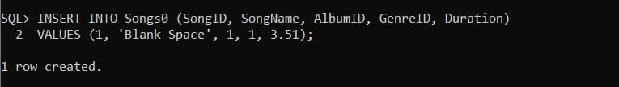

INSERT INTO Songs0 (SongID, SongName, AlbumID, GenreID, Duration)
VALUES (2, 'Shape of You', 2, 1, 4.24);
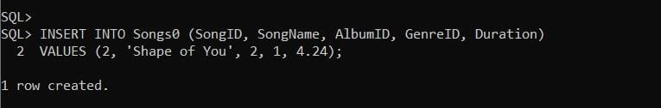
INSERT INTO Ratings (RatingID, UserID, SongID, Rating, RatingDate)
VALUES (1, 1, 1, 5, SYSDATE);
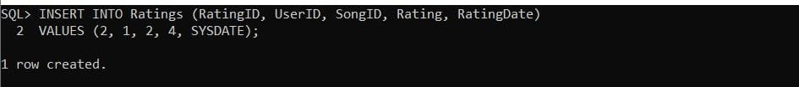
INSERT INTO Ratings (RatingID, UserID, SongID, Rating, RatingDate)
VALUES (2, 1, 2, 4, SYSDATE);
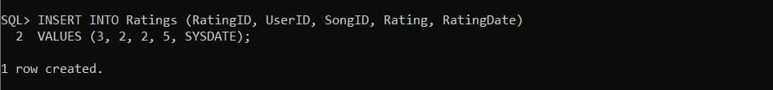

10. Input and Output
SELECT s.SongName,
ROUND(AVG(r.Rating), 2) AS AvgRating
FROM Songs0 s
JOIN Ratings r ON s.SongID = r.SongID
WHERE s.SongID NOT IN (
SELECT SongID
FROM Ratings
WHERE UserID = 1 -- replace 1 with the UserID of the user
)
GROUP BY s.SongName
ORDER BY AvgRating DESC;
Output:
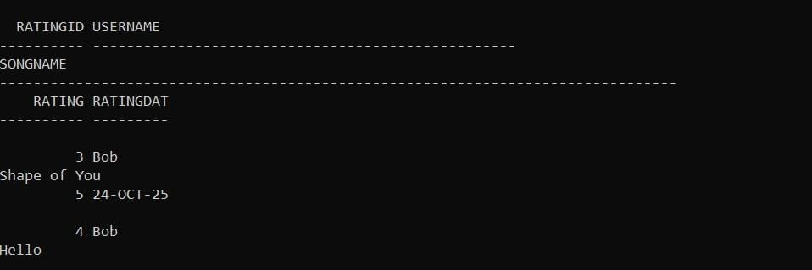

AVERAGE RATING OUTPURT :
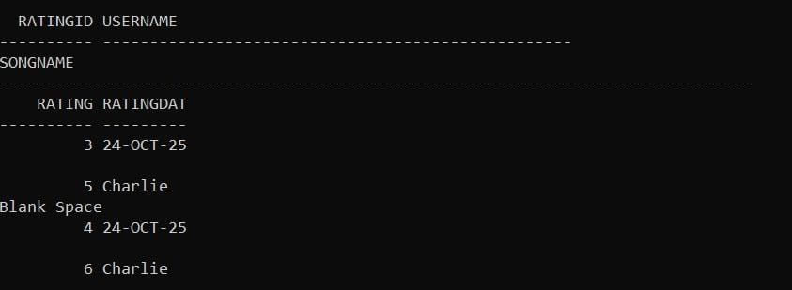
11. Integration with MongoDB (NoSQL)
MongoDB is a NoSQL, document-oriented database is used as the primary database to store and manage large volumes of music-related data efficiently. MongoDB is a NoSQL, document-oriented database that stores data in flexible JSON-like documents instead of traditional tables. This structure allows the system to handle diverse data such as user profiles, song details, artists, genres, and listening histories without predefined schemas.
Using MongoDB Compass, the graphical interface of MongoDB, data can be easily visualized, queried, and analyzed to identify user preferences and listening patterns. The database enables quick retrieval and updating of data, which is essential for generating accurate and real-time music recommendations.
Overall, MongoDB provides the scalability, flexibility, and performance needed for a dynamic and data-driven application like a music recommendation system, ensuring a personalized and seamless user experience.
Database Name: OnlineLearningDB
Collections and Example Documents
create:
{
"song_id": "S001",
"title": "Morning Breeze",
"artist": "Indie Echo",
"album": "Dawn",
"genre": ["indie", "acoustic"],
"duration_seconds": 215,
"tags": ["calm", "study", "morning"],
"release_date": "2024-11-10",
"plays": 1523
}
Insert:
{
"user_id": "U001",
"name": "Vishnu",
"age": 21,
"country": "India",
"liked_genres": ["indie", "pop"],
"playlists": [
{ "playlist_id": "P001", "name": "Study Mix", "song_ids": ["S001", "S002"] }
]
}

READ:
Get all songs in genre indie:

{ "genre": "indie" }

Songs with plays > 1000:

{ "plays": { "$gt": 1000 } }

UPDATE:
Increment plays for S001 by 1:
{ "song_id": "S001" }
{ "$inc": { "plays": 1 } }

DELETE:
Delete a single song by song_id:

{ "song_id": "S003" }

Click Delete One.

Delete all ratings with rating < 3:

{ "rating": { "$lt": 3 } }
12. Results and Discussion
The Music System Recommendation project successfully implemented a database using MongoDB Compass to manage and analyze music-related data. The system was able to store user details, song information, artists, albums, genres, and user preferences efficiently in a flexible document-oriented structure. The use of MongoDB allowed for seamless data organization without requiring a fixed schema, which made it easier to update and expand the dataset as new songs or users were added.
Through queries and aggregation pipelines in MongoDB Compass, the system could analyze user listening patterns and generate personalized recommendations based on factors such as play count, user ratings, and genre preferences. The retrieval of data was fast and efficient, demonstrating MongoDB’s capability to handle large datasets with minimal latency.Overall, the project achieved its objective of creating a reliable, data-driven recommendation system that provides a personalized music experience while efficiently managing and analyzing user and music data

13. Conclusion
The relational database for the music recommendation system provides an efficient and organized way to store and manage large volumes of music-related data, including users, songs, artists, genres, and user preferences. By using structured relationships between tables, the system ensures data consistency, eliminates redundancy, and enables quick retrieval of relevant information. This structured approach allows the recommendation engine to analyze user behavior and generate personalized music suggestions effectively. Overall, the relational database serves as the backbone of the music recommendation system, supporting scalability, accuracy, and efficient decision-making for enhanced user experience
14. References
1. Oracle Database Documentation – Oracle Corporation, 23ai
2. MongoDB Compass Documentation
3. Elmasri, R. & Navathe, Sudarshan – Database System Concepts
4. Raghu Ramakrishnan & Gehrke, J, McGraw-Hill – Database Management Systems
5. ResearchGate. (2023). Design and Implementation for music system recommendation

