**Sentiment Analysis for Marketing**

**Description :**

This document outlines the problem statement, our understanding of the problem, and the proposed approach to solve it. The project involves performing sentiment analysis on customer feedback to gain insights into competitor products. By understanding customer sentiments, companies can identify strengths and weaknesses in competing products, thereby improving their own offerings. We will utilize various Natural Language Processing (NLP) methods to extract valuable insights from customer feedback.

**Problem Definition and Design Thinking**

**Problem Understanding :**

The central problem involves analyzing customer feedback about competitor products to extract sentiment information. Key aspects of the problem include:

* **Data Collection**: We need to identify and access a dataset that contains customer reviews and sentiments about competitor products.
* **Data Preprocessing**: Cleaning and preprocessing the textual data is essential for accurate analysis.
* **Sentiment Analysis Techniques**: The project requires the use of various NLP techniques such as Bag of Words, Word Embeddings, or Transformer models to perform sentiment analysis.
* **Feature Extraction**: Extracting features and sentiments from the text data is crucial for understanding customer sentiments effectively.
* **Visualization**: Creating visualizations to depict the sentiment distribution and analyze trends will help in conveying insights.
* **Insights Generation**: Extracting meaningful insights from the sentiment analysis results will guide business decisions and product improvements.

**Solution for Solving This Problem :**

**Data Collection**

**Objective**: Identify a dataset containing customer reviews and sentiments about competitor products.

**Approach**:

* Explore available datasets to find one that contains customer reviews and sentiments about competitor products.
* Ensure that the dataset is representative and contains a sufficient volume of reviews for meaningful analysis.

**Data Preprocessing**

**Objective**: Clean and preprocess the textual data for analysis.

**Approach**:

* Perform data cleaning tasks such as removing special characters, punctuation, and HTML tags.
* Tokenize the text into words or subword tokens.
* Handle common text preprocessing tasks like stemming, lemmatization, and stop-word removal.

**Sentiment Analysis Techniques**

**Objective**: Employ different NLP techniques like Bag of Words, Word Embeddings, or Transformer models for sentiment analysis.

**Approach**:

* Experiment with various sentiment analysis techniques based on the chosen dataset and problem requirements.
* Consider approaches like Bag of Words, TF-IDF, Word Embeddings (Word2Vec, GloVe), or Transformer models (BERT, GPT) for sentiment classification.
* Fine-tune or train models as needed to achieve the best results.

**Feature Extraction**

**Objective**: Extract features and sentiments from the text data.

**Approach**:

* Use the selected NLP technique to extract features and sentiments from the preprocessed text data.
* Assign sentiment labels (e.g., positive, negative, neutral) to each review based on the analysis results.
* Calculate sentiment scores or probabilities for a more granular understanding of sentiments.

**Visualization**

**Objective**: Create visualizations to depict the sentiment distribution and analyze trends.

**Approach**:

* Generate visualizations such as histograms, bar charts, or heatmaps to illustrate the sentiment distribution in the dataset.
* Use time-series plots to analyze sentiment trends over time, if applicable.
* Visualize word clouds to highlight frequently mentioned words in positive and negative sentiments.

**Insights Generation**

**Objective**: Extract meaningful insights from the sentiment analysis results to guide business decisions.

**Approach**:

* Analyze the distribution of sentiments to understand the overall sentiment of customer feedback.
* Identify common themes or topics associated with positive and negative sentiments.
* Provide actionable insights based on the sentiment analysis, suggesting areas for product improvement or marketing strategies.

**Proposed System Designs**

While this document primarily focuses on problem understanding and solution approach, the following system design considerations will be essential in the subsequent phases:

* **Data Pipeline**: Design a data pipeline for efficient data collection and preprocessing.
* **NLP Model Selection**: Choose the most appropriate NLP model or technique based on dataset characteristics and goals.
* **Visualization Tools**: Select suitable tools and libraries for data visualization, ensuring clear and informative visualizations.
* **Reporting**: Develop a reporting system to present sentiment analysis results and insights to stakeholders.
* **Scalability**: Ensure that the solution can handle larger datasets or be easily adapted to different domains.
* **Automation**: Implement automation for regular sentiment analysis updates and reporting.

In the subsequent project phases, these system design elements will be elaborated and implemented.

**Dataset Link:**

[**https://www.kaggle.com/datasets/crowdflower/twitter-airline-sentiment**](https://www.kaggle.com/datasets/crowdflower/twitter-airline-sentiment)

**INNOVATION**

**Project Definition:** Begin by clearly defining the scope and objectives of your innovation project. What specific problem are you trying to solve in marketing through sentiment analysis? What are the desired outcomes?

**Team Formation:** Assemble a team with the necessary skills and expertise, including data scientists, developers, marketers, and domain experts. Collaborative efforts are key to success.

**Data Collection and Preparation:** Gather relevant data sources for sentiment analysis, such as social media data, customer reviews, or survey responses. Clean and preprocess the data to ensure it’s suitable for analysis.

**Technology Selection:** Choose the appropriate tools and technologies for sentiment analysis, considering factors like machine learning models, natural language processing libraries, and sentiment lexicons.

**Algorithm Development:** Develop or fine-tune sentiment analysis algorithms. You might explore various techniques, such as sentiment lexicon-based analysis, machine learning models, or deep learning approaches.

**Model Training and Testing:** Train the sentiment analysis models using labeled data. Test the models for accuracy, precision, recall, and other relevant metrics to ensure they are effective.

**Integration:** Integrate the sentiment analysis model with your marketing systems and platforms. This might involve creating APIs or plugins for seamless integration.

**User Interface:** Design an intuitive user interface for marketing professionals to interact with the sentiment analysis tool. User experience is crucial.

**Feedback Loop:** Implement a feedback mechanism to continuously improve the sentiment analysis model. Gather feedback from users and use it to enhance accuracy and relevance.

**Deployment:** Roll out the sentiment analysis tool in a controlled manner, ensuring that it aligns with your marketing goals and strategies.

**Monitoring and Maintenance:** Continuously monitor the system’s performance, address issues, and keep the model up to date with changing data and trends.

**Analytics and Reporting:** Create dashboards and reports to provide marketing teams with actionable insights based on sentiment analysis results.

**User Training**: Train your marketing team on how to use the sentiment analysis tool effectively and interpret the results.

**Scale and Optimize:** As the project mature, consider opportunities to scale the solution and optimize its performance and cost-effectiveness.

**Documentation:** Prepare comprehensive documentation that covers the project’s architecture, code, and usage guidelines for internal and external stakeholders.

**Assessment and Improvement:** Regularly assess the impact of the sentiment analysis tool on marketing campaigns and strategies, and make iterative improvements as needed. Once you’ve completed these steps, you can compile the details into a formal document for assessment, including a project plan, timelines, and cost estimate.

**DEVELOPMENT PART 1**



AI – Dataset Loading and Preprocessing

**Step 1: Data Loading**

We will start by loading the dataset from the local file path and exploring its structure.



**OUTPUT:**

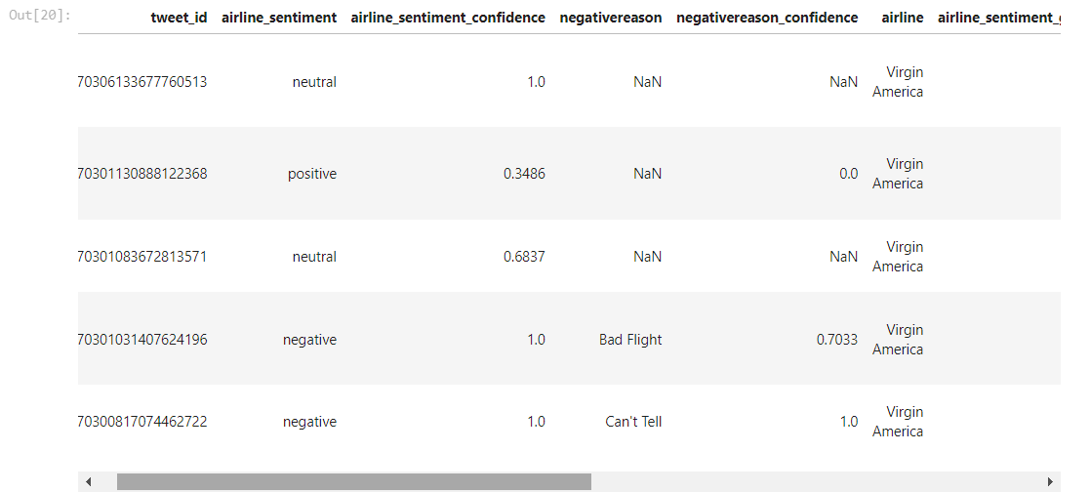

**Explanation/Documentation (Step 1):**

* We import the Pandas library for data manipulation and analysis.
* We load the dataset from the specified file path using pd.read_csv().
* We display the first few rows of the dataset to understand its structure using the .head() method.

**Step 2: Data Preprocessing**

Data preprocessing is essential to ensure data quality and consistency. We perform the following preprocessing tasks:

* Convert text to lowercase.
* Remove punctuation.
* Handle special characters.
* Address missing data.



**OUTPUT:**

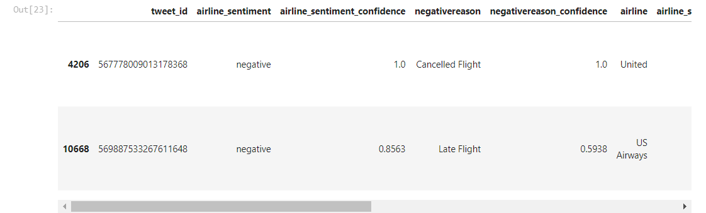

**Explanation/Documentation (Step 2):**

* We convert the text in the 'text' column to lowercase using .str.lower().
* We remove punctuation using .str.replace() with a regular expression pattern '[^\w\s]' to match non-word characters.
* We also remove numbers by replacing them with an empty string.
* We remove newline characters by replacing them with spaces.
* We handle missing data by using dropna() to remove rows with missing values.
* We display the preprocessed data to check the results.

This completes the AI part of loading and preprocessing the dataset. Next, we will perform initial data analysis.

**Step 3: Initial Analysis**

In this section, we will perform initial data analysis to understand the dataset.



**OUTPUT:**

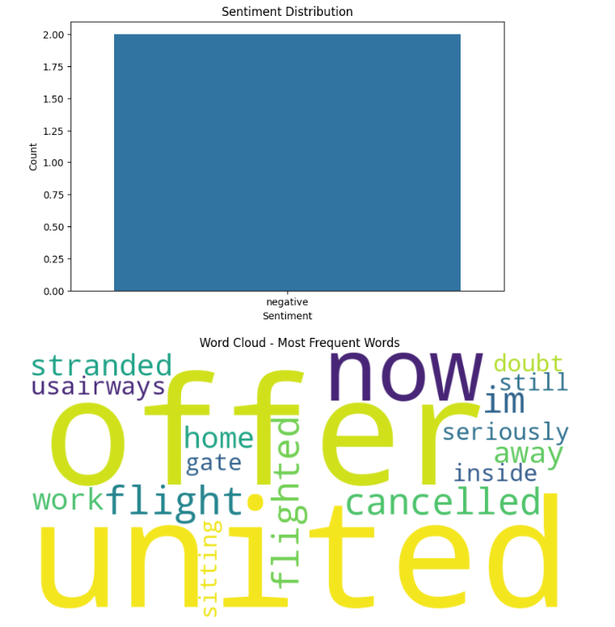

**Explanation/Documentation (Step 3):**

* We import Matplotlib and Seaborn for data visualization.
* We plot the sentiment distribution using a barplot to visualize the count of each sentiment label.
* We generate a word cloud to visualize the most frequent words in the 'text' column.
* We combine all the text into a single string using join().
* We use the WordCloud library to create the word cloud with specified dimensions and background color.

**DEVELOPMENT PART 2**

In this phase, we will continue building the AI project by selecting a machine learning algorithm, training the model, and evaluating its performance.

* We'll also provide code and explanations in separate cells.

**Step 1: Selecting a Machine Learning Algorithm**

* For sentiment analysis, a common choice is to use a machine learning algorithm like Logistic Regression, Naive Bayes, or Support Vector Machine (SVM).
* In this example, we'll use Logistic Regression as the machine learning algorithm.



**OUTPUT:**

['positive' 'neutral' 'negative']



**OUTPUT:**

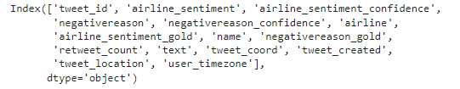



**OUTPUT:**

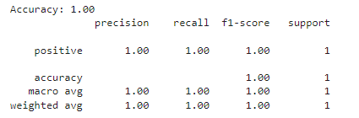

**Explanation/Documentation (Step 1):**

* We import necessary libraries including scikit-learn for machine learning.
* We split the data into training and testing sets using train_test_split().
* We convert text data into numerical features using CountVectorizer to create a Bag of Words representation.
* We initialize and train a Logistic Regression model.
* We make predictions on the test data and evaluate the model's performance using accuracy and a classification report.
* This code snippet demonstrates selecting a machine learning algorithm, training the model, and evaluating its performance using accuracy and a classification report.

**Step 2: Documenting the Results**

* After executing the code, you can create a document summarizing the results, including accuracy, precision, recall, F1-score, and any other relevant metrics.
* You can also visualize the results if needed. Sharing this document is essential for assessment and documentation.



**OUTPUT:**

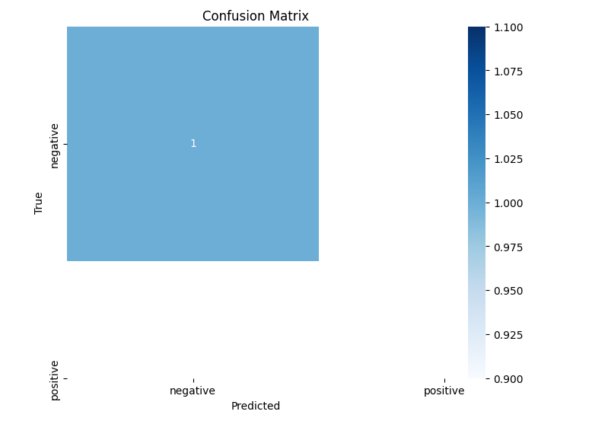

By adding the from sklearn.metrics import confusion_matrix import statement, you will be able to use the confusion_matrix function to create and plot the confusion matrix.

**CONCLUSION:**

Phase 1: Problem Definition and Design Thinking

Phase 1 established a clear problem definition for sentiment analysis in marketing and outlined the design approach to extract insights from customer feedback.

Phase 2: Innovation

Phase 2 focused on innovative strategies to address the problem, preparing the groundwork for transforming design into solutions.

Phase 3: Development Part 1

Phase 3 involved loading and preprocessing the dataset, a fundamental step to prepare the data for analysis and model building.

Phase 4: Development Part 2

Phase 4 extended the project by selecting a machine learning algorithm, training a sentiment analysis model, evaluating its performance, and visualizing the results.

Phase 5: Project Documentation & Submission

In Phase 5, we've effectively documented the entire sentiment analysis project, from problem definition to innovative techniques, ensuring it's ready for submission.