**St. Joseph’s UNIVERSITY**

**Bangalore-560027**



**Estd-1882**

**COMPUTER SCIENCE**

**PRACTICAL RECORD**

**(database application development lab)**

**Submitted by:**

**Student Name: Shashank**

**Roll No: 222CSC33**

**ST. JOSEPH’S UNIVERSITY**

**BANGALORE**



**LABORATORY CERTIFICATE**

This is to certify that Sri. Shashank has satisfactorily completed the course of laboratory assignments in Mobile Application development lab prescribed by St. Joseph’s University for the Third Semester Master’s degree course in MSc. Computer Science for the year 2023-24.

Teacher In-Charge – Ms Banu M

PG Coordinator – Dr B Nithya

Name: Shashank

Reg. No.: 222CSC33

Date of Exam: 3rd November 2023

***MOBILE APPLICATION DEVELOPMENT***

***INDEX***

|  |  |  |
| --- | --- | --- |
| S. No. | Program Names | Page No. |
| 1. | Design and develop a login screen | 02 |
| 2. | Write a program to demonstrate the activity lifecycle of android apps | 06 |
| 3. | Write a program to demonstrate usage of graphical primitives | 20 |
| 4. | Write a program to demonstrate explicit and implicit intents | 26 |
| 5. | Develop a registration page with checkbox, radio and image view. | 27 |
| 6. | Demonstrate usage of audio and video player based on user activity. | 37 |
| 7. | Develop movie rating app with ratings bar, image view, and other inputs | 43 |
| 8. | Develop a simple calculator in android | 51 |
| 9. | Develop custom splash screens for your app | 53 |
| 10. | Develop an app that displays your current location on map | 56 |
| 11. | Demonstrate CRUD operations with SQlite | 59 |
| 12. | Develop an app with menus | 61 |
| 13. | Demonstrate dynamically changing colors and fonts of text on button clicks | 62 |
| 14. | Demonstrate the use of shared preferences |  |

1. **Design and develop a login screen**

**Aim:** To develop a secure Android login Page application that enables users to authenticate and access personalized content with ease**.**

* 1. *Activity_main.xml*

<?xml version="1.0" encoding="utf-8"?>  
<androidx.constraintlayout.widget.ConstraintLayout xmlns:android="http://schemas.android.com/apk/res/android"  
 xmlns:app="http://schemas.android.com/apk/res-auto"  
 xmlns:tools="http://schemas.android.com/tools"  
 android:layout_width="match_parent"  
 android:layout_height="match_parent"  
 tools:context=".MainActivity"  
 android:background="#A18EC5">  
  
 <TextView  
 android:id="@+id/enterUN"  
 android:layout_width="250dp"  
 android:layout_height="41dp"  
 android:text="Enter your username"  
 android:textSize="25dp"  
 android:textColor="@color/black"  
 app:layout_constraintBottom_toBottomOf="parent"  
 app:layout_constraintEnd_toEndOf="parent"  
 app:layout_constraintHorizontal_bias="0.51"  
 app:layout_constraintStart_toStartOf="parent"  
 app:layout_constraintTop_toTopOf="parent"  
 app:layout_constraintVertical_bias="0.243" />  
  
 <TextView  
 android:id="@+id/enterPW"  
 android:layout_width="250dp"  
 android:layout_height="41dp"  
 android:text="Enter your password"  
 android:textSize="25dp"  
 android:textColor="@color/black"  
 app:layout_constraintBottom_toBottomOf="parent"  
 app:layout_constraintEnd_toEndOf="parent"  
 app:layout_constraintHorizontal_bias="0.523"  
 app:layout_constraintStart_toStartOf="parent"  
 app:layout_constraintTop_toTopOf="parent"  
 app:layout_constraintVertical_bias="0.515" />  
  
 <EditText  
 android:id="@+id/pw"  
 android:layout_width="wrap_content"  
 android:layout_height="wrap_content"  
 android:ems="12"  
 android:inputType="textPassword"  
 app:layout_constraintBottom_toBottomOf="parent"  
 app:layout_constraintEnd_toEndOf="parent"  
 app:layout_constraintHorizontal_bias="0.554"  
 app:layout_constraintStart_toStartOf="parent"  
 app:layout_constraintTop_toTopOf="parent"  
 app:layout_constraintVertical_bias="0.612" />  
  
 <EditText  
 android:id="@+id/un"  
 android:layout_width="wrap_content"  
 android:layout_height="wrap_content"  
 android:ems="12"  
 android:inputType="text"  
 app:layout_constraintBottom_toBottomOf="parent"  
 app:layout_constraintEnd_toEndOf="parent"  
 app:layout_constraintHorizontal_bias="0.497"  
 app:layout_constraintStart_toStartOf="parent"  
 app:layout_constraintTop_toTopOf="parent"  
 app:layout_constraintVertical_bias="0.348" />  
  
 <Button  
 android:id="@+id/Login"  
 android:layout_width="wrap_content"  
 android:layout_height="wrap_content"  
 android:textSize="20dp"  
 android:text="Login"  
 android:layout_marginTop="80dp"  
 app:layout_constraintBottom_toBottomOf="parent"  
 app:layout_constraintEnd_toEndOf="parent"  
 app:layout_constraintStart_toStartOf="parent"  
 app:layout_constraintTop_toTopOf="parent"  
 app:layout_constraintVertical_bias="0.718" />  
  
 <TextView  
 android:id="@+id/heading"  
 android:layout_width="match_parent"  
 android:layout_height="wrap_content"  
 android:text="Login Page"  
 android:background="@color/black"  
 android:textAlignment="center"  
 android:textColor="@color/white"  
 android:textSize="35dp"  
 app:layout_constraintBottom_toBottomOf="parent"  
 app:layout_constraintEnd_toEndOf="parent"  
 app:layout_constraintStart_toStartOf="parent"  
 app:layout_constraintTop_toTopOf="parent"  
 app:layout_constraintVertical_bias="0.001" />  
  
</androidx.constraintlayout.widget.ConstraintLayout>

* 1. *MainActivity.xml*

package com.example.login;  
  
import androidx.appcompat.app.AppCompatActivity;  
import android.os.Bundle;  
import android.view.View;  
import android.widget.Button;  
import android.widget.EditText;  
import android.widget.TextView;  
import android.widget.Toast;  
  
public class MainActivity extends AppCompatActivity {  
  
 private EditText usernameEditText;  
 private EditText passwordEditText;  
 private Button loginButton;  
  
 @Override  
 protected void onCreate(Bundle savedInstanceState) {  
 super.onCreate(savedInstanceState);  
 setContentView(R.layout.*activity_main*);  
  
 usernameEditText = findViewById(R.id.*un*);  
 passwordEditText = findViewById(R.id.*pw*);  
 loginButton = findViewById(R.id.*Login*);  
  
 loginButton.setOnClickListener(new View.OnClickListener() {  
 @Override  
 public void onClick(View view) {  
 // Get the entered username and password  
 String username = usernameEditText.getText().toString().trim();  
 String password = passwordEditText.getText().toString().trim();  
  
 // Check if the password meets the validation criteria  
 if (isValidPassword(password)) {  
 // Display a success message  
 String message = "Login successful! Welcome, " + username + "!";  
 Toast.*makeText*(MainActivity.this, message, Toast.*LENGTH_SHORT*).show();  
 } else {  
 // Display a more user-friendly message for an invalid password  
 Toast.*makeText*(MainActivity.this, "Password should be at least 6 characters long.", Toast.*LENGTH_SHORT*).show();  
 }  
 }  
 });  
 }  
  
 // Simple password validation: At least 6 characters  
 private boolean isValidPassword(String password) {  
 return password.length() >= 6;  
 }  
}

* 1. *Output*

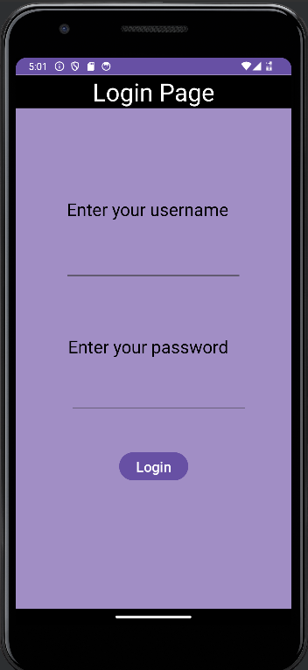

1. **Write a program to demonstrate the activity lifecycle of android apps**

**Aim:** To create an android application to understand and manage the activity life cycle,ensuring optimal performance and user experience throughout app interactions.

* 1. *Acitivity_main.xml*

***<?*xml version="1.0" encoding="utf-8"*?>*<androidx.constraintlayout.widget.ConstraintLayout  
 xmlns:android="http://schemas.android.com/apk/res/android"  
 xmlns:tools="http://schemas.android.com/tools"  
 xmlns:app="http://schemas.android.com/apk/res-auto"  
 android:layout_width="match_parent"  
 android:layout_height="match_parent"  
 tools:context=".MainActivity">  
  
 <TextView  
 android:layout_width="178dp"  
 android:layout_height="40dp"  
 android:layout_centerHorizontal="true"  
 android:layout_centerVertical="true"  
 android:text="Activity Life Cycle"  
 android:textColor="#3cff00"  
 android:textSize="20sp"  
 app:layout_constraintBottom_toBottomOf="parent"  
 app:layout_constraintEnd_toEndOf="parent"  
 app:layout_constraintStart_toStartOf="parent"  
 app:layout_constraintTop_toTopOf="parent" />  
  
 <Button  
 android:layout_width="wrap_content"  
 android:layout_height="wrap_content"  
 android:text="next"  
 app:layout_constraintBottom_toBottomOf="parent"  
 app:layout_constraintEnd_toEndOf="parent"  
 app:layout_constraintHorizontal_bias="0.798"  
 app:layout_constraintStart_toStartOf="parent"  
 app:layout_constraintTop_toTopOf="parent"  
 app:layout_constraintVertical_bias="0.717" />  
  
 <Button  
 android:layout_width="wrap_content"  
 android:layout_height="wrap_content"  
 android:text="Previous"  
 app:layout_constraintBottom_toBottomOf="parent"  
 app:layout_constraintEnd_toEndOf="parent"  
 app:layout_constraintHorizontal_bias="0.182"  
 app:layout_constraintStart_toStartOf="parent"  
 app:layout_constraintTop_toTopOf="parent"  
 app:layout_constraintVertical_bias="0.717" />  
  
  
</androidx.constraintlayout.widget.ConstraintLayout>**

* 1. *MainActivity.java*

**package com.codedost;  
  
import android.os.Bundle;  
import android.util.Log;  
import android.view.View;  
import android.widget.TextView;  
import android.widget.Toast;  
import androidx.appcompat.app.AppCompatActivity;  
  
public class MainActivity extends AppCompatActivity {  
  
 @Override  
 protected void onCreate(Bundle savedInstanceState) {  
 super.onCreate(savedInstanceState);  
 setContentView(R.layout.*activity_main*);  
 Log.*d*("Activity_Lifecycle","onCreate invoked");  
 Toast.*makeText*(MainActivity.this,"Created",Toast.*LENGTH_SHORT*).show();  
  
 }  
 @Override  
 protected void onStart() {  
 super.onStart();  
 Log.*d*("Activity_Lifecycle","onStart invoked"); Toast.*makeText*(MainActivity.this,"Start",Toast.*LENGTH_SHORT*).show();  
 }  
 @Override  
 protected void onResume() {  
 super.onResume();  
 Log.*d*("Activity_Lifecycle","onResume invoked"); Toast.*makeText*(MainActivity.this,"Resume",Toast.*LENGTH_SHORT*).show();  
 }  
 @Override  
 protected void onPause() {  
 super.onPause();  
 Log.*d*("Activity_Lifecycle","onPause invoked"); Toast.*makeText*(MainActivity.this,"Pause",Toast.*LENGTH_SHORT*).show();  
 }  
 @Override  
 protected void onStop() {  
 super.onStop();  
 Log.*d*("Activity_Lifecycle","onStop invoked"); Toast.*makeText*(MainActivity.this,"Stop",Toast.*LENGTH_SHORT*).show();  
 }  
 @Override  
 protected void onRestart() {  
 super.onRestart();  
 Log.*d*("Activity_Lifecycle","onRestart invoked"); Toast.*makeText*(MainActivity.this,"Restart",Toast.*LENGTH_SHORT*).show();  
 }  
 @Override  
 protected void onDestroy() {  
 super.onDestroy();  
 Log.*d*("Activity_Lifecycle","onDestroy invoked");  
 Toast.*makeText*(MainActivity.this,"Destroy",Toast.*LENGTH_SHORT*).show();  
 }**

* 1. *Output*

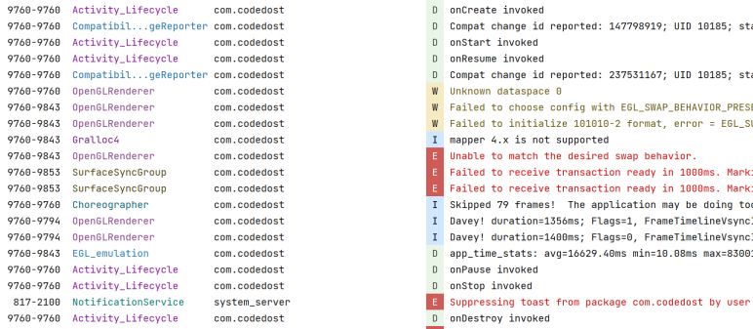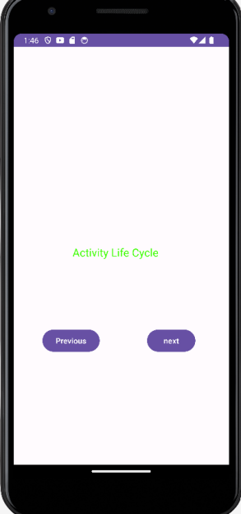

1. **Write a program to demonstrate usage of graphical primitive**

**Aim:** To develop a simple android application that draws basic graphical primitives on the screen.

* 1. *Activity_main.xml*

<?xml version="1.0" encoding="utf-8"?>  
<RelativeLayout xmlns:android="http://schemas.android.com/apk/res/android"  
 android:layout_width="match_parent"  
 android:layout_height="match_parent"  
 android:background="#000000">  
  
 <ImageView  
 android:id="@+id/imageView"  
 android:layout_width="match_parent"  
 android:layout_height="match_parent" />  
</RelativeLayout>

* 1. *MainActivity.java*

package com.example.graphical_primitives;  
  
import android.app.Activity;  
import android.graphics.Bitmap;  
import android.graphics.Canvas;  
import android.graphics.Color;  
import android.graphics.Paint;  
import android.graphics.drawable.BitmapDrawable;  
import android.os.Bundle;  
import android.widget.ImageView;  
  
public class MainActivity extends Activity  
{  
 @Override  
 public void onCreate(Bundle savedInstanceState)  
 {  
 super.onCreate(savedInstanceState);  
 setContentView(R.layout.*activity_main*);  
  
 //Creating a Bitmap  
 Bitmap bg = Bitmap.*createBitmap*(720, 1280, Bitmap.Config.*ARGB_8888*);  
  
 //Setting the Bitmap as background for the ImageView  
 ImageView i = (ImageView) findViewById(R.id.*imageView*);  
 i.setBackgroundDrawable(new BitmapDrawable(bg));  
  
 //Creating the Canvas Object  
 Canvas canvas = new Canvas(bg);  
  
 //Creating the Paint Object and set its color & TextSize  
 Paint paint = new Paint();  
 paint.setColor(Color.*rgb*(221,160,221));  
 paint.setTextSize(50);  
  
 //To draw a Rectangle  
 canvas.drawText("Rectangle", 420, 150, paint);  
 canvas.drawRect(400, 200, 650, 700, paint);  
  
 //To draw a Circle  
 canvas.drawText("Circle", 120, 150, paint);  
 canvas.drawCircle(200, 350, 150, paint);  
  
 //To draw a Square  
 canvas.drawText("Square", 120, 800, paint);  
 canvas.drawRect(50, 850, 350, 1150, paint);  
  
 //To draw a Line  
 canvas.drawText("Line", 480, 800, paint);  
 canvas.drawLine(520, 850, 520, 1150, paint);  
 }  
}

* 1. *Output*

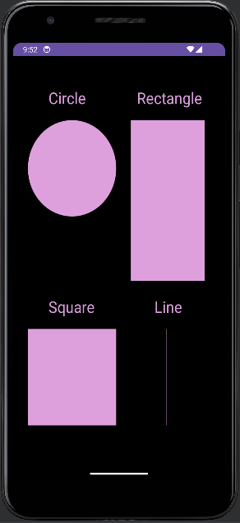

1. **Write a program to demonstrate explicit and implicit intents**

**Aim:** To Build an Android intent-based app that allows users to seamlessly share content between different apps and enhance cross-app functionality

* 1. *Activity_main.xml*

***<?*xml version="1.0" encoding="utf-8"*?>*<androidx.constraintlayout.widget.ConstraintLayout xmlns:android="http://schemas.android.com/apk/res/android"  
 xmlns:app="http://schemas.android.com/apk/res-auto"  
 xmlns:tools="http://schemas.android.com/tools"  
 android:layout_width="match_parent"  
 android:layout_height="match_parent"  
 tools:context=".MainActivity">  
  
 <TextView  
 android:id="@+id/counter_disp"  
 android:layout_width="wrap_content"  
 android:layout_height="wrap_content"  
 android:background="#4587EC"  
 android:padding="8dp"  
 android:paddingHorizontal="12dp"  
 android:text="0"  
 android:textColor="@color/white"  
 app:layout_constraintBottom_toBottomOf="parent"  
 app:layout_constraintEnd_toEndOf="parent"  
 app:layout_constraintStart_toStartOf="parent"  
 app:layout_constraintTop_toTopOf="parent"  
 app:layout_constraintVertical_bias="0.526" />  
  
 <TextView  
 android:layout_width="wrap_content"  
 android:layout_height="wrap_content"  
 android:background="#4587EC"  
 android:padding="4dp"  
 android:id="@+id/varcolortext"  
 android:text="Click the buttons below to count"  
 style="@style/constrain"  
 android:textColor="@color/white"  
 app:layout_constraintBottom_toBottomOf="parent"  
 app:layout_constraintEnd_toEndOf="parent"  
 app:layout_constraintStart_toStartOf="parent"  
 app:layout_constraintTop_toTopOf="parent"  
 app:layout_constraintVertical_bias="0.446" />  
  
  
 <Button  
 android:id="@+id/btn_prev"  
 android:layout_width="wrap_content"  
 android:layout_height="wrap_content"  
 android:onClick="countPrev"  
 style="@style/constrain"  
 android:text="Previous"  
 app:layout_constraintBottom_toBottomOf="parent"  
 app:layout_constraintEnd_toEndOf="parent"  
 app:layout_constraintHorizontal_bias="0.24"  
 app:layout_constraintStart_toStartOf="parent"  
 app:layout_constraintTop_toTopOf="parent"  
 app:layout_constraintVertical_bias="0.635" />  
  
 <Button  
 android:id="@+id/btn_next"  
 android:layout_width="wrap_content"  
 android:layout_height="wrap_content"  
 android:onClick="countNext"  
 style="@style/constrain"  
 android:text="Next"  
 app:layout_constraintBottom_toBottomOf="parent"  
 app:layout_constraintEnd_toEndOf="parent"  
 app:layout_constraintHorizontal_bias="0.765"  
 app:layout_constraintStart_toStartOf="parent"  
 app:layout_constraintTop_toTopOf="parent"  
 app:layout_constraintVertical_bias="0.635" />  
  
 <Button  
 android:id="@+id/button"  
 android:layout_width="wrap_content"  
 android:layout_height="wrap_content"  
 android:background="#000080"  
 android:onClick="changeTextColor"  
 android:text="Change Color"  
 style="@style/constrain"  
 android:fontFamily="sans-serif-black"  
 app:layout_constraintBottom_toBottomOf="parent"  
 app:layout_constraintEnd_toEndOf="parent"  
 app:layout_constraintStart_toStartOf="parent"  
 app:layout_constraintTop_toTopOf="parent"  
 app:layout_constraintVertical_bias="0.329" />  
  
 <Button  
 android:id="@+id/switchsecond"  
 style="@style/constrain"  
 android:layout_width="wrap_content"  
 android:layout_height="wrap_content"  
 android:onClick="countPrev"  
 android:text="switch activity"  
 app:layout_constraintBottom_toBottomOf="parent"  
 app:layout_constraintEnd_toEndOf="parent"  
 app:layout_constraintHorizontal_bias="0.498"  
 app:layout_constraintStart_toStartOf="parent"  
 app:layout_constraintTop_toTopOf="parent"  
 app:layout_constraintVertical_bias="0.778"  
 android:textColor="@color/black"  
 android:backgroundTint="#9ddef1"/>  
  
</androidx.constraintlayout.widget.ConstraintLayout>**

* 1. *Second_activity.xml*

***<?*xml version="1.0" encoding="utf-8"*?>*<LinearLayout android:layout_width="match_parent"  
 android:layout_height="match_parent"  
 xmlns:tools="http://schemas.android.com/tools"  
 tools:context=".SecondActivity"  
 xmlns:android="http://schemas.android.com/apk/res/android"  
 android:orientation="vertical"  
 android:gravity="center">  
  
 <TextView  
 android:layout_width="wrap_content"  
 android:layout_height="wrap_content"  
 android:text="Demonstration of intents and activity switching"  
 android:paddingVertical="18dp"  
 android:textSize="18sp"  
  
 >  
  
 </TextView>  
 <Button  
 android:layout_width="wrap_content"  
 android:layout_height="wrap_content"  
 android:layout_marginVertical="18sp"  
 android:text="switch back to main"  
 android:id="@+id/switchbtn"  
  
 >  
  
 </Button>  
  
 <Button  
 android:layout_width="wrap_content"  
 android:layout_height="wrap_content"  
 android:layout_marginVertical="18sp"  
 android:text="implicit intent"  
 android:onClick="implicitBtnCall"  
 android:id="@+id/impButton"  
  
 >  
  
 </Button>  
  
  
  
</LinearLayout>**

* 1. *MainActivity.java*

**package com.example.counterapp;  
  
import androidx.appcompat.app.AppCompatActivity;  
  
import android.content.Intent;  
import android.content.res.ColorStateList;  
import android.graphics.Color;  
import android.util.Log;  
import android.os.Bundle;  
import android.view.View;  
import android.widget.Button;  
import android.widget.TextView;  
  
  
public class MainActivity extends AppCompatActivity {  
  
 TextView counter;  
 TextView colorful_text;  
 private int count_var = 0;  
 private int[] colors = {Color.*BLACK*, Color.*BLUE*, Color.*GREEN*, Color.*RED*};  
 private int initial_color = 0;  
 @Override  
 protected void onCreate(Bundle savedInstanceState) {  
 super.onCreate(savedInstanceState);  
 setContentView(R.layout.*activity_main*);  
 counter = findViewById(R.id.*counter_disp*);  
 Button switch_second = findViewById(R.id.*switchsecond*);  
 switch_second.setOnClickListener(new View.OnClickListener() {  
 @Override  
 public void onClick(View view) {  
 Intent intent = new Intent(getApplicationContext(), SecondActivity.class);  
 startActivity(intent);  
  
 }  
 });  
  
 }  
 public void countNext(View view){  
 count_var++;  
 counter.setText(Integer.*toString*(count_var));  
 *//counter.setText(Integer.parseInt(counter.getText().toString())+1);* }  
 public void countPrev(View view){  
 *//counter.setText(Integer.parseInt(counter.getText().toString())-1);* count_var--;  
 counter.setText(Integer.*toString*(count_var));  
 }  
  
 public void changeTextColor(View view){  
 colorful_text = findViewById(R.id.*varcolortext*);  
 colorful_text.setTextColor(colors[initial_color]);  
 initial_color = (initial_color+1) % colors.length;  
 }  
}**

*d. SecondActivity.java*

package com.example.counterapp;  
  
import android.content.Intent;  
import android.net.Uri;  
import android.os.Bundle;  
import android.view.View;  
import android.widget.Button;  
  
import androidx.appcompat.app.AppCompatActivity;  
  
import java.net.URI;  
  
public class SecondActivity extends AppCompatActivity {  
 Button switchMain;  
 @Override  
 protected void onCreate(Bundle savedInstanceState){  
 super.onCreate(savedInstanceState);  
 setContentView(R.layout.second_activity);  
 switchMain = findViewById(R.id.switchbtn);  
  
 switchMain.setOnClickListener(new View.OnClickListener() {  
 @Override  
 public void onClick(View view) {  
 Intent intent = new Intent(getApplicationContext(), MainActivity.class);  
 startActivity(intent);  
 }  
 });  
 }  
  
 public void implicitBtnCall(View view){  
 Intent intent = new Intent(Intent.ACTION_VIEW);  
 intent.setData(Uri.parse("https://loyola-website.vercel.app/"));  
 startActivity(intent);  
 }  
}

* 1. *Manifest.xml*

***<?*xml version="1.0" encoding="utf-8"*?>*<manifest xmlns:android="http://schemas.android.com/apk/res/android"  
 xmlns:tools="http://schemas.android.com/tools">  
  
 <application  
 android:allowBackup="true"  
 android:dataExtractionRules="@xml/data_extraction_rules"  
 android:fullBackupContent="@xml/backup_rules"  
 android:icon="@mipmap/ic_launcher"  
 android:label="@string/app_name"  
 android:roundIcon="@mipmap/ic_launcher_round"  
 android:supportsRtl="true"  
 android:theme="@style/Theme.CounterApp"  
 tools:targetApi="31">  
 <activity  
 android:name=".MainActivity"  
 android:exported="true"  
 android:launchMode="singleInstance">  
 <intent-filter>  
 <action android:name="android.intent.action.MAIN" />  
  
 <category android:name="android.intent.category.LAUNCHER" />  
 </intent-filter>  
 </activity>  
 <activity  
 android:name=".SecondActivity"  
 android:exported="true"  
 android:launchMode="singleInstance">  
  
 </activity>  
 </application>  
  
</manifest>**

* 1. *Output*

<?xml version="1.0" encoding="utf-8"?>

<manifest xmlns:android="http://schemas.android.com/apk/res/android"

xmlns:tools="http://schemas.android.com/tools">

<application

android:allowBackup="true"

android:dataExtractionRules="@xml/data_extraction_rules"

android:fullBackupContent="@xml/backup_rules"

android:icon="@mipmap/ic_launcher"

android:label="@string/app_name"

android:roundIcon="@mipmap/ic_launcher_round"

android:supportsRtl="true"

android:theme="@style/Theme.CounterApp"

tools:targetApi="31">

<activity

android:name=".MainActivity"

android:exported="true"

android:launchMode="singleInstance">

<intent-filter>

<action android:name="android.intent.action.MAIN" />

<category android:name="android.intent.category.LAUNCHER" />

</intent-filter>

</activity>

<activity

android:name=".SecondActivity"

android:exported="true"

android:launchMode="singleInstance">

</activity>

</application>

</manifest>

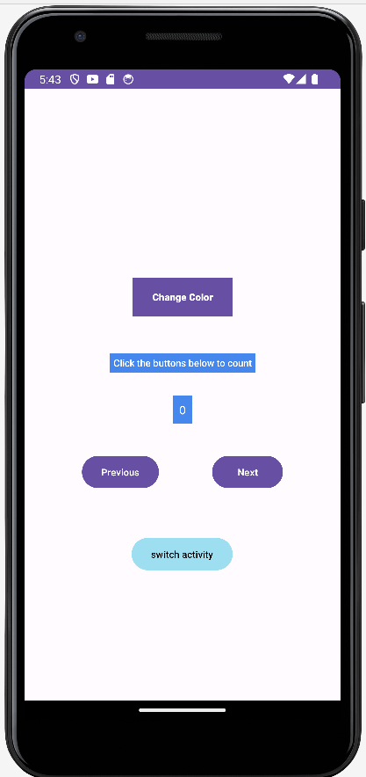 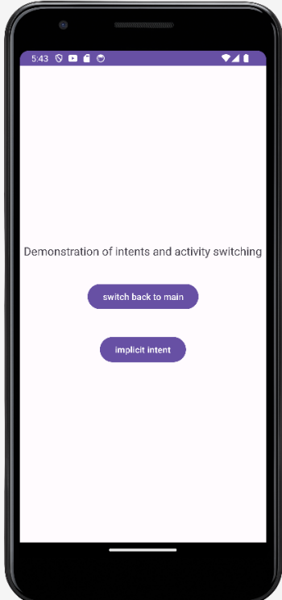 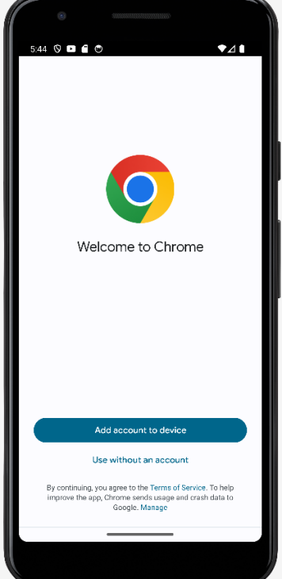

1. **Develop a registration page with checkbox, radio and image view.**

**Aim:** To demonstrate the usage of Registration page with checkbox, radio and image view.

* 1. *Activity_main.xml*

<?xml version="1.0" encoding="utf-8"?>  
<RelativeLayout xmlns:android="http://schemas.android.com/apk/res/android"  
 xmlns:app="http://schemas.android.com/apk/res-auto"  
 xmlns:tools="http://schemas.android.com/tools"  
 android:layout_width="match_parent"  
 android:layout_height="match_parent"  
 android:background="#D1B352"  
 android:padding="16dp"  
 tools:context=".MainActivity">  
  
 <ImageView  
 android:id="@+id/registrationImage"  
 android:layout_width="200dp"  
 android:layout_height="200dp"  
 android:layout_centerHorizontal="true"  
 android:contentDescription="Registration Image"  
 android:src="@drawable/ic_launcher_foreground" />  
  
 <EditText  
 android:id="@+id/editTextName"  
 android:layout_width="match_parent"  
 android:layout_height="wrap_content"  
 android:layout_below="@id/registrationImage"  
 android:layout_marginTop="16dp"  
 android:hint="Name" />  
  
 <CheckBox  
 android:id="@+id/checkBoxAgree"  
 android:layout_width="wrap_content"  
 android:layout_height="wrap_content"  
 android:layout_below="@id/editTextName"  
 android:layout_marginTop="16dp"  
 android:text="I am not a robot" />  
  
 <RadioGroup  
 android:id="@+id/radioGroupGender"  
 android:layout_width="wrap_content"  
 android:layout_height="wrap_content"  
 android:layout_below="@id/checkBoxAgree"  
 android:layout_marginTop="16dp">  
  
 <RadioButton  
 android:id="@+id/radioButtonMale"  
 android:layout_width="wrap_content"  
 android:layout_height="wrap_content"  
 android:text="Male" />  
  
 <RadioButton  
 android:id="@+id/radioButtonFemale"  
 android:layout_width="wrap_content"  
 android:layout_height="wrap_content"  
 android:text="Female" />  
  
 <RadioButton  
 android:id="@+id/radioButtonOther"  
 android:layout_width="wrap_content"  
 android:layout_height="wrap_content"  
 android:text="Other" />  
 </RadioGroup>  
  
 <Button  
 android:id="@+id/buttonRegister"  
 android:layout_width="match_parent"  
 android:layout_height="wrap_content"  
 android:layout_below="@id/radioGroupGender"  
 android:layout_marginTop="16dp"  
 android:text="Register" />  
  
</RelativeLayout>

* 1. *MainActivity.xml*

package com.example.registration_page;  
  
import android.os.Bundle;  
import android.view.View;  
import android.widget.Button;  
import android.widget.CheckBox;  
import android.widget.EditText;  
import android.widget.ImageView;  
import android.widget.RadioButton;  
import android.widget.RadioGroup;  
import android.widget.Toast;  
import androidx.appcompat.app.AppCompatActivity;  
  
public class MainActivity extends AppCompatActivity {  
  
 private ImageView registrationImage;  
 private EditText editTextName;  
 private CheckBox checkBoxAgree;  
 private RadioGroup radioGroupGender;  
 private Button buttonRegister;  
  
 @Override  
 protected void onCreate(Bundle savedInstanceState) {  
 super.onCreate(savedInstanceState);  
 setContentView(R.layout.*activity_main*);  
 registrationImage = findViewById(R.id.*registrationImage*);  
 editTextName = findViewById(R.id.*editTextName*);  
 checkBoxAgree = findViewById(R.id.*checkBoxAgree*);  
 radioGroupGender = findViewById(R.id.*radioGroupGender*);  
 buttonRegister = findViewById(R.id.*buttonRegister*);  
 buttonRegister.setOnClickListener(new View.OnClickListener() {  
 @Override  
 public void onClick(View view) {  
 String name = editTextName.getText().toString();  
 boolean agreedToTerms = checkBoxAgree.isChecked();  
 int selectedRadioButtonId = radioGroupGender.getCheckedRadioButtonId();  
 RadioButton selectedRadioButton = findViewById(selectedRadioButtonId);  
 String gender = selectedRadioButton != null ? selectedRadioButton.getText().toString() : "";  
 String message = "Name: " + name + "\nI am not a robot: " + agreedToTerms + "\nGender: " + gender;  
 Toast.*makeText*(getApplicationContext(), message, Toast.*LENGTH_LONG*).show();  
 }  
 });  
 }  
}

* 1. *Output*

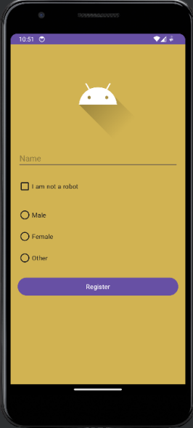

1. **Demonstrate usage of audio and video player based on user activity.**

**Aim:** To demonstrate the Audio and video player Application.

* 1. *Activity_main.xml*

*<?*xml version="1.0" encoding="utf-8"*?>*<androidx.constraintlayout.widget.ConstraintLayout xmlns:android="http://schemas.android.com/apk/res/android"  
 xmlns:app="http://schemas.android.com/apk/res-auto"  
 xmlns:tools="http://schemas.android.com/tools"  
 android:layout_width="match_parent"  
 android:layout_height="match_parent"  
 tools:context=".MainActivity">  
  
 <Button  
 android:id="@+id/btnstart"  
 android:layout_width="wrap_content"  
 android:layout_height="wrap_content"  
 android:text="Start"  
 app:layout_constraintBottom_toBottomOf="parent"  
 app:layout_constraintEnd_toEndOf="parent"  
 app:layout_constraintHorizontal_bias="0.125"  
 app:layout_constraintStart_toStartOf="parent"  
 app:layout_constraintTop_toTopOf="parent"  
 app:layout_constraintVertical_bias="0.525" />  
  
 <Button  
 android:id="@+id/btnstop"  
 android:layout_width="wrap_content"  
 android:layout_height="wrap_content"  
 android:text="Stop"  
 app:layout_constraintBottom_toBottomOf="parent"  
 app:layout_constraintEnd_toEndOf="parent"  
 app:layout_constraintHorizontal_bias="0.871"  
 app:layout_constraintStart_toStartOf="parent"  
 app:layout_constraintTop_toTopOf="parent"  
 app:layout_constraintVertical_bias="0.525" />  
  
 <Button  
 android:id="@+id/btnpause"  
 android:layout_width="wrap_content"  
 android:layout_height="wrap_content"  
 android:text="Pause"  
 app:layout_constraintBottom_toBottomOf="parent"  
 app:layout_constraintEnd_toEndOf="parent"  
 app:layout_constraintStart_toStartOf="parent"  
 app:layout_constraintTop_toTopOf="parent"  
 app:layout_constraintVertical_bias="0.525" />  
  
 <TextView  
 android:id="@+id/title"  
 android:layout_width="wrap_content"  
 android:layout_height="wrap_content"  
 android:fontFamily="sans-serif-medium"  
 android:text="Audio Player"  
 android:textSize="28dp"  
 app:layout_constraintBottom_toBottomOf="parent"  
 app:layout_constraintEnd_toEndOf="parent"  
 app:layout_constraintStart_toStartOf="parent"  
 app:layout_constraintTop_toTopOf="parent"  
 app:layout_constraintVertical_bias="0.075" />  
  
 <TextView  
 android:id="@+id/audioname"  
 android:layout_width="wrap_content"  
 android:layout_height="wrap_content"  
 android:fontFamily="sans-serif-medium"  
 android:text="Get rick rolled"  
 android:textSize="24dp"  
 android:textStyle="italic"  
 app:layout_constraintBottom_toBottomOf="parent"  
 app:layout_constraintEnd_toEndOf="parent"  
 app:layout_constraintHorizontal_bias="0.536"  
 app:layout_constraintStart_toStartOf="parent"  
 app:layout_constraintTop_toTopOf="parent"  
 app:layout_constraintVertical_bias="0.349" />  
  
 <Button  
 android:id="@+id/btnchange"  
 android:layout_width="151dp"  
 android:layout_height="40dp"  
 android:text="Change track"  
 app:layout_constraintBottom_toBottomOf="parent"  
 app:layout_constraintEnd_toEndOf="parent"  
 app:layout_constraintHorizontal_bias="0.498"  
 app:layout_constraintStart_toStartOf="parent"  
 app:layout_constraintTop_toTopOf="parent"  
 app:layout_constraintVertical_bias="0.71" />  
</androidx.constraintlayout.widget.ConstraintLayout>

* 1. *MainActivity.xml*

package com.example.audioplayer;  
  
import androidx.appcompat.app.AppCompatActivity;  
  
import android.media.AudioAttributes;  
import android.media.MediaPlayer;  
import android.net.Uri;  
import android.os.Bundle;  
import android.provider.MediaStore;  
import android.renderscript.RenderScript;  
import android.util.Log;  
import android.view.View;  
import android.widget.Button;  
import android.widget.TextView;  
  
import java.io.IOException;  
  
public class MainActivity extends AppCompatActivity {  
  
 Button pause_button, stop_button, start_button, change_track;  
  
  
 @Override  
 protected void onCreate(Bundle savedInstanceState) {  
 super.onCreate(savedInstanceState);  
 setContentView(R.layout.*activity_main*);  
 pause_button = findViewById(R.id.*btnpause*);  
 start_button = findViewById(R.id.*btnstart*);  
 stop_button = findViewById(R.id.*btnstop*);  
 change_track = findViewById(R.id.*btnchange*);  
 final int[] flag = {1};  
 final int[] trackNo = {0};  
 final MediaPlayer mp = new MediaPlayer();  
 Uri my_uri = Uri.*parse*("https://cdn.pixabay.com/audio/2023/01/16/audio_091569a832.mp3");  
 mp.setAudioAttributes(  
 new AudioAttributes.Builder()  
 .setContentType(AudioAttributes.*CONTENT_TYPE_MUSIC*)  
 .setUsage(AudioAttributes.*USAGE_MEDIA*)  
 .build()  
 );  
  
 try{  
 if(trackNo[0]==0) {  
  
 mp.setDataSource(getApplicationContext(), my_uri);  
 }  
 else {  
 mp.setDataSource(getApplicationContext(),Uri.*parse*("https://cdn.pixabay.com/audio/2023/07/30/audio_e0908e8569.mp3"));  
 }  
 mp.prepare();  
 }  
  
 catch(IOException e){  
 e.printStackTrace();  
 Log.*d*("Import failed","importing audio failed");  
 }  
  
 pause_button.setOnClickListener((View view )-> {  
 if(flag[0] ==1){  
 pause_button.setText("Resume");  
 }  
 else{  
 pause_button.setText("Pause");  
 mp.start();  
 }  
 flag[0] = flag[0] *-1;  
 mp.pause();  
 });  
  
 start_button.setOnClickListener((View view)->{  
 mp.start();  
 });  
  
 stop_button.setOnClickListener((View view)->{  
 mp.stop();  
 });  
  
 change_track.setOnClickListener((View view)->{  
 if(trackNo[0] == 0){  
 trackNo[0] =1;  
 }  
 else{  
 trackNo[0]= 0;  
 }  
 });  
  
  
 }  
}

* 1. *Output*

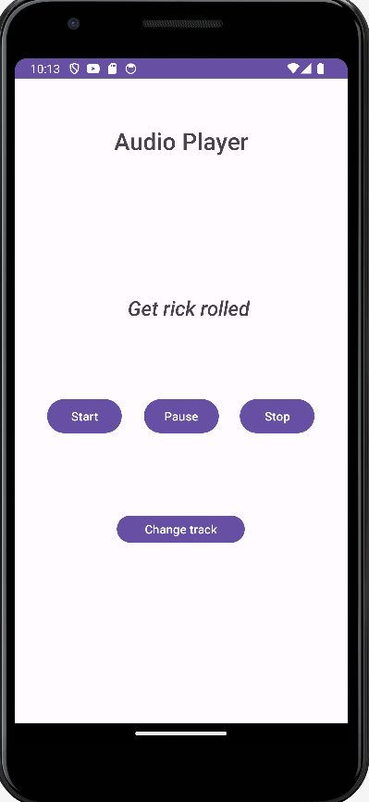

**Video Player**

Xml Code:

<?xml version="1.0" encoding="utf-8"?>

<androidx.constraintlayout.widget.ConstraintLayout

xmlns:android="http://schemas.android.com/apk/res/android"

xmlns:app="http://schemas.android.com/apk/res-auto"

xmlns:tools="http://schemas.android.com/tools"

android:layout_width="match_parent"

android:layout_height="match_parent"

tools:context=".MainActivity">

<VideoView

android:id="@+id/videoView"

android:layout_width="wrap_content"

android:layout_height="wrap_content"

app:layout_constraintBottom_toBottomOf="parent"

app:layout_constraintEnd_toEndOf="parent"

app:layout_constraintStart_toStartOf="parent"

app:layout_constraintTop_toTopOf="parent" />

<TextView

android:layout_width="match_parent"

android:layout_height="wrap_content"

android:fontFamily="monospace"

android:text=" Demons Layer's Trailor"

android:textColor="#E91E63"

android:textSize="20sp"

android:textStyle="bold"

tools:ignore="MissingConstraints" />

</androidx.constraintlayout.widget.ConstraintLayout>

**Java Code:**

package com.example.video;

import androidx.appcompat.app.AppCompatActivity;

import android.os.Bundle;

import android.widget.MediaController;

import android.widget.VideoView;

public class MainActivity extends AppCompatActivity {

@Override

protected void onCreate(Bundle savedInstanceState) {

super.onCreate(savedInstanceState);

setContentView(R.layout.activity_main);

VideoView videoView = (VideoView) findViewById(R.id.videoView);

videoView.setVideoPath("android.resource://" + getPackageName() + "/" + R.raw.dl);

MediaController mediaController = new MediaController(this);

mediaController.setAnchorView(videoView);

19

videoView.setMediaController(mediaController);

videoView.start();

}

}

**Output:**

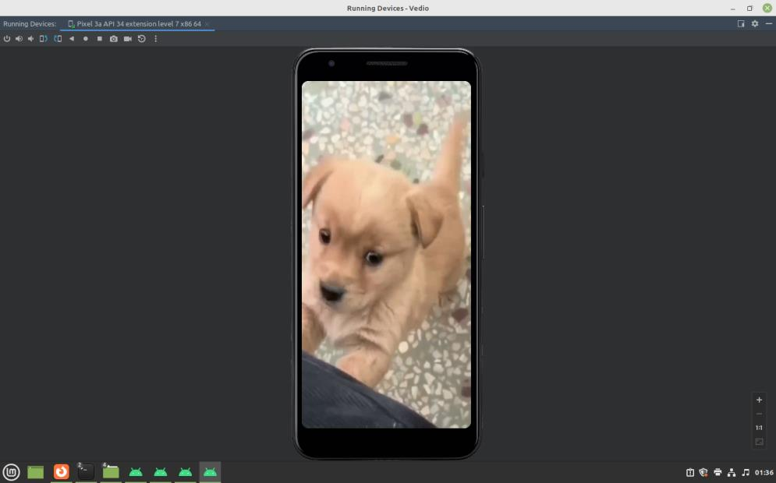

1. **Develop movie rating app with ratings bar, image view, and other inputs**

**Aim:** To demonstrate Movie Rating application.

* 1. *Activity_main.xml*

***<?*xml version="1.0" encoding="utf-8"*?>*<androidx.constraintlayout.widget.ConstraintLayout xmlns:android="http://schemas.android.com/apk/res/android"  
 xmlns:app="http://schemas.android.com/apk/res-auto"  
 xmlns:tools="http://schemas.android.com/tools"  
 android:layout_width="match_parent"  
 android:layout_height="match_parent"  
  
  
 tools:context=".MainActivity">  
  
 <TextView  
 android:id="@+id/textView2"  
 android:layout_width="match_parent"  
 android:layout_height="wrap_content"  
 android:background="#ADD8E6"  
 android:fontFamily="sans-serif-black"  
 android:textAlignment="center"  
 android:paddingVertical="12dp"  
 android:text="Popcorn and Pretzels"  
 android:textSize="34dp"  
 android:textStyle="bold"  
 app:layout_constraintBottom_toBottomOf="parent"  
 app:layout_constraintEnd_toEndOf="parent"  
 app:layout_constraintHorizontal_bias="0.444"  
 app:layout_constraintStart_toStartOf="parent"  
 app:layout_constraintTop_toTopOf="parent"  
 app:layout_constraintVertical_bias="0.001" />  
  
 <TextView  
 android:id="@+id/textView"  
 android:layout_width="wrap_content"  
 android:layout_height="wrap_content"  
 android:text="We hope you enjoyed watching"  
 android:textSize="24dp"  
 app:layout_constraintBottom_toBottomOf="parent"  
 app:layout_constraintEnd_toEndOf="parent"  
 app:layout_constraintStart_toStartOf="parent"  
 app:layout_constraintTop_toTopOf="parent"  
 app:layout_constraintVertical_bias="0.127" />  
  
 <ImageView  
 android:id="@+id/imageView"  
 android:layout_width="128dp"  
 android:layout_height="244dp"  
 app:layout_constraintBottom_toBottomOf="parent"  
 app:layout_constraintEnd_toEndOf="parent"  
 app:layout_constraintHorizontal_bias="0.498"  
 app:layout_constraintStart_toStartOf="parent"  
 app:layout_constraintTop_toTopOf="parent"  
 app:layout_constraintVertical_bias="0.209"  
 app:srcCompat="@drawable/poster" />  
  
 <TextView  
 android:id="@+id/textView3"  
 android:layout_width="wrap_content"  
 android:layout_height="wrap_content"  
 android:text="Please rate our services"  
 android:textSize="22dp"  
 app:layout_constraintBottom_toBottomOf="parent"  
 app:layout_constraintEnd_toEndOf="parent"  
 app:layout_constraintHorizontal_bias="0.193"  
 app:layout_constraintStart_toStartOf="parent"  
 app:layout_constraintTop_toTopOf="parent"  
 app:layout_constraintVertical_bias="0.493" />  
  
 <RatingBar  
 android:id="@+id/ratingBar"  
 android:layout_width="wrap_content"  
 android:layout_height="wrap_content"  
 android:rating="4"  
 android:theme="@style/RatingBar"  
 app:layout_constraintBottom_toBottomOf="parent"  
 app:layout_constraintEnd_toEndOf="parent"  
 app:layout_constraintHorizontal_bias="0.497"  
 app:layout_constraintStart_toStartOf="parent"  
 app:layout_constraintTop_toTopOf="parent"  
 app:layout_constraintVertical_bias="0.572" />  
  
 <TextView  
 android:id="@+id/textView4"  
 android:layout_width="wrap_content"  
 android:layout_height="wrap_content"  
 android:text="Select the type of seats"  
 android:textSize="22dp"  
 app:layout_constraintBottom_toBottomOf="parent"  
 app:layout_constraintEnd_toEndOf="parent"  
 app:layout_constraintHorizontal_bias="0.186"  
 app:layout_constraintStart_toStartOf="parent"  
 app:layout_constraintTop_toTopOf="parent"  
 app:layout_constraintVertical_bias="0.666" />  
  
 <RadioGroup  
 android:layout_width="378dp"  
 android:layout_height="40dp"  
 android:id="@+id/seattypegroup"  
 android:orientation="horizontal"  
 app:layout_constraintBottom_toBottomOf="parent"  
 app:layout_constraintEnd_toEndOf="parent"  
 app:layout_constraintHorizontal_bias="1.0"  
 app:layout_constraintStart_toStartOf="parent"  
 app:layout_constraintTop_toTopOf="parent"  
 app:layout_constraintVertical_bias="0.752">  
  
 <RadioButton  
 android:id="@+id/gold"  
 android:layout_width="wrap_content"  
 android:layout_height="wrap_content"  
 android:layout_marginHorizontal="12sp"  
 android:text="Gold"  
 android:onClick="onRadioButtonClicked"  
 app:layout_constraintBottom_toBottomOf="parent"  
 app:layout_constraintEnd_toEndOf="parent"  
 app:layout_constraintHorizontal_bias="0.194"  
 app:layout_constraintStart_toStartOf="parent"  
 app:layout_constraintTop_toTopOf="parent"  
 app:layout_constraintVertical_bias="0.749" />  
  
 <RadioButton  
 android:id="@+id/silver"  
 android:onClick="onRadioButtonClicked"  
 android:layout_width="wrap_content"  
 android:layout_height="wrap_content"  
 android:layout_marginHorizontal="12sp"  
 android:text="Silver"  
  
 app:layout_constraintBottom_toBottomOf="parent"  
 app:layout_constraintEnd_toEndOf="parent"  
 app:layout_constraintHorizontal_bias="0.784"  
 app:layout_constraintStart_toStartOf="parent"  
 app:layout_constraintTop_toTopOf="parent"  
 app:layout_constraintVertical_bias="0.749" />  
  
 <RadioButton  
 android:id="@+id/platinum"  
 android:layout_width="102dp"  
 android:layout_height="wrap_content"  
 android:onClick="onRadioButtonClicked"  
 android:layout_marginHorizontal="12sp"  
 android:text="Platinum"  
 app:layout_constraintBottom_toBottomOf="parent"  
 app:layout_constraintEnd_toEndOf="parent"  
 app:layout_constraintHorizontal_bias="0.784"  
 app:layout_constraintStart_toStartOf="parent"  
 app:layout_constraintTop_toTopOf="parent"  
 app:layout_constraintVertical_bias="0.749" />  
  
 </RadioGroup>  
  
 <CheckBox  
 android:id="@+id/vipcheck"  
 android:layout_width="wrap_content"  
 android:layout_height="wrap_content"  
 android:text="Are you a VIP member?"  
 android:textSize="22dp"  
 app:layout_constraintBottom_toBottomOf="parent"  
 app:layout_constraintEnd_toEndOf="parent"  
 app:layout_constraintHorizontal_bias="0.241"  
 app:layout_constraintStart_toStartOf="parent"  
 app:layout_constraintTop_toTopOf="parent"  
 app:layout_constraintVertical_bias="0.855" />  
  
 <Button  
 android:layout_width="wrap_content"  
 android:layout_height="wrap_content"  
 android:text="Submit"  
 android:onClick="onSubmit"  
 app:layout_constraintBottom_toBottomOf="parent"  
 app:layout_constraintEnd_toEndOf="parent"  
 app:layout_constraintStart_toStartOf="parent"  
 app:layout_constraintTop_toTopOf="parent"  
 app:layout_constraintVertical_bias="0.95"/>  
  
</androidx.constraintlayout.widget.ConstraintLayout>**

* 1. *MainActivity.xml*

**package com.example.moviereview;  
  
import androidx.appcompat.app.AppCompatActivity;  
  
import android.os.Bundle;  
import android.util.Log;  
import android.view.View;  
import android.widget.CheckBox;  
import android.widget.RadioButton;  
import android.widget.RatingBar;  
  
public class MainActivity extends AppCompatActivity {  
  
 RatingBar ratings;  
 CheckBox isVip;  
 float rating_points;  
 int seat_flag = 0;  
  
 @Override  
 protected void onCreate(Bundle savedInstanceState) {  
 super.onCreate(savedInstanceState);  
 setContentView(R.layout.activity_main);  
 }  
  
 public void onSubmit(View view){  
 ratings = findViewById(R.id.ratingBar);  
 rating_points=ratings.getRating();  
 isVip = findViewById(R.id.vipcheck);  
 boolean is_vip = isVip.isChecked();  
 Log.d("OUTPUT","Movie ratings: "+rating_points);  
 Log.d("OUTPUT","Seat type: "+this.seat_flag);  
 Log.d("OUTPUT","Are they VIP : "+is_vip);  
  
  
 }  
  
 public void onRadioButtonClicked(View view) {  
 *// Is the button now checked?* boolean checked = ((RadioButton) view).isChecked();  
  
 *// Check which radio button was clicked* int id = view.getId();  
 if (id == R.id.gold) {  
 if (checked) {  
 seat_flag = 0;  
 return;  
 }  
  
  
 } else if (id == R.id.platinum) {  
 if (checked) {  
 seat_flag = 1;  
 return;  
 }  
  
 } else if (id == R.id.silver) {  
 if (checked)  
 *// Ninjas rule* {  
 seat_flag=2;  
 return;  
 }  
 }  
 }  
 }**

* 1. *Output*

**

1. **Develop a simple calculator in android**

**Aim:** To develop a Simple Android Application for Native Calculator.

* 1. *Activity_main.xml*

***<?*xml version="1.0" encoding="utf-8"*?>*<androidx.constraintlayout.widget.ConstraintLayout xmlns:android="http://schemas.android.com/apk/res/android"  
 xmlns:app="http://schemas.android.com/apk/res-auto"  
 xmlns:tools="http://schemas.android.com/tools"  
 android:layout_width="match_parent"  
 android:layout_height="match_parent"  
  
 tools:context=".MainActivity">  
  
 <TextView  
 android:layout_width="wrap_content"  
 android:layout_height="wrap_content"  
 android:text="Simple calculator"  
 android:textAllCaps="true"  
 android:textFontWeight="900"  
 android:fontFamily="sans-serif-black"  
 android:textSize="24sp"  
 android:textColor="#f00000"  
 app:layout_constraintBottom_toBottomOf="parent"  
 app:layout_constraintEnd_toEndOf="parent"  
 app:layout_constraintStart_toStartOf="parent"  
 app:layout_constraintTop_toTopOf="parent"  
 app:layout_constraintVertical_bias="0.05" />  
  
 <EditText  
 android:id="@+id/num1"  
 android:layout_width="129dp"  
 android:layout_height="60dp"  
 android:background="#4E86B2"  
 android:ems="10"  
 android:textAlignment="center"  
 android:text="0"  
 android:inputType="number"  
 android:padding="3dp"  
 app:layout_constraintBottom_toBottomOf="parent"  
 app:layout_constraintEnd_toEndOf="parent"  
 app:layout_constraintHorizontal_bias="0.812"  
 app:layout_constraintStart_toStartOf="parent"  
 app:layout_constraintTop_toTopOf="parent"  
 app:layout_constraintVertical_bias="0.291" />  
  
 <EditText  
 android:id="@+id/num2"  
 android:layout_width="132dp"  
 android:layout_height="65dp"  
 android:background="#4E86B2"  
 android:ems="10"  
 android:text="0"  
 android:textAlignment="center"  
 android:inputType="number"  
 android:padding="3dp"  
 app:layout_constraintBottom_toBottomOf="parent"  
 app:layout_constraintEnd_toEndOf="parent"  
 app:layout_constraintHorizontal_bias="0.204"  
 app:layout_constraintStart_toStartOf="parent"  
 app:layout_constraintTop_toTopOf="parent"  
 app:layout_constraintVertical_bias="0.291" />  
  
 <Button  
 android:layout_width="55dp"  
 android:layout_height="50dp"  
 android:text="+"  
 app:layout_constraintBottom_toBottomOf="parent"  
 app:layout_constraintEnd_toEndOf="parent"  
 app:layout_constraintHorizontal_bias="0.238"  
 app:layout_constraintStart_toStartOf="parent"  
 app:layout_constraintTop_toTopOf="parent"  
 app:layout_constraintVertical_bias="0.513"  
 android:id="@+id/addbtn"/>  
  
 <Button  
 android:layout_width="55dp"  
 android:layout_height="50dp"  
 android:text="-"  
 android:id="@+id/subbtn"  
 app:layout_constraintBottom_toBottomOf="parent"  
 app:layout_constraintEnd_toEndOf="parent"  
 app:layout_constraintHorizontal_bias="0.441"  
 app:layout_constraintStart_toStartOf="parent"  
 app:layout_constraintTop_toTopOf="parent"  
 app:layout_constraintVertical_bias="0.513" />  
  
 <Button  
 android:layout_width="55dp"  
 android:layout_height="50dp"  
 android:text="*"  
 android:id="@+id/mulbtn"  
 app:layout_constraintBottom_toBottomOf="parent"  
 app:layout_constraintEnd_toEndOf="parent"  
 app:layout_constraintHorizontal_bias="0.643"  
 app:layout_constraintStart_toStartOf="parent"  
 app:layout_constraintTop_toTopOf="parent"  
 app:layout_constraintVertical_bias="0.513" />  
  
 <Button  
 android:layout_width="55dp"  
 android:layout_height="50dp"  
 android:text="/"  
 android:id="@+id/divbtn"  
 app:layout_constraintBottom_toBottomOf="parent"  
 app:layout_constraintEnd_toEndOf="parent"  
 app:layout_constraintHorizontal_bias="0.828"  
 app:layout_constraintStart_toStartOf="parent"  
 app:layout_constraintTop_toTopOf="parent"  
 app:layout_constraintVertical_bias="0.513" />  
  
  
  
 <TextView  
 android:id="@+id/num3"  
 android:layout_width="54dp"  
 android:layout_height="46dp"  
 android:background="#7AA3C4"  
 android:padding="8dp"  
 android:text="0"  
 android:textSize="20sp"  
 android:textAlignment="center"  
 android:gravity="center"  
 app:layout_constraintBottom_toBottomOf="parent"  
 app:layout_constraintEnd_toEndOf="parent"  
 app:layout_constraintStart_toStartOf="parent"  
 app:layout_constraintTop_toTopOf="parent"  
 app:layout_constraintVertical_bias="0.792" />  
  
 <TextView  
 android:layout_width="wrap_content"  
 android:layout_height="wrap_content"  
 android:text="The calculated answer is"  
 android:textSize="18sp"  
 android:fontFamily="sans-serif-black"  
 app:layout_constraintBottom_toBottomOf="parent"  
 app:layout_constraintEnd_toEndOf="parent"  
 app:layout_constraintHorizontal_bias="0.503"  
 app:layout_constraintStart_toStartOf="parent"  
 app:layout_constraintTop_toTopOf="parent"  
 app:layout_constraintVertical_bias="0.714" />  
  
  
</androidx.constraintlayout.widget.ConstraintLayout>**

* 1. *MainActivity.xml*

**package com.example.myapplication;  
  
import androidx.appcompat.app.AppCompatActivity;  
  
import android.os.Bundle;  
import android.text.TextUtils;  
import android.view.View;  
import android.widget.Button;  
import android.widget.EditText;  
import android.widget.TextView;  
  
public class MainActivity extends AppCompatActivity implements View.OnClickListener {  
  
 EditText num1, num2;  
 TextView num3;  
 Button add,sub,mul,div;  
  
 float a,b,c;  
  
 @Override  
 protected void onCreate(Bundle savedInstanceState) {  
 super.onCreate(savedInstanceState);  
 setContentView(R.layout.*activity_main*);  
 num1= findViewById(R.id.*num1*);  
 num2 = findViewById(R.id.*num2*);  
 num3 = findViewById(R.id.*num3*);  
 add = findViewById(R.id.*addbtn*);  
 sub = findViewById(R.id.*subbtn*);  
 mul = findViewById(R.id.*mulbtn*);  
 div = findViewById(R.id.*divbtn*);  
 add.setOnClickListener(this::onClick);  
 sub.setOnClickListener(this::onClick);  
 mul.setOnClickListener(this::onClick);  
 div.setOnClickListener(this::onClick);  
  
 }  
 @Override  
 public void onClick(View view){  
 float a = 0;  
 float b = 0;  
 float result = 0;  
 String oper = "";  
 if (TextUtils.*isEmpty*(num1.getText().toString()) || TextUtils.*isEmpty*(num2.getText().toString()))  
 return;  
 a = Float.*parseFloat*(num1.getText().toString());  
 b = Float.*parseFloat*(num2.getText().toString());  
 int id = view.getId();  
 if (id == R.id.*addbtn*) {  
 oper = "+";  
 result = a + b;  
 } else if (id == R.id.*subbtn*) {  
 oper = "-";  
 result = a - b;  
 } else if (id == R.id.*mulbtn*) {  
 oper = "*";  
 result = a * b;  
 } else if (id == R.id.*divbtn*) {  
 oper = "/";  
 result = a / b;  
 }  
 *// form the output line* num3.setText(Float.*toString*(result));  
 }  
}**

* 1. *Output*

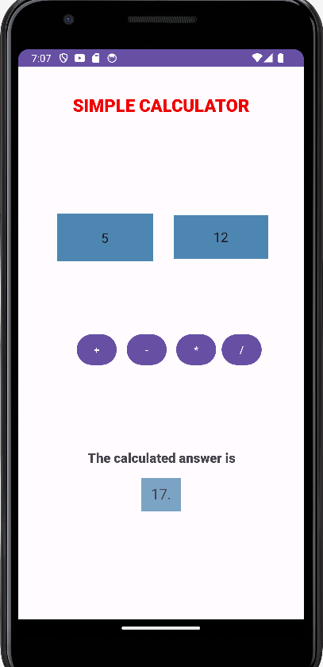

1. **Develop custom splash screens for your app**

**Aim:** Displaying custom designed Opening Screen.

* 1. *activity_main.xml*

<?xml version="1.0" encoding="utf-8"?>  
<RelativeLayout  
 xmlns:android="http://schemas.android.com/apk/res/android"  
 xmlns:app="http://schemas.android.com/apk/res-auto"  
 xmlns:tools="http://schemas.android.com/tools"  
 android:id="@+id/idRLContainer"  
 android:layout_width="match_parent"  
 android:layout_height="match_parent"  
 android:background="#635324"  
 android:orientation="vertical"  
 tools:context=".MainActivity">  
  
 <ImageView  
 android:id="@+id/idIVLogo"  
 android:layout_width="wrap_content"  
 android:layout_height="wrap_content"  
 android:layout_centerInParent="true"  
 android:layout_margin="25dp"  
 app:tint="@color/white" />  
  
 <!--on below line we are creating progress bar-->  
 <ProgressBar  
 android:id="@+id/idPBLoading"  
 android:layout_width="wrap_content"  
 android:layout_height="wrap_content"  
 android:layout_below="@id/idIVLogo"  
 android:layout_centerInParent="true"  
 android:indeterminateTint="@color/white" />  
  
 <ImageView  
 android:id="@+id/imageView"  
 android:layout_width="168dp"  
 android:layout_height="175dp"  
 android:layout_alignParentStart="true"  
 android:layout_alignParentTop="true"  
 android:layout_alignParentEnd="true"  
 android:layout_alignParentBottom="true"  
 android:layout_marginStart="125dp"  
 android:layout_marginTop="122dp"  
 android:layout_marginEnd="118dp"  
 android:layout_marginBottom="433dp"  
 app:srcCompat="@drawable/logo" />  
  
 <TextView  
 android:id="@+id/textView"  
 android:layout_width="147dp"  
 android:layout_height="36dp"  
 android:layout_alignParentStart="true"  
 android:layout_alignParentTop="true"  
 android:layout_alignParentEnd="true"  
 android:layout_alignParentBottom="true"  
 android:layout_marginStart="154dp"  
 android:layout_marginTop="320dp"  
 android:layout_marginEnd="110dp"  
 android:layout_marginBottom="374dp"  
 android:text="Welcome"  
 android:textColor="@color/white"  
 android:textSize="25sp" />  
</RelativeLayout>

* 1. *activity_main2.xml*

<?xml version="1.0" encoding="utf-8"?>  
<RelativeLayout xmlns:android="http://schemas.android.com/apk/res/android"  
 xmlns:app="http://schemas.android.com/apk/res-auto"  
 xmlns:tools="http://schemas.android.com/tools"  
 android:layout_width="match_parent"  
 android:layout_height="match_parent"  
 android:background="#000000"  
 tools:context=".MainActivity">  
  
 <TextView  
 android:id="@+id/textView4"  
 android:layout_width="411dp"  
 android:layout_height="49dp"  
 android:background="#000000"  
 android:text="Till the Last Bite"  
 android:textAlignment="center"  
 android:textSize="34sp"  
 android:textColor="#EFB813"  
 app:layout_constraintBottom_toBottomOf="parent"  
 app:layout_constraintEnd_toEndOf="parent"  
 app:layout_constraintHorizontal_bias="0.0"  
 app:layout_constraintStart_toStartOf="parent"  
 app:layout_constraintTop_toTopOf="parent"  
 app:layout_constraintVertical_bias="0.023" />  
  
 <ImageView  
 android:id="@+id/imageView2"  
 android:layout_width="match_parent"  
 android:layout_height="match_parent"  
 app:srcCompat="@drawable/bg" />  
  
  
</RelativeLayout>

*MainActivity.*java

package com.example.opening_screen;  
import android.content.Intent;  
import android.os.Bundle;  
import android.os.Handler;  
import android.view.WindowManager;  
import androidx.appcompat.app.AppCompatActivity;  
public class MainActivity extends AppCompatActivity {  
 @Override  
 protected void onCreate(Bundle savedInstanceState) {  
 super.onCreate(savedInstanceState);  
  
 // on below line we are configuring our window to full screen  
 getWindow().setFlags(WindowManager.LayoutParams.*FLAG_FULLSCREEN*,  
 WindowManager.LayoutParams.*FLAG_FULLSCREEN*);  
  
 setContentView(R.layout.*activity_main*);  
  
 new Handler().postDelayed(new Runnable() {  
 @Override  
 public void run() {  
 Intent i = new Intent(MainActivity.this, MainActivity2.class);  
  
 // on below line we are  
 // starting a new activity.  
 startActivity(i);  
 finish();  
 }  
 }, 2000);  
 }  
}

*MainActivity2.java*

package com.example.opening_screen;  
import androidx.appcompat.app.AppCompatActivity;  
import android.os.Bundle;  
public class MainActivity2 extends AppCompatActivity {  
 @Override  
 protected void onCreate(Bundle savedInstanceState) {  
 super.onCreate(savedInstanceState);  
 setContentView(R.layout.*activity_main2*);  
 }  
}

*AndroidManifest.xml*

<?xml version="1.0" encoding="utf-8"?>  
<manifest xmlns:android="http://schemas.android.com/apk/res/android"  
 xmlns:tools="http://schemas.android.com/tools">  
 <application  
 android:allowBackup="true"  
 android:dataExtractionRules="@xml/data_extraction_rules"  
 android:fullBackupContent="@xml/backup_rules"  
 android:icon="@mipmap/ic_launcher"  
 android:label="Opening_Screen"  
 android:roundIcon="@mipmap/ic_launcher_round"  
 android:supportsRtl="true"  
 android:theme="@style/Theme.Opening_Screen"  
 tools:targetApi="31">  
 <activity  
 android:name=".MainActivity2"  
 android:exported="false"/>  
 <activity  
 android:name=".MainActivity"  
 android:exported="true">  
 <intent-filter>  
 <action android:name="android.intent.action.MAIN" />  
 <category android:name="android.intent.category.LAUNCHER" />  
 </intent-filter>  
 </activity>  
 </application>  
</manifest>

**OUTPUT**

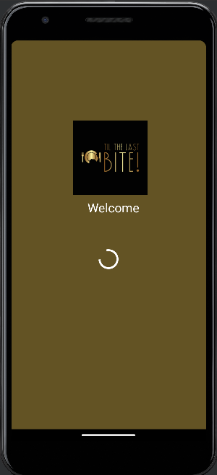 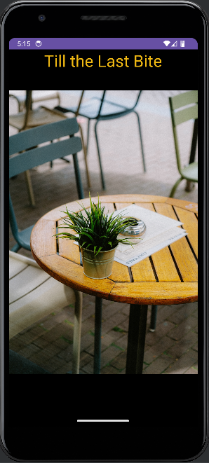

1. **Develop an app that displays your current location on map.**

**Aim:** Finding live location in google play service maps.

* 1. *Activity_main.xml*

***<?*xml version="1.0" encoding="utf-8"*?>*<RelativeLayout xmlns:android="http://schemas.android.com/apk/res/android"  
 xmlns:app="http://schemas.android.com/apk/res-auto"  
 xmlns:tools="http://schemas.android.com/tools"  
 android:layout_width="match_parent"  
 android:layout_height="match_parent"  
 tools:context=".MainActivity">  
   
 <fragment  
 android:id="@+id/google_map"  
 android:layout_width="match_parent"  
 android:layout_height="match_parent"  
 android:name="com.google.android.gms.maps.SupportMapFragment"/>  
  
</RelativeLayout>**

* 1. *MainActivity.xml*

**package com.example.androidmap;  
  
import androidx.annotation.NonNull;  
import androidx.appcompat.app.AppCompatActivity;  
import androidx.core.app.ActivityCompat;  
  
import android.content.pm.PackageManager;  
import android.location.Location;  
import android.os.Bundle;  
import android.view.WindowManager;  
import android.widget.Toast;  
  
import com.google.android.gms.location.FusedLocationProviderClient;  
import com.google.android.gms.location.LocationServices;  
import com.google.android.gms.maps.CameraUpdateFactory;  
import com.google.android.gms.maps.GoogleMap;  
import com.google.android.gms.maps.OnMapReadyCallback;  
import com.google.android.gms.maps.SupportMapFragment;  
import com.google.android.gms.maps.model.LatLng;  
import com.google.android.gms.maps.model.MarkerOptions;  
import com.google.android.gms.tasks.OnSuccessListener;  
import com.google.android.gms.tasks.Task;  
import com.karumi.dexter.Dexter;  
import com.karumi.dexter.PermissionToken;  
import com.karumi.dexter.listener.PermissionDeniedResponse;  
import com.karumi.dexter.listener.PermissionGrantedResponse;  
import com.karumi.dexter.listener.PermissionRequest;  
import com.karumi.dexter.listener.single.PermissionListener;  
  
public class MainActivity extends AppCompatActivity {  
  
 SupportMapFragment supportMapFragment;  
 FusedLocationProviderClient fusedLocationProviderClient;  
  
  
 @Override  
 protected void onCreate(Bundle savedInstanceState) {  
 super.onCreate(savedInstanceState);  
 setContentView(R.layout.*activity_main*);  
 getWindow().setFlags(WindowManager.LayoutParams.*FLAG_FULLSCREEN*, WindowManager.LayoutParams.*FLAG_FULLSCREEN*);  
  
 supportMapFragment = (SupportMapFragment) getSupportFragmentManager().findFragmentById(R.id.*google_map*);  
 fusedLocationProviderClient = (FusedLocationProviderClient) LocationServices.getFusedLocationProviderClient(this);  
  
 Dexter.withContext(getApplicationContext()).withPermission(android.Manifest.permission.*ACCESS_FINE_LOCATION*)  
 .withListener(new PermissionListener() {  
 @Override  
 public void onPermissionGranted(PermissionGrantedResponse permissionGrantedResponse) {  
 getCurrentLocation();  
 }  
  
 @Override  
 public void onPermissionDenied(PermissionDeniedResponse permissionDeniedResponse) {  
  
 }  
  
 @Override  
 public void onPermissionRationaleShouldBeShown(PermissionRequest permissionRequest, PermissionToken permissionToken) {  
 permissionToken.continuePermissionRequest();  
 }  
 }).check();  
  
 }  
  
 public void getCurrentLocation() {  
  
 if (ActivityCompat.checkSelfPermission(this, android.Manifest.permission.ACCESS_FINE_LOCATION) != PackageManager.PERMISSION_GRANTED && ActivityCompat.checkSelfPermission(this, android.Manifest.permission.ACCESS_COARSE_LOCATION) != PackageManager.PERMISSION_GRANTED) {  
return;  
 }  
 Task<Location> task = fusedLocationProviderClient.getLastLocation();  
 task.addOnSuccessListener(new OnSuccessListener<Location>() {  
 @Override  
 public void onSuccess(Location location) {  
 supportMapFragment.getMapAsync(new OnMapReadyCallback() {  
 @Override  
 public void onMapReady(@NonNull GoogleMap googleMap) {  
 if(location!=null){  
 LatLng latLng = new LatLng(location.getLatitude(), location.getLongitude());  
 MarkerOptions markerOptions = new MarkerOptions().position(latLng).title("Current Location");  
 googleMap.addMarker(markerOptions);  
 googleMap.animateCamera(CameraUpdateFactory.newLatLngZoom(latLng,15));  
 }  
 else{  
 Toast.makeText(MainActivity.this, "Please turn your location permissions on", Toast.LENGTH_SHORT).show();  
 }  
 }  
 });  
 }  
 });  
 }  
}**

* 1. *Output*

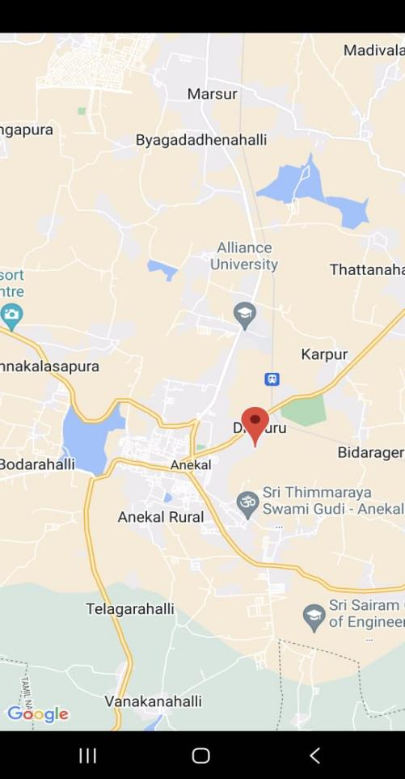

1. **Demonstrate CRUD operations with SQlite**

**Aim:**To demonstrate the Sqlite Database in android Application

* 1. *Activity_main.xml*

***<?*xml version="1.0" encoding="utf-8"*?>*<RelativeLayout xmlns:android="http://schemas.android.com/apk/res/android"  
 xmlns:app="http://schemas.android.com/apk/res-auto"  
 xmlns:tools="http://schemas.android.com/tools"  
 android:layout_width="match_parent"  
 android:layout_height="match_parent"  
 tools:context=".MainActivity">  
  
 <TextView  
 android:layout_width="match_parent"  
 android:layout_height="wrap_content"  
 android:text="Please enter the details below"  
 android:textSize="24dp"  
 android:layout_marginHorizontal="20sp"  
 android:id="@+id/parent"  
 />  
 <EditText  
 android:layout_width="match_parent"  
 android:layout_height="wrap_content"  
 android:id="@+id/name"  
 android:hint="Name"  
 android:textSize="22dp"  
 android:layout_below="@+id/parent"  
 android:inputType="textPersonName"/>  
 <EditText  
 android:layout_width="match_parent"  
 android:layout_height="wrap_content"  
 android:id="@+id/phone"  
 android:hint="Phone number"  
 android:textSize="22dp"  
 android:layout_below="@+id/name"  
 android:inputType="textPhonetic"/>  
 <EditText  
 android:id="@+id/email"  
 android:layout_width="match_parent"  
 android:layout_height="wrap_content"  
 android:hint="email@gamil.com"  
 android:textSize="22dp"  
 android:layout_below="@+id/phone"  
 android:inputType="textEmailAddress"/>  
  
 <Button  
 android:layout_width="match_parent"  
 android:layout_height="wrap_content"  
 android:id="@+id/insert_btn"  
 android:textSize="24dp"  
 android:text="Insert data"  
  
 android:layout_below="@+id/email"/>  
  
 <Button  
 android:layout_width="match_parent"  
 android:layout_height="wrap_content"  
 android:id="@+id/update_btn"  
 android:textSize="24dp"  
  
 android:text="Update data"  
 android:layout_below="@+id/insert_btn"  
  
 />  
  
 <Button  
 android:layout_width="match_parent"  
 android:layout_height="wrap_content"  
 android:id="@+id/delete_btn"  
 android:textSize="24dp"  
 android:text="delete data"  
  
 android:layout_below="@+id/update_btn"  
/>  
  
 <Button  
 android:layout_width="match_parent"  
 android:layout_height="wrap_content"  
 android:id="@+id/view_btn"  
 android:textSize="24dp"  
 android:text="View data"  
  
 android:layout_below="@+id/delete_btn"  
/>  
  
</RelativeLayout>**

* 1. *MainActivity.xml*

**package com.example.myapplication;  
  
import androidx.appcompat.app.AlertDialog;  
import androidx.appcompat.app.AppCompatActivity;  
  
import android.database.Cursor;  
import android.os.Bundle;  
import android.view.View;  
import android.widget.Button;  
import android.widget.EditText;  
import android.widget.Toast;  
  
public class MainActivity extends AppCompatActivity {  
  
 EditText name, email, phone;  
 Button insert, update, delete, view;  
 DBHelper DB;  
 @Override  
 protected void onCreate(Bundle savedInstanceState) {  
 super.onCreate(savedInstanceState);  
 setContentView(R.layout.activity_main);  
 name = findViewById(R.id.name);  
 email = findViewById(R.id.email);  
 phone = findViewById(R.id.phone);  
 insert = findViewById(R.id.insert_btn);  
 update = findViewById(R.id.update_btn);  
 delete = findViewById(R.id.delete_btn);  
 view = findViewById(R.id.view_btn);  
 DB = new DBHelper(this);  
  
 insert.setOnClickListener(new View.OnClickListener() {  
 @Override  
 public void onClick(View view) {  
 String nameTxt = name.getText().toString();  
 String emailTxt = email.getText().toString();  
 String phoneTxt = phone.getText().toString();  
  
 if (phoneTxt.length()!=10){  
 Toast.makeText(MainActivity.this, "invalid phone number", Toast.LENGTH_SHORT);  
 return;  
 }  
 if (emailTxt.indexOf("@")<0){  
 Toast.makeText(MainActivity.this, "invalid email", Toast.LENGTH_SHORT);  
  
 return;  
 }  
 Boolean checkinsertdata = DB.insertuserdata(nameTxt,phoneTxt, emailTxt );  
 if(checkinsertdata){  
 Toast.makeText(MainActivity.this, "New entry made", Toast.LENGTH_LONG).show();  
 }  
 Toast.makeText(MainActivity.this, "Entry failed", Toast.LENGTH_LONG).show();  
  
 }  
 });  
  
 update.setOnClickListener(new View.OnClickListener() {  
 @Override  
 public void onClick(View view) {  
 String nameTxt = name.getText().toString();  
 String emailTxt = email.getText().toString();  
 String phoneTxt = phone.getText().toString();  
  
 Boolean checkupdatedata = DB.updateuserdata(nameTxt,phoneTxt, emailTxt);  
 if(checkupdatedata){  
 Toast.makeText(MainActivity.this, "New Update made", Toast.LENGTH_LONG).show();  
 }else  
 Toast.makeText(MainActivity.this, "update failed", Toast.LENGTH_LONG).show();  
 }  
 });  
  
 delete.setOnClickListener(new View.OnClickListener() {  
 @Override  
 public void onClick(View view) {  
 String nameTxt = name.getText().toString();  
 Boolean checkdeletedata = DB.deletedata(nameTxt);  
 if(checkdeletedata){  
 Toast.makeText(MainActivity.this, "delete made", Toast.LENGTH_LONG).show();  
 }else  
 Toast.makeText(MainActivity.this, "delete failed", Toast.LENGTH_LONG).show();  
 }  
 });  
  
 view.setOnClickListener(new View.OnClickListener() {  
 @Override  
 public void onClick(View view) {  
  
 Cursor res = DB.getdata();  
 if(res.getCount() == 0){  
 Toast.makeText(MainActivity.this, "No entries present", Toast.LENGTH_LONG).show();  
 return;  
 }  
 StringBuffer buffer = new StringBuffer();  
 while(res.moveToNext()){  
 buffer.append("name : "+ res.getString(0)+"\n");  
 buffer.append("phone : "+ res.getString(1)+"\n");  
 buffer.append("email : "+ res.getString(2)+"\n\n");  
  
 }  
 AlertDialog.Builder builder = new AlertDialog.Builder(MainActivity.this);  
 builder.setCancelable(true);  
 builder.setTitle("User entries");  
 builder.setMessage(buffer.toString());  
 builder.show();  
 Toast.makeText(MainActivity.this, "update failed", Toast.LENGTH_LONG).show();  
 }  
 });  
 }  
}**

* 1. *Dbhelper.java*

**package com.example.myapplication;  
  
import android.content.ContentValues;  
import android.content.Context;  
import android.database.Cursor;  
import android.database.sqlite.SQLiteDatabase;  
import android.database.sqlite.SQLiteOpenHelper;  
  
import androidx.annotation.NonNull;  
import androidx.annotation.Nullable;  
  
public class DBHelper extends SQLiteOpenHelper {  
 public DBHelper(Context context) {  
 super(context, "Userdata.db", null, 1);  
 }  
  
 @Override  
 public void onCreate(SQLiteDatabase DB) {  
 DB.execSQL("create Table Userdetails(name Text PRIMARY KEY, phone Text, email Text) ");  
 }  
  
 @Override  
 public void onUpgrade(SQLiteDatabase DB, int i, int i1) {  
 DB.execSQL("drop table if exists Userdetails");  
 }  
  
 public boolean insertuserdata(String name, String phone, String email){  
 SQLiteDatabase DB = this.getWritableDatabase();  
 ContentValues cv = new ContentValues();  
 cv.put("name", name);  
 cv.put("phone", phone);  
 cv.put("email",email);  
  
 long result = DB.insert("Userdetails", null, cv);  
 return result!=-1;  
 }  
  
 public boolean updateuserdata(String name, String phone, String email){  
 SQLiteDatabase DB = this.getWritableDatabase();  
 ContentValues cv = new ContentValues();  
 cv.put("name", name);  
 cv.put("phone", phone);  
 Cursor cursor = DB.rawQuery("select * from Userdetails where name = ?", new String[] {name});  
 if (cursor.getCount()>0){  
 long result = DB.update("Userdetails", cv, "name=?", new String[]{name});  
 return (result!=-1);  
 }  
 return false;  
 }  
  
 public boolean deletedata(String name){  
 SQLiteDatabase DB = this.getWritableDatabase();  
 Cursor cursor = DB.rawQuery("select * from Userdetails where name = ?", new String[] {name});  
 if (cursor.getCount()>0){  
 long result = DB.delete("Userdetails", "name=?", new String[]{name});  
 return (result!=-1);  
 }  
 return false;  
 }  
  
 public Cursor getdata(){  
 SQLiteDatabase DB = this.getWritableDatabase();  
 Cursor cursor = DB.rawQuery("select * from Userdetails", null);  
 return cursor;  
 }  
}**

* 1. *Output*

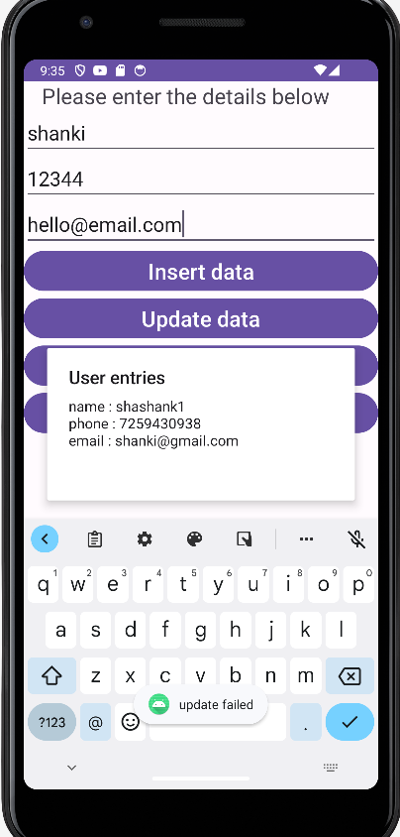

1. **Develop an app with menus**

**Aim**: Creating Option menu in android application

*activity_main.xml*

<?xml version="1.0" encoding="utf-8"?>  
<androidx.constraintlayout.widget.ConstraintLayout xmlns:android="http://schemas.android.com/apk/res/android"  
 xmlns:app="http://schemas.android.com/apk/res-auto"  
 xmlns:tools="http://schemas.android.com/tools"  
 android:layout_width="match_parent"  
 android:layout_height="match_parent"  
 android:background="#886FB5"  
 tools:context=".MainActivity">  
  
 <TextView  
 android:id="@+id/tv"  
 android:layout_width="wrap_content"  
 android:layout_height="wrap_content"  
 android:text="School of Academics"  
 android:textSize="36sp"  
 android:textColor="@color/black"  
 app:layout_constraintBottom_toBottomOf="parent"  
 app:layout_constraintEnd_toEndOf="parent"  
 app:layout_constraintStart_toStartOf="parent"  
 app:layout_constraintTop_toTopOf="parent" />  
  
</androidx.constraintlayout.widget.ConstraintLayout>

*options.xml*

<?xml version="1.0" encoding="utf-8"?>  
<menu xmlns:android="http://schemas.android.com/apk/res/android">  
  
 <item  
 android:id="@+id/i1"  
 android:title="Mathematics" />  
 <item  
 android:id="@+id/i2"  
 android:title="Chemistry" />  
 <item android:title="Information Technology" >  
 <menu>  
 <item  
 android:id="@+id/i3"  
 android:title="Computer Science" />  
 <item  
 android:id="@+id/i4"  
 android:title="Big Data Analytics" />  
 </menu>  
 </item>  
</menu>

*MainActivity.java*

package com.example.menu;  
  
import androidx.annotation.NonNull;  
import androidx.appcompat.app.AppCompatActivity;  
  
import android.os.Bundle;  
import android.view.Menu;  
import android.view.MenuInflater;  
import android.view.MenuItem;  
import android.widget.TextView;  
import android.widget.Toast;  
  
public class MainActivity extends AppCompatActivity {  
 TextView tv;  
  
 @Override  
 protected void onCreate(Bundle savedInstanceState) {  
 super.onCreate(savedInstanceState);  
 setContentView(R.layout.*activity_main*);  
 tv = findViewById(R.id.*tv*);  
 }  
  
 @Override  
 public boolean onCreateOptionsMenu(Menu menu) {  
 MenuInflater m = getMenuInflater();  
 m.inflate(R.menu.*options*, menu);  
 return true;  
 }  
  
 @Override  
 public boolean onOptionsItemSelected(@NonNull MenuItem item) {  
 int itemId = item.getItemId();  
  
 if (itemId == R.id.*i1*) {  
 tv.setText("Mathematics");  
 return true;  
 } else if (itemId == R.id.*i2*) {  
 tv.setText("Chemistry");  
 return true;  
 } else if (itemId == R.id.*i3*) {  
 tv.setText("Computer Science");  
 return true;  
 } else if (itemId == R.id.*i4*) {  
 tv.setText("Big Data Analytics");  
 return true;  
 }  
  
 return super.onOptionsItemSelected(item);  
 }  
}

*OUTPUT* 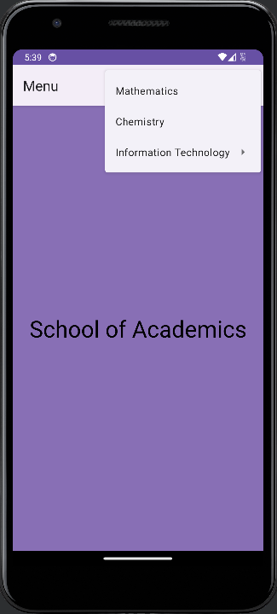

1. **Demonstrate dynamically changing colors and fonts of text on button clicks.**

**Aim:** To design an android app that utilizes GUI components,fonts and colors effectively to create an intuitive and visually appealing user interface for enhanced user engagement

* 1. *activity_main.xml*

*<?*xml version="1.0" encoding="utf-8"*?>*<androidx.constraintlayout.widget.ConstraintLayout xmlns:android="http://schemas.android.com/apk/res/android"  
 xmlns:app="http://schemas.android.com/apk/res-auto"  
 xmlns:tools="http://schemas.android.com/tools"  
 android:layout_width="match_parent"  
 android:layout_height="match_parent"  
 tools:context=".MainActivity">  
  
 <TextView  
 android:id="@+id/counter_disp"  
 android:layout_width="wrap_content"  
 android:layout_height="wrap_content"  
 android:background="#4587EC"  
 android:padding="8dp"  
 android:paddingHorizontal="12dp"  
 android:text="0"  
 android:textColor="@color/white"  
 app:layout_constraintBottom_toBottomOf="parent"  
 app:layout_constraintEnd_toEndOf="parent"  
 app:layout_constraintStart_toStartOf="parent"  
 app:layout_constraintTop_toTopOf="parent"  
 app:layout_constraintVertical_bias="0.526" />  
  
 <TextView  
 android:layout_width="wrap_content"  
 android:layout_height="wrap_content"  
 android:background="#4587EC"  
 android:padding="4dp"  
 android:id="@+id/varcolortext"  
 android:text="Click the buttons below to count"  
 style="@style/constrain"  
 android:textColor="@color/white"  
 app:layout_constraintBottom_toBottomOf="parent"  
 app:layout_constraintEnd_toEndOf="parent"  
 app:layout_constraintStart_toStartOf="parent"  
 app:layout_constraintTop_toTopOf="parent"  
 app:layout_constraintVertical_bias="0.446" />  
  
  
 <Button  
 android:id="@+id/btn_prev"  
 android:layout_width="wrap_content"  
 android:layout_height="wrap_content"  
 android:onClick="countPrev"  
 style="@style/constrain"  
 android:text="Previous"  
 app:layout_constraintBottom_toBottomOf="parent"  
 app:layout_constraintEnd_toEndOf="parent"  
 app:layout_constraintHorizontal_bias="0.24"  
 app:layout_constraintStart_toStartOf="parent"  
 app:layout_constraintTop_toTopOf="parent"  
 app:layout_constraintVertical_bias="0.635" />  
  
 <Button  
 android:id="@+id/btn_next"  
 android:layout_width="wrap_content"  
 android:layout_height="wrap_content"  
 android:onClick="countNext"  
 style="@style/constrain"  
 android:text="Next"  
 app:layout_constraintBottom_toBottomOf="parent"  
 app:layout_constraintEnd_toEndOf="parent"  
 app:layout_constraintHorizontal_bias="0.765"  
 app:layout_constraintStart_toStartOf="parent"  
 app:layout_constraintTop_toTopOf="parent"  
 app:layout_constraintVertical_bias="0.635" />  
  
 <Button  
 android:id="@+id/button"  
 android:layout_width="wrap_content"  
 android:layout_height="wrap_content"  
 android:background="#000080"  
 android:onClick="changeTextColor"  
 android:text="Change Color"  
 style="@style/constrain"  
 android:fontFamily="sans-serif-black"  
 app:layout_constraintBottom_toBottomOf="parent"  
 app:layout_constraintEnd_toEndOf="parent"  
 app:layout_constraintStart_toStartOf="parent"  
 app:layout_constraintTop_toTopOf="parent"  
 app:layout_constraintVertical_bias="0.329" />  
  
</androidx.constraintlayout.widget.ConstraintLayout>

* 1. *MainActivity.java*package com.example.counterapp;  
       
     import androidx.appcompat.app.AppCompatActivity;  
       
     import android.content.Intent;  
     import android.content.res.ColorStateList;  
     import android.graphics.Color;  
     import android.util.Log;  
     import android.os.Bundle;  
     import android.view.View;  
     import android.widget.Button;  
     import android.widget.TextView;  
       
       
     public class MainActivity extends AppCompatActivity {  
       
      TextView counter;  
      TextView colorful_text;  
      private int count_var = 0;  
      private int[] colors = {Color.BLACK, Color.BLUE, Color.GREEN, Color.RED};  
      private int initial_color = 0;  
      @Override  
      protected void onCreate(Bundle savedInstanceState) {  
      super.onCreate(savedInstanceState);  
      setContentView(R.layout.activity_main);  
      counter = findViewById(R.id.counter_disp);  
      Button switch_second = findViewById(R.id.switchsecond);  
      switch_second.setOnClickListener(new View.OnClickListener() {  
      @Override  
      public void onClick(View view) {  
      Intent intent = new Intent(getApplicationContext(), SecondActivity.class);  
      startActivity(intent);  
       
      }  
      });  
       
      }  
      public void countNext(View view){  
      count_var++;  
      counter.setText(Integer.toString(count_var));  
      //counter.setText(Integer.parseInt(counter.getText().toString())+1);  
      }  
      public void countPrev(View view){  
      //counter.setText(Integer.parseInt(counter.getText().toString())-1);  
      count_var--;  
      counter.setText(Integer.toString(count_var));  
      }  
       
      public void changeTextColor(View view){  
      colorful_text = findViewById(R.id.varcolortext);  
      colorful_text.setTextColor(colors[initial_color]);  
      initial_color = (initial_color+1) % colors.length;  
      }  
     }
  2. *Outputs*

 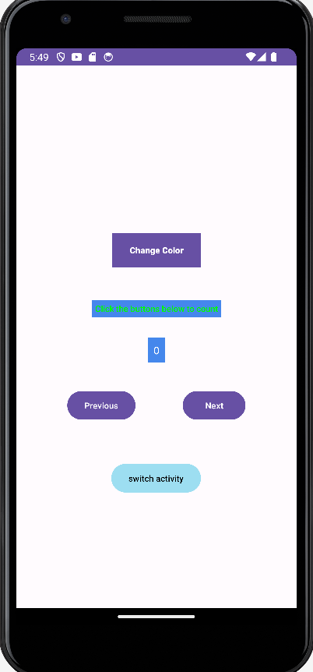

1. **Demonstrate the use of shared preferences**

**Aim:**To demonstrate the Shared Preferences.

*activity_main.xml*

<?xml version="1.0" encoding="utf-8"?>  
<LinearLayout xmlns:android="http://schemas.android.com/apk/res/android"  
 xmlns:app="http://schemas.android.com/apk/res-auto"  
 xmlns:tools="http://schemas.android.com/tools"  
 android:layout_width="match_parent"  
 android:layout_height="match_parent"  
 android:background="#85A59E"  
 android:orientation="vertical"  
 tools:context="com.example.sharedpreferences_studentdetails.MainActivity">  
  
 <TextView  
 android:id="@+id/textview"  
 android:layout_width="match_parent"  
 android:layout_height="wrap_content"  
 android:background="#000000"  
 android:gravity="center_horizontal"  
 android:textColor="@color/white"  
 android:textSize="30sp"  
 tools:text="Your text" />  
  
 <!-- New EditText fields for student details -->  
 <EditText  
 android:id="@+id/edittextName"  
 android:layout_width="match_parent"  
 android:layout_height="wrap_content"  
 android:layout_marginTop="20sp"  
 android:hint="Enter Name" />  
  
 <EditText  
 android:id="@+id/edittextRollNo"  
 android:layout_width="match_parent"  
 android:layout_height="wrap_content"  
 android:layout_marginTop="20sp"  
 android:hint="Enter Reg No" />  
  
 <EditText  
 android:id="@+id/edittextContactNo"  
 android:layout_width="match_parent"  
 android:layout_height="wrap_content"  
 android:layout_marginTop="20sp"  
 android:hint="Enter Contact Number" />  
  
 <Button  
 android:id="@+id/apply_text_button"  
 android:layout_width="wrap_content"  
 android:layout_height="wrap_content"  
 android:layout_gravity="center_horizontal"  
 android:text="apply text" />  
  
 <Switch  
 android:id="@+id/switch1"  
 android:layout_width="wrap_content"  
 android:layout_height="wrap_content"  
 android:layout_gravity="center_horizontal" />  
  
 <Button  
 android:id="@+id/save_button"  
 android:layout_width="wrap_content"  
 android:layout_height="wrap_content"  
 android:layout_gravity="center_horizontal"  
 android:text="save data" />  
  
</LinearLayout>

*MainActivity.java*

package com.example.sharedpreferences_studentdetails;  
import android.content.SharedPreferences;  
import android.os.Bundle;  
import android.view.View;  
import android.widget.Button;  
import android.widget.EditText;  
import android.widget.Switch;  
import android.widget.TextView;  
import android.widget.Toast;  
  
import androidx.appcompat.app.AppCompatActivity;  
  
public class MainActivity extends AppCompatActivity {  
 private TextView textView;  
 private EditText editText, editTextName, editTextRollNo, editTextContactNo;  
 private Button applyTextButton, saveButton;  
 private Switch switch1;  
  
 public static final String *SHARED_PREFS* = "sharedPrefs";  
 public static final String *TEXT* = "text";  
 public static final String *SWITCH1* = "switch1";  
  
 private String text, studentName, studentRollNo, studentContactNo;  
 private boolean switchOnOff;  
  
 @Override  
 protected void onCreate(Bundle savedInstanceState) {  
 super.onCreate(savedInstanceState);  
 setContentView(R.layout.*activity_main*);  
  
 textView = findViewById(R.id.*textview*);  
 editText = findViewById(R.id.*edittextName*);  
 applyTextButton = findViewById(R.id.*apply_text_button*);  
 saveButton = findViewById(R.id.*save_button*);  
 switch1 = findViewById(R.id.*switch1*);  
  
 editTextName = findViewById(R.id.*edittextName*);  
 editTextRollNo = findViewById(R.id.*edittextRollNo*);  
 editTextContactNo = findViewById(R.id.*edittextContactNo*);  
  
 applyTextButton.setOnClickListener(new View.OnClickListener() {  
 @Override  
 public void onClick(View view) {  
 textView.setText(editTextName.getText().toString());  
 }  
 });  
  
 saveButton.setOnClickListener(new View.OnClickListener() {  
 @Override  
 public void onClick(View view) {  
 saveData();  
 }  
 });  
  
 loadData();  
 updateViews();  
 }  
  
 public void saveData() {  
 SharedPreferences sharedPreferences = getSharedPreferences(*SHARED_PREFS*, *MODE_PRIVATE*);  
 SharedPreferences.Editor editor = sharedPreferences.edit();  
  
 editor.putString(*TEXT*, textView.getText().toString());  
 editor.putBoolean(*SWITCH1*, switch1.isChecked());  
  
 // Save additional student details  
 editor.putString("NAME", editTextName.getText().toString());  
 editor.putString("ROLL_NO", editTextRollNo.getText().toString());  
 editor.putString("CONTACT_NO", editTextContactNo.getText().toString());  
 editor.apply();  
  
 Toast.*makeText*(this, "Data saved", Toast.*LENGTH_SHORT*).show();  
 }  
  
 public void loadData() {  
 SharedPreferences sharedPreferences = getSharedPreferences(*SHARED_PREFS*, *MODE_PRIVATE*);  
 text = sharedPreferences.getString(*TEXT*, "");  
 switchOnOff = sharedPreferences.getBoolean(*SWITCH1*, false);  
 studentName = sharedPreferences.getString("NAME", "");  
 studentRollNo = sharedPreferences.getString("ROLL_NO", "");  
 studentContactNo = sharedPreferences.getString("CONTACT_NO", ""); }  
  
 public void updateViews() {  
 textView.setText(text);  
 switch1.setChecked(switchOnOff);  
  
 editTextName.setText(studentName);  
 editTextRollNo.setText(studentRollNo);  
 editTextContactNo.setText(studentContactNo); // Updated to set contact number  
 }  
}

*OUTPUT*

