🡪 JQuery ls “light-weight, do more” javascript library.

🡪 it is used to manipulate HTML, Javascript, CSS.

🡪it can be downloaded using CDN or Download from Jquery website.

🡪Syntax:**$(selector).action**

🡪 $(document.getready(function ()){…});

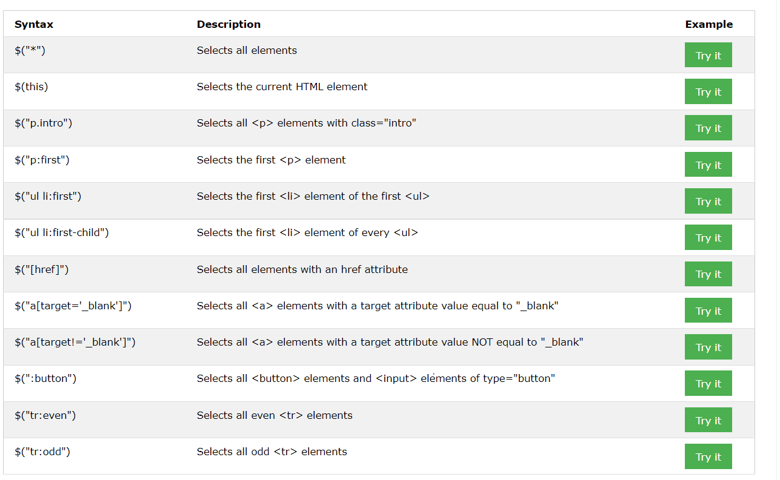

**Events**

**🡪click** event raises when user clicks on HTML Element

🡪 **dblclick** event raises when user double click on HTML Element.

🡪**mouseenter** event raises when user enters an HTML Element through Mouse.

🡪 **mouseleave** event raises when user leaves an HTML Element through Mouse.

🡪focus(),hover(), on() are some other events

Syntax:

$(“element”).event_name(function ()

{

//action….

}

**JQuey Effects**

**🡪hide()** is used to hide the element

Example:

$(“#id”).click(function()

{

$(“this”).hide();

});

**🡪show()** is used to show the element

Example:

$(“#id”).click(function()

{

$(“this”).show();

});

🡪 **toggle()** is used to toggle the effect of element between hide and show.

Example:

$(“#id”).click(function()

{

$(“this”).toggle();

});

**🡪fadeIn() is** used to fade an hidden element with speed as “slow”, “fast”

**Synatx:**$( “id”).fadein(speed,callback)

**Example:** $(#id1”).fadein(“slow”)

🡪 **fadeOut() is** used to fadeout visible element with speed as “slow”, “fast”

**Synatx:**$( “id”).fadeout(speed,callback)

**Example:** $(#id1”).fadeout(“fast”)

🡪 **fadetoggle() is** used to toggle between fadein() and fadeout() with speed as “slow”, “fast”

**Synatx:**$( “id”).fadetoggle(speed,callback)

**Example:** $(#id1”).fadetoggle(2000)

🡪 fadeTo() method allows fading to a given opacity (value between 0 and 1).

**Synatx:**$( “id”).fadeto(speed,opacity)

**Example:** $(#id1”).fadetoggle(“slow”,0.8)

**🡪slideDown()** is used to slidedown the element.

**Syntax**:$(‘selector’).slideDown(speed,callback)

**Example**:$(“.id1”).slideDown(“slow”,2000).

**🡪 slideUp()** is used to slideup the element.

**Syntax**:$(‘selector’).slideUp(speed,callback)

**Example**:$(“.id1”).slideUp(“fast”,2000).

🡪 **slideToggle()** is used to toggle between slideup and slidedown the element.

**Syntax**:$(‘selector’).slideToggle(speed,callback)

**Example**:$(“.id1”).slideToggle(“slow”,2000).

**JQuery Animation**

🡪JQuery Animation is used to perform animations and animate() used to create custom animations.

**Syntax:** $(“selector”).animate([params..],callback)

**Example:**

$("button").click(function(){  
  $("div").animate({left: '250px'});  
});

🡪 used to manipulate existing CSS properties.

**Example**:

$("button").click(function(){

$("div").animate({left: '250px'});

});

**JQuery Stop():**

**🡪 JQuery stop()** is used to stop the animation effect appied**.**

**🡪 The stop()** method works for all jQuery effect functions, including sliding, fading and custom animations**.**

**Syntax**

**$(selector).stop(stopAll,goToEnd);**

**Example**

$("#stop").click(function(){

$("#panel").stop();

});

**JQuery Callback**

**Example**

$("button").click(function(){

$("p").hide("slow", function(){

alert("The paragraph is now hidden");

});

});

**JQuery get**

**🡪**we can get text, HTML, val for element.

🡪.html() is used to get the HTML code for element

**Example**

$(“#btn1”).click(function(){

$(“#test”).html(); //<b id=”test”>bold</b>

<b id=”test”>bold</b>

<button id=”btn1”>SHOW HTML

🡪 text is used to get the text for HTML element

**Example**

$(“#btn1”).click(function(){

$(“#test”).text(); // “bold”

<b id=”test”>bold</b>

<buuton id=”btn1”>SHOW HTML

🡪 attr() is used to get the attribute for element

**Example**

$(“#btn1”).click(function(){

$(“#test”).attr(); //bold

<b id=”test”>bold</b>

<buuton id=”btn1”>SHOW HTML

🡪same as get() ,Just include code,text, css to use set() method

JQuery ADD Elements

🡪**append()** - Inserts content at the end of the selected elements.

**Example:**$(“#id1”).append(“Hello”).

🡪prepend() - Inserts content at the beginning of the selected elements.

**Example:**$(“#id1”).prepend(“Hello”).

🡪 after() - Inserts content after the selected elements

**Example:**$(“#id1”).after(“Hello”).

🡪before() - Inserts content before the selected elements

**Example:**$(“#id1”).after(“Hello”).

🡪 The jQuery remove() method also accepts one parameter, which allows you to filter the elements to be removed.

**Example:** $("p").remove(".test");

🡪 addClass() - Adds one or more classes to the selected elements

**Example:**

<style>

.sec

{

fontSize:30;

color:green;

}

</style>

<script>

$(“#id1”).addclass(“sec”)

</script>

🡪 removeClass() - Removes one or more classes from the selected elements

**Example**

$("button").click(function(){

$("h1, h2, p").removeClass("blue");

});

🡪 toggleClass() - Toggles between adding/removing classes from the selected elements

**Example**

$("button").click(function(){

$("h1, h2, p").toggltClass("blue");

});

🡪 css() - Sets or returns the style attribute

**JQuery Dimmensions**

