**DEEP LEARNING BASED CAT BREED CLASSIFICATION**

**Objective:** The main objective of this project is to classify different cat breeds using deep learning based CNN algorithm.

**Abstract:** The automatic classification of animal images is an onerous task due to the challenging image conditions, especially when it comes to animal breeds. In this paper, we built a model based on Convolutional Neural Network (CNN) of deep learning that which can classify the cat breeds. We are mainly considering the CNN based transfer learning that which is used to train the dataset of cat breed and based on this training we can classify the cat breeds.

**Keywords:** Cat Breed, Classification, Deep Learning, CNN

**Existing System:** This model emphasizes an existing method that which is designed using the ANN algorithm of deep learning. As the automatic classification of animal images is a difficult task due to the challenging image conditions, and therefore its detection and analysis methods should be improved. Where, the classification of animal breeds is important to recognize for which ANN is used that which can classify the animal breeds and mainly for the cat breeds.

**Disadvantages of Existing System:**

* Less feature compatibility
* Fixed size input and output
* Low accuracy

**Proposed System:** In our proposed method we are performing the cat breed classification using convolution neural network (CNN) of deep learning. The automatic classification of animal images is an onerous task due to the challenging image conditions, especially when it comes to animal breeds. In this paper, we built a model based on Convolutional Neural Network (CNN) of deep learning, where we are using the transfer learning method (MobileNet) that which can classify the cat breeds. We are mainly considering the CNN based transfer learning that which is used to train the dataset of cat breed and based on this training we can classify the cat breeds. The block diagram of the proposed method is shown in below figure.

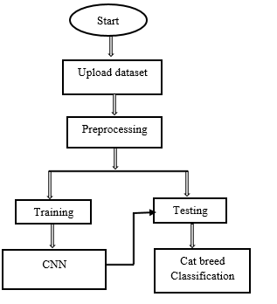

**Fig. Block diagram of proposed method**

**Advantages of proposed system:**

* Accurate classification
* Less complexity
* High performance

**Applications:**

* Picture retrieval
* Animal classifications
* Classifications

**Software & Hardware Requirements:**

# **H/W Configuration:**

# Processor : I3/Intel Processor

* Hard Disk : 160GB
* RAM : 8Gb

**S/W Configuration:**

* Operating System : Windows 7/8/10 .
* Server side Script : HTML, CSS & JS.
* IDE : Pycharm.
* Libraries Used : Numpy, IO, OS, Flask, keras.
* Technology : Python 3.6+.

**LEARNING OUTCOMES:**

* Practical exposure to
  + - * Hardware and software tools
      * Solution providing for real time problems
      * Working with team/individual
      * Work on creative ideas
* Testing techniques
* Error correction mechanisms
* What type of technology versions is used?
* Working of Tensor Flow
* Implementation of Deep Learning techniques
* Working of CNN algorithm
* Working of Transfer Learning
* Working of MobileNet algorithm
* Building of model creations
* Scope of project
* Applications of the project
* About Python language
* About Deep Learning Frameworks
* Use of Data Science